OHS Notice Board Guide
To ensure consistency with the requirements of the Department of Education and Training (the Department) OHS Consultation and Communication Procedure the following items are to be displayed on OHS notice boards in the workplace:
- HSW Policy  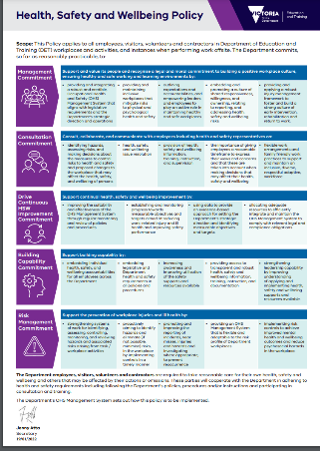 |  | - Corporate/Regional Office OHS Issue Resolution Flowchart  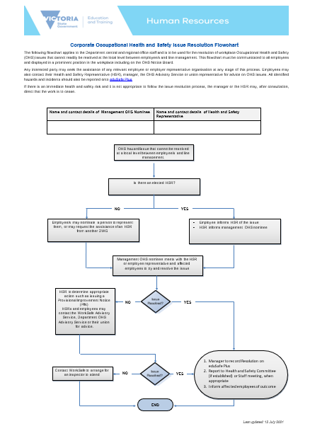 |  | - Staff Meeting and /or HSC Meeting Minutes  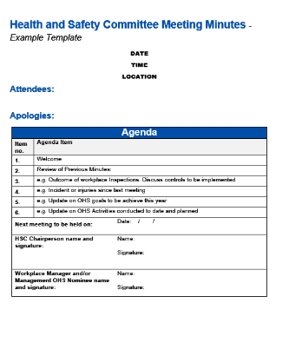 |  | - Emergency Management Contact Details or First Aid Summary Sheet  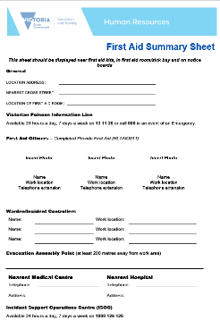
- Emergency Evacution Plan  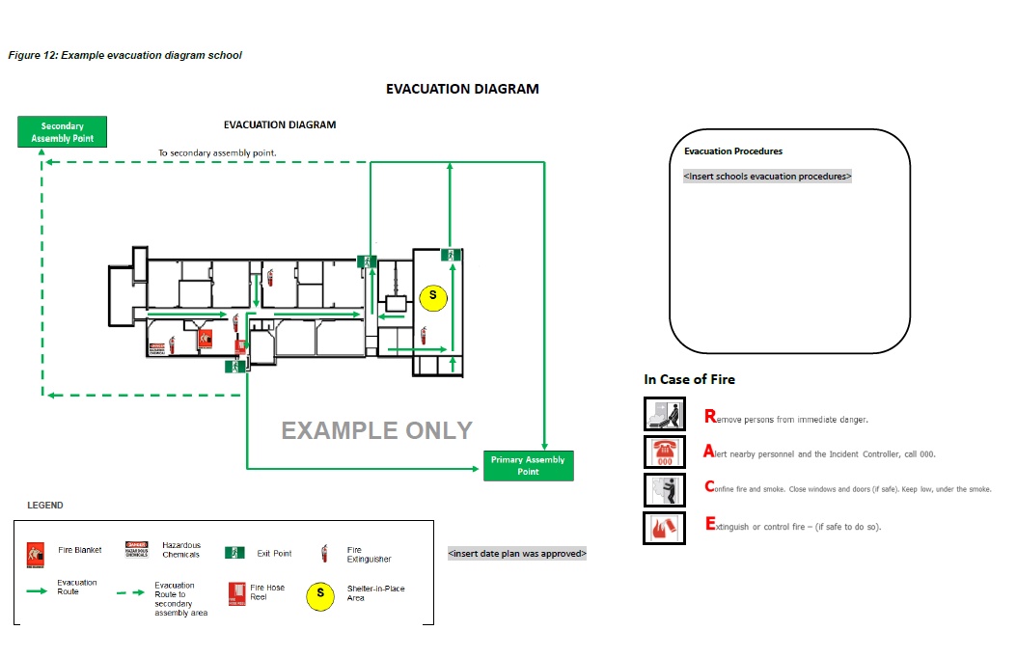 |  | - “If you are injured poster”  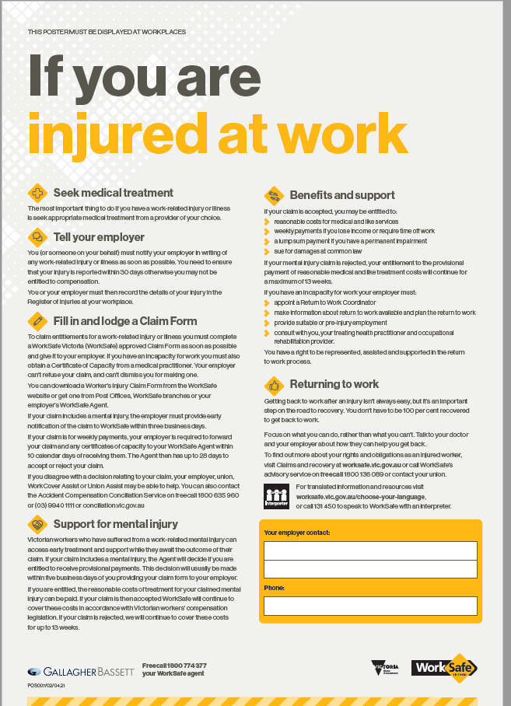 |  | - Employee Assistance Program |  | 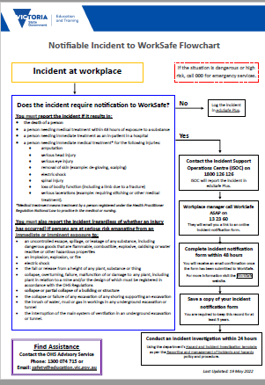  - Notifiable Incidents to WorkSafe Victoria Flowchart
- Returning To Work Following a Workplace Injury  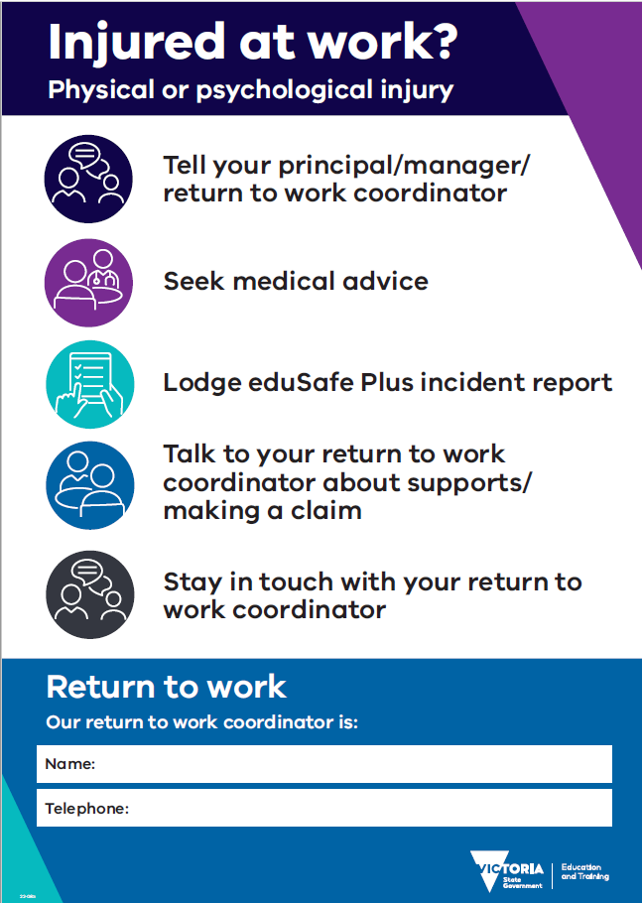 |  | - Corporate / Regional Offices OHS Activities Calendar or equivalent  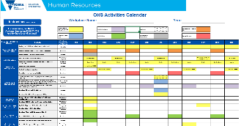 |  | 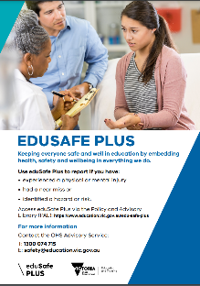  - Reporting and Management of Incidents and Hazards

