KNOWLEDGE EXCHANGE PROGRAM

An innovative program
designed to provide
Department leaders with the
opportunity to see first-hand
the live experience of schools

The Knowledge Exchange Program aims to provide corporate leaders with an understanding of how their work area outcomes are delivered and implemented in a school setting and the level of impact. This will enable them to build on implementation strategies and ensure effective delivery. Host schools will also gain an understanding of the corporate areas that support their work.
The key objectives of the program are to:
- Build capability and understanding to optimise effective implementation and impact of policy development in a school setting focused on improving outcomes for students through implementing the Education State agenda
- Strengthen relations and professional practice across the Department and enable greater mutual understanding and cooperation between schools and corporate
- Promote open dialogue between schools and corporate and potentially increase the number of school leaders who could be consulted with on Departmental initiatives.
Participants will benefit by developing:
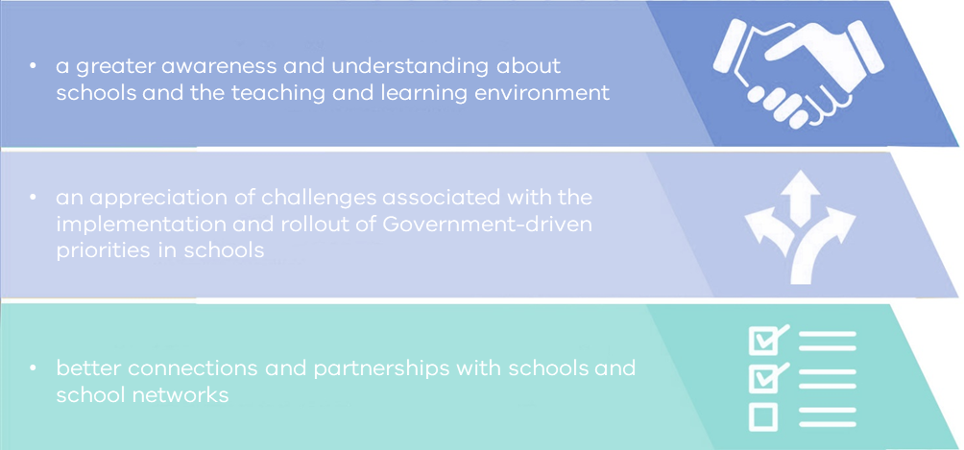
OUTLINE
The program will take place in Term 2 and 3 of the 2020 school year. Placements offer an immersion in a school and are full time and usually run for six weeks. An expression of interest process will be used to identify participants’ desired learning outcomes, areas of interest or expertise and availability. They will then be matched to schools to collaborate with them on the planning and implementation of policy and programs or by sharing expertise and skills to undertake specific projects or programs.
KEY DATES
Expressions of interest due: 7 February 2020
Placements: During Term 2 (14 April-26 June) or Term 3 (13 July-18 September) 2020
For more information:
http://www.education.vic.gov.au/hrweb/pd/Pages/knowledge.aspx
or contact Mark Dunlop, Organisational Consultant, People Services,
- telephone: (03) 7022 1125
- email: dunlop.mark.j@edumail.vic.gov.au

