# Maxxia – our new Salary Packaging and Novated Lease Partner

**This Issue contains…**

* Maxxia – our new Salary Packaging and Novated Lease Partner
* Position Allowance
* Change of Executive Class TRP to cash
* Permission to Teach (PTT) for final year pre-service teachers for 2023
* Youth Employment Scheme (YES) – 2022/2023
* Workers’ Compensation Leave for the Christmas School Vacation Period
* Workers’ Compensation Notification of Current Weekly Earnings (CWE’s)

**Recruitment Hints & Tips**

* VIT annual registration – now overdue

**eduPay Hints and Tips**

* Education Support Class employees – leave and attendance

**School Local Payroll Hints and Tips**

* Education Support Class (casual and non-casual) employees updated pay rates and translation from 2 Jan 2022 – processed in pay 2212

**The eduPay Way**

* Time in Lieu
* Recruitment Reimagined
* Data Insights

**End of Term checklist**

Salary packaging is an employee benefit that lets you pay for a range of expenses with your pre-tax salary, potentially reducing your taxable income and increasing your disposable income. Visit [educationvic.maxxia.com.au](https://educationvic.maxxia.com.au/?cid=emp:email:launch:detvi_camp:home&consultant=generic) for information on what you are eligible to package, educational videos, FAQ’s, calculators and the latest vehicle offers. You can also live chat with a Maxxia consultant.

**Webinar sessions:** Maxxia’s 10-minute online webinar will take you through the benefits available and answer any questions you might have. [Register now](https://forms.office.com/pages/responsepage.aspx?id=5W6Ipx5O1EWHgfi-lKgvD-HUQ8ML2sFDmjjUIvPysf5UMktEMFJTUENaSUlLSkRCOEhUMEdGNloyUy4u) at a date and time that suits you.

Employees with any questions regarding a novated lease, additional super contribution or other existing salary packaging claim that transitioned from the previous salary packaging provider should email their query to [transitions@maxxia.com.au](mailto:transitions@maxxia.com.au).

# Position Allowance

Assistant principals, teachers and education support class employees at level 2, level 1 ranges 3 to 5 or level 1 range 2 step 8 (step 1 to 7 are not eligible) are entitled to be paid in December each year, a position allowance equivalent to one per cent of the total salary to which the employee is normally entitled as at 1 December of the year in which the allowance is paid. The allowance will be allocated pro rata for part time employees and will be discounted for times when unpaid leave was taken throughout the year.

Position allowance for eligible employees has been paid in Pay 2212 (pay day 15 December 2022) to reflect the provision of the VGSA 2022. Recalculation will be made to eligible employees with regular leave purchase allowance, and the balance will be paid in pay 2213 (pay day 29 December 2022). Eligible employees who were terminated and rehired in pay 2211 and 2212, will have position allowance calculated and paid in pay 2213.

# Change of Executive Class TRP to cash

All eligible executive class employees were translated from a Total Remuneration Package (TRP) to a cash salary as part of VGSA 2022. This translation occurred in pay 2212 (commencing 4/12/2022) for all executive class employees who are members of an accumulation superannuation fund or a SMSF (self-managed superannuation fund).

This results in a reduction in the annual amount shown on the payslip, the removal of the SGC CONTRACT deduction from the payslip with SGC being paid instead ‘on top’ of their cash salary (shown on the super section on the payslip now).  For most employees there is no variance to their net pay.  However, in limited circumstances, where large amounts were salary sacrificed before tax, a small variation to the net pay may result.

Employees who are members of the ESSSuper Defined Benefit funds (New, Revised and SERBS) will continue to be paid a TRP with their employer contribution being deducted from their fortnightly pay.  Refer to the relevant section of the VGSA 2022 on the [Industrial Agreements - Resources](https://www2.education.vic.gov.au/pal/industrial-agreements/resources) page.

As part of this process all employees in receipt of Higher Duties to the executive class level that crossed pay 2212 will be adjusted to reflect the change to cash salary from 4/12/2022.  This includes any future dated HD entries.  All new future dated higher duties allowances are calculated to the new cash salary.

# Permission to Teach (PTT) for final year pre-service teachers for 2023

The VIT has announced that PTT (COVID-19) for casual support has been extended into 2023. Notification of this and full details are available on the [VIT website](https://www.vit.vic.edu.au/news/ptt-covid-19-has-been-extended-2023).

This extension for 2023 will allow final year pre-service teachers to apply for VIT PTT registration that will enable them to be employed as a casual paraprofessional through local payroll. It continues to be the case that PTT attained for this purpose will not suffice for appointment to a teaching service position on central payroll, and where that is desired, the school and employee must follow standard PTT processes.

# Youth Employment Scheme (YES) – 2022/2023

The 2022-23 financial year sees the continuation of the YES program. This program offers young people facing barriers the opportunity to work for 12 months while studying for a Certificate III or IV qualification. DET has placements available for YES Trainees, including a limited number of Disability stream placements. Further information is available by contacting Schools Recruitment Unit [youth.employment.scheme@education.vic.gov.au](mailto:youth.employment.scheme@education.vic.gov.au)

**Note:** Subsidies for YES placements are currently under review. Once finalised, schools will be notified of the amounts. Principals/Managers are advised that in placing a YES trainee, they will be responsible for meeting the non-subsidized portion of the salary costs (including on-costs and administration), estimated to be around $40,000.

This year further support will be provided by the Schools Recruitment Unit, and YES trainees will be eligible to attend additional training sessions designed to prepare YES trainees for future employment prospects. Information will be sent to the trainee and school at the commencement of each placement.

**Eligibility:** To be eligible for a YES placement, participants must:

* be aged 15-29 at the commencement of the traineeship
* be unemployed or not working more than 15 hours per week
* not be currently engaged in tertiary education; and
* not possess a university-level qualification (excluding certificate level 1-4 courses).

Preference is also given to YES applications which identify ‘disadvantaged’ young people, including those who are:

* Long-term unemployed
* Resident in a rural or remote area of Victoria
* Have a disability or mental illness
* Aboriginal or Torres Strait Islander Person.

[For further information on YES placements and to reserve placement/s for your school please email](mailto:youth.employment.scheme@edumail.vic.gov.au.%20For%20further%20information%20on%20the%20YES%20placements%20please%20contact%20%20%20): [youth.employment.scheme@education.vic.gov.au](mailto:youth.employment.scheme@education.vic.gov.au).

# Workers’ Compensation Leave for the Christmas School Vacation Period

Under the *Workplace Injury Rehabilitation and Compensation Act 2013*, Workers’ Compensation recipients are to be paid their weekly compensation benefits in their normal fortnightly pay.

To ensure workers’ compensation recipients are paid their compensation entitlements over the Christmas school vacation period, principals and/or business managers need to ensure certificates of capacity (COC) are processed prior to the end of Term 4 2022 and emailed to Gallagher Bassett.

Gallagher Bassett have advised they will accept extended certificates over the 2022-2023 holiday period only.  Principals and/or business managers are asked to advise workers’ compensation recipients to obtain an extended COC prior to the end of Term 4 covering the absence up to 31 January 2023. On receipt of COC the leave is to be entered on eduPay before the end of 2022 to avoid under/overpayments during the holiday period reflecting the return to work the employee was completing at the end of Term 4 2022. If the employee had no capacity to work in term 4 then Workcover leave is required to be entered for the entire holiday period.

Please note the extension of certificates over the Christmas school vacation is only accepted by Gallagher Bassett to minimise potential overpayments during this break.  Throughout the remainder of the year certificates should be no longer than 28 calendar days in duration unless otherwise approved by Gallagher Bassett.

Please ensure that where an employee is about to or has exhausted the make-up pay entitlement (leave code 641), the max rate payable amount is obtained from Gallagher Bassett and is recorded in the compensation rate/week field on eduPay using leave code 636.

Please refer to the [make-up pay entitlement balance instructions](https://edugate.eduweb.vic.gov.au/edrms/EHSWD/WCU/Support_Materials/Make%20Up%20Pay%20Entitlement%20Balance%20Instructions.pdf) for checking balances. Further information on processing workers’ compensation leave can be found in the [WorkSafe and TAC User Guide](https://edugate.eduweb.vic.gov.au/Services/HR/Documents/UGS-WorkCover-TAC-Absences.pdf) on HRWeb and the [Workers’ Compensation PAL Site](https://www2.education.vic.gov.au/pal/workers-compensation/resources).

**Action**:    Record workers’ compensation entries to cover the vacation period up to 31 January 2023 only where the Principal believes the employee will remain on workers’ compensation leave and an appropriate extended certificate has been received.  
Record a ‘stop pay’ following the workers’ compensation entry.

# Workers’ Compensation Notification of Current Weekly Earnings (CWE’s)

Business Managers/HR Administrators are reminded of the requirement to report Current Weekly Earnings (CWE’s) to Gallagher Bassett when a worker is on a partial Return to Work program.  CWE’s can now be generated on eduPay following these instructions: [Current Weekly Earnings Instructions](https://edugate.eduweb.vic.gov.au/edrms/EHSWD/WCU/Support_Materials/Current%20Weekly%20Earnings%20Instructions.pdf?Web=1).

It is highly recommended that Business Managers/HR Administrators generate the Current Weekly Earnings report on a fortnightly basis, adding a reminder in your outlook for the Monday after pay day i.e., on 5 December generate the 2211 PAY PERIOD report and email.

Where schools have an employee who has exhausted their make-up pay entitlement, now in 636 POST MUP, generate the CWE’s for the **2211 PAY PERIOD** on 5 December 2022. Email the report to your employee’s case manager at Gallagher Bassett and confirm the max rate payable (important if change in working hours) to ensure an accurate rate is used over the school holiday period.

If these details/documents are not submitted within a 3-month period, Gallagher Bassett can refuse reimbursement to the Department under Section 179 of the Workplace Injury Rehabilitation and Compensation Act 2013.

For further queries please contact the Return to Work and Compensation Team by telephone on (03) 7022 0780 or by email [workers.compensation.advisory@education.vic.gov.au](mailto:workers.compensation.advisory@education.vic.gov.au)

Recruitment Hints & Tips

# VIT annual registration – now overdue

* Invoices were issued by the VIT for annual VIT registration renewal in August. Registration was due by 30 September 2022 and is now overdue.
* Late payment fees may apply to registrations finalised after 30 September and before 31 December 2022.
* Teachers who have not finalised registration by 31 December 2022 may be unable to undertake teaching duties at the commencement of the 2023 school year.
* Schools can view the status of their teacher registration by viewing “My School” portal, available from the [VIT website](https://www.vit.vic.edu.au/home).
* Education Support Class employees who hold VIT Registration in lieu of a Working with Children Clearance must have renewed and updated eduPay by 30 September 2022.  If not renewed by now a WWC Clearance card is required instead.
* Employees are to update their renewed VIT and/or WWC Clearance information using Employee Self Service on eduPay.  HR Administrators then review the entries and if valid, mark them as Registered/Card presented on the Suitability for Employment page.

**Action**: Principals are asked to bring this to their employee’s attention and encourage renewal as soon as possible. HR Administrators are asked to review entries and update the suitability page after validating the recorded entries.

eduPay Hints and Tips

# Education Support Class employees – leave and attendance

Refer to [HRM Online News 11-2022](https://www.education.vic.gov.au/hrweb/Documents/HRM-Online-11-2022.docx) for details on Education Support Common Start Date – 27 January 2023.

Term 4 school vacation- 2022-2023

Automated recording of leave on eduPay

* Term 4 leave was recorded by central process over the weekend: 11-12 December 2022.
* Where leave has not been recorded, an exception report has been sent to each school. Access report from email or in Report Manager on eduPay.
* Determine action to take where necessary – refer to help at [Annual Leave Automated Entry – ESC User Guide](https://edugate.eduweb.vic.gov.au/Services/HR/Pages/eduPay_UGuides.aspx)

Applying for Leave

* Employee who receives the Regular Leave Purchase Allowance (LPA) applies for leave using ESS. Principal is the leave approver.
* These employees are not eligible for the Ad-hoc LPA.
* School Council Employees who are not employed in the ES structure (e.g.: GSCFLX) will not have leave recorded. Manual entry of leave for these employees is required – employee via ESS or HR Administrator directly at *HR Admin > Manage Leave > Update/View Absence Events (tile path in eduPay)*

Attendance for duty

* ESC Not receiving the Regular Leave Purchase Allowance who agrees/required to attend for duty may be eligible for the Ad-hoc LPA
* Where attendance occurs, adjust any recorded leave to reflect their attendance hours.
* Where the additional paid leave entitlements have a positive balance, record the Ad-Hoc LPA for the equivalent number of hours.
* Update is completed in the first pay period after the school vacation.
* Where leave is exhausted before the end of the school vacation period, these employees have no further entitlement to leave and are not eligible for the Ad-Hoc LPA and are therefore considered to be ‘on duty’.
* Refer to the [eduPay User Guides](https://edugate.eduweb.vic.gov.au/Services/HR/Pages/eduPay_UGuides.aspx) for Allowances and Annual Leave Automated Entry – ESC on eduGate.
* Refer to the [Annual Leave](https://www2.education.vic.gov.au/pal/annual-leave-teaching-service/overview), [Attendance and Working Hours](https://www2.education.vic.gov.au/pal/attendance-and-working-hours-teaching-service/overview) and [Allowances-Teaching Service](https://www2.education.vic.gov.au/pal/allowances-teaching-service/overview) on HRWeb for policy information

School Local Payroll Hints and Tips

# Education Support Class (casual and non-casual) employees updated pay rates and translation from 2 Jan 2022 – processed in pay 2212

The translation to the revised education support class (ESC) classification and increased pay rate for *eligible* casual and non-casual ESC as identified in [Ministerial Order 1389](https://www2.education.vic.gov.au/pal/ministerial-orders-employment/overview) has been processed in pay 2212, pay day 15 December 2022.

The eduPay way



# The eduPay Way

I know it’s December and the last HRM Online for the year - *but back at eduPay HQ, we’re not slowing down any time soon* - and we’ve got some great eduPay gifts for you 😊

It was so great to see so many Business Managers at our Ask us Anything sessions with our eduPay experts recently, and while it feels like we’ve been talking about Time in Lieu *forever*, we’ve still got a few more exciting updates on this feature for you. And a couple of other newbies just around the corner…

**Time in Lieu**

There are currently 2 interim options in place via a query and existing absence entitlement report to assist schools with the management of Time in Lieu. Both BMs and Principals can access these options and the existing [Quick Reference Guide](https://edugate.eduweb.vic.gov.au/Services/HR/Documents/QRG-Time-in-Lieu.pdf) has been updated to include these.

Next week we’ll have the new TiL reporting facility available in eduPay which will look and feel very similar to the existing Vacation Leave Estimator (including a summary page with a status legend for ease of visibility, ability to export to excel and detailed information when you select an employee) so it will feel familiar from day 1. See snapshot below…

We’ll also update the existing QRG for you on launch, so keep an eye out for an announcement in eduPay.

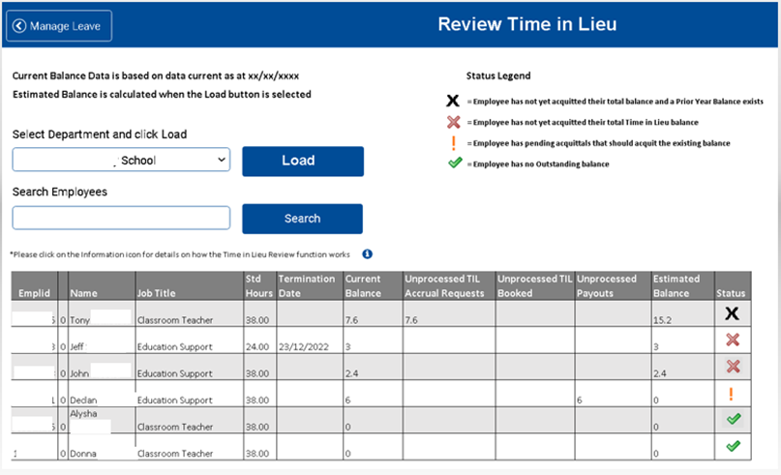

**More VGSA items arriving in the 2nd pay period in December**

* **Position Allowance** – automated payment
* **School Local Payroll and casuals** – ESC Translations and pay increase
* **Executive Principals** – Salary increase and backpay processed
* **Accrue Annual Leave** - for Principals and Teachers

**Recruitment Reimagined**

To continue to achieve our objective of improving the candidate pool for our recruiters, we have just undertaken an initiative to ensure the currency of applicants and data integrity in the Job Opportunity pool is up to date. Over 3000 emails were sent to applicants:

* **Requesting them to update their JO record** within a specified timeframe or their JO record will be withdrawn
* **Advising them if they have recently been hired,** their JO record will be withdrawn
* **Notifying them if they will shortly be finishing up a current fixed term employment** to submit or resubmit a JO application to advise they are becoming available

**The next round of updates is currently in development and will arrive early in the new year. They include:**

* Job opportunity pool search changes
* Placing applicants for advertised jobs into the JO pool automatically

**Data Insights**

The new eduPay visualisation tool is nearly here for schools. We’ve just done a pilot of the Data Insights tool which allows you to explore, visualise and build an analytic dashboard for your most important Human Capital Management analytics. We’ll be using this new tool to assist you with both recruitment and Time in Lieu – here’s a snapshot of what it might look like for TiL. But more on this later 😉

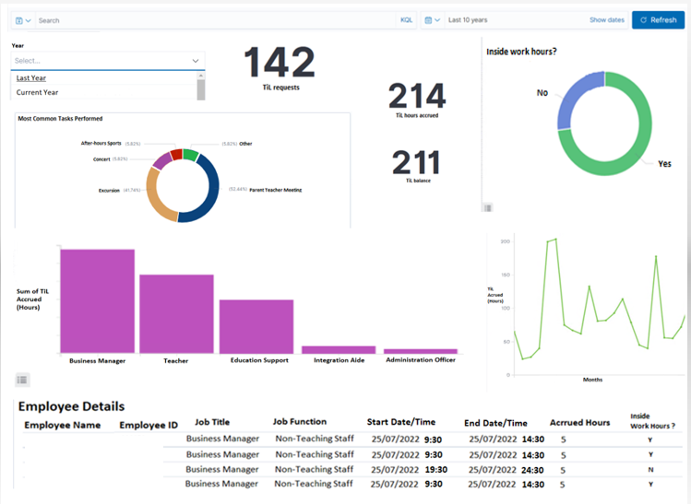

**2023 new hires – eduPay account created overnight**

Oh and a little something extra that we did this time last year, and it was such a hit (for all the obvious reasons 😉) so we’ve done it again this year! **From 1.12.22 to 20.12.22, all new hires for the beginning of the next year will have their eduPay account created overnight.** This means you can onboard your staff before the end of year break.

We’ve got more exciting features planned to reimagine for you next year, including eduPay going to the cloud – *yay* – but before we click over to 2023, let’s see what we’ve done as a team this year…

* **750+** BMs in working groups
* **200+** Communications
* **31** Working Group sessions
* **20** Formal Training sessions
* **18** Conference Presentations
* **15** Support Guides which include FAQs

Thank you to all our BM friends of eduPay who’ve dedicated their time and support by participating in our working group sessions this year. You are designing eduPay features to work for you, as they need to and when they need to. We can’t do this without you! The FOMO is real – so if you want to join in next year – email [tania.rann@education.vic.gov.au](mailto:tania.rann@education.vic.gov.au) – just pop FOMO in the subject and I’ll get on it.

And we can’t wait to do it all again with you next year. Wishing everyone a very happy holiday and safe travels across the festive season.

Warmest wishes from T and the eduPay team back at HQ.



Thank you for another amazing year, and hope you enjoy the holidays and have a Happy New Year!

*End of term checklist continues on the next page…*

# End of Term checklist

Payroll reminders

* ***Avoid incorrect pays for returning employees*** *–* Be aware of any employees returning from long term leave next term and make a note to check:
  + (a) they actually resume and
  + (b) they will be paid correctly.
* ***Avoid Overpayments***. Ensure leave is approved and recorded for employees who are to commence unpaid leave.
* ***Ceasing Employees***. Ensure all terminations have been processed on eduPay and where applicable a copy of the employee’s written notice of cessation of employment which has been accepted by the principal is placed on the employee’s personnel file.
* ***Unused Long Service Leave on Termination***. Adjust the *‘payout LSL on termination’* checkbox on Job Data on eduPay as required. Eligible employees will be paid out for LSL unless the box is unchecked. Employees can now make this adjustment in Self Service – encourage them to do so. Long Service Leave that has been paid out cannot be reversed and reinstated.
* ***Payroll Validation and Certification*** – validate and certify any outstanding pay periods.
* ***Check/Review all employee’s leave/payroll records*** *–* Ensure ALL employees leave/payroll records are correct prior to the end of term 4 ensuring employees are paid correctly in accordance with relevant policy on HRWeb/PAL during the vacation period.

Leave reminders

* ***Complete*** *all ESC Annual Leave exception report entries*
* ***Record/process leave*** for employees commencing or extending unpaid or half pay leave. Ensure ***539 LWOP APPRV*** is used for Leave Without Pay entries where leave has been approved by the principal. Encourage employees to apply for leave using Employee Self Service wherever possible.
* ***Review all Stop Pay entries****.* A Stop Pay is not an official leave type. Stop pay is used as a temporary measure to ensure an employee is not overpaid following workers’ compensation absence or long-term unpaid leave. Determine the correct leave type for these employees (if applicable) and adjust their records accordingly.
* ***Record workers’ Compensation Certificates*** *–* record Certificates of Capacity over the vacation period. See article included in this issue on covering the vacation period
* ***Process all outstanding leave entries*** – record and process any outstanding leave entries through ESS, MSS or EDM

Recruitment Reminders

* ***WWCC Check***. Review the WWCC Status page (***Manage Staff > Suitability for Employment – select WWCC Status***) and take action on pending, invalid or expiring Working with Children Check records. It is an employment requirement for education support class employees (ESC) to hold a valid Working with Children (WWC) Check except where they hold current VIT registration. It is also an offence for a person to be engaged in child related work in a school without a valid WWC Check. As a result, eduPay will not allow the employment of the person without valid WWC Check data entered. Prior to employing any ESC or other non-teaching employee ensure they have a valid and current employee type WWC Check card and the card details are recorded on eduPay at the time of their hire/rehire.

A current employee can record their renewed or new card details through Employee Self Service (ESS) and the HR Administrator then validates this entry on the Suitability for Employment page.

* ***VIT Registration***. Remind all employees that their VIT Registration renewals must be completed by 31 December 2022, or they may not be able to teach in 2023. See reminder article in the Recruitment Hints & Tips section
* ***Principal Class appointments, promotions or transfers.*** Principal and Assistant Principal appointments, promotions or transfers are completed by Schools People Services on return of the signed Contract of Employment. School operators must not complete Job Data transactions for principal class employees.
* ***Employment Offers***.Ensure all employment offers for any hires or rehires have been accepted in writing and the school’s copy of the employment offer is placed on the employee’s personnel file.
* ***Complete the Hire/Rehire of staff as appropriate*** – after completing the Hire/Rehire of an employee, ask the employee to update their taxation and superannuation details directly in ESS (this can be done in advance of actual commencement and completed from home). For fixed term teacher positions filled by fixed term teachers (i.e. not ongoing teachers on temporary transfer) ensure the correct employment end date is used on eduPay – refer to the [Fixed Term Teacher Vacancy Ready Reckoner](https://www2.education.vic.gov.au/pal/recruitment-schools/resources) on PAL. The Employment Task List should be used to assist in the hire/rehire process, available on HRWeb at: [Recruitment in Schools](https://www2.education.vic.gov.au/pal/recruitment-schools/resources)
* ***Promotion and Transfer of teachers and ESC employees***.Ensure any promotions and transfers of ongoing employees have been processed and any documentation in relation to the promotion or transfer is placed on the employee’s personnel file.
* ***Record Higher Duties*** – Ensure all higher duties assignments commencing next term are approved by the principal, processed on eduPay and a copy of the approved Higher Duties form placed on the employee’s personnel file.

Other Reminders

* ***WWC Check and Volunteers***. Ensure all Volunteers have a valid WWC Check card in accordance with your school’s visitor policy. An employee card can be used to volunteer but a volunteer card cannot be used for paid employment.
* ***WWC Check and Contractors***. Ensure the assessment of the suitability of contractors to be on school premises is consistent with the department’s *Suitability for Employment Policy* and your school policy. Contact the [Employee Conduct Branch](mailto:employee.conduct@educaton.vic.gov.au) if advice is required.
* ***Personnel Files***. For previous employees who transfer to or are rehired at your school, request the personnel file from their previous school. Where another school requests the personnel file for a previous employee, make sure all documentation has been securely included and send it to the new school by registered mail. For further information on personnel files, see the HRWeb topic – [Records Management](http://www.education.vic.gov.au/hrweb/workm/Pages/recmgt.aspx).