# Common Progression Cycle ends

This Issue contains…

* Common Progression Cycle ends 30 April 2025
* eduSafe Plus training for term 2 2025
* Superannuation – DOE and SLP payroll - reminder
* Aware Super Clearing House – employer assistance for School Local Payroll - reminder
* eduPay hints and tips

The eduPay Way

* Cancel leave – the new way
* Business manager phishing course

# 30 April 2025

Principals are reminded that the Common Progression Cycle ends on 30 April 2025, where an employee has completed one of the following:

**PDP process on eduPay**

* Record the appropriate outcome on the eduPay performance plan with ‘Standards Met’ or ‘Standards Not Met’.
* Progress and fully complete the performance plan immediately and no later than close of business Friday 2 May 2025.
* The result recorded in the PDP is used to progress or not progress the employee accordingly.

**Statement of Expectations**

Progression will be applied for eligible employees from 1 May 2025. Please note the following:

* ***Met expectations*** – no action is required, eduPay will calculate eligibility and apply progression where eligible from 1 May 2025.
* ***Did not meet expectations*** – Principal to email [payrollservices@education.vic.gov.au](mailto:payrollservices@education.vic.gov.au) with the employee name, employee ID and a statement that performance expectations were not met, no later than 30 April 2025.

Principals should note that eduPay will automatically calculate eligibility and process salary progression for all eligible employees that have an outcome of Standards Met effective from 1 May 2025. No action is required by schools for the processing of salary progression for employees on eduPay.

At this time, the payroll update for progression is planned for the weekend of 3-4 May 2025 with progression for eligible employees included in pay 2423, pay day 15 May 2025. Confirmation of the processing will be included on the dashboard announcement tile.

In the week commencing 5 May 2025, please check the outcomes on eduPay are what is expected for your employees. If there are any issues with the progression process or the outcome is not what was expected contact the Schools People Services on **1800 641 943** for assistance and correction.

**Please do not update or amend or overwrite the Progression row on eduPay.**

# eduSafe Plus training for term 2 2025

The eduSafe Plus training schedule is currently being finalised for this term and sessions will soon be available for enrolment via [LearnEd](https://edupayelm.eduweb.vic.gov.au/psc/ELMPPRD1/EMPLOYEE/PSFT_LM/c/LM_OD_EMPLOYEE_FL.LM_FND_LRN_FL.GBL?Page=LM_FND_LRN_RSLT_FL&Action=U&KWRD=edusafe%2520plus&PortalActualURL=https%3a%2f%2fedupayelm.eduweb.vic.gov.au%2fpsc%2fELMPPRD1%2fEMPLOYEE%2fPSFT_LM%2fc%2fLM_OD_EMPLOYEE_FL.LM_FND_LRN_FL.GBL%3fPage%3dLM_FND_LRN_RSLT_FL%26Action%3dU%26KWRD%3dedusafe%252520plus&PortalRegistryName=EMPLOYEE&PortalServletURI=https%3a%2f%2fedupayelm.eduweb.vic.gov.au%2fpsp%2fELMPPRD1%2f&PortalURI=https%3a%2f%2fedupayelm.eduweb.vic.gov.au%2fpsc%2fELMPPRD1%2f&PortalHostNode=ELM&NoCrumbs=yes&PortalKeyStruct=yes).

Live webinars will run between week 3 and 8 of term 2. We look forward to seeing you there. From term 3 onwards, eduSafe Plus will move towards a self-directed learning environment - more news to come soon on what this will look like.

eduSafe Plus is a consolidated online system for reporting and managing incidents, hazards, sick bay and first aid events. It also enables management of your Occupational Health and Safety (OHS) management requirements, OHS assurance actions, and workers' compensation claims.

### Benefits of eduSafe Plus:

* reduces administrative burden in managing OHS activities
* strengthens provision of serviced support
* enables proactive OHS planning
* provides data security, safeguarding sensitive health, safety, and wellbeing information
* helps your school to be well prepared for your OHS Assurance assessment.

Resources to help you use eduSafe Plus, such as guides and videos, are always available via the [Knowledge Base](https://services.educationapps.vic.gov.au/edusafeplus?id=kb_view2).

Should you need specific support please reach to the Statewide OHS Services Team and the Return to Work and Workers’ Compensation Teams (refer to PAL: [Useful contacts](https://www2.education.vic.gov.au/pal/occupational-health-safety-wellbeing-management/guidance/useful-contacts)).

Remember that the [Statewide OHS services team](https://www2.education.vic.gov.au/pal/occupational-health-safety-wellbeing-management/guidance/useful-contacts#:~:text=vic.gov.au-,Statewide%20OHS%20Services%20Team,-The%20Statewide%20OHS) is available to work with you onsite. For more information about their services please email your [region](https://www2.education.vic.gov.au/pal/occupational-health-safety-wellbeing-management/guidance/useful-contacts#:~:text=Regional%20OHS%20Services%20contacts). Here is their [charter](https://content.sdp.education.vic.gov.au/media/ohs-services-charter-3035) on how they can assist you with OHS at your school.

Please log eduSafe Plus issues and queries via the [service portal](https://services.educationapps.vic.gov.au/dp).

**Please note:** ServiceNow, the system that hosts eduSafe Plus, will soon undergo one of its twice-yearly updates. To minimise disruption to our users these updates are scheduled over a weekend.

It is anticipated that eduSafe Plus will be offline from 6pm Friday 16 May to midnight Sunday 18 May. Any changes can be found via the eduSafe Plus landing page.

Superannuation – DOE and SLP payroll - r*eminder*

It is important that employees who have not recorded their superannuation from their recent Hire or Rehire are reminded to record or check superannuation. This applies to both the DOE and SLP payrolls:

* A superannuation entry is required for DOE and each active SLP employer as follows for:
* those who have been employed but are not actively engaged each fortnight (SLP)
* those who are part of a department initiative and their payments may not always attract superannuation
* persons who are employed on eduPay but are not paid directly by the department or the school council (e.g.: paid by an agency), and
* employees who elect the department’s default super fund, Aware Super Future Saver (there is no automatic enrolment to the default fund).
* An entry is required for every active employer (DOE and each SLP location).
* Take action on any certification message regarding superannuation by contacting the employee and having them record their super immediately on eduPay. If the super has been recorded and the message continues to appear, please email details to: [payrollservices@education.vic.gov.au](mailto:payrollservices@education.vic.gov.au) for further investigation.

Aware Super Clearing House – employer assistance for School Local Payroll - *reminder*

The following contact information is available for School Local Payroll (SLP) employers who require assistance and have queries regarding their SLP Aware Super Clearing House portal:

* Aware Super Clearing House - Employer Support Team contact number is 1300 878 737.

eduPay hints and tips

**Higher Duties assignments (Acting Principals and Assistant Principals)**

Generally, where higher duties are to be paid to an employee acting in a principal role, schools are to forward the details to the Principal Employment Coordinator (PEC) in the region, who will then provide it to the Regional Director’s office for approval. If approved, the PEC will advise Schools People Services (SPS) to process the payment in eduPay. The principal is to authorise higher duties for assignments to the assistant principal position.

Higher duties for an employee who is substantively already a principal or assistant principal are to be forwarded to SPS for processing. They are not to be processed by the school, as SPS holds their personnel files centrally. This includes assistant principals acting in another, presumably higher range, assistant principal role.

If a school has a substantive teacher (including leading teacher and learning specialists) who has been approved by the principal to receive higher duties payment to an ***assistant principal*** role, following the selection process described on the PAL page: [Higher Duties – Teaching Service](https://www2.education.vic.gov.au/pal/higher-duties-teaching-service/overview), the school’s HR administrator can then use the guided activity in eduPay to submit an online request for the payment of higher duties to the principal for their approval.

Follow the steps to request higher duties as described in the eduPay guide: [School Allowance – Requesting Higher Duties](https://edugate.eduweb.vic.gov.au/Services/IT/eduPay/Customer/Higher%20duties%20-%20School%20Allowances%20QRG.pdf).

It is important when requesting the higher duties payment to an ***assistant principal***role, that the **correct salary grade (07X, not 08X) is used** to ensure the correct higher duties amount is paid.

In the higher duties details (step 3 below), enter the details related to the assignment:

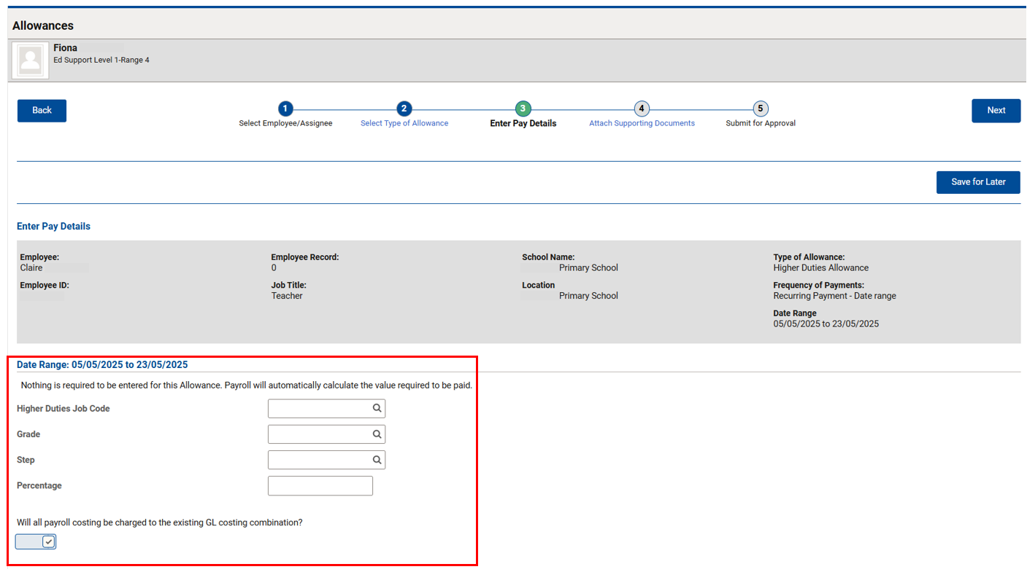

When a teacher (including leading teacher and learning specialist) has been assigned higher duties as an assistant principal, use the below Job Code and Grade relevant to the role that they are assigned to:

|  |  |  |
| --- | --- | --- |
| Higher Duties role: | Higher Duties Job Code | Grade |
| Assistant Principal Range 1 | AP-1 | 071 |
| Assistant Principal Range 2 | AP-2 | 072 |
| Assistant Principal Range 3 | AP-3 | 073 |
| Assistant Principal Range 4 | AP-4 | 074 |

* Enter the relevant step, based on the years of experience in the acting role. More information on progression in the higher duties, can be found on PAL: [Higher Duties – Teaching Service](https://www2.education.vic.gov.au/pal/higher-duties-teaching-service/overview).
* Enter the percentage (if the acting employee will not be doing 100% of the duties) for the acting assignment as assistant principal. If no percentage is entered, it is assumed that the person is performing 100% of the higher duties role. The requestor should discuss with the principal if unsure as to what the values should be.

If the teacher is participating in a sabbatical scheme, please contact SPS for further information and guidance in processing any higher duties assignment to an assistant principal role.

**Reminder:** All higher duties assignments to a principal role needs to be forwarded to the PEC who will provide it to the Regional Director for approval. If approved, the PEC will then advise SPS to process the higher duties assignment and payment.

For other higher duties assignments, follow the selection guidelines as described on PAL: [Higher Duties – Teaching Service](https://www2.education.vic.gov.au/pal/higher-duties-teaching-service/overview) and follow the steps in the eduPay guide to request higher duties: [School Allowance – Requesting Higher Duties](https://edugate.eduweb.vic.gov.au/Services/IT/eduPay/Customer/Higher%20duties%20-%20School%20Allowances%20QRG.pdf).

If there are any questions or guidance required on how to process on eduPay, please contact the Schools People Services team.

Relevant eduPay guides will be updated shortly.

**The eduPay Way**



After a busy March, April has been all about new business manager Business Working Groups for both Time in Lieu and Data Insights – Payroll (email the [team](mailto:tania.rann@education.vic.gov.au) if you’re keen to join), as well as getting ready for our annual eduPay upgrade which successfully occurred over the Easter weekend.

Annual upgrades are required to be consistent with the latest version of eduPay.

Cancel leave – *the new way*

Leave requests can now be cancelled from the ‘View Requests’ page. The ‘Cancel Absence’ button has been added to the View Requests page.

To cancel a leave request, the new way:

* **Go to Employee Self Service > Apply for Leave** or Employee Self Serve > Leave History
* **Click ‘View all requests’** at the top of the page
* **Select** the applicable absence event
* **Click the ‘Cancel Absence’ button** to cancel the selected absence event

Please note cancelling leave can still be actioned the old way too.

Business manager phishing course

Be ready for end of financial year scam time. The end of financial year (EOFY) is one of the busiest periods of the year for scammers.

Thank you to the 730 business managers who completed the Phishing for business managers [eLearning course](https://edupay.eduweb.vic.gov.au/psp/EDUPPRD1/EMPLOYEE/PSFT_LM/c/LM_OD_EMPLOYEE_FL.LM_CRS_DTL_FL.GBL?Page=LM_CRS_DTL_FL&Action=U&LM_ACT_ID=7594&LM_CI_ID=1965&NAV=URL) by April 1, 2025.

**The department sees a dramatic spike in phishing attacks both at the end of school term and at the EOFY,** making term 2 one of the more dangerous times to be working with financial delegations. It is not too late to complete the module. **Complete the 20 minute** [**module**](https://edupay.eduweb.vic.gov.au/psp/EDUPPRD1/EMPLOYEE/PSFT_LM/c/LM_OD_EMPLOYEE_FL.LM_CRS_DTL_FL.GBL?Page=LM_CRS_DTL_FL&Action=U&LM_ACT_ID=7594&LM_CI_ID=1965&NAV=URL) **now**. The Phishing for BMs eLearning course puts business managers in the shoes of a cybercriminal, and BMs will learn how and why they are targeted. The course will arm business managers with everything needed, including what tactics and information is used to get around their defences, and provide information on how to report these emails.

The course code is **DET-932-1** via [LearnED](https://edupay.eduweb.vic.gov.au/psp/EDUPPRD1/EMPLOYEE/PSFT_LM/c/LM_OD_EMPLOYEE_FL.LM_CRS_DTL_FL.GBL?Page=LM_CRS_DTL_FL&Action=U&LM_ACT_ID=7594&LM_CI_ID=1965&NAV=URL).

A reminder, the [one.stop.shop](https://edugate.eduweb.vic.gov.au/Services/IT/eduPay/Customer/eduPay%20Support%20for%20BMs.pdf) eduPay guide is updated and is the only eduPay guide you need, with over 4,700 views.

The eduPay team looks forward to seeing business managers in person or virtually in term 2.