# Workers’ Compensation new claim lodgement process

**This Issue contains…**

* Workers Compensation – new claim lodgement process
* 2022 PDP template – now available in eduPay
* The WWCC number is in use – what does this mean?

**Recruitment Hints & Tips**

* ROL Upgrade/Outage
* Annual Ongoing Translation Offers
* Provisional Appointments

**School Local Payroll Hints & Tips**

* VECTEA Global Salary Increase

**eduPay Hints & Tips**

* Superannuation & Stapling
* Hire/Rehire avoiding duplicate employee IDs
* Need help? Contacting the Department

**The eduPay Way**

* Reducing your administrative burden – the eduPay way…

There are now early notification requirements for Return-to-Work Coordinators and the workers’ compensation agent to ensure workers can get the early support they need for a work-related mental injury. You are required to send the new *Worker’s injury claim form* Part A for any mental injury claims to Gallagher Bassett to the email address provided below within **3 business days** of receiving a claim from your worker. The remaining documents (employer form, part B worker form, certificate etc) will then need to be forwarded to Gallagher Bassett within **10 calendar days** of receiving the workers’ form.

All physical injury claims remain under the previous process however using the new form, the completed workers’ compensation claim forms **MUST** be emailed to Gallagher Bassett within **10 calendar days** from receipt, along with:

* A completed Workers injury form
* A completed Employer Claim Report
* Workers’ compensation certificates of capacity
* Medical invoices/information and
* Return to work arrangements if applicable

***# Important note: if you do not have all documentation, please submit the Workers Injury Claim form within the specified timeframe and send any other documentation as it is completed or received by the injured worker.***

Please see below contact details for Gallagher Bassett:

* **For new claims:** [educlaims@gbtpa.com.au](mailto:educlaims@gbtpa.com.au)
* For phone Enquiries: **1300 975 609** or **03 9297 9100**

To assist in completing the employer claim form please note:

* Workplace number: **school number**
* Scheme registration number: **1624618**

# 2022 PDP template is now available on eduPay

The 2022 template for the PDP is now available on eduPay for employees in the Teaching Service who elect to complete the standard PDP process. Employees may now commence the process for creating and recording their 2022 PDP.

Access *My PDP > Create PDP*. Ensure the dates read as 1/1/2022 – 31/12/2022

Select the correct template depending on your employment classification. Add the reviewer and create the PDP.

# The WWC Check number is already in use error – what does this mean?

eduPay error message - WWCC already in use


If you receive the above error message while completing the manage appointments process you have in all probability created a duplicate employee ID. The number for the WWC Check is already recorded against another employee record.

The error message received advises you to contact People Systems and Services (PSS) for advice. In order to confirm the duplicate employee ID and what that employee ID is, provide the WWCC card number or provide a copy of the WWC Check card in your email.

PSS will provide the details of the ‘other’ record. Where a duplicate is identified, action will be required to reverse the appointment for the duplicate record from your vacancy and start the appointment process by searching for the employee again and selecting the original employee ID.

If you require assistance with this process, contact the [Schools Recruitment Unit](mailto:schools.recruitment@education.vic.gov.au) or call 1800 641 943 and the options for SRU. Additionally, refer to the Hire/Rehire - *Avoid creating a duplicate employee ID* article in this edition of HRM Online to help avoid a duplicate record.

Recruitment Hints & Tips

**Upcoming ROL Upgrade/Outage**

There will be a scheduled Recruitment Online (ROL) upgrade during the weekend of 2-3 April 2022, please note both recruiters and applicants will not be able to access ROL during this period.

Applicants may opt to submit an application directly to the school if a vacancy close date coincides with the upgrade. Schools are required to accept applications from individuals who were unable to submit an application during the upgrade period.

When advertising positions that are to close during this period, we recommend you consider extending the advertised closing date beyond the upgrade period.

# Annual Ongoing Translation employment offers

Communication regarding the central annual translation process of fixed term employees to ongoing was emailed to Principals on Wednesday, 23 March 2022. Principals are requested to provide a response to this communication before 30 April 2022 to [SR.Annual.Translation@education.vic.gov.au](mailto:SR.Annual.Translation@education.vic.gov.au). Where a response is not received by this date, action will be taken centrally to offer ongoing employment to the eligible employees.

Further information or questions regarding the process should be forwarded to Anthony Baranyay, A/Manager, Schools Recruitment Unit by email to [SR.Annual.Translation@education.vic.gov.au](mailto:SR.Annual.Translation@education.vic.gov.au).

# Provisional Appointments

* A provisional appointment occurs where a current ongoing teaching service employee is the successful applicant for another ongoing teaching service position, or, for a fixed term teaching service position greater than 12 months (except for special schools and region/central locations).
* A transfer or promotion of an ongoing employee is provisional and is subject to review which commences when the applicant accepts the offer.  Appointment to the position is pending the outcome of that review.
* Appointment of external applicants, current fixed term employees, or where an ongoing employee is the successful applicant to a fixed term position of less than 12 months – a provisional appointment period does not apply.  In these instances, the appointment can be confirmed immediately when the successful applicant accepts the offer

School Local Payroll Hints & Tips

# VECTEA Global Salary Increase

The Global Salary Increase (GSC) for employees paid under the [*Victorian Early Childhood Teachers and Educators Agreement 2020*](https://www.fwc.gov.au/documents/documents/agreements/fwa/ae511947.pdf) (VECTEA) will be recorded through a central process to increase all eligible employee’s pay rates on the School Local Payroll through a central process

The central process will insert a GSC row effective from 10 April 2022 (first full pay on/after 1 April 2022) and increase the rate to the new minimum set out in the Agreement as follows:

* where the current rate is below the new minimum – insert new GSC row and increase the rate to the new minimum OR
* where the current rate is above the new minimum – insert new GSC row and not change the current rate.

The update is planned for the weekend of 2-3 April 2022. Apart from checking employees have been updated correctly, no action by schools in relation to this pay increase is required.

eduPay Hints & Tips

# Superannuation

A reminder that all employees are required to record, or at minimum, check their superannuation directly on eduPay using the Onboarding process or directly through Employee Self Service. A certification message is also provided as a reminder to Business Managers/HR Administrators that an employee has not yet recorded their superannuation.

An update to eduPay was released last November where on hire/rehire the system attempts to identify a current open superannuation entry or the most recent superannuation entry across all DOE and SLP employers and replicates the fund and enrols the employee into this fund from the Hire/Rehire date.

Although the system has done this automatically, it is important that correct super details are indicated therefore, please ensure the employee checks their superannuation to make sure their records are correct. If not take corrective action immediately (preferably before their first pay finalisation). A help document is available from the link on the Super page in eduPay or directly from the [eduPay help page on eduGate](https://edugate.eduweb.vic.gov.au/Services/HR/Pages/eduPay-ESShelp.aspx) (Enter or Update Superannuation Details guide).

Where the system cannot identify a fund to replicate, the certification message will be included in the payroll certification pages. Contact the employee and have them record their choice of superannuation.

Superannuation Stapling

The certification message and revised automatic replication of super entries described above is designed to remove the requirement to staple an employee’s superannuation fund. The stapling process requires access to the department or school council’s Australian Taxation Office portal to request superannuation details for the employee. The stapling process is time consuming and unnecessary where the employee has recorded their superannuation directly on eduPay.

In order to meet superannuation requirements, towards the end of each quarter, the department will complete a manual check of any missing superannuation entries for the quarter and will record the identified superannuation fund. If no fund is identified, the default VicSuper Future Saver will be used.

Employees on the School Local Payroll for this quarter (ending 31/3/2022) will be included in this manual process, however for future entries where stapling is required for SLP employees this will need to be completed by the Business Manager/HR Administrator on the school’s ATO portal, and the results sent to PSS for eduPay update (screenshot of the ATO results).

You can avoid this process and the additional workload if you make sure the employee has recorded their superannuation directly on eduPay without delay. This includes an employee who may only be engaged for the one day.

To complete the stapling process a minimum of one payroll run is required to connect the employee with the Department or School Council. The entry on the ATO portal requires the employee’s full name, date of birth, tax file number and in some instances their address details.

# Hire/Rehire – Avoid creating a duplicate employee ID

All staff are issued with an employee ID when they first commence employment on eduPay. This employee ID remains the same throughout all subsequent employment periods for both DOE and every SLP employer. One employee ID record ensures payroll integrity, the service history and entitlements are carried forward to each period of employment and only one eduMail email account is created.

A large number of duplicate employee ID’s continue to be created by operators. ***It is imperative that duplicate records are NOT created.*** To help stop the creation of duplicate employee records and a new employee ID, eduPay and ROL have a number of system checks, protections and warnings built in to avoid duplication of employee records. Read these warnings carefully and take appropriate action to avoid duplication.

1. **A*sk prospective employees whether they have been previously employed by the Department or by another school on the local payroll***. Ensure you have their date of birth and full name, including any variations of their name they may have worked under previously available – this includes whether any middle names have been included previously. Ensure your internet browser is displaying dates in the standard Australian date format (dd/mm/yyyy). A number of duplicate records occur because the date is recorded in the American date format (mm/dd/yyyy).
2. Verify the Employee ID of the successful applicant in ROL. This step undertakes a search of previous records to identify any possible match. The search must be completed for all successful applicants to vacancies, including School Local Payroll employees.
3. Compare the results against the details provided by the prospective employee and attach the hire to the correct person from available search results. Only where details do not match should a new employee ID be created.

Deliberate alteration to prospective employee data to avoid built in system protections when hiring a person thereby creating a duplicate record is against Department policy and may be subject to further investigation.

For further assistance, Business Managers and HR Administrators are to refer of the following resources:

* ROL Recruiter Guide [Recruiter User Guide](https://edugate.eduweb.vic.gov.au/Services/HR/Pages/ROL-Help-Recruiter.aspx).
* eduPay [School Appointments User Guide](https://edugate.eduweb.vic.gov.au/Services/HR/Documents/UGS-School-Appts.pdf)
* Schools Recruitment Unit – 1800 641 943, select option for Schools’ Recruitment Unit.

# Need help? - Contacting the Department

Please use the table provided in [HRM Online 3-2022](https://www.education.vic.gov.au/hrweb/Documents/HRM-Online-03-2022.docx) (page 5) as your guide to contact the correct area in People Services.

This is especially important when using the [Services Portal](https://services.educationapps.vic.gov.au/dp?id=sc_category&sys_id=4e8eb0dadb279890e8ad456a3a961962&catalog_id=-1&spa=1) – ensure you click the correct team for your enquiry. Selecting the incorrect team can delay the review of your enquiry and it may not always be possible to redirect the enquiry to the correct area.

Services Portal available options:

* ***Corporate People Services*** – *not applicable to schools*. This is for central/regional VPS employees not employed in schools.
* ***People Systems and Services*** – Overpayment repayments (only), taxation (including VISA taxation), Under 18 WWC Check override, Paid Parental Leave, superannuation and recalling pays.
* ***Schools People Services*** – your initial point of contact for all enquiries relating to current employees (other than recruitment).
* ***Schools Recruitment Unit*** – support for Recruitment Online and other recruitment-based enquiries.

The eduPay way



Working Groups, BM Networking events and our first big launch for the year with a design refresh and ROL moving in with eduPay – it’s all happening back at eduPay HQ (oh and a new logo – look up!)

Many of you are keen participants in our **feature working groups** – you know the ones… Those virtual meet ups where you tell us what’s not working for you with a particular feature, we listen and then we mock up some designs for your feedback and approval, and then you get to have-a-play before everyone else does… Just a little teaser, if you want to join us – you know what to do (email the [eduPay](mailto:tania.rann@education.vic.gov.au) team) 😊 Upcoming sessions include:

* GL Overrides – Friday 1st April
* Change of Hours – early term 2

Our big launch is HAPPENING. Both eduPay and ROL will be unavailable over the weekend of 2/3 April. So from Monday 4 April, ROL will be available via eduPay. Yes, you read that right – no more logging into two systems – just as you requested. All you need is eduPay. You’ll find a ‘recruiting’ tile available on your HR Admin homepage and a new ‘recruiting’ homepage in your drop down list of homepages. Here’s a sneak peek of one we prepared earlier 😉

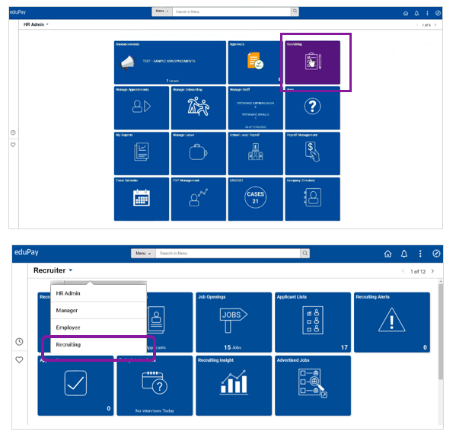

Oh, and on Monday 4 April you will notice your homepage looks a little different too – *good different*. That’s because we wanted eduPay to look its very best before ROL moved in…

**You’ll find the following new design features enabled** to make your homepage transition easier **(1),** recalling your favourites (heart icon) and recently viewed (clock icon) simpler **(2)** finding functions and people more efficiently with the new Global Search feature **(3),** moving between homepages a cinch **(4),** notifications front and centre **(5)** and the NavBar pane with breadcrumbs reintroduced **(6).**

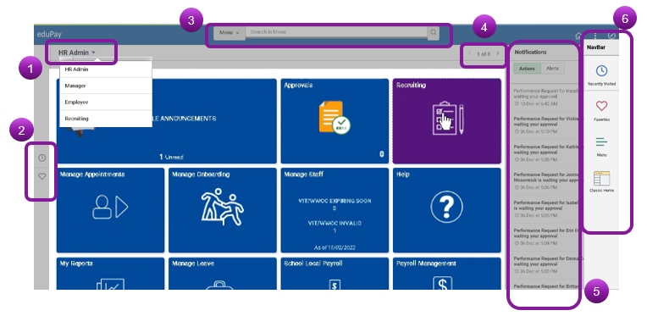

Four training sessions were very well attended over the last week but ICYMI – a recording will be available in the video lounge of the [Cases 21 Portal](https://edugate.eduweb.vic.gov.au/Services/bussys/cases21/CASES21%20Support%20Videos/Forms/AllItems.aspx?RootFolder=%2fServices%2fbussys%2fcases21%2fCASES21%20Support%20Videos%2fTraining%20and%20Support%20Videos%2feduPay&FolderCTID=0x0120006399E25BF18E6543AE5AEEA429D4647B) (eduPay New Features Term 1 2022) and a Quick Reference Guide will be available via the announcements page in eduPay – both in time for launch.

The eduPay team look forward to seeing you at an upcoming BM Network meeting or online at one of our virtual sessions.