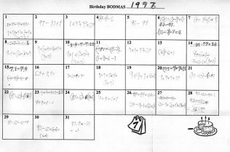
Task Description

Using their birth year (e.g. 1996) students create expressions using a variety of operations on the digits
(1, 9, 9, 6) to fill the boxes for each “date” on a calendar month.

This activity is well suited to classes with a wide range of student abilities, and is excellent for use during a focus on operations.

Length of Task
In the trial, this activity took students around 100 minutes to complete.

Materials
- One blank calendar per student

Key Mathematical Concepts
- Order of operations (BODMAS)
- Application of a variety of operations (including addition, subtraction, division, multiplication, indices, square root, and any others deemed appropriate given students’ skill level) to create expressions with a known answer.

Using the Activity
Whole group Instructions
Explain the instructions to the class as a whole group. These are:

Using their birth year (e.g. 1996) students are required to create expressions using each digit of that year (1, 9, 9, 6) to attempt to fill the boxes for each "date" on a calendar month. For example, ‘1 + 9 + 9 + 6’ would be written in the "25" date box. Students can use any of the basic operations (+, -, x, ÷) and can manipulate numbers by creating decimals, fractions, squaring numbers (or other indices from their birth year), and square rooting numbers. Students are also allowed to round numbers off and can use brackets to control the order of operations used. Each birth year's digit must be used once in every calculation. To make the activity more achievable, the number ‘0’ can be used in any calculation.

Work through some examples (on the teacher's birth year) with the class as a group, prior to handing out the blank calendars for students to complete individually (including the use of brackets). For example, the teacher could create expressions for 1963 as:

(1 x 9) + (9 ÷ 3) = 12
1 x (9 + 9) – 3 = 15
(9 x 3) + 1 - 9 = 18

Depending on the skill level of the class, deliberate inclusion of indices and square roots may be beneficial in the examples. The teacher may choose to clarify the specific operations that are permitted during the initial discussion and write them on the whiteboard for reference, or generate them as students work on the activity.

During the Activity
Some students may need support in extending beyond using only the four basic operations (+,-, ÷, x). In the trial, the teacher led a focus group for students needing support, to assist them in extending their strategies and skills.

Other students may find it quite easy to find an expression for every date square. In these cases, students could be encouraged to find multiple expressions for each date.

Review – whole group
When students are finished (or when the time is right), ask them to share their strategies for completing the grid with the whole group.

Prerequisite Knowledge
Students should be familiar with the following operations:

- add
- subtract
- multiply
- divide

Students should also be familiar with using parentheses to control the order of operations.

Simple indices (e.g. squaring, x⁰=1, x¹=x) will be useful knowledge for completion this activity. If students are not already aware of them, the teacher may introduce this during the initial discussion.

Links to VELS
Key VELS Links

Dimension | Standard
Number (Level 3.25) | Use of brackets to determine order of operations.
Number (Level 4) | They explain and use mental and written algorithms for the addition, subtraction, multiplication and division of natural numbers (positive whole numbers).  Students identify square…numbers. They recognise and calculate simple powers of whole numbers (for example, 2⁴ = 16).
Number (Level 4.75) | Addition, multiplication and division of integers.  Calculation of squares and cubes of rational numbers  Mental computation of square roots of rational numbers associated with known perfect squares.

Related VELS Links

Dimension | Standard
Structure (Level 3.5) | Consistent and correct use of conventions for order of operations.
Working Mathematically (Level 3.5) | Efficient communication when using mathematical language, symbols and representations.

Assessment
To be working at VELS Level 4, students should clearly demonstrate an ability to create expressions involving order of operations, the four basic operators (+, -, ÷, x), and simple powers. They should be able to complete the majority of the squares in the grid within the timeframe of 100 minutes. Student Work Sample 2 is an example of work at this level.

Potential Student Difficulties / Enabling Suggestions
The teacher in the trial found that some students had difficulty completing the grid. He created a teacher–led focus group to help these students extend their strategies and skills. This activity is well suited to being completed as a homework project.

Extension Suggestions
The teacher could introduce new operations to increase the challenge of this activity (for example, n!, square root, x^{n} (where n is one of the birthday digits), etc.

Teacher Advice and Feedback
The teacher in the trial considered this activity went as well as he had hoped, and the specific mathematical goals he set were met during the course of the lesson. Most students were reported as being on task, learned some new mathematics, could start without assistance and were engaged in higher-order thinking.

The teacher considered this activity to be well suited for use as a focus on operations, as it requires students to utilise their existing knowledge to fill in some of the boxes with easy expressions, but they also need to use some mathematical strategies (squaring, fractions, rounding fractions/decimals to the nearest whole number, etc.) to find the remaining solutions.

The teacher also found that this activity highlighted the varied ability and understanding of number within the classroom. The task was such that it could challenge all students and extend their capacities. For example, most students in the trial class had not encountered indices before, but their trepidation at using them dissolved once they experimented with the concept.

Student Feedback
This activity was trialled in a Grade 5/6 class, with 19 students responding via survey. 90% of these students considered they had learned some new maths, had been challenged and could now use this maths on other problems. 95% felt they had thought about maths for most of the lesson and all students could see more than one way of doing the tasks. This suggests the students were engaged and considered the activity educational.

Students were also asked to comment on what they had specifically learned from the lesson. Their answers all related to number operations, but clearly students gained a deeper understanding of quite different mathematics from each other, depending upon their own personal learning needs. Samples of their comments are:

I learned…

- ‘how to divide large numbers’
- ‘square roots’
- ‘BODMAS, Rounding off’
- ‘how to use brackets’
- ‘division’
- ‘how to use things like square roots and numbers to the power of 0, 1 etc. in BODMAS problems’

Acknowledgements
Thanks to teachers and students in the Merging Minds cluster of schools for their invaluable input through the use and feedback of this activity in their classrooms.

Example 1
Working at or above VELS Level 4.

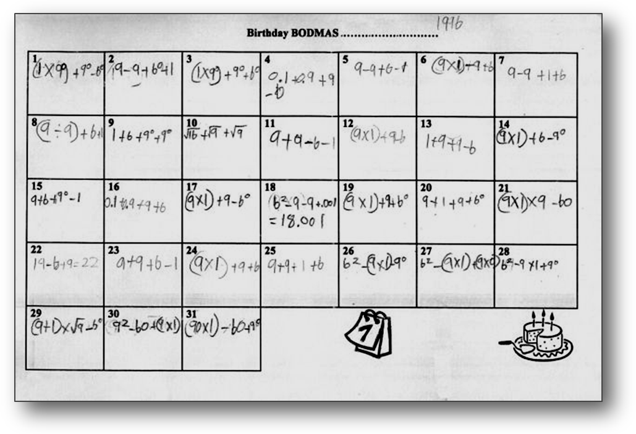
This student has demonstrated a clear understanding of order of operations, the four basic operators (+, -, ÷, x), squares and simple powers. In addition, this student has computed square roots of commonly known square numbers (VELS 4.75).

Example 2
Working at VELS Level 4.

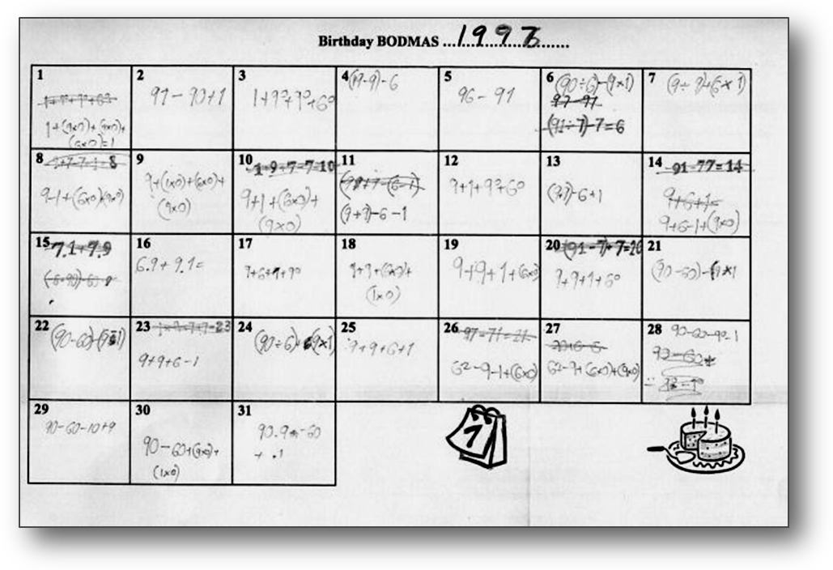
This student has demonstrated a clear understanding of order of operations, the four basic operators, squares and simple powers.
Example 3
Working below VELS Level 4.

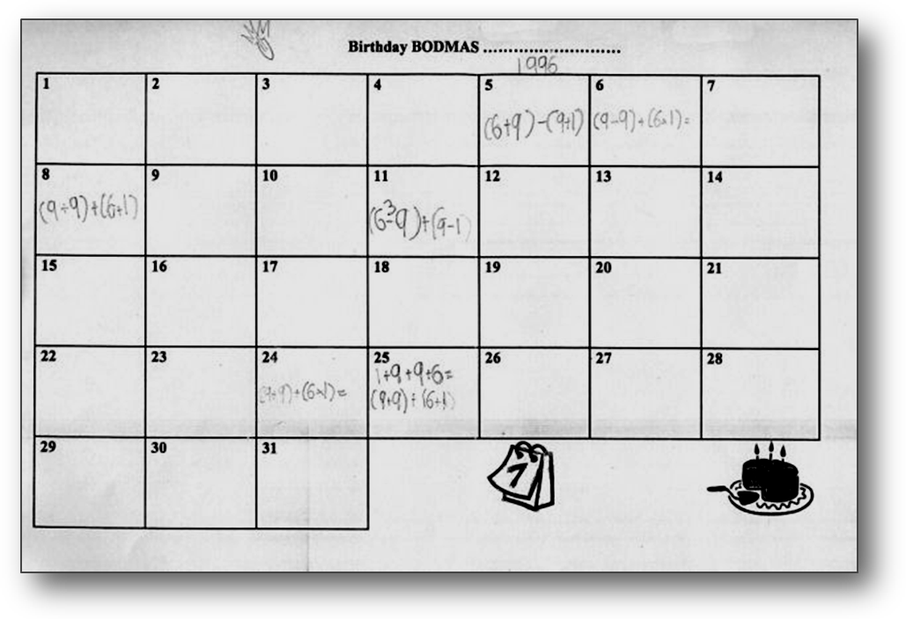
This student has been able to demonstrate an understanding of order of operations and the four basic operators, although not all computations are correct (e.g. for the 11th of the month). This student seemed to have difficulty with the task (or perhaps was not on task), having completed only 6 expressions in 100 minutes.

