Year P-2 EduPass registration
eduPass fast card

Introduction
You need to register to use eduPass. You will be given a registration letter by your eduPass Administrator containing your username, temporary password, and the url to access your account.

1.
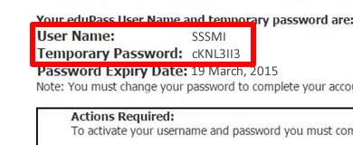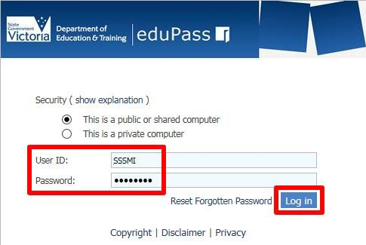
From the eduPass login screen, enter your username and temporary password from your registration letter and click on the Log in button.

2.
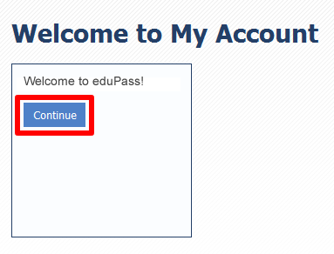
Click on the continue button.

3.
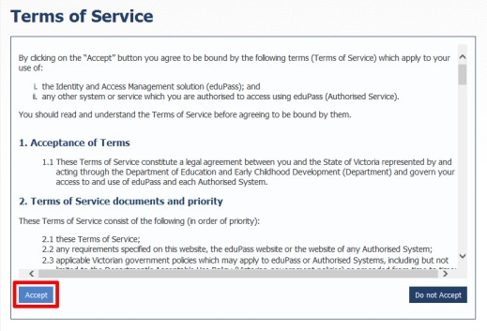
Read the Terms of Service and click on the Accept button.

4.
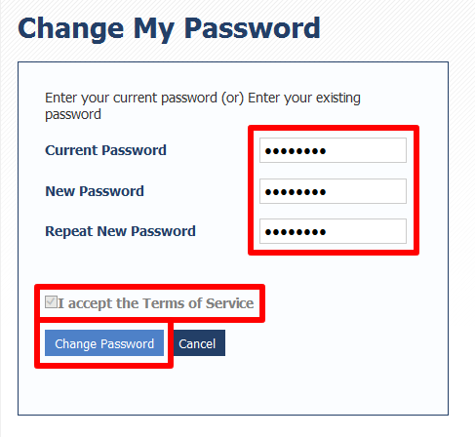
After entering your temporary password, enter your new password twice and accept the Terms of Service. Then, click on the Change Password button to complete the process.

Password rules: Your password must include at least seven characters, and include at least one character from at least three out of the four sets below:
• Uppercase letter (A-Z)
• Lowercase letter (a-z)
• Numeral (0-9)
• Special character ()~`#$&@^
Note, your password cannot contain your own name (first name or last name in full).

