Year 3-12 EduPass self-service
eduPass fast card

Introduction
After your initial registration in eduPass, you can change your 4-digit PIN and secret questions any time you like. This is called ‘Self Service’.

1.
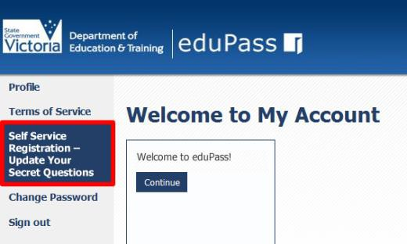
From the My Account Home page, click on the Self Service Registration – Update Your Secret Questions option.

2.
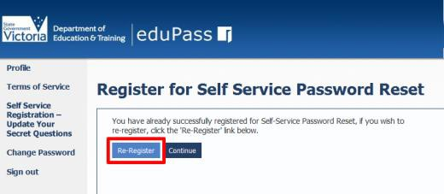
Click on the Re-Register button.

3.
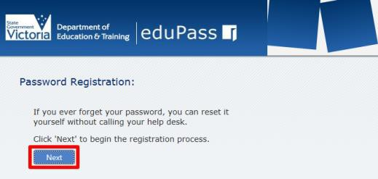
Click on the Next button.

4.
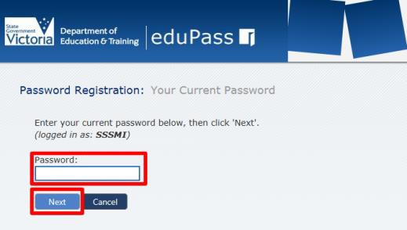
Enter your current password, then click on the Next button.

5.
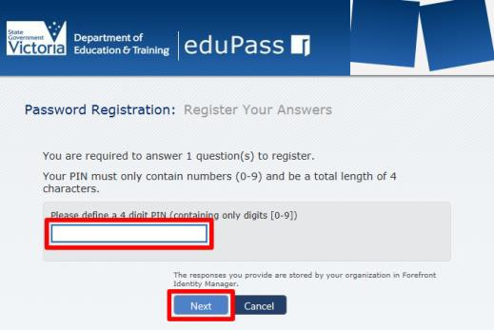

Enter a new 4-digit pin and click on the Next

button.

6.
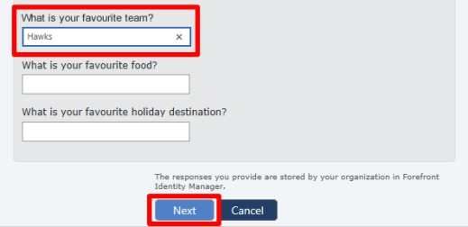
Answer at least three of the secret questions, and then click on the Next button.
Remember that:
- each answer must contain at least four characters
- no two answers can be the same.

7.
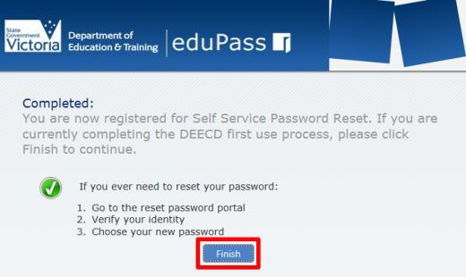
Click on the Finish button to complete the process.

Password rules: Your password must include at least seven characters, and include at least one character from at least three out of the four sets below:
• Uppercase letter (A-Z)
• Lowercase letter (a-z)
• Numeral (0-9)
• Special character ()~`#$&@^
Note, your password cannot contain your own name (first name or last name in full).

