Year 3-12 Reset forgotten eduPass password
eduPass fast card

Introduction
To reset your password if you forget it, you have to remember your user name, PIN and the answers to the secret questions that you set up earlier.

1.
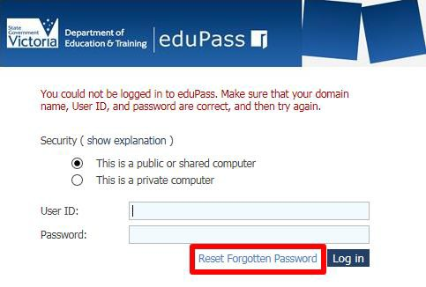
From the eduPass for Students log in screen, click on the Reset Forgotten Password link.

2.
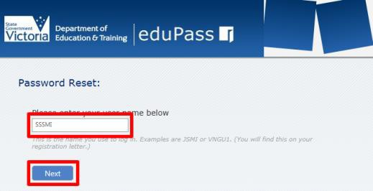
Enter your user name and click on the Next button.

3.
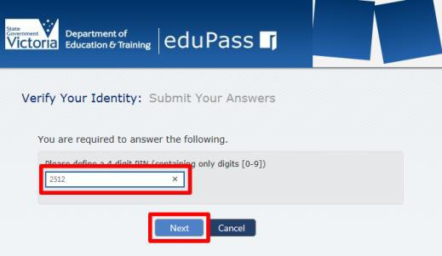
Enter your user name and click on the Next button.

4.
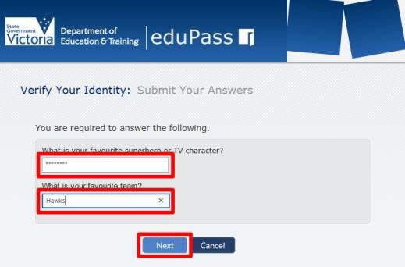
Two of your secret questions will be shown. Type the answers to both questions and then click on the Next button.

5.
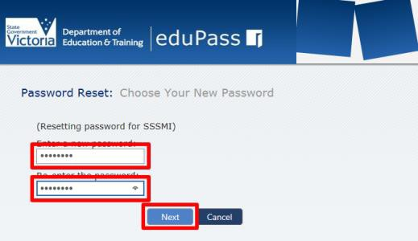
Type a new password that meets the Department’s rules in the Enter a new password field. Then type the same password in the Re-enter the password field and click on the Next button to complete the process.

Password rules: Your password must include at least seven characters, and include at least one character from at least three out of the four sets below:
• Uppercase letter (A-Z)
• Lowercase letter (a-z)
• Numeral (0-9)
• Special character ()~`#$&@^
Note, your password cannot contain your own name (first name or last name in full).

