Student Years 3-12: Changing your eduPass Password
EduPass fast card

1.
Proceed to the eduPass My Account website: https://edupassmyaccount.education.vic.gov.au

2.
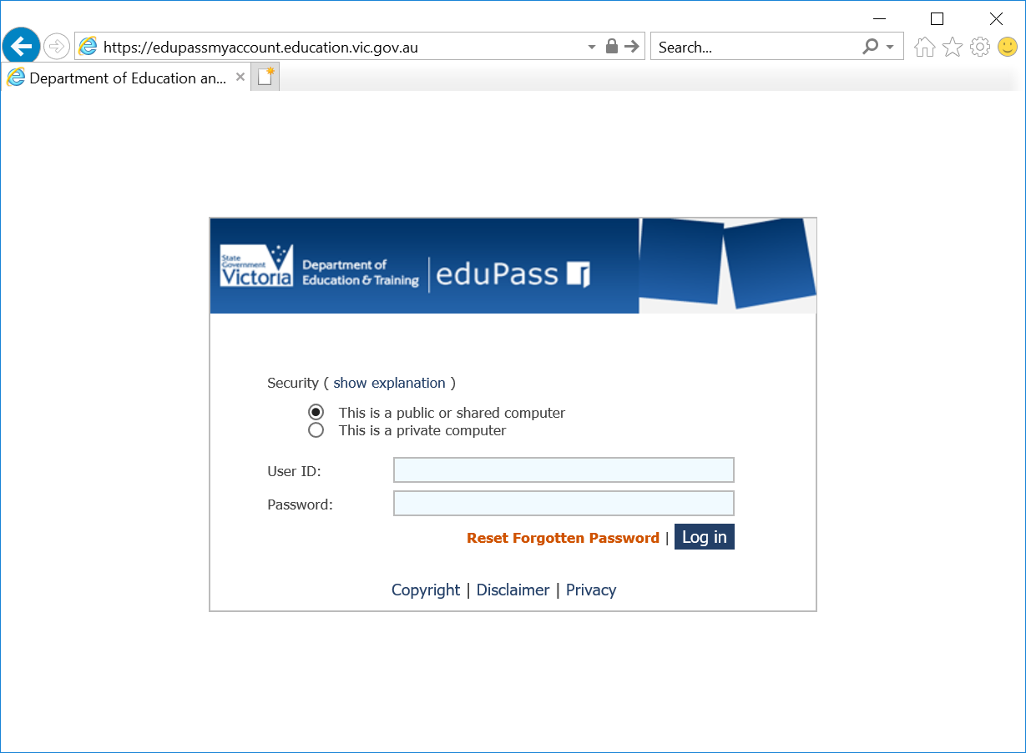
Log in using the password provided to on your eduPass letter.

3.
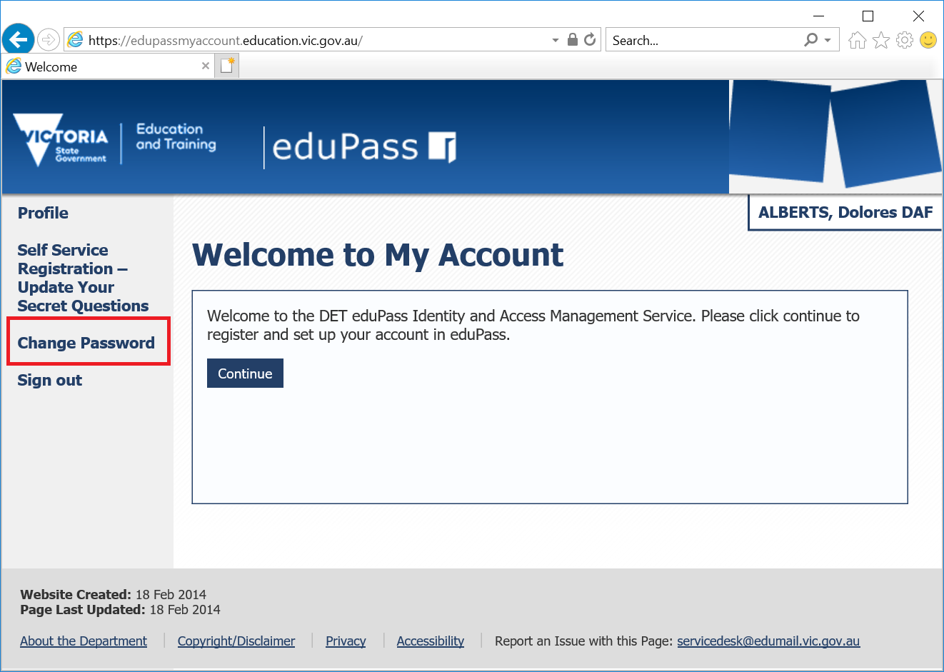
From the eduPass My Account homepage, click on ‘Change Password’ in the left-hand menu.

4.
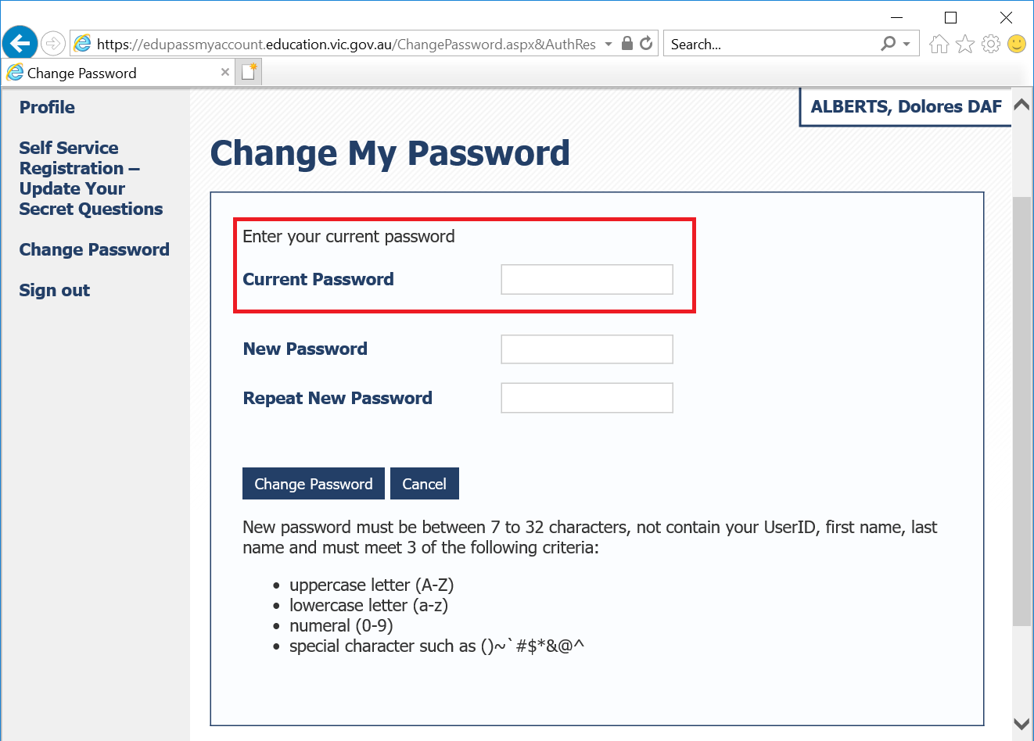
Follow the on screen instructions.
Enter the Password provided to you from your eduPass letter into the Current Password field.

5.
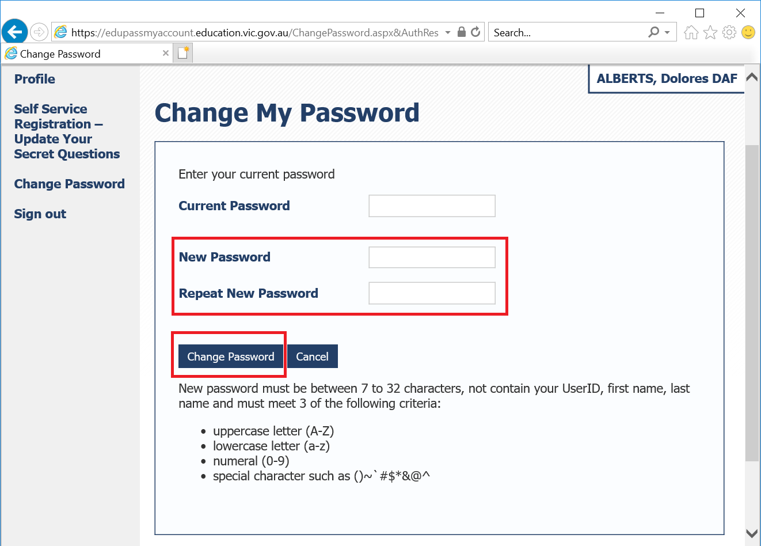
Enter the password you would like to use into the New Password field and repeat it in the box below this and then click ‘Change Password’.

6.
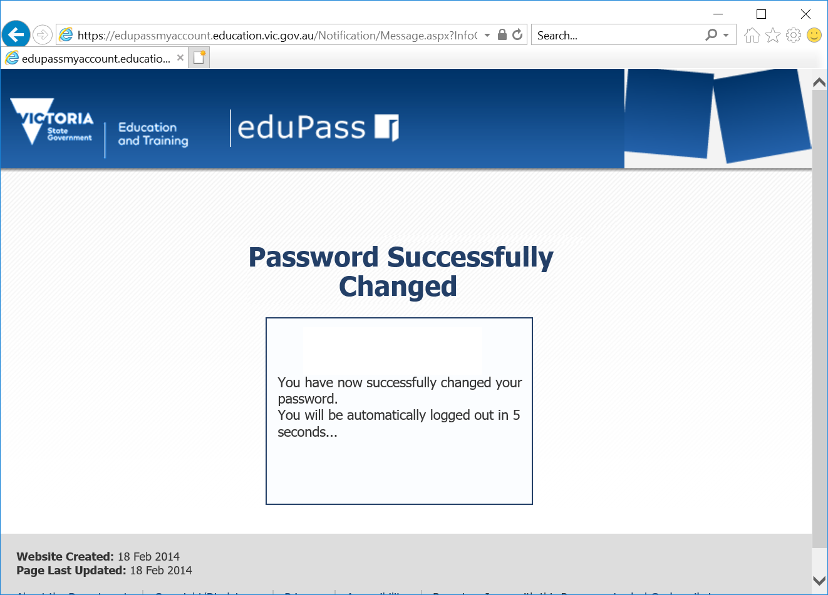
Once completed you will be presented a window advising you have successfully changed your password and that you will be logged out in 5 seconds.

7.
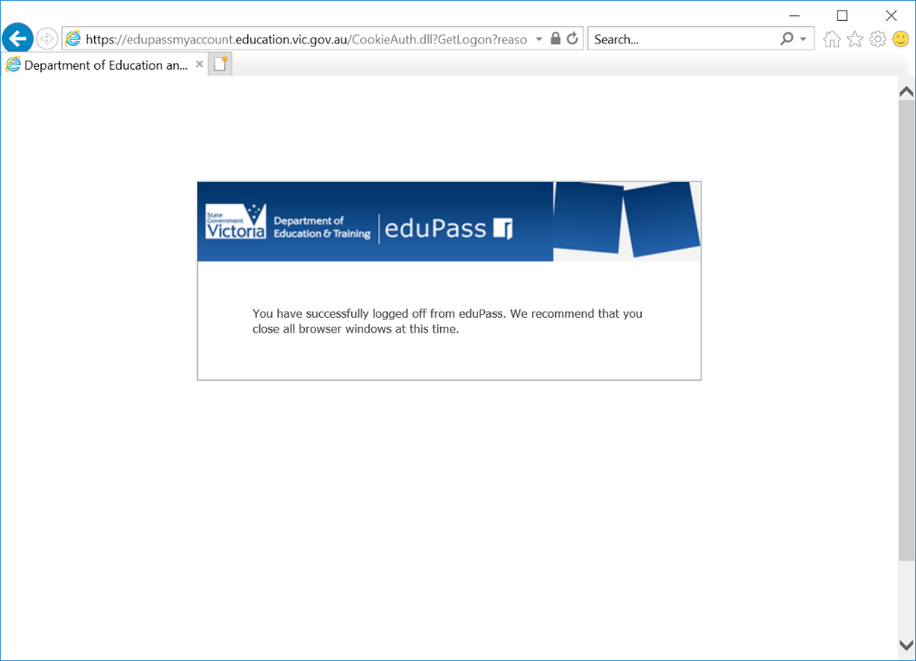
You will then be advised to close the web browser window to finalise the process.
Your password is now changed and you can use the password that you set from this moment onwards.

