2020 Prep bag ‘first day of school’ design competition entries

Helen Ces

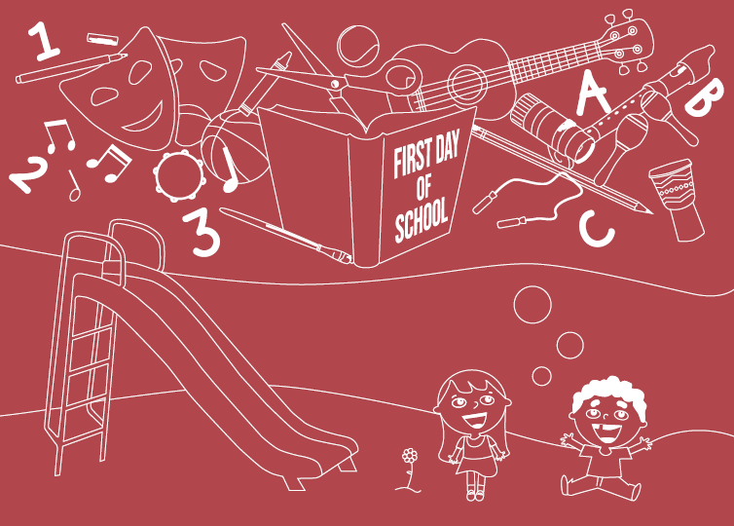

rationale
The design I have created encapsulates the idea that the first day of school can be a very scary yet an exciting experience, like it was for me. The various illustrations presented symbolises the new and different items that children are exposed to and become familiar with. However, in spite of these fears, school is a still something children dream of.

Nina Alston

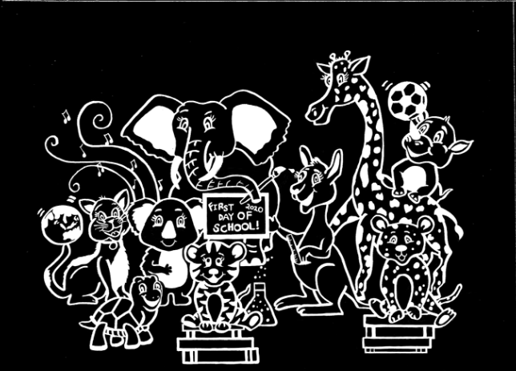

rationale
With the jolly animals acting as a cheer squad for the eager, yet perhaps nervous Prep students, I wanted to create a design that incorporated the diverse aspects of school through the use of sporting goods, music and books, as well as displaying encouragement through the cartoon creatures.

Polly Reid

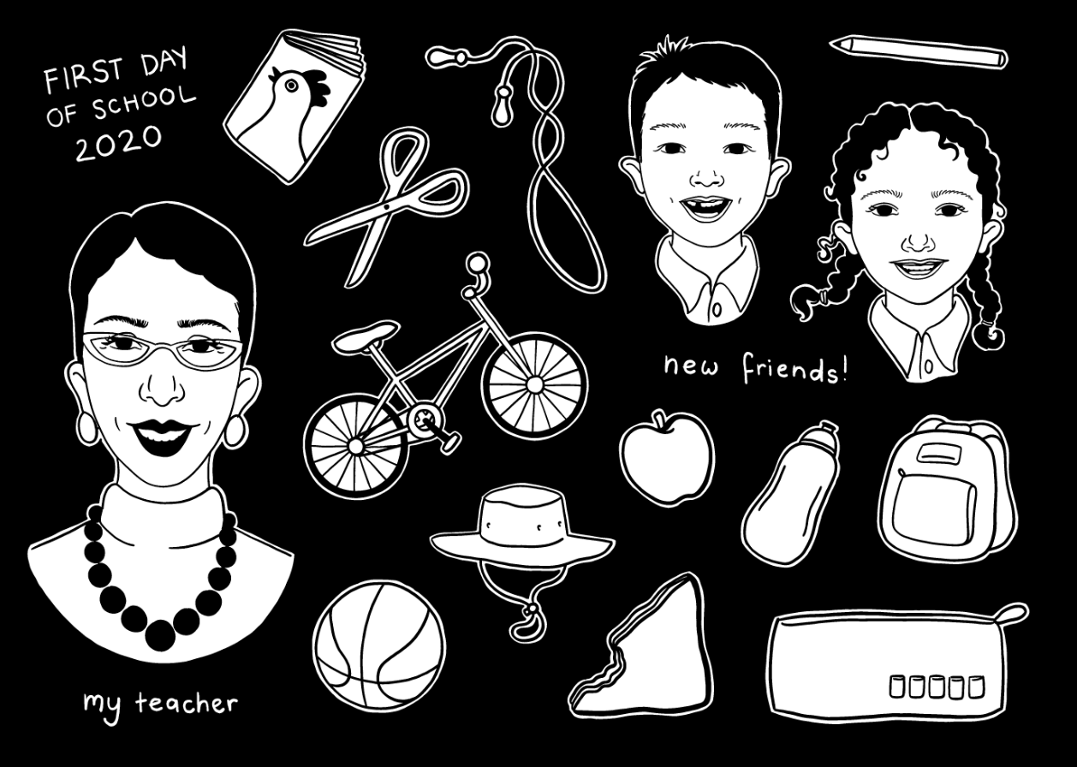

rationale
When I reflect on my first day of school, I don’t remember complete scenes or events, but rather isolated images of people and objects significant to me. Therefore, I chose to create a collage-style illustration featuring broadly representative and relatable characters and iconic objects that any prep could find to be a memorable part of their first day of school.

Isabella Manakis

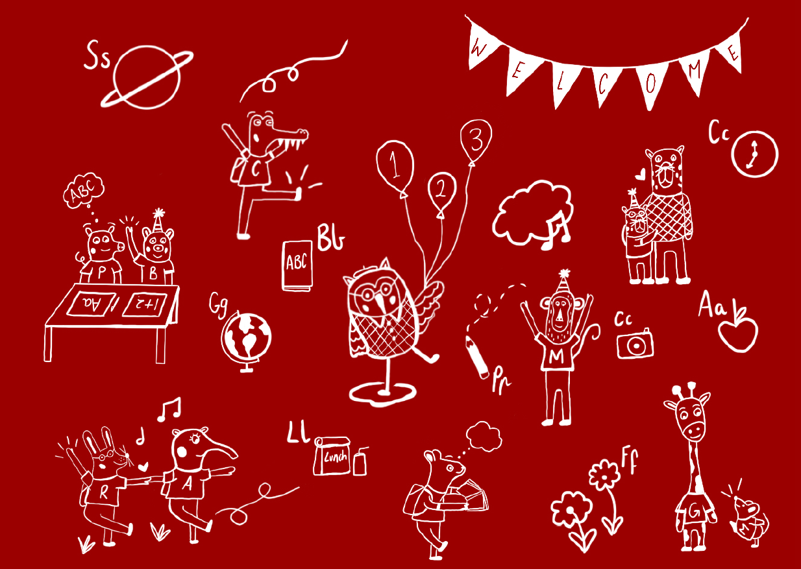

rationale
Beginning their educational journey, children will be introduced to numerous students of differing socio-economic, religious and cultural backgrounds. Each of these students will embark on an identical journey with their overall enjoyment and growth reliant on the relationships formed with their fellow pupils. Diversity in this instance has been depicted through the quirky and playful illustration of various animals.

Ana Livia Maiorino

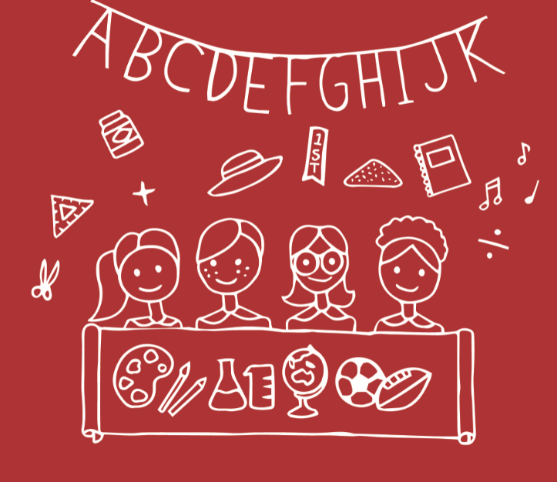

rationale
The design depicts various elements which contribute to a prep's experience in primary school. In their first day of school preps are as equally excited to meet their new friends as they are eager to learn new things. From different subjects to people, the design embraces individuality and acceptance from all students.

Brittany Spencer

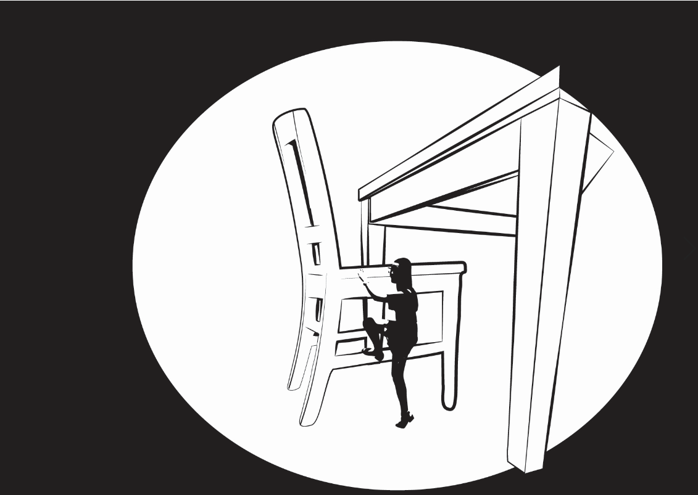

rationale
Whilst brainstorming what comes to mind when I think of a ‘first day of school’, I realised I had just experienced a parallel moment to it when playing on a larger-than-life desk and chair at the Broad Contemporary Art Museum. In the photograph of me there, the emotions in my face captured what the child feels – nervousness and also excitement. Not only that, but it conveys the detachment from their parents and attachment to the unfamiliar. Furthermore, it conveys how everything is oversized and must be grown into. My design recreates this photograph in graphic form, aiming to portray how a child’s first day of school is a fantastical adventure of continuous new stimulus.

Jasmine Kennedy

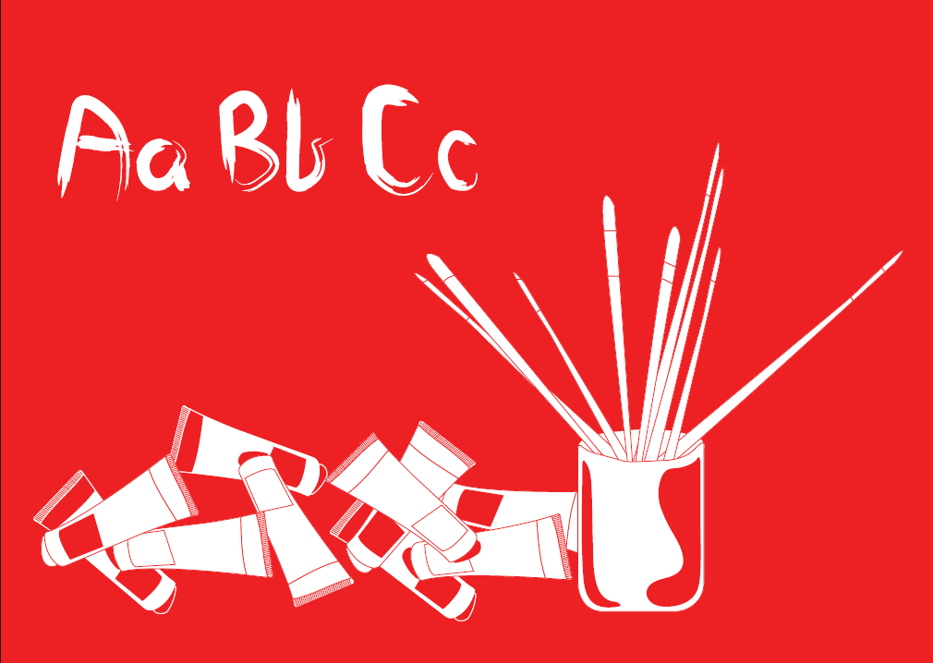

rationale
To me prep, and primary school in general, is all about being creative and slowly growing as a human.
It's a part of your life where everything is taught in a tactile and creative way, constantly being engaged and most importantly having fun. I tried to show that throughout my design, learning whilst being immersed in a fun activity.

