Ventilation advice for the classroom

Published and correct as at 21 January 2022

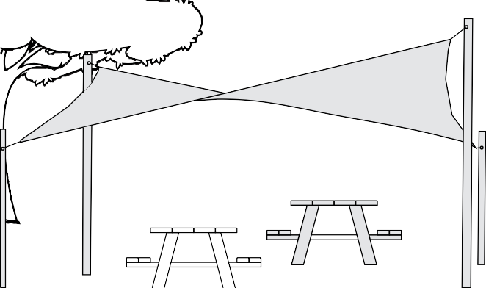
- Conduct learning outside as much as possible.

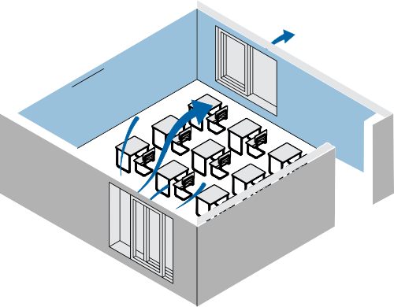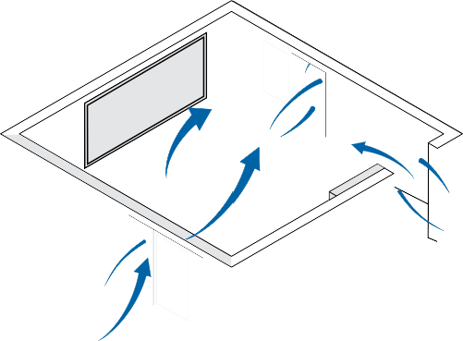
- Open windows and doors to the outside to maximise ventilation.
- Open windows and doors on multiple sides of the room.
- Keep windows open, even when a room is unoccupied, as much as possible.

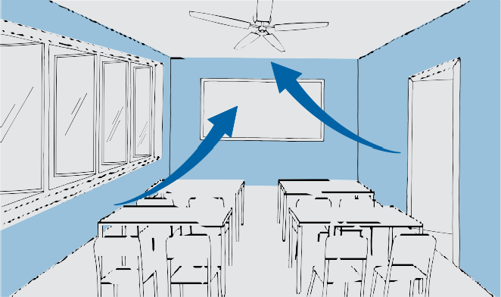
- Maximise air movement by turning on ceiling fans or using oscillating pedestal fans.

- For thermal comfort, use heating and air conditioning systems – even when windows and doors are open.

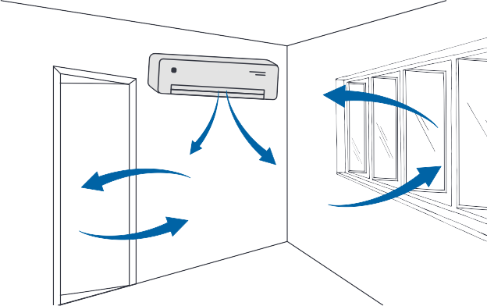
- When not required for thermal comfort, operate split system air conditioners on the fan only setting to increase air movement.

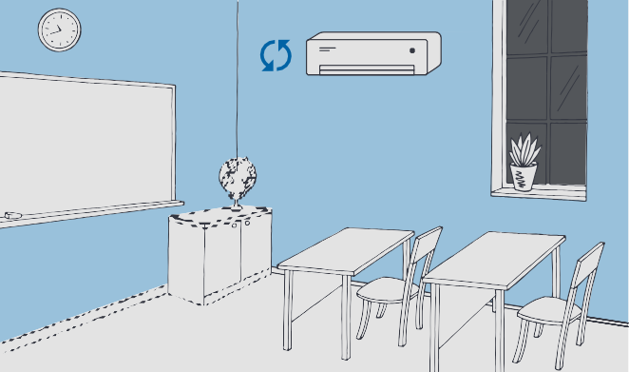
- When outdoor air quality is poor (e.g due to bushfire smoke or thunderstorm asthma), close windows and set air conditioners to recirculate air, where possible.

- Minimise the use of spaces that can’t be ventilated, or place an air purifier in these spaces.

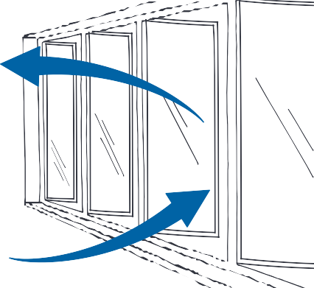
- Ensure that as many windows as possible can be opened.
- If you have a window that opens at top and bottom, then open both parts of the window.
If you find a window that is designed to be open but is stuck, report it to school leadership so maintenance can be arranged.

For more information, review the Ventilation and Air Purification resources on the
Policy and Advisory Library.

