Post-secondary transition support guide for final year students with disability

Transition planning for students with disability is a long-term process that occurs over several years, increasing in intensity in senior years of schooling. While 2020 has brought disruptions, students, schools and families have been working over the longer-term towards a post-school destination for 2021. This remains the goal and focus as students finish schooling with a sense of achievement.

KEY MESSAGES
Schools
- As a general rule, schools should progress students to their post-school setting in 2021. The dedication, innovation and expertise of special education teachers, classroom teachers, and education support staff during the coronavirus (COVID-19) pandemic has been exceptional. The majority of students have continued with their learning and gained new skills.
- Schools commit to supporting students’ readiness for life after school through conducting Student Support Groups, making adjustments in Individual Education Plans, reviewing student’s career aspirations and post-school plans, and facilitating transition supports.
Students and their families
- Students will be supported by their school, family and community who will work together to transition them to their new setting in 2021 with confidence and cohesion.
- To support students whose learning has been disrupted, all schools including specialist schools will implement opportunities to consolidate learning and educational experiences, which will support the transition to post-secondary options.

POST-SECONDARY TRANSITION SUPPORTS AVAILABLE
It is recommended that schools deliver transition supports using a tiered framework of available supports (outlined below). Using a tiered approach will ensure all final year students receive universal transition information and supports, as well as ensure identified students receive targeted and individualised transition support as needed.
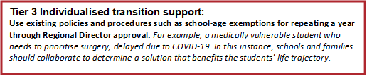

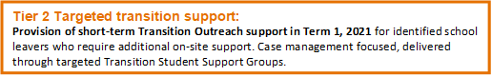

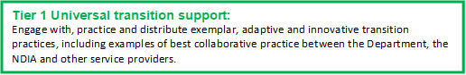

Tier 1: Universal Supports – Library of resources:
Students, Families and Schools in Partnership with the NDIA and Service Providers
- School Leavers Webinar for Autistic Students  – I CAN Network and NDIA  - Insights for Autistic School Leavers Webinar  - Humans on the Autism Spectrum: school leavers  - Navigating Young Adult Life  - ACD & the NDIS  - AMAZE & the NDIS Transition Webinars | - Ticket to Work  - Ticket to Work – A Video for Parents  - “Let’s Talk About Work” booklet  - Career Education and Workplace Learning for Students with Disability  - Structured Workplace Learning and Work Experience During Covid-19

Tier 2: TARGETED TRANSITION SUPPORTS
Short-term Transition Outreach Support
Provision of short-term transition outreach support be made available in Term 1, 2021 for identified school leavers who require additional transition support. Delivered through Student Support Groups (SSG) and resourced by the Department’s Post-Secondary Transition Funding Grant 2020-21.
Post-Secondary Transition Funding Grant 2020-21
- Specialist schools are eligible to receive one fixed payment of $750.00 per final year student, transitioning to post-secondary options in 2021. Specialist schools will receive information about funding allocation during Term 4, 2020, and their confirmed allocation will be provided in Term 1, 2021.
- Mainstream schools will have the opportunity to apply for Post-Secondary Transition Funding reimbursement of up to $750 for final year students with disability (supported through the Program for Students with Disabilities) transitioning to post-school options in 2021. Further information including reimbursement processes will be provided to mainstream schools in Term 4, 2020.
What does this look like in practice?
- Time-release for a staff member to lead the schools’ 2020-21 approach to transition, including supporting teachers to conduct transition-focused Student Support Groups
- Release a staff member to liaise with families, the NDIA, and/or service providers, including to review existing, or establish new, NDIS plans
- Develop and distribute “service provider information show-bags” to students/families
- Drive students to the location of their new settings for a walk to familiarise themselves with their new setting Area
- Set up simulated employment/community environments within the school to practice skills
- Develop and use resources to support students’ transition: social stories, filming “About Me” student videos, virtual provider fairs.

Tier 3: INDIVIDUALISED TRANSITION SUPPORTS
A case by case basis approach to individualised transition support, including using existing policies and procedures such as school-age exemptions for repeating a year through Regional Director approval.
Requests to repeat a year
The Department of Education and Training’s Repeating a Year Level Policy is supplemented with resources to better support principals to have conversations with families who may be considering the merits of their child repeating a year. These resources also outline the evidence behind the impacts of repeating a year. Refer to the Department’s Repeating a Year Level Policy on the Policy and Advisory Library.

