## Steps to determine a school’s Rurality Parameters

Step 1 : Determine the SA1 7-digit Code

1. Open web browser and navigate to this [map](https://dbr.abs.gov.au/absmaps/index.html)
2. Enter school address

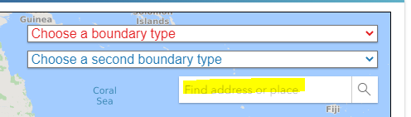

1. Select ‘2016 Statistical Area Level 1 (SA1)’ option from the ‘Choose a boundary type’ dropdown:

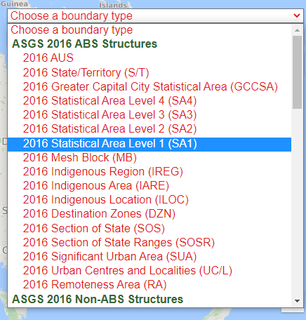

1. Click the map near the location to bring up a dialogue box, which includes the 11-digit SA 1 Main Code:

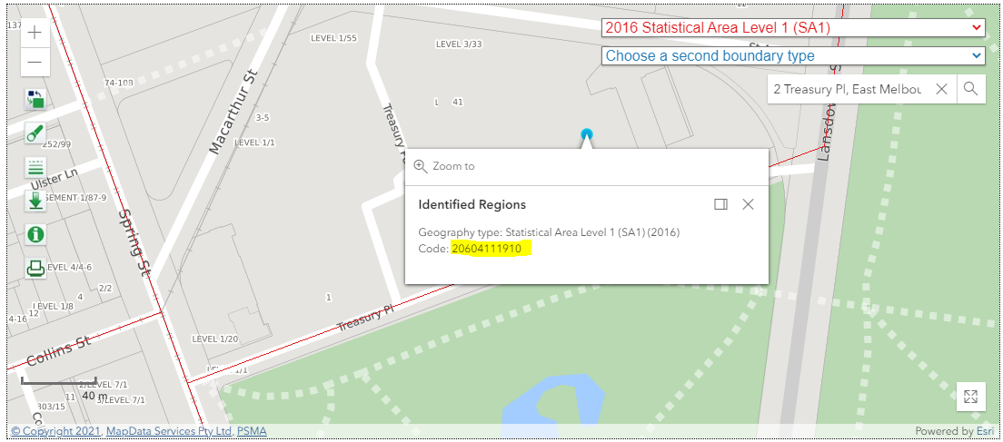

1. The ABS describe the ‘SA1 Coding Structure’ [here](https://www.abs.gov.au/ausstats/abs@.nsf/Lookup/by%20Subject/1270.0.55.001~July%202016~Main%20Features~Statistical%20Area%20Level%201%20(SA1)~10013), as follows: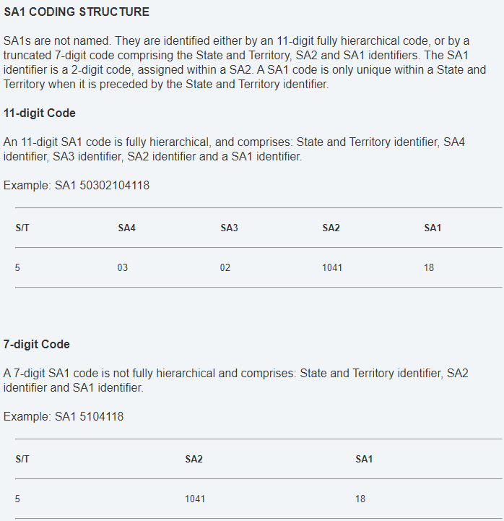
2. Based on the above, the SA1 7-digit Code in the above example would be **2**0604**111910**, so: 2111910

Step 2 : ARIA data from ABS website

1. On your browser, navigate to [this page](https://www.abs.gov.au/AUSSTATS/abs@.nsf/DetailsPage/1270.0.55.005July%202016?OpenDocument) on the ABS webpage
2. Click on the link to [download data in CSV format](https://www.abs.gov.au/ausstats/subscriber.nsf/log?openagent&1270055005_ra_2016_aust_csv.zip&1270.0.55.005&Data%20Cubes&F996E7BF2B99079FCA258251000C7F6C&0&July%202016&16.03.2018&Latest)
3. Look up the text in ‘RA_NAME_2016’ column against the SA1 7-digit Code (calculated in step 1) given in the column ‘SA1_7DIGITCODE_2016’

Step 2 : UCL data from ABS website

1. On your browser, click on the link to [download data in CSV format](https://www.abs.gov.au/ausstats/subscriber.nsf/log?openagent&1270055004_sa1_ucl_sosr_sos_2016_aust_csv.zip&1270.0.55.004&Data%20Cubes&EE5F4698A91AD2F8CA2581B1000E09B0&0&July%202016&09.10.2017&Latest)
2. Look up the text in ‘SOSR_NAME_2016’ column against the SA1 7-digit Code (calculated in step 1) given in the column ‘SA1_7DIGITCODE_2016’