Promoting air flow in our schools
Published and correct as at 28 January 2022

Open windows and doors as much as possible.
Open windows and doors on multiple sides of the room, if possible.
Keep air purifiers running all day, during and after occupation.

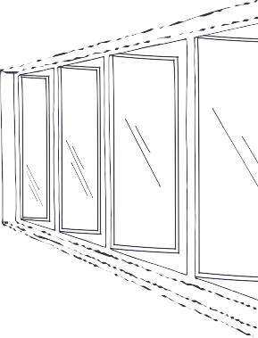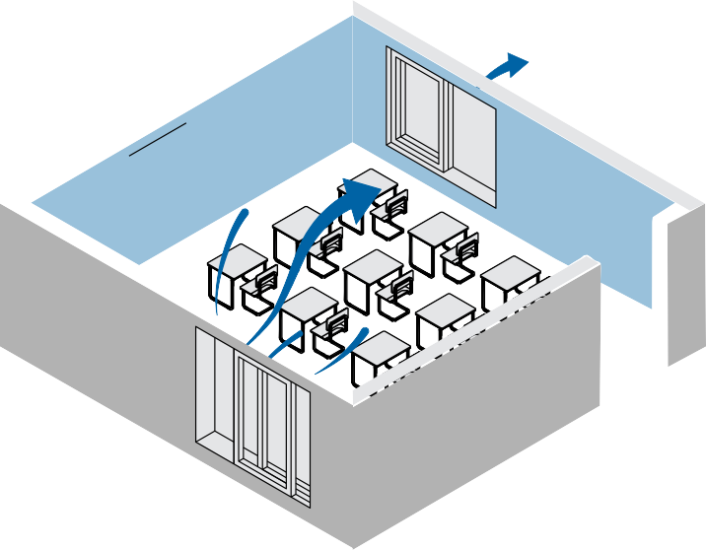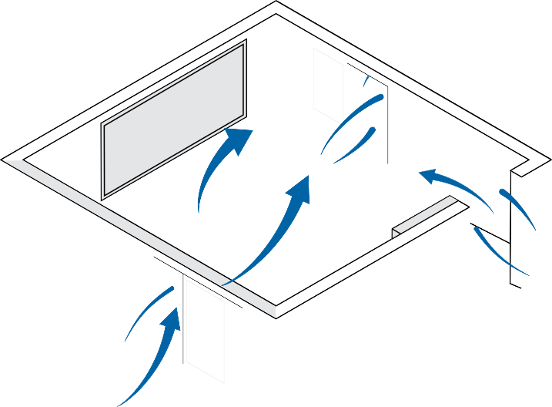
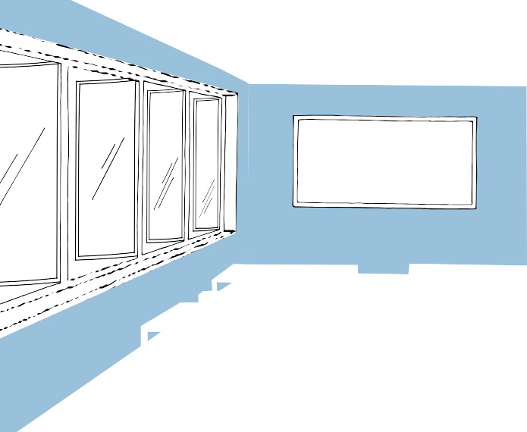
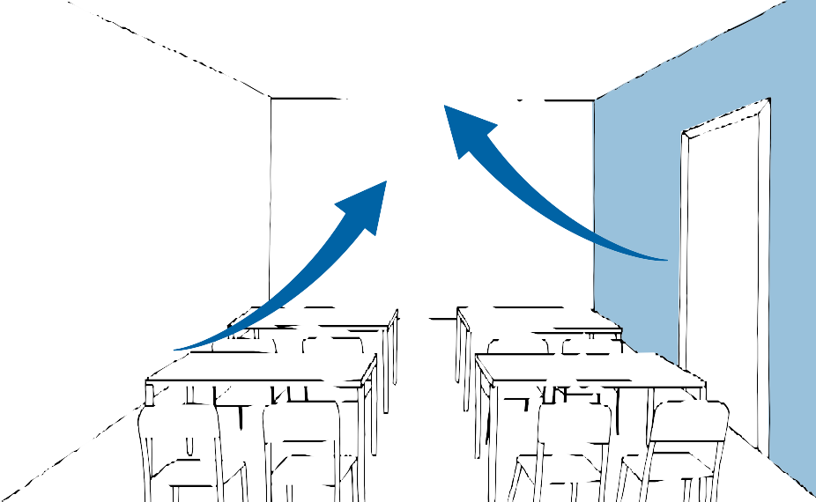
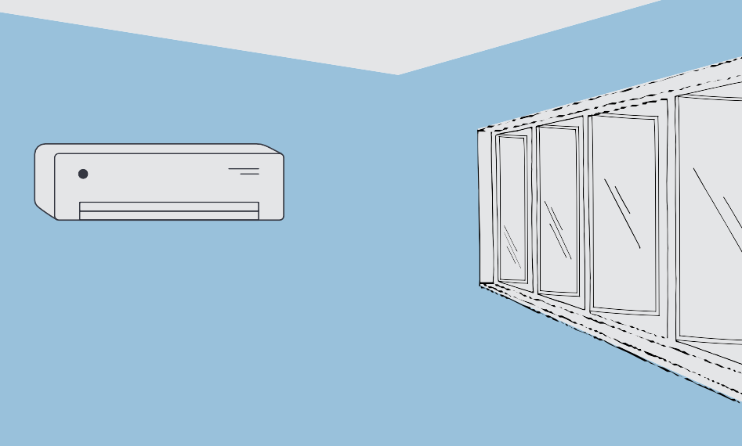
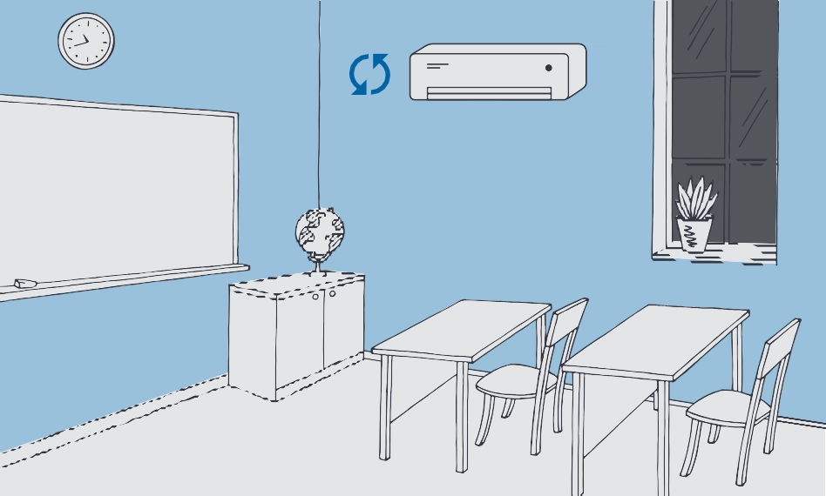

Maximise air movement by turning on ceiling fans or using oscillating pedestal fans.
For thermal comfort, use heating and air conditioning systems – even when windows and doors are open.
When outdoor air quality is poor (e.g. bushfire smoke or thunderstorm asthma) close windows and set air conditioners to recirculate air.

For detailed information visit: www.coronavirus.vic.gov.au

22-017

