School Community Safety Order Scheme
Communications Toolkit
July 2022

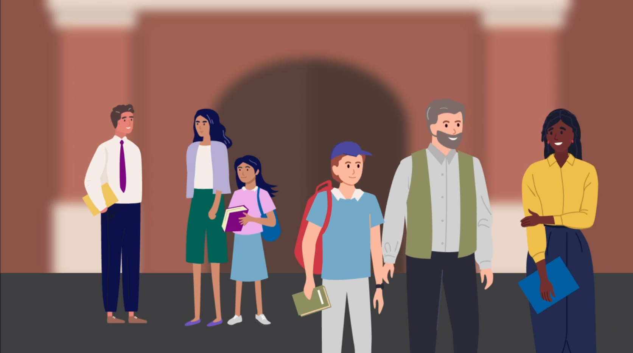

Content

Introduction
Suggested email content
Suggested talking points for meetings
Suggested social media content and email banner
Relevant resources
Extra parenting resources and supports

Introduction

Schools are positive places of learning and work where everyone has a right to a safe and healthy environment. Everyone is responsible for maintaining respectful, supportive relationships in their school community.
The Department of Education and Training has introduced the School Community Safety Order Scheme to help prohibit or limit violence, aggression or other behaviours that make staff, students or others feel unsafe in Victorian schools.
The Scheme is part of the Victorian Government’s broader strategy to manage the risks to the safety of school staff and students and the school community resulting from the behaviours of a small minority of parents and other adults who interact with schools.
You are encouraged to use communications materials contained in this toolkit to raise awareness about the new Scheme with your members and to promote positive, respectful relationships between adults in our school communities.
With your help and support, we can make sure both staff and students have a safe and healthy environment where they can thrive.

Suggested email to members
Please consider using the content below for your members. You can customise the content as required for your style and audiences.
Dear [Audience]
Schools are positive places of learning where everyone has a right to feel safe. When parents/carers and school staff work together as one team, our students do better and thrive. Everyone at school, particularly staff and parents/carers, is responsible for creating a safe and respectful environment for learning and work.
Schools are positive places of learning where everyone has a right to feel safe. When parents/carers and school staff work together as one team, our students do better and thrive. Everyone at school, particularly staff and parents/carers, is responsible for creating a safe and respectful environment for learning and work.
From Term 3, 2022, the School Community Safety Order Scheme will come into effect in all Victorian schools. This Scheme allows principals and other authorised persons to issue ongoing or immediate school community safety orders that place limitations on the way certain parents, carers or other adults who act in a harmful, abusive or threatening way behave towards staff, students or others in the school community. Click here for more information about the Scheme, including a short video that provides an overview of the Scheme.
This Scheme provides a range of safeguards for people who may be subject to an order and their child. For example, before issuing an ongoing school community safety order, an authorised person must consider the person’s response to the notice to issue an order and how an order may impact their child. Orders can only be issued as a last resort option if it is the least restrictive option to address the behaviour.
If a parent or carer has been issued with an ongoing order, they have the right to appeal the order so it is reviewed by a person other than the person who issued the order. If they are unhappy with the outcome of the internal review, you may appeal the decision at the Victorian Civil Administrative Tribunal. To read more about the protections built into the Scheme for parents, carers and other adults who may be subject to an order (including information on appeal rights), access the Department’s website.
Everyone at school, particularly staff and parents/carers, play a role in making school a better place for learning and work. The Respectful Behaviours within the School Community Policy outlines the shared roles of parents, carers and school staff in creating a positive environment for learning. You can find the policy and other resources to build a positive relationship with your school community here.
We encourage you to use and share these communications materials to raise awareness about the new policy with other parents and carers and promote positive, respectful relationships between adults in our school communities.

Suggested talking points for member meetings

Please consider using the content below as speaking notes for meetings with members of your organisation and information sessions. You can customise the content as required for your style and audiences.

- We all know aggression towards staff, students or others in the school community can have a significant impact on physical and mental health, safety, and wellbeing. The impact can also be felt by the wider school community.
- This is why the Department has introduced the School Community Safety Order Scheme, which allows authorised persons to make orders to prohibit or limit unacceptable behaviour from a small number of parents, carers and other adults who engage in harmful, threatening, or abusive behaviour.
- The Scheme is now in place for all Victorian schools and is part of a broader strategy to manage the risks to the safety of school staff, students, and the school community.
- Principals and other authorised persons in Victorian schools will be able to issue orders and set limits on how that person can behave around certain people, at certain times, at the school or other places where school activities happen. The order may also include special exceptions like times when, or areas where, it does not apply.
- Orders are issued as the very last resort where they are the least restrictive option available to deal with the behaviour.
- If a parent or carer has been issued with an ongoing order, they have the right to appeal the order so it is reviewed by a person other than the person who issued the order. If they are unhappy with the outcome of the internal review, you may appeal the decision at the Victorian Civil Administrative Tribunal.
- Importantly, the Scheme will also provide safeguards for students whose parent/s are subject to an order so that they can continue to access the school. This includes establishing a communication and access protocol to outline measures to be taken to ensure parents may continue to be informed about their child’s education.
- You can read more about the protections built into the Scheme for parents and carers and age appropriate information for students on the Department’s website.
- With your help and support, we can ensure a safe and healthy environment for students and school staff.
- If you would like any more information or to discuss this further, please reach out to me.

Suggested social media content and email banner
Here are some sample email banners and social media posts that can be used across your own social channels to help promote respectful behaviours in the community.
Please tag the Department of Education and Training so we can like and share your posts.
DET LinkedIn
DET Twitter
Social media post copy:
We all deserve to feel safe in our school community. Respect staff, students and each other. Go to Creating safer school communities for more information.
Social media images
Right click and save an image to use for your social media posts.
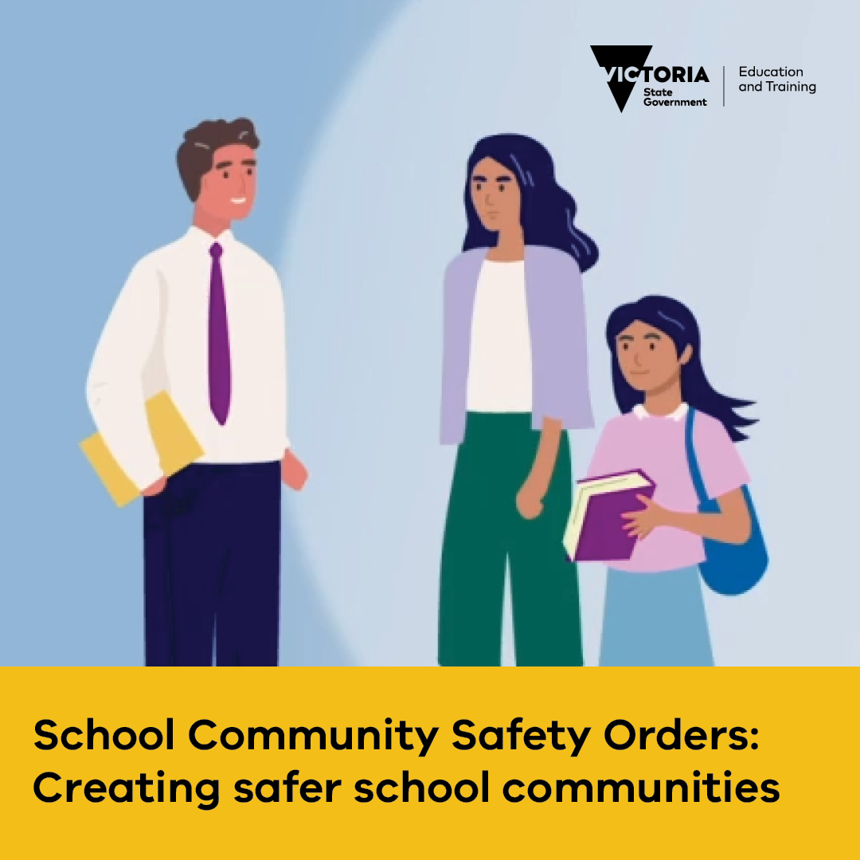
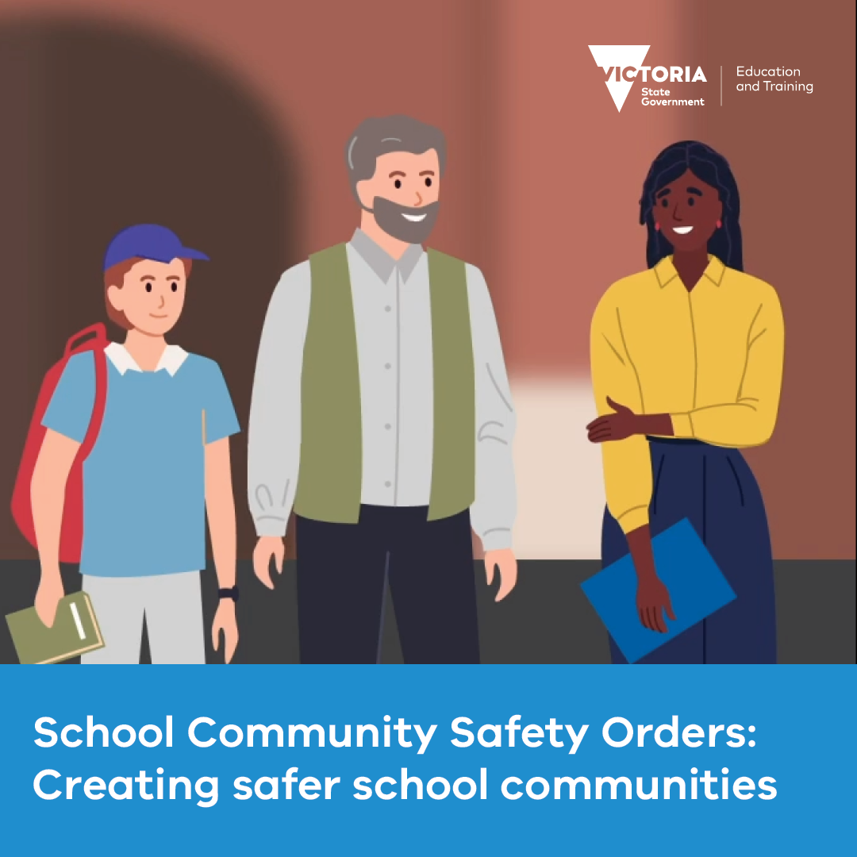

Email banners
Right click and save an image to use as an email banner. Please ensure you hyperlink your email banner to: www.vic.gov.au/creating-safer-school-communities
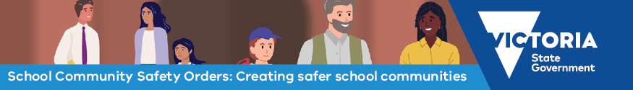
Go to Creating safer school communities for more information.
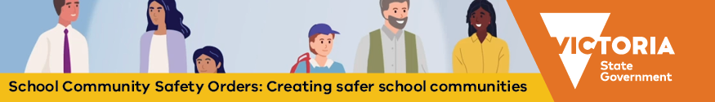
Go to Creating safer school communities for more information.

Posters

Download and print the staff facing poster for display in settings reserved for school staff.

Download and print the parent facing poster for display in settings where parents, carers and adults in the school community frequent. The poster is available in 30+ languages here under ‘Safety at Work for School Staff communications material’.

Relevant resources
- Information about the School Community Safety Order Scheme is available on the DET website. This includes a short video providing an overview of the Scheme and information for parents on appeal rights, procedural fairness for parents and carers and remaining involved in your child’s education despite an Order being made.
- The Creating safer school communities page includes a link to the Respectful Behaviours within the School Community Policy, which communicates the shared responsibility staff, parents and other adults have in behaving respectfully.
- Building a positive relationship with your child's school page includes resources to support safe and respectful relationships in our school communities, including information about getting involved with the school, advice on how to raise a concern or complaint, and parenting support resources.

Extra parent support services and resources
- Department of Families, Fairness and Housing – services and support for families, including:
  - Strengthening Parent Support Program – a free program for parents and carers with a child from birth to 18 years, with a disability or developmental delay.
  - Regional Parenting Services – support for parents and carers of children from birth to 18 years located in regional Victoria.
  - Family intervention services – advice on how to develop your parenting skills when you’re having difficulties in managing your child’s behaviour.
  - Child, family and relationship services – family support services to help parents raise their children.
  - Raising Children Network – guidance on supporting school age children, including resources, videos, articles and apps.
  - Parentline – a confidential counselling and support services for parents and carers of children from birth to 18 years old.
  - Child behaviour – information about how to manage and build positive behaviour with your child.
  - Parenting Ideas – resources about raising confident, happy and resilient children.
  - MyTime program – support for parents and carers of children with disabilities. Skilled facilitators provide guidance to help access local services and reliable information.
  - Triple P Parenting program – ideas and strategies to help parents and carers including ways to set routines, manage behaviours and how to take care of yourself

