School Community Safety Order Scheme
Communications Toolkit
July 2022

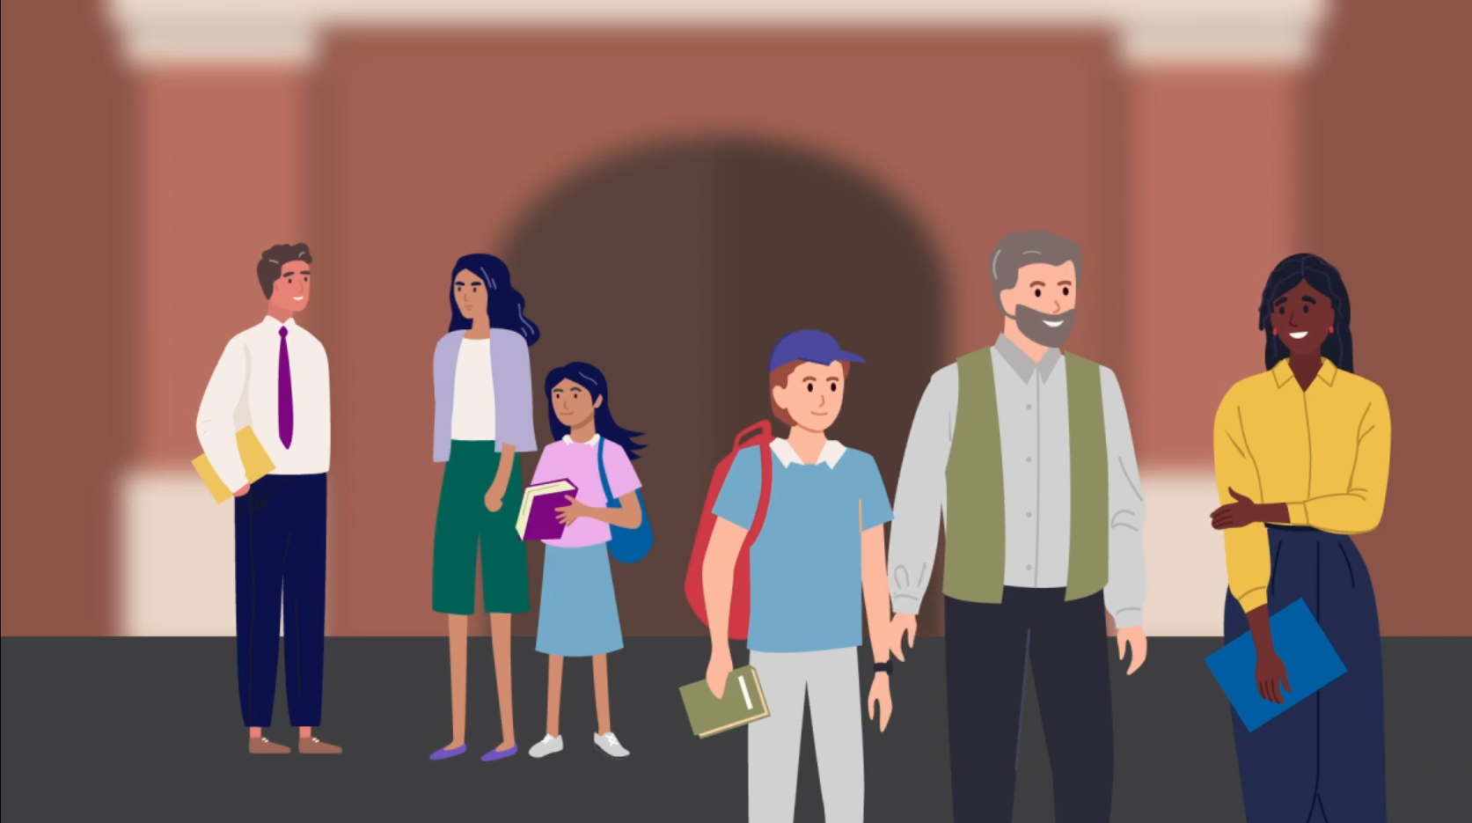

Content

Introduction
Suggested newsletter from principal to school community
Suggested email to school staff
Suggested talking points for school meetings
Suggested social media content and email banner
Safety at Work posters
Relevant resources

Introduction

Schools are positive places of learning and work where everyone has a right to a safe and healthy environment. Everyone is responsible for maintaining respectful, supportive relationships in their school community.
The Department of Education and Training has launched the School Community Safety Order The Department of Education and Training has introduced the School Community Safety Order Scheme to help prohibit or limit violence, aggression or other behaviours that make staff, students or others feel unsafe in Victorian schools.
The Scheme is part of the Victorian Government’s broader strategy to manage the risks to the safety of school staff and students and the school community resulting from the behaviours of a small minority of parents and other adults who interact with schools.
Schools are encouraged to use communications materials contained in this toolkit to raise awareness about the new Scheme and to promote positive, respectful relationships between adults in our school communities.
With your help and support, we can make sure both staff and students have a safe and healthy environment where they can thrive.

Suggested newsletter from principal to school community

Please consider using the content below to communicate the Scheme and new parent webpage to the school community. You can customise the content as required for your style and audiences.
Dear [Audience]
Schools are positive places of learning where everyone has a right to a safe and healthy learning environment. Schools are also workplaces, and school staff deserve to work in an environment where they don’t feel threatened or unsafe.
From Term 3, 2022, the School Community Safety Order Scheme (Scheme) will come into effect in all Victorian schools. This Scheme allows principals and other authorised persons to issue ongoing or immediate school community safety orders that place limitations on the way certain parents, carers or other adults who act in a harmful, abusive or threatening way behave towards staff, students or others in the school community. Click here for more information about the Scheme, including a short video that provides an overview of the Scheme.
This Scheme provides a range of safeguards for people who may be subject to an order and their child. For example, before issuing an ongoing school community safety order, an authorised person must consider the person’s response to the notice to issue an order and how an order may impact their child. Orders can only be issued as a last resort option if it is the least restrictive option to address the behaviour. To read more about the protections built into the Scheme for parents, carers and other adults who may be subject to an order (including information on appeal rights), access the Department’s website.
Everyone at school, particularly staff and parents/carers, play a role in making school a better place for learning and work. The Respectful Behaviours within the School Community Policy outlines the shared roles of parents, carers and school staff in creating a positive environment for learning.
Our mutual objective is to support your child’s education. To do this, we ask that feedback and complaints are both constructive and respectful. Parents are reminded to follow the school’s complaints policy or process or the Department’s Complaints Policy if you wish to raise any constructive and respectful feedback.
You can find the Respectful Behaviours within the School Community Policy and other resources to build a positive relationship with our school community here.
[insert Principal’s name and contact details].

Suggested email to school staff

Please consider using the content below in an email to staff. You can customise the content as required for your style and audiences.
Dear colleagues,
Schools are positive places of learning where everyone has a right to feel safe.
We all have a right to feel safe at work and protected from any aggression, violence or behaviour that make us feel unsafe. This type of behaviour can significantly affect our health, safety and wellbeing and can also impact our colleagues and wider school community.
School Community Safety Scheme
The Department of Education and Training has strengthened the legal protections available to all Victorian schools in response to unacceptable behaviour from parents, carers and other adults in the school community by introducing the School Community Safety Order Scheme.
Established under the Education and Training Reform Amendment (Protection of School Communities) Act 2021, the Scheme provides new measures and actions when inappropriate behaviour is levelled towards people in our school community.
The Scheme empowers authorised persons, such as myself as principal, to issue School Community Safety Orders to prohibit or limit unacceptable or unreasonable behaviour. These orders are a last resort option where they are the least restrictive option available to deal with the behaviour. You can watch a short video providing an overview of the Scheme here.
For more information, access the Department’s website, which also includes age appropriate information tailored to students seeking more information about the Scheme.
Respectful Behaviours within the School Community Policy
The Scheme is just one part of the Department’s initiatives to address work-related violence in schools. The Department’s Respectful Behaviours within the School Community Policy on the new Creating safer school communities page of the Department’s website communicates the shared responsibility staff, parents and other adults have in behaving respectfully.
I encourage you to familiarise yourself with the policy to understand what constitutes unacceptable or unreasonable behaviours to help us set expectations of respectful behaviour within our school community.
Please also insert the attached banner into your email signature to promote respectful behaviour in our schools.
Reporting unacceptable behaviour
Aggression and violence have no place in our school community and should never be viewed as part of our job. I urge you to bring to my attention any unacceptable behaviour that you experience or witness at our school.
As always, I am here to support you in these matters to ensure your health and safety is prioritised to reduce the risk of these events occurring and to help resolve any matters before they escalate to harmful behaviours.
If you would like any more information or to discuss this further, please reach out to me (and/or our health and safety representative/s) at any time.

Kind regards,
[Principal name]

Suggested talking points for school meetings
Please consider using the content below as speaking notes for staff meetings, health and safety committee meetings or school council meetings. You can customise the content as required for your style and audiences.
- We all know aggression towards staff, students or others in the school community can have a significant impact on physical and mental health, safety, and wellbeing. Aggression and violence have no place in our school community and should never be viewed as part of the job.
- This is why the Department of Education and Training has introduced the School Community Safety Order Scheme, which allows me as principal to make orders to prohibit or limit unacceptable behaviour from parents, carers and other adults who engage in harmful, threatening, or abusive behaviour.
- The Scheme is now in place for all Victorian schools, including non-government schools, and is part of a broader strategy to manage the risks to the safety of school staff, students, and the school community.
- Principals and other authorised persons in Victorian schools will be able to issue orders and set limits on how that person can behave around certain people, at certain times, at the school or other places where school activities happen. The order may also include special exceptions like times when, or areas where, it does not apply.
- Orders are issued as the very last resort where they are the least restrictive option available to deal with the behaviour.
- I encourage you to access the Department’s website to familiarise yourself with the Scheme.
- I urge you to continue to bring to my attention any unacceptable behaviour that you experience or witness at our school.
- If you would like any more information or to discuss this further, please reach out to me and our health and safety representative at any time.

Suggested social media content and email banner
Here are some sample email banners and social media posts that can be used across your own social channels to help promote respectful behaviours in the community.
Please tag the Department of Education and Training so we can like and share your posts.
DET LinkedIn
DET Twitter
Social media post copy:
We all deserve to feel safe in our school community. Respect staff, students and each other. Go to Creating safer school communities for more information.
Social media images
Right click and save an image to use for your social media posts.
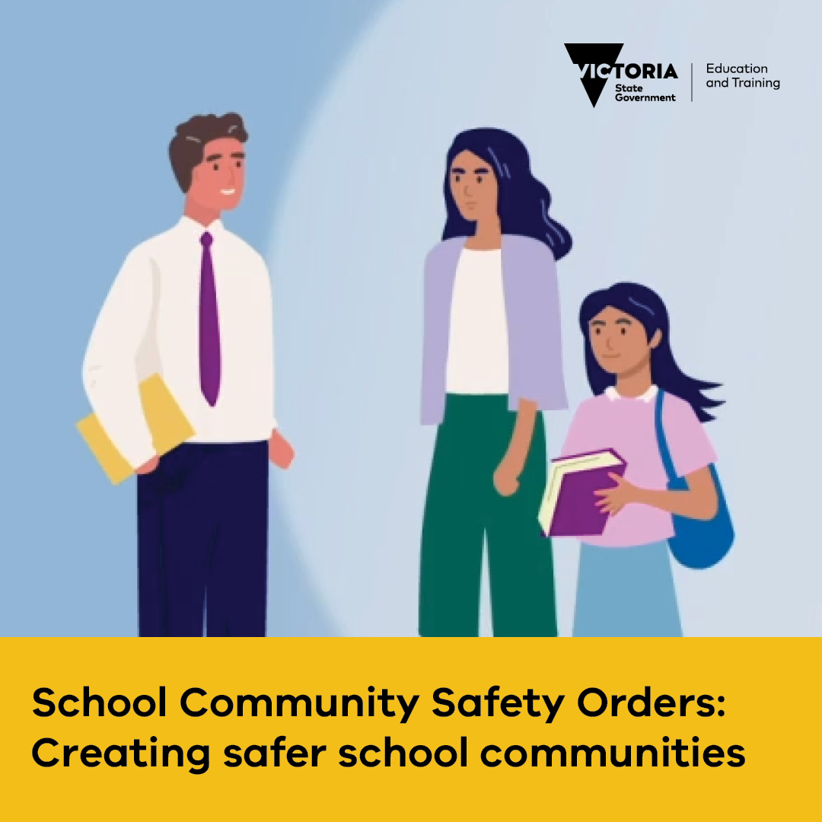
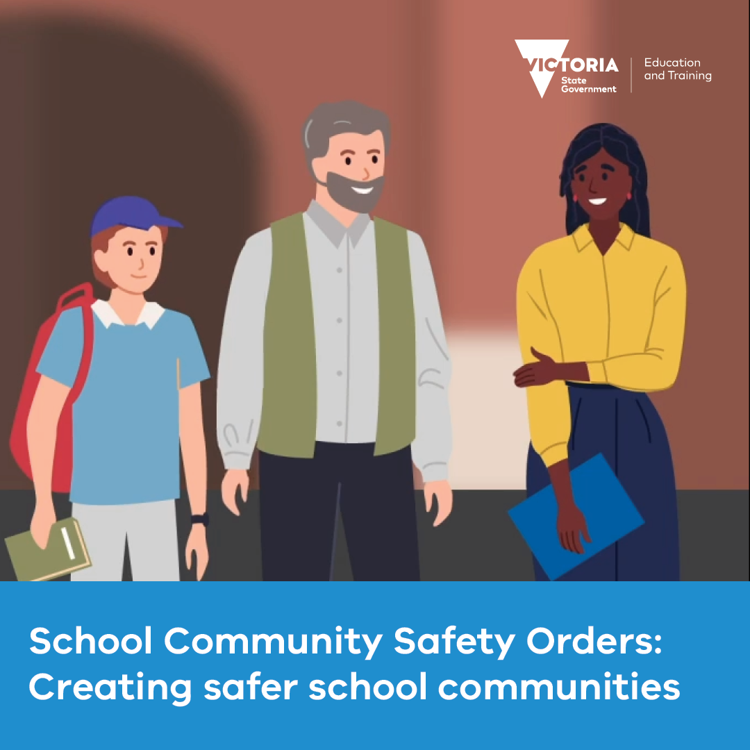

Email banners
Right click and save an image to use as an email banner. Please ensure you hyperlink your email banner to: www.vic.gov.au/creating-safer-school-communities
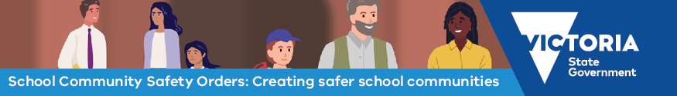
Go to Creating safer school communities for more information.
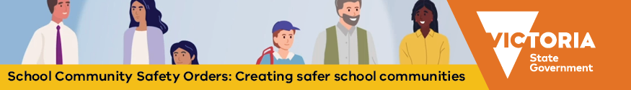
Go to Creating safer school communities for more information.

Posters

Download and print the staff facing poster for display in settings reserved for school staff.

Download and print the parent facing poster for display in settings where parents, carers and adults in the school community frequent. The poster is available in 30+ languages here under ‘Safety at Work for School Staff communications material’.

‘Five minutes with staff’ newsletter story template

Articles that profile staff in your school newsletter can humanise staff and help build empathy. Use these questions to create profiles of school staff in your school newsletter or digital platforms. These are example questions; you may wish to use 4–6 per article and rotate the questions or add in your own.

5 minutes with [staff member name]

- How long have you worked at [school name]?
- What is your role at the school?
- What is the most rewarding part of your job?
- What is your ideal way to unwind and relax?
- What’s your most fond childhood memory?
- When you were little what did you aspire to be?
- What was your favourite subject at school?
- How many languages do you speak?
- What skill would you like to master?
- What book/tv series/podcasts are you right into at the moment?
- What is your favourite sport to watch or play?
- Do you play a musical instrument? If so, which one?
- What would you sing at karaoke night?
- If you could choose to be anything for a day, what would it be?
- If you could only eat one meal for the rest of your life, what would it be?
- If you were a super-hero, what powers would you have?
- What’s your favourite holiday destination?
- Who would you want to play you in a movie of your life?
- Do you collect anything?

Relevant resources

Supports available to non-government schools
- The Ministerial Guidelines provide detailed sector-neutral information and guidance for people who are authorised to issue orders.
- The School Community Safety Order Scheme eLearn module with essential information about the Scheme, such as who an order can be issued to and how to issue an order. Completion is required for all principals and other authorised persons prior to issuing an order.
- Information about the School Community Safety Order Scheme is available on the DET website, including a short video providing an overview of the Scheme.
- The Creating safer school communities page on the DET website, with a link to the Respectful Behaviours within the School Community Policy, can assist in establishing behavioural expectations for parents, carers and other adult members of the school community.

Information for parents
- Information about the School Community Safety Order Scheme is available on the DET website. This includes a short video providing an overview of the Scheme and information for parents on appeal rights, procedural fairness for parents and carers and remaining involved in your child’s education despite an Order being made.
- The Creating safer school communities page includes a link to the Respectful Behaviours within the School Community Policy, which communicates the shared responsibility staff, parents and other adults have in behaving respectfully.
- Building a positive relationship with your child's school page includes resources to support safe and respectful relationships in our school communities, including information about getting involved with the school, advice on how to raise a concern or complaint, and parenting support resources.

