Victorian International Student Information Tool

User Manual for ISCs

Developed by Ulhas Rao
Senior Information Systems Business Analyst
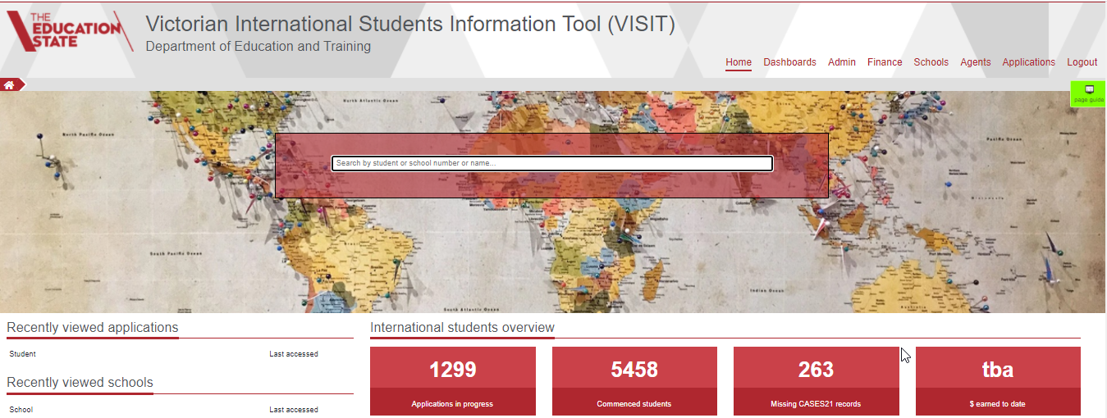

TABLE OF CONTENTS
1.1 About VISIT 2
1.2 Overview 4
1.3 International Students 5
1.4 Disbursements 6
1.5 Pending actions 7
1.6 Documents 9
1.7 Commencing data 10
1.8 Dashboards 11
1.9 Homestay profiles 11

USERS AGREEMENT:
This document has been made available to you to enable you to learn and perform your duties related to confirming places for International Students. While every effort has been made to keep identities of individual students unknown, you may not distribute this document to anyone without the express and written authorisation from International Education Division.
Any data shared or distributed will be considered as breach of privacy as per terms of agreement. Please refer to the website of the Department for the Privacy policy.
https://www.education.vic.gov.au/Pages/privacypolicy.aspx AND
https://www.education.vic.gov.au/Pages/schoolsprivacypolicy.aspx

INTRODUCTION

About VISIT
VISIT stands for Victorian International Student Information Tool
It has been developed as a replacement to the legacy system – OSP (Overseas Student Program). It has been developed using the latest Microsoft technology and is cloud based. Being cloud based it can be accessed from anywhere, as long there is Internet connection and you have valid Department employee ID and granted permission to access the application.
Current version allows both International Education Division (IED) staff as well as ISCs from schools to login and carry out their individual functions. The access is role based, which allows staff to access certain pages and functions within the system.
Some of the advantages of the system are:
- is a user-friendly, web-based system accessible anytime, anywhere and on any device.
- provides real time and historical reporting functionality
- increases application processing efficiency by reducing manual data entry (e.g. of tuition fees).
- improves financial functions, (e.g. by including payment plan, refunds, bulk invoicing and disbursement processing functions for IED staff).
- decreases school administration relating to student application processing and acceptance, and post-enrolment student support.
- schools can view their enrolled students and school support data in real time 24/7
- will provide schools with access to their ISP information in one easy to use location.
- allows schools to view their disbursements within the system and compare to their enrolled students, including summary attributes of the student.
- increases efficiency in VSL application processing for both Host Schools and VSL.
- will support legislative compliance with the Education Services for Overseas Students Act and National Code, and support DET to acquit its responsibilities as a Commonwealth registered international education provider.
When you login to VISIT (URL) – https://visit.educationapps.vic.gov.au/home
You will be presented with the following page
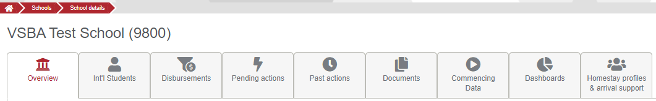
Brief description of each of the tabs
- Here all the details about the school are displayed. The address, campus details, Name of the ISC
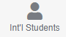 A list of all students who are enrolled at the school and their year levels
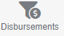All disbursements made to the school and details of each batch
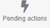The place where the ISC will go to confirm the RTP received from IED
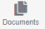 Any documents related to the school will be uploaded here
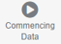A list of all students who are supposed to commence with their expected start date
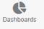A list of charts based on the school enrolments
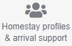 A tab where you can create Homestay profiles for your school. You can associate the students who would be staying at these places. You print the Homestay profile and Arrival Support form from this tab.
Let us go through each of the tabs and see what data is available and how it would help you in performing your duties.

Overview
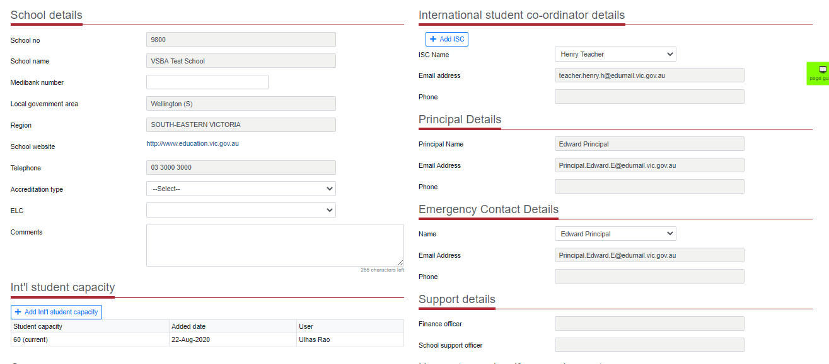
The school details are retrieved from the School Master database. It displays details about the address, website, phone and accreditation status.
Where known, International Education (IED) has populated the ISC and Principal Information. However, it is possible to change the ISC by clicking on the drop-down arrow and choosing a different staff member.
If a new staff member joins the school and is to perform the role of an ISC, then there is a three step process that needs to be completed.
- The new staff member is added into the CASES database.
- Inform the IED system Administrator or your school support contact
- Once IED confirm, you should be able to see the staff member in the list. Choose the relevant staff member and click on update. The new staff member is included as the ISC for your school.

The Finance and School Support staff from IED are displayed in the Support details.

The student cap information is displayed. Any changes to this information will be managed by IED.
The campuses information is also displayed.

International Students
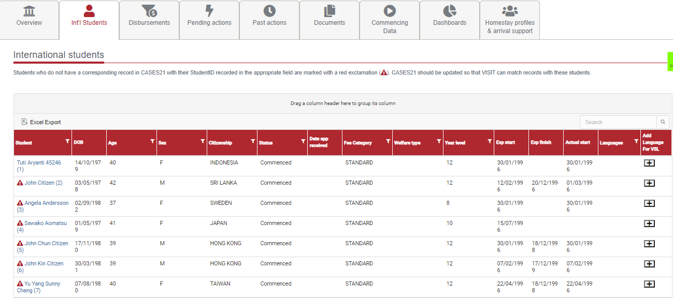
Here you will see all students studying at your school. You can filter the list based on the fee category or by year level.
Once you have updated CASES21 with the actual start, that date will be displayed in the grid as well.
But the most important function that you will do through this tab, is add the VSL details, if a student wants to study a language.
To complete this task, follow the following steps:
- Click on the icon in the last column. This will display a new grid on the top as follows
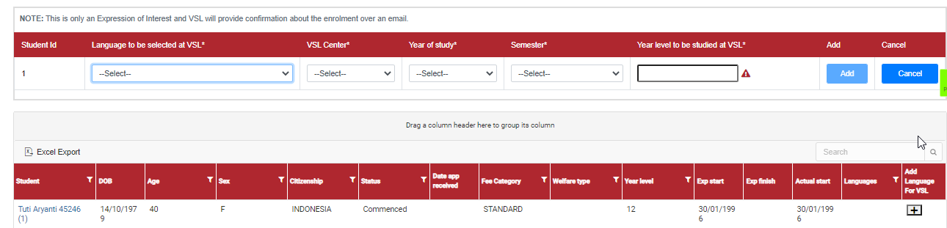
- Select the language from the drop down list, this will filter the centres that offer the language
- Select the Centre where the student would like to attend the language class 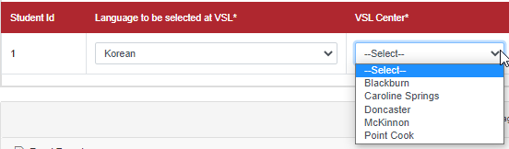
- Select the year of study – this is either the current year or the next year. The options are restricted 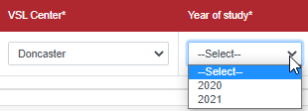
- Select the Semester when the student wants to study. Semester 1 implies Terms 1 and 2, and Semester 2 implies Terms 3 and 4.
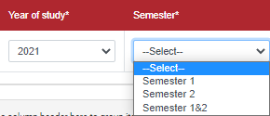
- Next select the year level. You can enter either the students’ current year level or one above the current.
- Click Add. This will be displayed in the grid below. An email is sent by the system to the VSL centre about your (student’s request). VSL will get back to you and confirm the enrolment.

Disbursements
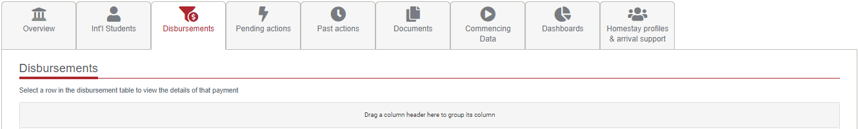
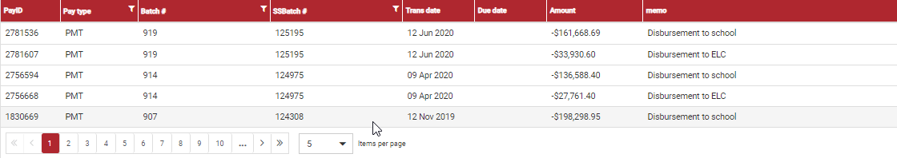
There are two grids under this tab. The first grid displays the various batches through which disbursements have been made to the individual schools.
When you click on any one the rows another grid is displayed giving the details of each student in that batch.
Due to Privacy reasons, no screen shot of the student details can be displayed here.

Pending actions
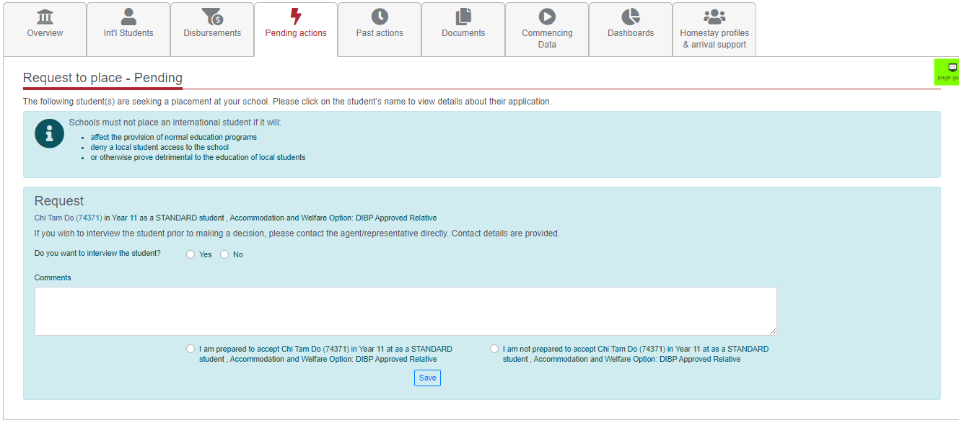
This is the tab, where all Requests to place a student are displayed. Probably one of the more used tab in the system.
Here you can accept the student after reviewing the student’s application. To view the student’s application, right click on the student and open in a new tab.
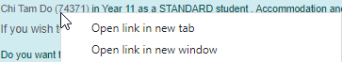
All student details are displayed as a read only view
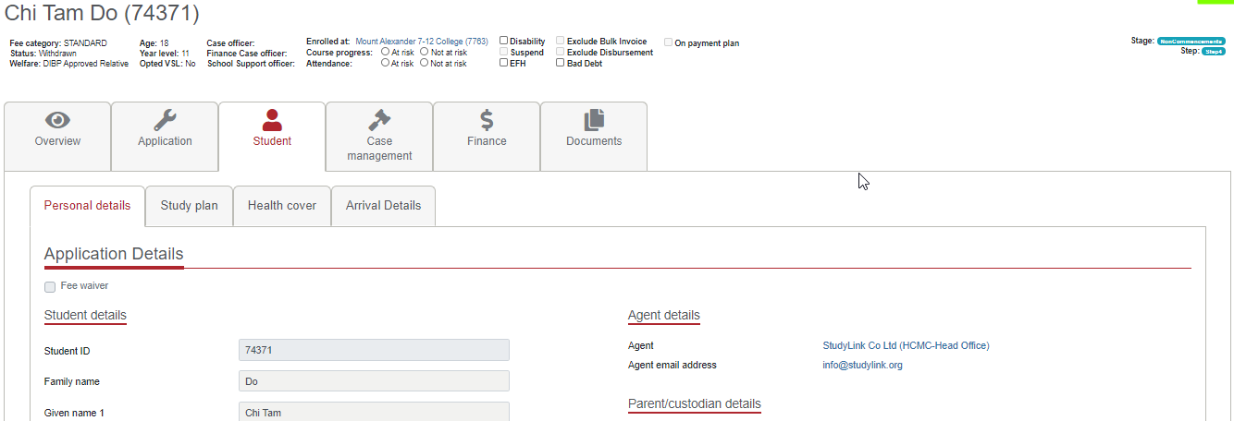
Scroll to view the various details
Click on the study plan tab, to view the course details
If the student is a Welfare 4 student, and has submitted the arrival details to IED, the same can be viewed in the arrivals tab.
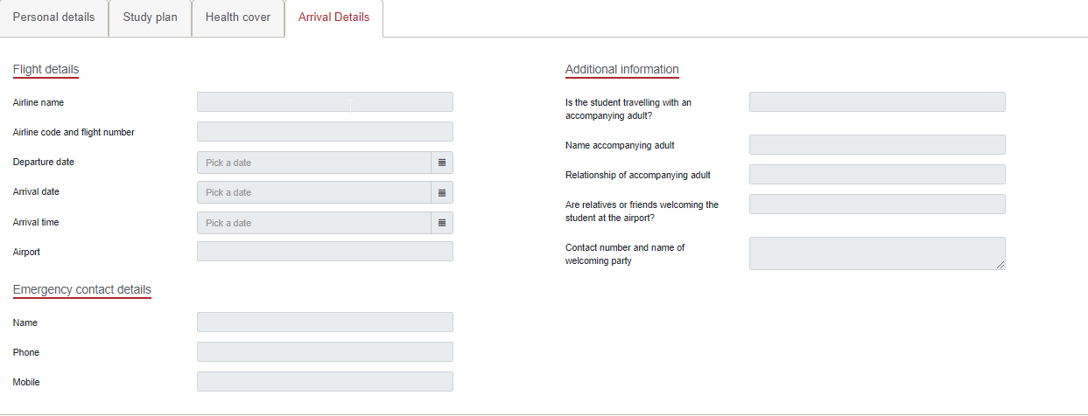
You can also view the financials transactions for a particular student by clicking on the Finance tab, under a student.
The following details are displayed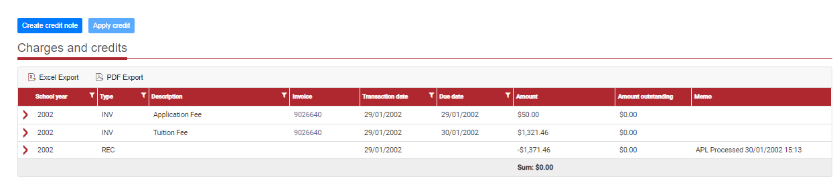
You can view the disbursements by click on the arrow next to the tuition fee line (). When you do this the details are displayed
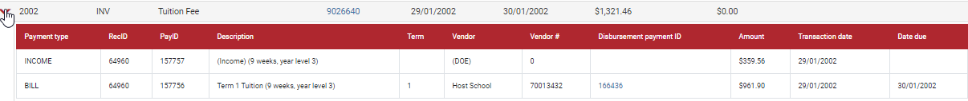
Please note this is only a sample and does not reflect current disbursements and is for a sample student from the past.

Documents
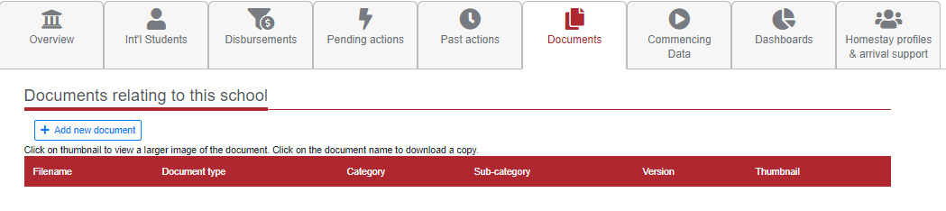
To add a document, follow the steps outlined below:
- Click on the ‘Add new document’
- 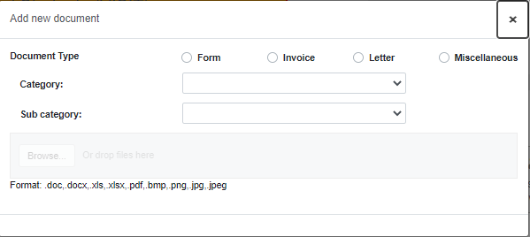
- Choose the type
- Select Category and a relevant sub category (if available)
- Click on Browse and select the file from the folder you have saved it
- The file will be uploaded and be visible in the grid below
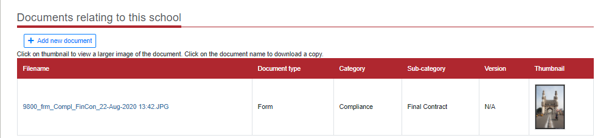
You will upload the photo of the ISC at the school using this tab. The category and sub-category
are
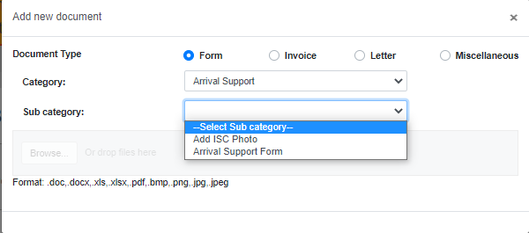
The only point to remember is that the file name for the photo has to be
Isccoordinator_firstname_lastname.jpg (e.g. ISCCORDINATOR_John_Citizen.jpg
The system verifies that the file name matches the ISC name in the overview page, and does not allow you to upload any incorrectly named file.

Commencing data
Here a list of all students who have paid their fees, but not commenced is listed.

Dashboards
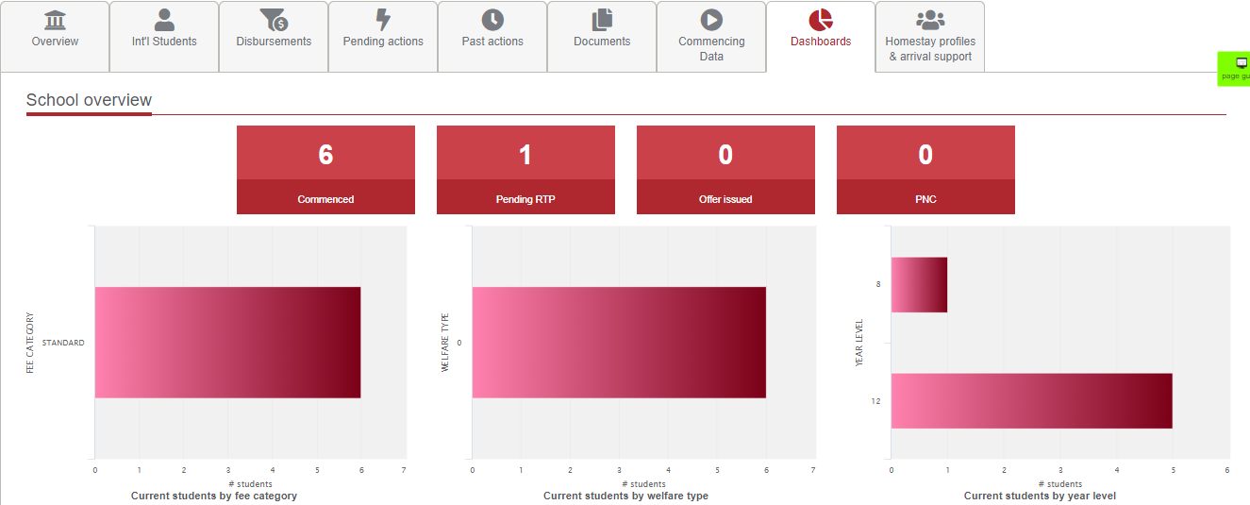

Depending on the number of students enrolled, this tab will show the numbers and charts for those numbers.

Homestay profiles
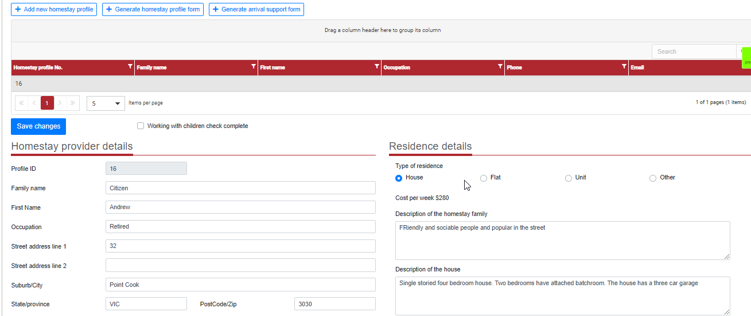

You can create as any homestay profiles as you wish. When you click on the ‘Add new homestay profile’ a row is created in the grid as shown above. Upon clicking on this row a detailed section is displayed below.
You have enter the details and click on save.
When you click on the button add family member, a pop-up box is displayed.
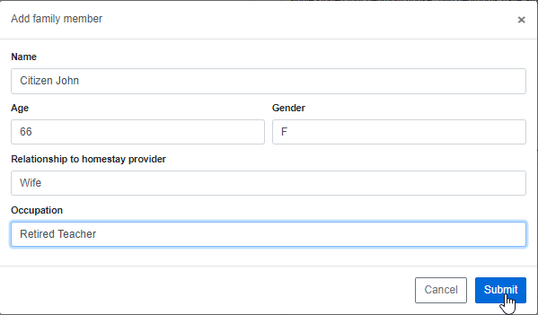
After entering the details and clicking on submit, the same data is saved and displayed. You can add as many family members as you wish and who are living in the house.
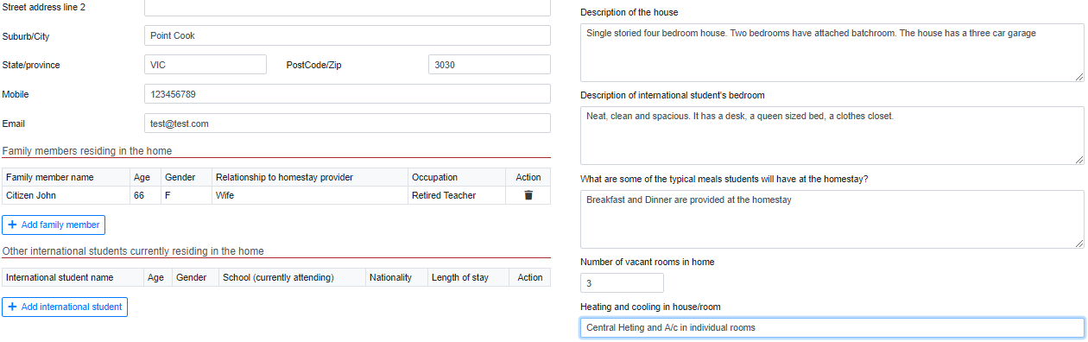
Once all the details have been entered and you have saved, you add international students. This is done by
- Click on Generate Homestay profile
- A pop-up box asking you to enter the student’s ID
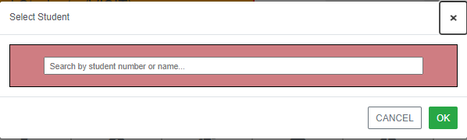
- Once this is entered, the student is added to the grid and a form is automatically downloaded. You can send this form to IED as well as the Parents/Agents for their reference.

