Head Start School-Based Apprenticeships and Traineeships
Head Start supports young people to do an apprenticeship or traineeship while at school. Head Start students benefit from genuine paid employment, training in a nationally recognised qualification, and strong literacy, numeracy and other skills that are needed to be successful in the workplace.

Supported school-based apprenticeships and traineeships

What are school-based apprenticeships and traineeships?

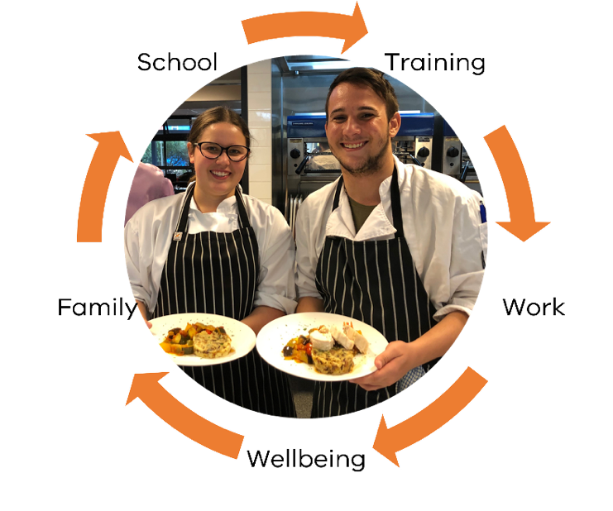
School-based apprenticeships and traineeships (SBATs) combine senior secondary education (VCE, VCE Vocational Major, or Victorian Pathways Certificate) with part-time employment and skills training in a dedicated field.

Students enter the apprenticeship or traineeship under a formal training contract with an employer. The training must lead to a nationally recognised qualification, as determined by the Victorian Registration and Qualification Authority.

SBAT students are contracted to their employer and paid a government regulated wage as an apprentice or trainee. Regular school attendance is combined with a minimum of one timetabled day a week of employment and/or structured training. The student’s work and training should last at least 13 hours a week on average which should be divided into at least 7 hours of employment and up to 6 hours of training.

SBATs powered by Head Start
To manage an SBAT effectively, students need to balance school, training and work all while managing their wellbeing. That’s where Head Start comes in.
Head Start provides quality end-to-end support to help students achieve real benefits from their SBAT.
At every step of Head Start participation, students are supported by a dedicated team of school-based coordinators, industry and learning specialists. Supports include:
- Pathway planning
- Preparing for workplace success
- Matching with a suitable employer
- Work trials
- Wellbeing support and advocacy
- Learning support
- Transition support from school to employment and/or further training

Finding quality sBATs through Head Start

Head Start matches motivated well-prepared students to quality employment opportunities.
- Students can start the Head Start program in year 10, 11 or 12
- Students work with a Head Start coordinator to identify their interests, goals and needs
- Students work for an employer who is committed to mentoring young people within their industry
- Head Start finds suitable employers and arranges work trials so students fully understand what the role involves before starting an apprenticeship or traineeship
- Head Start works with the school to create a flexible, individualised timetable so that students can work, train and study successfully
- Where possible, students are provided with increased time in the workplace to increase their experience and employabilty

Training for real jobs through Head Start
There are over 150 courses available as SBATs ranging from certificate II to certificate IV connected to current and emerging job roles across a wide range of industries including:

- Agriculture / Aquaculture / Horticulture
- Arts
- Automotive
- Business
- Construction
- Emerging technologies
- Engineering
- Fashion
- Health
- Hospitality
- Sport and Recreation
- Transport and Logistics
- Travel and Tourism

From 2023, all government school secondary students will be able to access the Head Start program.

To learn more about Head Start visit www.vic.gov.au/headstart
For school policy, guidance and resources visit the Policy and Advisory Library (PAL):
School Based Apprenticeships and Traineeships: Policy | education.vic.gov.au

