Safety at Work for School Staff
Communications Toolkit
July 2022

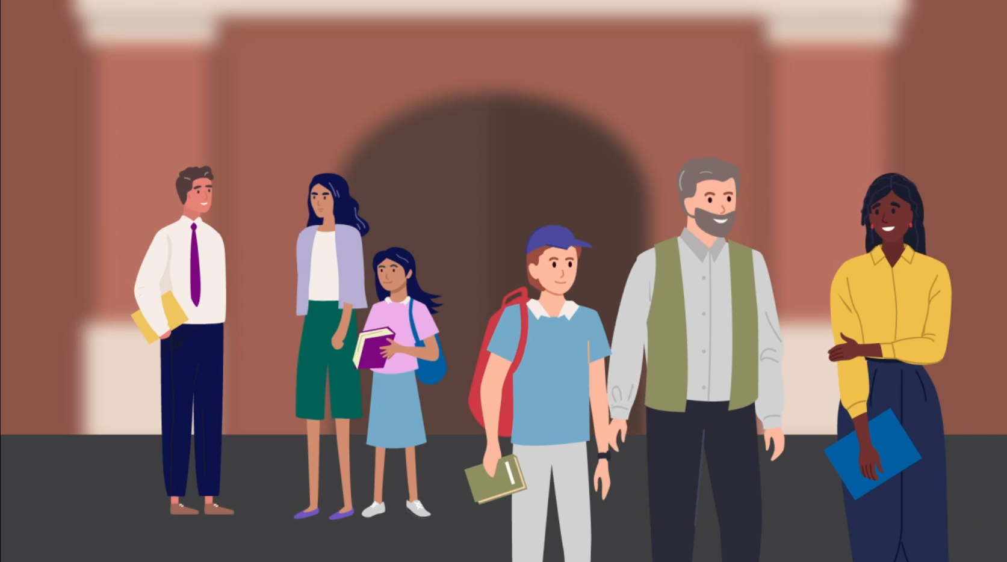

Content

Introduction
Suggested email content to members
Suggested talking points for member meetings
Suggested social media content and email banner
Safety at Work posters
Relevant resources

Introduction

Schools are positive places of learning and work where everyone has a right to a safe and healthy environment. Everyone is responsible for maintaining respectful, supportive relationships in their school community.

The Department of Education and Training has introduced the School Community Safety Order Scheme to help prohibit or limit violence, aggression or other behaviours that make staff, students or others feel unsafe in Victorian schools.
The Scheme is part of the Victorian Government’s broader strategy to manage the risks to the safety of school staff and students and the school community resulting from the behaviours of a small minority of parents and other adults who interact with schools.
You are encouraged to use communications materials contained in this toolkit to raise awareness about the new Scheme with your members and to promote positive, respectful relationships between adults in our school communities.
With your help and support, we can make sure both staff and students have a safe and healthy environment where they can thrive.

Suggested email content to members

Please consider using the content below for your members. You can customise the content as required for your style and audiences.

Schools are positive places of learning where everyone has a right to feel safe.
We all have a right to feel safe at work and protected from any aggression, violence or behaviour that make us feel unsafe. This type of behaviour can significantly affect our health, safety and wellbeing and can also impact our colleagues and wider school community.
School Community Safety Scheme
The Department of Education and Training has strengthened the legal protections available to all Victorian schools in response to unacceptable behaviour from parents, carers and other adults in the school community by introducing the School Community Safety Order Scheme.
Established under the Education and Training Reform Amendment (Protection of School Communities) Act 2021, the Scheme provides new measures and actions when inappropriate behaviour is levelled towards people in our school community.
The Scheme empowers authorised persons, including principals, to issue School Community Safety Orders to prohibit or limit unacceptable or unreasonable behaviour. These orders are a last resort option where they are the least restrictive option available to deal with the behaviour. You can watch a short video providing an overview of the Scheme here.
For more information, access the School Community Safety Order Scheme Policy and the Department’s website, which also includes information tailored to students seeking more information about the Scheme.
Respectful Behaviours within the School Community Policy
The Scheme is just one part of the Department’s initiatives to address work-related violence in schools. The Department’s Respectful Behaviours within the School Community Policy on the new Creating safer school communities page of the Department’s website communicates the shared responsibility staff, parents and other adults have in behaving respectfully.
We encourage you to familiarise yourself with the policy to understand what constitutes unacceptable or unreasonable behaviours to help us set expectations of respectful behaviour within your school community.
The Work-Related Violence in Schools Policy and Procedure is also available to provide guidance on how to:
- help establish and promote respectful and safe parent and carer behaviour
- prevent and de-escalate unacceptable behaviours
- access support and services to restore wellbeing after an incident.
- Please also insert the attached banner into your email signature to promote respectful behaviour in schools.
Reporting unacceptable behaviour
All school staff are encouraged to raise any health, safety or wellbeing concerns with their school leaders in the first instance, and also inform their elected Health and Safety Representative/s. School staff should also report any risks or incidents via eduSafe Plus so the Department can also provide appropriate supports.
The Department is there to support you in these matters to ensure your health and safety is prioritised to reduce the risk of these events occurring and to help resolve any matters before they escalate to harmful behaviours.
If you would like any more information, please reach out to me.

Suggested talking points for member meetings
Please consider using the content below as speaking notes for meetings with members of your organisation. You can customise the content as required for your style and audiences.
- We all know aggression towards staff, students or others in the school community can have a significant impact on physical and mental health, safety, and wellbeing. Aggression and violence have no place in our school community and should never be viewed as part of the job.
- This is why the Department of Education and Training has introduced the School Community Safety Order Scheme, which allows me as principal to make orders to prohibit or limit unacceptable behaviour from parents, carers and other adults who engage in harmful, threatening, or abusive behaviour.
- The Scheme is now in place for all Victorian schools and is part of a broader strategy to manage the risks to the safety of school staff, students, and the school community.
- Principals and other authorised persons in Victorian schools will be able to issue orders and set limits on how that person can behave around certain people, at certain times, at the school or other places where school activities happen. The order may also include special exceptions like times when, or areas where, it does not apply.
- Orders are issued as the very last resort where they are the least restrictive option available to deal with the behaviour.
- You can access the School Community Safety Orders Policy for more information about the Scheme.
- I urge you to continue to report on eduSafe Plus and bring to my attention any unacceptable behaviour that you experience or witness at our school.
- If you would like any more information or to discuss this further, please reach out to me.

Suggested social media content and email banner
Here are some sample email banners and social media posts that can be used across your own social channels to help promote respectful behaviours in the community.
Please tag the Department of Education and Training so we can like and share your posts.
DET LinkedIn
DET Twitter
Social media post copy:
We all deserve to feel safe in our school community. Respect staff, students and each other. Go to Creating safer school communities for more information.
Social media images
Right click and save an image to use for your social media posts.
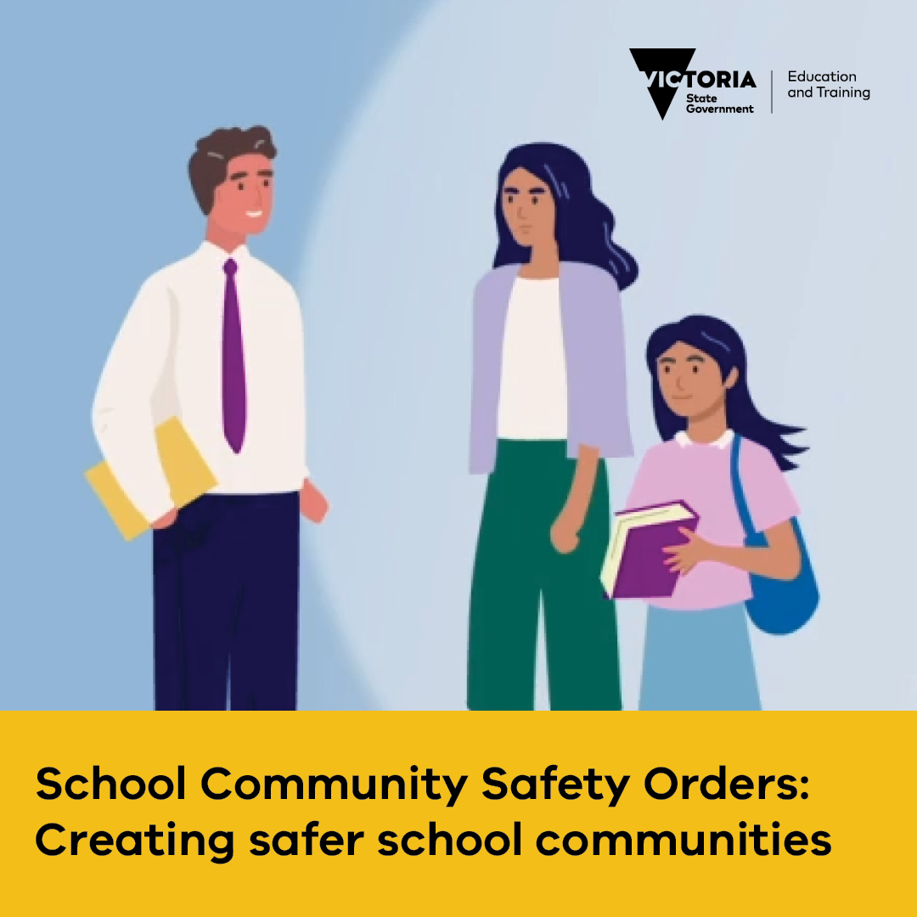
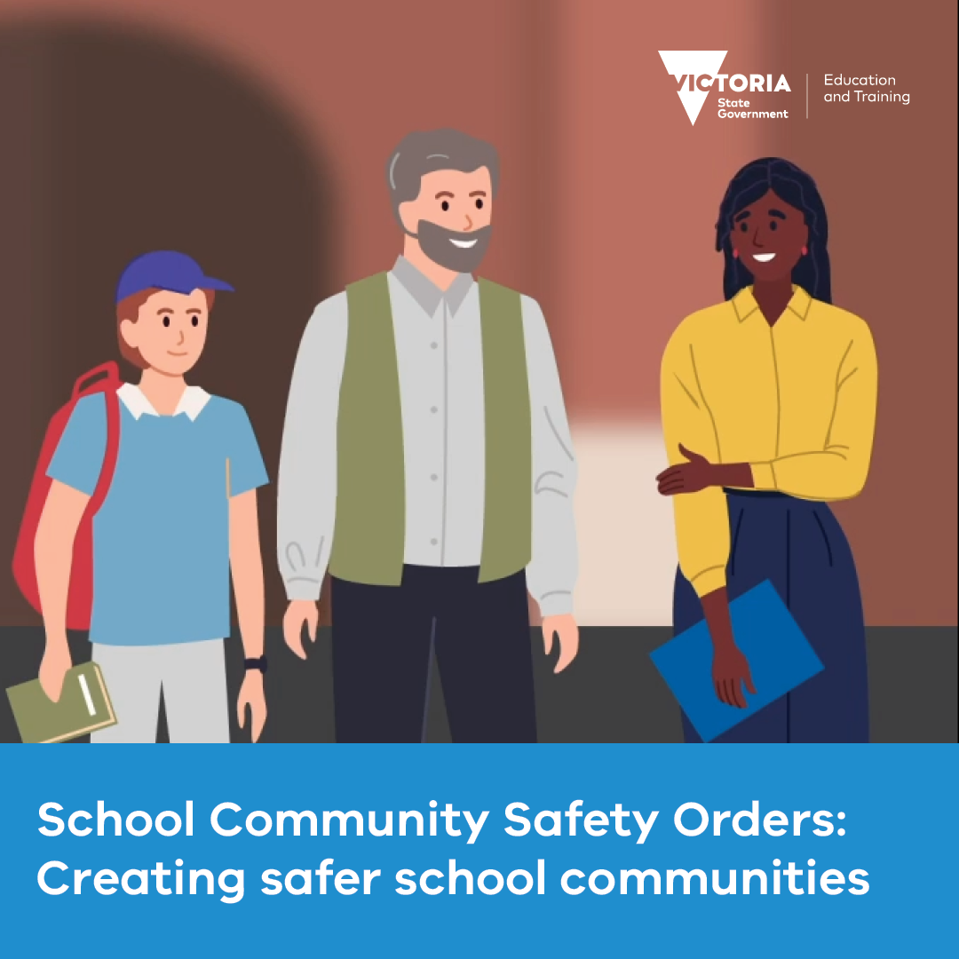

Email banners
Right click and save an image to use as an email banner. Please ensure you hyperlink your email banner to: www.vic.gov.au/creating-safer-school-communities
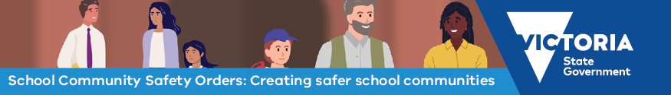
Go to Creating safer school communities for more information.
Go to Creating safer school communities for more information.

Posters

Download and print the staff facing poster for display in settings reserved for school staff.

Download and print the parent facing poster for display in settings where parents, carers and adults in the school community frequent. The poster is available in 30+ languages here under ‘Safety at Work for School Staff communications material’.

Relevant resources

Supports available to government school peak bodies
- The School Community Safety Orders Policy contains guidance for principals and DET staff who are authorised to issue orders, including templates.
- Information about the School Community Safety Order Scheme is available on the DET website, including a short video providing an overview of the Scheme.
- The Creating safer school communities page on the DET website, with a link to the Respectful Behaviours within the School Community Policy, can assist in establishing behavioural expectations for parents, carers and other adult members of the school community.
- The Ministerial Guidelines provide detailed sector-neutral information and guidance for people who are authorised to issue orders.
- The School Community Safety Order Scheme eLearn module with essential information about the Scheme, such as who an order can be issued to and how to issue an order. Completion is required for all principals and other authorised persons prior to issuing an order.
- The Work-Related Violence in Schools Policy and Procedure also provides guidance on how establishing and promoting respectful and safe parent and carer behaviour; preventing and de-escalating unacceptable behaviours; and, accessing support and services to restore wellbeing after an incident.
- eduSafe Plus reporting system for incidents and risks.

Information for parents
- Information about the School Community Safety Order Scheme is available on the DET website. This includes a short video providing an overview of the Scheme and information for parents on appeal rights, procedural fairness for parents and carers and remaining involved in your child’s education despite an Order being made.
- The Creating safer school communities page includes a link to the Respectful Behaviours within the School Community Policy, which communicates the shared responsibility staff, parents and other adults have in behaving respectfully.
- Building a positive relationship with your child's school page includes resources to support safe and respectful relationships in our school communities, including information about getting involved with the school, advice on how to raise a concern or complaint, and parenting support resources.
- Information about the School Community Safety Order Scheme is available on the DET website. A short video is available with an overview of the Scheme.

