BUILDING PROFESSIONALS FACTSHEET
QUOTING TO INSTALL FLAGPOLES AT VICTORIAN GOVERNMENT SCHOOLS

Victorian government schools may be seeking quotes from building professionals to install flagpoles at school campuses across the state.  Schools can enter into contracts with Australian registered businesses to install these flagpoles.  Please familiarise yourself with the Victorian School Building Authority’s Building Quality Standards Handbook.  Project Objectives:  To deliver a flagpole that complies with the Department’s Building Quality Standards Handbook, the Building Code of Australia (National Construction Code) and Building Regulations.  To install a flagpole that is child safe.  To create a flagpole that can withstand extreme weather conditions. | Victorian government schools may be seeking to have three flagpoles installed at each campus.  This factsheet is designed to inform and assist building professionals in the provision of quotes related to these works.  SCHOOL ACTIONS  Schools are advised to:  - engage a building professional with experience in installing flagpoles by following the Procuring Low-value Construction Works or Services policy. As the health and safety of all students and staff is the Department’s highest priority, schools are recommended (where possible) to use VBA Registered Builders to complete these works and ensure they are certified as structurally sound by a structural engineer.  - provide building professionals with the following documents so that they understand the specifications and contractual requirements of proposed works:  - this Factsheet, and  - the “Flagpoles at Victorian government Schools – Minor Works Contract template”, available at:  www.education.vic.gov.au/PAL/flagpoles-minor-works-contract-template.doc.  WHAT DOES A BUILDING PROFESSIONAL REQUIRE TO BE ABLE TO QUOTE?  To be able to quote, a building professional must:  - receive a Request for Quote from a Victorian government school,  - have a current Australian Business Number (ABN),  - have a minimum of $10 million Public Liability Insurance, and  - be able to install the flagpole by November 2023.  PERMITS AND CERTIFICATION?  - A Building Permit is not required for flagpoles under 8 metres in height. (It is recommended that flagpoles not exceed 6 metres in height, or 7.5 metres in appropriate situations.)  - No certification or sign-off is required from a building surveyor or engineer to instal a flagpole under 8 metres in height. However (and although not mandatory), the Victorian School Building Authority (VSBA) recommends that a building professional registered with the Victorian Building Authority (VBA) and a structural engineer be engaged or consulted wherever necessary.  Some preliminary considerations  - Flagpoles should be installed at the entrance to school campuses, where possible. Other locations might include areas where a school community assembles, such as quadrangles or outdoor courtyard spaces.  - Flagpoles can be:  - Free-standing with a fixed base  - Free-standing with a hinged base  - Building attached  See Attachment A (below) for sample drawings.  - In consultation with schools, building professionals should consider whether there are any known issues concerning the proposed site/ground. For example, speak to school staff and try to determine if asbestos has been found here in the past or are there existing services running under this location.  - Under Electricity Safety (General) Regulations 2019, there are minimum distances to aerial lines which need to be complied with.  - Schools should provide as much information as is known so that building professionals can proceed with due diligence, including preliminary ground investigations. Under the School Council Minor Works Contract, a building professional will assume responsibility for the remediation of any damage to services.  ENGAGEMENT OF SERVICES  - Information pertaining to the content of your quote is outlined on the next page.  - If your quote is successful and your business is engaged to supply and install a flagpole, you will need to complete the School Council Minor Works Contract for Flagpole Projects, available at www.education.vic.gov.au/PAL/flagpoles-minor-works-contract-template.doc.

WHAT NEEDS TO BE INCLUDED IN MY FLAGPOLE QUOTE?
As a guide your quote needs to align as closely as possible with the following Department of Education and Training policy/requirements:
- Building Quality Standards Handbook (https://www.education.vic.gov.au/Documents/school/principals/in frastructure/vsba-building-quality-handbook.pdf). Specifically, page 33, 3.4.1, “Flagpoles must comply with the NCC Section B1.4 Determination of structural resistance of materials and forms of construction”. (See Attachment B, below.)
- Building regulations, specifically, Building Regulations 2018 – Regulation 97
Masts Poles etc.
(1) A mast pole, ariel, antenna, chimney, flue or service pipe –
(a) When attached to a building, must not exceed a height of 3m above the highest point of the roof or building; or
(b) When not attached to a building, must not exceed 8m above the ground level.
(2) The report and consent of the relevant council must be obtained to an application for a building permit in relation to a design that does not comply with this regulation.
- National Construction Code (page 754, volume 1)
Attachments to buildings
(1) An attachment to a building that is in the nature of a balcony or awning, bridge, gangway, hoarding or trade sign, sky sign, mast, flagpole, tower, aerial or antenna, lantern, cathead, crane, chimney, flue or duct, or an installation for cleaning and maintenance must—
have all metal parts of corrosion resistant metal, or other metal suitably protected; and
(a) not overhang any street boundary at a height less than 2.5 m above the footpath, or 4 m above the roadway;
(b) and be provided with drainage to prevent rainwater or condensate falling onto or running across the footpath, unless
(c) either it is a retractable awning in the nature of a sun blind, or unless the total catchment area for run-off is less than 1.5 m2
- Aluminium poles are preferred over steel, to mitigate issues with steel erosion.
- External rope flagpoles are not allowed to mitigate safety issues.
- Flagpoles should be installed outside the entrances to school campuses where possible.
- Ideally the flagpoles will match.
The VSBA accepts that there may be challenges in complying with all requirements (particularly due to the availability of materials, COVID-19 and extreme weather events), and schools can accept quotes which relate to works and materials of a similar or higher standard instead. The VSBA’s primary concern in relation to these works is to ensure that they are structurally sound and pose no risk to student and staff safety.
Your quote (invoice) should contain the following:
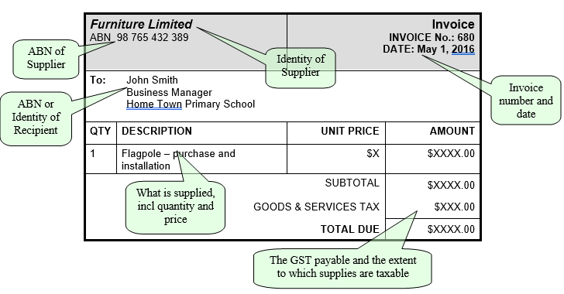
HOW WILL MY BUSINESS BE PAID?
Schools will enter into a contract and make payments with you directly.

Attachment A – Drawings
These sample drawings have been prepared as a guide to application on school sites
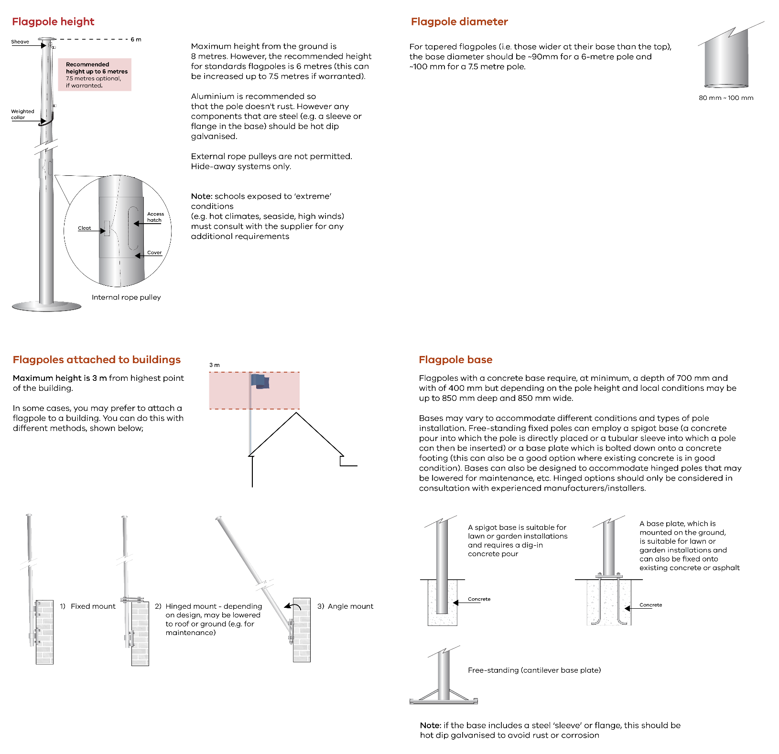

Attachment B – General Legal Matters
What requirements or restrictions are associated with the installation of flagpoles under the Building Act 1993?
How building regulation legislation applies to the installation of flagpoles:
- The Building Act 1993 (Vic), the Building Regulations 2018 (Vic.), and the Building Code of Australia (BCA – referred to, now, as the National Construction Code) (incorporated by reference into the Regulations) govern the regulation of buildings and building work in Victoria.
- A flagpole is, pursuant to the BCA, a Class 10b structure. Class 10b structures include “a fence, mast, antenna, retaining wall or free-standing wall or swimming pool or the like.”
- Regulation 97 and Schedule 3 of the Regulations includes ‘poles’ as a similar Class 10b structure.
- A “structure” is a building pursuant to section 3(1) of the Act.
Whether a building permit is required:
- Pursuant to section 16(1) of the Act, a building permit is required to carry out building work. However, by operation of section 16(6) of the Act, that section does not apply where the building work is exempted under the Act or Regulations.
- Regulation 23 provides that a building permit is not required for building work specified in column 2 of the table in Schedule 3 to the Regulations. Further, regulation 279 provides that building work specified in column 2 of the table in Schedule 3 to the Regulations is exempt from the regulations specified in column 3 of that table.
- Column 2 of item 13 of Schedule 3 specifies the following building work: Any mast, pole, antenna, aerial or similar Class 10b structure—
- attached to a building and which does not exceed a height of 3 m above the highest point of the attachment to the building; or
- not attached to a building and which does not exceed a height of 8 m above ground level.
- Column 3 of item 13 to Schedule 3 provides that the building work above is exempt from all parts of the Regulations.
- Accordingly, in respect of a proposed flagpole that is not attached to a building (eg: is fixed into the ground) and does not exceed 8 metres in height or a proposed flagpole that is affixed to a building but does not exceed a height of 3 metres above the highest point of the building:
- a building permit under section 16(1) of the Act is not required; and
- the construction or installation of the flagpole will not need to comply with the Regulations and in particular, the relevant structural requirements in the BCA (which are incorporated into the Regulations by reference by operation of regulation 10).
What standards apply to the installation work:
- As noted above, where the flagpole satisfies the requirements of paragraph 7 above, that flagpole does not need to comply with the requirements of the Regulations or the BCA.
- Where the flagpole does not satisfy the requirements of paragraph 7 above, it will require a building permit and therefore need to comply with the requirements of the BCA. In particular, because it is a structure, and a Class 10 building, we consider that it would need to meet the performance requirements for structural stability and resistance under the BCA Volume Two. Clause P2.1.1 of the BCA 2019 Volume Two (Amendment 1) provides:
P2.1.1 Structural stability and resistance
(a) A building or structure, during construction and use, with appropriate degrees of reliability, must—
(i) perform adequately under all reasonably expected design actions; and
(ii) withstand extreme or frequently repeated design actions; and
(iii) be designed to sustain local damage, with the structural system as a whole remaining stable and not being damaged to an extent disproportionate to the original local damage; and
(iv) avoid causing damage to other properties,
by resisting the actions to which it may reasonably be expected to be subjected.
- Under clause P2.2.1(b) of the BCA, there are a number of physical actions to be considered in respect to structural stability and resistance, including permanent actions (dead loads), wind action, earthquake action, rainwater action, earth pressure action and ground movement. Complex verification methods apply.
- Deemed to Satisfy (DtS) provisions of the BCA can be met via two pathways: ‘acceptable construction practices’ and ‘acceptable construction manuals’. Where compliance is not sought through the DtS provisions, a performance solution must be used, or a combination of performance solution and DtS methodology.
- Under Part 3.0 of the BCA, there are acceptable construction practices for complying with performance requirement P2.1.1. Depending on the design action, referenced documents and other considerations in Part 3.0 of the BCA will apply. While manufacturers of flagpoles may provide specifications which are intended to comply with the BCA and referenced documents like Australian Standards, they are unlikely to be able to meet the DtS requirements in every circumstance and may be of limited utility.
- The Department of Education and Training (DET) or the VSBA may choose to engage an endorsed building engineer to prepare a design for flagpoles of certain heights at government schools. A design could be prepared whether a flagpole exceeds 8 m or not, and can incorporate a design which will comply with the structural performance requirements of the BCA notwithstanding that the BCA may not apply. The engineer’s design can consider a flagpole manufacturer’s specifications and any installation recommendations as part of that design.
- Work health and safety requirements will also apply, as will rules and regulations in respect to underground assets and overhead powerlines. See below for further details.
Whether a report and consent is required:
- Regulation 97 provides:
97 – Masts, poles etc.
(1) A mast, pole, aerial, antenna, chimney, flue or service pipe—
(a) when attached to a building, must not exceed a height of 3 m above the highest point of the roof of the building; or
(b) when not attached to a building, must not exceed 8 m above the ground level.
(2) The report and consent of the relevant council must be obtained to an application for a building permit in relation to a design that does not comply with this regulation.
- Accordingly, where the flagpole does not satisfy the requirements of paragraph 7 above and a building permit is required, report and consent in accordance with clause 97 must also be obtained.
- Note however, paragraph 36 of this advice and the application of the Regulations where a planning permit is required.
Is the installation of a flagpole commercial or domestic building work, and can a domestic builder carry out the work at a government school?
Whether the work is commercial or domestic:
- Under the Act, ‘domestic building work’ has the same meaning as it has in the Domestic Building Contracts Act 1995 (Vic.) (DBCA). Section 5 of the DBCA defines ‘domestic building work’ as work on or associated with a home. Accordingly, we consider that the building work will be non-domestic building work (i.e. commercial building work) because it cannot be described as ‘domestic building work’ under the DBCA.
Whether a domestic builder can carry out the work at a government school:
- If no building permit is required for the installation of the flagpole, then there is no limitation in the Act on who may carry out that installation work. This means that the work can be carried out by a builder who carries out only domestic building work or by someone who is not registered as a building practitioner at all.
- Where a building permit is required, section 24B of the Act specifies who can carry out the building work, as follows:
22.1 if the cost of the building work will not exceed $10,000 (including materials and labour), the builder for the installation of the flagpole can be:
22.1.1 a building practitioner (whether registered or not);
22.1.2 the owner of the building or land on which the installation is to be carried out;
22.1.3 a registered architect; or
22.1.4 an endorsed building engineer.
22.2 If the cost of the building work will exceed $10,000 (including materials and labour), the builder for the installation of the flagpole must be:
22.2.1 a registered building practitioner (other than a provisionally registered builder subcontractor or a registered builder subcontractor);
22.2.2 the owner of the building or land in or on which the building work is to be carried out;
22.2.3 a registered architect; or
22.2.4 an endorsed building engineer.
- Accordingly, where a building permit is required, the work must be carried out by a person falling within the specified categories, which vary, depending on whether the cost of the work exceeds $10,000. If a building practitioner is used, that practitioner does not need to be a registered commercial builder and in fact, need not be registered at all if the cost of the work is less than $10,000.
- Notwithstanding that the building work will be commercial in nature, the BCA that will apply will be BCA Volume Two. This version of the BCA is generally associated with domestic building work. However, it will apply to Class 10 buildings regardless whether they’re built in conjunction with a domestic building. It is notable that the BCA does not provide comprehensive requirements for the installation of Class 10b structures.
- Further to this, there is a specific class of domestic building practitioner limited to the erection of poles, masts and antennas. There is no corresponding class of commercial builder.
- Accordingly, we consider that a domestic builder, commercial builder, registered architect or endorsed building engineer could carry out the work where a building permit is required and the building work will exceed $10,000.
If a building permit is required, are there any Australian Standards and minimum requirements in terms of materials, depth and height restrictions?
- There are no specific Australian Standards that apply to the installation or construction of a flagpole. What is required is that the flagpole complies with the structural requirements described in paragraphs 11 to 14 above. Depending on whether a DtS method or performance solution method is used, there may be Australian Standards which are applicable to the flagpoles construction to meet the structural performance requirements. Accordingly, the materials, depths and methods for anchoring the flagpole will vary. Although it is not a mandatory requirement, an endorsed building engineer can determine these elements and factors to achieve compliance with the BCA.
- In respect to height restrictions, the Regulations specify that the report and consent of the local council will need to be obtained for a flagpole that exceeds 8 m in height. In addition, the flagpole will not be permitted to be erected or constructed over an easement without the report and consent of the relevant authority, or within certain minimum distances of an overhead powerline.
Are there any restrictions regarding location to power poles, etc?
- The person carrying out the design or installation of the flagpole will need to ensure the structure will comply with the performance requirements in the BCA.
- There are numerous flagpole designs with varying diameters, heights and materials. The base of the flagpole may also vary, as will the depths of footings. In some cases, the design and construction of the flagpole will be contingent on the size and weight of the flags. The relevant manufacturer or an engineer will be able to specify the appropriate design and installation appropriate for a school’s needs.
- The builder or person carrying out the installation must also comply with workplace health and safety requirements, including adhering to ‘No Go Zone’ rules when working near overhead power lines, and utilising the ‘Before You Dig Australia’ service. These obligations apply irrespective of whether a building permit is required.
- Specific for construction near distribution or transmission overhead powerlines, ‘No Go Zones’ of between 3 metres and 10 metres apply, depending on the powerline.
- The installation of flagpoles must comply with rules regarding construction near power lines, and where excavation for footings is required, will need to ensure underground assets are not disturbed.
- The report and consent of the relevant authority (which may be a water corporation or council) in respect of a drainage easement is required under regulation 130 of the Regulations. Section 148 of the Water Act 1989 (Vic.) may also apply to restrict the installation of a flagpole if there is an easement vested in Melbourne Water Corporation or another water supply authority.
- Pursuant to regulation 610 of the Electricity Safety (General) Regulations 2019 (Vic.), there are also mandatory minimum distances from parts of buildings or structures to protected aerial lines. The distances for a structure not normally accessible to a person range from 0.6 metres to 5.0 metres depending on the voltage of the aerial line. These distances may not consider sag and sway of the aerial lines, and it is recommended that when proposing to erect a structure near power lines, the electricity distributor should be contacted.
- Depending on the location of the school, the planning scheme applicable to that municipality may also restrict the design or construction of a flagpole. For example, under the Melbourne Planning Scheme, a planning permit is not required for a flagpole, but other planning schemes may have differing requirements. Where a relevant planning scheme applies to the regulation of flagpoles, and a planning permit is required, regulation 97 of the Regulations will not apply. Where a planning scheme does not apply, the Regulations will still apply including the requirement that report and consent of council is obtained where the flagpole will exceed 8 metre in height.
What does the National Construction Code (NCC) have to add?
B1.4 Determination of structural resistance of materials and forms of construction:

The structural resistance of materials and forms of construction must be determined in accordance with the following, as appropriate:
- Masonry (including masonry-veneer, unreinforced masonry and reinforced masonry): AS 3700, except—
- '(for piers—isolated or engaged)' is removed from Clause 8.5.1(d); and
- where Clause 8.5.1 requires design as for unreinforced masonry in accordance with Section 7, the member must also be designed as unreinforced masonry in accordance with Tables 10.3 and 4.1(a)(i)(C) of AS 3700.
- Concrete:
- Concrete construction (including reinforced and prestressed concrete): AS 3600.
- Autoclaved aerated concrete: AS 5146.1.
- Post-installed and cast-in fastenings: AS 5216.
- Steel construction:
- Steel structures: AS 4100.
- Cold-formed steel structures: AS/NZS 4600.
- Residential and low-rise steel framing: NASH Standard – Residential and Low-Rise Steel Framing Part 1 or Part 2.
- Composite steel and concrete: AS/NZS 2327.
- Aluminium construction: AS/NZS 1664.1 or AS/NZS 1664.2.
- Timber construction:
- Design of timber structures: AS 1720.1.
- * * * * *
- Timber structures: AS 1684.2, AS 1684.3 or AS 1684.4.
- Nailplated timber roof trusses: AS 1720.5.

