Framework for Improving Student Outcomes 2.0

October 2021

FRAMEWORK FOR IMPROVING STUDENT OUTCOMES (FISO 2.0)
The FISO 2.0 sets out five core elements that together realise the goals of excellence and equity through developing the learning and wellbeing of every student.
When integrated, these elements build a positive environment through strong relationships that enables all students to become happy, healthy, and resilient; successful lifelong learners; and active, informed members of just and sustainable communities.

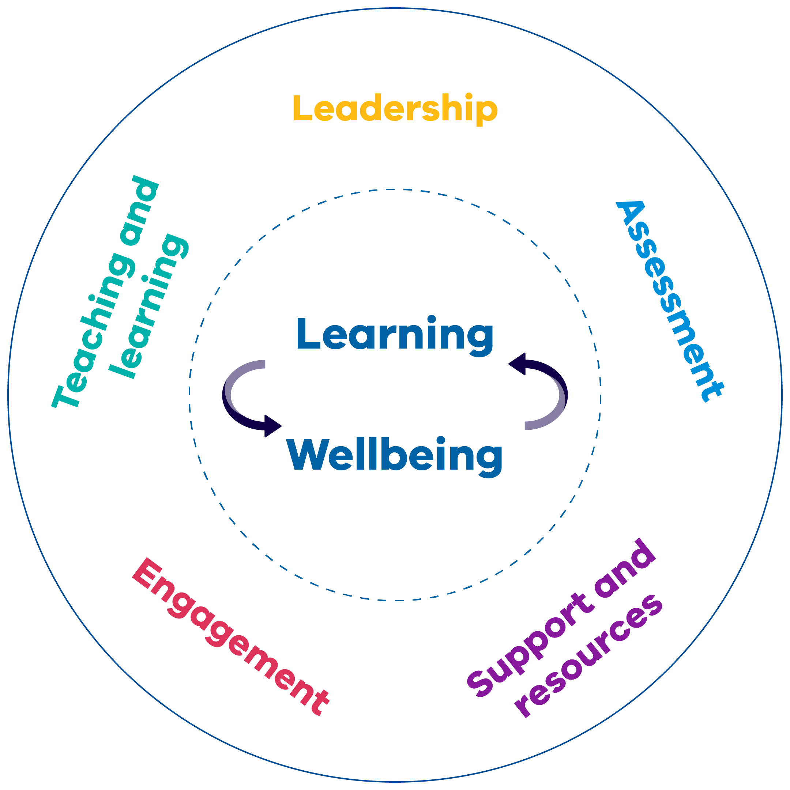

OUTCOMES
Learning is the ongoing acquisition by students of knowledge, skills and capabilities, including those defined by the Victorian Curriculum and senior secondary pathways.
Wellbeing is the development of the capabilities necessary to thrive, contribute and respond positively to the challenges and opportunities of life.

CORE ELEMENTS
Outlined below are the descriptors for each of the five core elements. Each element is made up of two dimensions which are available under the guidance tab.

Leadership | is the development of shared processes and actions by staff and students that build a positive school climate for learning and wellbeing through practices and relationships based on high expectations, shared values and a culture of trust.
Teaching and Learning | refers to responsive practices and curriculum programs through which students develop their knowledge, skills and capabilities
Assessment | is the use of evidence and data by school leaders and teachers to assess student learning growth, attainment and wellbeing capabilities and to design and implement priorities for improvement.
Engagement | refers to the relationships and actions that support student learning, participation and sense of belonging to their school community
Support and resources | refers to the processes, products, services and partnerships that enable every student to strengthen their wellbeing capabilities and achieve the highest levels of learning growth

DIMENSIONS
The dimensions are structured around the core elements and indicate priority areas of practice that improve students’ learning and wellbeing.
Leadership | The strategic direction and deployment of resources to create and reflect shared goals and values; high expectations; and a positive, safe and orderly learning environment
 | Shared development of a culture of respect and collaboration with positive and supportive relationships between students and staff at the core
Teaching and Learning | Documented teaching and learning program based on the Victorian Curriculum and senior secondary pathways, incorporating extra-curricula programs
 | Use of common and subject-specific high impact teaching and learning strategies as part of a shared and responsive teaching and learning model implemented through positive and supportive student-staff relationships
Assessment | Systematic use of assessment strategies and measurement practices to obtain and provide feedback on student learning growth, attainment and wellbeing capabilities
 | Systematic use of data and evidence to drive the prioritisation, development, and implementation of actions in schools and classrooms
Engagement | Activation of student voice and agency, including in leadership and learning, to strengthen students’ participation and engagement in school
 | Strong relationships and active partnerships between schools and families/carers, communities, and organisations to strengthen students’ participation and engagement in school
Support and resources | Responsive, tiered and contextualised approaches and strong relationships to support student learning, wellbeing and inclusion
 | Effective use of resources and active partnerships with families/carers, specialist providers and community organisations to provide responsive support to students

