Inclusive Student Voice Toolkit

Acknowledgements
The Department of Education and Training (the department) acknowledges and pays respects to Elders and all Victorian Aboriginal communities. We honour and respect Traditional Owners, past and present, and value the rich culture and history of the First Peoples of this land.

This toolkit has been adapted with permission from Jenkin, E., Wilson, E., Murfitt, K., Clarke, M., Campain, R. and Stockman, L. (2015) Inclusive Practice for Research with Students with Disability: A Guide. The authors would like to acknowledge previous contributions from children with disability and their families along with dedicated staff in Vanuatu and Papua New Guinea. This guide was funded by the Department of Foreign Affairs and Trade and developed in partnership with Save the Children (Vanuatu and Papua New Guinea), Vanuatu Disability Promotion and Advocacy Association (VDPA) and the former Papua New Guinea Assembly of Disabled Persons.
This toolkit was developed collaboratively between the department and Deakin University.
Jenkin, E., Cross, J., Germaine, D., Wilson, E,. Murfitt, K., Campain, R., (2021). Inclusive Student Voice Tool Kit., Department of Education and Training, Victoria.

We thank Youth Disability Advocacy Service (YDAS) for input and contributions to the development of the toolkit. YDAS has contributed significantly to the practice guidance and some practice examples in this toolkit are sourced from YDAS workshop participants, who are disabled young people.

Feedback
The department welcomes questions, comments and feedback on the Inclusive Student Voice Toolkit. Your engagement and contribution will contribute to its ongoing development and improvement.
To contact the department about the toolkit email: disability.inclusion@education.vic.gov.au

Contents
Acknowledgements 2
Inclusive Student Voice Toolkit 4
Summary of the inclusive student voice tools 4
Functional needs and potential adjustments 9
Questions to explore with students 11
Communicating with students 13
Getting to know the student 15
Photo library 17
Story in a bag 21
Sound library 24
Character 28
Drawing 32
Camera 34
Guided tour 37
Story telling 39
Feeling okay 41
Professional reading and resources 43

Inclusive Student Voice Toolkit
The toolkit has been developed to support the implementation of Disability Inclusion and to complement Amplify. The toolkit provides accessible and multi-modal tools to support the voice, agency and leadership of students with disability. It is developed primarily for use by school staff and regional staff in preparation for the Disability Inclusion Profile. The toolkit can also be used by parents and to support any purpose related to inclusive student voice, agency and leadership. Some tools are tactile, others are sound or picture-based and students can choose tools that suit their interests.
The tools are designed to suit a range of accessibility needs and are non-literacy based. The tools are flexible and designed to be adapted to suit each student’s age, interests, disability, communication modality and participation needs. Each tool has a description and some basic tips about how it could be used.

Summary of the inclusive student voice tools
This table provides an overview and description of the tools in this kit. Use the links to jump to the relevant section of this document.
The tools facilitate and support the views of students with disability. Tools are a means to generate communication and conversation in a more playful, accessible and supported way. The focus is on what is communicated both through using the tools and through the conversation that occurs around this activity. The tools are based on extensive research and practical use in various contexts.
The practice considerations describe the student characteristics and functional needs that each tool is intended to best support. Before assuming which tools will be accessible for specific students, it is important to ask students for their input on which tools are appropriate to meet their needs.

Tool | Summary | Practice considerations
Photo library | Students select photos from an existing or custom-made photo library. The photos act as a prompt to conversation and to help identify their strengths, needs and interests. | Especially useful for students who have an intellectual disability, are Deaf or hard of hearing, and very young students.  May suit some students with low vision.  × Not suitable for students who are blind.
Story in a bag | Students pick a selection of familiar, everyday objects such as stationery, lunch boxes and sport equipment from a bag and identify them. Like the photo library, items are tactile prompts for conversation. | Originally designed for students who are blind or have low vision, but is enjoyed by students with other disabilities too.  × May not suit students with tactile sensitivities.
Sound library | Students listen to a library of sounds and identify the sounds. Like the photo library and story in a bag, the sounds are used as prompts for conversation. | Originally designed for students who are blind or low vision but is enjoyed by students with other disabilities too.  × Not suitable for students who are Deaf.  May suit some students who are hard of hearing.
Character | An animal, soft toy or doll is used for young or shy students to refer to rather than themselves. For example, ‘imagine this kangaroo is you, what do you think the kangaroo likes about being here at school?’  Older students may like to create an avatar for themselves and refer to the avatar about likes and dislikes. | Suits students who are shy or quiet. Students may have a favourite toy that they would like to use.  The avatar would suit students that enjoy using technology.  Can be adapted to suit the student’s age.
Drawing | Students are encouraged to draw or paint as a method to express voice either through the artwork or as part of the conversation that occurs alongside the activity. Students can draw or paint on paper, a mask, or draw in the sand or dirt using their finger or a stick. | May suit students who are familiar with drawing and enjoy the activity.  × Not suitable for students who are blind.  May suit some students with low vision.  × May not suit students with tactile sensitivities.
Camera | Students take photos in their school surroundings of their likes/interests and dislikes or objects/places they wish to discuss further. Photos may be printed out and students may choose to write about them, they can also share the photos on their own device.  Work within your school’s photo policy.  Encourage the student to use technology that suits them to take the photos. | Suits students who like to be on the move.  × Not suitable for students who are blind.  May suit some students with low vision.  Some students may require assistance to take photos of their choice.
Guided tour | Students walk or mobilise with their support person and describe places that they enjoy being in, are important to them or feel safe in. Encourage students to discuss their reasons for identifying these places. | Suits students who like to be on the move.  Some students may require assistance with mobility.
Story telling | Stories and discussion are used to help the student communicate their ideas. This tool is especially effective when there is a rapport between students and staff. | Suits students who are articulate in speech or Auslan.  Suits students from cultures where story telling is a culturally safe and familiar activity.
Feeling okay | Ideas to help the student to feel okay after students share something that upsets or worries them. | Can be pictorial or word based depending on what suits the student.
Purpose of the toolkit
Amplify provides a suite of resources to support student voice, agency and leadership for all students, including students with disability. The Inclusive Student Voice toolkit has been developed to cater specifically for students who may be non-speaking or have lower levels of literacy. The multi-modal tools are also suitable for any student who prefers visual, audio, tactile, place or character-based prompts. This toolkit expands on the existing Disability Inclusion Student Voice Tool that is literacy-based and verbally oriented. The intention is to provide a range of flexible options that students can choose, and that can be tailored to meet individual needs.
The toolkit has been designed to support student voice in the Disability Inclusion Profile. The toolkit may also be used more broadly for any purpose related to student voice, agency, leadership and inclusion, for example:
- The toolkit can be used to identify student strengths and goals as part of developing Individual Education Plans (IEPs).
- The toolkit can support implementation of FISO 2.0 by building student engagement. The toolkit can support students to undertake curriculum planning.

Student voice and the Disability Inclusion Profile
The Disability Inclusion Profile is a new strengths-based process to help schools and families identify each student’s strengths, interests, needs, and the adjustments that will help support their learning. Student voice is central to the Disability Inclusion Profile.
The toolkit is designed to support the process of eliciting student voice, strengths, interests, needs and goals prior to and/or during the profile meeting. The student and key people who understand the student’s education and support needs will complete the profile together: family and caregivers, school staff and others, as appropriate. Detailed information about the Disability Inclusion Profile is available at the Policy and Advisory Library.
The Disability Inclusion Profile records the student voice input, including whether a student attends the profile meeting, or provides documentation or materials beforehand. Where no student voice input is provided, the profile facilitator will consider whether this may indicate that the student requires additional support with communication or if the student is choosing not to provide information.

Supporting student voice
Many students can use these tools independently and in a self-directed manner. For students that may need support, the toolkit includes guidance for a support person or people to help students express their voice. This could be a teacher, inclusion coordinator, educational support staff member, allied health practitioner or other staff member. Students may have a preference about the staff member/s they want to work with, and that should be respected for the best chance of engagement in the process. Throughout the toolkit, the support person or people are referred to as ‘staff’.
Generally, students will know the support person who helps them use these tools. For situations where the student and staff member don’t know each other, it is important to take time to establish rapport. Staff need to adapt to the diversity of students such as their age, language, personality, gender, cultural context and individual interests. The level of participation will vary according to a student’s age, interests, personality, comfort, setting, functional needs and rapport with the staff.
While the toolkit describes how the tools can be used in a school setting, the tools can also be used at home or in the student’s community, with parents, guardians and caregivers according to the student and family’s preferences. Some tools include a description and guidance about use at home or in the community.

Student participation in the Disability Inclusion Profile is voluntary
Students need to be informed about the Disability Inclusion Profile and their choice to participate or not. Students will be encouraged to express their feelings, interests and priorities. Students may need reassurance that this process is not school-work and will not be assessed. Students can choose how much they would like to participate and what information they would like to share.
When given adequate time and when information is provided in an accessible format, it is expected that most students will be able to understand the Disability Inclusion Profile process and make informed decisions. Information about the Disability Inclusion Profile should be provided in different formats, dependent on student need, and the tools in this kit can be helpful for communicating about the profile itself. For example, staff may include Easy English, pictures and symbols, Auslan, use of a soft toy or doll that students can communicate with, stickers indicating thumbs up and down, pictures of facial expressions, cameras, and drawing. Observing students’ facial expressions and body language can be valuable for staff to ascertain assent or dissent. An Easy English explanation of Disability Inclusion is available here.
In many situations, the staff member supporting the student to use the tools will have a role in listening to the student’s expression and documenting or relaying the student’s input. Students should have the opportunity to review and confirm their input before it is provided to the Disability Inclusion Profile process.

Functional needs and potential adjustments
In addition to different tools suiting different needs, the table below describes potential adjustments and strategies for engaging with students. Prior to engaging with students in the activities listed in the toolkit, this table will help you to consider the supports and adjustments that students may need and put these in place as much as possible.
Area of functional need | Examples of adjustments and strategies
Vision | - Offer tactile, electronic, and/or aural prompts, such as the opportunity to hear questions, use a screen-reader with a computer, or to feel objects associated with question and/or the answer.  - Use large font and high contrast in text and pictures.  - Offer a Braille translation of questions if student uses Braille, and opportunity to respond in Braille, or electronic version.  - Offer opportunity to audio tape answers to questions and listen back over their answer to check this.
Hearing | - Use visual prompts (Auslan, text, pictures, symbols).  - May require interpreter for communication.  - Use text (written instructions and questions) rather than verbal instructions.  - Use captioning or relevant text system if student uses such systems (note text may need to be broken up into smaller sections).
Intellectual | - Use simple language with concrete supports, such as visuals or audio support (for example, use photos, images or key word sign/Makaton to supplement text or verbal instructions, visual cue cards etc.).  - Carefully construct the question format to make simple and concrete/specific.  - Ask about one element / topic at a time.  - Provide time to answer, and/or repeat the question.  - Use simple answer choices (e.g. a 2 point scale or two options such as ‘like’ or ‘don’t like’).  - Design a method for the preferred communication mode of the student – recognise the use of facial expressions, gesture and behaviours.  - Prepare a range of methods to support the diverse needs of people with intellectual disability.  - Recognise and facilitate the role of communication partners (i.e. someone who knows the student and how they communicate) to assist the student to understand the questions and communicate or translate/interpret their answers.
Communication | - Identify the preferred communication mode of the student and design the process around this.  - Provide time to answer questions (as different communication modes can take extra time).  - Use communication supports (including augmentative communication supports), which may also require alternative seating or lighting to assist use of this mode.  - Provide various communication modes, such as written and video recorded answers. Voice to text or text to voice technology may be useful for some students.  - Let non-speaking students know that they can use their existing communication books, cards or other preferred methods.  - Recognise and facilitate the role of communication partners (i.e. someone who knows the student and how they communicate) to assist the student to communicate or translate/interpret their communication.  - Customise your communication to incorporate facial expressions, gestures, signs, symbols, personalised vocabulary used by the student. Let the student know that you will use their preferred gestures, symbols and vocabulary.
Physical / Mobility | - Meet in a venue within the school grounds that is easily accessible to the student. Ask the student where the best location would be and follow their guidance.  - Support the student to use the assistive technology that they prefer. Provide alternatives to writing/drawing (requiring hand dexterity) if needed.  - Be prepared to accommodate the seating/lying position of the student by moving materials into the viewing range of the student.  - Provide a scribe to write down answers if the student requires, or an opportunity to audio or video record answers.  - Break up the activities over shorter periods of time if the student experiences fatigue or pain.
Psychosocial / diverse learners | - Plan ahead and talk through the process ahead of time, so that students know what to expect.  - Let the student know that they can choose which tools they prefer, that they can stop at any point, or choose to do something different.  - Have a support person available to provide support should the student become withdrawn, anxious or distressed.  - Listen with empathy and validate emotional responses.  - Strategies from other categories may be useful.

Questions to explore with students
The Inclusive Student Voice toolkit provides multi-modal ways to explore the student’s likes, interests, strengths, goals, needs and learning. The questions below expand on the existing Student Voice Tool and can be asked through the tools to prepare for a profile meeting.
This list of questions is a guide. Staff can use these tools to explore other questions and issues of interest with students. If a student doesn’t engage with some questions, consider offering alternative phrasings. Staff can also ask students, ‘Is there anything I haven’t asked that you’d like to cover?’ or ‘What would you like me to ask you about?’
Area | Questions | Examples
Abilities and strengths | What are some of the things you can do?  What are you proud of doing?  What are you good at? | Write my name, say hello.  Swim, write good history essays, ride a bike, be a good friend.
Likes and interests | What do you like to do?  What’s your favourite food? Favourite game? Favourite toy / TV show? Favourite subject at school?  What’s fun to do?  Where is your favourite place? | I like the Wiggles, I like pizza, I like Minecraft.  I like being outside. I like the beach.  I like playing with my dog.
Goals and hopes | What would you like to do in the future?  What’s something you’d like to improve at?  What would you like to do more of?  What would you like to learn more about? | Make new friends, take the train on my own, finish VCAL.
Supports and adjustments | What helps you do tasks?  What helps you communicate?  What helps you take care of yourself?  What helps you to get on with other people?  What helps you to move around?  What helps you use your hands?  What helps you play games, sports or do fun things? | I use my Auslan Interpreter, my Pragmatic Organisation Dynamic Display (PODD) or other assistive technology.  I need to hold my fidget/bear/other special item to feel calm.  I need a special knife to help me cut food when I’m cooking.
Learning | What helps you learn and use your learning?  What else could your school do to help you learn?  What do you want your teachers to know about how you learn? | I need a quiet environment.  I need a place to rest when I am feeling very tired.  Sometimes asking for help is hard.  I need my teachers to recognise that school tasks should be adapted to be available in my preferred format.
Characteristics | What describes you as a person? What are you like?  What do you want your teachers to know about you? | I am organised, I am a chatterbox, I am funny.  Disabled young people’s experiences of disability are not always constant. My capacity and needs can change day to day.

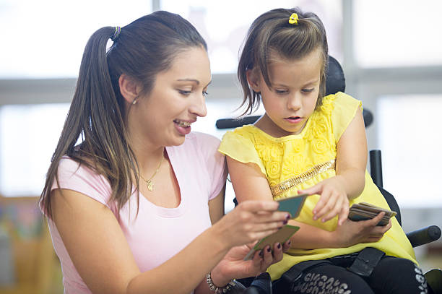
Communicating with students
Communication picture cards

Summary
This section includes some communication tips for working with students with disability. The core of any engagement with students is building trust and good communication between the student and staff member. This section may be most useful for staff that haven’t worked with students with disability before.
1 Communication picture cards can be hel 1

Process
Here are some points to consider when communicating with students with disability:
- Think about the student’s age, level of understanding and communication method, but try not to make any assumptions about their needs.
- Be a good listener. This involves being observant, supportive and understanding. Make sure your body language and responses communicate to the student that you are interested and engaged.
- Lots of communication can happen without talking. Think about the student and your:
- tone of voice
- facial expression
- jokes and laughter
- eye contact
- gesture and other non-verbal communication
- seating position.
At the same time, it’s important to recognise that for some students, communication that occurs through body language can be very hard to participate in.
- When you talk together, remember to:
- ask open questions (however sometimes closed questions may be helpful for some students)
- ask one question at a time
- use simple language until you determine what language level is appropriate for the student, and be mindful of not patronising the student
- check the student understands you and that you understand the message the student is conveying.
- communicate in the student’s first language, and use interpreters if needed
- stay calm, slow down and take the time to listen
- don’t feel the need to fill the gaps in conversation, let the student lead
- look at the student rather than their interpreter or communication aid
- think about your own body language and tone of voice
- observe what is happening around you. Is there a lot of noise creating a distracting environment? Are there too many people in the room for the student to comfortably communicate? Ask the student if any of that needs to changes.
Practice examples
Aime is a 12-year-old non-speaker with a physical disability. She communicates using her body. She smiles and giggles when she is happy. She cries out when she is unhappy, or uncomfortable. Aime is not comfortable making eye contact so we were careful to avoid looking directly at her. Spending time with Aime helped us to understand how she communicates and for us to feel comfortable together.
Tom is 13 years old and has a physical disability as well as limited verbal communication. The staff member asked Tom what his hopes and dreams are. Tom gave the sound and action of a car. When we asked why, he gave the action of driving a vehicle. Time spent with Tom and speaking with him made us aware of his communication style in expressing his thoughts and feelings, helping us understand how he indicates happiness and approval, sadness, upset and disapproval. His happiness around cars demonstrated that cars are very important to Tom.

Getting to know the student

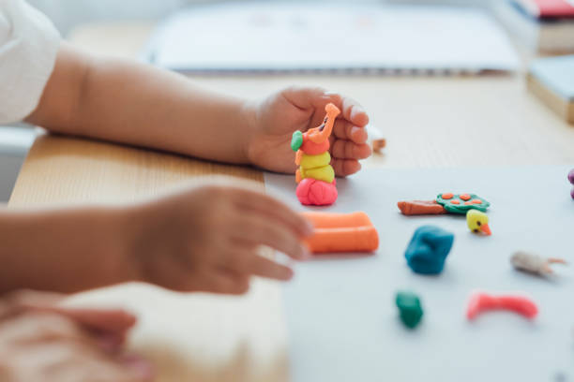
Summary
Modelling clay can be used
Intended as a fun activity, this is a way of spending time with the student to help them feel more comfortable with the staff member. The staff member can also learn more about the student, their life and their preferred communication. This may help staff to suggest the best tool or tools to use (photo library, story in a bag etc.), or make the student feel more comfortable to express what tools they want to use. This activity is helpful for when staff members and students have not previously worked together.

Activity suggestions
- The student makes something that identifies something about them such as a craft activity or a picture book that they can keep. Staff can refer to the item in future to start conversations with the student.
Different activities may include:
- air dried clay, playdough, polymer to make a sculpture, or paint a mask that identifies them.
- paint or draw a picture. This can be on paper, or in sand using a stick.
- make a story book about themselves - “My name is…I am x years old, I live with…I like…, I don’t like…” This may include a photo of the student.
- read, sing, make music together.
- play the student's favourite game.
- play with a favourite toy or a toy from the student's classroom
- use or play with an everyday item that may be found in nature.
- play a computer game together or watch a topic of interest on the internet.
You can ask the student what activity they would like to with you. Additionally, the inclusive student voice tools below can also be used as ‘getting to know you’ activities.

Preparation and activity
- Prepare materials such as:
- paints
- crayons, markers, pencils
- paper, cardboard,
- mask, air-dried clay or polymer
- technology that takes photos
- toys (age appropriate)
- everyday items and craft supplies.
- Explain your ideas to the student about what you might do together. Think about adapting the options and activities to suit the student's strengths and communication style.
Practice examples
Varun is 16 years old, is Deaf and has a physical disability. When asked questions about what Varun was interested in, he talked a lot about computer games. In a meeting, Varun brought his tablet and played his favourite game with the staff member. This helped them to get to know each other and build a relationship, and gave Varun the opportunity to share something he liked and was good at with the staff member.

Inclusive Student Voice Tools

Photo library

Summary
In this process, the student selects photos from a library or collection of photos to help explore their interests, likes, goals, strengths and learning at school. The photo library is a set of photos that can be compiled from photos taken around the student’s school or community, purchased sets of photo cards, creative commons or public domain images sourced online, newspaper or magazine clippings, or stock images.
Also known as the picture library, this tool was originally designed for people wi th intellectual disabilities and has proven to be helpful for a range of functional needs. It is a useful tool to prompt students about aspects of their lives, including those that they have not yet experienced (or may desire to experience) or may have difficulty articulating.
The photos are a prompt to help the student explore ideas and express themselves. There is no one right way to do this process, you can be creative. Choosing the photos can lead to other activities that might be useful such as:
- Taking or sourcing additional photos of things the student wants to include.
- The student drawing or writing about the photos.

How to make a photo library
- Think about all the areas of a student's life that may be relevant to explore, including items or activities around the school. The photo library may reflect health, housing, play, social life (friends), family life, food and drink, education, safety, transport, holidays, work, communicating, culture, spiritual life, money, animals, future aspirations, etc.
- Photos can be taken around the school grounds to capture images that relate to learning, play and day to day life. Images should relate to the student’s interests, likes and goals, considering a broad range of answers and areas of the student’s life.
- Students may be engaged here to take photos of their world. Students may also want to engage in sourcing images online, for example through google images, online image sharing platforms, or from magazine clippings. Students may want to add to an existing photo library or make their own.
- Photos can be viewed together on a screen, printed, or a combination. Ask students if they would prefer to have the photos digital or physical. For example, students could first choose the photos they’d like to work with on a screen, then print a selection.

Taking photos in school settings
All photos need to align with the Department’s Photographing, Filming and Recording Students policy requirements and your school’s policy. Where a student wants to include an identifiable photo of another student, for example to represent friendships, if necessary, alternatives could include using stock photos or photos of non-identifiable objects such as school bags or playgrounds. It is important to explain to the student why you might not include photos that are identifiable.

Process
Here is a process for how a photo library could help prepare for a Disability Inclusion Profile:
- Hold a session with the student where you explain that you are going to ask some questions and that the student might like to use the photos to help them answer.
- Ask the student about their interests, likes, goals and learning at school.
- The student can answer in any way they want, including telling you the answer. Offer the photos as an option to help them answer. Explain that the student might want to choose some photos that are relevant to them.
- Ask the student to lay out the photos in front of them slowly. Offer to lay them out yourself if they would prefer that. The student may want to touch, hold and look at printed photos.
- Give the student time to look carefully at each photo.
- Tell the student they can choose as many photos as they like.
- Set each of the photos chosen aside into a separate collection – presented so the student can see them together. The student may want to arrange them into groups or patterns.
- Either while the student is choosing, or after the student has finished choosing, ask them to tell you about each photo they have chosen. Ask what it means to them, and why they have chosen it.
- Use other prompts to expand their initial answers.
- Take note of what they tell you and take a photo of the collection of photos.
- Be positive about the student’s choices and what they are telling you.
- Give the student the option of keeping a copy of the photos, including if they want digital copies.
- In providing input to the Disability Inclusion Profile, you can describe the photo library activity including what the student expressed, and with permission, provide a photo of the student’s chosen photos.

Considerations
- Photos need to be specific to each student’s context, including their age, geographic location, interests, culture etc. Providing only general photos will not be as successful or meaningful.
- Having too many photos to choose from can overwhelm the student. In these instances, staff can reduce the number of photos to be used by leaving out photos that represent similar ideas. Try to maintain as much breadth of topics as possible.
- The student can be influenced by conversations and commentary of other staff or students nearby. Provide a quiet environment for the student to undertake this activity.
- Try not to assume what a photo means to a student who has picked it. Photos can mean entirely different things to each student. This emphasises the importance of asking the student why they picked the photo and allowing time for the student to explain their choice. It can also be important to not describe the images to the student until they ask, or have selected them, as that places assumptions on what they could mean.
- Be patient as this activity can take some time, and offer breaks to the student if they need them.
- Use open-ended questions to prompt discussion of the photo. (Not all students may understand the question ‘why’, e.g., ‘why is this important’, so other questions and discussion can be helpful to prompt around this).
- As a variation to the photo library, students may find it useful to make or to view cards with images that can represent their needs. For example, a student could develop cards with meanings such as ‘I need time out’ or, ‘I need quiet’, which the student could show to a teacher subtly during class. The cards could be part of a collaborative and agreed approach to students communicating their needs. Support the student to engage in this process if they require it.
Practice examples
Morgan, a year 10 student, uses an online photo sharing platform in their spare time to find recipes and photos of cooking. When Morgan is invited to work with a photo library, they decide to make their own by using their preferred online photo platform. This enables them to have agency in the process and means the conversation they have about the photos is more personal and meaningful for them.
A photo library included a photo of a man working on a farm. One student chose it and then explained that when he grows up, he would like to be a farmer and work on the land. The next student who chose the photo explained, ‘I picked this photo as that man looks like my father. I miss him and I’d like to see my father again.’ This demonstrates that the tool is versatile and that it is up to students how they interpret the photos. It acts as a prompt and a starting point for conversation.

Story in a bag

Summary
This process involves filling a bag with a selection of familiar objects to help the student communicate about their interests, likes, goals, strengths and learning at school. The student removes objects from the bag, identifies them and selects any that they would like to explore. Originally designed for students who are blind or have low vision, it has proved to be a fun process for students with a range of disabilities.
There is no one right way to do this process, you can be creative. The objects in the bag are a prompt to help the student talk or communicate. Handling the objects can lead to other activities that might be useful such as:
- Collecting objects the student wants to include or talk about.
- The student drawing or writing more about the objects or the ideas they represent to that student.

Making a story in a bag
- Think about all the areas of a student's life that may be relevant. For example, consider health, housing, play, social life (friends), family life, food and drink, items from school, safety, transport, nature, holidays, work, communicating, culture, spiritual life and religion, money etc. You might also want to look at the Photo Library and think about what objects represent each picture. Objects in the bag may be different in rural and urban areas and will vary according to the student’s age.
- Travel around the school and collect objects that are likely to be familiar to the student, considering a broad range of areas of the student’s life. Usually these will be everyday objects like a piece of fruit, a drink bottle, a tennis ball, and objects that represent other things - for example, a pen and book which might mean 'school' or education to the student.
- Consider age-appropriate objects and note that these will vary for different students. Other examples include a lunch box, items from nature such as gum leaves, figurines, a sun hat, or items from lost property.
- Find or make a bag to put the objects in and place the objects in the bag.
- Include around 10-15 items for each exercise, taking care to consider the age and circumstances of the student.
- Note that some students have tactile sensitivities and so items selected should not aggravate these difficulties. Some students may want to choose the objects to go into the bag themselves, or be aware of what objects are in the bag before engaging. Ask the student how you can make the activity accessible for them.

Process
- Explain that you are going to ask some questions and that the student might like to use the objects in the bag to help answer them.
- Explain that to help the student, you have a bag with familiar things in it, such as a toy car, old mobile phone, make up mirror, tennis ball, gum leaves, squishy ball, sun hat.
- Explain that the student can explore the bag, pull out the objects and feel them, and talk about them if they help them answer the questions.
- Explain that the bag is intended to have only nice / safe things in it, and you think exploring the bag and the things in it will be fun.
- Ask the student about their interests, likes, goals, strengths, needs and learning at school.
- The student can answer this in any way they want, including telling you the answer. Offer the bag full of objects as an option to help them answer. Explain that the student might want to choose some objects from the bag to explore their ideas.
- Go through the bag slowly. Remember that the process of feeling an object takes longer than looking at an object. Allow the student to explore the bag and each object freely. For example, if there is a shoe in the bag, they might want to try it on.
- Allow the student to handle the objects one at a time and talk about each one if they wish. The student may want to identify each object (e.g. 'this is an orange'), and you should agree and affirm this. The student might want to comment on or describe the object. You should affirm their description and perhaps add a little bit more information.
- After the student has had time to identify and handle the object, ask what the object prompts them to think about – their interests, likes, goals, strengths, needs and learning at school. It may be helpful to continue prompting the student as they explore the objects. The student may want to make multiple observations about the same object. For example, with a tennis ball, a student could like playing sports with friends at school, and at the same time, not like touching tennis balls without gloves on because they don’t like the sensation of the tennis ball on their skin.
- Take note of what they tell you, including which object they are speaking about.
- Tell the student they can stop and talk about as many objects as they like.
- Ask the student if there are other objects they would like to include in the bag. For example: 'If this was a bag of things that told people what was important to you in life, what else would be in the bag?' 'Is anything important missing from the bag?' ‘Is there anything you want to take out of the bag?’
- Be positive about the student’s choices and what they are telling you.
- This activity is a lot of fun. Some students who were blind or have low vision really enjoyed guessing what the objects were. It's okay for the student to enjoy playing with the bag and the objects. You may want to let them play first, then go through the questions as discussed above.

Considerations
- Students may become interested in specific items in the bag and may want to pause to have free play.
- Students may want to bring items from home to school for this activity.
Practice examples
Toya is a 14-year-old with a physical disability. We used the story in the bag and Toya identified the objects in the bag. Toya chose the football and this prompted her to discuss her enjoyment of sport. She reported that despite wanting to play sport, she felt uncomfortable joining in due to a higher presence of boys participating in sport at her school.

Sound library

Summary
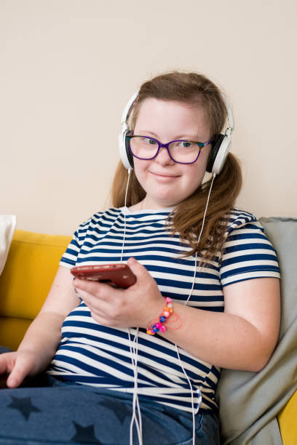
The sound library consists of short audio recordings of local sounds to help the student explore their interests, likes, goals, strengths and learning at school. The student listens to the sounds and selects sounds that help them communicate about their life. This is a similar tool to the photo library, providing audio prompts rather than visual prompts. The sound library can also be used to explore music that students enjoy or relate to.
There is no one right way to do this process, you can be creative. The sounds are a prompt to help the student talk or communicate. Choosing the sounds can lead to other activities that might be useful such as:
- recording sounds of things the student wants to include or talk about
- tThe student drawing, writing or talking more about the topics of the sounds.

Required equipment
- Laptop, tablet or audio recorder/player (with charger or spare batteries). Note that some students may prefer to use their own smartphone or device.
- Headphones or a private area where sounds can be played.

Making a sound library
- Think about all the areas of a student's life that may be relevant, for example, consider health, housing, play, social life (friends), family life, food and drink, education, safety, transport, holidays, work, communicating, culture, spiritual life, money, animals, etc.
- Travel around the school and make short (e.g. 20 – 30 second) recordings of sounds that may be relevant, considering a broad range of answers and areas of the student’s life.
- Organise the sounds into a playlist or audio file. This could be on a computer or iPad, transported via USB, or could be put onto an online platform such as school intranets or google drive.
- Make a list of all the sounds in order and title the files descriptively.
- If possible, find sounds similar to local sounds online. Usually, sounds recorded professionally and available on the internet are of a higher recording quality and have less disruptive background noise.
- Consider co-design: ask students if they want to make their own library of sounds. Students may also want to put together a playlist with some of their favourite music that provides a soundtrack for their likes and interests.

Process
- Play the sounds or music and use them as prompts for discussion. Explain that students may draw from the sounds to answer or explore questions.
- If needed, show the student how the audio device works. The student can choose to use headphones, or opt to listen to the sounds aloud.
- Ask the student about their interests, likes, goals, strengths, needs and learning at school, for example, you can ask the student to choose any sounds that remind them of things they like, what they want to do in the future, what they are good at, etc.
- The student can answer this in any way they want, including telling you the answer. Offer the sounds as an option to help them answer. Explain that the student will hear some sounds which might make them think about the questions.
- Explain that the student can stop the sounds and talk about any that help them answer the questions. Go through the Sound Library slowly, following the student’s lead.
- You can ask the student to choose any sounds that remind them of things they like, what they want to do in the future, what they are good at, etc.
- Tell the student they can stop at any time and talk about as many sounds as they like.
- The student might like to listen to all the sounds first and identify them. The student might also want to comment on them (e.g. ‘that sounds like my uncle’s truck’). Affirm their comments if they make them.
- You may need to repeat questions and ask follow-up prompting questions about the sounds.
- For each sound the student talks about, ask them to tell you about it, what it means to them, and why they have chosen it. Take note of what they tell you.
- Ask the student if they would like to listen to the sounds again. Repeat the process if they do.
- Be positive about the student’s choices and what they are telling you.
- Where possible, the student may want to keep a copy of the sounds, for example on USB or on a personal device such as a smart phone.
- When providing input for the Disability Inclusion Profile, you could provide a summary of the sounds that interested the student, and why. Ask the student’s permission to share. Additionally, you could provide a copy of the sounds themselves to be played at the profile meeting.

Considerations
- Ensure sounds are age appropriate. For example, a sound library for a 17-year-old will be very different to a library for a 5-year-old. Ask students for feedback on the sound library and make changes based on their suggestions.
- Ensure sounds reflect local context and experience of the students such as local nature sounds, traffic, and the school bell.
- It may be helpful to replay sounds.
- Be comfortable with the technology (both recording sounds but also playing sounds and use of headphones). Ensure equipment has sufficient power storage and is in working order.
Practice examples
Luke is 6 years old with a physical and communication disability. The staff member put together a sound library including music that they knew Luke liked from previous work with him. Luke was so happy, smiling and shouting. The staff member asked him what the most important thing in his life is, and he was shouting and pointing in the direction the music was playing. Music makes him feel comfortable. The music engaged him and the staff member was able to ask the questions to which he could communicate his answers.
Uyen is a 17-year-old with psychosocial disabilities. When a staff member was explaining the sound library activity to her, she expressed that she had already created several playlists that she uses to feel good depending on what mood she is in. She showed the staff member the playlist she listens to through her noise reducing headphones whenever the school yard is too loud and overwhelming. They then talked about what sounds were triggering for her and how she uses music as a support.

Luke is 6 years old with a physical and communication disability. The staff member put together a sound library including music that they knew Luke liked from previous work with him. Luke was so happy, smiling and shouting. The staff member asked him what the most important thing in his life is, and he was shouting and pointing in the direction the music was playing. Music makes him feel comfortable. The music engaged him and the staff member was able to ask the questions to which he could communicate his answers.
Uyen is a 17-year-old with psychosocial disabilities. When a staff member was explaining the sound library activity to her, she expressed that she had already created several playlists that she uses to feel good depending on what mood she is in. She showed the staff member the playlist she listens to through her noise reducing headphones whenever the school yard is too loud and overwhelming. They then talked about what sounds were triggering for her and how she uses music as a support.

Character

Summary
This process uses a character, which may include a doll, avatar, animal or soft toy to help the student communicate and explore their interests, likes, goals, strengths, needs and learning at school. The character tool is about roleplay, giving students an opportunity to express themselves indirectly through a doll, or to create an avatar to represent themselves.
Characters have been used in research with young children with disability in a range of different ways, for example to gain consent or dissent, and to express thoughts and feelings in a less direct way. Ask students if this activity would be useful for them, and if they have any ideas about what would suit them best.
Older students that enjoy using technology may wish to create an avatar that represents them. Some students may have experience with role-playing games (RPGs) and staff can explain that this tool is like an RPG character.

Choosing a character
There are a range of creative options for how this tool can be used, such as:
- Dolls, soft toys or plush animals. These should be culturally safe and resemble a character that students will be familiar with.
- Dolls could be gender-neutral, or gendered (i.e., boy or girl dolls) to suit the student’s preference. Students with physical disability may prefer dolls that reflect their bodies.
- Students may prefer to play with a group of small plush animals, or some students may have a favourite toy that they want to use.
- Students that enjoy using technology may create an avatar that represents themselves or who they would like to be, for example using a game or online platform.
- Example platforms are Apple ID, Snapchat, Picrew or Bitmoji. Students who already play RPGs (such as Dungeons and Dragons) may have an existing character that they want to share.
- Students may want to draw a character or avatar physically or digitally.

Process
Here are some ways that a character could assist student voice and agency:
- To gain and re-gain consent. For example, the staff member might ask:
- ‘What if this doll wanted to talk to me, could she decide ‘yes’ or ‘no’? Well, that’s the same with you, it’s up to you if you decide to talk to me/us’.
- To get to know the student. Ask about the features of the avatar and how it represents them.
- To promote play. Characters can be used in role-plays and other forms of play. Play activities are a good way for the staff member and student to get to know each other and to support reserved or quiet students.
- The staff member and the student can both use characters to ‘talk’ to each other about the questions. Alternatively, two staff can demonstrate how to play with the characters by interacting their characters with each other.
- To help students feel comfortable. Some students may be reserved or wish to talk about sensitive issues. It may help to refer to the character instead of themselves. This way, the attention is on the character rather than them. Characters may also help if the student wishes to share something that is difficult. It may be helpful to let students know that sometimes characters can say difficult things that the student may not want to say themselves.
- Ask the character to respond to questions. The character could be used for describing a student’s day, starting with the character being asleep and waking up. For example:
- ‘Imagine this kangaroo is you, tell me what the kangaroo does after breakfast’.
- ‘Imagine this bear is moving into your family and she is like you…what do you think the bear will like about being in your family/ house?’
- ‘If this doll had a disability like you, what do you think he would like to do in the future?’
- After the activity, leave the character/avatar with the student if possible.
- With the student’s permission, staff may provide a summary or quotes from what the character said or represents about the student’s likes, interests and goals as preparation for the Disability Inclusion Profile.

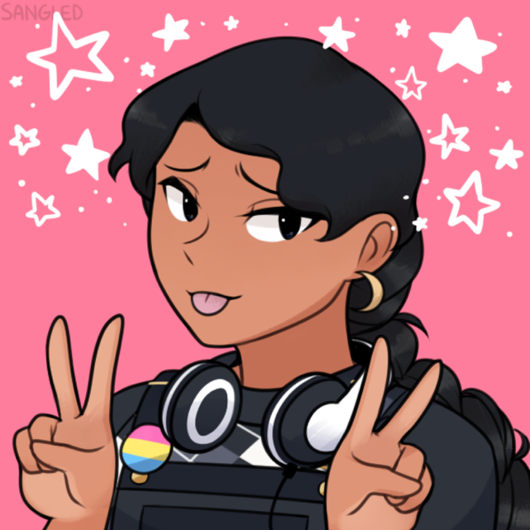
Considerations
- Dolls may not suit all genders and contexts. Young people with disability who tested this tool reported that some students may find a doll infantilising. Staff need to be sensitive about whether a doll would be appropriate and be led by the student.
- Many characters and activities related to this may suit very young students. The creation of avatars may suit older students.
- The staff member needs to be able to play with the student, or in front of student, without embarrassment.

Drawing
Practice examples
Liam is 6 years old. Liam needs support with communication and comprehension. The staff member tried different tools and found that Liam was not interested in answering questions. The staff member then tried using the character tool by asking questions to a puppet. Liam was intrigued, joined in and began answering the questions for the puppet. The use of the puppet worked well as a prompt with Liam.
Anita is an autistic 16-year-old with physical disabilities. She spends her free time playing video games with her friends online. She already has an avatar that she uses when playing online. When a staff member mentioned the character tool could be online, she showed them her avatar and talked about how much she enjoys playing video games. Anita feels like she can be herself more when she plays with her avatar.

Summary
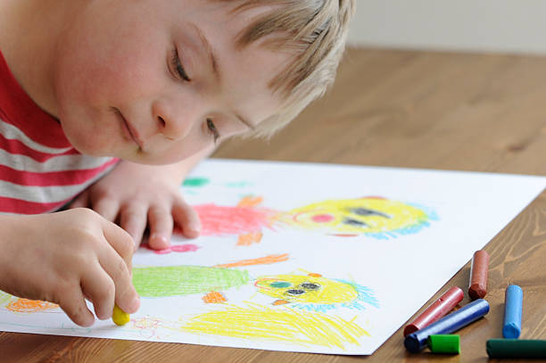
In this process we invite the student to draw or paint pictures to explore their interests, likes, goals, strengths and learning at school. Drawing and art have long been used as universally acceptable tools to express voice. Drawing is enjoyable to students across a variety of ages. It is important that students interpret their own drawings as they can have multiple meanings.
There is no one right way to do this process. Drawing pictures (and telling stories about them) is a prompt to help the student talk or communicate about their lives.

Resources required
- Choice of equipment for drawing should reflect the circumstances of the student and be something that the student has likely used before or had exposure to within their community.
- Examples include paper, pencils, coloured markers, crayons, paints, whiteboard or blackboard, chalk, sand and stick/finger, along with drawing apps or software, and devices to use them on. The student should be encouraged to bring their own equipment if they have technology they like to use.

Process
- Explain that you are going to ask some questions and that the student might like to draw pictures (and tell stories about or explain the pictures) to help answer the questions.
- Ask the student about their interests, likes, goals, strengths, needs and learning at school.
- The student can answer this in any way they want, including telling you the answer. Explain that the student might want to draw some pictures to explore what they like, what they are hopeful about, what they find fun, and so on.
- Tell the student they can choose any of the equipment to draw a picture.
- Some students may be more comfortable with drawing if the staff member draws with them. Ask the student if they prefer this.
- Reassure the student that they are not being assessed, monitor the student’s comfort level, and remember the student may stop at any time.
- Either while the student is drawing, or after the student has finished drawing, ask questions about the drawing, and help the student tell the story of the drawing/painting. Ask what it means to them, and why they have drawn it.
- Use other prompts to expand their initial answers.
- Take note of what they tell you.
- The student may do one single drawing or multiple drawings. Ensure you have enough equipment available for them to do multiple drawings.
- Take a photo of the drawings with permission. Leave the original drawing with the student so that students have ownership over their work.
- Be positive about the student’s drawings and what they are telling you.
- When providing input for the Disability Inclusion Profile, you could provide a summary of the student’s drawings and reflections on what this means to the student. With permission, you could provide pictures of some or all the student’s drawings.

Considerations
- Students can forget the question being asked and just want to draw what they want to draw. If so, allow some time for the student to do drawings of their own choice, then ask them if they would like to do a special drawing to prepare for the Disability Inclusion Profile meeting.
- While most students enjoy drawing, some students may not find it interesting, or might feel that their drawing or painting skills are being assessed.
Practice examples
Konna, age 8, communicates in Auslan and enjoys drawing. He drew a different picture for each question. When asked, ‘What do you like to do?’ Konna drew a picture of a person playing soccer. Konna signed ‘I drew a person playing soccer. I want to be a soccer player and play with my friends.’

Camera

Summary
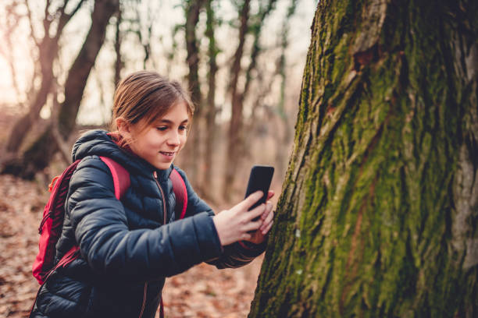
This tool equips the student to take their own photos and can expand on the Photo Library tool. In this process, the student takes photos to explore their interests, likes, goals, strengths, needs, and learning. It has been found to be an accessible method for a range of students with different disabilities.
Supporting the student to take photos is a prompt to help the student talk or communicate about their lives. This guidance will first discuss taking photos in a school setting, and then discuss the possibility of students taking photos at home. Remember that all photos need to be taken and used in line with your school’s policy.

Equipment required
- Tablets with cameras will generally be the most useful technology in school settings. Digital and polaroid cameras, and phone cameras may also be suitable. Use technology that the student is comfortable with, including their own personal devices.
- Charging cable or batteries and enough memory or storage space on the camera or device.

Process – taking photos at school
- Explain that you are going to ask the student to take photos as a way of exploring their interests, likes, goals, strengths, needs and learning. You might need to provide guidance about what to take photos of, for example, ‘take some photos of the things that are important in your life’ or ‘take some photos of what you like to learn at school / what you want to do when you leave school’.
- If needed, show the student how to use the camera, but don’t assume they don’t know how to do it. Ask them if they want help learning how to use it.
- If staff need to accompany the student while they take photos, move with the student at their own pace. Move from your starting point, for example the student’s classroom, to explore the school, such as the hall, library and playground. Follow the student’s lead.
- Ask questions in response to the student’s explanation of what they are taking photos of.
- The staff member will enable the student to lead and choose the direction and destination.
- There may need to be several sessions for students with fatigue or pain.
- Take note of what the student says about the photos they are taking.
- Keep external distraction to a minimum by having staff and the student walk by themselves where possible.
- Make time to go through the photos with the student and seek clarification of what the photo is about and what it means to them. You could encourage the student to choose the photos that have the most significance to them and explore why.
- Be positive about the student’s choices and what they are telling you. Where students have an interest in photography, they may appreciate comments about their photographic work.
- Leave a copy of the photos with the student.
- In providing input to the Disability Inclusion Profile, you can describe the Camera activity including a summary of what the student expressed, or the student can describe themselves.
- With permission and in line with your school’s policies, you may also provide a copy of the student’s chosen photos. Students may choose if, and which photos they would like to share.

Considerations – general
- This is a particularly good activity for older students (8 +).
- When other tools are not useful, this tool might be helpful in encouraging the student to share information about their life.
- Students that are more comfortable with handling technology generally feel more confident to take photos.
- The student may prefer the staff member to take the photos. Where it is challenging for the student to hold, maneuver or see through the camera, the student can direct the staff member to take the photos as identified by the student.
- The process can take time with older students as they may spend more time thinking through the choice of images.
- There is a possibility that fellow students will want to also view the photos taken. Reassure the student that it is their choice as to whether they wish to show others their photos. Provide support and options if the student does want to share their photos with others.

Considerations – taking photos at home
It may be useful for students to be given a camera (or technology that can take photos) to loan or keep for a period of time. This provides the opportunity for the student to take photos of their home, community or everyday life. These photos can provide significant insight into a student’s priorities, goals and aspirations. It can also overlap with artistic expression and photography as an interest.
It may be suitable for some students to take photos at home or in the community using cameras on their personal or family smart phones, other personal cameras, or borrow a camera from school. Where students take photos off school premises, students can then choose which photos to share and explore in a session with a staff member.
Factors to be aware of:
- If lending cameras to students, consider that in some instances cameras may be lost, or stolen, and privacy may be compromised if the camera has stored photos of other students.
- If taking photos on phones, students should receive guidance and supervision as needed related to sending images electronically, privacy and consent.
- When taking photos unsupervised, students may need guidance related to privacy and consent in taking images of other people, and avoiding unsuitable images.
Practice examples
Max is 10 years old and is Deaf and prefers lip reading to using sign language. Max wanted staff to know that he works very hard at school. Max was intrigued by, and enjoyed using a camera. When Max was asked what his hopes were for the future, he explained, ‘I took this picture of my mother while she was standing at the front of the classroom. I think that one day I will become a teacher like my mother … because I want to help other children.’

Guided tour

Summary
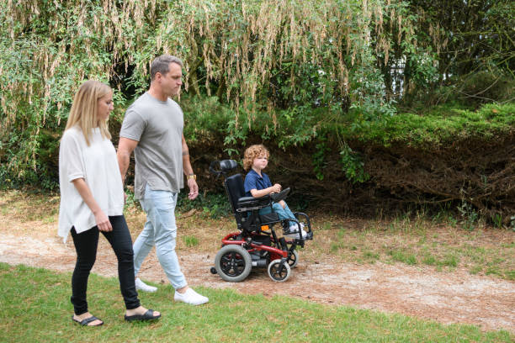
In this process, the student will take the staff member on a tour of their school to explore their interests, likes, goals, strengths, needs and learning at school.
There is no one right way to do this process. Facilitating the student to conduct a tour is a prompt to help the student communicate and reflect on the significance of different places in their life. This can also lead to other conversations about their interests, likes, goals, strengths, needs and learning at school.
This tool may also be useful to explore and plan for different student needs, for example identifying safe places to go for a student experiencing a panic attack.

Guided tour of home and community settings
Some students may want to take their parents, guardians or caregivers on a guided tour of their home or local community, such as a favourite park. This could be accompanied by taking photos, like in the Camera tool. When preparing parents for the Disability Inclusion Profile meeting and discussing student voice, staff can raise this activity as a possibility.

Process
- Explain that you are going to ask the student to show you around and tell you about their school (e.g. what do you like at school; where is your favourite place; where do you go at lunchtime?).
- Ask follow-up questions to explore the student’s interests, goals, strengths, needs and learning.
- From your starting point, e.g. the student’s classroom, move around the area at the student’s pace, to locations such as the playground, paths, oval, art room. Let the student guide you where they want to go.
- Ask questions in response to the student’s explanation of what they are showing the staff member.
- The staff member must let the student take the lead and initiate the path being taken and the destination.
- Take note of what the student is saying.
- Keep external distraction to a minimum by having staff and student walk by themselves where possible.
- When providing input for the Disability Inclusion Profile, you could provide a summary of the Guided Tour and reflections on what this means to the student. You could include a photo or description of the student’s favourite places. Ask the student’s permission to share this information in the profile meeting, and get their guidance on what they want you to share.

Considerations
- Several sessions may be needed over different days for students with fatigue and/or pain.
- The student may be distracted or influenced by other students discussing the path being taken by the student, or the places of interest being selected by the student. If needed, you can stop the activity and recommence later.
- This tool may not suit some students with mobility support needs, but don’t assume what their capacity is before asking them.
Practice examples
Toby, age 12, with a physical disability, took us on a tour around his school. The first place he went was the oval. He explained he wanted to play footy with the other kids. He showed us the small drainage ditch around the oval and explained his wheelchair could not cross this easily and also got stuck in the thick grass on either side.
Isaac, age 15, has a psychosocial condition. He used the guided tour to show the staff member two places where he feels safe when he is anxious or panicking: under a tree next to the oval and a bench next to the library. Isaac and the staff agreed that these are places he is able to go when needed, and this helped him to feel safer and more able to focus at school.

Toby, age 12, with a physical disability, took us on a tour around his school. The first place he went was the oval. He explained he wanted to play footy with the other kids. He showed us the small drainage ditch around the oval and explained his wheelchair could not cross this easily and also got stuck in the thick grass on either side.
Isaac, age 15, has a psychosocial condition. He used the guided tour to show the staff member two places where he feels safe when he is anxious or panicking: under a tree next to the oval and a bench next to the library. Isaac and the staff agreed that these are places he is able to go when needed, and this helped him to feel safer and more able to focus at school.

Story telling

Summary
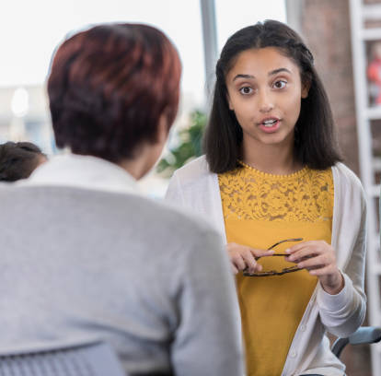
In this process, stories and discussion are used to help the student explore their interests, likes, goals, strengths and learning at school. In oral-tradition communities, this is a common way of sharing information and documenting information over time. It will also suit students who are comfortable to speak aloud or in Auslan without prompts from additional tools.
There is no one right way to do this process. Storytelling and listening is a prompt to help the student talk or communicate about their lives.

Resources required
- An Auslan or language interpreter where needed.
- Any assistive technology that the student usually uses.

Process
- Explain that you are going to ask some questions and that the student might like to use stories to help answer them. For example, can you tell me about a time when you found out about something you want to do when you leave school?
- It may be useful for the staff member to start by telling a story about their experience around the school, for example a time when they were able to do something they enjoy doing. Stories need to be authentic, and staff should take care to avoid patronising the student and to build rapport.
- The student and staff member talk about this story and the student is encouraged to ask questions about the story.
- The staff member then invites the student to tell them a story about their own experiences.
- The staff member can use prompting questions to expand the story to collect other information.
- Take note of what the student tells you, and inform them you are doing this. Depending on the comfort levels of the student, you could take notes at the time or immediately after the discussions.
- Be positive about the student’s stories and what they are telling you.
- When providing input for the Disability Inclusion Profile, you could provide a summary of the student’s storytelling and reflections on what this means to the student, provide a story in full or excerpt, or a combination. Ask the student’s permission to share this information in the profile meeting, as well as what parts of their story they might not want shared.

Considerations
- Students may feel embarrassed about talking in front of adults. Staff should limit the number of people watching this activity to make the student feel more comfortable.
- May be more suitable for students who are articulate communicators and those who are older.
- Some students may be comfortable to be asked questions directly.
Practice examples
Michel is a seven-year-old boy who has an intellectual disability and is hard of hearing. During our time with Michel we soon came to realise that he is sociable and enjoys chatting and having conversations with others. Story-telling worked well with Michel especially as we had good rapport and he felt comfortable with us. Michel told a story about cooking with his Aunty on a holiday and how he would like to cook for his family. Sharing stories created an ease in asking the questions that Michel thought about at length before responding.

Feeling okay

Summary
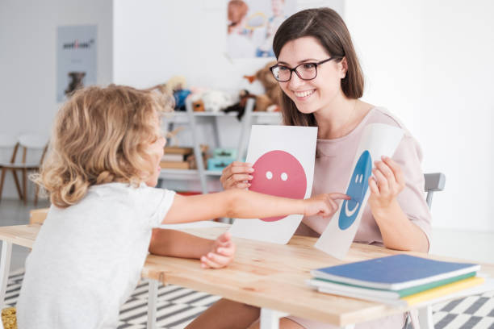
The ‘feeling okay’ tools are a strategy to ensure student’s emotional safety before, after, or during participating in activities.
There may be times when students share something that upsets or worries them. We can tell when a student is sad or distressed by:
- watching how they get along with others (they may have conflict with others or they may be afraid to play)
- the student may tell us directly
- their body language and expressions (for example, they may withdraw, start crying or stop the conversation if it is painful)
- physical changes. For example, the student may have nightmares, feel sick or have trouble sleeping.
It is helpful for students to share their feelings. The following prompts are steps staff can take to help the student to feel okay and to end the session with positive experiences that help to balance or neutralise the sad feelings, memories or fears.

Process
- Take notice of the student’s expressions and behaviour. If the student is becoming withdrawn or sad, stop the activity or discussion.
- Ask the student to share what is upsetting them, be a good listener and take time to provide comfort. Students can feel relieved to share their feelings. If the child makes a disclosure of neglect or abuse, follow the mandatory reporting guidelines.
- Do an activity with the student. The activity may be one that you know the student likes such as singing or a game, or they might make something that they can keep. Staff can ask the student if they have a favourite activity they would like to do. Do not pressure the student into doing an activity, instead offer and follow their lead.
- When doing the activity, such as drawing a visual picture (or telling a story), ask the student to draw (or answer) different questions that are about positive topics, such as:
- The person I love the most is…I am best at …
- I feel safe with … My happiest memory is …
- If I was the Prime Minister, I would …
- Be positive! Tell the student encouraging statements like:
- I know you are feeling sad but it was very brave of you to tell me what made you sad.
- I can see that you really care about your family/pet/friend.
- I can see you worked hard to make that painting.
5. Make a plan with the student. Tell the student when you are going to meet again. Tell the student it is up to them if they wish to discuss what is making them sad in a future session. Ask them if they have any questions for you.
6. Look after yourself. The student’s experiences may bring up feelings for you. You may want to talk to a colleague, supervisor or express your feelings in a way that works for you.
Practice examples
Mika is 14 years old and is autistic. They started to become distressed during their session with the staff member and stopped answering questions or looking at the staff member. The staff member asked Mika if they wanted to keep going or stop for the day, to which Mika replied that they wanted to stop. The staff member and Mika then came up with a plan about when they would meet again, where Mika agreed to come back to the same room the following day. The staff member told Mika they could talk about what made them upset tomorrow, but that it was optional.

Professional reading and resources
The following provides a list of resources that may be helpful in using the tools, and references for further reading.
A full reference list and the bibliography that informed the original toolkit is available at the Voices of Children with Disability Website via Inclusive Practice for Research with Children with Disability: A Guide: http://www.voicesofchildrenwithdisability.com/
Citation: Jenkin, E., Wilson, E., Murfitt, K., Clarke, M., Campain, R. and Stockman, L. (2015) Inclusive Practice for Research with Children with Disability: A Guide.

Resources
Photo library tool
Picture My Future, also known as Image-supported Goal Exploration, uses pictures to help people with disability to explore and express their hopes and dreams for the future. The Picture My Future website includes a guide to collecting pictures that may be helpful for the photo library tool: guide to Collecting Pictures’ https://picturemyfuture.com/picture-my-future-resources/
An example of a photo library can be viewed at http://picturemyfuture.com/wp-content/uploads/2013/05/1547_DEAK_PMFB-picturemyfuturebook_A4_v4_Web.pdf. You can use photos from this source if appropriate.
Character tool
Some students have found that Picrew is a useful resource for the character tool. Picrew is in Japanese language and google translate may assist. Picrew is a service that enables you to create an image maker with your own illustrations. Picrew: https://picrew.me/
Story in a bag tool
Paths to literacy is a resource for students who are blind or visually impaired. The site includes a guide to making a ‘story box’ which is useful for the story in a bag tool: https://www.pathstoliteracy.org/making-story-box
Assistive communication
Talking mats are an evidence-based communication tool, available in physical and digital formats. Talking mats are a flexible and creative tool with specifically commissioned images and symbols, developed in collaboration with people who use the mats. https://www.talkingmats.com

Professional reading
(ARACY) Australian Research Alliance for Children and Youth and the (NSW CCYP) NSW Commission for Children and Young People (2008) Involving children and young people in research: a compendium of papers and reflections from a think tank co-hosted by the Australian Research Alliance for Children and Youth and the NSW Commission for Children and Young People, accessed on 9 September, 2021.
Clark, A (2017). Listening to young children, expanded third edition: A guide to understanding and using the mosaic approach. Jessica Kingsley Publishers.
Crivello, G, Camfield, L and Woodhead, M (2009) How can Children tell us about their wellbeing? Exploring the potential of participatory research approaches within young lives. Social Indicators Research,90(1), 51-72.
Germain, R (2004) An exploratory study using cameras and Talking Mats to access the views of young people with learning disabilities on their out‐of‐school activities. British Journal of Learning Disabilities. 32(4), 170-174. doi:1111/j.1468-3156.2004.00317.x
Gray, C and Winter, E (2011) Hearing voices: Participatory research with preschool children with and without disabilities. European Early Childhood Education Research Journal, 19(3), 309-320, doi:1080/1350293X.2011.597963
Gray, C and Winter, E (2011) The ethics of participatory research involving young children with special needs. In Researching young children's perspectives,46-57. Routledge.
McNeilly, P, Macdonald, G and Kelly, B (2021) Rights Based, Participatory Interviews with Disabled Children and Young People: Practical and Methodological Considerations. Comprehensive child and adolescent nursing, pp.1-10. doi:1080/24694193.2021.1874078
Mitchell, W, Franklin, A, Greco, V and Bell, M (2009) Working with children with learning disabilities and/or who communicate non‐verbally: Research experiences and their implications for social work education, increased participation and social inclusion. Social Work Education, 28(3), 309-324. doi: 1080/02615470802659530
Morris, J (2003) Including all children: Finding Out About the Experiences of children with Communication and/or Cognitive Impairments. Children & Society. 17 (5), 337–348. doi: 1002/CHI.754

