Instructions for reporting of Tier 2 school-level expenditure
The following instructions are provided to support schools with their reporting of Disability Inclusion Tier 2 school-level funding expenditure transactions. If you have any questions about the reporting and/or allowable uses of Tier 2 funding, please contact your Disability Inclusion Regional Implementation Team (details on page 4) for support.

- Reporting Tier 2 school-level credit transactions
All school-based salaries and wages funded from Tier 2 school-level funding for existing and new staff members must be reported against the project code titled ‘Disability Inclusion Tier 2’ (project charge code 283004) in eduPay, using a custom costing.
Where expenditure relating to an employee is charged at 100% to Disability Inclusion Tier 2 funding, it’s recommended that schools use the following job titles using the ‘look up’ tool in the Job Information tab:
- Disability Inclusion Leading Teacher
- Disability Inclusion Learning Specialist
- Disability Inclusion Support
- Disability Inclusion Teacher
Once an existing job title is selected, the system will automatically populate the GL Expense Type and/or GL Project (283004) accordingly.
The steps involved in completing a custom costing for an employee in eduPay, specifically for a split ledger transaction, are as follows:
- Use Custom costing (formerly called GL Overrides). Navigate to HR Admin homepage > Manage Staff > Job Information > Job Data
- Add a job record from the work location tab
- Select a job effective date (can be future or retrospective). If there is an existing job record with the same effective date, then increment by 1 on the effective sequence number.
- Select ‘Data Change’ from the dropdown on the ‘Action’ field
- Select ‘GL Change’ from the dropdown on the ‘Reason’ field
- Click on the second tab ‘Job Information’
- Scroll to the ‘GL Chartfield’ section
- Answer ‘Yes’ to ‘Do you want to update GL default’
- Update the current GL transaction, amending the percentage of salary to be charged to the existing code in the ‘Percent’ column
- Click on the ‘Add’ icon to add a new GL row
- Click on the lookup icon to search for project code 283004
- Add the percentage of salary to be charged according to the FTE time fraction that the staff member is employed
- Review the GL transaction(s), then save the job data record.
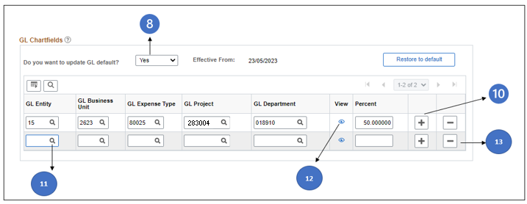
For higher duties assignments, or broader training, please refer to the GLO training video.
Please refer to the GLO Support Guide for further information.

- Reporting Tier 2 school-level cash transactions: CASES21
All cash transactions funded through Tier 2 funding must be reported against CASES21 sub-program code 5102, titled Disability Inclusion Tier 2, as follows:
CASES21 Instructions
- In CASES21, go to program code 510: Disability Inclusion (Please note that code 510 was previously known as Integration Support).
- Select sub program code 5102: Disability Inclusion Tier 2, as the funding source for the transaction, as shown below.
Program Code | Sub program code | Program/Subprogram title
510 |  | Disability Inclusion (Previously known as Integration Support)
 | 5102 | Disability Inclusion Tier 2

- Allocate the transaction against one of the General Ledger expenditure categories listed in the table below, from the Chart of Accounts for Victorian Government Schools.
Allowable account codes | Account Title
80052 | Non-Teaching Staff
80070 | Specialist Teachers
80071 | Casual relief Teaching Staff
80080 | Superannuation
80081 | Workcover
81001 | Annual Leave
86101 | Non-Curriculum Consumables
86104 | Curriculum Consumables
86105 | Computer Applications <$5,000
86201 | Library Books
86401 | Furniture/Fittings <$5,000
86402 | Repairs/Maint Equipment
86404 | Technology Equipment <$5,000
86803 | Affiliations
86910 | Conferences/ Courses/ Seminars
89202 | Technical Support – General  *Please select this category for ‘Minor building or internal environmental modifications under $5,000 (GST inclusive), which must be provided by an external contractor/builder and cover all costs associated with the work’.
89204 | Service Provider
89205 | Agency Staff (Agency provided CRT employment of CRTs/ES or other Staff)
89360 | School to School Transfers

- Schools are asked to provide a clear description for the expenditure. The description should show what the expenditure is and how that is supporting the teaching and learning of students with disability and additional learning needs in your school.

Disability Inclusion Regional Implementation Teams
Regional Implementation Teams are available to support schools to implement Disability Inclusion. Please contact these teams, using the details below, should you have any questions about Disability Inclusion and Tier 2 funding.
- North-West Victoria Region: nwvr.disability.inclusion@education.vic.gov.au
- North-Eastern Victoria Region: nevr.disability.inclusion@education.vic.gov.au
- South-West Victoria Region: swvr.disability.inclusion@education.vic.gov.au
- South-East Victoria Region: sevr.disability.inclusion@education.vic.gov.au

