The Australian Fire Danger Rating System

Background
In September 2022, Australia implemented the Australian Fire Danger Rating System (AFDRS). This is a nationally consistent system for fire danger ratings based on the latest scientific research. This will result in more accurate predictions for fire danger. It has fewer levels (from 6 to 4). It also has clearer, simplified messaging for all communities.

The department worked with the Commonwealth Scientific and Industrial Research Organisation (CSIRO) to update our bushfire risk methodology in line with the changes. There were minimal changes to the methodology and department policy because of the AFDRS.

The changes were implemented for last bushfire season, but this information sheet is a reminder.

Key Changes
The below outlines the approach under the AFDRS:
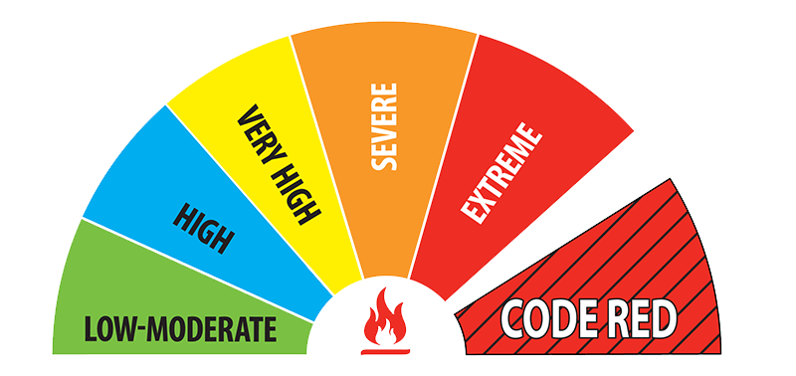 | 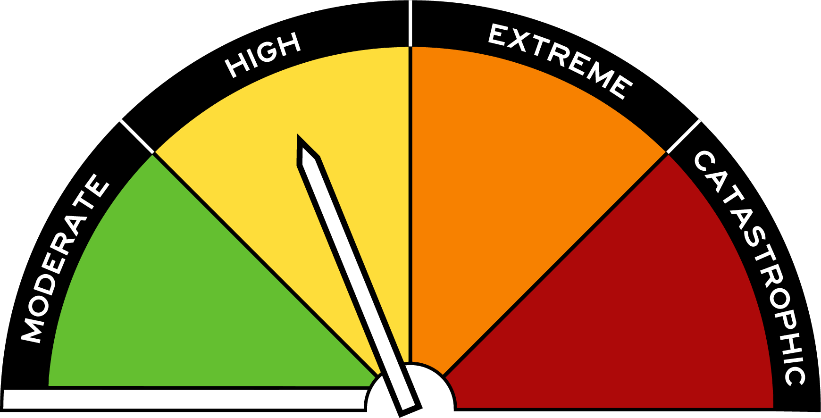
Old Victorian Fire Danger Rating | New Australian Fire Danger Rating

Fire Danger Rating | Key messages for the community
Catastrophic | If a fire starts and takes hold, lives are likely to be lost. For your survival leave bushfire risk areas.
Extreme | Fires will spread quickly and be extremely dangerous. Take action now to protect your life and property.
High | Fires can be dangerous. Be ready to act.
Moderate | Most fires can be controlled. Plan and prepare.

- Extreme fire danger rating (FDR) under the AFDRS covers what used to be known as Severe and Extreme.
- Catastrophic fire danger represents the worst conditions (previously Code Red).
As a result, the triggers for pre-emptive relocation and closure on elevated fire danger days were adjusted slightly to reflect this new system.
- Category 1 and Category 2 schools will relocate or close in accordance with their pre-approved plan on a day forecast Extreme FDR for their LGA.
- Like before, all schools on the BARR (Category 1-3) and Category 4 list must close on a forecast Catastrophic FDR day in their weather district. Their buses will be cancelled. All other buses that travel through the Catastrophic FDR area will also be cancelled.

Bushfire Safety for Workers training
The Country Fire Authority (CFA) offers an e-learning module called Bushfire Safety for Workers. This course is highly recommended. It was designed to support people who work in and travel through bushfire risk areas as part of their job. It was updated to reflect the AFDRS. Visit the CFA website: https://www.cfa.vic.gov.au/atrisk

Learn more
If you have any questions, please contact your regional emergency management staff or email emergency.management@education.vic.gov.au.

Visit https://www.afac.com.au/initiative/afdrs.

