Individual Anaphylaxis Management Plan
This plan is to be completed by the principal or nominee on the basis of information from the student's medical practitioner (ASCIA Action Plan for Anaphylaxis) provided by the parent.
It is the parent’s responsibility to provide the school with a copy of the student's ASCIA Action Plan for Anaphylaxis containing the emergency procedures plan (signed by the student's medical practitioner) and an up-to-date photo of the student - to be appended to this plan; and to inform the school if their child's medical condition changes.
School |  |  |  | Phone
Student
DOB |  |  |  | Year level
Severely allergic to:

Other health conditions

Medication at school

EMERGENCY CONTACT DETAILS (PARENT)
Name |  |  |  | Name
Relationship |  |  |  | Relationship
Home phone |  |  |  | Home phone
Work phone |  |  |  | Work phone
Mobile |  |  |  | Mobile
Address |  |  |  | Address

EMERGENCY CONTACT DETAILS (ALTERNATE)
Name |  |  |  | Name
Relationship |  |  |  | Relationship
Home phone |  |  |  | Home phone
Work phone |  |  |  | Work phone
Mobile |  |  |  | Mobile
Address |  |  |  | Address
Medical practitioner contact |  | Name
 |  | Phone
Emergency care to be provided at school
Storage location for adrenaline autoinjector (device specific) (EpiPen® or Anapen®)

ENVIRONMENT
To be completed by principal or nominee. Please consider each environment/area (on and off school site) the student will be in for the year, e.g. classroom, canteen, food tech room, sports oval, excursions and camps etc.
Name of environment/area:
Risk identified | Actions required to minimise the risk |  |  |  | Who is responsible? |  | Completion date?
Name of environment/area:
Risk identified | Actions required to minimise the risk |  |  |  | Who is responsible? |  | Completion date?
Name of environment/area:
Risk identified | Actions required to minimise the risk |  |  |  | Who is responsible? |  | Completion date?

Name of environment/area:
Risk identified | Actions required to minimise the risk | Who is responsible? | Completion date?
Name of environment/area:
Risk identified | Actions required to minimise the risk | Who is responsible? | Completion date?

(continues on next page)

One of the following completed ASCIA Action Plans: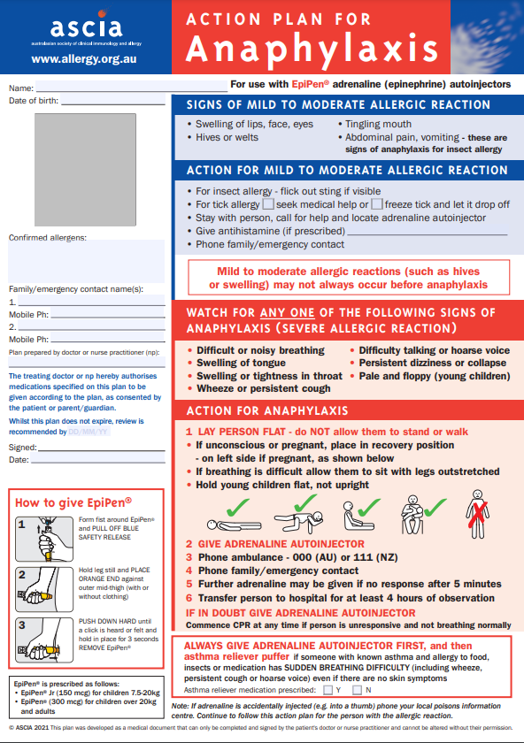OR
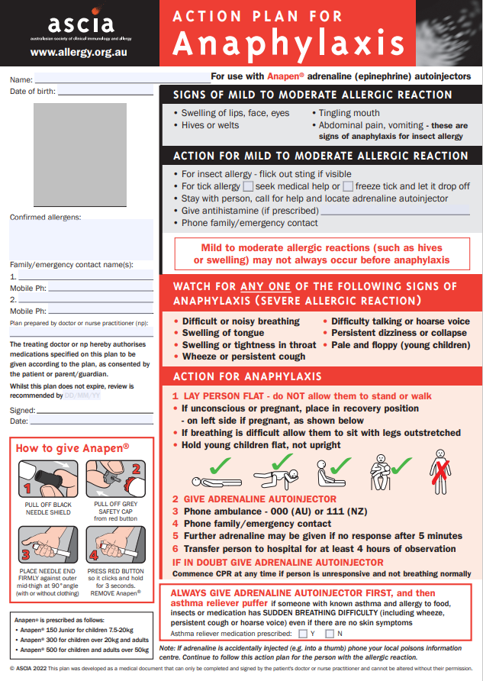
Parents and guardians (via their medical practitioner) can access the ASCIA Action Plan from:
http://www.allergy.org.au/health-professionals/anaphylaxis-resources/ascia-action-plan-for-anaphylaxis

This Individual Anaphylaxis Management Plan will be reviewed on any of the following occurrences (whichever happen earlier):
- annually
- if the student's medical condition, insofar as it relates to allergy and the potential for anaphylactic reaction, changes
- as soon as practicable after the student has an anaphylactic reaction at school
- when the student is to participate in an off-site activity, such as camps and excursions, or at special events conducted, organised or attended by the school (eg. class parties, elective subjects, cultural days, fetes, incursions).
I have been consulted in the development of this Individual Anaphylaxis Management Plan.
I consent to the risk minimisation strategies proposed.
Risk minimisation strategies are available at Chapter 8 – Risk Minimisation Strategies of the Anaphylaxis Guidelines
Signature of parent:
Date:
I have consulted the parents of the students and the relevant school staff who will be involved in the implementation of this Individual Anaphylaxis Management Plan.
Signature of principal (or nominee):
Date:

