School Bus Management System (SBMS)
Quick Reference Guide for New and Existing Travellers
The School Bus Program (SBP) assists students in regional and rural Victoria with travel to their nearest government or appropriate non-government school. This guide explains how your family can access the SBP through the online SBMS.
Pages 1 – 3 provides steps for first time users. Pages 4 – 5 provides steps for existing users.
SBMS website: https://schoolbus.educationapps.vic.gov.au

New Travellers
Step | SBMS screen view
1. Register an account  First time applicants (parents/guardians) for the School Bus Program will need to register an account which includes providing an email address, residential and postal address, telephone number and emergency contact details. | 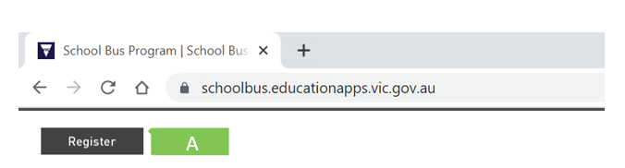  1
2. Add travellers  Travellers (children) must be added to your account before an application to access the School Bus Program can be submitted. | 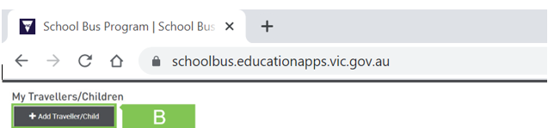  2
3. Create a new application  Once all travellers have been added to your SBMS account, you can create new applications for travel for each traveller.  When you create a new application, it will use the residential address provided for the applicant.  If the traveller is in joint custody and requires a bus from both addresses, the second parent/guardian must register and add another application for the child from their address.  When submitting a new travel application you will be required to select:  - the traveller type (e.g. Primary/Secondary School)  - the first Term and Year the child will travel  - the child’s enrolled school and year level at time of travel  - the days of travel.  Should the application not meet the eligibility requirements (e.g. the enrolled school is not the nearest school), you will be asked if you qualify for an exception or exemption. If applicable, select the relevant exception or exemption and upload supporting documentation.  If you do not meet any of the exception or exemption criteria, check No Exemptions/Exceptions at the bottom of the page and click Next.  You must agree to the Terms of Use in order to submit your application. | 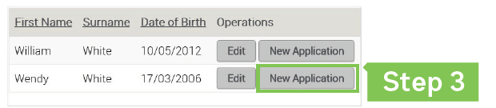  3  C
4. Manage Offer  When you have submitted a new or renewed travel application, the Status will change to Submitted or Under Review (if you have selected an exception or exemption criteria).  An application in Submitted status will be processed overnight.  An application in Under Review may take up to 5 working days to process.  Once processed, you will receive an email notification of your travel assessment details (if you have provided your email address), or you will be sent a letter by post.  If your application has been successful, the Status will change to Offer Made and you can choose to  - Accept the offer and if applicable, pay the fare (students cannot travel until this step is complete), or  - Decline the offer.  You must accept or decline the offer using the Manage Offer button next to the traveller’s application details.  If the bus is at capacity, the application Status will change to Waitlisted. You will receive a notification when a seat becomes available. | 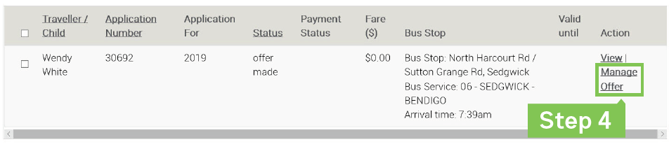  4

Existing Travellers
Step | SBMS screen view
1. Login  If you are an existing user, you can login with your username and password.  In the event you have forgotten your password, click the Reset Password button and follow the steps to reset  the password.  If you have forgotten your username, please call 1800 338 663 or email SchoolBus@education.vic.gov.au for further assistance. | 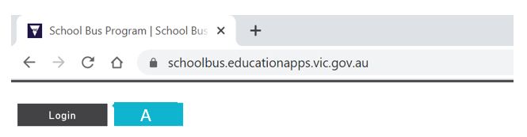  1
2. Manage your account  Click My account in the top menu bar (next to Log out) to view and edit your personal information, including your address and emergency contact details.  Under Edit Account you can:  - Change Email/Password (including Username)  - Change Profile (telephone, residential address and postal address) | 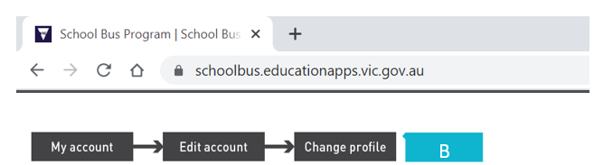  2
3. Renew Applications  Most travel applications will automatically renew at the end of each year. If your child’s application status is Accepted, you will receive an email at the end of the year with a travel offer for the following year.  However, if your child has had a break from travel or their travel application has lapsed and their circumstances have not changed (e.g. the address and school remain the same), the application should be renewed rather than creating a new one.  Renewing an application will ensure that the existing travel conditions are maintained.  If you have moved address or your child has enrolled at a different school, please update your details and create a  new application – see step 3 on page 1. | 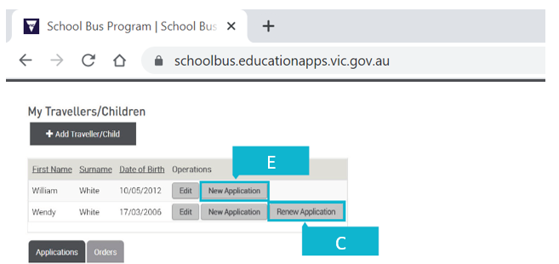  3  3  3
4. Manage Offer  If you have submitted a new or renewed travel application, please follow the Manage Offer steps on page 3.  If your travel application was automatically renewed and you have received notification of a travel offer, you can choose to  - Accept the offer and if applicable, pay the fare (students cannot travel until this step is complete), or  - Decline the offer.  You must accept or decline the offer using the Manage Offer button next to the traveller’s application details. | 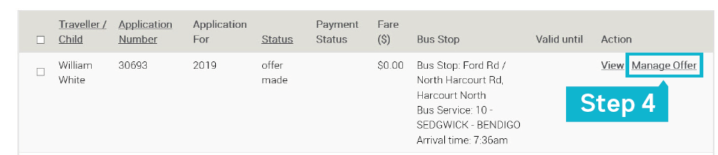  4

