sample Personal Emergency Evacuation Plan (PEEP): studenT TEMPLATE

What is a PEEP?
A Personal Emergency Evacuation Plan (PEEP) is a practical measure to ensure appropriate actions are taken for an individual in the event of an emergency, where that person requires additional or specific assistance to evacuate a building or premises.
Who needs a PEEP?
A PEEP is required for students who may need assistance in the event of an emergency due to:
- Mobility impairment
- Hearing impairment
- Visual impairment
- Cognitive impairment
- Temporary condition (medical condition or short-term injury)
The document provides a framework to guide the planning and provision of emergency evacuation of a person with an assistance need.
How is a PEEP used?
The role of PEEPs for students is to ensure that planning is completed for the individual and the assistant on the process to evacuate in an emergency situation. PEEPs are rehearsed, and if necessary adjusted as a part of the school’s overall emergency drills/exercises – PEEPs are not intended to be used for reference in the actual emergency situation.
The plan should outline the specific procedure to be followed in the event an evacuation is triggered and will also state the designated person(s) who will provide assistance during the evacuation. This is a sample template and can be tailored to suit the individual’s circumstances.
Where possible, the student should have an age-appropriate role in contributing to their plan and the decisions taken.
Who receives a copy of a PEEP?
Once completed, a copy of the PEEP should only be shared by the principal on a ‘need to know’ basis. This generally includes the student’s parent/carer, the student (as appropriate), the specified assistant/s and the relevant warden.
To ensure compliance with the Privacy and Data Protection Act 2014 (Vic), if this PEEP contains any private/sensitive information, it must be securely maintained and kept separate to your school’s Emergency Management Plan (EMP).

NOTE: This sample template is a guide only and should be used as an aid to develop or supplement your EMP. Please adapt it as appropriate to ensure relevance to your school.

Personal Emergency Evacuation Plan (PEEP)

This part is to be completed by the Parent/carer and student (as appropriate)
Student Name
School/Campus
Address and Location (Building/floor)
Is an assistance animal involved? Yes ☐ No ☐

What type of assistance does the student require?
(Please describe the procedure/actions necessary to assist them)

What, if any, equipment is required for evacuation?
(Please list the equipment e.g. mobility aid, ventilator)

THIS PART IS TO BE COMPLETED BY THE SCHOOL
The student understands the general emergency response and evacuation procedure? Yes ☐ No ☐

How will the student receive updates to the emergency response procedures?
(E.g. text, email, Braille etc.)

How will the student be notified of an emergency?
(E.g. visual alarm, personal vibrating device, SMS, etc or N/A)

Step by Step Evacuation Procedure:
(List the procedure agreed with the parent/carer and/or student)

Example only
- As directed by the class teacher/warden: After/ahead of the main flow of evacuation and with the help of the designated assistant, make way to nearest safe area/ designated area at own speed with assistant
- Evacuation route may depend on location/type of emergency: (refer to diagram on next page)
  - Closest / quickest – to Stairwell 1
  - Alternate – to Stairwell 2
- Seek refuge in emergency stairwell or other suitable location with evacuation assistant and wait for further instruction from the area warden or emergency services on site
- If no instruction received from the warden, call 000
- Proceed to assembly point if safe to do so
Is the assistant/s trained in the emergency response and evacuation procedures? Yes ☐ No ☐
Is the assistant/s trained in the use of the required evacuation equipment? Yes ☐ No ☐ N/A ☐

Diagram of preferred route for assisted evacuation:
(Please insert diagram here or attach to this form)

EXAMPLE ONLY
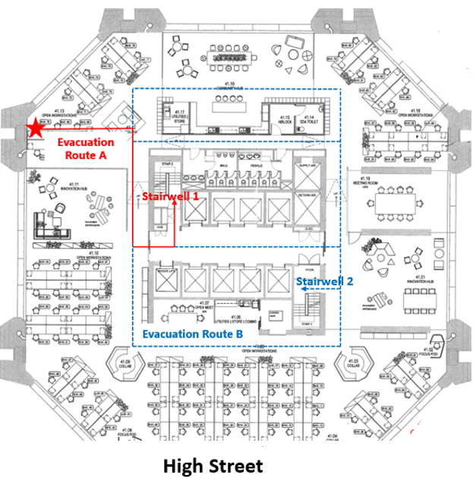

Date this PEEP <insert Created or Reviewed> ..... / .... / .... Next Review Date ..... / ..... / ....

DISTRIBUTION
Name | Position Title/Role | Mobile | Email
<insert student name>
<insert assistant name>
<insert warden/asssitant name or delete row>
<insert parent/carer name>
<insert any other person in receipt of this PEEP or delete row>

Parent/Carer Name ………………………………………………..

………………………………………………… Date: ..... / ..... / …..
Signature

Principal Name ……………………………………..…………

………………………………………………… Date: ..... / ..... / …..
Signature

