sample Personal Emergency Evacuation Plan (PEEP): EMPLOYEE TEMPLATE
What is a PEEP?
A Personal Emergency Evacuation Plan (PEEP) is a practical measure to ensure appropriate actions are taken for an individual in the event of an emergency, where that person requires additional or specific assistance to evacuate a building or premises.
Who needs a PEEP?
A PEEP is required for employees who may need assistance in the event of an emergency due to:
- Mobility impairment
- Hearing impairment
- Visual impairment
- Cognitive impairment
- Temporary condition (medical condition or short-term injury)
The document provides a framework to guide the planning and provision of emergency evacuation of a person with an assistance need.
How is a PEEP used?
The role of PEEPs for employees is to ensure that planning is completed for the individual and the buddy on the process to evacuate in an emergency situation. PEEPs are rehearsed, and if necessary adjusted as a part of the facility’s overall emergency drills/exercises – PEEPs are not intended to be used for reference in the actual emergency situation.
The plan should outline the specific procedure to be followed in the event an evacuation is triggered and will also state the designated person(s) who will provide assistance (buddy) during the evacuation. This is a sample template and can be tailored to suit the individual’s circumstances.
Who receives a copy of a PEEP?
Once completed, a copy of the PEEP should only be shared by the relevant officer-in-charge (e.g. Principal/Director/Senior Manager) on a ‘need to know’ basis. This generally includes the employee, the specified buddy/s and the relevant warden (visit the Hybrid Working page to contact your area warden).
To ensure compliance with the Privacy and Data Protection Act 2014 (Vic), this PEEP must be securely stored and only made accessible to the above listed audience. It should be kept separate to your facility’s Emergency Management Plan (EMP).

NOTE: This sample template is a guide only and should be used as an aid to develop or supplement your EMP. Please adapt it as appropriate to ensure relevance to your school.

Personal Emergency Evacuation Plan (PEEP)

This part is to be completed by the employee
Name
Location (Building/floor)
Is an assistance animal involved? Yes ☐ No ☐

Do you understand the emergency response and evacuation procedures? Yes ☐ No ☐

What type of assistance do you require?
(Please describe the procedure/actions necessary to assist you)

What, if any, equipment is required for evacuation?
(Please list the equipment e.g. mobility aid, ventilator)

THIS PART IS TO BE COMPLETED BY THE OFFICER IN CHARGE (Principal/Senior Manager/Director)
How will the employee receive updates to the emergency response procedures?
(E.g. text, email, Braille etc.)

How will the employee be notified of an emergency?
(E.g. visual alarm, personal vibrating device, SMS etc. or N/A)

Step by Step Evacuation Procedure:
(List the procedure agreed with the employee)

Example only
- As directed by floor warden: After main flow of evacuation, make way to the designated area or assembly point at own speed with evacuation buddy
- Evacuation route may depend on location/type of emergency: (refer to diagram on next page)
  - Closest / quickest – to Stairwell 1
  - Alternate – to Stairwell 2
- Seek refuge in emergency stairwell or other suitable location with evacuation buddy, and wait for further instruction from floor warden or emergency services on site
- If no instruction received from fire warden, call 000
- Proceed to assembly point

Is the buddy/s trained in the emergency response and evacuation procedures? Yes ☐ No ☐

Is the buddy/s trained in the use of the required evacuation equipment? Yes ☐ No ☐ N/A ☐

Diagram of preferred route for assisted evacuation:
(Please insert diagram here or attach to this form)

EXAMPLE ONLY
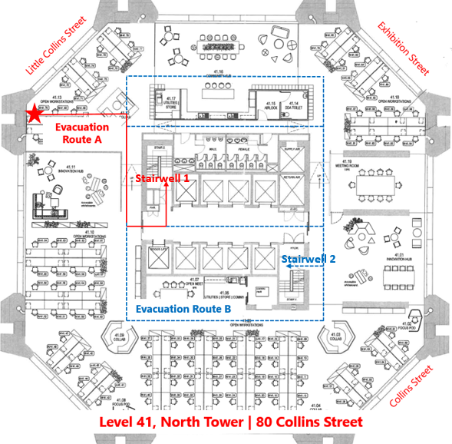

Date this PEEP <insert Created or Reviewed> ..... / .... / .... Next Review Date ..... / ..... / ....

DISTRIBUTION
Name | Position Title/Role | Mobile | Email
<insert employee name>
<insert buddy name>
<insert officer-in-charge/manager/director/principal name>
<insert warden name>
<insert any other person in receipt of this PEEP or delete row>

Employee ………………………………………………… Date: ..... / ..... / …..
Signature

Officer-in-Charge Name …………………………………….. Position Title ……………………………………

……………………………………… Date: ..... / ..... / …..
Signature

