Mental Health in Primary Schools: instructions for reporting Mental Health and Wellbeing Leader salary expenditure.
The Mental Health in Primary Schools Program provides funding to government schools through the Student Resource Package to employ a Mental Health and Wellbeing Leader. The following instructions are provided to support schools with reporting of Mental Health and Wellbeing leader salary expenditure.

Reporting school-level credit transactions
School-based salaries and wages for staff members that are employed as a Mental Health and Wellbeing Leader must be reported against the project code 245006 titled Mental Health in Primary Schools as follows:
Using EduPay, allocate the staff member, whether new or existing, to the Mental Health in Primary Schools project code 245006 – see below.
(a) If the staff member is only working as the Mental Health and Wellbeing Leader (100% salary), i.e. no other role in the school such as classroom teacher, learning tutor or assistant principal, please select ‘Mental Health and Wellbeing Leader (primary schools)’ as the default job title.
- Use Job Title Default GL Costing. Navigate to HR Admin homepage > Manage Staff > Job Information > Job Data
- Add a job record from the work location tab
- Select a job effective date
- Select ‘Data Change’ from the dropdown on the ‘Action’ field
- Select ‘GL Change’ from the dropdown on the ‘Reason’ field
- Click on the second tab ‘Job Information’
- Under Job Title, untick the ‘Job Title’ checkbox
- Select the lookup icon on the job title field to bring up a list of job titles
- Tick the checkbox next to ‘Job Title Default Exists’, click <Search>.
Each job title is associated with an expense type and/or project code.
- Select ‘Mental Health and Wellbeing Leader (primary schools)’ from the job title default list.
- Review, then save the job record.
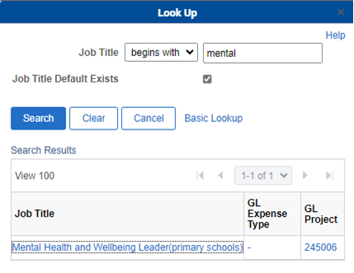
(b) If the staff member’s salary is sitting across multiple positions (split ledger), please assign the partial salary based on the appropriate time fraction to project code 245006.
- Use Custom costing (formerly called GL Overrides). Navigate to HR Admin homepage > Manage Staff > Job Information > Job Data
- Add a job record from the work location tab
- Select a job effective date (can be future or retrospective). If there is an existing job record with the same effective date, then increment by 1 on the effective sequence number.
- Select ‘Data Change’ from the dropdown on the ‘Action’ field
- Select ‘GL Change’ from the dropdown on the ‘Reason’ field
- Click on the second tab ‘Job Information’
- Scroll to the ‘GL Chartfield’ section
- Answer ‘Yes’ to ‘Do you want to update GL default’
- Update the current GL transaction, amending the percentage of salary to be charged to the existing code in the ‘Percent’ column.
- Click on the ‘Add’ icon to add a new GL row
- Click on the lookup icon to search for project code 245006
- Add the percentage of salary to be charged to the Mental Health in Primary Schools code according to the time fraction that the staff member is performing Mental Health and Wellbeing Leader role.
- Review the GL transaction(s), then save the job data record.
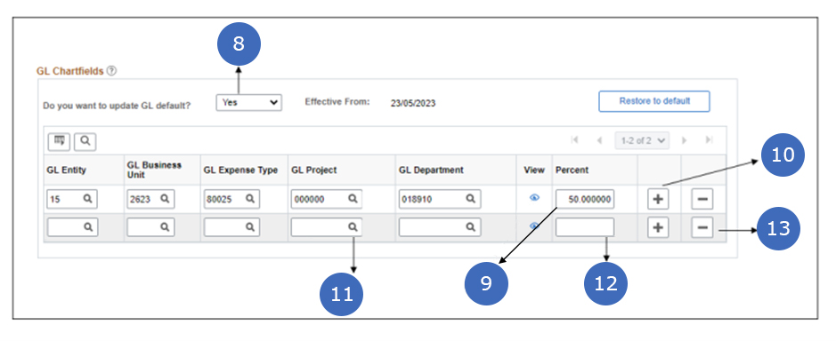

For more information, please see QRG – GLO User Guide or contact mentalhealth@education.vic.gov.au.

