Respectful Behaviour within the School Community
Communications Toolkit
July 2023

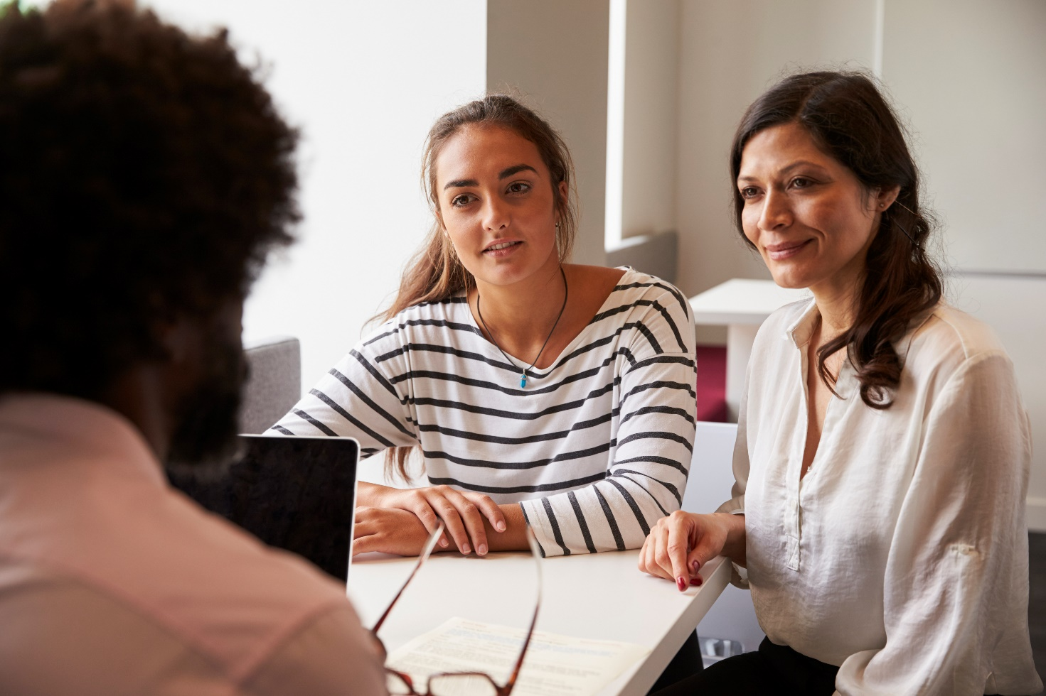

Content

Introduction
Suggested email from principal to school community
Suggested email from principal to school staff
Suggested social media content
Posters
‘Five minutes with staff’ newsletter story template
Additional resources

Introduction

Everyone in the school community has a right to a safe and healthy learning environment and workplace. All school staff have a right to feel safe at work, and protected from any aggression, violence or behaviour that presents a safety risk.

Instances of violence and aggression towards school staff from parents, carers or other adult members of the school community can have a significant impact on the health, safety and wellbeing of the person who experiences this. The impact can also be felt by the wider school community. No one should be threatened or intimidated at work or at school.
The department has a suite of resources to set clear expectations of behaviour and make schools safer for staff, students, and their families.
Part of this suite of resources is the Respectful Behaviours within the School Community Policy, which promotes the importance of respectful and collaborative relationships between parents and carers and school staff.
It sets out clear guidelines on the expected standards of behaviour for parents, carers and other adults who interact with the school community to reduce the risk and incidence of work-related violence towards school staff.
Schools are encouraged to use communications materials contained in this toolkit to raise awareness about the policy and to promote positive, respectful relationships between adults in our school communities.

Suggested email from principal to school community

Please consider using the content below for principals to communicate the policy and parent webpage to the school community. You can customise the content as required for your style and audiences.

Dear [Audience]
When parents, carers and school staff work together as one team, our students do better. Everyone at school, particularly staff and parents/carers, play a role in making school a better place for learning and work.
Parents, carers and school staff have a relationship that can last many years. This is an opportunity to work together to create a positive relationship in the best interests of your child. When this relationship is built on respect and trust, students learn better and feel like they belong in the school.

Every member of our school community has a right to feel safe and be protected.
The department’s Respectful Behaviours within the School Community Policy describes the positive behaviour expected from parents, carers, and other adults in Victorian school communities. The policy sets clear standards of behaviour to create a safe, respectful, and inclusive learning environment for students, staff and adults.
There are also resources to support safe and respectful relationships in our school community, including information about getting involved in the school, advice on how to raise a concern or complaint, and parenting support resources. You can find the policy and these resources here.
You may also see a new poster up around our school, promoting positive behaviour.
For more information on how to engage positively with our school, please contact [insert Principal’s name and contact details].

Suggested email from principal to school staff

Please consider using the content below in an email to staff, or as speaking notes for a staff meeting. You can customise the content as required for your style and audiences.

Dear colleagues,

Instances of violence and aggression towards school staff from parents, carers or other adults can have a significant impact on the health, safety and wellbeing of the staff member who experiences this behaviour, as well as their colleagues around them. The impact can also be felt by the wider school community.

Respectful Behaviours within the School Community Policy

The Department has a policy outlining expectations of behaviour for adult members of the school community. The Respectful Behaviours within the School Community Policy sets out clear standards of behaviours that help create and support a safe, respectful and inclusive learning environment for students, staff and adult members of our school community. It sits alongside a suite of other resources for parents and schools, to support safe and respectful relationships within schools. You may see posters for staff and parents on display around our school.

I encourage you to familiarise yourself with the policy and I urge you to report and bring to my attention any instances of violence and aggression that you experience or witness at our school. Aggression and violence have no place in our school community and should never be viewed as part of the job.

Advice page on managing challenging parent/carer behaviour
The department’s Work-related Violence in Schools Policy and Procedure includes a chapter on managing challenging parent/carer behaviours.
This chapter outlines strategies and resources to help schools prevent and manage unacceptable behaviours from parents, carers, and other adult members of the school community. This includes guidance to help establish and promote respectful and safe engagement with parents and carers, prevent and de-escalate unacceptable behaviours and access support and services to restore wellbeing after an incident.
As always, I am here to support you in these matters to ensure your health and safety is prioritised, to reduce the risk of these events occurring and to help resolve any matters before they escalate to harmful behaviours. In addition to bringing any risks or incidents to my attention, please ensure you make a report via eduSafe Plus so the Department can also help to provide appropriate supports.

If you would like any more information or to discuss this further, please reach out to me (and/or your health and safety representative/s) at any time.

Kind regards,
[Principal name]

Suggested social media content

Here are some sample social media posts that can be used across your own social channels to help encourage awareness of respectful behaviours in the community.
Please tag the Department of Education so we can like and share your posts.
DE LinkedIn
DE Twitter

Post 1
Safe and respectful school communities create a better environment for children to thrive. It's important for everyone to be respectful and kind to each other. Learn more about the Department of Education’s policy - Respectful Behaviours within the School Community. Respectful Behaviours within the School Community Policy (education.vic.gov.au)

Post 2
All school staff have a right to feel safe at work. Aggression, violence or any behaviour that makes staff feel unsafe, are not acceptable in our schools.
It's important that adults in our school community continue to treat each other with kindness and respect. Learn more about the expectations of behaviour in Victorian school communities. Respectful behaviours in schools (education.vic.gov.au)

Post 3
Safe and respectful school communities create a better environment for children to thrive. Learn more about the expectations of behaviour in Victorian school communities. Respectful behaviours in schools (education.vic.gov.au)
Right click and save an image to use in your posts
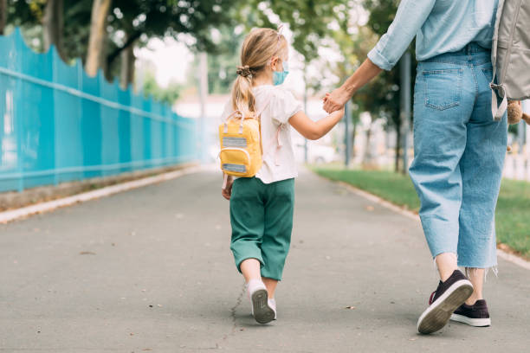

Posters

Download and print the staff facing poster for display in settings reserved for school staff.

Download and print the parent facing poster for display in settings where parents, carers and adults in the school community frequent. The poster is available in 30+ languages here under ‘Safety at Work for School Staff communications material’.

‘Five minutes with staff’ newsletter story template

Articles that profile staff in your school newsletter can humanise staff and help build empathy. Use these questions to create profiles of school staff in your school newsletter or digital platforms. These are example questions; you may wish to use 4–6 per article and rotate the questions or add in your own.

5 minutes with [staff member name]

- How long have you worked at [school name]?
- What is your role at the school?
- What is the most rewarding part of your job?
- What is your ideal way to unwind and relax?
- What’s your most fond childhood memory?
- When you were little what did you aspire to be?
- What was your favourite subject at school?
- How many languages do you speak?
- What skill would you like to master?
- What book/tv series/podcasts are you into at the moment?
- What is your favourite sport to watch or play?
- Do you play a musical instrument? If so, which one?
- What would you sing at karaoke night?
- If you could choose to be anything for a day, what would it be?
- If you could only eat one meal for the rest of your life, what would it be?
- If you were a superhero, what powers would you have?
- What’s your favourite holiday destination?
- Who would you want to play you in a movie of your life?
- Do you collect anything?

Extra parenting support services and resources

- Department of Families, Fairness and Housing – services and support for families, including:
  - Strengthening Parent Support Program – a free program for parents and carers with a child from birth to 18 years, with a disability or developmental delay.
  - Regional Parenting Services – support for parents and carers of children from birth to 18 years located in regional Victoria.
  - Child, family and relationship services – family support services to help parents raise their children.
- Parentline – a confidential counselling and support services for parents and carers of children from birth to 18 years old. The Orange Door – the main way to access Family Services is by talking to the Orange Door. This includes support with wellbeing, challenging behaviour, safety and family violence. Everyone is welcome, services are free and you don’t need a referral.
- Raising Children Network – guidance on supporting school age children, including resources, videos, articles and apps.
- MyTime program – support for parents and carers of children with disabilities. Skilled facilitators provide guidance to help access local services and reliable information.
- Triple P Positive Parenting Program – ideas and strategies to help parents and carers including ways to set routines, manage behaviours and how to take care of yourself. Free parenting courses are available.

© State of Victoria (Department of Education) 2021. Except where otherwise noted, material in this document is provided under a Creative Commons Attribution 4.0 International Please check the full copyright notice

