Deciding how to report JobTrainer students
This fact sheet explains how you can enrol and report JobTrainer students to ensure your allocation of JobTrainer places is maximised and students pay the lowest available tuition fee.

JobTrainer places are limited
JobTrainer places are limited and many students will already be eligible for equivalent low fee places under Skills First.

To maximise your JobTrainer allocation, you can make strategic decisions to save places for students who have no other enrolment option, while ensuring each student gets the lowest fee - either a Free TAFE fee waiver (at TAFE), a JobTrainer concession or a Skills First Concession.

Assessing the student
Once you’ve determined that a student is eligible for the JobTrainer benefits, you can find out if they need a JobTrainer place to get the lowest fee.
Check if the student:
- needs an exemption to the ‘upskilling’ and/or ‘two at level in a lifetime’ Skills First eligibility settings
- is entitled to a Skills First concession (they hold an accepted concession card, or they’re eligible for concession under another initiative, like the Indigenous Completions Initiative or the Asylum Seeker VET Program).

The ‘decision tree’ diagram
Once you’ve assessed the student’s circumstances, the ‘decision tree’ diagram on the next page can help you decide how to enrol and report students who are eligible for JobTrainer.
We’ve created a version for TAFEs that includes Free TAFE reporting and one for all other training providers.
It’s your decision how you report a JobTrainer student who is also eligible for mainstream Skills First without needing the JobTrainer benefits. But using a Skills First place where possible, while still ensuring the student gets the lowest tuition fee available, can save JobTrainer places for students who have no other option.

Diplomas and advanced diplomas
Under Skills First, concessions can usually only be applied up to a Certificate IV level (except under particular initiatives, such as the Indigenous Completions initiative).
Under JobTrainer, concessions can be granted to students enrolling in programs on the JobTrainer Funded Programs Report at any AQF level, including Diplomas and Advanced Diplomas.

Further information
Submit an enquiry via SVTS using the category ‘JobTrainer’
Fact sheet: Understanding the 2022 JobTrainer arrangements
.

For TAFES

Deciding how to report JobTrainer students
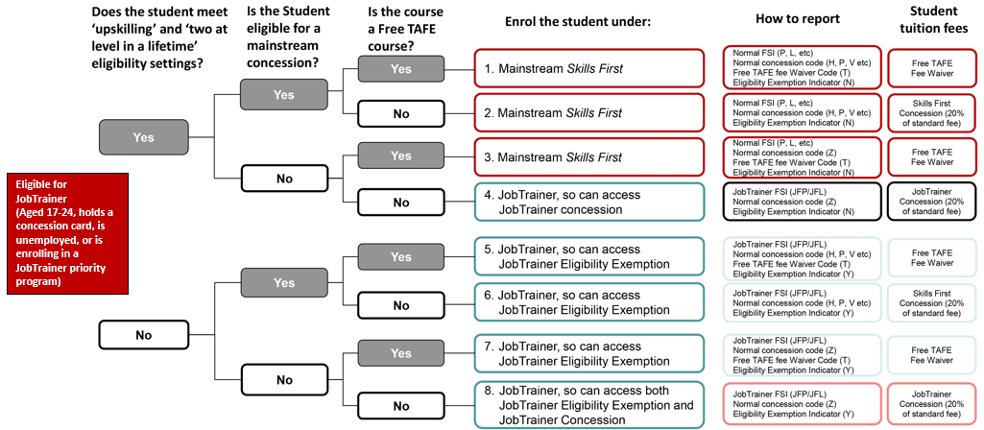

For non-TAFES

Deciding how to report JobTrainer students
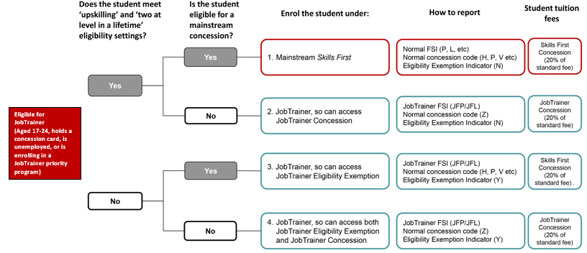

© State of Victoria (Department of Education and Training) 2021. Except where otherwise noted, material in this document is provided under a Creative Commons Attribution 4.0 International Please check the full copyright notice

