Victorian Training Market Report

2014

Published by the  
Communications Division  
for the Higher Education and Skills Group  
Department of Education and Training

Melbourne   
March 2015

©State of Victoria (Department of Education and Training) 2015

The copyright in this document is owned by the State of Victoria (Department of Education and Training), or in the case of some materials, by third parties (third party materials). No part may be reproduced by any process except in accordance with the provisions of the Copyright Act 1968, the National Education Access Licence for Schools (NEALS) (see below) or with permission.

An educational institution situated in Australia which is not conducted for profit, or a body responsible for administering such an institution may copy and communicate the materials, other than third party materials, for the educational purposes of the institution.

Authorised by the Department of Education  
and Training,  
2 Treasury Place, East Melbourne, Victoria, 3002.  
This document is also available on the internet at  
http://www.education.vic.gov.au/training/providers/market/pages/reports.aspx.

**Contents**

Executive Summary 4

Notes on the Data 6

Glossary 7

1. Vocational Training Summary 9

Vocational Training by Funding Type 9

Qualification Levels 13

Vocational Training Completions 18

Age Profile 23

Vocational Education and Training in Schools (VETiS) 25

Gender 28

Government Subsidised Activity and Participation by Regions 29

Government Subsidised Training by Training Provider Type 35

TAFE Performance 39

Learn Local Performance 47

2. Apprenticeships and Traineeships 53

Apprenticeships and Traineeships Overall 53

Apprenticeships 54

Traineeships 61

3. Training in Specialised or In Shortage Occupations 69

4. Learners Facing Barriers to Participation 73

Vocational Training Delivery to Learner Groups Facing Barriers 73

Indigenous Students 75

Students with a Disability 76

Students with a Culturally and Linguistically Diverse (CALD) Background 77

Unemployed Students 78

[Young People (aged 15 to 19) Without Year 12 or Equivalent and  
Not at School 79](#_Toc414601808)

Students with Low Prior Qualification 80

Foundation Level Training 81

# Executive Summary

Introduction

Vocational education and training has a significant role to play in helping people move into employment, improve their employment, progress to further education, and for those who face barriers to participation to build a bridge to employment and broader community engagement.

This report draws on the data provided to the Department of Education and Training by the more than 700 training providers that deliver government subsidised training in Victoria. Performance in 2014 is compared to that of previous years to provide a picture of changes and trends over time.

Fewer students were in government subsidised training in 2014 compared to 2013

* There were 443,687 students enrolled in government subsidised training in 2014, this was 8 per cent lower than 2013.These students were enrolled in 557,846 government subsidised courses in 2014, this was 14 per cent lower than 2013.
* Sixty three per cent of all government subsidised enrolments were at the Certificate III to IV levels in 2014. This was down on the 2013 result by 1 per cent.

Completion rates have been steadily declining

* There has been a steady decline in the completion rate from 2011 onwards. By the end of 2014, 34 per cent of courses commenced in 2013 were reported as being completed. This is in comparison to 41 per cent of courses commenced in 2011 were reported as being completed by 2014.

There are declining numbers of young people in government subsidised training

* The most significant decline in age groups between 2013 and 2014 was by 15 to 19 year olds. In 2014 there were 85,334 15 to 19 year olds enrolled in training, this was 18 per cent lower than the 2013 result.
* Within this age group there is a particularly vulnerable group; young people aged 15 to 19 who are not at school and who do not have their Year 12, or an equivalent qualification. For this group of young people enrolments dropped by 14 per cent.

Declines in training participation have occurred across the state

* While all regions showed a decline in the number of students participating in government subsidised training between 2013 and 2014, regional areas were impacted more significantly. There was a 12 per cent decline in the number of students living in regional Victoria enrolled in government subsidised training compared to a 7 per cent decline in metropolitan Melbourne.
* In 2014 10.9 per cent (about 1 in 10) of 15 to 64 year olds in the Victorian population were participating in government subsidised training, this was down on 2013 by 1.2 percentage points. All regions of the state had lower participation rates in 2014 than in 2013.

There has been a decline in enrolments by TAFEs

* The number of government subsidised enrolments by TAFEs dropped by 33 per cent over the last year, from 207,943 to 139,182 in 2014.
* In 2014 over half (56 per cent) of all government subsidised enrolments were with Private Registered Training Organisations. The share held by TAFEs was 25 per cent in 2014, down from 32 per cent in 2013.

Apprentice enrolments have been stable over the last year

* In 2014, there were 43,453 government subsidised apprentice course enrolments, this was marginally higher than in 2013.
* About one third of apprentice courses were enrolled in by students who were aged 15 to 19. Enrolments by this age group were lower in 2014 compared to previous years, down by 4 per cent compared to 2013.

Traineeships continue their large decline

* In 2014, there were 38,483 government subsidised trainee course enrolments. This was lower than previous years; 2014 enrolments were down by 34 per cent compared to 2013.In 2014, trainee course enrolments were lower than 2011, 2012 and 2013 across all age groups.

Training in areas of skills and industry need increased in 2014

* Government subsidised enrolments for qualifications in specialised or in shortage occupations rose 9 per cent to 207,202 enrolments in 2014. These enrolments accounted for 47 per cent of all industry specific enrolments in 2014. Occupations considered to be specialised and in shortage include child care workers, aged and disabled carers, cooks, motor mechanics and enrolled nurses.

# Notes on the Data

This Report includes key metrics, such as training delivery by funding source, qualification level, course completion, age of learners, regional activity and learners facing barriers to participation. An analysis of alignment to industry needs is also provided.

The main source of vocational training statistics in this publication is the training activity database referred to as Skills Victoria Training System (SVTS). Data included in the report are a snapshot in time and based on data as reported to Higher Education and Skills Group (HESG) in the Department by training providers.

Annual data included in this report may differ to those in previous publications as the Department is continuously updating classifications to improve data quality and consistency across years. From time to time changes to reporting and data standards may lead to minor revisions to data previously reported. The data reported in this report was extracted in February 2015.

### Special caveats and notes

* The former dual sector TAFEs (i.e. delivered through a University) have been labelled as University throughout this report, this covers RMIT, Swinburne, Federation and Victoria Universities.
* To ensure a degree of consistency of “foundation courses” in this report, any course that was identified in the foundation skills list of courses whether in 2013 or 2014 is considered for the purposes of this report as a foundation course.
* For the purposes of this report the term Learn Local is used interchangeably with Adult and Community Education (ACE). However, it should be noted that only Learn Local organisations report through to the Adult, Community and Further Education Board, ACE organisations are self-identified and are not required to report through to the Board. In 2014 there were a very small number of Learn Local organisations that self-identified to SVTS as private registered training organisations (RTO) and therefore are not included in the count of Learn Local organisations.
* Data presented in the section of Training in Specialised and In-Shortage Occupations is for industry specific enrolments, i.e. training with a direct labour market outcome. This covers government subsidised training in Australian Qualifications Framework (AQF) qualifications, and excludes training in foundation skills, education pathways and low-level courses in languages other than English.
* A ‘-‘ shown in a table indicates that the figure was nil.

### Reporting scope

* This report includes government subsidised activities in all sectors, and domestic fee-for-service activities in the TAFE sector.
* Fee-for-service activities that took place in the private RTO, university and Learn Local sectors are outside the scope.

### What’s new

* Data on enrolments in Diploma courses that had VET FEE-HELP is included.
* Completion and non-completion rates are reported for the first time, with completion status by year of commencement also reported.
* Additional data on completions reported by training providers is included, to better present some of the limitations associated with past approach that was used for reporting completions.
* Data on VET in Schools is presented for the first time.
* A section on TAFE performance is included, providing an overview of TAFE performance in government subsidised and fee-for-service training activity.
* Data on apprenticeships and traineeships has been moved to its own section, with additional information on new course commencements and the occupations of courses.

# Glossary

|  |  |
| --- | --- |
| Term | Definition |
| Australian Qualifications Framework (AQF) | The Australian Qualifications Framework (commonly known as the AQF) is a unified system of national qualifications in schools, vocational education and training (TAFEs and private providers) and the higher education sector (mainly universities). |
| Industry code (ANZSIC) | The Australian and New Zealand Standard Industrial Classification (ANZSIC) is a classification that provides a framework for organising data about industry by grouping business units carrying out similar productive activities. |
| Government subsidised | Course or training activity that attracts a level of funding or subsidy from the Victorian Government, for example funding entitlement under the Victorian Training Guarantee. |
| Student Contact Hours | In practice, this reflects the nominal hours allocated to training activity as reported by the provider. |
| ACFE | Through the Adult, Community and Further Education (ACFE) Board, the Victorian Government provides funding to community-based organisations, known as [Learn Local organisations](http://www.education.vic.gov.au/training/learners/learnlocal/pages/default.aspx), and two adult education institutions, the [CAE](http://www.cae.edu.au/) and [AMES](http://www.ames.net.au/), for delivery of education and training programs to a broad range of Victorians over compulsory school-leaving age - young people, older people, people with special needs, people from diverse cultural backgrounds – with a special focus on people who have had limited prior access to education. |
| Foundation | Foundation skills courses help address issues basic skills gaps for vocational education and training students. Gaining these base level skills in literacy, numeracy and workforce preparation skills improve a student’s chances following training of employment, provide opportunities for further education and broader social participation. |
| Region | One of nine geographical areas or regions, these match the nine former administrative regions of the Department. |

# Vocational Training Summary

## Vocational Training by Funding Type

This section provides an overview of training activity measured in terms of student numbers, course enrolments and student contact hours.

Key points

* There were 443,687 students enrolled in government subsidised training in 2014, this was 8 per cent lower than 2013.
* There were 523,921 students in government subsidised and TAFE fee-for-service (AQF I+ only) training in total in 2014, this was 5 per cent lower than 2013.
* The number of government subsidised enrolments reported in 2014 was 557,846, this was 14 per cent lower than 2013.
* There were 666,601 government subsidised and TAFE fee-for-service (AQF I+) enrolments in total reported in 2014, this was lower than 2013 by 10 per cent.

Table 1.1.1: Student enrolments in vocational training by funding type, 2009 to 2014

|  |  |  |  |  |  |  |
| --- | --- | --- | --- | --- | --- | --- |
|  | **2009** | **2010** | **2011** | **2012** | **2013** | **2014** |
| Government subsidised | 299,602 | 339,226 | 430,280 | 509,797 | 484,765 | 443,687 |
| TAFE domestic fee-for-service* | 66,985 | 67,214 | 67,799 | 79,640 | 75,085 | 86,964 |
| **Total\*\*** | **357,206** | **396,346** | **488,649** | **579,701** | **550,030** | **523,921** |

*Data on TAFE fee-for-service includes qualification at AQF level I and above.

**TAFE students whose enrolments are made up of a combination of government subsidised and self-funding have been counted in both funding categories. The total, however, has eliminated the duplicates.

Table 1.1.2: Change in number of students enrolled in vocational training by funding type

|  |  |  |  |  |  |
| --- | --- | --- | --- | --- | --- |
|  | **% change 2009 to 2014** | **% change 2010 to 2014** | **% change 2011 to 2014** | **% change 2012 to 2014** | **% change 2013 to 2014** |
| Government subsidised | 48% | 31% | 3% | -13% | -8% |
| TAFE domestic fee-for-service* | 30% | 29% | 28% | 9% | 16% |
| **Total\*\*** | **47%** | **32%** | **7%** | **-10%** | **-5%** |

*Data on TAFE fee-for-service includes qualification at AQF level I and above.

**TAFE students whose enrolments are made up of a combination of government subsidised and self-funding have been counted in both funding categories. The total, however, has eliminated the duplicates.

Figure 1.1: Students enrolled in vocational training by funding type, 2009 to 2014

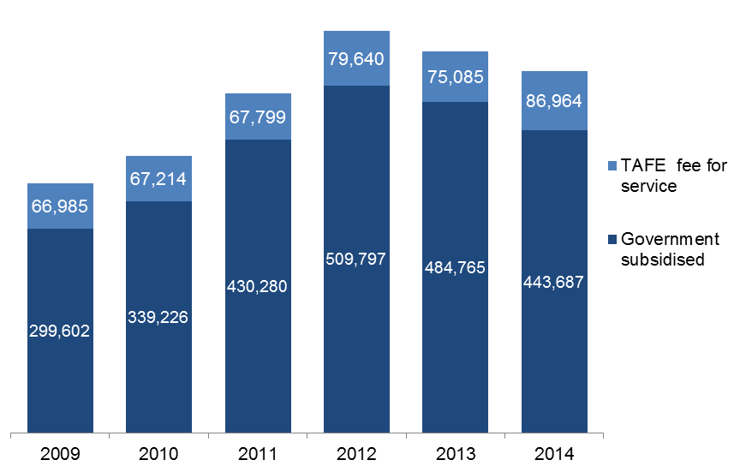

Table 1.2.1: Course enrolments in vocational training by funding type, 2009 to 2014

|  |  |  |  |  |  |  |
| --- | --- | --- | --- | --- | --- | --- |
|  | **2009** | **2010** | **2011** | **2012** | **2013** | **2014** |
| Government subsidised | 376,795 | 426,905 | 548,728 | 670,438 | 645,697 | 557,846 |
| TAFE domestic fee-for-service* | 72,586 | 72,658 | 73,875 | 97,216 | 92,925 | 108,755 |
| **Total** | **449,381** | **499,563** | **622,603** | **767,654** | **738,622** | **666,601** |

* Data on TAFE fee-for-service includes qualification at AQF level 1 and above.

Table 1.2.2: Change in number of course enrolments in vocational training by funding type

|  |  |  |  |  |  |
| --- | --- | --- | --- | --- | --- |
|  | **% change 2009 to 2014** | **% change 2010 to 2014** | **% change 2011 to 2014** | **% change 2012 to 2014** | **% change 2013 to 2014** |
| Government subsidised | 48% | 31% | 2% | -17% | -14% |
| TAFE domestic fee-for-service* | 50% | 50% | 47% | 12% | 17% |
| **Total** | **48%** | **33%** | **7%** | **-13%** | **-10%** |

*Data on TAFE fee- for- service includes qualification at AQF level 1 and above.

Figure 1.2: Course enrolments in vocational training by funding type, 2009 to 2014

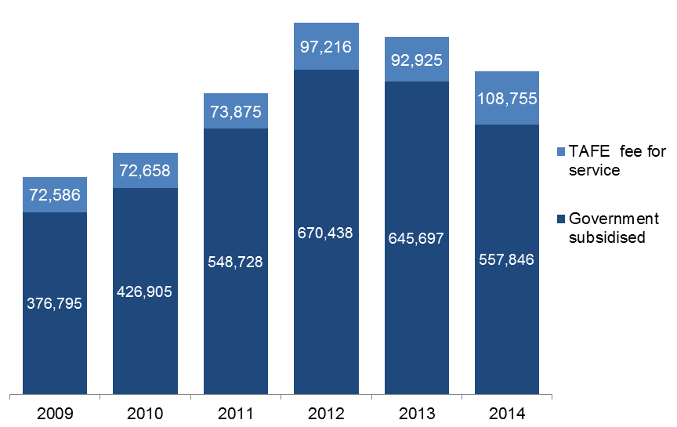

Table 1.3.1: Student contact hours (millions) by funding type, 2009 to 2014

|  |  |  |  |  |  |  |
| --- | --- | --- | --- | --- | --- | --- |
|  | **2009** | **2010** | **2011** | **2012** | **2013** | **2014** |
| Government subsidised | 95.6 | 112.4 | 146.9 | 188.8 | 183.2 | 180.9 |
| TAFE domestic fee-for-service* | 14.5 | 13.2 | 12.6 | 15.4 | 14.6 | 18.1 |
| **Total** | **110.1** | **125.6** | **159.6** | **204.2** | **197.7** | **199.0** |

*Data on TAFE fee-for-service includes qualification at AQF level 1 and above.

Table 1.3.2: Change in number of student contact hours by funding type

|  |  |  |  |  |  |
| --- | --- | --- | --- | --- | --- |
|  | **% change 2009 to 2014** | **% change 2010 to 2014** | **% change 2011 to 2014** | **% change 2012 to 2014** | **% change 2013 to 2014** |
| Government subsidised | 89% | 61% | 23% | -4% | -1% |
| TAFE domestic fee-for-service* | 25% | 37% | 43% | 18% | 24% |
| **Total** | **81%** | **58%** | **25%** | **-3%** | **1%** |

*Data on TAFE fee-for-service includes qualification at AQF level 1 and above.

Figure 1.3: Student contact hours (millions) in vocational training by funding type, 2009 to 2014

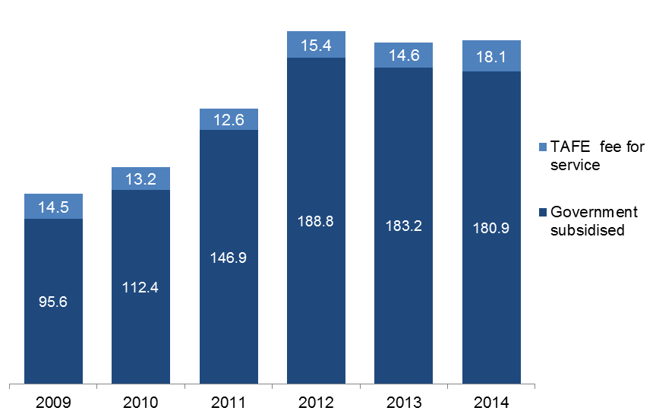

## Qualification Levels

Lower level qualifications such as Certificate I and II provide literacy, numeracy and work preparation skills to people without post-school qualifications so that they have the opportunity to go on to further study or secure employment.

Mid-level skills are essential to the Victorian economy and help drive economic activity across the state. A significant proportion of apprenticeships and traineeships require attainment of a mid-level qualification and are crucial to many key industries.

### Government Subsidised Course Enrolments

Key points

* The 2014 data shows that there were 352,663 government subsidised course enrolments at the Certificate III to IV levels which represented 63 per cent of all government subsidised enrolments. This was down on the 2013 result by 1 per cent.
* Government subsidised course enrolments at the Certificate I to II levels were lower in 2014 than 2013 by 52 per cent.
* In 2014, there were 64,391 government subsidised enrolments in Diploma and above qualification, this was lower than 2013 by 6 per cent.
* In 2014, there was an increase in government subsidised enrolments in ‘Other’ qualification category on the 2013 figure, this was mainly due to an increase in enrolments in the Literacy and Numeracy Support foundation course which was introduced in late 2013.

Table 1.4.1: Government subsidised course enrolments by qualification level, 2009 to 2014

|  |  |  |  |  |  |  |
| --- | --- | --- | --- | --- | --- | --- |
|  | **2009** | **2010** | **2011** | **2012** | **2013** | **2014** |
| Cert I/II | 83,638 | 93,834 | 119,439 | 154,760 | 167,745 | 79,907 |
| Cert III/IV | 165,863 | 201,687 | 287,858 | 365,939 | 356,168 | 352,663 |
| Diploma & Above | 63,657 | 71,241 | 90,319 | 94,773 | 68,404 | 64,391 |
| *VET FEE-HELP\** | *854* | *9,463* | *11,099* | *11,566* | *18,403* | *17,755* |
| *Without any VET FEE-HELP\** | *62,803* | *61,778* | *79,220* | *83,207* | *50,001* | *46,636* |
| Module Only | 40,702 | 37,269 | 30,321 | 30,604 | 31,140 | 35,215 |
| Secondary Education** | 6,914 | 7,600 | 7,670 | 7,756 | 9,094 | 9,147 |
| Other*** | 16,013 | 15,274 | 13,121 | 16,606 | 13,146 | 16,523 |
| **Total\*\*\*\*** | **376,795** | **426,905** | **548,728** | **670,438** | **645,697** | **557,846** |

* In 2014 a small number of contracted training providers failed to submit information on VET FEE-HELP.

** Includes VCE/VCAL courses of study.

***Other includes statement of attainment, other non-award courses or not elsewhere classified.

**** The 2009 total includes 8 enrolments in Higher Education. There were no enrolments in Higher Education after 2009.

Table 1.4.2: Change in number of government subsidised course enrolments by qualification level

|  |  |  |  |  |  |
| --- | --- | --- | --- | --- | --- |
|  | **% change 2009 to 2014** | **% change 2010 to 2014** | **% change 2011 to 2014** | **% change 2012 to 2014** | **% change 2013 to 2014** |
| Cert I/II | -4% | -15% | -33% | -48% | -52% |
| Cert III/IV | 113% | 75% | 23% | -4% | -1% |
| Diploma & Above | 1% | -10% | -29% | -32% | -6% |
| *VET FEE-HELP\** | *1979%* | *88%* | *60%* | *54%* | *-4%* |
| *Without any VET FEE-HELP\** | *-26%* | *-25%* | *-41%* | *-44%* | *-7%* |
| Module Only | -13% | -6% | 16% | 15% | 13% |
| Secondary Education** | 32% | 20% | 19% | 18% | 1% |
| Other*** | 3% | 8% | 26% | 0% | 26% |
| **Total\*\*\*\*** | **48%** | **31%** | **2%** | **-17%** | **-14%** |

* In 2014 a small number of contracted training providers failed to submit information on VET FEE-HELP.

** Includes VCE/VCAL courses of study.

***Other includes statement of attainment, other non-award courses or not elsewhere classified.

**** The 2009 total includes 8 enrolments in Higher Education. There were no enrolments in Higher Education after 2009.

Table 1.5.1: Government subsidised course enrolments, excluding foundation skills courses by qualification level, 2009 to 2014

|  |  |  |  |  |  |  |
| --- | --- | --- | --- | --- | --- | --- |
|  | **2009** | **2010** | **2011** | **2012** | **2013** | **2014** |
| Cert I/II | 65,392 | 73,385 | 79,922 | 64,123 | 44,041 | 31,659 |
| Cert III/IV | 159,613 | 194,877 | 278,390 | 348,362 | 337,047 | 344,884 |
| Diploma & Above | 63,657 | 71,241 | 90,319 | 94,773 | 68,404 | 64,391 |
| Module Only | 40,702 | 37,269 | 30,321 | 30,604 | 31,140 | 35,215 |
| Secondary Education* | 6,914 | 6,950 | 6,031 | 6,093 | 6,489 | 7,429 |
| Other** | 14,792 | 13,431 | 9,902 | 7,974 | 8,263 | 7,972 |
| **Total\*\*\*** | **351,078** | **397,153** | **494,885** | **551,929** | **495,384** | **491,550** |

* Includes VCE/VCAL courses of study.

**Other includes statement of attainment, other non-award courses or not elsewhere classified.

*** The 2009 total includes 8 enrolments in Higher Education. There were no enrolments in Higher Education after 2009.

Table 1.5.2: Change in number of government subsidised course enrolments, excluding foundation skills courses by qualification level

|  |  |  |  |  |  |
| --- | --- | --- | --- | --- | --- |
|  | **% change 2009 to 2014** | **% change 2010 to 2014** | **% change 2011 to 2014** | **% change 2012 to 2014** | **% change 2013 to 2014** |
| Cert I/II | -52% | -57% | -60% | -51% | -28% |
| Cert III/IV | 116% | 77% | 24% | -1% | 2% |
| Diploma & Above | 1% | -10% | -29% | -32% | -6% |
| Module Only | -13% | -6% | 16% | 15% | 13% |
| Secondary Education* | 7% | 7% | 23% | 22% | 14% |
| Other** | -46% | -41% | -19% | 0% | -4% |
| **Total\*\*\*** | **40%** | **24%** | **-1%** | **-11%** | **-1%** |

* Includes VCE/VCAL courses of study.

**Other includes statement of attainment, other non-award courses or not elsewhere classified.

*** The 2009 total includes 8 enrolments in Higher Education. There were no enrolments in Higher Education after 2009.

Table 1.6.1: Government subsidised course enrolments in foundation skills courses by qualification level, 2009 to 2014

|  |  |  |  |  |  |  |
| --- | --- | --- | --- | --- | --- | --- |
|  | **2009** | **2010** | **2011** | **2012** | **2013** | **2014** |
| Cert I/II | 18,246 | 20,449 | 39,517 | 90,637 | 123,704 | 48,248 |
| Cert III/IV | 6,250 | 6,810 | 9,468 | 17,577 | 19,121 | 7,779 |
| Secondary Education* | 0 | 650 | 1,639 | 1,663 | 2,605 | 1,718 |
| Other** | 1,221 | 1,843 | 3,219 | 8,632 | 4,883 | 8,551 |
| **Total** | **25,717** | **29,752** | **53,843** | **118,509** | **150,313** | **66,296** |

* Includes VCAL (Foundation) course of study.

**Other includes statement of attainment.

Table 1.6.2: Change in number of government subsidised course enrolments in foundation skills courses by qualification level

|  |  |  |  |  |  |
| --- | --- | --- | --- | --- | --- |
|  | **% change 2009 to 2014** | **% change 2010 to 2014** | **% change 2011 to 2014** | **% change 2012 to 2014** | **% change 2013 to 2014** |
| Cert I/II | 164% | 136% | 22% | -47% | -61% |
| Cert III/IV | 24% | 14% | -18% | -56% | -59% |
| Secondary Education* | - | 164% | 5% | 3% | -34% |
| Other** | 600% | 364% | 166% | -1% | 75% |
| **Total** | **158%** | **123%** | **23%** | **-44%** | **-56%** |

* Includes VCAL (Foundation) course of study.

**Other includes statement of attainment.

### TAFE Domestic Fee-for-Service Course Enrolments

Key points

* For TAFE domestic fee-for service enrolments at AQF Certificate 1 and above (excluding foundation courses), Certificate III to IV is the largest qualification group.
* TAFE fee-for-service enrolments at all qualification levels were higher in 2014 than 2013.

Table 1.7.1: TAFE domestic fee-for-service course enrolments by qualification level (AQF 1+), 2009 to 2014

|  |  |  |  |  |  |  |
| --- | --- | --- | --- | --- | --- | --- |
|  | **2009** | **2010** | **2011** | **2012** | **2013** | **2014** |
| Cert I/II | 34,402 | 35,171 | 35,799 | 46,469 | 44,521 | 50,024 |
| Cert III/IV | 32,473 | 31,973 | 32,058 | 43,203 | 40,126 | 49,190 |
| Diploma & Above | 4,683 | 4,258 | 4,633 | 5,948 | 6,833 | 8,066 |
| *VET FEE-HELP\** | *105* | *437* | *756* | *940* | *1,031* | *1,544* |
| *Without any VET FEE-HELP\** | *4,578* | *3,821* | *3,877* | *5,008* | *5,802* | *6,522* |
| Higher Education | 1,028 | 1,256 | 1,385 | 1,596 | 1,445 | 1,475 |
| **Total** | **72,586** | **72,658** | **73,875** | **97,216** | **92,925** | **108,755** |

* In 2014 a small number of contracted training providers failed to submit information on VET FEE-HELP.

Table 1.7.2: Change in number of TAFE domestic fee-for-service course enrolments by qualification level (AQF 1+)

|  |  |  |  |  |  |
| --- | --- | --- | --- | --- | --- |
|  | **% change 2009 to 2014** | **% change 2010 to 2014** | **% change 2011 to 2014** | **% change 2012 to 2014** | **% change 2013 to 2014** |
| Cert I/II | 45% | 42% | 40% | 8% | 12% |
| Cert III/IV | 51% | 54% | 53% | 14% | 23% |
| Diploma & Above | 72% | 89% | 74% | 36% | 18% |
| *VET FEE-HELP\** | *1370%* | *253%* | *104%* | *64%* | *50%* |
| *Without any VET FEE-HELP\** | *42%* | *71%* | *68%* | *30%* | *12%* |
| Higher Education | 43% | 17% | 6% | -8% | 2% |
| **Total** | **50%** | **50%** | **47%** | **12%** | **17%** |

* In 2014 a small number of contracted training providers failed to submit information on VET FEE-HELP.

Table 1.8.1: TAFE domestic fee-for-service course enrolments, excluding foundation skills courses by qualification level (AQF 1+), 2009 to 2014

|  |  |  |  |  |  |  |
| --- | --- | --- | --- | --- | --- | --- |
|  | **2009** | **2010** | **2011** | **2012** | **2013** | **2014** |
| Cert I/II | 28,922 | 29,919 | 31,194 | 37,447 | 33,765 | 39,409 |
| Cert III/IV | 31,226 | 30,640 | 30,865 | 41,687 | 38,356 | 47,203 |
| Diploma & Above | 4,683 | 4,258 | 4,633 | 5,948 | 6,833 | 8,066 |
| Higher Education | 1,028 | 1,256 | 1,385 | 1,596 | 1,445 | 1,475 |
| **Total** | **65,859** | **66,073** | **68,077** | **86,678** | **80,399** | **96,153** |

Table 1.8.2: Change in number of TAFE domestic fee-for-service course enrolments, excluding foundation skills courses by qualification level (AQF 1+)

|  |  |  |  |  |  |
| --- | --- | --- | --- | --- | --- |
|  | **% change 2009 to 2014** | **% change 2010 to 2014** | **% change 2011 to 2014** | **% change 2012 to 2014** | **% change 2013 to 2014** |
| Cert I/II | 36% | 32% | 26% | 5% | 17% |
| Cert III/IV | 51% | 54% | 53% | 13% | 23% |
| Diploma & Above | 72% | 89% | 74% | 36% | 18% |
| Higher Education | 43% | 17% | 6% | -8% | 2% |
| **Total** | **46%** | **46%** | **41%** | **11%** | **20%** |

Table 1.9.1: TAFE domestic fee-for-service course enrolments in foundation skills courses by qualification level (AQF 1+), 2009 to 2014

|  |  |  |  |  |  |  |
| --- | --- | --- | --- | --- | --- | --- |
|  | **2009** | **2010** | **2011** | **2012** | **2013** | **2014** |
| Cert I/II | 5,480 | 5,252 | 4,605 | 9,022 | 10,756 | 10,615 |
| Cert III/IV | 1,247 | 1,333 | 1,193 | 1,516 | 1,770 | 1,987 |
| **Total** | **6,727** | **6,585** | **5,798** | **10,538** | **12,526** | **12,602** |

Table 1.9.2: Change in number of TAFE domestic fee-for-service course enrolments in foundation skills courses by qualification level (AQF 1+)

|  |  |  |  |  |  |
| --- | --- | --- | --- | --- | --- |
|  | **% change 2009 to 2014** | **% change 2010 to 2014** | **% change 2011 to 2014** | **% change 2012 to 2014** | **% change 2013 to 2014** |
| Cert I/II | 94% | 102% | 131% | 18% | -1% |
| Cert III/IV | 59% | 49% | 67% | 31% | 12% |
| **Total** | **87%** | **91%** | **117%** | **20%** | **1%** |

## Vocational Training Completions

Apart from the community and social benefits associated with higher levels of educational attainment, there is strong evidence that people who complete vocational training qualifications are at an advantage in the labour market in terms of employment and wage outcomes compared with those who do not complete their courses.

### Completion Rate of Government Subsidised Qualifications

The Department has developed an improved approach to the measurement and reporting of course completions, which supports the calculation of a completion rate. This was not possible with the reported completion data published previously. Data based on the previous approach is presented in the next section.

At any given point in time, the course completion rate is the proportion of courses completed of all courses commenced in the same year. For example, by the end of 2014, 22 per cent of courses that were commenced in 2014 were reported as completed. This completion rate (of courses that commenced in 2014) will increase if the training activity data is extracted at a later date. That is, it would be expected that some of the training that was still in progress would have been completed or discontinued. This is particularly the case for courses that take more than a year to complete, such as an apprenticeship which may take up to four years.

This section provides a snapshot taken at the end of 2014 of reported completion rates by courses that commenced between 2009 and 2014. Data presented in this section does not include bridging and enabling courses and other non-award courses.

Key points

* By the end of 2014, 34 per cent of courses commenced in 2013 were reported as being completed. This is in comparison to 41 per cent of courses commenced in 2011 which were reported as being completed by 2014.
* While the completion rate in 2014 was just 22 per cent, over a quarter of courses commenced in 2014 were still in progress.
* Just over half (51 per cent or 173,108) of all courses commenced in 2014 were not completed, i.e. there was no more activity associated with the course.
* There has been a steady decline in the completion rate from 2011 onwards. Since 2012 the number of courses commenced each year has also been steadily declining.

Figure 1.4: Reported course completion rate of government subsidised training by year of course commencement, 2009 to 2014

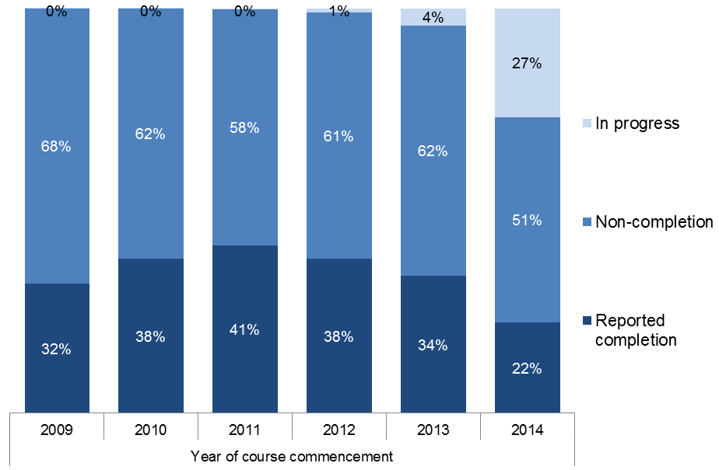

Figure 1.5: Number of reported courses completed, not completed and still in progress of government subsidised training by year of course commencement, 2009 to 2014

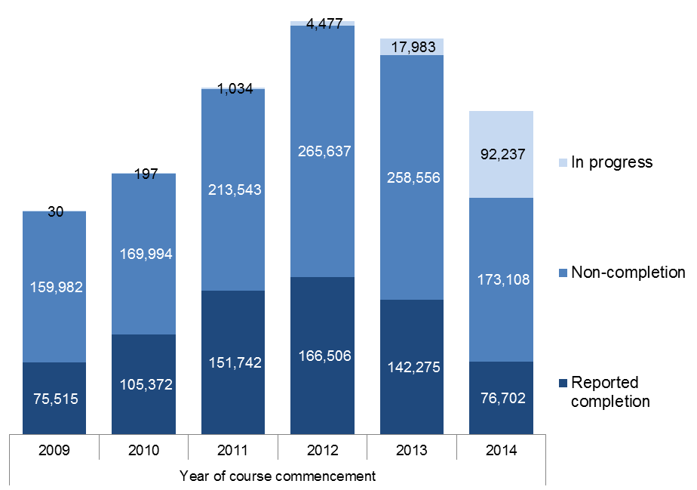

### Total completions reported by training providers

Prior to 2014 and the new approach to calculating course completions included in the previous section, the only information on course completions available for publication was the total number of course completions reported to the Department by training providers.

There are a number of limitations with this data:

* it is not readily possible to differentiate whether the completion was a government subsidised or fee-for-service course;
* data submitted by training providers includes course completions that may have occurred prior to the current year, for example in 2014 13 per cent of reported completions occurred in the years prior to 2014 when they were reported to the Department.

This section expands on course completion information, similar to that included in previous editions of the Training Market Report,

Key points

* There were 249,687 course completions reported to the Department in 2014 by training providers, this was up by 13 per cent on the 2013 result.
* Of these completions reported in 2014, 217,359 (87 per cent) were actually completed in 2014, 30,246 (12 per cent) were completed in 2013 and 2,082 (1 per cent) were completed in 2012 or earlier.

Table 1.10.1: Course completions reported by training providers (government subsidised and fee-for-service) in vocational training by when completion occurred, 2009 to 2014

|  |  |  |  |  |  |  |
| --- | --- | --- | --- | --- | --- | --- |
|  | **When completion was reported to the Department** | | | | | |
| **When the completion occurred** | **2009** | **2010** | **2011** | **2012** | **2013** | **2014** |
| Completion occurred in reported year | 108,780 | 126,471 | 159,067 | 209,422 | 182,988 | 217,359 |
| Completion occurred in previous year | 22,468 | 19,864 | 25,277 | 26,775 | 30,579 | 30,246 |
| Completion occurred 2 or more years earlier | 2,107 | 6,291 | 3,156 | 2,347 | 6,973 | 2,082 |
| **Total** | **133,355** | **152,626** | **187,500** | **238,544** | **220,540** | **249,687** |

Table 1.10.2: Change in number of course completions reported by training providers (government subsidised and fee-for-service) in vocational training by when completion occurred

|  |  |  |  |  |  |
| --- | --- | --- | --- | --- | --- |
| **When the completion occurred** | **% change 2009 to 2014** | **% change 2010 to 2014** | **% change 2011 to 2014** | **% change 2012 to 2014** | **% change 2013 to 2014** |
| Completion occurred in reported year | 100% | 72% | 37% | 4% | 19% |
| Completion occurred in the previous year | 35% | 52% | 20% | 13% | -1% |
| Completion occurred 2 or more years earlier | -1% | -67% | -34% | -11% | -70% |
| **Total** | **87%** | **64%** | **33%** | **5%** | **13%** |

Table 1.11.1: Course completions reported by training providers (government subsidised and fee-for-service) in vocational training by qualification level, 2009 to 2014

|  |  |  |  |  |  |  |
| --- | --- | --- | --- | --- | --- | --- |
|  | **When completion was reported to the Department** | | | | | |
|  | **2009** | **2010** | **2011** | **2012** | **2013** | **2014** |
| Cert I/II | 26,345 | 29,065 | 37,892 | 44,564 | 47,907 | 52,218 |
| Cert III/IV | 64,625 | 75,100 | 107,083 | 146,805 | 127,083 | 150,755 |
| Diploma & Above | 24,149 | 30,800 | 34,989 | 43,025 | 40,226 | 31,668 |
| Higher Education | 167 | 179 | 338 | 477 | 267 | 138 |
| Other | 17,934 | 17,418 | 6,998 | 3,306 | 4,795 | 12,657 |
| Secondary Education | 113 | 64 | 200 | 367 | 261 | 298 |
| **Total\*** | **133,355** | **152,626** | **187,500** | **238,544** | **220,540** | **249,687** |

* Total completions reported in 2009, 2013 and 2014 include courses that were not able to be coded into a qualification category (22, 1 and 1,953 completions, respectively).

Table 1.11.2: Change in number of course completions reported by training providers (government subsidised and fee-for-service) in vocational training by qualification level

|  |  |  |  |  |  |
| --- | --- | --- | --- | --- | --- |
|  | **% change 2009 to 2014** | **% change 2010 to 2014** | **% change 2011 to 2014** | **% change 2012 to 2014** | **% change 2013 to 2014** |
| Cert I/II | 98% | 80% | 38% | 17% | 9% |
| Cert III/IV | 133% | 101% | 41% | 3% | 19% |
| Diploma & Above | 31% | 3% | -9% | -26% | -21% |
| Higher Education | -17% | -23% | -59% | -71% | -48% |
| Other | -29% | -27% | 81% | 283% | 164% |
| Secondary Education | 164% | 366% | 49% | -19% | 14% |
| **Total\*** | **87%** | **64%** | **33%** | **5%** | **13%** |

* Total completions reported in 2009, 2013 and 2014 include courses that were not able to be coded into a qualification category (22, 1 and 1,953 completions, respectively).

## Age Profile

To support the increased workforce participation levels required by the Victorian economy over the next decade, improved engagement with education and training by all age groups is required.

### Government Subsidised Training

Key points

* Young people aged 15 to 24 accounted for 40 per cent of all students enrolled in government subsidised training in 2014, down from 41 per cent in 2013.
* The most significant decline in age groups between 2013 and 2014 was by 15 to 19 year olds. In 2014 there were 85,334 15-19 year olds enrolled in training, this was 18 per cent lower than the 2013 result.
* The numbers of students enrolled in government subsidised training in 2014 were lower than those in 2013 across all age groups.

Table 1.12.1: Students enrolled in government subsidised training by age group, 2009 to 2014

|  |  |  |  |  |  |  |
| --- | --- | --- | --- | --- | --- | --- |
|  | **2009** | **2010** | **2011** | **2012** | **2013** | **2014** |
| 15 to 19* | 75,957 | 88,258 | 108,720 | 120,467 | 104,562 | 85,334 |
| 20 to 24 | 59,188 | 71,432 | 87,796 | 100,938 | 96,335 | 93,105 |
| 25 to 44 | 102,418 | 112,644 | 148,488 | 180,197 | 178,871 | 167,117 |
| 45 to 64 | 52,853 | 60,225 | 77,134 | 96,372 | 93,068 | 87,389 |
| Other** | 9,186 | 6,667 | 8,142 | 11,823 | 11,929 | 10,742 |
| **Total** | **299,602** | **339,226** | **430,280** | **509,797** | **484,765** | **443,687** |

* From 2014 students still at school (covering the 15 to 19 age group) could no longer access Victorian Training Guarantee funded training, unless part of an approved School Based Apprenticeship or Traineeship (SBAT).

** Other includes age under 15 years old, 65 years and over or not stated.

Table 1.12.2: Change in number of students enrolled in government subsidised training by age group

|  |  |  |  |  |  |
| --- | --- | --- | --- | --- | --- |
|  | **% change 2009 to 2014** | **% change 2010 to 2014** | **% change 2011 to 2014** | **% change 2012 to 2014** | **% change 2013 to 2014** |
| 15 to 19* | 12% | -3% | -22% | -29% | -18% |
| 20 to 24 | 57% | 30% | 6% | -8% | -3% |
| 25 to 44 | 63% | 48% | 13% | -7% | -7% |
| 45 to 64 | 65% | 45% | 13% | -9% | -6% |
| Other** | 17% | 61% | 32% | -9% | -10% |
| **Total** | **48%** | **31%** | **3%** | **-13%** | **-8%** |

* From 2014 students still at school (covering the 15 to 19 age group) could no longer access Victorian Training Guarantee funded training, unless part of an approved School Based Apprenticeship or Traineeship (SBAT).

** Other includes age under 15 years old, 65 years and over or not stated.

### TAFE Domestic Fee-For-Service

Key points

* In 2014,there were 86,964students enrolled in TAFE fee-for-service at the Certificate I and above levels. Thirty nine per cent of these students were between 15 and 24years old.
* Student numbers in 2014 were higher than those in 2013 across all age groups.

Table 1.13.1: Students enrolled in TAFE fee-for-service at Certificate I and above coursesby age group, 2009 to 2014

|  |  |  |  |  |  |  |
| --- | --- | --- | --- | --- | --- | --- |
|  | **2009** | **2010** | **2011** | **2012** | **2013** | **2014** |
| 15 to 19 | 20,070 | 21,198 | 21,448 | 22,255 | 19,595 | 22,981 |
| 20 to 24 | 8,528 | 8,506 | 7,729 | 9,389 | 9,225 | 10,798 |
| 25 to 44 | 24,337 | 23,166 | 23,506 | 30,237 | 29,693 | 33,970 |
| 45 to 64 | 12,138 | 12,856 | 13,410 | 16,246 | 15,254 | 17,683 |
| Other* | 1,912 | 1,488 | 1,706 | 1,513 | 1,318 | 1,532 |
| **Total** | **66,985** | **67,214** | **67,799** | **79,640** | **75,085** | **86,964** |

*Other includes age under 15 years old, 65 years and over or not stated.

Table 1.13.2: Change in number of students enrolled in TAFE fee-for-service at Certificate I and above courses by age group

|  |  |  |  |  |  |
| --- | --- | --- | --- | --- | --- |
|  | **% change 2009 to 2014** | **% change 2010 to 2014** | **% change 2011 to 2014** | **% change 2012 to 2014** | **% change 2013 to 2014** |
| 15 to 19 | 15% | 8% | 4% | -3% | 17% |
| 20 to 24 | 46% | 48% | 63% | 15% | 14% |
| 25 to 44 | 73% | 83% | 80% | 19% | 15% |
| 45 to 64 | 72% | 64% | 58% | 16% | 22% |
| Other* | -10% | 16% | 1% | 6% | 19% |
| **Total** | **50%** | **50%** | **47%** | **12%** | **17%** |

*Other includes age under 15 years old, 65 years and over or not stated.

## Vocational Education and Training in Schools (VETiS)

VET in Schools (VETiS) is designed to expand opportunities and pathways for senior secondary students, and improve educational outcomes in line with the Victorian Government's objective to increase the number of young people completing Year 12 or equivalent. VETiS also addresses the skills and employment needs of industry in Victoria by providing young people in a senior secondary course with vocational training.

VETiS is defined as any nationally recognised vocational education and training that is counted as credit towards a senior secondary certificate, i.e. Victorian Certificate of Education (VCE) or the Victorian Certificate of Applied Learning (VCAL).

VET may be undertaken within VCE VET programs or through School Based Apprenticeships and Traineeships (SBAT), which includes part-time employment, part-time training, and part-time school; or through a recognition mechanism called Block Credit Recognition in the VCE.

This section provides an overview of students participating in VETiS and their certificate enrolments.Data is sourced from the annual statistical information of the Victorian Curriculum and Assessment Authority, with a summary available at:<http://www.vcaa.vic.edu.au/Pages/vce/statistics/subjectstats.aspx>.

Key points

* In 2014, there were 50,628 students who participated in VETiS, and just under 4,000 of them participated in a School Based Apprenticeships and Traineeships (SBAT) program.
* The overall student participation in VETiS in 2014 was 2 per cent higher than 2013. The increase in VETiS participation was due to the increases in school students and students who were enrolled in VCE/VCAL in the TAFE/University sectors.
* The majority of VETiS activity was delivered by VET providers, i.e. TAFEs, Universities, Learn Local and Private RTOs.

Figure 1.6: Number of students participating in VETiS by program type*,  
2009 to 2014

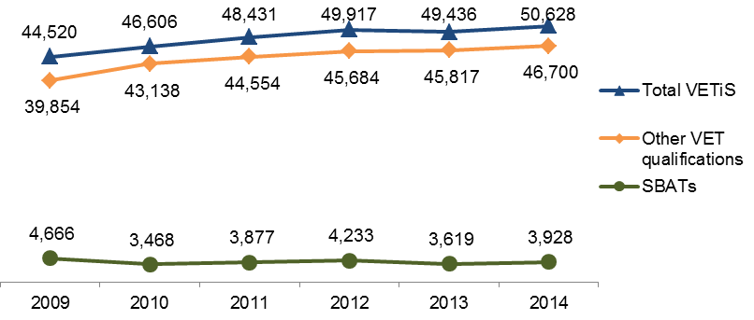

* Students who were enrolled in both SBAT and Other VET qualifications are counted only once in the SBAT category. In 2014, about 30 per cent of SBAT students were also enrolled in Other VET qualifications. This percentage ranges from 26 to 30 per cent between 2009 and 2014.

Table 1.14.1: Number of students participating in VETiS by program type,  
2009 to 2014

|  |  |  |  |  |  |  |
| --- | --- | --- | --- | --- | --- | --- |
|  | **2009** | **2010** | **2011** | **2012** | **2013** | **2014** |
| SBATs | 4,666 | 3,468 | 3,877 | 4,233 | 3,619 | 3,928 |
| Other VET qualifications | 39,854 | 43,138 | 44,554 | 45,684 | 45,817 | 46,700 |
| **Total VETiS** | **44,520** | **46,606** | **48,431** | **49,917** | **49,436** | **50,628** |

Table 1.14.2: Change in number of students participating in VETiS by program type

|  |  |  |  |  |  |
| --- | --- | --- | --- | --- | --- |
|  | **% change 2009 to 2014** | **% change 2010 to 2014** | **% change 2011 to 2014** | **% change 2012 to 2014** | **% change 2013 to 2014** |
| SBATs | -16% | 13% | 1% | -7% | 9% |
| Other VET qualifications | 17% | 8% | 5% | 2% | 2% |
| **Total VETiS** | **14%** | **9%** | **5%** | **1%** | **2%** |

Table 1.15.1: Students participating in VETiS by sector in which they were enrolled in, 2009 to 2014

|  |  |  |  |  |  |  |
| --- | --- | --- | --- | --- | --- | --- |
|  | **2009** | **2010** | **2011** | **2012** | **2013** | **2014** |
| VET - TAFE/University | 2,361 | 2,763 | 2,855 | 2,933 | 3,406 | 3,611 |
| VET - Learn Local/Private RTO | 808 | 777 | 860 | 1,077 | 1,172 | 1,157 |
| School | 41,351 | 43,066 | 44,716 | 45,907 | 44,858 | 45,860 |
| **Total** | **44,520** | **46,606** | **48,431** | **49,917** | **49,436** | **50,628** |

Table 1.15.2: Change in number of students participating in VETiS by sector in which they were enrolled in

|  |  |  |  |  |  |
| --- | --- | --- | --- | --- | --- |
|  | **% change 2009 to 2014** | **% change 2010 to 2014** | **% change 2011 to 2014** | **% change 2012 to 2014** | **% change 2013 to 2014** |
| VET - TAFE/University | 53% | 31% | 26% | 23% | 6% |
| VET - Learn Local/Private RTO | 43% | 49% | 35% | 7% | -1% |
| School | 11% | 6% | 3% | 0% | 2% |
| **Total** | **14%** | **9%** | **5%** | **1%** | **2%** |

Table 1.16.1: Certificate enrolments in VETiS by program type and sector in which training activity was delivered, 2009 to 2014

|  |  |  |  |  |  |  |
| --- | --- | --- | --- | --- | --- | --- |
|  | **2009** | **2010** | **2011** | **2012** | **2013** | **2014** |
|  | **School Based Apprenticeships and Traineeships (SBAT)** | | | | | |
| VET - TAFE/University | 2,346 | 2,017 | 1,355 | 1,312 | 1,843 | 1,920 |
| VET - Learn Local/Private RTO | 2,799 | 1,933 | 3,001 | 3,160 | 1,918 | 2,030 |
| School | 97 | 100 | 17 | 10 | 26 | 74 |
| **Total SBATs** | **5,242** | **4,050** | **4,373** | **4,482** | **3,787** | **4,024** |
|  | **Other VET qualification** | | | | | |
| VET - TAFE/University | 28,672 | 31,371 | 31,948 | 33,824 | 33,147 | 33,650 |
| VET - Learn Local/Private RTO | 16,001 | 18,049 | 20,218 | 21,056 | 22,868 | 24,633 |
| School | 10,861 | 10,336 | 10,509 | 9,076 | 8,661 | 8,050 |
| **Total other VET qualifications** | **55,534** | **59,756** | **62,675** | **63,956** | **64,676** | **66,333** |
| **Total VETiS** | **60,776** | **63,806** | **67,048** | **68,438** | **68,463** | **70,357** |

Table 1.16.2: Change in number of certificate enrolments in VETiS by program type and sector in which training activity was delivered

|  |  |  |  |  |  |
| --- | --- | --- | --- | --- | --- |
|  | **% change 2009 to 2014** | **% change 2010 to 2014** | **% change 2011 to 2014** | **% change 2012 to 2014** | **% change 2013 to 2014** |
|  | **School Based Apprenticeships and Traineeships (SBAT)** | | | | |
| VET - TAFE/University | -18% | -5% | 42% | 46% | 4% |
| VET - Learn Local/Private RTO | -27% | 5% | -32% | -36% | 6% |
| School | -24% | -26% | 335% | 640% | 185% |
| **Total SBATs** | **-23%** | **-1%** | **-8%** | **-10%** | **6%** |
|  | **Other VET qualification** | | | | |
| VET - TAFE/University | 17% | 7% | 5% | -1% | 2% |
| VET - Learn Local/Private RTO | 54% | 36% | 22% | 17% | 8% |
| School | -26% | -22% | -23% | -11% | -7% |
| **Total other VET qualifications** | **19%** | **11%** | **6%** | **4%** | **3%** |
| **Total VETiS** | **16%** | **10%** | **5%** | **3%** | **3%** |

## Gender

The vocational training system is also focused on accessibility and gender equality, ensuring all Victorians have the same opportunity to succeed in their lives and maintain well-being through education and training.

### Government Subsidised Training

Key points

* In 2014 there were 234,910 male students enrolled in government subsidised training, this was 9 per cent lower than in 2013.
* In 2014 there were 208,139 female students enrolled in government subsidised training, this was 8 per cent lower than in 2013.
* In 2014 about 47 per cent of all students enrolled in government subsidised training were female, this was similar to the 2013 result.

Table 1.17.1: Students enrolled in government subsidised training by gender,   
2009 to 2014

|  |  |  |  |  |  |  |
| --- | --- | --- | --- | --- | --- | --- |
|  | **2009** | **2010** | **2011** | **2012** | **2013** | **2014** |
| Female | 140,902 | 161,552 | 208,499 | 251,863 | 226,567 | 208,139 |
| Male | 157,257 | 176,404 | 220,712 | 257,188 | 257,600 | 234,910 |
| Not stated | 1,443 | 1,270 | 1,069 | 746 | 598 | 638 |
| **Total** | **299,602** | **339,226** | **430,280** | **509,797** | **484,765** | **443,687** |

Table 1.17.2: Change in number of students enrolled in government subsidised training by gender

|  |  |  |  |  |  |
| --- | --- | --- | --- | --- | --- |
|  | **% change 2009 to 2014** | **% change 2010 to 2014** | **% change 2011 to 2014** | **% change 2012 to 2014** | **% change 2013 to 2014** |
| Female | 48% | 29% | 0% | -17% | -8% |
| Male | 49% | 33% | 6% | -9% | -9% |
| Not stated | -56% | -50% | -40% | -14% | 7% |
| **Total** | **48%** | **31%** | **3%** | **-13%** | **-8%** |

## Government Subsidised Activity and Participation by Regions

Training data are presented for nine geographical regions to provide a greater level of detail on training delivery and participation.

### Delivery Region

This section focuses on the delivery of government subsidised training by location as defined by nine geographical regions. Training courses can be undertaken by both students who live locally and students who travel from outside the local area.

Key points

* All regions showed a decline between 2013 and 2014 in the number of government subsidised enrolments delivered in each region.
* The Hume region had the largest decrease between 2013 and 2014 of 35 per cent, while Northern Metropolitan Melbourne had the lowest with a decline of 4 per cent.

Table 1.18.1: Government subsidised enrolments by delivery region, 2009 to 2014

|  |  |  |  |  |  |  |
| --- | --- | --- | --- | --- | --- | --- |
|  | **2009** | **2010** | **2011** | **2012** | **2013** | **2014** |
| Barwon South West | 31,786 | 35,800 | 50,054 | 62,544 | 51,971 | 45,454 |
| Grampians | 16,194 | 15,005 | 17,187 | 18,867 | 17,876 | 16,440 |
| Loddon Mallee | 27,936 | 28,320 | 32,758 | 37,103 | 33,209 | 25,673 |
| Hume | 26,042 | 24,673 | 27,275 | 34,412 | 47,109 | 30,757 |
| Gippsland | 22,386 | 22,509 | 20,467 | 19,668 | 17,961 | 16,520 |
| Eastern Metropolitan | 52,174 | 60,140 | 73,646 | 75,971 | 68,097 | 56,149 |
| Western Metropolitan | 67,854 | 88,628 | 135,755 | 183,835 | 182,248 | 170,994 |
| Southern Metropolitan | 67,663 | 81,765 | 107,609 | 140,050 | 135,994 | 115,536 |
| Northern Metropolitan | 52,411 | 56,429 | 68,739 | 87,301 | 83,255 | 80,327 |
| Interstate | 64 | 115 | 59 | 122 | 257 | 5 |
| Other* | 13,384 | 14,969 | 17,494 | 14,888 | 11,910 | 2,888 |
| **Total** | **376,795** | **426,905** | **548,728** | **670,438** | **645,697** | **557,846** |

* Other includes on-line delivery and workplace delivery where the location cannot be defined.

Table 1.18.2: Change in number of government subsidised enrolments by delivery region, 2009 to 2014

|  |  |  |  |  |  |
| --- | --- | --- | --- | --- | --- |
|  | **% change 2009 to 2014** | **% change 2010 to 2014** | **% change 2011 to 2014** | **% change 2012 to 2014** | **% change 2013 to 2014** |
| Barwon South West | 43% | 27% | -9% | -27% | -13% |
| Grampians | 2% | 10% | -4% | -13% | -8% |
| Loddon Mallee | -8% | -9% | -22% | -31% | -23% |
| Hume | 18% | 25% | 13% | -11% | -35% |
| Gippsland | -26% | -27% | -19% | -16% | -8% |
| Eastern Metropolitan | 8% | -7% | -24% | -26% | -18% |
| Western Metropolitan | 152% | 93% | 26% | -7% | -6% |
| Southern Metropolitan | 71% | 41% | 7% | -18% | -15% |
| Northern Metropolitan | 53% | 42% | 17% | -8% | -4% |
| Interstate | -92% | -96% | -92% | -96% | -98% |
| Other* | -78% | -81% | -83% | -81% | -76% |
| **Total** | **48%** | **31%** | **2%** | **-17%** | **-14%** |

* Other includes on-line delivery and workplace delivery where the location cannot be defined.

### Participation

This section presents data on students undertaking government subsidised training by the area where they live. Areas are defined as nine geographical regions. Students may undertake their training locally or travel to locations outside their local region.

Key points

* All regions showed a decline in the number of students participating in government subsidised training between 2013 and 2014.
* The largest percentage decline between 2013 and 2014 in the number of students enrolled in government subsidised training was the Loddon Mallee region where there was a 15 per cent decline.
* Overall there was a 12 per cent decline between 2013 and 2014 in the number of students living in regional Victoria enrolled in government subsidised training. The decline in metropolitan Melbourne was 7 per cent over the same period.

Table 1.19.1: Students enrolled in government subsidised training by residential area – region, 2009 to 2014

|  |  |  |  |  |  |  |
| --- | --- | --- | --- | --- | --- | --- |
|  | **2009** | **2010** | **2011** | **2012** | **2013** | **2014** |
| Barwon South West | 26,278 | 28,984 | 36,062 | 41,302 | 36,727 | 31,564 |
| Grampians | 14,438 | 15,359 | 18,447 | 21,360 | 19,831 | 17,961 |
| Loddon Mallee | 21,028 | 21,900 | 27,376 | 31,471 | 27,989 | 23,912 |
| Hume | 19,902 | 20,003 | 23,155 | 26,487 | 26,072 | 23,846 |
| Gippsland | 19,053 | 20,661 | 21,516 | 21,192 | 20,333 | 17,952 |
| Eastern Metropolitan | 44,874 | 51,570 | 65,838 | 75,192 | 66,844 | 58,653 |
| Western Metropolitan | 40,297 | 48,153 | 67,500 | 89,683 | 89,085 | 85,614 |
| Southern Metropolitan | 60,913 | 71,373 | 94,333 | 116,134 | 112,601 | 102,082 |
| Northern Metropolitan | 46,638 | 53,901 | 70,266 | 79,622 | 78,148 | 74,385 |
| Interstate | 4,513 | 4,767 | 5,301 | 6,321 | 5,773 | 5,740 |
| Other* | 1,668 | 2,555 | 486 | 1,033 | 1,362 | 1,978 |
| **Total** | **299,602** | **339,226** | **430,280** | **509,797** | **484,765** | **443,687** |

* Other includes not stated and unknown.

Table 1.19.2: Change in number of students enrolled in government subsidised training by residential area – region

|  |  |  |  |  |  |
| --- | --- | --- | --- | --- | --- |
|  | **% change 2009 to 2014** | **% change 2010 to 2014** | **% change 2011 to 2014** | **% change 2012 to 2014** | **% change 2013 to 2014** |
| Barwon South West | 20% | 9% | -12% | -24% | -14% |
| Grampians | 24% | 17% | -3% | -16% | -9% |
| Loddon Mallee | 14% | 9% | -13% | -24% | -15% |
| Hume | 20% | 19% | 3% | -10% | -9% |
| Gippsland | -6% | -13% | -17% | -15% | -12% |
| Eastern Metropolitan | 31% | 14% | -11% | -22% | -12% |
| Western Metropolitan | 112% | 78% | 27% | -5% | -4% |
| Southern Metropolitan | 68% | 43% | 8% | -12% | -9% |
| Northern Metropolitan | 59% | 38% | 6% | -7% | -5% |
| Interstate | 27% | 20% | 8% | -9% | -1% |
| Other* | 19% | -23% | 307% | 91% | 45% |
| **Total** | **48%** | **31%** | **3%** | **-13%** | **-8%** |

* Other includes not stated and unknown.

### Participation Rates of 15 to 64 Year olds

This section presents estimates of the proportion of the population undertaking government subsidised training over time and by geographical region. Areas are defined as nine geographical regions. Students may undertake their training locally or travel to locations outside their local region.

Key points

* In 2014 10.9 per cent (about 1 in 10) of 15 to 64 year olds in the Victorian population were participating in government subsidised training, this was down on 2013 by 1.2 percentage points.
* By geographical region where the student resides, the Hume region had the highest participation rate at 14 per cent in 2014 and Eastern Metropolitan Melbourne had the lowest at 8 per cent.

Figure 1.7: Estimated participation rate of students aged 15 to 64 years in government subsidised training, 2009 to 2014

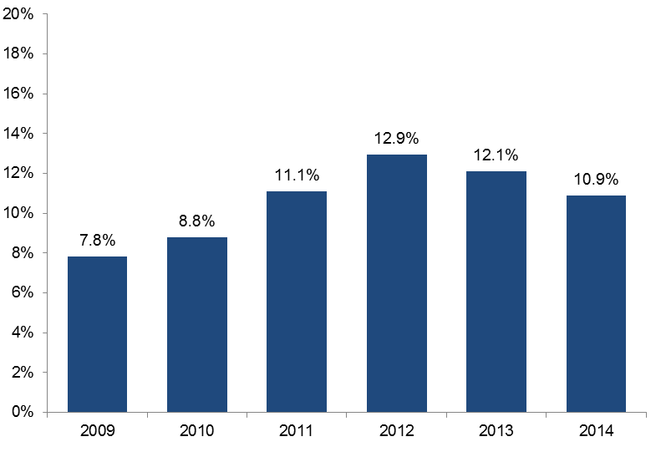

Figure 1.8: Estimated participation rate of students aged 15 to 64 years in government subsidised training by region, 2013 and 2014

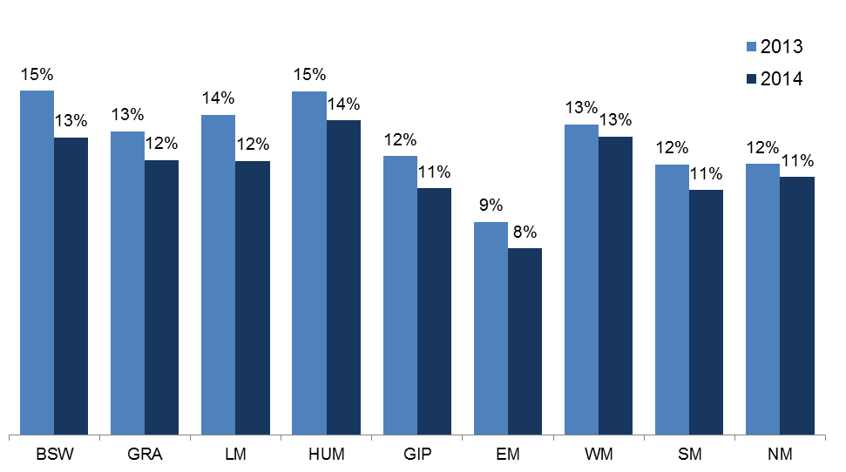

The 2013 estimated resident population published by the Australian Bureau of Statistics were used to calculate the participation rate for each regional area in both 2013 and 2014 as the 2014 population data at the sub-state level was not yet available.

|  |  |
| --- | --- |
| Barwon South West | BSW |
| Grampians | GRA |
| Loddon Mallee | LM |
| Hume | HUM |
| Gippsland | GIP |
| Eastern Metropolitan | EM |
| Western Metropolitan | WM |
| Southern Metropolitan | SM |
| Northern Metropolitan | NM |

## Government Subsidised Training by Training Provider Type

Key points

* All provider types, except Private Registered Training Organisations (RTO), showed a decline in the number of government subsidised enrolments between 2013 and 2014. Private RTOs showed a marginal increase of 1,538.
* In 2014 over half (56 per cent) of all government subsidised enrolments were with Private RTOs. The share held by TAFEs was 25 per cent in 2014, down from 32 per cent in 2013.

Table 1.20: Government subsidised training providers by sector, 2009 to 2014

|  |  |  |  |  |  |  |
| --- | --- | --- | --- | --- | --- | --- |
|  | **2009** | **2010** | **2011** | **2012** | **2013** | **2014** |
| Learn Local | 320 | 316 | 309 | 298 | 283 | 280 |
| University | 4 | 4 | 4 | 4 | 4 | 4 |
| PrivateRTO | 246 | 344 | 422 | 445 | 428 | 411 |
| TAFE | 14 | 14 | 14 | 14 | 14 | 12 |

In February 2015, when the 2014 data was extracted, there were 499 contracted training providers.

Table 1.21.1: Number of government subsidised enrolments by sector, 2009 to 2014

|  |  |  |  |  |  |  |
| --- | --- | --- | --- | --- | --- | --- |
|  | **2009** | **2010** | **2011** | **2012** | **2013** | **2014** |
| Learn Local | 68,304 | 63,810 | 64,573 | 80,217 | 74,136 | 70,064 |
| University | 68,461 | 76,331 | 69,869 | 68,052 | 51,483 | 34,927 |
| Private RTO | 57,412 | 99,758 | 220,695 | 308,829 | 312,135 | 313,673 |
| TAFE | 182,618 | 187,006 | 193,591 | 213,340 | 207,943 | 139,182 |
| **Total** | **376,795** | **426,905** | **548,728** | **670,438** | **645,697** | **557,846** |

Table 1.21.2: Change in number of government subsidised enrolments by sector

|  |  |  |  |  |  |
| --- | --- | --- | --- | --- | --- |
|  | **% change 2009 to 2014** | **% change 2010 to 2014** | **% change 2011 to 2014** | **% change 2012 to 2014** | **% change 2013 to 2014** |
| Learn Local | 3% | 10% | 9% | -13% | -5% |
| University | -49% | -54% | -50% | -49% | -32% |
| Private RTO | 446% | 214% | 42% | 2% | 0% |
| TAFE | -24% | -26% | -28% | -35% | -33% |
| **Total** | **48%** | **31%** | **2%** | **-17%** | **-14%** |

Table 1.22: Percentage share of government subsidised enrolments for each year by sector, 2009 to 2014

|  |  |  |  |  |  |  |
| --- | --- | --- | --- | --- | --- | --- |
|  | **2009** | **2010** | **2011** | **2012** | **2013** | **2014** |
| Learn Local | 18% | 15% | 12% | 12% | 11% | 13% |
| University | 18% | 18% | 13% | 10% | 8% | 6% |
| Private RTO | 15% | 23% | 40% | 46% | 48% | 56% |
| TAFE | 48% | 44% | 35% | 32% | 32% | 25% |
| Total | **100%** | **100%** | **100%** | **100%** | **100%** | **100%** |

Figure 1.9: Percentage share of government subsidised enrolments by sector, 2009 to 2014

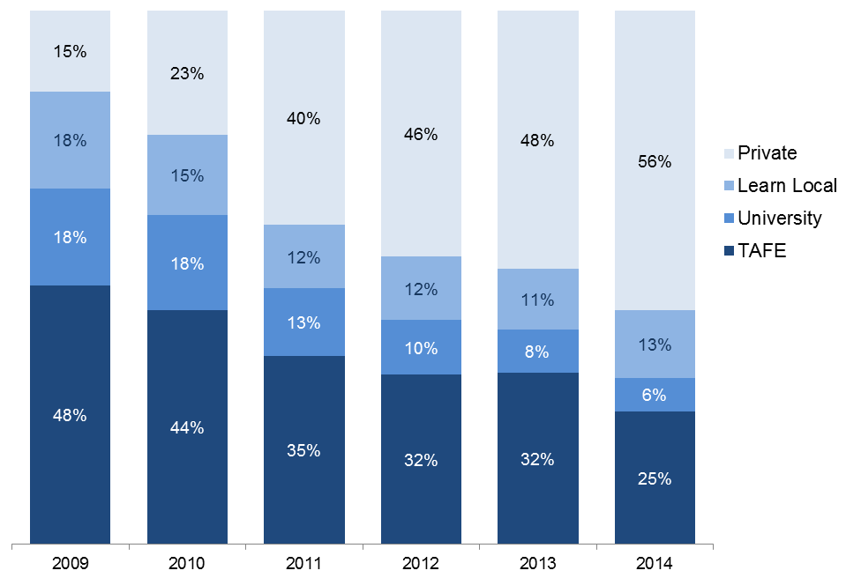

Table 1.23: Government subsidised course enrolments (AQF I and higher only), proportional share across sectors by occupation, 2014

*Percentages total across rows in the table below*

|  |  |  |  |  |  |
| --- | --- | --- | --- | --- | --- |
|  | **TAFE** | **Univer-sity** | **Private RTO** | **Learn Local** | **Total (number)** |
| Clerical and Administrative Workers | 12% | 4% | 82% | 3% | 59,804 |
| Community and Personal Service Workers | 17% | 5% | 70% | 8% | 124,475 |
| Labourers | 32% | 4% | 61% | 3% | 32,654 |
| Machinery Operators and Drivers | 13% | 0% | 87% | 0% | 58,979 |
| Managers | 40% | 3% | 56% | 2% | 13,980 |
| Professionals | 34% | 20% | 43% | 3% | 23,554 |
| Sales Workers | 18% | 4% | 76% | 2% | 9,591 |
| Technicians and Trades Workers | 45% | 12% | 42% | 1% | 116,603 |
| Other* | 23% | 6% | 52% | 18% | 57,321 |
| **Total (AQF I+ only)** | **26%** | **7%** | **63%** | **5%** | **496,961** |

*Other includes foundation skills and LOTE courses, and courses that were not able to be coded directlyinto the Australian and New Zealand Standard Classification of Occupation.

Table 1.24: Government subsidised course enrolments (AQF I and higher only), proportional share across sectors by industry, 2014

*Percentages total across rows in the table below*

|  |  |  |  |  |  |
| --- | --- | --- | --- | --- | --- |
|  | **TAFE** | **Univer-sity** | **Private RTO** | **Learn Local** | **Total (number)** |
| Accommodation and Food Services | 25% | 0% | 71% | 3% | 28,446 |
| Administrative and Support Services | 28% | 1% | 68% | 3% | 11,084 |
| Agriculture, Forestry and Fishing | 58% | 1% | 40% | 1% | 11,884 |
| Arts and Recreation Services | 41% | 12% | 45% | 3% | 12,199 |
| Construction | 46% | 13% | 40% | 0% | 59,589 |
| Cross-industry | 15% | 7% | 76% | 3% | 55,176 |
| Education and Training | 27% | 7% | 56% | 11% | 9,585 |
| Electricity, Gas, Water and Waste Services | 56% | 11% | 33% | 0% | 1,019 |
| Financial and Insurance Services | 5% | 4% | 90% | 0% | 2,757 |
| Health Care and Social Assistance | 17% | 5% | 68% | 9% | 104,613 |
| Information Media and Telecommunications | 39% | 38% | 22% | 1% | 3,236 |
| Manufacturing | 21% | 5% | 74% | 0% | 44,759 |
| Mining | 78% | 0% | 22% | 0% | 347 |
| Other Services | 40% | 5% | 53% | 2% | 20,277 |
| Professional, Scientific and Technical Services | 48% | 35% | 17% | 0% | 10,560 |
| Public Administration and Safety | 17% | 6% | 76% | 0% | 8,562 |
| Rental, Hiring and Real Estate Services | 46% | 6% | 47% | 0% | 1,890 |
| Retail Trade | 27% | 5% | 66% | 2% | 9,934 |
| Transport, Postal and Warehousing | 14% | 0% | 86% | 0% | 42,885 |
| Wholesale Trade | 5% | 3% | 92% | 0% | 837 |
| Other* | 23% | 6% | 52% | 18% | 57,321 |
| **Total (AQF I+ only)** | **26%** | **7%** | **63%** | **5%** | **496,961** |

*Other includes foundation skills and LOTE courses, and courses that were not able to be coded directly into the Australian and New Zealand Standard Industry Classification.

## TAFE Performance

TAFEs are valued public institutions that play a significant role in meeting the needs of the economy while also strengthening their communities. TAFEs work to address skills needs, support the development of work-ready training graduates and lower barriers to participation for disadvantaged and high needs learners across the state.

This section provides an overview of the training activity of TAFEs. It includes information on both government subsidised training and fee-for-service training activity.

### TAFE – Overall delivery

Key points

* In 2014 there were a total of 220,020 students studying at TAFE, in government subsidised and fee-for-service (AQF and non-AQF). This was the lowest over 2009 to 2014 and 6 per cent lower than 2013.
* In 2014 overall training activity by TAFEs, including all government subsidised and all fee-for-service (AQF and non-AQF) course enrolments were the lowest over 2009 to 2014 at 289,591in 2014. The 2014 result was down by 15 per cent compared to 2013.

Table 1.25.1: Students in government subsidised and fee-for-service training by TAFE, 2009 to 2014

|  |  |  |  |  |  |  |
| --- | --- | --- | --- | --- | --- | --- |
|  | **2009** | **2010** | **2011** | **2012** | **2013** | **2014** |
| Government subsidised | 145,894 | 147,608 | 141,216 | 143,806 | 140,318 | 111,232 |
| Fee-for-service* | 139,928 | 131,592 | 122,213 | 123,803 | 107,147 | 119,323 |
| **Total\*\*** | **268,635** | **262,115** | **249,139** | **254,029** | **234,714** | **220,020** |

* Includes students studying AQF and non-AQF course of study

** Government subsidised and fee-for-service enrolments do not add to the total as a student may be enrolled in both at the same time

Table 1.25.2: Change in number of students enrolled in government subsidised and fee-for-service training by TAFE

|  |  |  |  |  |  |
| --- | --- | --- | --- | --- | --- |
|  | **% change 2009 to 2014** | **% change 2010 to 2014** | **% change 2011 to 2014** | **% change 2012 to 2014** | **% change 2013 to 2014** |
| Government subsidised | -24% | -25% | -21% | -23% | -21% |
| Fee-for-service* | -15% | -9% | -2% | -4% | 11% |
| **Total\*\*** | **-18%** | **-16%** | **-12%** | **-13%** | **-6%** |

* Includes students studying AQF and non-AQF course of study

** Government subsidised and fee-for-service enrolments do not add to the total as a student may be enrolled in both at the same time

Table 1.26.1: Government subsidised and fee-for-service enrolments by TAFE, 2009 to 2014

|  |  |  |  |  |  |  |
| --- | --- | --- | --- | --- | --- | --- |
|  | **2009** | **2010** | **2011** | **2012** | **2013** | **2014** |
| Government subsidised | 182,618 | 187,006 | 193,591 | 213,340 | 207,943 | 139,182 |
| Fee-for-service | 160,631 | 151,513 | 142,435 | 152,012 | 131,921 | 150,409 |
| *AQF level 1+* | *72,586* | *72,658* | *73,875* | *97,216* | *92,925* | *108,755* |
| *Non-AQF* | *88,045* | *78,855* | *68,560* | *54,796* | *38,996* | *41,654* |
| **Total** | **343,249** | **338,519** | **336,026** | **365,352** | **339,864** | **289,591** |

*Includes short courses, statement of attainment and secondary education

Table 1.26.2: Change in number of government subsidised and fee-for-service enrolments by TAFE

|  |  |  |  |  |  |
| --- | --- | --- | --- | --- | --- |
|  | **% change 2009 to 2014** | **% change 2010 to 2014** | **% change 2011 to 2014** | **% change 2012 to 2014** | **% change 2013 to 2014** |
| Government subsidised | -24% | -26% | -28% | -35% | -33% |
| Fee-for-service | -6% | -1% | 6% | -1% | 14% |
| *AQF level 1+* | *50%* | *50%* | *47%* | *12%* | *17%* |
| *Non-AQF* | *-53%* | *-47%* | *-39%* | *-24%* | *7%* |
| **Total** | **-16%** | **-14%** | **-14%** | **-21%** | **-15%** |

*Includes short courses, statement of attainment and secondary education

### TAFE Government Subsidised Training – Apprenticeships and Traineeships

Key points

* TAFEs are a major provider of apprentice training, in 2014 there were 26,069 government subsidised apprentice enrolments delivered by TAFEs, which represented a 60 per cent share of all government subsidised apprentice enrolments across all sectors.
* In 2014 TAFEs delivered 6,485 government subsidised trainee enrolments, which accounted for a 17 per cent share of all government subsidised trainee enrolments.

Table 1.27: Government subsidised apprentice enrolments by TAFE,   
2009 to 2014

|  |  |  |  |  |  |  |
| --- | --- | --- | --- | --- | --- | --- |
|  | **2009** | **2010** | **2011** | **2012** | **2013** | **2014** |
| Number | 27,004 | 29,024 | 28,744 | 27,742 | 26,317 | 26,069 |
| TAFE share | 65% | 64% | 62% | 62% | 61% | 60% |

Table 1.28:Government subsidised trainee enrolments by TAFE, 2009 to 2014

|  |  |  |  |  |  |  |
| --- | --- | --- | --- | --- | --- | --- |
|  | **2009** | **2010** | **2011** | **2012** | **2013** | **2014** |
| Number | 14,315 | 13,033 | 12,270 | 12,312 | 8,011 | 6,485 |
| TAFE Share | 29% | 23% | 15% | 14% | 14% | 17% |

### TAFE Government Subsidised Training – Learners Facing Barriers

Key points

* In 2014there were 2,095 Indigenous students enrolled in government subsidised training at TAFEs. This represented a 34 per cent share of all Indigenous students in government subsidised training across all sectors in 2014.
* In 2014 there were 22,246 unemployed students enrolled in government subsidised training in TAFE. This represented a 16 per cent share of all unemployed students in government subsidised training.
* In 2014 there were 8,400 student with a disability enrolled in government subsidised training at TAFEs. This represented a 20 per cent share of all disabled students in government subsidised training.
* In 2014 there were 19,584 students from a culturally and linguistically diverse background (CALD) enrolled in government subsidised training at TAFEs. This represented a 14 per cent share of all CALD students in government subsidised training.
* In 2014 there were 10,059 young people without at least Year 12 or a Certificate II, not at school and enrolled in government subsidised training in a Certificate II or above in TAFE. This represented a 45 per cent of all these students in government subsidised training in 2014.
* In 2014 there were 55,081 older students not holding a Certificate III or above and enrolled in government subsidised training in TAFE. This represented a 22 per cent share of all these students in government subsidised training in 2014.

Table 1.29: Indigenous students enrolled in government subsidised training in TAFE, 2009 to 2014

|  |  |  |  |  |  |  |
| --- | --- | --- | --- | --- | --- | --- |
|  | **2009** | **2010** | **2011** | **2012** | **2013** | **2014** |
| Number | 2,435 | 2,602 | 2,523 | 2,283 | 2,390 | 2,095 |
| TAFE Share | 56% | 54% | 45% | 37% | 37% | 34% |

Table 1.30: Unemployed students enrolled in government subsidised training in TAFE, 2009 to 2014

|  |  |  |  |  |  |  |
| --- | --- | --- | --- | --- | --- | --- |
|  | **2009** | **2010** | **2011** | **2012** | **2013** | **2014** |
| Number | 24,578 | 25,388 | 25,816 | 27,059 | 29,503 | 22,246 |
| TAFE Share | 49% | 41% | 29% | 23% | 22% | 16% |

Table 1.31: Disabled students enrolled in government subsidised training in TAFE, 2009 to 2014

|  |  |  |  |  |  |  |
| --- | --- | --- | --- | --- | --- | --- |
|  | **2009** | **2010** | **2011** | **2012** | **2013** | **2014** |
| Number | 10,270 | 10,821 | 11,203 | 10,437 | 9,780 | 8,400 |
| TAFE Share | 43% | 40% | 33% | 26% | 24% | 20% |

**Table 1.32: Culturally and Linguistically Diverse (CALD) students enrolled in government subsidised training in TAFE, 2009 to 2014**

|  |  |  |  |  |  |  |
| --- | --- | --- | --- | --- | --- | --- |
|  | **2009** | **2010** | **2011** | **2012** | **2013** | **2014** |
| Number | 28,187 | 27,355 | 25,510 | 22,963 | 26,877 | 19,584 |
| TAFE Share | 45% | 39% | 26% | 18% | 20% | 14% |

Table 1.33: Young people without at least Year 12 or a Certificate II, not at school and enrolled in government subsidised training in Certificate II or above in TAFE, 2009 to 2014

|  |  |  |  |  |  |  |
| --- | --- | --- | --- | --- | --- | --- |
|  | **2009** | **2010** | **2011** | **2012** | **2013** | **2014** |
| Number | 13,766 | 13,590 | 12,796 | 11,981 | 10,023 | 10,059 |
| TAFE Share | 61% | 52% | 44% | 41% | 41% | 45% |

Table 1.34: Older students not holding a Certificate III or above and enrolled in government subsidised training in TAFE, 2009 to 2014

|  |  |  |  |  |  |  |
| --- | --- | --- | --- | --- | --- | --- |
|  | **2009** | **2010** | **2011** | **2012** | **2013** | **2014** |
| Number | 63,479 | 64,471 | 69,130 | 71,145 | 69,719 | 55,081 |
| TAFE Share | 48% | 43% | 32% | 27% | 27% | 22% |

### TAFE Fee-For-Service Training Activity

Fee-for-service activity includes both AQF (Certificate I or above) and non-AQF (statement of attainment, short courses and secondary education). This section provides an overview of total fee-for-service activity by TAFEs.

Key points

* In 2014 33 per cent of TAFE fee-for-service enrolments (including AQF and non-AQF) were at the Certificate I and II level.
* In 2014 25 to 44 year olds had the highest level of fee-for-service enrolments at TAFE at 62,734, which represented 42 per cent of all TAFE fee-for-service enrolments.
* In 2014 50,859 fee-for-service enrolments were delivered in regional Victoria, this was up by 17 per cent on 2013.
* In 2014 95,994 fee-for-service enrolments were delivered in metropolitan Melbourne by TAFEs, this was up by 21 per cent on 2013.
* In 2014 the top occupation was Food Preparation Assistants with 10,785 fee-for-service enrolments, up on 2013 by 79 per cent.

Table 1.35.1: Total fee-for-service (AQF and non-AQF) enrolments by TAFE by qualification level, 2009 to 2014

|  |  |  |  |  |  |  |
| --- | --- | --- | --- | --- | --- | --- |
|  | **2009** | **2010** | **2011** | **2012** | **2013** | **2014\*** |
| Cert I/II | 34,402 | 35,171 | 35,799 | 46,469 | 44,521 | 50,024 |
| Cert III/IV | 32,473 | 31,973 | 32,058 | 43,203 | 40,126 | 49,190 |
| Diploma & Above | 4,683 | 4,258 | 4,633 | 5,948 | 6,833 | 8,066 |
| Higher Education | 1,028 | 1,256 | 1,385 | 1,596 | 1,445 | 1,475 |
| Module Only | 0 | 0 | 0 | 0 | 0 | 574 |
| Other | 87,987 | 78,836 | 68,503 | 54,516 | 38,569 | 40,301 |
| Secondary Education | 58 | 19 | 57 | 273 | 427 | 454 |
| **Total** | **160,631** | **151,513** | **142,435** | **152,012** | **131,921** | **150,409** |
| *325 unknown in 2014 | | | | |  |  |

Table 1.35.2: Total fee-for-service (AQF and non-AQF) enrolments by TAFE by qualification level, 2009 to 2014

|  |  |  |  |  |  |
| --- | --- | --- | --- | --- | --- |
|  | **% change 2009 to 2014** | **% change 2010 to 2014** | **% change 2011 to 2014** | **% change 2012 to 2014** | **% change 2013 to 2014** |
| Cert I/II | 45% | 42% | 40% | 8% | 12% |
| Cert III/IV | 51% | 54% | 53% | 14% | 23% |
| Diploma & Above | 72% | 89% | 74% | 36% | 18% |
| Higher Education | 43% | 17% | 6% | -8% | 2% |
| Module Only | - | - | - | - | - |
| Other | -54% | -49% | -41% | -26% | 4% |
| Secondary Education | 683% | 2289% | 696% | 66% | 6% |
| **Total** | **-6%** | **-1%** | **6%** | **-1%** | **14%** |

Table 1.36.1: Fee-for-service (AQF and non-AQF) enrolments by TAFE by age, 2009 to 2014

|  |  |  |  |  |  |  |
| --- | --- | --- | --- | --- | --- | --- |
|  | **2009** | **2010** | **2011** | **2012** | **2013** | **2014** |
| 15 to 19 | 33,339 | 32,438 | 31,117 | 31,782 | 25,904 | 31,021 |
| *At school* | *17,008* | *19,135* | *20,502* | *21,081* | *18,302* | *20,418* |
| *Not at School* | *16,331* | *13,303* | *10,615* | *10,701* | *7,602* | *10,603* |
| 20 to 24 | 20,749 | 20,332 | 17,981 | 19,956 | 18,113 | 20,652 |
| 25 to 44 | 63,026 | 59,294 | 56,151 | 62,389 | 56,230 | 62,734 |
| 45 to 64 | 36,481 | 36,513 | 34,211 | 34,627 | 28,898 | 33,212 |
| Other* | 7,036 | 2,936 | 2,975 | 3,258 | 2,776 | 2,790 |
| **Total** | **160,631** | **151,513** | **142,435** | **152,012** | **131,921** | **150,409** |

* Other includes age under 15 years old, 65 years and over or not stated.

Table 1.36.2: Change in number of fee-for-service (AQF and non-AQF) enrolments by TAFE by age

|  |  |  |  |  |  |
| --- | --- | --- | --- | --- | --- |
|  | **% change 2009 to 2014** | **% change 2010 to 2014** | **% change 2011 to 2014** | **% change 2012 to 2014** | **% change 2013 to 2014** |
| 15 to 19 | -7% | -4% | 0% | -2% | 20% |
| *At school* | *20%* | *7%* | *0%* | *-3%* | *12%* |
| *Not at School* | *-35%* | *-20%* | *0%* | *-1%* | *39%* |
| 20 to 24 | 0% | 2% | 15% | 3% | 14% |
| 25 to 44 | 0% | 6% | 12% | 1% | 12% |
| 45 to 64 | -9% | -9% | -3% | -4% | 15% |
| Other* | -60% | -5% | -6% | -14% | 1% |
| **Total** | **-6%** | **-1%** | **6%** | **-1%** | **14%** |

* Other includes age under 15 years old, 65 years and over or not stated.

Table 1.37.1: Fee-for-service (AQF and non-AQF) enrolments by TAFE by delivery region, 2009 to 2014

|  |  |  |  |  |  |  |
| --- | --- | --- | --- | --- | --- | --- |
|  | **2009** | **2010** | **2011** | **2012** | **2013** | **2014** |
| Barwon South West | 19,066 | 18,046 | 16,832 | 17,040 | 12,734 | 11,505 |
| Grampians | 186 | 0 | 0 | 0 | 0 | 266 |
| Loddon Mallee | 8,519 | 7,251 | 6,392 | 8,780 | 7,224 | 8,244 |
| Hume | 15,817 | 17,236 | 15,166 | 16,811 | 14,760 | 15,834 |
| Gippsland | 11,343 | 10,985 | 12,700 | 14,852 | 8,872 | 15,010 |
| Eastern Metropolitan | 10,704 | 9,262 | 8,256 | 7,109 | 7,317 | 9,534 |
| Western Metropolitan | 21,604 | 20,464 | 17,546 | 23,634 | 20,603 | 27,978 |
| Southern Metropolitan | 32,860 | 31,755 | 28,911 | 28,204 | 30,835 | 36,905 |
| Northern Metropolitan | 24,411 | 21,406 | 21,393 | 20,672 | 20,747 | 21,577 |
| Interstate | 791 | 153 | 180 | 435 | 1,947 | 4,068 |
| Other | 15,436 | 15,041 | 15,149 | 14,867 | 7,413 | 0 |
| **Total** | **160,631** | **151,513** | **142,435** | **152,012** | **131,921** | **150,409** |

Table 1.37.2: Change in number of fee-for-service (AQF and non-AQF) enrolments by TAFE by delivery region

|  |  |  |  |  |  |
| --- | --- | --- | --- | --- | --- |
|  | **% change 2009 to 2014** | **% change 2010 to 2014** | **% change 2011 to 2014** | **% change 2012 to 2014** | **% change 2013 to 2014** |
| Barwon South West | -40% | -36% | -32% | -32% | -10% |
| Grampians | 43% | - | - | - | - |
| Loddon Mallee | -3% | 14% | 29% | -6% | 14% |
| Hume | 0% | -8% | 4% | -6% | 7% |
| Gippsland | 32% | 37% | 18% | 1% | 69% |
| Eastern Metropolitan | -11% | 3% | 15% | 34% | 30% |
| Western Metropolitan | 30% | 37% | 59% | 18% | 36% |
| Southern Metropolitan | 12% | 16% | 28% | 31% | 20% |
| Northern Metropolitan | -12% | 1% | 1% | 4% | 4% |
| Interstate | 414% | 2559% | 2160% | 835% | 109% |
| Other | -100% | -100% | -100% | -100% | -100% |
| **Total** | **-6%** | **-1%** | **6%** | **-1%** | **14%** |

Table 1.38.1: Top 10 occupations for fee-for-service (AQF and non-AQF) enrolments by TAFE, 2009 to 2014

|  |  |  |  |  |  |  |
| --- | --- | --- | --- | --- | --- | --- |
|  | **2009** | **2010** | **2011** | **2012** | **2013** | **2014** |
| Food Preparation Assistants | 6,938 | 6,757 | 6,564 | 7,236 | 6,013 | 10,785 |
| Personal Carers and Assistants | 2,722 | 2,747 | 2,145 | 8,715 | 6,602 | 7,339 |
| Construction and Mining Labourers | 2,103 | 6,662 | 6,749 | 6,670 | 5,244 | 5,436 |
| Tertiary Education Teachers | 3,695 | 3,251 | 4,453 | 4,961 | 5,109 | 4,481 |
| Stationary Plant Operators | 1,576 | 1,385 | 3,110 | 4,587 | 4,372 | 4,238 |
| Miscellaneous Labourers | 2,575 | 2,559 | 3,097 | 3,306 | 3,465 | 4,056 |
| Farm, Forestry and Garden Workers | 3,058 | 2,774 | 3,427 | 3,194 | 3,394 | 3,569 |
| Building and Engineering Technicians | 762 | 904 | 1,635 | 2,323 | 3,077 | 3,357 |
| Cleaners and Laundry Workers | 3,736 | 2,395 | 2,138 | 2,528 | 2,903 | 2,931 |
| Food Trades Workers | 1,353 | 1,404 | 1,565 | 1,664 | 1,892 | 2,695 |
| Other/unknown* | 132,113 | 120,675 | 107,552 | 106,828 | 89,850 | 101,522 |
| **Total** | **160,631** | **151,513** | **142,435** | **152,012** | **131,921** | **150,409** |

* Including training not directly related to an occupation

Table 1.38.2: Change in the number of the top 10 occupations for fee-for-service (AQFand non-AQF) enrolments by TAFE

|  |  |  |  |  |  |
| --- | --- | --- | --- | --- | --- |
|  | **% change 2009 to 2014** | **% change 2010 to 2014** | **% change 2011 to 2014** | **% change 2012 to 2014** | **% change 2013 to 2014** |
| Food Preparation Assistants | 55% | 60% | 64% | 49% | 79% |
| Personal Carers and Assistants | 170% | 167% | 242% | -16% | 11% |
| Construction and Mining Labourers | 158% | -18% | -19% | -19% | 4% |
| Tertiary Education Teachers | 21% | 38% | 1% | -10% | -12% |
| Stationary Plant Operators | 169% | 206% | 36% | -8% | -3% |
| Miscellaneous Labourers | 58% | 58% | 31% | 23% | 17% |
| Farm, Forestry and Garden Workers | 17% | 29% | 4% | 12% | 5% |
| Building and Engineering Technicians | 341% | 271% | 105% | 45% | 9% |
| Cleaners and Laundry Workers | -22% | 22% | 37% | 16% | 1% |
| Food Trades Workers | 99% | 92% | 72% | 62% | 42% |
| Other/unknown* | -23% | -16% | -6% | -5% | 13% |
| **Total** | **-6%** | **-1%** | **6%** | **-1%** | **14%** |

* Including training not directly related to an occupation

## Learn Local Performance

Through the Adult, Community and Further Education (ACFE) Board in 2014, the Victorian Government supported 314 Learn Local providers and two Adult Education Institutions (AEIs), the Council for Adult Education (CAE) and Adult Multicultural Education Services (AMES). Learn Local providers and adult education institutions deliver pre-accredited programs to Victorians with limited prior educational attainment and limited access to vocational education and training. For that education and training delivery, Learn Local (ACE) providers were contracted an allocation of scheduled pre-accredited training hours for approved courses that supported adult learners, their communities and that created pathways to nationally accredited training or employment. The training supported learners’ personal development in the knowledge, skills and attributes necessary to participate in society and secure employment.

In addition to pre-accredited training delivery, there were 119 Learn Local (ACE) providers that were Registered Training Organisations (RTOs) delivering government funded accredited provision, including both AEIs. This chapter of the report provides a snapshot of the contribution of the Learn Local (ACE) sector to government funded vocational education and training in Victoria[1].

The following report sub-sections identify the delivery results for the Learn Local (ACE) sector in its respective pre-accredited and accredited program areas. In 2014, 52 per cent of reported student activity was in pre-accredited program delivery (26,130 students), and 48 per cent of reported student activity was in accredited program delivery (24,363 students).

### Learn Local (ACE) Pre-accredited Training

Key points

* More government subsidised students engaged in more pre-accredited program enrolments in 2014 than in preceding year. In comparison to 2013, 1,104 more students engaged in pre-accredited programs during 2014 (up 4 per cent to 26,130) and there were 4,314 more reported course enrolments (up 12 per cent to 41,579) in pre-accredited training.
* The increase of student participation in pre-accredited programs in 2014 was not consistently distributed across the eight ACFE Board regional areas. Student participation in pre-accredited programs increased in the Victorian regional areas of Grampians, Loddon Mallee and Gippsland. Of these regions, the largest single rate of increase was reported in the Grampians (up 23 per cent to 1,425 students). Student participation decreased in the remaining two regional Victoria areas of Hume and Barwon South West. In metropolitan regions, student participation in pre-accredited programs increased in Eastern Metropolitan Melbourne (up 10 per cent to 3,967 students) and Southern Metropolitan Melbourne (up 6 per cent to 5,760 students). There was a decrease in student participation in pre-accredited programs in North-western Metropolitan Melbourne by 3 per cent to 6,996 students. In addition, the two AEIs reported an increase of student participation in 2014 (up 63 per cent to 1,155 students).
* In 2014, Learn Local (ACE) providers reported increased participation of ACFE Board Priority Learners in pre-accredited programs. Increased student participation was reported in all Priority Learner categories, with the largest net increase being for people of a culturally and linguistically diverse background (CALD), up 9 per cent to 7,423 students. Victorians with a self-declared disability increased participation in pre-accredited programs by 9 per cent to 6,761 students. Disengaged Youth experienced the greatest increase rate, but from a relatively low base (up 18 per cent to 1,161 students). The priority learner categories are not mutually exclusive and reported students may be identified in any one or a combination of these categories.

Table 1.39.1: Government subsidised pre-accredited training, Learn Local (ACE) providers, 2009 to 2014

|  |  |  |  |  |  |  |
| --- | --- | --- | --- | --- | --- | --- |
|  | **2009** | **2010** | **2011** | **2012** | **2013** | **2014** |
| Course enrolments | 38,092 | 36,696 | 31,247 | 34,451 | 37,265 | 41,579 |
| Students | 23,604 | 23,857 | 21,397 | 24,193 | 25,026 | 26,130 |

Table 1.39.2: Government subsidised pre-accredited training, Learn Local (ACE) providers, change in number of course enrolments and student numbers

|  |  |  |  |  |  |
| --- | --- | --- | --- | --- | --- |
|  | **% change 2009 to 2014** | **% change 2010 to 2014** | **% change 2011 to 2014** | **% change 2012 to 2014** | **% change 2013 to 2014** |
| Course enrolments | 9% | 13% | 33% | 21% | 12% |
| Students | 11% | 10% | 22% | 8% | 4% |

Figure 1.10: Students enrolled in government subsidised pre-accredited training with Learn Local (ACE) providers by training delivery area, 2009 to 2014

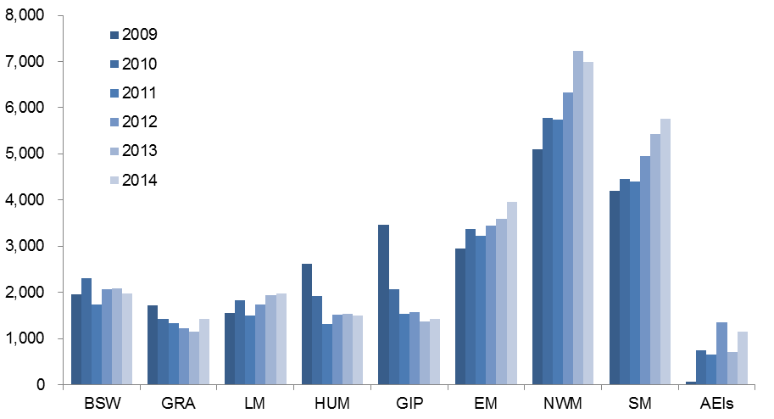



Table 1.40.1: ACFE Board Priority Learners enrolled in government subsidised   
pre-accredited training with Learn Local (ACE) providers, 2009 to 2014

|  |  |  |  |  |  |  |
| --- | --- | --- | --- | --- | --- | --- |
|  | **2009** | **2010** | **2011** | **2012** | **2013** | **2014** |
| CALD (LOTE) | 4,316 | 4,916 | 5,738 | 6,831 | 6,782 | 7,423 |
| Disability | 4,212 | 4,942 | 4,762 | 5,615 | 6,184 | 6,761 |
| Disengaged Youth | 422 | 944 | 501 | 798 | 982 | 1,161 |
| Early school leavers | 5,964 | 5,883 | 4,939 | 5,239 | 5,464 | 5,469 |
| Indigenous | 224 | 343 | 335 | 414 | 451 | 457 |
| Males 45 to 64 | 2,502 | 2,719 | 2,426 | 2,671 | 2,616 | 2,822 |
| Unemployed | 5,174 | 5,740 | 5,328 | 6,309 | 7,119 | 7,655 |
| Vulnerable workers | 4,430 | 5,128 | 4,940 | 5,664 | 5,518 | 5,932 |

Note: ACFE Board Priority Learner categories are not mutually exclusive.Detail on these categories is available at:[www.education.vic.gov.au/Documents/about/research/acfepublications/hardtoreachlearn.pdf](http://www.education.vic.gov.au/Documents/about/research/acfepublications/hardtoreachlearn.pdf)

Table 1.40.2: Change in number of ACFE Board Priority Learners enrolled in government subsidised pre-accredited training with Learn Local (ACE) providers

|  |  |  |  |  |  |
| --- | --- | --- | --- | --- | --- |
|  | **% change 2009 to 2014** | **% change 2010 to 2014** | **% change 2011 to 2014** | **% change 2012 to 2014** | **% change 2013 to 2014** |
| CALD (LOTE) | 72% | 51% | 29% | 9% | 9% |
| Disability | 61% | 37% | 42% | 20% | 9% |
| Disengaged Youth | 175% | 23% | 132% | 45% | 18% |
| Early school leavers | -8% | -7% | 11% | 4% | 0% |
| Indigenous | 104% | 33% | 36% | 10% | 1% |
| Males 45 to 64 | 13% | 4% | 16% | 6% | 8% |
| Unemployed | 48% | 33% | 44% | 21% | 8% |
| Vulnerable workers | 34% | 16% | 20% | 5% | 8% |

### Learn Local (ACE) Accredited Training

Key points

* Reported student participation in Learn Local (ACE) providers’ delivery of accredited programs decreased in 2014. The providers reported 24,363 students in accredited programs, being an 18 per cent decrease on the previous year.
* In 2014, student participation in regional Victorian Learn Local (ACE) providers’ accredited programs decreased an average 21 per cent. Loddon Mallee reported the most significant decrease of all regional areas, down 48 per cent to 2,155 students. Student participation in accredited programs within Metropolitan Melbourne areas also decreased on 2013 levels. In North-Western Metropolitan Melbourne, student engagement decreased by 9 per cent (6,773 students). Students reported in Southern Metropolitan Melbourne decreased by 10 per cent (3,872 students). Delivery into Eastern Metropolitan Melbourne had a decrease of 12 per cent (2,058 students). The Adult Education Institutes reported a 26 per cent decrease in student participation in accredited delivery in 2014 (2,553 students).
* In 2014, participation in accredited programs by students identified by the ACFE Board Priority Learner group categories decreased overall, with the exception of students with a self-declared disability, which increased participation of 6 per cent (5,736 students). Significant decreases were reported for Unemployed Victorians in accredited training, a 10 per cent reduction (10,056 students). The participation of CALD students decreased 14 per cent (7,409 students). Similarly, the participation of students identified as Early School Leavers decreased 17 per cent (5,736 students). The priority learner categories are not mutually exclusive and reported students may be identified in any one or a combination of these categories.

Table 1.41.1: Government subsidised accredited training, Learn Local (ACE) providers, 2009 to 2014

|  |  |  |  |  |  |  |
| --- | --- | --- | --- | --- | --- | --- |
|  | **2009** | **2010** | **2011** | **2012** | **2013** | **2014** |
| Course enrolments | 30,212 | 27,114 | 33,326 | 45,766 | 36,871 | 28,406 |
| Students | 25,691 | 23,652 | 27,469 | 36,333 | 29,659 | 24,363 |

Table 1.41.2: Government subsidised accredited training, Learn Local (ACE) providers, change in course enrolments and student numbers

|  |  |  |  |  |  |
| --- | --- | --- | --- | --- | --- |
|  | **% change 2009 to 2014** | **% change 2010 to 2014** | **% change 2011 to 2014** | **% change 2012 to 2014** | **% change 2013 to 2014** |
| Course enrolments | -6% | 5% | -15% | -38% | -23% |
| Students | -5% | 3% | -11% | -33% | -18% |

Figure 1.11: Students enrolled in government subsidised accredited training with Learn Local (ACE) providers by training delivery area, 2009 to 2014

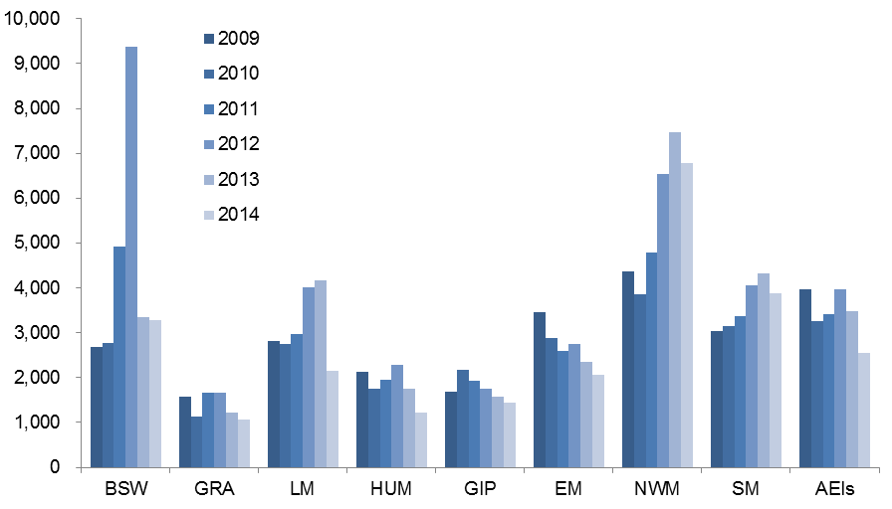



Table 1.42.1: ACFE Board Priority Learners enrolled in government subsidised accredited training with Learn Local (ACE) providers, 2009 to 2014

|  |  |  |  |  |  |  |
| --- | --- | --- | --- | --- | --- | --- |
|  | **2009** | **2010** | **2011** | **2012** | **2013** | **2014** |
| CALD (LOTE) | 6,268 | 5,621 | 6,691 | 8,953 | 8,569 | 7,409 |
| Disability | 3,529 | 3,543 | 4,611 | 6,020 | 5,430 | 5,736 |
| Disengaged Youth | 1,992 | 1,781 | 2,554 | 3,506 | 2,814 | 2,488 |
| Early school leavers | 6,441 | 5,626 | 7,086 | 9,105 | 6,920 | 5,747 |
| Indigenous | 335 | 339 | 460 | 569 | 552 | 486 |
| Males 45 to 64 | 1,828 | 1,667 | 2,054 | 2,583 | 2,236 | 1,995 |
| Unemployed | 7,307 | 6,935 | 9,402 | 13,685 | 11,118 | 10,056 |
| Vulnerable workers | 5,067 | 4,797 | 5,764 | 7,250 | 7,336 | 5,647 |

Note: ACFE Board Priority Learner categories are not mutually exclusive.Detail on these categories is available at: [www.education.vic.gov.au/Documents/about/research/acfepublications/hardtoreachlearn.pdf](http://www.education.vic.gov.au/Documents/about/research/acfepublications/hardtoreachlearn.pdf)

Table 1.42.2: Change in number of ACFE Board Priority Learners enrolled in government subsidised accredited training with Learn Local (ACE) providers

|  |  |  |  |  |  |
| --- | --- | --- | --- | --- | --- |
|  | **% change 2009 to 2014** | **% change 2010 to 2014** | **% change 2011 to 2014** | **% change 2012 to 2014** | **% change 2013 to 2014** |
| CALD (LOTE) | 18% | 32% | 11% | -17% | -14% |
| Disability | 63% | 62% | 24% | -5% | 6% |
| Disengaged Youth | 25% | 40% | -3% | -29% | -12% |
| Early school leavers | -11% | 2% | -19% | -37% | -17% |
| Indigenous | 45% | 43% | 6% | -15% | -12% |
| Males 45 to 64 | 9% | 20% | -3% | -23% | -11% |
| Unemployed | 38% | 45% | 7% | -27% | -10% |
| Vulnerable workers | 11% | 18% | -2% | -22% | -23% |

# Apprenticeships and Traineeships

## Apprenticeships and Traineeships Overall

Key points

* There were 80,042 students who were enrolled in 81,935 government subsidised apprenticeship or traineeship courses in 2014.
* The number of government subsidised enrolments in 2014 were down by 19 per cent compared to 2013. The number of students in training was down by 20 per cent over the same period.

Table 2.1.1: Government subsidised training in apprenticeships and traineeships by course enrolments and students, 2009 to 2014

|  |  |  |  |  |  |  |
| --- | --- | --- | --- | --- | --- | --- |
|  | **2009** | **2010** | **2011** | **2012** | **2013** | **2014** |
| Course enrolments | 90,818 | 102,143 | 126,461 | 134,314 | 101,605 | 81,935 |
| Students | 89,585 | 99,989 | 124,478 | 133,145 | 100,641 | 80,042 |

Table 2.1.2: Government subsidised training in apprenticeships and traineeships: change in number of course enrolments and student numbers

|  |  |  |  |  |  |
| --- | --- | --- | --- | --- | --- |
|  | **% change 2009 to 2014** | **% change 2010 to 2014** | **% change 2011 to 2014** | **% change 2012 to 2014** | **% change 2013 to 2014** |
| Course enrolments | -10% | -20% | -35% | -39% | -19% |
| Students | -11% | -20% | -36% | -40% | -20% |

## Apprenticeships

Key points

* In 2014, there were 43,453 government subsidised apprentice course enrolments. Of these, 39 per cent (17,105) were new enrolments commencing in 2014.
* The overall number of apprentice course enrolments was marginally higher in 2014 than 2013.
* About one third of apprentice course enrolments were by students aged 15 to 19. Enrolments by this age group were lower in 2014 compared to previous years.
* The vast majority of apprentice course enrolments were in occupations classified as Technicians and Trade Workers, which include Automotive and Engineering Trades Workers, Construction Trades Workers, Electrotechnology and Telecommunications Trades Workers, Engineering ICT and Science Technicians, Food Trades Workers, Other Technicians and Trades Workers, and Skilled Animal and Horticultural Workers.

Figure 2.1: Government subsidised apprentice course enrolments:total enrolments and new commencing enrolments, 2009 to 2014

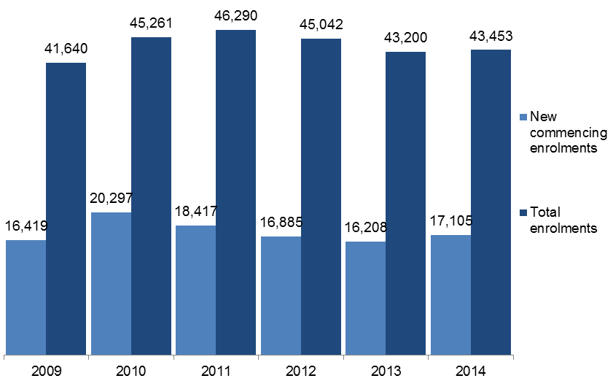

Table 2.2.1: Government subsidised apprentice course enrolments: number of new commencing enrolments and total enrolments, 2009 to 2014

|  |  |  |  |  |  |  |
| --- | --- | --- | --- | --- | --- | --- |
|  | **2009** | **2010** | **2011** | **2012** | **2013** | **2014** |
| New commencing enrolments | 16,419 | 20,297 | 18,417 | 16,885 | 16,208 | 17,105 |
| Total enrolments | 41,640 | 45,261 | 46,290 | 45,042 | 43,200 | 43,453 |

Table 2.2.2: Government subsidised apprentice course enrolments: change in number of new commencing enrolments and total enrolments

|  |  |  |  |  |  |
| --- | --- | --- | --- | --- | --- |
|  | **% change 2009 to 2014** | **% change 2010 to 2014** | **% change 2011 to 2014** | **% change 2012 to 2014** | **% change 2013 to 2014** |
| New commencing enrolments | 4% | -16% | -7% | 1% | 6% |
| Total enrolments | 4% | -4% | -6% | -4% | 1% |

Table 2.3.1: Government subsidised apprentice course enrolments by age group, 2009 to 2014

|  |  |  |  |  |  |  |
| --- | --- | --- | --- | --- | --- | --- |
|  | **2009** | **2010** | **2011** | **2012** | **2013** | **2014** |
| 15 to 19 | 18,391 | 19,429 | 19,321 | 17,300 | 15,192 | 14,542 |
| 20 to 24 | 16,451 | 18,092 | 18,521 | 18,791 | 18,171 | 18,464 |
| 25 to 44 | 6,266 | 7,125 | 7,765 | 8,101 | 8,527 | 8,859 |
| 45 to 64 | 501 | 593 | 668 | 840 | 1,282 | 1,555 |
| Other* | 31 | 22 | 15 | 10 | 28 | 33 |
| **Total** | **41,640** | **45,261** | **46,290** | **45,042** | **43,200** | **43,453** |

*Other includes age under 15 years old, 65 years and over or not stated.

Table 2.3.2: Change in number of government subsidised apprentice course enrolments by age group

|  |  |  |  |  |  |
| --- | --- | --- | --- | --- | --- |
|  | **% change 2009 to 2014** | **% change 2010 to 2014** | **% change 2011 to 2014** | **% change 2012 to 2014** | **% change 2013 to 2014** |
| 15 to 19 | -21% | -25% | -25% | -16% | -4% |
| 20 to 24 | 12% | 2% | 0% | -2% | 2% |
| 25 to 44 | 41% | 24% | 14% | 9% | 4% |
| 45 to 64 | 210% | 162% | 133% | 85% | 21% |
| Other* | 6% | 50% | 120% | 230% | 18% |
| **Total** | **4%** | **-4%** | **-6%** | **-4%** | **1%** |

*Other includes age under 15 years old, 65 years and over or not stated.

Table 2.4.1: Government subsidised apprentice course enrolments by occupation, 2009 to 2014

|  |  |  |  |  |  |  |
| --- | --- | --- | --- | --- | --- | --- |
|  | **2009** | **2010** | **2011** | **2012** | **2013** | **2014** |
| Clerical and Administrative Workers | 3 | 2 | 1 | 3 | 3 | 2 |
| Community and Personal Service Workers* | 123 | 129 | 127 | 108 | 90 | 55 |
| Labourers** | 77 | 60 | 114 | 132 | 88 | 75 |
| Machinery Operators and Drivers | 2 | 1 | 2 | 1 | 0 | 1 |
| Managers | 2 | 0 | 0 | 0 | 0 | 0 |
| Professionals | 0 | 0 | 0 | 0 | 1 | 1 |
| Sales Workers | 99 | 109 | 169 | 282 | 195 | 344 |
| Technicians and Trades Workers | 41,334 | 44,960 | 45,877 | 44,516 | 42,823 | 42,975 |
| *Automotive and Engineering Trades Workers* | *9,282* | *9,405* | *9,236* | *9,537* | *9,117* | *9,067* |
| *Construction Trades Workers* | *14,765* | *16,882* | *18,023* | *16,677* | *15,041* | *14,192* |
| *Electrotechnology and Telecommunications Trades Workers* | *6,846* | *7,655* | *7,811* | *7,596* | *7,617* | *7,807* |
| *Engineering, ICT and Science Technicians* | *31* | *28* | *75* | *133* | *511* | *669* |
| *Food Trades Workers* | *4,286* | *4,354* | *4,256* | *4,290* | *4,535* | *5,151* |
| *Other Technicians and Trades Workers* | *4,503* | *4,779* | *4,508* | *4,348* | *4,237* | *4,324* |
| *Skilled Animal and Horticultural Workers* | *1,621* | *1,857* | *1,968* | *1,935* | *1,765* | *1,765* |
| **Total** | **41,640** | **45,261** | **46,290** | **45,042** | **43,200** | **43,453** |

* Community and Personal Services occupational category included courses such as Diploma of Dental Technology and Certificate IV in Racing (Jockey).

** Labourers occupational category included courses such as Certificate III in Automotive Glazing, Technology, Certificate III in Laundry Operations and Certificate III in Dry Cleaning Operations.

Table 2.4.2: Change in number of government subsidised apprentice course enrolments by occupation

|  |  |  |  |  |  |
| --- | --- | --- | --- | --- | --- |
|  | **% change 2009 to 2014** | **% change 2010 to 2014** | **% change 2011 to 2014** | **% change 2012 to 2014** | **% change 2013 to 2014** |
| Clerical and Administrative Workers | -33% | 0% | 100% | -33% | -33% |
| Community and Personal Service Workers | -55% | -57% | -57% | -49% | -39% |
| Labourers | -3% | 25% | -34% | -43% | -15% |
| Machinery Operators and Drivers | -50% | 0% | -50% | 0% | - |
| Managers | -100% | - | - | - | - |
| Professionals | - | - | - | - | 0% |
| Sales Workers | 247% | 216% | 104% | 22% | 76% |
| Technicians and Trades Workers | 4% | -4% | -6% | -3% | 0% |
| *Automotive and Engineering Trades Workers* | *-2%* | *-4%* | *-2%* | *-5%* | *-1%* |
| *Construction Trades Workers* | *-4%* | *-16%* | *-21%* | *-15%* | *-6%* |
| *Electrotechnology and Telecommunications Trades Workers* | *14%* | *2%* | *0%* | *3%* | *2%* |
| *Engineering, ICT and Science Technicians* | *2058%* | *2289%* | *792%* | *403%* | *31%* |
| *Food Trades Workers* | *20%* | *18%* | *21%* | *20%* | *14%* |
| *Other Technicians and Trades Workers* | *-4%* | *-10%* | *-4%* | *-1%* | *2%* |
| *Skilled Animal and Horticultural Workers* | *9%* | *-5%* | *-10%* | *-9%* | *0%* |
| **Total** | **4%** | **-4%** | **-6%** | **-4%** | **1%** |

Table 2.5.1: Government subsidised new apprentice course commencements by occupation, 2009 to 2014

|  |  |  |  |  |  |  |
| --- | --- | --- | --- | --- | --- | --- |
|  | **2009** | **2010** | **2011** | **2012** | **2013** | **2014** |
| **Technicians and Trades Workers** | |  |  |  |  |  |
| Automotive and Engineering Trades Workers | 2,926 | 4,476 | 3,494 | 3,448 | 3,199 | 3,534 |
| Construction Trades Workers | 6,171 | 7,360 | 7,168 | 5,910 | 5,215 | 5,278 |
| Electrotechnology and Telecommunications Trades Workers | 2,579 | 3,127 | 2,620 | 2,333 | 2,274 | 2,459 |
| Engineering, ICT and Science Technicians | 20 | 15 | 56 | 68 | 456 | 367 |
| Food Trades Workers | 1,997 | 2,145 | 1,942 | 2,205 | 2,343 | 2,700 |
| Other Technicians and Trades Workers | 1,741 | 2,002 | 2,011 | 1,942 | 1,920 | 1,789 |
| Skilled Animal and Horticultural Workers | 836 | 1,011 | 870 | 715 | 654 | 689 |
| Other apprentices - occupations | 149 | 161 | 256 | 264 | 147 | 289 |
| **Total** | **16,419** | **20,297** | **18,417** | **16,885** | **16,208** | **17,105** |

Table 2.5.2: Change in number of government subsidised new apprentice course commencements by occupation

|  |  |  |  |  |  |  |  |
| --- | --- | --- | --- | --- | --- | --- | --- |
|  | **% change 2009 to 2014** | **% change 2010 to 2014** | **% change 2011 to 2014** | | **% change 2012 to 2014** | | **% change 2013 to 2014** |
| **Technicians and Trades Workers** | | | |  | |  | |
| Automotive and Engineering Trades Workers | 21% | -21% | 1% | | 2% | | 10% |
| Construction Trades Workers | -14% | -28% | -26% | | -11% | | 1% |
| Electrotechnology and Telecommunications Trades Workers | -5% | -21% | -6% | | 5% | | 8% |
| Engineering, ICT and Science Technicians | 1735% | 2347% | 555% | | 440% | | -20% |
| Food Trades Workers | 35% | 26% | 39% | | 22% | | 15% |
| Other Technicians and Trades Workers | 3% | -11% | -11% | | -8% | | -7% |
| Skilled Animal and Horticultural Workers | -18% | -32% | -21% | | -4% | | 5% |
| Other apprentices - occupations | 94% | 80% | 13% | | 9% | | 97% |
| **Total** | **4%** | **-16%** | **-7%** | | **1%** | | **6%** |

Table 2.6.1: Government subsidised apprentice course enrolments by industry, 2009 to 2014

|  |  |  |  |  |  |  |
| --- | --- | --- | --- | --- | --- | --- |
|  | **2009** | **2010** | **2011** | **2012** | **2013** | **2014** |
| Accommodation and Food Services | 2,773 | 2,809 | 2,647 | 2,728 | 3,008 | 3,611 |
| Administrative and Support Services | 430 | 527 | 562 | 474 | 263 | 113 |
| Agriculture, Forestry and Fishing | 37 | 29 | 34 | 49 | 80 | 173 |
| Arts and Recreation Services | 560 | 586 | 647 | 653 | 601 | 619 |
| Construction | 21,812 | 24,799 | 26,133 | 24,712 | 23,293 | 22,870 |
| Cross-industry | 1 | 1 | 0 | 1 | 0 | 0 |
| Electricity, Gas, Water and Waste Services | 195 | 200 | 240 | 235 | 319 | 377 |
| Financial and Insurance Services | 2 | 1 | 0 | 0 | 0 | 0 |
| Health Care and Social Assistance | 104 | 104 | 103 | 83 | 70 | 30 |
| Information Media and Telecommunications | 25 | 14 | 3 | 1 | 0 | 1 |
| Manufacturing | 6,781 | 6,881 | 6,748 | 6,752 | 6,633 | 6,342 |
| Other Services | 6,690 | 6,967 | 6,774 | 6,848 | 6,514 | 6,780 |
| Professional, Scientific and Technical Services | 139 | 156 | 161 | 158 | 293 | 295 |
| Public Administration and Safety | 93 | 102 | 98 | 111 | 101 | 98 |
| Retail Trade | 1,895 | 1,949 | 2,013 | 2,137 | 1,977 | 2,124 |
| Transport, Postal and Warehousing | 11 | 20 | 11 | 13 | 4 | 10 |
| Wholesale Trade | 93 | 115 | 116 | 87 | 44 | 9 |
| **Total** | **41,640** | **45,261** | **46,290** | **45,042** | **43,200** | **43,453** |

Table 2.6.2: Change in number of government subsidised apprentice course enrolments by industry

|  |  |  |  |  |  |
| --- | --- | --- | --- | --- | --- |
|  | **% change 2009 to 2014** | **% change 2010 to 2014** | **% change 2011 to 2014** | **% change 2012 to 2014** | **% change 2013 to 2014** |
| Accommodation and Food Services | 30% | 29% | 36% | 32% | 20% |
| Administrative and Support Services | -74% | -79% | -80% | -76% | -57% |
| Agriculture, Forestry and Fishing | 368% | 497% | 409% | 253% | 116% |
| Arts and Recreation Services | 11% | 6% | -4% | -5% | 3% |
| Construction | 5% | -8% | -12% | -7% | -2% |
| Cross-industry | -100% | -100% | - | -100% | - |
| Electricity, Gas, Water and Waste Services | 93% | 89% | 57% | 60% | 18% |
| Financial and Insurance Services | -100% | -100% | - | - | - |
| Health Care and Social Assistance | -71% | -71% | -71% | -64% | -57% |
| Information Media and Telecommunications | -96% | -93% | -67% | 0% | - |
| Manufacturing | -6% | -8% | -6% | -6% | -4% |
| Other Services | 1% | -3% | 0% | -1% | 4% |
| Professional, Scientific and Technical Services | 112% | 89% | 83% | 87% | 1% |
| Public Administration and Safety | 5% | -4% | 0% | -12% | -3% |
| Retail Trade | 12% | 9% | 6% | -1% | 7% |
| Transport, Postal and Warehousing | -9% | -50% | -9% | -23% | 150% |
| Wholesale Trade | -90% | -92% | -92% | -90% | -80% |
| **Total** | **4%** | **-4%** | **-6%** | **-4%** | **1%** |

## Traineeships

Key points

* In 2014, there were 38,483 government subsidised trainee course enrolments. Of these, 44 per cent (16,976) were new enrolments commencing in 2014.
* The number of trainee course enrolments in 2014 was lower than previous years, 2014 total enrolments were down by 34 per cent compared to 2013.
* In 2014, trainee course enrolments were lower than 2011, 2012 and 2013 across all age groups.

Figure 2.2: Government subsidised trainee course enrolments:total enrolments and new commencing enrolments, 2009 to 2014

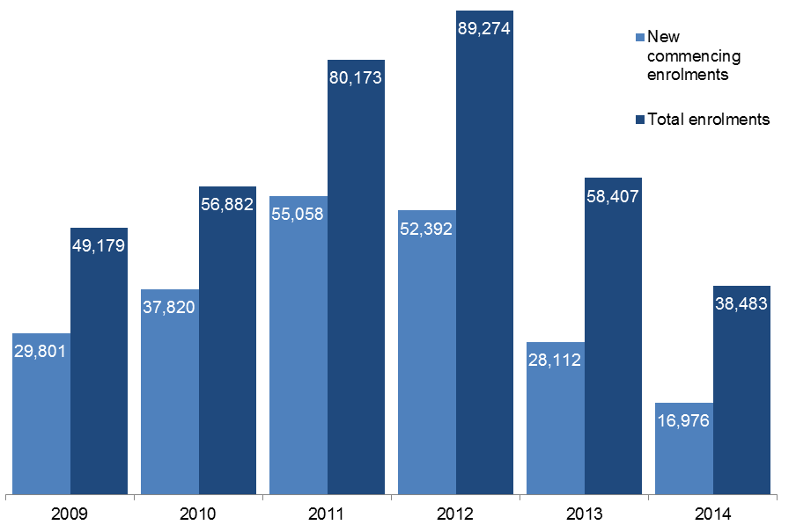

Table 2.7.1: Government subsidised trainee course enrolments: number of new commencing enrolments and total enrolments, 2009 to 2014

|  |  |  |  |  |  |  |
| --- | --- | --- | --- | --- | --- | --- |
|  | **2009** | **2010** | **2011** | **2012** | **2013** | **2014** |
| New commencing enrolments | 29,801 | 37,820 | 55,058 | 52,392 | 28,112 | 16,976 |
| Total enrolments | 49,179 | 56,882 | 80,173 | 89,274 | 58,407 | 38,483 |

Table 2.7.2: Government subsidised trainee course enrolments: change in number of new commencing enrolments and total enrolments

|  |  |  |  |  |  |
| --- | --- | --- | --- | --- | --- |
|  | **% change 2009 to 2014** | **% change 2010 to 2014** | **% change 2011 to 2014** | **% change 2012 to 2014** | **% change 2013 to 2014** |
| New commencing enrolments | -43% | -55% | -69% | -68% | -40% |
| Total enrolments | -22% | -32% | -52% | -57% | -34% |

Table 2.8.1: Government subsidised trainee course enrolments by age group, 2009 to 2014

|  |  |  |  |  |  |  |
| --- | --- | --- | --- | --- | --- | --- |
|  | **2009** | **2010** | **2011** | **2012** | **2013** | **2014** |
| 15 to 19 | 20,756 | 22,744 | 26,096 | 25,530 | 14,425 | 10,829 |
| 20 to 24 | 11,024 | 12,470 | 15,266 | 15,497 | 9,812 | 7,425 |
| 25 to 44 | 12,410 | 14,847 | 24,584 | 29,558 | 20,393 | 12,422 |
| 45 to 64 | 4,552 | 6,514 | 13,648 | 18,014 | 13,273 | 7,550 |
| Other* | 437 | 307 | 579 | 675 | 504 | 257 |
| **Total** | **49,179** | **56,882** | **80,173** | **89,274** | **58,407** | **38,483** |

*Other includes age under 15 years old, 65 years and over or not stated.

Table 2.8.2: Change in number of government subsidised trainee course enrolments by age group

|  |  |  |  |  |  |
| --- | --- | --- | --- | --- | --- |
|  | **% change 2009 to 2014** | **% change 2010 to 2014** | **% change 2011 to 2014** | **% change 2012 to 2014** | **% change 2013 to 2014** |
| 15 to 19 | -48% | -52% | -59% | -58% | -25% |
| 20 to 24 | -33% | -40% | -51% | -52% | -24% |
| 25 to 44 | 0% | -16% | -49% | -58% | -39% |
| 45 to 64 | 66% | 16% | -45% | -58% | -43% |
| Other* | -41% | -16% | -56% | -62% | -49% |
| **Total** | **-22%** | **-32%** | **-52%** | **-57%** | **-34%** |

*Other includes age under 15 years old, 65 years and over or not stated.

Table 2.9.1: Government subsidised trainee course enrolments by qualification level, 2009 to 2014

|  |  |  |  |  |  |  |
| --- | --- | --- | --- | --- | --- | --- |
|  | **2009** | **2010** | **2011** | **2012** | **2013** | **2014** |
| Cert I/II | 11,136 | 11,697 | 8,855 | 4,222 | 2,564 | 2,748 |
| Cert III/IV | 36,757 | 42,470 | 62,928 | 72,083 | 49,323 | 32,987 |
| Diploma & Above | 1,260 | 2,714 | 8,390 | 12,969 | 6,520 | 2,748 |
| **Total\*** | **49,179** | **56,882** | **80,173** | **89,274** | **58,407** | **38,483** |

*Totals for 2009 and 2010 include a small number of enrolments at non-AQF level, e.g. statement of attainment (26 and 1 enrolments, respectively).

Table 2.9.2: Change in number of government subsidised trainee course enrolments by qualification level

|  |  |  |  |  |  |
| --- | --- | --- | --- | --- | --- |
|  | **% change 2009 to 2014** | **% change 2010 to 2014** | **% change 2011 to 2014** | **% change 2012 to 2014** | **% change 2013 to 2014** |
| Cert I/II | -75% | -77% | -69% | -35% | 7% |
| Cert III/IV | -10% | -22% | -48% | -54% | -33% |
| Diploma & Above | 118% | 1% | -67% | -79% | -58% |
| **Total** | **-22%** | **-32%** | **-52%** | **-57%** | **-34%** |

Table 2.10.1: Government subsidised trainee course enrolments by occupation, 2009 to 2014

|  |  |  |  |  |  |  |
| --- | --- | --- | --- | --- | --- | --- |
|  | **2009** | **2010** | **2011** | **2012** | **2013** | **2014** |
| Clerical and Administrative Workers | 8,870 | 11,700 | 19,725 | 23,143 | 12,441 | 6,093 |
| Community and Personal Service Workers | 15,575 | 16,171 | 18,777 | 18,917 | 11,972 | 9,813 |
| Labourers | 6,163 | 7,025 | 12,096 | 13,735 | 10,407 | 7,666 |
| Machinery Operators and Drivers | 2,756 | 3,826 | 6,550 | 8,800 | 10,097 | 7,091 |
| Managers | 245 | 478 | 1,004 | 1,529 | 1,097 | 804 |
| Professionals | 94 | 292 | 909 | 1,398 | 868 | 203 |
| Sales Workers | 13,604 | 15,295 | 18,658 | 18,682 | 7,716 | 3,157 |
| Technicians and Trades Workers | 1,843 | 2,094 | 2,454 | 3,046 | 3,809 | 3,656 |
| **Total\*** | **49,179** | **56,882** | **80,173** | **89,274** | **58,407** | **38,483** |

*Totals for 2009, 2010 and 2012 include a small number of enrolments that were not able to be coded directly into ANZSCO (29, 1 and 24 enrolments, respectively).

Table 2.10.2: Change in number of government subsidised trainee course enrolments by occupation

|  |  |  |  |  |  |
| --- | --- | --- | --- | --- | --- |
|  | **% change 2009 to 2014** | **% change 2010 to 2014** | **% change 2011 to 2014** | **% change 2012 to 2014** | **% change 2013 to 2014** |
| Clerical and Administrative Workers | -31% | -48% | -69% | -74% | -51% |
| Community and Personal Service Workers | -37% | -39% | -48% | -48% | -18% |
| Labourers | 24% | 9% | -37% | -44% | -26% |
| Machinery Operators and Drivers | 157% | 85% | 8% | -19% | -30% |
| Managers | 228% | 68% | -20% | -47% | -27% |
| Professionals | 116% | -30% | -78% | -85% | -77% |
| Sales Workers | -77% | -79% | -83% | -83% | -59% |
| Technicians and Trades Workers | 98% | 75% | 49% | 20% | -4% |
| **Total** | **-22%** | **-32%** | **-52%** | **-57%** | **-34%** |

Table 2.11.1: Government subsidised new trainee course commencements by occupation, 2009 to 2014

|  |  |  |  |  |  |  |
| --- | --- | --- | --- | --- | --- | --- |
|  | **2009** | **2010** | **2011** | **2012** | **2013** | **2014** |
| Clerical and administrative workers | 5,777 | 8,103 | 14,163 | 12,836 | 4,443 | 2,545 |
| Community and personal service workers | 9,691 | 10,143 | 12,195 | 11,567 | 6,493 | 5,697 |
| Labourers | 3,744 | 4,666 | 8,779 | 7,071 | 4,904 | 3,042 |
| Machinery operators and drivers | 1,293 | 2,646 | 4,245 | 5,213 | 5,763 | 2,139 |
| Managers | 181 | 343 | 740 | 1,042 | 460 | 418 |
| Professionals | 71 | 248 | 711 | 781 | 145 | 50 |
| Sales workers | 8,007 | 10,486 | 12,773 | 11,964 | 3,554 | 1,136 |
| Technicians and trades workers | 1,012 | 1,184 | 1,452 | 1,894 | 2,350 | 1,949 |
| **Total** | **29,776** | **37,819** | **55,058** | **52,368** | **28,112** | **16,976** |

Table 2.11.2: Change in government subsidised new traineeship course commencements by occupation

|  |  |  |  |  |  |
| --- | --- | --- | --- | --- | --- |
|  | **% change 2009 to 2014** | **% change 2010 to 2014** | **% change 2011 to 2014** | **% change 2012 to 2014** | **% change 2013 to 2014** |
| Clerical and administrative workers | -56% | -69% | -82% | -80% | -43% |
| Community and personal service workers | -41% | -44% | -53% | -51% | -12% |
| Labourers | -19% | -35% | -65% | -57% | -38% |
| Machinery operators and drivers | 65% | -19% | -50% | -59% | -63% |
| Managers | 131% | 22% | -44% | -60% | -9% |
| Professionals | -30% | -80% | -93% | -94% | -66% |
| Sales workers | -86% | -89% | -91% | -91% | -68% |
| Technicians and trades workers | 93% | 65% | 34% | 3% | -17% |
| **Total** | **-43%** | **-55%** | **-69%** | **-68%** | **-40%** |

Table 2.12.1: Government subsidised trainee course enrolments by industry, 2009 to 2014

|  |  |  |  |  |  |  |
| --- | --- | --- | --- | --- | --- | --- |
|  | **2009** | **2010** | **2011** | **2012** | **2013** | **2014** |
| Accommodation and Food Services | 7,858 | 8,517 | 10,068 | 10,665 | 5,638 | 3,806 |
| Administrative and Support Services | 4,562 | 5,722 | 7,166 | 6,595 | 3,991 | 2,495 |
| Agriculture, Forestry and Fishing | 1,084 | 1,119 | 1,664 | 2,123 | 2,480 | 2,351 |
| Arts and Recreation Services | 2,270 | 2,242 | 2,700 | 2,563 | 1,021 | 1,702 |
| Construction | 365 | 412 | 715 | 925 | 930 | 634 |
| Cross-industry | 5,055 | 6,755 | 12,771 | 16,186 | 7,844 | 3,771 |
| Education and Training | 401 | 362 | 495 | 439 | 1,092 | 508 |
| Electricity, Gas, Water and Waste Services | 148 | 115 | 220 | 284 | 175 | 71 |
| Financial and Insurance Services | 351 | 383 | 535 | 543 | 554 | 478 |
| Health Care and Social Assistance | 6,426 | 6,657 | 7,540 | 7,754 | 6,720 | 5,613 |
| Information Media and Telecommunications | 173 | 168 | 149 | 154 | 281 | 304 |
| Manufacturing | 3,108 | 4,845 | 10,856 | 14,360 | 12,872 | 8,728 |
| Mining | 52 | 23 | 16 | 34 | 93 | 52 |
| Other Services | 664 | 564 | 554 | 477 | 323 | 310 |
| Professional, Scientific and Technical Services | 248 | 275 | 315 | 337 | 267 | 216 |
| Public Administration and Safety | 77 | 58 | 49 | 95 | 240 | 227 |
| Rental, Hiring and Real Estate Services | 257 | 268 | 369 | 379 | 246 | 169 |
| Retail Trade | 13,345 | 15,042 | 18,330 | 18,300 | 7,334 | 2,806 |
| Transport, Postal and Warehousing | 2,596 | 3,142 | 5,195 | 6,485 | 6,023 | 4,177 |
| Wholesale Trade | 110 | 212 | 467 | 551 | 283 | 64 |
| **Total\*** | **49,179** | **56,882** | **80,173** | **89,274** | **58,407** | **38,483** |

*Totals for 2009, 2010 and 2012 include a small number of enrolments that were not able to be coded directly into ANZSIC (29, 1 and 24 enrolments, respectively).

Table 2.12.2: Change in number of government subsidised trainee course enrolments by industry

|  |  |  |  |  |  |
| --- | --- | --- | --- | --- | --- |
|  | **% change 2009 to 2014** | **% change 2010 to 2014** | **% change 2011 to 2014** | **% change 2012 to 2014** | **% change 2013 to 2014** |
| Accommodation and Food Services | -52% | -55% | -62% | -64% | -32% |
| Administrative and Support Services | -45% | -56% | -65% | -62% | -37% |
| Agriculture, Forestry and Fishing | 117% | 110% | 41% | 11% | -5% |
| Arts and Recreation Services | -25% | -24% | -37% | -34% | 67% |
| Construction | 73% | 54% | -11% | -31% | -32% |
| Cross-industry | -25% | -44% | -70% | -77% | -52% |
| Education and Training | 27% | 40% | 3% | 16% | -53% |
| Electricity, Gas, Water and Waste Services | -52% | -38% | -68% | -75% | -59% |
| Financial and Insurance Services | 36% | 25% | -11% | -12% | -14% |
| Health Care and Social Assistance | -13% | -16% | -26% | -28% | -16% |
| Information Media and Telecommunications | 76% | 81% | 104% | 97% | 8% |
| Manufacturing | 181% | 80% | -20% | -39% | -32% |
| Mining | 0% | 126% | 225% | 53% | -44% |
| Other Services | -53% | -45% | -44% | -35% | -4% |
| Professional, Scientific and Technical Services | -13% | -21% | -31% | -36% | -19% |
| Public Administration and Safety | 195% | 291% | 363% | 139% | -5% |
| Rental, Hiring and Real Estate Services | -34% | -37% | -54% | -55% | -31% |
| Retail Trade | -79% | -81% | -85% | -85% | -62% |
| Transport, Postal and Warehousing | 61% | 33% | -20% | -36% | -31% |
| Wholesale Trade | -42% | -70% | -86% | -88% | -77% |
| **Total** | **-22%** | **-32%** | **-52%** | **-57%** | **-34%** |

# Training in Specialised or In Shortage Occupations

To operate efficiently the economy needs the right mix of skills. Shortages in critical skills can limit production, increase workforce workloads, impact on safety and limit innovation. For these reasons data on training in skills shortage areas is reported.

The other important category of skills to monitor is ‘specialised’ skills; skills with a long-lead time to develop and with high economic value. While these skills are not necessarily in shortage, should they become difficult to access firms will be significantly impacted. Reporting on enrolments in specialised skills provides a guide to the ‘pipeline’ of these skills.

Note: all data in this section is for industry specific enrolments, i.e. training with a direct labour market outcome. This covers government subsidised training in AQF qualifications, and excludes training in foundation skills, education pathways and low-level courses in languages other than English.

Key points

* There were 439,640 enrolments in industry specific training in 2014. Of these, 207,202 enrolments were in qualifications related to specialised or in shortage occupations in 2014.
* Enrolments aligned to specialised or in shortage occupations accounted for 47 per cent of all industry specific enrolments in 2014. The proportion of industry training aligned to specialised or in shortage occupations has increased by 4 percentage points since 2013.
* In 2014, there were 169,730 enrolments (39 per cent of all industry specific enrolments) in qualifications aligned to occupations in shortage.
* In 2014, enrolments in qualifications for specialised occupations accounted for 30 per cent of all industry specific enrolments (133,745 enrolments).
* Private RTOs accounted for a majority of training related to critical occupations; 59 per cent of delivery in 2014.
* The highest number of enrolments were in qualifications aligned to Child Care Workers and Aged or Disabled Carers in 2014.

Figure 3.1: Percentage of government subsidised industry specific enrolments in either specialised or in shortage occupations, 2009 to 2014

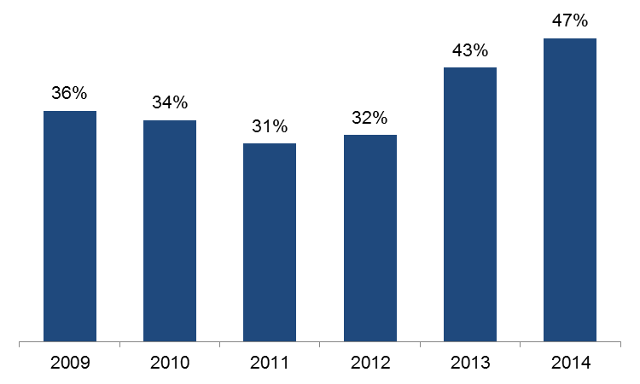

Figure 3.2: Percentage of government subsidised industry specific enrolments in either specialised or in shortage occupations by sector, 2011 to 2014

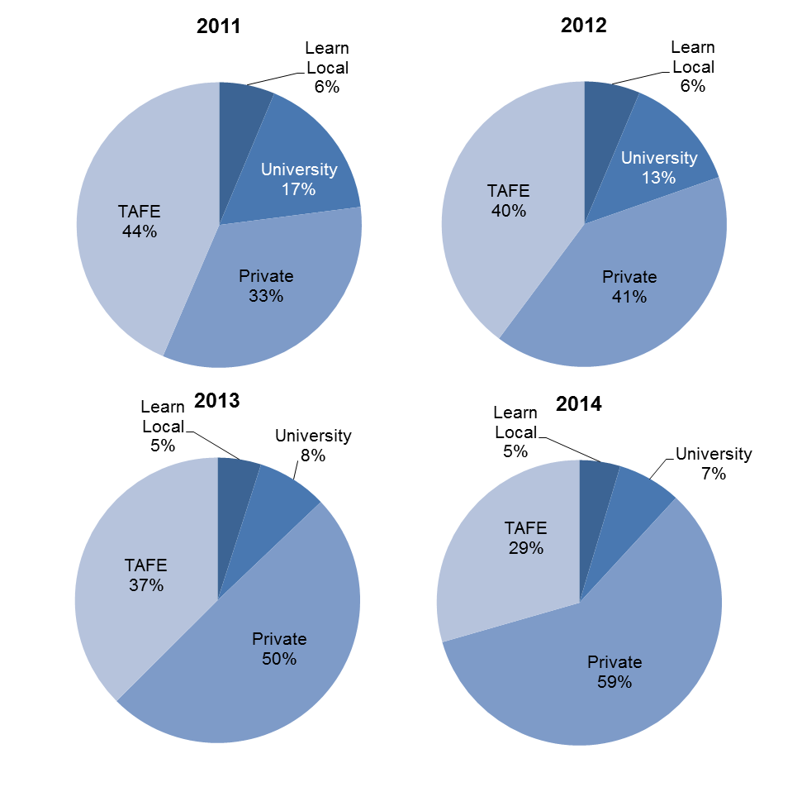

Table 3.1: Government subsidised training delivery for qualifications aligned to either specialised or in shortage occupations, 2009 to 2014

|  |  |  |  |  |  |  |
| --- | --- | --- | --- | --- | --- | --- |
|  | **2009** | **2010** | **2011** | **2012** | **2013** | **2014** |
| Enrolments | 102,235 | 115,872 | 136,200 | 162,126 | 190,554 | 207,202 |
| Hours (millions) | 33.6 | 38.7 | 43.9 | 54.4 | 69.0 | 74.0 |

**Table 3.2:Government subsidised training delivery for qualifications not aligned to either specialised or in shortage occupations, 2009 to 2014**

|  |  |  |  |  |  |  |
| --- | --- | --- | --- | --- | --- | --- |
|  | **2009** | **2010** | **2011** | **2012** | **2013** | **2014** |
| Enrolments | 182,820 | 220,888 | 306,615 | 343,211 | 257,572 | 232,438 |
| Hours (millions) | 49.2 | 61.7 | 86.3 | 109.8 | 81.3 | 80.1 |

Table 3.3: Government subsidised training delivery for qualifications aligned to specialised occupations, 2009 to 2014

|  |  |  |  |  |  |  |
| --- | --- | --- | --- | --- | --- | --- |
|  | **2009** | **2010** | **2011** | **2012** | **2013** | **2014** |
| Enrolments | 58,753 | 64,204 | 71,051 | 79,462 | 90,299 | 133,745 |
| Hours (millions) | 19.5 | 20.8 | 21.4 | 25.5 | 34.7 | 48.5 |

Note: AWPA Specialised Occupation List was updated in 2014

Table 3.4: Government subsidised training delivery for qualifications aligned to in shortage occupations, 2009 to 2014

|  |  |  |  |  |  |  |
| --- | --- | --- | --- | --- | --- | --- |
|  | **2009** | **2010** | **2011** | **2012** | **2013** | **2014** |
| Enrolments | 91,227 | 105,366 | 127,604 | 151,798 | 154,275 | 169,730 |
| Hours (millions) | 29.5 | 35.0 | 41.0 | 50.6 | 52.8 | 61.0 |

Note: DET Victorian Skill Shortage List was updated in 2013

Table 3.5: Government subsidised training delivery aligned to specialised or in shortage occupations, top ten by 2014 enrolments, 2009 to 2014

|  |  |  |  |  |  |  |
| --- | --- | --- | --- | --- | --- | --- |
| **Occupations** | **2009** | **2010** | **2011** | **2012** | **2013** | **2014** |
| Child Care Worker | 9,039 | 14,258 | 19,695 | 25,599 | 30,122 | 37,075 |
| Aged or Disabled Carer | 8,237 | 8,830 | 12,962 | 16,896 | 20,420 | 22,468 |
| Truck Driver (General) | 4,434 | 4,648 | 7,526 | 10,605 | 14,579 | 13,033 |
| Cook | 3,847 | 4,078 | 4,512 | 5,218 | 7,600 | 12,351 |
| Motor Mechanic (General) | 4,755 | 4,863 | 5,131 | 6,590 | 8,321 | 8,895 |
| Building Associate | 1,379 | 1,621 | 2,716 | 4,637 | 5,568 | 8,711 |
| Enrolled Nurse | 4,819 | 5,332 | 6,440 | 7,244 | 7,606 | 7,575 |
| Carpenter | 7,236 | 7,940 | 8,532 | 7,590 | 7,624 | 7,309 |
| Electrician (General) | 2,344 | 4,568 | 6,073 | 7,475 | 7,596 | 7,303 |
| Plumber (General) | 4,993 | 6,293 | 7,044 | 7,187 | 7,073 | 6,913 |

Table 3.6: Industry enrolments in qualifications related to either specialised or in shortage occupations

|  |  |  |  |  |  |  |  |  |  |  |
| --- | --- | --- | --- | --- | --- | --- | --- | --- | --- | --- |
| **Industry** | **Enrolments (Total industry specific qualifications)** | | | | | **Enrolments (Specialised OR in shortage)** | | | | |
| **Share 2014** | **2011** | **2012** | **2013** | **2014** | **Share 2014** | **2011** | **2012** | **2013** | **2014** |
| Accommodation and Food Services | 6% | 35,489 | 44,629 | 30,254 | 28,446 | 11% | 8,007 | 11,822 | 18,518 | 23,115 |
| Administrative and Support Services | 3% | 20,575 | 21,593 | 15,585 | 11,084 | - | - | - | - | - |
| Agriculture, Forestry and Fishing | 3% | 9,486 | 9,797 | 8,313 | 11,884 | 0.3% | 577 | 646 | 650 | 663 |
| Arts and Recreation Services | 3% | 27,465 | 26,649 | 15,890 | 12,199 | 1% | 771 | 680 | 1,322 | 1,467 |
| Construction | 14% | 47,721 | 51,939 | 62,702 | 59,589 | 20% | 33,659 | 37,090 | 44,366 | 41,459 |
| *Cross-industry e.g. project managers, HR* | 13% | 81,461 | 90,951 | 60,263 | 55,176 | 1% | 3,841 | 3,253 | 2,113 | 2,641 |
| Education and Training | 2% | 10,192 | 10,098 | 12,710 | 9,585 | 2% | 6,245 | 5,691 | 3,918 | 3,853 |
| Electricity, Gas, Water and Waste Services | 0.2% | 1,029 | 952 | 772 | 1,019 | 0.4% | 845 | 769 | 524 | 766 |
| Financial and Insurance Services | 1% | 6,733 | 6,289 | 3,109 | 2,757 | - | 11 | 96 | 55 | - |
| Health Care and Social Assistance | 24% | 61,399 | 77,646 | 87,333 | 104,613 | 46% | 55,294 | 70,248 | 77,563 | 94,442 |
| Information Media and Telecommunications | 1% | 3,773 | 3,876 | 3,305 | 3,236 | 0.3% | 488 | 524 | 530 | 582 |
| Manufacturing | 10% | 33,696 | 41,625 | 43,467 | 44,759 | 3% | 8,592 | 8,900 | 7,975 | 7,226 |
| Mining | 0.1% | 276 | 531 | 368 | 347 | - | - | - | - | - |
| Other Services | 5% | 19,515 | 21,089 | 21,107 | 20,277 | 4% | 4,672 | 5,933 | 7,411 | 8,405 |
| Professional, Scientific and Technical Services | 2% | 12,465 | 12,117 | 10,567 | 10,560 | 0.5% | 3,137 | 3,116 | 1,077 | 997 |
| Public Administration and Safety | 2% | 7,877 | 8,372 | 8,128 | 8,562 | 0.1% | 399 | 415 | 347 | 230 |
| Rental, Hiring and Real Estate Services | 0.4% | 1,552 | 2,293 | 1,722 | 1,890 | - | - | - | - | - |
| Retail Trade | 2% | 33,241 | 35,976 | 15,379 | 9,934 | 1% | 1,368 | 1,806 | 2,418 | 2,521 |
| Transport, Postal and Warehousing | 10% | 28,018 | 38,012 | 46,121 | 42,885 | 9% | 8,293 | 11,137 | 21,767 | 18,836 |
| Wholesale Trade | 0.2% | 853 | 903 | 1,031 | 837 | - | 1 | - | - | - |
| **All industries** | **100%** | **442,815** | **505,337** | **448,126** | **439,640** | **100%** | **136,200** | **162,126** | **190,554** | **207,202** |

# Learners Facing Barriers to Participation

## Vocational Training Delivery to Learner Groups Facing Barriers

Young people and adult learners, who may be members of more than one equity group, can have complex and multiple learning needs, and may have contact with a range of government services and programs. There is a significant evidence base that demonstrates the value and importance of education and training to these groups. However, higher needs learners may face a combination of barriers to effective engagement in education and training including low levels of previous educational achievement, low aspirations, poor access to training and broader barriers such as poverty, homelessness and poor health.

Vocational training has continued to be a critical enabler in openinguppathways for higher needs and disadvantaged learners through the provision of tailored, individualised services, often in partnership with other service providers.

Table 4.1.1: Students enrolled in government subsidised training by selected learner groups*, 2009 to 2014

|  |  |  |  |  |  |  |
| --- | --- | --- | --- | --- | --- | --- |
|  | **2009** | **2010** | **2011** | **2012** | **2013** | **2014** |
| Indigenous | 4,318 | 4,801 | 5,590 | 6,178 | 6,480 | 6,167 |
| Students with a disability | 23,623 | 27,237 | 34,148 | 40,250 | 40,517 | 41,318 |
| CALD | 62,102 | 70,582 | 97,245 | 126,322 | 137,654 | 139,148 |
| Unemployed | 50,176 | 62,514 | 89,329 | 118,482 | 135,048 | 135,910 |

Young people without at least Year 12 or a Certificate II, not at school and enrolled in government subsidised training in Certificate II or above, 2009 to 2014

|  |  |  |  |  |  |  |
| --- | --- | --- | --- | --- | --- | --- |
| Aged 15-19 | 22,574 | 26,312 | 28,935 | 29,499 | 24,663 | 22,128 |

Older students not holding a Certificate III or above and enrolled in government subsidised training, 2009 to 2014

|  |  |  |  |  |  |  |
| --- | --- | --- | --- | --- | --- | --- |
| Aged 20-64 | 131,847 | 149,569 | 214,042 | 266,228 | 260,856 | 249,109 |

*The above groups of students are not mutually exclusive.

Table 4.1.2: Change in number of students enrolled in government subsidised training by selected learner group*

|  |  |  |  |  |  |
| --- | --- | --- | --- | --- | --- |
|  | **% change 2009 to 2014** | **% change 2010 to 2014** | **% change 2011 to 2014** | **% change 2012 to 2014** | **% change 2013 to 2014** |
| Indigenous | 43% | 28% | 10% | 0% | -5% |
| Students with a disability | 75% | 52% | 21% | 3% | 2% |
| CALD | 124% | 97% | 43% | 10% | 1% |
| Unemployed | 171% | 117% | 52% | 15% | 1% |
| Aged 15-19 without at least Year 12 or a Cert II, not at school and enrolled in Cert II or above | -2% | -16% | -24% | -25% | -10% |
| Aged 20-64 not holding a Cert III or above | 89% | 67% | 16% | -6% | -5% |

*The above groups of students are not mutually exclusive.

## Indigenous Students

### Course Enrolments

Key points

The 2014 data shows that:

* There were 6,167 Indigenous students who were enrolled in 7,737 government subsidised training courses.
* In 2014, while the total number of government subsidised course enrolments by Indigenous students was 10 per cent lower than 2013, the number of enrolments in Certificate III and above had increased(by 7 per cent).
* Sixty two per cent of enrolments by Indigenous students were in Certificate III and above levels.

Table 4.2.1: Government subsidised enrolments by qualification level for Indigenous students, 2009 to 2014

|  |  |  |  |  |  |  |
| --- | --- | --- | --- | --- | --- | --- |
|  | **2009** | **2010** | **2011** | **2012** | **2013** | **2014** |
| Cert I/II | 2,508 | 2,825 | 3,167 | 2,873 | 3,074 | 1,675 |
| Cert III/IV | 2,198 | 2,319 | 3,078 | 3,628 | 3,957 | 4,196 |
| Diploma & Above | 423 | 431 | 564 | 612 | 515 | 598 |
| Module only | 409 | 415 | 410 | 507 | 327 | 535 |
| Secondary Education* | 378 | 415 | 242 | 282 | 344 | 370 |
| Other** | 309 | 235 | 117 | 294 | 427 | 363 |
| **Total** | **6,225** | **6,640** | **7,578** | **8,196** | **8,644** | **7,737** |

*Includes VCE/VCAL courses of study.

**Other includes statement of attainment, other non-award courses or not elsewhere classified.

Table 4.2.2: Change in number of government subsidised enrolments by qualification level for Indigenous students

|  |  |  |  |  |  |
| --- | --- | --- | --- | --- | --- |
|  | **% change 2009 to 2014** | **% change 2010 to 2014** | **% change 2011 to 2014** | **% change 2012 to 2014** | **% change 2013 to 2014** |
| Cert I/II | -33% | -41% | -47% | -42% | -46% |
| Cert III/IV | 91% | 81% | 36% | 16% | 6% |
| Diploma & Above | 41% | 39% | 6% | -2% | 16% |
| Module only | 31% | 29% | 30% | 6% | 64% |
| Secondary Education* | -2% | -11% | 53% | 31% | 8% |
| Other** | 17% | 54% | 210% | 23% | -15% |
| **Total** | **24%** | **17%** | **2%** | **-6%** | **-10%** |

*Includes VCE/VCAL courses of study.

**Other includes statement of attainment, other non-award courses or not elsewhere classified.

## Students with a Disability

### Course Enrolments

Key points

The 2014 data shows that:

* There were 41,318 students with a disability who were enrolled in 55,015 government subsidised training courses.
* While the number of students with a disability enrolled in government subsidised training in 2014 was 2 per cent higher than in 2013, the number of enrolments by these students declined by 5 per cent between 2013 and 2014.
* The decline in course enrolments by students with a disability in 2014 in comparison to 2013 was mainly due to a considerable decrease in enrolments at the Certificates I to II levels. However, there were increases in module only enrolments and enrolments at the Certificate III to IV levels in 2014.
* Forty five per cent of enrolments by students with a disability were in Certificate III to IV and above levels.

Table 4.3.1: Government subsidised enrolments by qualification level for students with a disability, 2009 to 2014

|  |  |  |  |  |  |  |
| --- | --- | --- | --- | --- | --- | --- |
|  | **2009** | **2010** | **2011** | **2012** | **2013** | **2014** |
| Cert I/II | 11,175 | 12,355 | 16,281 | 19,977 | 20,854 | 15,108 |
| Cert III/IV | 9,008 | 10,956 | 16,496 | 21,158 | 20,369 | 21,075 |
| Diploma & Above | 3,576 | 4,024 | 4,852 | 5,001 | 3,879 | 3,809 |
| Module only | 8,389 | 8,330 | 7,202 | 7,658 | 8,696 | 10,433 |
| Secondary Education* | 835 | 992 | 1,161 | 1,150 | 1,463 | 1,483 |
| Other** | 1,678 | 1,776 | 2,030 | 2,661 | 2,731 | 3,107 |
| **Total** | **34,661** | **38,433** | **48,022** | **57,605** | **57,992** | **55,015** |

* Includes VCE/VCAL courses of study.

**Other includes statement of attainment, other non-award courses or not elsewhere classified.

Table 4.3.2: Change in number of government subsidised enrolments by qualification level for students with a disability

|  |  |  |  |  |  |
| --- | --- | --- | --- | --- | --- |
|  | **% change 2009 to 2014** | **% change 2010 to 2014** | **% change 2011 to 2014** | **% change 2012 to 2014** | **% change 2013 to 2014** |
| Cert I/II | 35% | 22% | -7% | -24% | -28% |
| Cert III/IV | 134% | 92% | 28% | 0% | 3% |
| Diploma & Above | 7% | -5% | -21% | -24% | -2% |
| Module only | 24% | 25% | 45% | 36% | 20% |
| Secondary Education* | 78% | 49% | 28% | 29% | 1% |
| Other** | 85% | 75% | 53% | 17% | 14% |
| **Total** | **59%** | **43%** | **15%** | **-4%** | **-5%** |

* Includes VCE/VCAL courses of study.

**Other includes statement of attainment, other non-award courses or not elsewhere classified.

## Students with a Culturally and Linguistically Diverse (CALD) Background

### Course Enrolments

Key points

The 2014 data shows that:

* There were 139,148 students from a CALD background enrolled in 176,532 government subsidised training courses.
* While the number of students with a CALD background enrolled in government subsidised training in 2014 was 1 per cent higher than in 2013, the number of enrolments by these students declined by 4 per cent. The biggest decline in course enrolments was in Certificate I to II levels in comparison to enrolments in 2012 and 2013.
* Seventy one per cent of course enrolments by students from a CALD background werein Certificate III to IV and above levels.

Table 4.4.1: Government subsidised enrolments by students from a CALD background by qualification level, 2009 to 2014

|  |  |  |  |  |  |  |
| --- | --- | --- | --- | --- | --- | --- |
|  | **2009** | **2010** | **2011** | **2012** | **2013** | **2014** |
| Cert I/II | 20,136 | 20,441 | 28,468 | 41,582 | 49,524 | 31,624 |
| Cert III/IV | 30,710 | 38,502 | 61,984 | 88,906 | 97,695 | 103,634 |
| Diploma & Above | 15,670 | 17,272 | 22,366 | 23,138 | 19,011 | 21,377 |
| Module only | 11,620 | 12,138 | 11,661 | 10,735 | 11,631 | 13,549 |
| Secondary Education* | 1,246 | 1,219 | 1,259 | 1,096 | 1,168 | 1,151 |
| Other** | 4,113 | 4,148 | 4,958 | 7,269 | 4,764 | 5,197 |
| **Total** | **83,495** | **93,720** | **130,696** | **172,726** | **183,793** | **176,532** |

* Includes VCE/VCAL courses of study.

**Other includes statement of attainment, other non-award courses or not elsewhere classified.

Table 4.4.2: Change in number of government subsidised enrolments by students from a CALD background by qualification level

|  |  |  |  |  |  |
| --- | --- | --- | --- | --- | --- |
|  | **% change 2009 to 2014** | **% change 2010 to 2014** | **% change 2011 to 2014** | **% change 2012 to 2014** | **% change 2013 to 2014** |
| Cert I/II | 57% | 55% | 11% | -24% | -36% |
| Cert III/IV | 237% | 169% | 67% | 17% | 6% |
| Diploma & Above | 36% | 24% | -4% | -8% | 12% |
| Module only | 17% | 12% | 16% | 26% | 16% |
| Secondary Education* | -8% | -6% | -9% | 5% | -1% |
| Other** | 26% | 25% | 5% | -29% | 9% |
| **Total** | **111%** | **88%** | **35%** | **2%** | **-4%** |

* Includes VCE/VCAL courses of study.

**Other includes statement of attainment, other non-award courses or not elsewhere classified.

## Unemployed Students

### Course Enrolments

Key points

The 2014 data shows that:

* There were 135,910 unemployed students who were enrolled in 172,634 government subsidised training courses.
* While the number of unemployed students enrolled in government subsidised training in 2014 was 1 per cent higher than in 2013, the number of enrolments by these students declined by 6 per cent. This was due to a significant decline in enrolments in Certificate I to II levels in 2014.
* Sixty nine per cent of course enrolments by unemployed students were in Certificate III to IV and above levels.

Table 4.5.1: Government subsidised enrolments by unemployed students by qualification level, 2009 to 2014

|  |  |  |  |  |  |  |
| --- | --- | --- | --- | --- | --- | --- |
|  | **2009** | **2010** | **2011** | **2012** | **2013** | **2014** |
| Cert I/II | 21,610 | 25,738 | 37,028 | 54,075 | 66,751 | 35,283 |
| Cert III/IV | 21,248 | 30,193 | 54,514 | 77,244 | 87,028 | 104,880 |
| Diploma & Above | 10,694 | 13,194 | 16,629 | 15,658 | 13,150 | 13,944 |
| Module only | 11,656 | 10,590 | 8,344 | 7,882 | 8,823 | 9,951 |
| Secondary Education* | 2,346 | 2,569 | 2,873 | 2,973 | 3,283 | 3,441 |
| Other** | 3,688 | 3,719 | 3,592 | 5,059 | 4,049 | 5,135 |
| **Total** | **71,242** | **86,003** | **122,980** | **162,891** | **183,084** | **172,634** |

* Includes VCE/VCAL courses of study.

** Other includes statement of attainment, other non-award courses or not elsewhere classified.

Table 4.5.2: Change in number of government subsidised enrolments by unemployed students by qualification level

|  |  |  |  |  |  |
| --- | --- | --- | --- | --- | --- |
|  | **% change 2009 to 2014** | **% change 2010 to 2014** | **% change 2011 to 2014** | **% change 2012 to 2014** | **% change 2013 to 2014** |
| Cert I/II | 63% | 37% | -5% | -35% | -47% |
| Cert III/IV | 394% | 247% | 92% | 36% | 21% |
| Diploma & Above | 30% | 6% | -16% | -11% | 6% |
| Module only | -15% | -6% | 19% | 26% | 13% |
| Secondary Education* | 47% | 34% | 20% | 16% | 5% |
| Other** | 39% | 38% | 43% | 2% | 27% |
| **Total** | **142%** | **101%** | **40%** | **6%** | **-6%** |

* Includes VCE/VCAL courses of study.

** Other includes statement of attainment, other non-award courses or not elsewhere classified.

## Young People (aged 15 to 19) Without Year 12 or Equivalent and Not at School

### Course Enrolments

Key points

The 2014 data shows that:

* There were 22,128 students who were aged 15 to 19 without at least Year 12 or a Certificate II and not at school, enrolled in 25,224 government subsidised courses at Certificate II and above levels.
* The number of these students declined by 10 per cent between 2013 and 2014.

Table 4.6.1: Government subsidised enrolments at Certificate II and above by students aged 15 to 19 without at least Year 12 or a Certificate II and not at school, 2009 to 2014

|  |  |  |  |  |  |  |
| --- | --- | --- | --- | --- | --- | --- |
|  | **2009** | **2010** | **2011** | **2012** | **2013** | **2014** |
| Cert II | 8,582 | 10,838 | 12,658 | 12,013 | 9,979 | 6,364 |
| Cert III/IV | 15,805 | 18,351 | 20,353 | 22,109 | 18,701 | 18,038 |
| Diploma & Above | 808 | 851 | 1,761 | 967 | 590 | 822 |
| **Total** | **25,195** | **30,040** | **34,772** | **35,089** | **29,270** | **25,224** |

Table 4.6.2: Change in number of government subsidised enrolments at Certificate II and above by students aged 15 to 19 without at least Year 12 or a Certificate II and not at school

|  |  |  |  |  |  |
| --- | --- | --- | --- | --- | --- |
|  | **% change 2009 to 2014** | **% change 2010 to 2014** | **% change 2011 to 2014** | **% change 2012 to 2014** | **% change 2013 to 2014** |
| Cert II | -26% | -41% | -50% | -47% | -36% |
| Cert III/IV | 14% | -2% | -11% | -18% | -4% |
| Diploma & Above | 2% | -3% | -53% | -15% | 39% |
| **Total** | **0%** | **-16%** | **-27%** | **-28%** | **-14%** |

## Students with Low Prior Qualification

### Course Enrolments

Key points

* There were 249,109 students who were aged 20 to 64 and not holding a Certificate III or above qualification enrolled in 313,899 government subsidised courses.

Table 4.7.1: Government subsidised enrolments by students aged 20 to 64 not holding a Certificate III or above, 2009 to 2014

|  |  |  |  |  |  |  |
| --- | --- | --- | --- | --- | --- | --- |
|  | **2009** | **2010** | **2011** | **2012** | **2013** | **2014** |
| Course enrolments | 166,189 | 185,395 | 271,765 | 345,675 | 342,310 | 313,899 |
| Up-Skilling* | 100,177 | 118,589 | 190,642 | 251,512 | 241,122 | 238,509 |

* Up-skilling refers to studying at a higher level than their current qualification.

Table 4.7.2: Change in number of government subsidised enrolments by students aged 20 to 64 not holding a Certificate III or above

|  |  |  |  |  |  |
| --- | --- | --- | --- | --- | --- |
|  | **% change 2009 to 2014** | **% change 2010 to 2014** | **% change 2011 to 2014** | **% change 2012 to 2014** | **% change 2013 to 2014** |
| Course enrolments | 89% | 69% | 16% | -9% | -8% |
| Up-Skilling* | 138% | 101% | 25% | -5% | -1% |

* Up-skilling refers to studying at a higher level than their current qualification.

## Foundation Level Training

An efficient and effective training market is vital to provide better outcomes for students and employers, as well as the wider Victorian community. It is particularly important to make sure school leavers and adults without solid literacy and numeracy skills are given the opportunity to acquire them. Gaining these base level skills in literacy, numeracy and workforce preparation skills will greatly improve a student’s chances following training of employment, provide opportunities for further education and broader social participation.

There were changes in subsidy and courses being included in the Foundation Skills list at the end of 2013 and in 2014. For the purpose of this report, foundation level of training includes courses that were listed in the Foundation Skills lists whether in 2013 or 2014 to ensure a consistent series of data on like courses are reported.

Key points

* There were 60,682 students enrolled in 66,296 government subsidised foundation skills courses in 2014.Course enrolments were down by 56 per cent on 2013 level.

Table 4.8.1: Government subsidised training in foundation skills courses: course enrolments and students, 2009 to 2014

|  |  |  |  |  |  |  |
| --- | --- | --- | --- | --- | --- | --- |
|  | **2009** | **2010** | **2011** | **2012** | **2013** | **2014** |
| Course enrolments | 27,894 | 30,723 | 53,856 | 118,509 | 150,313 | 66,296 |
| Students | 23,154 | 25,711 | 43,530 | 98,068 | 123,968 | 60,682 |

Table 4.8.2: Change in government subsidised training in foundation skills courses: number of course enrolments and student numbers

|  |  |  |  |  |  |
| --- | --- | --- | --- | --- | --- |
|  | **% change 2009 to 2014** | **% change 2010 to 2014** | **% change 2011 to 2014** | **% change 2012 to 2014** | **% change 2013 to 2014** |
| Course enrolments | 138% | 116% | 23% | -44% | -56% |
| Students | 162% | 136% | 39% | -38% | -51% |

Table 4.9.1: Students enrolled in government subsidised foundation skills courses by age group, 2009 to 2014

|  |  |  |  |  |  |  |
| --- | --- | --- | --- | --- | --- | --- |
|  | **2009** | **2010** | **2011** | **2012** | **2013** | **2014** |
| 15 to 19 | 5,236 | 6,559 | 11,198 | 27,858 | 34,410 | 12,798 |
| 20 to 24 | 2,452 | 3,060 | 6,038 | 18,817 | 24,586 | 10,277 |
| 25 to 44 | 9,721 | 10,320 | 16,387 | 31,394 | 40,567 | 20,756 |
| 45 to 64 | 4,841 | 5,068 | 8,736 | 16,636 | 20,779 | 14,144 |
| Other* | 904 | 704 | 1,171 | 3,363 | 3,626 | 2,707 |
| **Total** | **23,154** | **25,711** | **43,530** | **98,068** | **123,968** | **60,682** |

*Other includes age under 15 years old, 65 years and over or not stated.

Table 4.9.2: Change in number of students enrolled in government subsidised foundation skills courses by age group

|  |  |  |  |  |  |
| --- | --- | --- | --- | --- | --- |
|  | **% change 2009 to 2014** | **% change 2010 to 2014** | **% change 2011 to 2014** | **% change 2012 to 2014** | **% change 2013 to 2014** |
| 15 to 19 | 144% | 95% | 14% | -54% | -63% |
| 20 to 24 | 319% | 236% | 70% | -45% | -58% |
| 25 to 44 | 114% | 101% | 27% | -34% | -49% |
| 45 to 64 | 192% | 179% | 62% | -15% | -32% |
| Other* | 199% | 285% | 131% | -20% | -25% |
| **Total** | **162%** | **136%** | **39%** | **-38%** | **-51%** |

*Other includes age under 15 years old, 65 years and over or not stated.

1. The counts of 314 Learn Local (ACE) providers supported by the ACFE board, 119 Learn Local (ACE) providers delivering accredited programs and two Adult Education Institutions contracted to deliver pre-accredited and accredited programs by the conclusion of 2014 are correct at this publication date.