The Vocational Education & Training Market
2013

Overview
In 2013 there were 645,000 government subsidised enrolments in Victoria. Since 2008, the number of government subsidised enrolments has increased by 69% or 263,700.
This growth has occurred against a backdrop of subdued economic conditions and while the Victorian economy has been undergoing substantial structural change. The training sector plays a pivotal role in building the base for the state’s future productive capacity and the flexibility of our workforce. The sector’s ability to develop the skills for businesses today and to respond to emerging skills needs is a key advantage for Victoria.
This brochure complements a broader set of reports on 2013 training activity to be released at a later date which will include analysis of overall trends and trends by industry and regions.
Due to the above trend growth in 2012, it is more meaningful to compare outcomes over a longer period. While government subsidised enrolments in 2013 were 3.8 per cent lower than in 2012, they were 17.5 per cent higher than 2011 and 51 per cent higher than in 2010.
Chart 1: Government Subsidised and TAFE Fee for Service Enrolments, 2008 to 2013

Data includes government subsidised activities in all sectors at all qualification levels and domestic fee-for-service activities in the TAFE sector at the Australian Qualifications Framework Certificate I and above. Data rounded.

Government Subsidised Training Delivery
Between 2008 and 2013 the number of government subsidised enrolments increased by 69 per cent. In 2013 there were 645,000 government subsidised enrolments delivered by training providers to 484,300 students over 183.1 million hours.
Table 1: Government Subsidised VET Delivery, 2008 to 2013
 | 2008 | 2009 | 2010 | 2011 | 2012 | 2013
Course enrolments | 381,300 | 376,800 | 426,900 | 548,700 | 670,400 | 645,000
Students | 294,700 | 299,600 | 339,200 | 430,300 | 509,800 | 484,300
Hours (million) | 87.4 | 95.6 | 112.4 | 146.9 | 188.8 | 183.1

 | % change  2008-2013 | % change  2009-2013 | % change  2010-2013 | % change  2011-2013 | % change  2012-2013
Course enrolments | 69% | 71% | 51% | 18% | -4%
Students | 64% | 62% | 43% | 13% | -5%
Hours (million) | 110% | 92% | 63% | 25% | -3%

The significant growth in government subsidised training activity up to 2012 was not always in areas of industry and economic need. In response, the Victorian Government released the Refocusing Vocational Training (RVT) in Victoria reform package in May 2012.
Under RVT, government subsidies have been rebalanced to direct public investment in training to where it is most needed.
The highest subsidy levels are allocated to courses where their contribution to the economy is assessed as high, and where government subsidy is seen as essential to enable delivery of and participation in training.
Lower subsidy levels may indicate evidence of over-supply, or that less government support is required to promote training in these areas. For example, diplomas often attract lower subsidy rates in recognition of the greater private benefits flowing to students from completing these qualifications and because students can access financial support through VET FEE-HELP to meet upfront costs.

Alignment of Training to Industry Skills Needs
The demand driven system for vocational training allows businesses, students and training providers to respond to the changing needs of the economy. The chart below shows employment and government subsidised enrolments. An analysis of 2013 data shows a high alignment between the share of employment and the share of training delivery in Victoria’s largest industries; 60 per cent of training is delivered in the six highest employing industries which account for 59 per cent of all Victorian jobs.
Chart 2: Industry share of Victorian employment and vocational training 2013
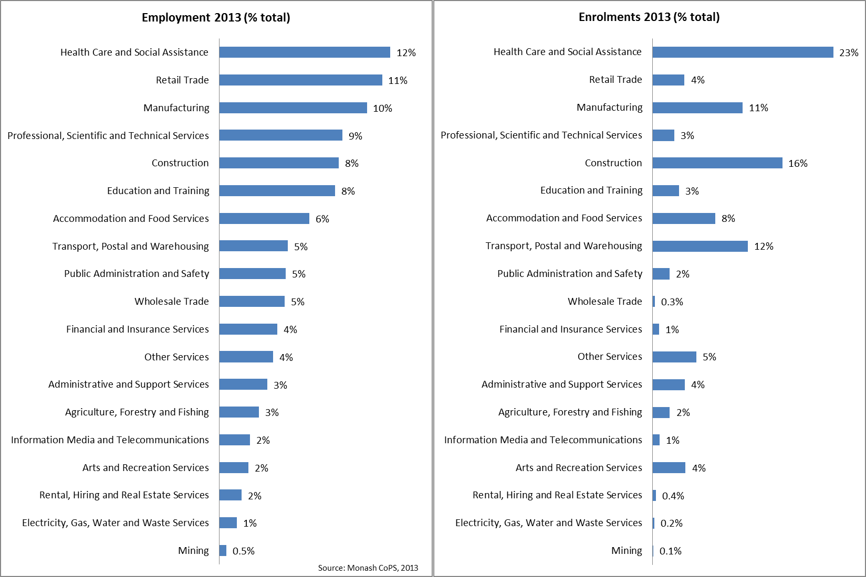
Specific parts of the training market may also be designated as “in shortage” or “specialised”. Occupations included in these categories include aged and disability care workers, childcare workers, electricians, motor mechanics and nurses. Identifying occupations in this way offers students and training providers further information about how their training can match with current employment trends.
There has also been a marked increase in training in areas of critical importance to the Victorian economy with training in “in shortage” and “specialised” areas seeing strong activity growth.
Government subsidised enrolments in “in shortage” occupations have increased by 96,200 or 123 per cent between 2008 and 2013. Even in comparison to the unusually high level of delivery in 2012, 2013 recorded an increase of 22,800 or 15 per cent on 2012 results. Government subsidised enrolments in specialised occupations also increased between 2008 and 2013 by 33,800 or 60 per cent. Between 2012 and 2013 government subsidised enrolments in specialised occupations increased by 10,800 or 14 per cent. Training in these critical areas now accounts for 41 per cent of all industry specific* government subsidised enrolments in 2013.
* Industry specific excludes enrolments in foundation skills, educational pathways and low-level LOTE courses

Chart 3: Government subsidised enrolments in “in shortage” or specialised skill occupations, 2008 to 2013
Profile of Vocational Education and Training Government Subsidy
As mentioned previously, from July 2012 funding bands for government subsidised training were introduced. The allocation of funding within these bands is designed to better target areas of greatest public benefit and future jobs growth. Where there is not a strong need for Government support the training subsidies have been reduced.
Proportionally, there has been a marked shift in commencement patterns when comparing the 2013 results with pre-July 2012. In 2013, 69 per cent of all government subsidised commencing enrolments were in areas of highest value to the economy, represented by subsidy bands A and B (Chart 4). This compared with 49 per cent of commencements in subsidy bands A and B in pre-July 2012. Courses with less vocational outcome, or in labour market oversupply (Band D & E) represented 9 per cent of all government subsidised commencements in 2013, down from 31 per cent Pre-July 2012.
Chart 4: Commencing Enrolments by Funding Bands

*Pre-July 2012 refers to January to June 2012. Due to rounding the sum may not add up to 100 per cent.

Apprenticeships
The 2013 results show that there has been a decline in government subsidised enrolments for Apprenticeships between 2012 and 2013. In line with national trends and reflecting in part subdued business conditions, Apprenticeships have declined by 1,800 or 4 per cent.
Chart 5: Government Subsidised Enrolments by Apprentices, 2008 to 2013

Traineeships
Chart 6: Government Subsidised Enrolments by Traineeships, 2008 to 2013

The 2013 results show that there has been a decline in government subsidised enrolments for Traineeships between 2012 and 2013. Traineeships have declined by 30,900 or 35 per cent, mostly in courses that are subsidised in the lowest funding band (D and E), which reflects the previous oversupply of training.

Learners facing barriers
While we are seeing evidence of the realignment of the vocational training sector, learners facing barriers are increasing their participation in training. The 2013 results show that there were increases in the numbers of each learner cohort. The number of unemployed students showed the largest increase across the cohorts between 2012 and 2013 with 14 per cent growth and even higher between 2011 and 2013 with a 51 per cent increase.
Table 2: Number of Government Subsidised Students by Learners Facing Barriers*, 2008 to 2013
 | 2008 | 2009 | 2010 | 2011 | 2012 | 2013
Indigenous | 4,400 | 4,300 | 4,800 | 5,600 | 6,200 | 6,500
Students with a disability | 23,900 | 23,600 | 27,200 | 34,100 | 40,300 | 40,500
CALD | 58,100 | 62,100 | 70,600 | 97,300 | 126,400 | 137,500
Unemployed | 41,800 | 50,200 | 62,500 | 89,300 | 118,500 | 134,800

Change in numbers of Learners Facing Barriers
 | % change  2008-2013 | % change  2009-2013 | % change  2010-2013 | % change  2011-2013 | % change  2012-2013
Indigenous | 49% | 50% | 35% | 16% | 5%
Students with a disability | 69% | 71% | 49% | 18% | 1%
CALD | 136% | 121% | 95% | 41% | 9%
Unemployed | 223% | 169% | 116% | 51% | 14%
*Numbers in the above cohort groups are not mutually exclusive. CALD – Culturally and Linguistically Diverse
Participation in training across Victoria
In 2013 all areas of Victoria, except Eastern Metropolitan Melbourne, had a participation rate above 10 per cent, with Barwon South Western and the Hume areas having the highest at 15 per cent. Between 2008 and 2013 nearly all areas across the State experienced an increase in the participation rate of 15 to 64 year olds in vocational training.
Chart 7: Participation Rate of 15 to 64 Year Olds in Government Subsidised Training in 2013

Provider type
Government subsidised training is provided by a broad range of providers, from small private RTOs to large TAFEs that have multiple campuses across the State.
Through the implementation of the Government’s response to the TAFE Reform Panel’s recommendations, TAFE institutes are being supported to transition to a more sustainable basis so that they can continue to meet the needs of learners and industry by improving educational outcomes. There has been generally strong performance by Victoria’s TAFEs in the delivery of vocational training, between 2008 to 2013 delivery increased by 15 per cent.
Government subsidised delivery by provider type, enrolments
 | 2008 | 2009 | 2010 | 2011 | 2012 | 2013
Learn Local | 73,800 | 68,300 | 63,800 | 64,600 | 80,200 | 73,500
Private RTOs | 54,000 | 57,400 | 99,800 | 220,700 | 308,800 | 312,000
Dual Sector Universities | 72,400 | 68,500 | 76,300 | 69,900 | 68,100 | 51,500
TAFE | 181,100 | 182,600 | 187,000 | 193,600 | 213,300 | 207,900
Total | 381,300 | 376,800 | 426,900 | 548,700 | 670,400 | 645,000
Percentage share of government subsidised enrolments by provider type, 2008 to 2013
 | 2008 | 2009 | 2010 | 2011 | 2012 | 2013
Learn Local | 19% | 18% | 15% | 12% | 12% | 11%
Private RTOs | 14% | 15% | 23% | 40% | 46% | 48%
Dual Sector Universities | 19% | 18% | 18% | 13% | 10% | 8%
TAFE | 47% | 48% | 44% | 35% | 32% | 32%
Total | 100% | 100% | 100% | 100% | 100% | 100%

Change in Government subsidised delivery by provider type, enrolments
 | % change  2008-2013 | % change  2009-2013 | % change  2010-2013 | % change  2011-2013 | % change  2012-13
Learn Local | 0% | 8% | 15% | 14% | -8%
PRIV | 478% | 444% | 213% | 41% | 1%
Dual Sector Universities | -29% | -25% | -33% | -26% | -24%
TAFE | 15% | 14% | 11% | 7% | -3%
Total | 69% | 71% | 51% | 18% | -4%

