# Victorian Training Market SNAPSHOT 2020

|  |
| --- |
|  |

This report provides detailed information on the student and provider profiles of the Government-funded Vocational Education Training (VET) market in Victoria over the 2020 calendar year. Vocational education training was one of the sectors that were adversely impacted by the COVID-19 pandemic, where lockdowns and travel restrictions have led to disruption in training activity. The Government-funded VET system aims to provide high quality training and improve access for students, giving Victorians skills they need to respond to uncertain times.

**There were a total of 47,391 Free TAFE enrolments at the end of 2020, which is a 19.3 per cent increase from 2019.**

|  |
| --- |
|  |

*Free TAFE for Priority Courses*



**Free TAFE played an important role in training graduates with skills that are high in demand, especially in the context of the pandemic. Nursing and cyber security were the most popular Free TAFE courses in 2020.**

|  |
| --- |
|  |

|  |
| --- |
|  |

**Student satisfaction with the training system and quality in 2020 improved or remained similar to 2019, despite the pandemic.**

Student Satisfaction

**The proportion of VET completers who are satisfied with their training or have achieved their main reason for study improved compared with the previous year.**

**

**A growing share of Indigenous students, unemployed and students with a disability receive training at TAFEs.**

|  |
| --- |
|  |

Learner Cohorts



**The training system continues to support all Victorians and provide access to high quality training that supports their learning needs and lead to strong job outcomes.**

|  |
| --- |
|  |

**Enrolments in courses related to health care and social assistance increased by 9 per cent despite the pandemic.**

**Training is growing Victoria’s pool of skilled workers, particularly in Government priority areas. Government-funded enrolments increased in courses related to the National Disability Insurance Scheme and Family Violence Prevention.**

Jobs and Skills



|  |
| --- |
| TAFE Network share of students |

TAFE Network



***Skills First* has rebuilt TAFEs and increased their market share, placing the   
TAFE Network at the centre of the Victorian training sector.**

# National comparisons

* The COVID-19 pandemic in 2020 led to a lower volume of training in the VET sector. Lockdowns and restrictions became barriers for students to receive on-site training, which is the predominant mode of delivery for vocational education training.
* In 2020, there were 265,200 students enrolled in the Government-funded VET system in Victoria, an 8 per cent decrease from 2019 (Figure 1).
* The proportion of working age population participating in Government-funded VET in Victoria was slightly lower in 2020 than previous years but remained stable (Figure 2).
* While there were fewer commencements in Victoria in 2020 than 2019, Victoria had a higher share of continuing enrolments than Australia. This indicates that many students remained in the training system, rather than withdrawing from training (Figure 3).

Figure 1. Change in the number of Government-funded students between 2019 and 2020, by states and territories

Source: National Centre for Vocational Education Research 2021, Government-funded students and courses 2020: DataBuilder

Note: The percentages represent the growth rates between 2019 and 2020.

Figure 2. VET participation rate of Victorians aged 15 to 64

Source: National Centre for Vocational Education Research 2021, Government-funded students and courses 2020: DataBuilder; Australian Bureau of Statistics, Estimated Resident Population

Figure 3. Share of commencements and continuing enrolments (2019-2020)

Source: National Centre for Vocational Education Research 2021, Government-funded students and courses 2020: DataBuilder

# Market performance

* The results from the Department’s Student and Employer Survey conducted in 2021 show a decline in satisfaction rates in some areas of the training system. This was likely linked to reduced opportunities for placements and employment, as well as the difficulties in providing hands-on demonstrations and practical use of tools and equipment.
* However, a similar proportion of VET completers in 2020 reported an improved employment status, when compared with completers in 2019, prior to the pandemic.
* Moreover, the proportion of completers who achieved their main reason for training has been increasing in recent years (Table 2).

Table 1. Numbers of training organisations, students, commencements, and total enrolments, by provider type (2018-2020)

|  |  |  |  |  |  |
| --- | --- | --- | --- | --- | --- |
|  | **Provider type** | **2018** | **2019** | **2020** | **% Change 2019-2020** |
| **Training organisations** | TAFE Network | 16 | 16 | 16 | 0% |
| ACE | 258 | 251 | 235 | ▼-6% |
| Private | 268 | 233 | 208 | ▼-11% |
| All | 542 | 500 | 459 | ▼-8% |
| **Students** | TAFE Network | 124 729 | 141 095 | 137 573 | ▼-2% |
| ACE | 48 283 | 47 605 | 34 674 | ▼-27% |
| Private | 92 962 | 90 660 | 90 052 | ▼-1% |
| All | 265 974 | 279 360 | 262 299 | ▼-6% |
| **Commencements** | TAFE Network | 85 191 | 101 345 | 83 126 | ▼-18% |
| ACE | 66 828 | 68 408 | 45 580 | ▼-33% |
| Private | 50 315 | 52 411 | 50 743 | ▼-3% |
| All | 202 334 | 222 164 | 179 449 | ▼-19% |
| **Total Enrolments** | TAFE Network | 139 177 | 154 828 | 146 843 | ▼-5% |
| ACE | 74 310 | 75 231 | 52 874 | ▼-30% |
| Private | 101 343 | 98 183 | 96 884 | ▼-1% |
| All | 314 830 | 328 242 | 296 601 | ▼-10% |

Source: Department of Education and Training Victoria, Training Market Data

Figure 4. Government-funded enrolments, by provider type (2018-2020)

Source: Department of Education and Training Victoria, Training Market Data

Table 2. Student and Employer Satisfaction Survey (selected results, 2018-2020)

|  |  |  |  |  |
| --- | --- | --- | --- | --- |
|  | **2018** | **2019** | **2020** | **Change 2019-20 (pp)** |
| **Proportion of employers who were satisfied with training** | 78.5 | 79.1 | 75.3 | ▼-3.8 pp |
| **Proportion of VET completers who are satisfied with their training** | 85.3 | 86.7 | 86.5 | ▼-0.2 pp |
| **Proportion of VET completers with an improved employment status after training** | 50.1 | *55.4 | 55.7 | ▲0.3 pp |
| **Proportion of VET completers who achieved their main reason for training** | 83.5 | 85.1 | 85.3 | ▲0.2 pp |

Source: Department of Education and Training Victoria, Student and Employer Survey

Note: Year represents the time students left training (eg. students who completed training in 2020 were surveyed in 2021).

*A change of survey methodology was introduced in 2020 for this measure. Comparisons with 2018 should be made with caution.

# Training delivery & industries

* The Victorian TAFE and training system aims to develop skills that lead to real jobs. Support is given to courses that align to industry needs and workforce demands, have strong job outcomes, and are linked to Government priorities of greatest value to the Victorian economy.
* Enrolments in courses related to health care and social assistance continued to grow in 2020, as opposed to other industries (Table 3). This suggests that there has been a growing demand in health care and social workers, and the demand has risen during the pandemic.
* The training system has been producing graduates with specialised skills to meet industry demand. It has also been focusing on skills to assist people with disadvantaged backgrounds. This is reflected in the Government priority areas, where student participation in the National Disability Insurance Scheme (NDIS) and family violence remained strong despite the pandemic (
* Table 4).
* In terms of training delivery, the COVID-19 pandemic affected the mix of training delivery modes between regions. Metropolitan Melbourne had a higher share of training delivered remotely, as there were more providers shifting to online training platforms in compliance with the restrictions. Training outside of metropolitan Melbourne was largely delivered on-site or at workplaces, as regional Victoria had less disruption in training activity (Figure 5).

Table 3. Industries with top 5 total enrolments (2018-2020)

|  |  |  |  |  |
| --- | --- | --- | --- | --- |
| **Industry** | **2018** | **2019** | **2020** | **Change% change 2019-20** |
| **Health Care and Social Assistance** | 62 518 | 67 979 | 74 436 | ▲9% |
| **Construction** | 51 075 | 54 259 | 52 817 | ▼-3% |
| **Other Services** | 16 760 | 16 103 | 14 892 | ▼-8% |
| **Education and Training** | 11 574 | 15 642 | 13 110 | ▼-16% |
| **Professional, Scientific and Technical Services** | 10 469 | 11 368 | 11 234 | ▼-1% |

Source: Department of Education and Training Victoria, Training Market Data

Table 4. Total enrolments in Government priority areas, by provider type (2018-2020)

|  |  |  |  |  |  |
| --- | --- | --- | --- | --- | --- |
| **Priority areas** | **Provider type** | **2018** | **2019** | **2020** | **% Change 2019-20** |
| **NDIS** | TAFE Network | 12 232 | 18 653 | 21 607 | ▲16% |
|  | ACE | 5 004 | 6 044 | 6 883 | ▲14% |
|  | Private | 13 368 | 14 101 | 15 065 | ▲7% |
|  | All | 30 604 | 38 798 | 43 555 | ▲12% |
| **Family Violence** | TAFE Network | 8 972 | 11 847 | 12 919 | ▲9% |
|  | ACE | 2 343 | 2 597 | 3 060 | ▲18% |
|  | Private | 5 741 | 6 006 | 5 207 | ▼-13% |
|  | All | 17 056 | 20 450 | 21 186 | ▲4% |
| **Infrastructure** | TAFE Network | 33 555 | 35 886 | 34 183 | ▼-5% |
|  | ACE | 165 | 48 | - | ▼-100% |
|  | Private | 17 267 | 18 122 | 19 454 | ▲7% |
|  | All | 50 987 | 54 056 | 53 637 | ▼-1% |
| **High-Value** | TAFE Network | 3 485 | 4 106 | 4 075 | ▼-1% |
| **Traineeships** | ACE | 1 112 | 1 076 | 586 | ▼-46% |
|  | Private | 7 567 | 7 263 | 5 681 | ▼-22% |
|  | All | 12 164 | 12 445 | 10 342 | ▼-17% |
| **Apprentices** | TAFE Network | 36 388 | 37 361 | 35 601 | ▼-5% |
|  | ACE | 158 | 155 | 165 | ▲6% |
|  | Private | 11 660 | 11 303 | 11 065 | ▼-2% |
|  | All | 48 206 | 48 819 | 46 831 | ▼-4% |

Source: Department of Education and Training Victoria, Training Market Data

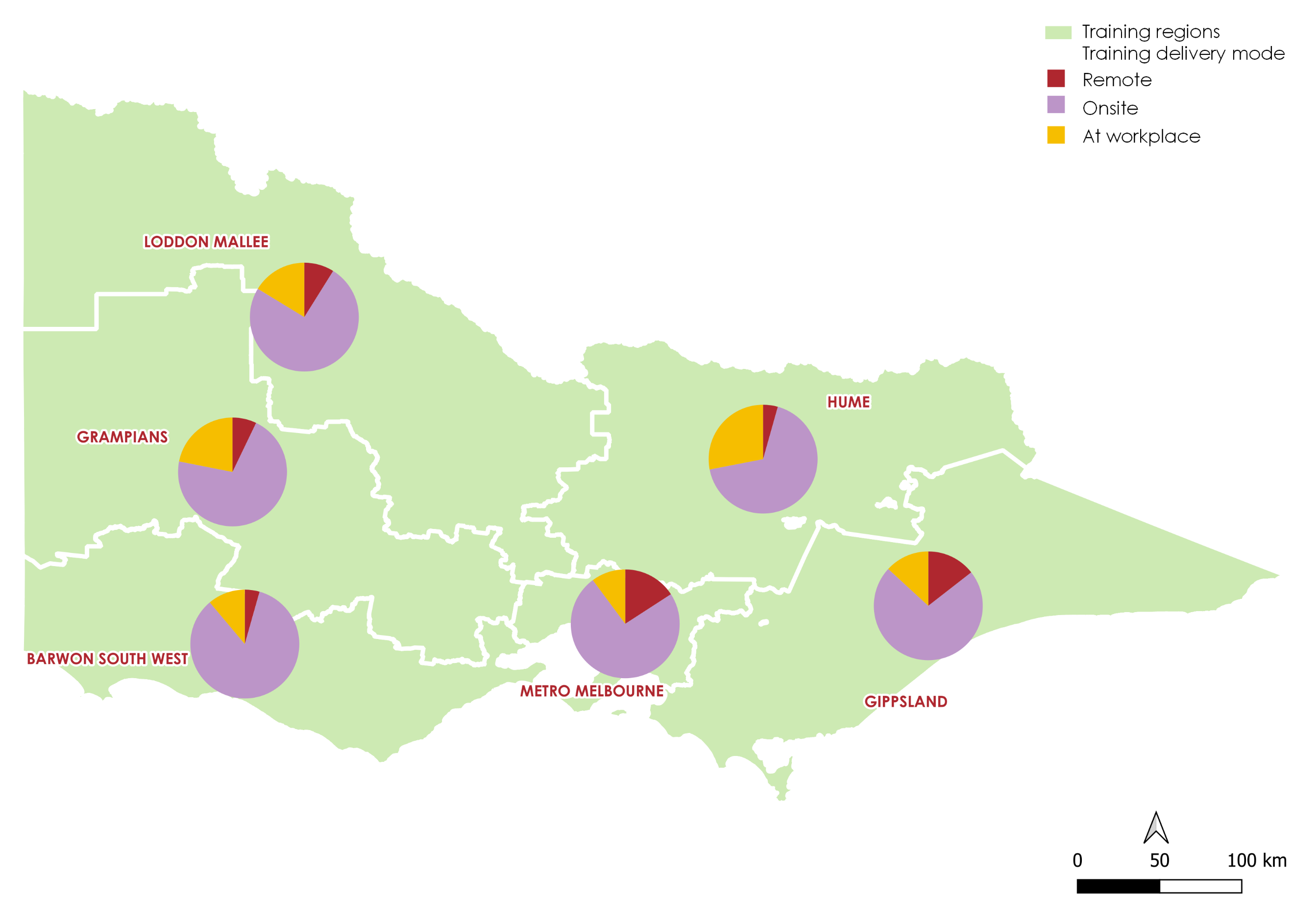Figure 5. Training delivery mode, by region (2020)

Source: Department of Education and Training Victoria, Training Market Data

|  |  |  |  |
| --- | --- | --- | --- |
| **Region** | **Remote** | **Onsite** | **At Workplace** |
| **Barwon South West** | 4% | 85% | 11% |
| **Grampians** | 7% | 71% | 22% |
| **Loddon Mallee** | 9% | 75% | 16% |
| **Hume** | 4% | 68% | 28% |
| **Gippsland** | 14% | 72% | 13% |
| **Metro Melbourne** | 16% | 74% | 10% |

# Equitable Access

* Skills First aims to create an inclusive training system that ensures all Victorians have access to high quality training that leads to strong job outcomes, regardless of age, background, circumstance or postcode.
* The TAFE Network plays an important part in helping our most disadvantaged and/or disengaged students to access and stay connected with training. The TAFE Network accounted for the majority of enrolments by early school leavers (70.5 per cent) and more than half of the enrolments by Indigenous students (51.8 per cent) in 2020 (Table 5).
* One of the great successes in recent times is the growing participation of female students in VET. The growth is especially pronounced among the TAFE Network, whereas female participation overall rose steadily over the last three years (Table 6).

Table 5. Total enrolments, by key cohorts (2020)

|  |  |  |  |
| --- | --- | --- | --- |
| **Cohort** | **Enrolments** | **Cohort as a % of total enrolments** | **% of total cohort enrolments at TAFE Network** |
| **Unemployed** | 72 905 | 24.6% | 36.8% |
| **Early School Leaver** | 18 934 | 6.4% | 70.5% |
| **Women** | 156 253 | 52.7% | 42.4% |
| **Women returning to work** | 16 352 | 5.5% | 21.8% |
| **Indigenous** | 5 666 | 1.9% | 51.8% |
| **Culturally and linguistically diverse** | 101 128 | 34.1% | 34.6% |
| **With disability** | 31 800 | 10.7% | 41.5% |

Source: Department of Education and Training Victoria, Training Market Data

Table 6.Total enrolments, by provider type and gender (2018-2020)

|  |  |  |  |  |
| --- | --- | --- | --- | --- |
|  | **Provider type** | **2018** | **2019** | **2020** |
| **TAFE Network** | **Female** | 57 043 (41.1%) | 67 720 (43.8%) | 66 281 (45.3%) |
| **Male** | 81 890 (58.9%) | 86 725 (56.2%) | 80 039 (54.7%) |
| **All providers** | **Female** | 160 765 (51.2%) | 172 306 (52.7%) | 156 253 (52.9%) |
| **Male** | 153 145 (48.8%) | 154 824 (47.3%) | 139 211 (47.1%) |

Source: Department of Education and Training Victoria, Training Market Data

# free tafe for priority courses

* Free TAFE for priority courses began on 1 January 2019. At the end of 2020, there were a total of 47,391 Free TAFE enrolments, representing a 19.3 per cent increase from 2019.
* Free TAFE aims to lift quality and improve access for students to study at TAFEs. During the pandemic, the program gave Victorians the opportunity they needed to upskill and secure rewarding jobs. Female participation in Free TAFE was more pronounced than males, with higher proportions of female students who were unemployed or not in the labour force than male students (Figure 6).

There was also a higher proportion of Free TAFE students who were unemployed and seeking training in 2020. This shows that some people who became unemployed during the COVID-19 pandemic were utilising Free TAFE for training and upskilling to improve employment status (

* Table 7).
* Free TAFE has been instrumental in supporting the health and community sector fill critical job vacancies, in equipping students with skills and to improve the lives of Victorians. The most popular courses at regions were related to these sectors (Figure 7). Cyber security was the second most popular course in 2020, as increasing use of online platforms prompted higher demand in workers with these skills (Table 8).

Figure 6. Total Free TAFE erolments by gender and labour force status (2020)

Source: Department of Education and Training Victoria, Training Market Data

Table 7. Free TAFE commencements, by labour force status (2019-2020)

|  |  |  |
| --- | --- | --- |
| **Gender** | **2019** | **2020** |
| **Employed** | 21 526 (60.6%) | 16 203 (58.1%) |
| **Unemployed** | 9 916 (27.9%) | 8 696 (31.2%) |
| **Not In The Labour Force** | 4 084 (11.5%) | 2 992 (10.7%) |

Source: Department of Education and Training Victoria, Training Market Data

Table 8. Top 10 Free TAFE course commencements (2020)

|  |  |  |
| --- | --- | --- |
| **Gender** | **Course name** | **% of total Free TAFE commencements** |
| **Diploma of Nursing** | 2 849 | 9.4% |
| **Certificate IV in Cyber Security** | 2 171 | 7.1% |
| **Diploma of Early Childhood Education and Care** | 1 901 | 6.2% |
| **Certificate III in Individual Support** | 1 725 | 5.7% |
| **Certificate IV in Accounting and Bookkeeping** | 1 604 | 5.3% |
| **Diploma of Building and Construction (Building)** | 1 482 | 4.9% |
| **Certificate III in Early Childhood Education and Care** | 1 443 | 4.7% |
| **Certificate IV in Community Services** | 1 350 | 4.4% |
| **Certificate IV in Disability** | 1 116 | 3.7% |
| **Diploma of Community Services** | 1 039 | 3.4% |

Source: Department of Education and Training Victoria, Training Market Data

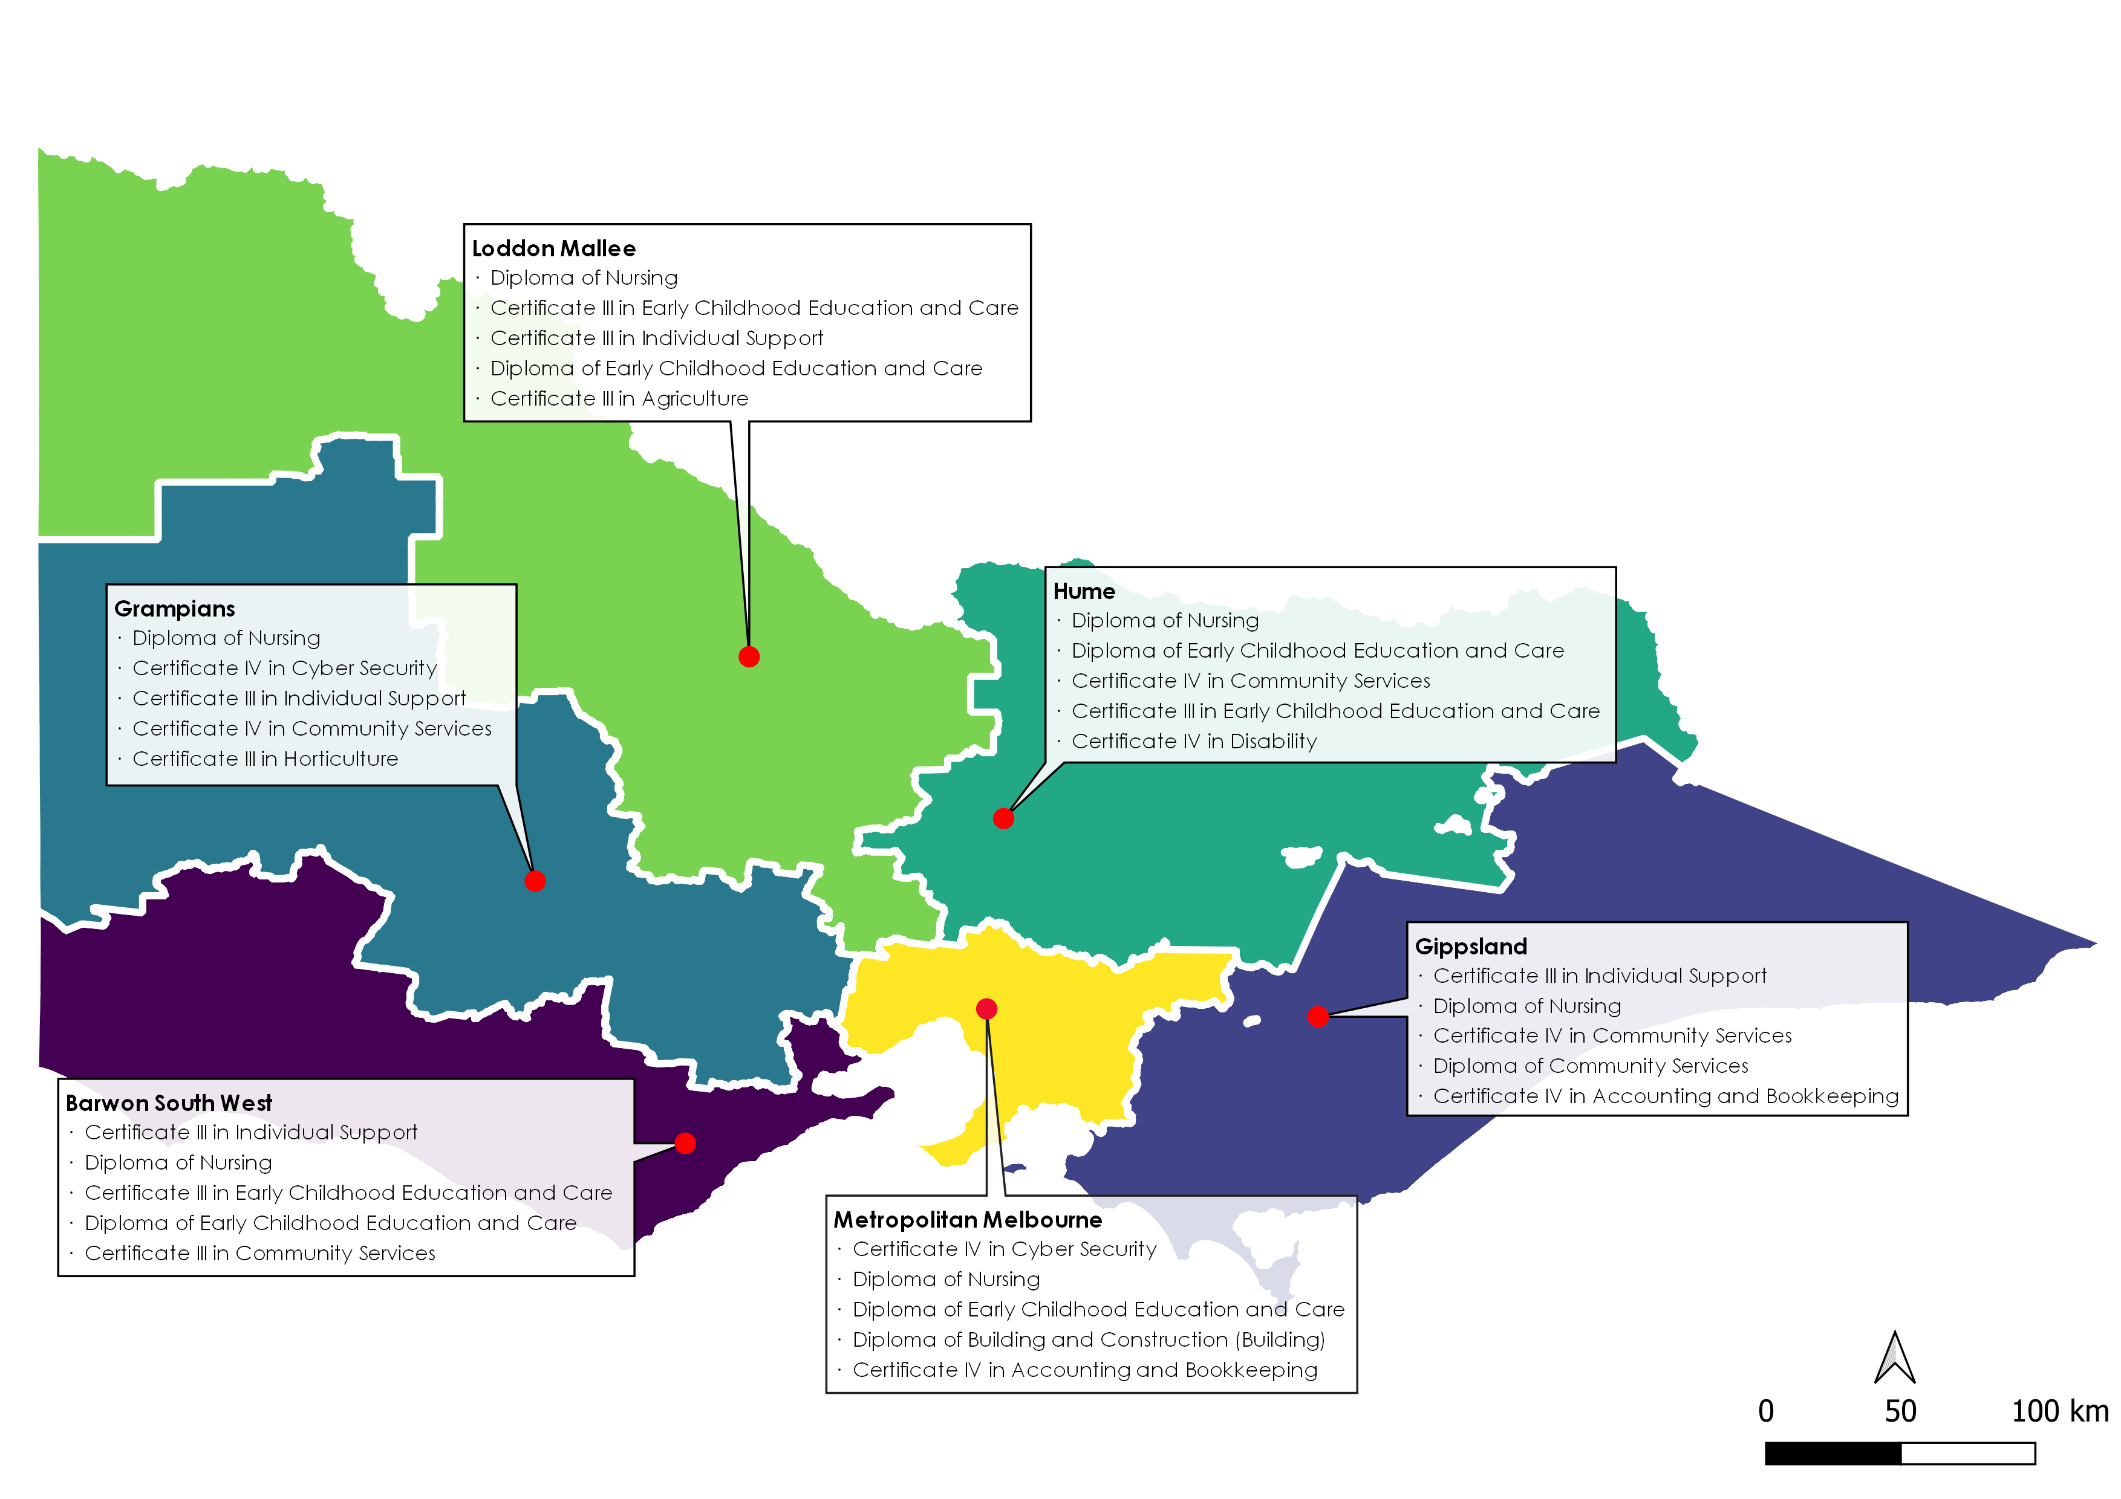Figure 7. Top 5 Free TAFE course commencements, by region (2020)

Source: Department of Education and Training Victoria, Training Market Data

# Notes on the data

***Data source***

The main source of VET data in this report is DET’s training activity database, referred to as the Skills Victoria Training System (SVTS). This administrative data are reported to DET by Government‑funded training providers.

SVTS data included in this report may differ to previous publications as classifications are updated from time to time to improve data quality and consistency across years. In addition, changes to reporting and data standards may lead to minor revisions to data previously reported.

SVTS data presented in this report is not comparable to other publicly available data such as:

* National Centre for Vocational Education Research (NCVER) data – the information reported by NCVER is sourced from data submitted by all states and territories. While the NCVER data for Victoria are sourced from data submitted by the Victorian Department of Education and Training, there will be marginal differences between Departmental data and published NCVER data due to national statistical and counting rules that seek to ensure consistency and comparability between jurisdictions.
* Budget Paper No. 3 data (Chapter 2 - Department performance statements) because of differences in counting rules and definitions.

The main measures used in this report are students, course enrolments and course commencements. New course commencements show the number of new course enrolments in a given year, as courses often take more than one year to complete. Total course enrolments include both new commencements and continuing enrolments. A student may be enrolled in more than one course at a training provider during a given reporting period.

The report also draws on publicly available data on the VET system from NCVER (which allow for inter-jurisdictional comparisons) and from the Australian Bureau of Statistics.

***Data scope***

This report covers government-funded training activity only. Training activity for the 2020 full year is compared with the same period in 2018 and 2019 to provide a picture of changes and trends over time.

***Learn Local and Adult and Community Education (ACE)***

The Training Market Report generally classifies providers as TAFE, Dual Sector, Adult and Community Education (ACE) or private. However, some data sources use a slightly different definition – Learn Local – rather than ACE. Only Learn Local organisations report activity through to the Adult, Community and Further Education Board, while ACE organisations are self-identified and are not required to do so. Some Learn Local organisations self‑identify as private RTOs and are therefore not included in the ACE definition.

***Industry classifications***

All industry titles and classifications included in this Report are defined as per the Australian and New Zealand Standard Industrial Classifications (ANZSIC). For more information, see: <https://www.abs.gov.au/ANZSIC>.

Where a qualification is considered relevant across several industries, enrolments have been proportionally allocated across relevant ANZSIC industries using employment data as a guide.

***Regional analysis***

Data on regional training are reported by the region in which the training was delivered (as distinct from the region where the student lives). Note a course can be delivered to a student across multiple regions. In these cases, the course enrolment will be counted in each region in which it was delivered.