Victorian Training Market Report   
2013



Prepared by Department of Education and  
Early Childhood Development

Melbourne  
June 2014

©State of Victoria (Department of Education  
and Early Childhood Development) 2014

The copyright in this document is owned by the State of Victoria (Department of Education and Early Childhood Development), or in the case of some materials, by third parties (third party materials). No part may be reproduced by any process except in accordance with the provisions of the Copyright Act 1968, the National Education Access Licence for Schools (NEALS) (see below) or with permission.

An educational institution situated in Australia which is not conducted for profit, or a body responsible for administering such an institution may copy and communicate the materials, other than third party materials, for the educational purposes of the institution.

Authorised by the Department of Education  
and Early Childhood Development,   
2 Treasury Place, East Melbourne, Victoria, 3002

This document is also available on the internet at

http://www.education.vic.gov.au/training/providers/market/Pages/reports.aspx

Contents

Executive Summary 7

Notes about the data 9

Reporting scope 9

Vocational Training Summary 11

Vocational Training by Funding Type 11

Qualification Levels 14

Vocational Training Completions 18

Age Profile 21

Gender Profile 23

Government Subsidised Activity and Participation by Regions 24

Government Subsidised Delivery by Provider Type 30

Learn Local Performance 34

Learners Facing Barriers to Participation 41

Vocational Training Delivery to Learner Cohorts Facing Barriers 41

Indigenous Students 43

Students with a Disability 44

Students with a Culturally and Linguistically Diverse (CALD) Background 45

Unemployed Students 46

Young People (Aged 15 to 19) without Year 12 or Equivalent and Not at School 47

Students with Low Prior Qualifications 48

Foundation Level Training 49

Alignment of Training to Industry Skills Needs 51

Enrolments by Industry and Occupation 52

Apprentices 57

Trainees 61

Training in Specialised and In-Shortage Related Occupations 65

## Victorian Training Market Reports

### This Victorian Training Market Report for 2013 is the latest in an on-going series of reports produced by the Department of Education and Early Childhood Development (DEECD). The aim of the report is to provide a summary of Victorian Vocational Education and Training (VET) market performance and responsiveness to industry needs. The full year report includes data reported by training providers for the full year 2013 and provides an overview based on a snapshot of training activity data as at the end of December 2013.

This Report complements a broader set of reports on 2013 training activity to be released separately as part of the 2013 Victorian Training Market Report; the additional reports will include analysis of trends by industry and region.

These reports and other information products produced by the Department help inform students, employers, industry and other key stakeholders on the Victorian vocational training system. These reports have been regularly enhanced and refined in response to stakeholder feedback. Starting from 2014 a number of developments will be implemented to expand the scope of analysis and data available:

* **An on line data portal** available in the second half of 2014. The portal will be available through the Department’s public web site and offer up to date reporting on training activity and progressively support interactive exploration of training data through “point and click” charts and maps.
* A half year **Victorian Training Market Report** that will expand on the usual set of indicators reported and include greater depth of analysis on vocational training activity, such as an analysis of students pathways and outcomes. The half year report will build upon the previous quarterly Reports, responding to stakeholder requests for greater depth of analysis which was not possible in the quarterly Reports.
* **E-marketplace** which will facilitate connections between employers and training providers. Employers will be able to anonymously post their training requirements and training providers will be able to provide responses online. The E-marketplace will be available in the third quarter of 2014.

### Victoria is recognised as a leader nationally on making data and information easily accessible to stakeholders to support their engagement and participation in the Victorian vocational training system. Already available data and information products available through [www.education.vic.gov.au](http://www.education.vic.gov.au) include:

* **Regional Reports** that examines training delivery in each of Victoria’s regions in the context of the local population, economy and workforce, building a picture of the relationship between local training system and regional skills needs, training market performance and responsiveness.
* **Industry Reports** that combines industry intelligence and economic analysis with training activity data to build a more complete picture of the relationship between industry skills needs, employment opportunities and skills training.
* **Rate your training** a new ratings tool where employers can rate the quality and performance of a training provider they have used, and where employers can review and compare the ratings of other employers.
* **Industry blog** to provide up to date news and alerts on developments for people interested in skills and training issues in Victoria, the blog features a range of topics relevant to stakeholders and information on recent industry events.
* **Industry Participation Model (IPM) Portfolio Industry Reports** describe training and economic activity and developments related to Victorian key industry sectors. Highlighted are both the challenges faced in attracting the right skills and the opportunities businesses, training providers and government have to address these.
* **Industry skills update – e- Alerts** are provided regularly to subscribers and feature the latest news about the Industry Participation Model activities, market facilitation and related government initiatives; reports and training performance information.
* **Victorian Skills Gateway** – a one stop shop of Victorian vocational education and training information that helps students find the best training option that meets their needs. Searches can be performed on occupations, courses, training providers and by location.

# Executive Summary

Victoria’s training system is building the skills of the current and future Victorian workforce. The system is highly responsive, meeting the needs of both students and employers, and government investment is supporting large numbers of students who are increasingly choosing to study in areas of most demand in the labour market.

* Government subsidies supported the training of 484,300 students in 2013, over 43 per cent more than in 2010. In 2013 these students were enrolled in 645,000 courses.
* There were 116,900 TAFE domestic fee for service enrolments in 2013, higher than 2010 by more than 13 per cent.
* The number of completions of qualifications (including government subsidised and TAFE fee for service) was 220,200 in 2013, higher than 2010 by 44 per cent.

Access to training in regional Victoria has increased, with enrolments up by almost 30 per cent, from 106,900 in 2010 to over 130,000 in 2013.

* Delivery of government subsidised training in the nine geographic reporting regions shows growth in all regions between 2010 and 2013 except Gippsland.
* When looking at enrolments based on where a student lives, rather than where they study, Gippsland is the only regional area where student numbers were lower in 2013 than 2010 but by only 2 per cent.
* The estimated participation rate of vocational education and training students shows that in 2013 the Barwon South West and Hume regions had the highest participation rate (15 per cent), closely followed by the Western Metropolitan Melbourne region at 14 per cent. The lowest participation rate in government subsidised training was the Eastern metropolitan area at 9 per cent.

Victoria’s economy is experiencing the highest rate of structural change across in country. Training is a key mechanism to assist industry and workers in industries experiencing such changes. The Victorian skills system in responding to industry needs, with more enrolments in areas of training relevant to the needs of employers which is more likely to result in positive employment outcomes for students.

* Between 2010 and 2013 training enrolments in specialised or skill shortage occupations increased by 59 per cent, and now represent 41 per cent of all enrolments.[1]
* The top five enrolling specialised or in shortage occupations in 2013 were child carers (30,100 enrolments), aged and disabled carers (20,400), truck drivers (14,600), welfare support workers (11,600) and motor mechanics (8,400).
* 60 per cent of enrolments were delivered in the six highest employing Victorian industry sectors, which account for 59 per cent of all Victorian jobs.

As Victoria transitions to a higher skilled, knowledge-based economy, demand for training has increased. Victoria’s flexible training system is opening up more pathways to further learning and employment.

* The proportion of students who were unemployed, not in the labour force or employed in lower skilled and declining occupations rose from 36 per cent of all students in 2010 to 47 per cent in 2013.
* Participation by Indigenous students and students with a disability has also grown between 2010 and 2013 – by 30 per cent and 51 per cent respectively.

Victoria’s training providers continue to be valued by businesses and learners, delivering traditional trades training together with cross-industry and foundation skills.

* Almost half of all TAFE enrolments were in Certificate III-IV and the top three industry areas of enrolment were construction, health care and social assistance and manufacturing.
* Nearly 70 per cent of all private Registered Training Organisation enrolments were in Certificate III-IV and the top three industry areas of enrolment were health care and social assistance, transport, postal and warehousing and manufacturing.
* In the Learn Local sector, over 40 per cent of enrolments were module only enrolments and the top three industry areas were health care and social assistance, accommodation and food services and education and training.

In 2013, the number of government subsidised enrolments by private Registered Training Organisations was 48 per cent of all delivery, TAFEs delivered 40 per cent of training and the Learn Local sector 11 per cent.

## Notes about the data

This Report includes key metrics, such as training delivery by funding source, qualification level, course completion, age of learners, learners facing barriers to participation and regional activity. An analysis of alignment to industry needs is also provided.

The main source of vocational training statistics in this publication is the training activity database referred to as Skills Victoria Training System (SVTS). Data included in the report are a snapshot in time and based on data as reported to Higher Education and Skills Group (HESG) in the Department by training providers. For TAFE Institutes, there is an additional regulatory requirement that they also submit their fee for service activity data.

Full year data between 2008 and 2013 are included to show longer term trends. Generally percentage changes include the change from 2008, 2011, 2012 to 2013. However, key tables include information on each percentage change, i.e. 2008 to 2013, 2009 to 2013 and so forth.

The 2013 data were extracted from SVTS as at 22 February 2013. Annual data included in this report may differ from data released by the National Centre for Vocational Education and Research (NCVER) due to use of different business rules to ensure national consistency for reporting purposes and that data may be revised slightly prior to submission to NCVER and by the NCVER itself.

Annual data included in this report may differ to those in previous publications as the DEECD is continuously updating classifications to improve data quality and consistency across years. For example the apportionment of enrolments between the apprentice/trainee categories is marginally different to what was reported previously, this is a result of a correction to the classification of some courses. From time to time changes to reporting and data standards may lead to minor revisions to data previously reported. The data reported in this report was extracted on 22 February 2014; some minor changes occurred to the full year 2013 data following this date and are not reflected in this report. For example following this date about 700 government subsidised enrolments were recoded from pre-accredited to accredited to correct an earlier data quality issue.

Data shown in the tables are rounded to the nearest 100 when the figures are greater than 1,000; to the nearest 50 when they are between 100 and 1,000; and to the nearest 10 when they are less than 100. The percentage changes, e.g. between 2008 and 2013, are calculated based on the unrounded data.

For the purposes of this report the term Learn Local is used interchangeably with Adult and Community Education (ACE). However it should be noted that only Learn Local organisations report through to the ACFE Board, ACE organisations are self-identified and are not required to report through to the Board. In 2013 there were a very small number of Learn Local organisations that self-identified to SVTS as Private RTOs and therefore are not included in the count of Learn Local organisations for the purpose of this report.

## Reporting scope

This report includes government subsidised activities in all sectors at all qualification levels, and domestic fee for service activities in the TAFE sector at Australian Qualification Framework (Certificate I and above).

Fee for service activities below Certificate I in the domestic TAFE sector are not included, such as short courses. Fee for service activities that took place in the private RTO and Adult Community Education sectors are also outside the scope.

Since 2012, the scope of reporting of government subsidised training changed. ZC - Corrections delivery contracted directly with TAFE Institutes and ZP - Corrections funding through private prisons have been allocated to fee for service funding. Prior to 2012, these funded enrolments were allocated to government subsidised training.

# Vocational Training Summary

## Vocational Training by Funding Type

This section provides an overview of training activity measured in terms of course enrolments, student contact hours and student numbers.

|  |
| --- |
| Key Points The 2013 data shows that:   * There were 645,000 government subsidised course enrolments, 183.1 million government subsidised student contact hours and 484,300 government subsidised students. * TAFE domestic fee for service activity at Australian Qualification Framework (AQF) Certificate 1 and above recorded 116,900 enrolments, 19.8 million student contact hours and 96,700 students. |

Table 1.1.1: Enrolments in vocational training by funding type, 2008–2013

|  |  |  |  |  |  |  |
| --- | --- | --- | --- | --- | --- | --- |
|  | **2008** | **2009** | **2010** | **2011** | **2012** | **2013** |
| Government subsidised | 381,300 | 376,800 | 426,900 | 548,700 | 670,400 | 645,000 |
| TAFE domestic fee for service | 89,400 | 100,800 | 103,700 | 102,200 | 124,900 | 116,900 |
| **Total** | **470,700** | **477,600** | **530,600** | **650,900** | **795,300** | **761,900** |

* Fee for Service figures are TAFE on-shore domestic AQF Level 1 and above.

Table 1.1.2: Change in enrolments in vocational training by funding type

|  |  |  |  |  |  |
| --- | --- | --- | --- | --- | --- |
|  | **% change 2008-2013** | **% change 2009-2013** | **% change 2010-2013** | **% change 2011-2013** | **% change 2012-2013** |
| Government subsidised | 69% | 71% | 51% | 18% | -4% |
| TAFE domestic fee for service* | 31% | 16% | 13% | 14% | -6% |
| **Total** | **62%** | **60%** | **-4%** | **17%** | **-4%** |

*Fee for Service figures are TAFE on-shore domestic AQF Level 1 and above.

Figure 1.1: Enrolments in vocational training by funding type, 2008–2013

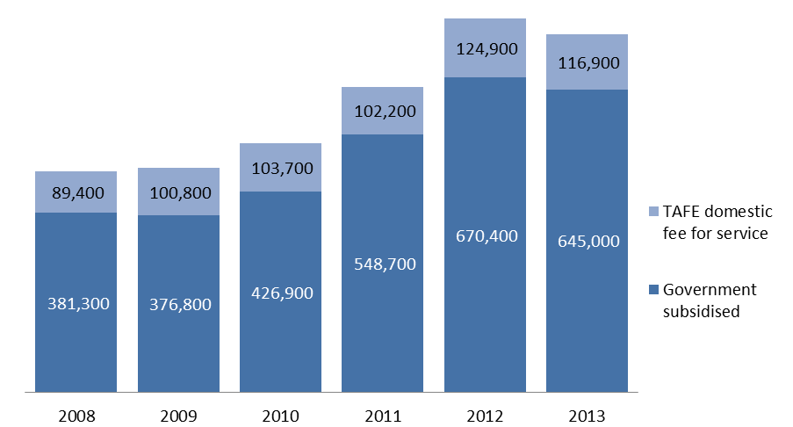

Table 1.2.1: Student contact hours[2] (millions) by funding type, 2008–2013

|  |  |  |  |  |  |  |
| --- | --- | --- | --- | --- | --- | --- |
|  | **2008** | **2009** | **2010** | **2011** | **2012** | **2013** |
| Government subsidised | 87.4 | 95.6 | 112.4 | 146.9 | 188.8 | 183.1 |
| TAFE domestic fee for service* | 17.1 | 20.4 | 19.4 | 18.5 | 21.9 | 19.8 |
| **Total** | **104.5** | **116.0** | **131.8** | **165.5** | **210.7** | **202.9** |

*Fee for Service figures are TAFE on-shore domestic AQF Level 1 and above.

Table 1.2.2: Change in student contact hours (millions) by funding type

|  |  |  |  |  |  |
| --- | --- | --- | --- | --- | --- |
|  | **% change 2008-2013** | **% change 2009-2013** | **% change 2010-2013** | **% change 2011-2013** | **% change 2012-2013** |
| Government subsidised | 110% | 92% | 63% | 25% | -3% |
| TAFE domestic fee for service* | 16% | -3% | 2% | 7% | -9% |
| **Total** | **94%** | **75%** | **54%** | **23%** | **-4%** |

*Fee for Service figures are TAFE on-shore domestic AQF Level 1 and above.

Figure 1.2: student contact hours (millions) by funding type, 2008–2013

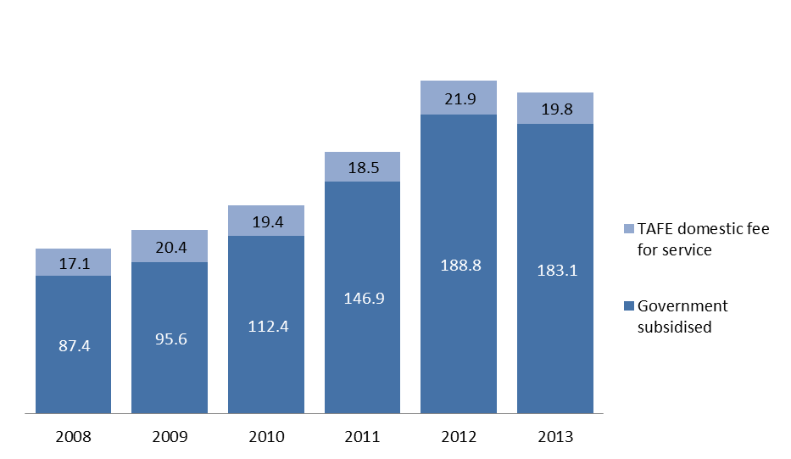

The average government subsidised hours per student have continued to increase from about 297 hours per student in 2008 to 378 in 2013. The 2013 result was also higher than the 2011 result at 342 hours per student and the 2012 result at 370 hours per student.

Table 1.3.1: Number of students by funding type, 2008–2013

|  |  |  |  |  |  |  |
| --- | --- | --- | --- | --- | --- | --- |
|  | **2008** | **2009** | **2010** | **2011** | **2012** | **2013** |
| Government subsidised | 294,700 | 299,600 | 339,200 | 430,300 | 509,800 | 484,300 |
| TAFE domestic fee for service* | 80,400 | 93,100 | 96,000 | 94,200 | 105,200 | 96,700 |
| **Total\*\*** | **366,700** | **381,300** | **422,500** | **512,900** | **603,200** | **569,300** |

*Fee for Service figures are TAFE on-shore domestic AQF Level 1 and above.

**TAFE students whose enrolments are made up of a combination of government subsidies and self-funding have been counted in both funding categories. The total, however, has eliminated the duplicates.

Table 1.3.2: Change in number of students by funding type

|  |  |  |  |  |  |
| --- | --- | --- | --- | --- | --- |
|  | **% change 2008-2013** | **% change 2009-2013** | **% change 2010-2013** | **% change 2011-2013** | **% change 2012-2013** |
| Government subsidised | 64% | 62% | 43% | 13% | -5% |
| TAFE domestic fee for service* | 20% | 4% | 1% | 3% | -8% |
| **Total\*\*** | **55%** | **49%** | **35%** | **11%** | **-6%** |

*Fee for Service figures are TAFE on-shore domestic AQF Level 1 and above.

**TAFE students whose enrolments are made up of a combination of government subsidies and self-funding have been counted in both funding categories. The total, however, has eliminated the duplicates.

Figure 1.3: Number of students by funding type, 2008–2013

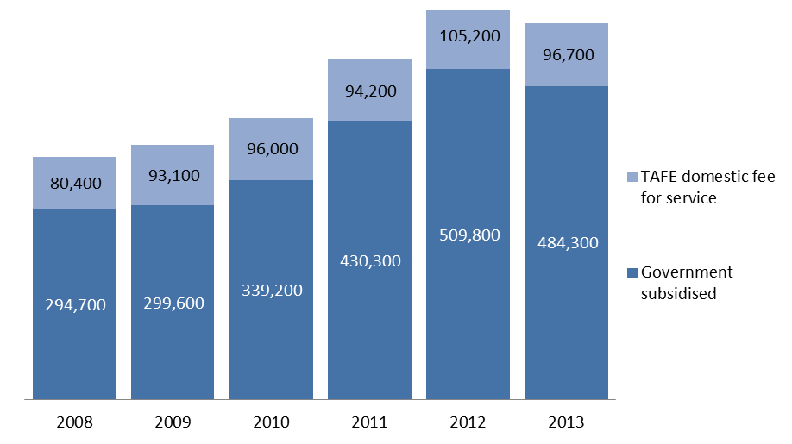

## Qualification Levels

Lower level qualifications such as Certificate I and II, provide literacy, numeracy, and work preparation skills to people without post-school qualifications so that they have the opportunity to go on to further study or find employment.

Mid-level skills are essential to the Victorian economy and help drive economic activity across the state. A significant proportion of apprenticeships and traineeships entail attainment of a mid-level qualification and are crucial to many key industries. Apprenticeships and traineeships are undertaken as a contract between the apprentice/trainee and an employer. While undertaking on-the-job learning, the apprentice/trainee receives complementary training through a vocational training provider.

For the purposes of this report Foundation include Foundation skills, workplace preparation, education pathways and low level language other than English courses.

### Government Subsidised Enrolments

|  |
| --- |
| Key Points  * Government subsidised non-foundation course enrolments at the Certificate I to II levels were 43,700 and at the Certificate III-IV levels were 336,100 in 2013. * Of the non-foundation courses of study, enrolments in Certificate III-IV represented the largest qualification group. * Government subsidised Foundation course enrolments at the Certificate I to II level were 124,000 and at the Certificate III-IV levels were 20,100 in 2013. |

Table 1.4.1: Government subsidised enrolments (excluding Foundation, workplace preparation, education pathways and LOTE) by qualification level, 2008–2013

|  |  |  |  |  |  |  |
| --- | --- | --- | --- | --- | --- | --- |
| **Qualification level** | **2008** | **2009** | **2010** | **2011** | **2012** | **2013** |
| Cert I-II | 63,500 | 64,100 | 72,600 | 79,400 | 63,900 | 43,700 |
| Cert III-IV | 157,400 | 157,800 | 193,600 | 277,300 | 347,500 | 336,100 |
| Diploma & Above | 55,700 | 63,700 | 71,200 | 90,300 | 94,800 | 68,400 |
| Module Only | 50,200 | 40,700 | 37,300 | 30,300 | 30,600 | 31,100 |
| Secondary, SoA and other | 16,100 | 15,000 | 13,700 | 10,600 | 10,000 | 8,500 |
| **Total** | **342,500** | **340,900** | **388,000** | **487,700** | **546,600** | **487,800** |

SoA – Statement of Attainment.

Table 1.4.2: Change in Government subsidised enrolments (excluding Foundation, workplace preparation, education pathways and LOTE) by qualification level

|  |  |  |  |  |  |
| --- | --- | --- | --- | --- | --- |
| **Qualification level** | **% change 2008-2013** | **% change 2009-2013** | **% change 2010-2013** | **% change 2011-2013** | **% change 2012-2013** |
| Cert I-II | -31% | -32% | -40% | -45% | -32% |
| Cert III-IV | 114% | 113% | 74% | 21% | -3% |
| Diploma & Above | 23% | 7% | -4% | -24% | -28% |
| Module Only | -38% | -23% | -16% | 3% | 2% |
| Secondary, SoA and other | -47% | -43% | -38% | -20% | -15% |
| **Total (excl foundation courses)** | **42%** | **43%** | **26%** | **0%** | **-11%** |

SoA – Statement of Attainment.

Table 1.5.1: Government subsidised enrolments (only including Foundation, workplace preparation, education pathways and LOTE) by qualification level, 2008–2013

|  |  |  |  |  |  |  |
| --- | --- | --- | --- | --- | --- | --- |
| **Qualification level** | **2008** | **2009** | **2010** | **2011** | **2012** | **2013** |
| Cert I-II | 23,600 | 19,500 | 21,300 | 40,000 | 90,800 | 124,000 |
| Cert III-IV | 8,000 | 8,100 | 8,100 | 10,600 | 18,400 | 20,100 |
| Secondary, SoA and other | 6,800 | 7,900 | 9,200 | 10,200 | 14,400 | 13,000 |
| **Total** | **38,800** | **35,900** | **38,900** | **61,100** | **123,900** | **157,200** |

SoA – Statement of Attainment.

Table 1.5.2: Change in Government subsidised enrolments (only including Foundation, workplace preparation, education pathways and LOTE) by qualification level

|  |  |  |  |  |  |
| --- | --- | --- | --- | --- | --- |
| **Qualification level** | **% change 2008-2013** | **% change 2009-2013** | **% change 2010-2013** | **% change 2011-2013** | **% change 2012-2013** |
| Cert I-II | 425% | 535% | 483% | 210% | 37% |
| Cert III-IV | 150% | 150% | 147% | 90% | 9% |
| Module Only | 93% | 64% | 42% | 28% | -9% |
| **Total** | **305%** | **338%** | **304%** | **157%** | **27%** |

SoA – Statement of Attainment.

### TAFE Domestic Fee for Service Enrolments

|  |
| --- |
| Key Point  * Proportionally, enrolments in Certificate I-II (non-Foundation) were the largest qualification group amongst TAFE domestic fee for service enrolments at Australian Qualification Framework Certificate 1 and above courses. |

Table 1.6.1: TAFE domestic fee for service enrolments (excluding Foundation, workplace preparation, education pathways and LOTE) by qualification level (AQF 1+), 2008–2013

|  |  |  |  |  |  |  |
| --- | --- | --- | --- | --- | --- | --- |
| **Qualification level** | **2008** | **2009** | **2010** | **2011** | **2012** | **2013** |
| Cert I-II | 41,300 | 48,400 | 51,500 | 49,500 | 57,700 | 56,500 |
| Cert III-IV | 40,000 | 43,400 | 42,600 | 42,800 | 55,300 | 48,100 |
| Diploma & Above | 7,300 | 8,000 | 8,300 | 8,500 | 10,200 | 10,900 |
| Higher Education | 750 | 1,000 | 1,300 | 1,400 | 1,600 | 1,400 |
| **Total** | **89,400** | **100,800** | **103,700** | **102,200** | **124,900** | **116,900** |

Table 1.6.2: Change in Government in TAFE domestic fee for service enrolments (excluding Foundation, workplace preparation, education pathways and LOTE) by qualification level (AQF 1+)

|  |  |  |  |
| --- | --- | --- | --- |
| **Qualification level** | **% change 2008-2013** | **% change 2011-2013** | **% change 2012-2013** |
| Cert I-II | 37% | 14% | -2% |
| Cert III-IV | 20% | 12% | -13% |
| Diploma & Above | 48% | 28% | 6% |
| Higher Education | 97% | 4% | -9% |
| **Total** | **31%** | **14%** | **-6%** |

Table 1.7.1: TAFE domestic fee for service enrolments (only including Foundation, workplace preparation, education pathways and LOTE) by qualification level (AQF 1+),   
2008–2013

|  |  |  |  |  |  |  |
| --- | --- | --- | --- | --- | --- | --- |
| **Qualification level** | **2008** | **2009** | **2010** | **2011** | **2012** | **2013** |
| Cert I-II | 8,300 | 7,400 | 7,400 | 6,400 | 11,700 | 13,700 |
| Cert III-IV | 1,800 | 2,200 | 2,100 | 1,900 | 2,500 | 2,700 |
| **Total** | **10,000** | **9,600** | **9,500** | **8,400** | **14,200** | **16,400** |

Table 1.7.2: Change in TAFE domestic fee for service enrolments (only including Foundation, workplace preparation, education pathways and LOTE) by qualification level (AQF 1+)

|  |  |  |  |
| --- | --- | --- | --- |
| **Qualification level** | **% change 2008-2013** | **% change 2011-2013** | **% change 2012-2013** |
| Cert I-II | 66% | 112% | 17% |
| Cert III-IV | 53% | 42% | 10% |
| **Total** | **63%** | **96%** | **16%** |

### Government Subsidised Student Contact Hours

|  |
| --- |
| Key Point  * Government subsidised student contact hours at Certificate III to IV levels in 2013 accounted for 112.2 million hours. |

Table 1.8.1: Government subsidised student contact hours (millions) by qualification level, 2008–2013

|  |  |  |  |  |  |  |
| --- | --- | --- | --- | --- | --- | --- |
| **Qualification level** | **2008** | **2009** | **2010** | **2011** | **2012** | **2013** |
| Cert I-II | 14.2 | 15.2 | 17.5 | 22.6 | 27.9 | 32.6 |
| Cert III-IV | 44.9 | 48.8 | 59.1 | 81.7 | 112.8 | 112.2 |
| Diploma & Above | 22.9 | 26.0 | 30.9 | 36.2 | 41.2 | 31.0 |
| Module Only | 1.4 | 1.6 | 1.6 | 1.3 | 1.4 | 1.5 |
| Secondary, SoA and other | 3.9 | 4.0 | 3.3 | 5.2 | 5.5 | 5.9 |
| **Total** | **87.4** | **95.6** | **112.4** | **146.9** | **188.8** | **183.1** |

SoA: Statement of Attainment.

Table 1.8.2: Change in Government subsidised student contact hours (millions) by qualification level

|  |  |  |  |
| --- | --- | --- | --- |
| **Qualification level** | **% change 2008-2013** | **% change 2011-2013** | **% change 2012-2013** |
| Cert I-II | 130% | 44% | 17% |
| Cert III-IV | 150% | 37% | -1% |
| Diploma & Above | 35% | -14% | -25% |
| Module Only | 7% | 16% | 7% |
| Secondary, SoA and other | 51% | 13% | 8% |
| **Total** | **110%** | **25%** | **-3%** |

SoA: Statement of Attainment.

## Vocational Training Completions

### Vocational training completions

Apart from the community and social benefits associated with higher levels of educational attainment, there is strong evidence that people who complete vocational training qualifications are at an advantage in the labour market in terms of employment and wage outcomes compared with those who do not complete their courses and those who do not enrol in any post-school education and training. The benefits associated with completion do not detract from the value of outcomes students may achieve from participating in vocational training courses, without necessarily completing their award (such as better skills associated with lifelong learning), but they do suggest that employment and earnings outcomes are improved for students who gain qualifications.

Following is a summary of vocational training completions between 2008 and 2013. Vocational training completions refer to course qualifications or a Statement of Attainment that have been reported as being complete in the reporting year 2013. It is important to note that the reporting scope for completions in this report includes all government subsidised and fee for service enrolments at any course level by all providers.

Completions data is indicative only of completions patterns between 2008 and 2013 and are known to under-report completions due to:

* wide variations in administrative practices for Victorian training organisations in identifying, recording and reporting qualification completion, and
* variations in student intent and behaviour in completing qualifications, many students do not require a completed qualification to obtain employment.

The Department is aware of the issue of under reporting completions and from Quarter 2 2014, will be implementing a standard completions methodology using administrative data, complementary to the NCVER approach, which will be used to supplement reporting of completion results in future reports.

Table 1.9.1: Number of vocational course completions (government subsidised and TAFE fee-for-service), 2008–2013

|  |  |  |  |  |  |  |
| --- | --- | --- | --- | --- | --- | --- |
|  | **2008** | **2009** | **2010** | **2011** | **2012** | **2013** |
| VET completions | 133,300 | 133,400 | 152,600 | 187,500 | 238,500 | 220,200 |

Table 1.9.2: Change in number of vocational course completions (government subsidised and TAFE fee-for-service)

|  |  |  |  |
| --- | --- | --- | --- |
|  | **% change 2008-2013** | **% change 2011-2013** | **% change 2012-2013** |
| VET completions | 65% | 17% | -8% |

**Figure 1.4: Number of vocational course completions (government subsidised and TAFE fee-for-service), 2008–2013**

|  |
| --- |
| Key Points  * Courses at Certificate III-IV made up the largest number of completions in 2013. * Between 2008 and 2013 the number of completions at the Certificate III-IV more than doubled. |

Table 1.10.1: Number of vocational course completions by level (government subsidised and TAFE fee-for-service), 2008–2013

|  |  |  |  |  |  |  |
| --- | --- | --- | --- | --- | --- | --- |
|  | **2008** | **2009** | **2010** | **2011** | **2012** | **2013** |
| Cert I-II | 25,200 | 26,300 | 29,100 | 37,900 | 44,600 | 47,900 |
| Cert III-IV | 60,200 | 64,600 | 75,100 | 107,100 | 146,800 | 127,100 |
| Diploma & Above | 24,900 | 24,100 | 30,800 | 35,000 | 43,000 | 40,200 |
| Secondary, SoA and other | 22,900 | 18,100 | 17,500 | 7,200 | 3,700 | 4,700 |
| Higher Education | 90 | 150 | 200 | 350 | 500 | 250 |
| **Total** | **133,300** | **133,400** | **152,600** | **187,500** | **238,500** | **220,200** |

### Table 1.10.2: Change in number of vocational course completions by level (government subsidised and TAFE fee-for-service), 2008–2013

|  |  |  |  |
| --- | --- | --- | --- |
|  | **% change 2008-2013** | **% change 2011-2013** | **% change 2012-2013** |
| Cert I-II | 90% | 26% | 8% |
| Cert III-IV | 111% | 19% | -13% |
| Diploma & Above | 61% | 15% | -7% |
| Secondary, SoA and other | -80% | -35% | 28% |
| Higher Education | 214% | -21% | -44% |
| **Total** | **65%** | **17%** | **-8%** |

### Figure 1.5: Share of vocational training completions by qualification level, 2008 and 2013

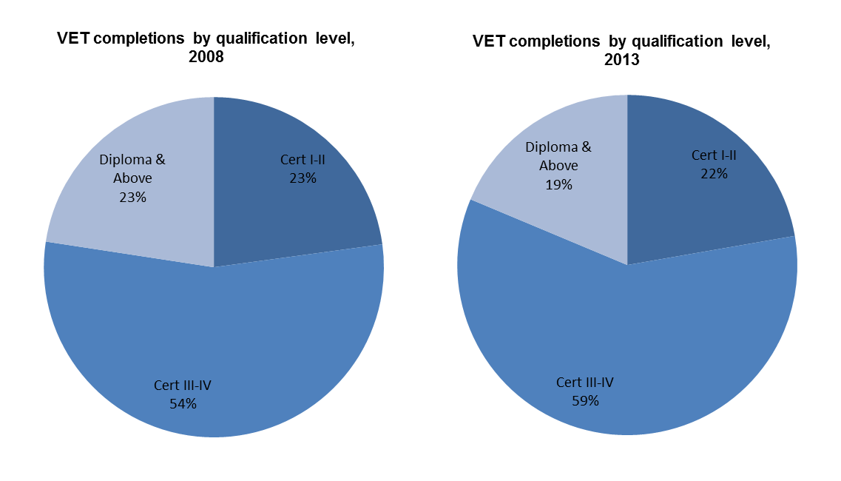

|  |
| --- |
| Key Points  * The proportional share the completions by the different Certificate levels between 2008 and 2013 has changed, with Diploma and above and Certificate I-I declining and Certificate III-IV increasing. |

## Age Profile

### Vocational Training Delivery by Age Group

To enable the increased workforce participation levels required by the Victorian economy over the next decade, improved engagement with education and training by all age groups is required.

### Students by Age Group in Government Subsidised Training

|  |
| --- |
| Key Points  * Young people aged 15 to 24 years accounted for 41 per cent of all students undertaking government subsidised training in 2013, down from 45 per cent in 2008. * Students aged 15-19 were the only age cohort with student numbers in 2013 which were lower than the numbers for the same age group in 2011 and 2012. |

Table 1.11.1: Government subsidised students by age group, 2008–2013

|  |  |  |  |  |  |  |
| --- | --- | --- | --- | --- | --- | --- |
| **Age group** | **2008** | **2009** | **2010** | **2011** | **2012** | **2013** |
| 15 to 19 | 74,400 | 76,000 | 88,300 | 108,700 | 120,500 | 104,600 |
| 20 to 24 | 58,800 | 59,200 | 71,400 | 87,800 | 100,900 | 96,300 |
| 25 to 44 | 99,700 | 102,400 | 112,600 | 148,500 | 180,200 | 178,700 |
| 45 to 64 | 51,100 | 52,900 | 60,200 | 77,100 | 96,400 | 92,900 |
| Under 15, over 64, not stated | 10,700 | 9,200 | 6,700 | 8,100 | 11,800 | 11,800 |
| **Total** | **294,700** | **299,600** | **339,200** | **430,300** | **509,800** | **484,300** |

Table 1.11.2: Change in government subsidised students by age group

|  |  |  |  |
| --- | --- | --- | --- |
| **Age group** | **% change 2008-2013** | **% change 2011-2013** | **% change 2012-2013** |
| 15 to 19 | 41% | -4% | -13% |
| 20 to 24 | 64% | 10% | -5% |
| 25 to 44 | 79% | 20% | -1% |
| 45 to 64 | 82% | 20% | -4% |
| Under 15, over 64, not stated | 10% | 45% | 0% |
| **Total** | **64%** | **13%** | **-5%** |

### Students by Age Group in TAFE Domestic Fee for Service

|  |
| --- |
| Key Points  * The number of students enrolled in TAFE domestic fee for service at AQF Certificate 1 and above was 96,700 in 2013. Thirty seven per cent of students were aged between 15 and 24 years. * Similar to the trend in government subsidised provision, aged 15-19 is the only significant age cohort with student numbers in 2013 lower than the corresponding numbers in 2011. |

Table 1.12.1: TAFE domestic fee for service (AQF1+): students by age group, 2008–2013

|  |  |  |  |  |  |  |
| --- | --- | --- | --- | --- | --- | --- |
| **Age group** | **2008** | **2009** | **2010** | **2011** | **2012** | **2013** |
| 15 to 19 | 22,900 | 26,400 | 28,800 | 28,300 | 28,900 | 24,800 |
| 20 to 24 | 9,300 | 11,100 | 11,400 | 10,300 | 11,600 | 11,200 |
| 25 to 44 | 29,700 | 34,800 | 34,500 | 34,100 | 40,600 | 38,800 |
| 45 to 64 | 16,500 | 18,400 | 19,300 | 19,500 | 22,100 | 20,200 |
| Under 15, over 64, not stated | 2,000 | 2,400 | 2,100 | 2,100 | 2,000 | 1,800 |
| **Total** | **80,400** | **93,100** | **96,000** | **94,200** | **105,200** | **96,700** |

Table 1.12.2: Change in TAFE domestic fee for service (AQF1+): students by age group

|  |  |  |  |
| --- | --- | --- | --- |
| **Age group** | **% change 2008-2013** | **% change 2011-2013** | **% change 2012-2013** |
| 15 to 19 | 8% | -12% | -14% |
| 20 to 24 | 20% | 8% | -4% |
| 25 to 44 | 31% | 14% | -4% |
| 45 to 64 | 22% | 4% | -9% |
| Under 15, over 64, not stated | -14% | -17% | -11% |
| **Total** | **20%** | **3%** | **-8%** |

## Gender Profile

**Vocational Training Delivery by Gender**

The vocational training system is also focused on accessibility and gender equality, ensuring all Victorians have the same opportunity to succeed in their lives and maintain well-being through education and training.

**Students by Gender in Government Subsidised Training**

|  |
| --- |
| **Key Points**   * The number of female and male students increased by 62 and 66 per cent respectively between 2008 and 2013. * Between 2012 and 2013 there was a decline of 10 per cent in the numbers of female students in government subsidised training, this decline came from courses in Retail Trade, Accommodation and Food and Arts and Recreation. All areas where there was a previous oversupply of training required to meet the needs of industry. |

**Table 1.13.1: Government subsidised students by gender, 2008–2013**

|  |  |  |  |  |  |  |
| --- | --- | --- | --- | --- | --- | --- |
| **Gender** | **2008** | **2009** | **2010** | **2011** | **2012** | **2013** |
| Female | 139,800 | 140,900 | 161,600 | 208,500 | 251,900 | 226,300 |
| Male | 154,700 | 157,300 | 176,400 | 220,700 | 257,200 | 257,400 |
| **Total** | **294,700** | **299,600** | **339,200** | **430,300** | **509,800** | **484,300** |

**Table 1.13.2: Change in government subsidised students by gender**

|  |  |  |  |
| --- | --- | --- | --- |
| **Gender** | **% change 2008-2013** | **% change 2011-2013** | **% change 2012-2013** |
| Female | 62% | 9% | -10% |
| Male | 66% | 17% | 0% |
| **Total** | **64%** | **13%** | **-5%** |

## Government Subsidised Activity and Participation by Regions

For the purpose of providing an overview of government subsidised training activity by region, training data are presented for the four departmental administrative regions. In addition, government subsidised training data are further disaggregated into nine smaller geographical areas to provide a more granular level of detail on training delivery and participation.

South-Western departmental region comprises Barwon South West, Grampians and Western Metropolitan regional areas. North-Western departmental region comprises Loddon Mallee and Northern Metropolitan regional areas. North-Eastern departmental region comprises Hume and Eastern Metropolitan regional areas. South-Eastern departmental region comprises Gippsland and Southern Metropolitan regional areas.

### Delivery Region

This section focuses on the delivery of government subsidised training by location as defined by four departmental administrative regions or nine small geographical regions. Training courses can be undertaken by students who live locally or outside the local area.

|  |
| --- |
| Key Points  * Similar to the overall state-wide trend, government subsidised courses delivered in 2013 across four administrative regions were lower compared to 2012, but higher compared to 2011, except the North Eastern region where courses delivered in 2013 were higher than in 2012. * Further disaggregation of the delivery data into nine smaller areas or regions, shows that there were some regional variations against the overall state-wide trend:   + Courses delivered in Hume region in 2013 were higher than in 2011 and 2012;   + Courses delivered in Gippsland and Eastern Metropolitan regions were lower in 2013 compared to both 2011 and 2012. * Government subsidised courses delivered in Gippsland region in 2013 were 12 per cent lower than 2011 and 9 per cent lower than 2012. * Government subsidised courses delivered in Eastern Metropolitan region in 2013 were 10 per cent and 8 per cent lower compared to 2011 and 2012, respectively. |

Table 1.14.1: Government subsidised enrolments by departmental delivery region, 2008–2012

|  |  |  |  |  |  |  |
| --- | --- | --- | --- | --- | --- | --- |
| **Delivery Location** | **2008** | **2009** | **2010** | **2011** | **2012** | **2013** |
| South-Western | 119,600 | 115,800 | 139,400 | 202,900 | 267,800 | 253,300 |
| North-Western | 70,500 | 80,300 | 84,700 | 101,500 | 124,400 | 116,400 |
| North-Eastern | 84,700 | 78,200 | 84,800 | 100,900 | 110,400 | 115,000 |
| South-Eastern | 90,300 | 90,000 | 104,300 | 128,100 | 157,100 | 152,100 |
| **All Regions Total** | **364,400** | **363,900** | **412,600** | **532,200** | **656,800** | **634,100** |
| Other | 17,400 | 13,400 | 15,100 | 17,600 | 15,000 | 12,200 |
| **Total VET** | **381,300** | **376,800** | **426,900** | **548,700** | **670,400** | **645,000** |

*Other: online and workplace delivery.

Table 1.14.2: Change in government subsidised enrolments by departmental delivery region

|  |  |  |  |
| --- | --- | --- | --- |
| **Delivery Location** | **% change 2008-2013** | **% change 2011-2013** | **% change 2012-2013** |
| South-Western | 112% | 25% | -5% |
| North-Western | 65% | 15% | -6% |
| North-Eastern | 36% | 14% | 4% |
| South-Eastern | 68% | 19% | -3% |
| **All Regions Total** | **74%** | **19%** | **-3%** |
| Other | -30% | -31% | -19% |
| **Total VET** | **69%** | **18%** | **-4%** |

*Other: online and workplace delivery.

Table 1.15.1: Government subsidised enrolments by delivery region, 2008–2013

|  |  |  |  |  |  |  |
| --- | --- | --- | --- | --- | --- | --- |
| **Delivery Location** | **2008** | **2009** | **2010** | **2011** | **2012** | **2013** |
| Barwon South West | 28,800 | 31,800 | 35,800 | 50,100 | 62,500 | 52,000 |
| Grampians | 14,600 | 16,200 | 15,000 | 17,200 | 18,900 | 17,900 |
| Loddon Mallee | 23,600 | 27,900 | 28,300 | 32,800 | 37,100 | 33,200 |
| Hume | 29,100 | 26,000 | 24,700 | 27,300 | 34,400 | 47,100 |
| Gippsland | 26,700 | 22,400 | 22,500 | 20,500 | 19,700 | 18,000 |
| Eastern Metropolitan | 55,500 | 52,200 | 60,100 | 73,600 | 76,000 | 68,100 |
| Western Metropolitan | 76,300 | 67,900 | 88,600 | 135,800 | 186,400 | 183,600 |
| Southern Metropolitan | 63,600 | 67,700 | 81,800 | 107,600 | 137,400 | 134,100 |
| Northern Metropolitan | 46,900 | 52,400 | 56,400 | 68,700 | 87,300 | 83,200 |
| **All Regions Total** | **364,400** | **363,900** | **412,600** | **532,200** | **656,800** | **634,100** |
| Other | 17,400 | 13,400 | 15,100 | 17,600 | 15,000 | 12,200 |
| **Total VET** | **381,300** | **376,800** | **426,900** | **548,700** | **670,400** | **645,000** |

Table 1.15.2: Change in government subsidised enrolments by delivery region

|  |  |  |  |
| --- | --- | --- | --- |
| **Delivery Location** | **% change 2008-2013** | **% change 2011-2013** | **% change 2012-2013** |
| Barwon South West | 81% | 4% | -17% |
| Grampians | 22% | 4% | -5% |
| Loddon Mallee | 41% | 1% | -11% |
| Hume | 62% | 73% | 37% |
| Gippsland | -33% | -12% | -9% |
| Eastern Metropolitan | 23% | -8% | -10% |
| Western Metropolitan | 141% | 35% | -2% |
| Southern Metropolitan | 111% | 25% | -2% |
| Northern Metropolitan | 77% | 21% | -5% |
| **All Regions Total** | **74%** | **19%** | **-3%** |
| Other | -30% | -31% | -19% |
| **Total VET** | **69%** | **18%** | **-4%** |

### Participation

This section presents data on students undertaking government subsidised training by the area where they live. Areas are defined as the four departmental administrative regions or nine smaller geographical regions. Students may undertake their training locally or travel to locations outside their local region.

|  |
| --- |
| Key Points  * In line with the overall state-wide trend, the numbers of students who participated in government subsidised training in 2013 were lower in each of the four Departmental administrative regions compared to 2012, but higher compared to 2011. * When data was further disaggregated into nine regions, they show that there were some variations against the overall state-wide trend. The number of students undertaking government subsidised training who lived in Gippsland region in 2013 was lower compared to 2011, 2012 and 2008. * In terms of the participation rate of students aged 15-64 in government subsidised vocational education and training in 2013, the Hume and Barwon South West regions had the highest estimated participation rate, followed by Loddon Mallee region. The lowest participation rate was in Eastern Metropolitan region. |

Table 1.16.1: Government subsidised students by residential location - departmental region, 2008–2013

|  |  |  |  |  |  |  |
| --- | --- | --- | --- | --- | --- | --- |
| **Residential location** | **2008** | **2009** | **2010** | **2011** | **2012** | **2013** |
| South-Western | 75,700 | 100,900 | 114,200 | 153,900 | 199,200 | 189,400 |
| North-Western | 69,700 | 67,700 | 75,800 | 97,600 | 111,100 | 106,100 |
| North-Eastern | 65,500 | 64,800 | 71,600 | 89,000 | 101,700 | 92,800 |
| South-Eastern | 78,900 | 80,000 | 92,000 | 115,800 | 137,300 | 132,600 |
| **All Regions Total** | **289,800** | **293,400** | **331,900** | **424,500** | **502,400** | **477,200** |
| Other* | 4,900 | 6,200 | 7,300 | 5,800 | 7,400 | 7,100 |
| **Total students** | **294,700** | **299,600** | **339,200** | **430,300** | **509,800** | **484,300** |

*Other includes not stated, unknown, interstate or overseas.

Table 1.16.2: Change in government subsidised students by residential location - departmental region

|  |  |  |  |
| --- | --- | --- | --- |
| **Residential location** | **% change 2008-2013** | **% change 2011-2013** | **% change 2012-2013** |
| South-Western | 150% | 23% | -5% |
| North-Western | 52% | 9% | -4% |
| North-Eastern | 42% | 4% | -9% |
| South-Eastern | 68% | 14% | -3% |
| **All Regions Total** | **65%** | **12%** | **-5%** |
| Other* | 46% | 23% | -3% |
| **Total students** | **64%** | **13%** | **-5%** |

*Other includes not stated, unknown, interstate or overseas.

Table 1.17.1: Government subsidised students by residential area – region, 2008–2013

|  |  |  |  |  |  |  |
| --- | --- | --- | --- | --- | --- | --- |
| **Residential location** | **2008** | **2009** | **2010** | **2011** | **2012** | **2013** |
| Barwon South West | 24,500 | 26,300 | 29,000 | 36,100 | 41,300 | 36,700 |
| Grampians | 13,900 | 14,400 | 15,400 | 18,400 | 21,400 | 19,800 |
| Loddon Mallee | 20,500 | 21,000 | 21,900 | 27,400 | 31,500 | 28,000 |
| Hume | 21,300 | 19,900 | 20,000 | 23,200 | 26,500 | 26,100 |
| Gippsland | 21,900 | 19,100 | 20,700 | 21,500 | 21,200 | 20,300 |
| Eastern Metropolitan | 44,300 | 44,900 | 51,600 | 65,800 | 75,200 | 66,800 |
| Western Metropolitan | 37,200 | 40,300 | 48,200 | 67,500 | 89,700 | 89,100 |
| Southern Metropolitan | 57,000 | 60,900 | 71,400 | 94,300 | 116,100 | 112,300 |
| Northern Metropolitan | 49,100 | 46,600 | 53,900 | 70,300 | 79,600 | 78,100 |
| **All Regions Total** | **289,800** | **293,400** | **331,900** | **424,500** | **502,400** | **477,200** |
| Other | 4,900 | 6,200 | 7,300 | 5,800 | 7,400 | 7,100 |
| **Total students** | **294,700** | **299,600** | **339,200** | **430,300** | **509,800** | **484,300** |

Table 1.17.2: Change in government subsidised students by residential area – region

|  |  |  |  |
| --- | --- | --- | --- |
| **Residential location** | **% change 2008-2013** | **% change 2011-2013** | **% change 2012-2013** |
| Barwon South West | 50% | 2% | -11% |
| Grampians | 42% | 8% | -7% |
| Loddon Mallee | 36% | 2% | -11% |
| Hume | 23% | 13% | -2% |
| Gippsland | -7% | -5% | -4% |
| Eastern Metropolitan | 51% | 1% | -11% |
| Western Metropolitan | 139% | 32% | -1% |
| Southern Metropolitan | 97% | 19% | -3% |
| Northern Metropolitan | 59% | 11% | -2% |
| **All Regions Total** | **65%** | **12%** | **-5%** |
| Other | 46% | 23% | -3% |
| **Total students** | **64%** | **13%** | **-5%** |

Figure 1.6: Estimated participation rate[3] of students aged 15-64 in government subsidised training by region, 2013

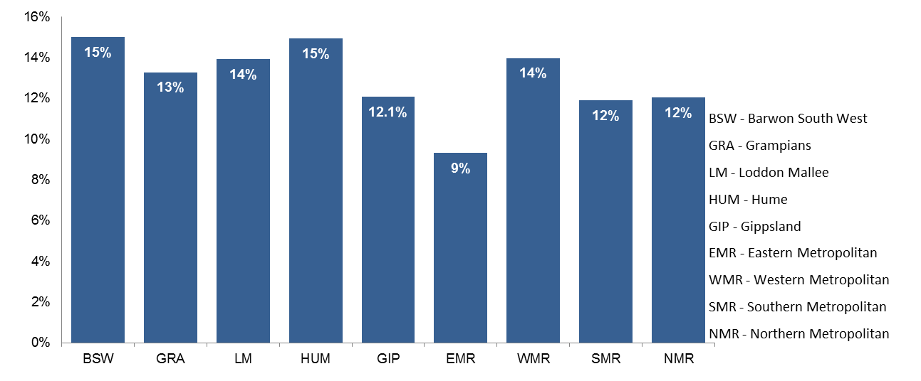

## Government Subsidised Delivery by Provider Type

|  |
| --- |
| Key Points  * In 2013 the number of government subsidised enrolments by Private RTOs represented 48 per cent of delivery by all sectors; this was up on the 2012 result of 46 per cent. TAFEs, excluding Universities, represented 32 per cent of all government subsidised enrolments. * The TAFE sector, including Universities, had a larger share of government subsidised enrolments than Private RTOs in Construction; Arts and Recreation Services; Professional, Scientific and technical Services; Agriculture, Forestry and Fishing; Information media and Telecommunications; Rental, Hiring and Real Estate Services and Electricity, Gas, Water and Waste Services industries. * Private RTOs had a larger proportional share in Health Care and Social Assistance; Transport, Postal and Warehousing; Manufacturing; Accommodation and Food Services; Administrative and Support Services; Retail Trade; Education and Training; Public Administration and Safety and Financial and Insurance Services industries. * TAFEs account for 57 per cent of the proportional share of the delivery of Foundation skills courses of study, Private RTOs account for 32 per cent and Learn Local 12 per cent. |

This section provides an overview of government subsidised delivery by sector. While the introductory tables separate University (former dual sector providers) and TAFEs, for consistency with previous reporting they are combined under the group of TAFE.

**Table 1.18: Government subsidised delivery by provider number*, 2008–2013**

|  |  |  |  |  |  |  |
| --- | --- | --- | --- | --- | --- | --- |
|  | **2008** | **2009** | **2010** | **2011** | **2012** | **2013** |
| Learn Local[4] | 342 | 320 | 316 | 309 | 298 | 282 |
| Private RTO | 201 | 246 | 344 | 422 | 445 | 428 |
| University | 4 | 4 | 4 | 4 | 4 | 4 |
| TAFE | 14 | 14 | 14 | 14 | 14 | 14 |

* The above providers include those providing pre-accredited and accredited subsidised training. The number of training providers with a 2014 Service Agreement was 505 as at March 2014.

Table 1.19.1: Number of government subsidised enrolments by provider type, 2008 to 2013

|  |  |  |  |  |  |  |
| --- | --- | --- | --- | --- | --- | --- |
|  | **2008** | **2009** | **2010** | **2011** | **2012** | **2013** |
| Learn Local | 73,800 | 68,300 | 63,800 | 64,600 | 80,200 | 73,500 |
| Private RTOs | 54,000 | 57,400 | 99,800 | 220,700 | 308,800 | 312,000 |
| Universities | 72,400 | 68,500 | 76,300 | 69,900 | 68,100 | 51,500 |
| TAFE | 181,100 | 182,600 | 187,000 | 193,600 | 213,300 | 207,900 |

Table 1.19.2: Change in number of government subsidised enrolments by provider type

|  |  |  |  |  |  |
| --- | --- | --- | --- | --- | --- |
|  | **% change 2008-2013** | **% change 2009-2013** | **% change 2010-2013** | **% change 2011-2013** | **% change 2012-13** |
| Learn Local | 0% | 8% | 15% | 14% | -8% |
| Private RTO | 478% | 444% | 213% | 41% | 1% |
| Universities | -29% | -25% | -33% | -26% | -24% |
| TAFE | 15% | 14% | 11% | 7% | -3% |

Table 1.20: Percentage share of government subsidised enrolments for each year by provider type, 2008 to 2013

|  |  |  |  |  |  |  |
| --- | --- | --- | --- | --- | --- | --- |
|  | **2008** | **2009** | **2010** | **2011** | **2012** | **2013** |
| Learn Local | 19% | 18% | 15% | 12% | 12% | 11% |
| Private RTOs | 14% | 15% | 23% | 40% | 46% | 48% |
| Universities | 19% | 18% | 18% | 13% | 10% | 8% |
| TAFE | 47% | 48% | 44% | 35% | 32% | 32% |
| **Total** | **100%** | **100%** | **100%** | **100%** | **100%** | **100%** |

Figure 1.7: Percentage share of Government subsidised enrolments by provider type, 2008 to 2013

Table 1.21: Government subsidised enrolments (AQF1+), proportional share across provider types by industry, 2013

|  |  |  |  |  |
| --- | --- | --- | --- | --- |
|  | **TAFE** | **Private RTOs** | **Learn Local** | **Total (number)** |
| A: Agriculture, Forestry and Fishing | 50% | 48% | 2% | 8,300 |
| B: Mining | 73% | 27% | 0% | 350 |
| C: Manufacturing | 32% | 68% | 0% | 43,500 |
| D: Electricity, Gas, Water and Waste Services | 85% | 15% | 0% | 750 |
| E: Construction | 69% | 31% | 0% | 62,700 |
| F: Wholesale Trade | 12% | 87% | 0% | 1,000 |
| G: Retail Trade | 24% | 74% | 3% | 15,400 |
| H: Accommodation and Food Services | 24% | 70% | 6% | 30,300 |
| I: Transport, Postal and Warehousing | 21% | 78% | 0% | 46,100 |
| J: Information Media and Telecommunications | 81% | 17% | 2% | 3,300 |
| K: Financial and Insurance Services | 12% | 88% | 0% | 3,100 |
| L: Rental, Hiring and Real Estate Services | 52% | 48% | 0% | 1,700 |
| M: Professional, Scientific and Technical Services | 93% | 6% | 0% | 10,500 |
| N: Administrative and Support Services | 25% | 72% | 3% | 15,600 |
| O: Public Administration and Safety | 28% | 72% | 0% | 8,100 |
| P: Education and Training | 41% | 50% | 8% | 12,700 |
| Q: Health Care and Social Assistance | 28% | 62% | 10% | 87,300 |
| R: Arts and Recreation Services | 50% | 46% | 4% | 15,900 |
| S: Other Services | 51% | 46% | 2% | 21,100 |
| T: Cross-industry | 26% | 70% | 4% | 60,300 |
| U: Foundation Skills and LOTE | 57% | 32% | 12% | 144,200 |
| Not applicable / Unknown | 2% | 47% | 51% | 50 |
| **Total (AQF1+)** | **42%** | **52%** | **6%** | **592,300** |

**Table 1.22 Government subsidised enrolments (AQF1+), summary of selected characteristics within provider type, 013**



## Learn Local Performance

### Learn Local (ACE) Pre-accredited and Accredited training

Through the Adult, Community and Further Education (ACFE) Board, the Victorian Government funds 298 [Learn Local adult and community education (ACE) organisations](http://www.education.vic.gov.au/training/learners/learnlocal/pages/default.aspx), including two adult education institutions, the Council for Adult Education ([CAE](http://www.cae.edu.au/)) and Adult Multicultural Education Services ([AMES](http://www.ames.net.au/)) to deliver pre-accredited training to Victorians with limited prior educational attainment and limited access to vocational education and training. Learn Local providers support learners’ personal development in the knowledge, skills and attributes necessary to participate in society and secure employment. In addition to pre-accredited program delivery, there are 117 Learn Local providers that additionally are registered training organisations (RTOs) delivering accredited provision. This chapter of the report provides a snapshot of the contribution of the Learn Local (ACE) sector to government funded vocational training in Victoria.

The Victorian Government recently launched *Learn Local: Focusing on the Future*. This strategy has been developed by the Department of Education and Early Childhood Development and the ACFE Board in consultation with Learn Local peak bodies and providers. The strategy recognises Learn Local providers’ current opportunities and challenges in the context of recent training market reforms and confirms their role in providing a supportive and inclusive learning environment for people to engage in high quality training. *Learn Local: Focusing on the Future* sets out the actions that government will undertake to help the sector meet its potential, sharpen its focus and improve its sustainability and responsiveness.

The ratio between pre-accredited and accredited programs in 2013 marginally shifted from the pattern of previous years. In 2011 and 2012, Learn Local providers had delivered slightly more course enrolments into accredited than pre-accredited programs. In 2013, pre-accredited course enrolments increased to comprise fifty per cent of all course enrolments reported by Learn Local providers (36,600 pre-accredited enrolments). Accordingly, the remaining fifty per cent of all reported course enrolments were in accredited programs (36,900 accredited enrolments).

### Learn Local (ACE) Pre-accredited training

|  |
| --- |
| Key Points  * The ACFE Board purchased 1.9m hours of annual pre-accredited delivery in 2013, which represented an across the board increase in pre-accredited delivery, and included an additional delivery priority of improving the digital literacy of the Victorian workforce. * In comparison to the preceding year, the increased purchase in 2013 led to increases of 0.2m more hours (up 13 per cent), 2,100 more course enrolments (up 6 per cent to 36,600 enrolments in 2013) and 300 more students (up 1 per cent to 24,500 students) in pre-accredited training. The contrasting headline rates of more hours to marginally more students was a result of Learn Locals reporting more multiple course enrolments per student and increased course duration in 2013 than in previous years. * The marginal increase of students in 2013 was attributed to delivery in the western regions of Victoria. Pre-accredited delivery in the South Western Victoria and North Western Victoria regions increased a combined 9 per cent over 2012-2013, which contrasts to the reported 19 per cent increase in pre-accredited students in these regions over 2011-2013. In comparison, annual 2013 delivery rates to pre-accredited students in the North Eastern Victoria and South Eastern Victoria regions did not match that of the previous year (down 1 per cent). This contrasts a combined 11 per cent increase over 2011 to 2013 across these two regions. In addition, the two Adult Education Institutes (AEIs) reported over 600 fewer enrolled students in 2013 than the previous year (a 47 per cent decrease on 2012). |

* During 2013, Learn Local (ACE) providers increased pre-accredited program delivery to the majority of ACFE Board Priority Learner groups in comparison to the preceding year. For example, students not in work were a significant priority group in pre-accredited delivery. In 2013 there were 600 more unemployed students in pre-accredited training (up 9 per cent to 6,900 students) over 2012 levels. Also, 500 more Victorians with a self-declared disability engaged in pre-accredited training than in 2012 (up 9 per cent to 6,100 students). Disengaged Youth in pre-accredited training experienced the greatest rate of increase over 2012-2013, but from a relatively low base (up 16 per cent to 1,000 students). The increases on 2012-2013 reported delivery across the majority of ACFE Board Priority Learner groups contrast to the 2011-2013 results where, for example, 1,300 more Victorians with a self-declared disability studied in pre-accredited programs than in 2011 (a 29 per cent increase). In summary, ACFE Board Priority Learners generally participated in pre-accredited training at rates above the headline rate of all student involvement. It must be noted that the priority learner categories are not mutually exclusive and reported students may self-identify in any one or a combination of these categories.

Table 1.23.1: Government subsidised pre-accredited training, Learn Local (ACE) providers, 2008-2013

|  |  |  |  |  |  |  |
| --- | --- | --- | --- | --- | --- | --- |
|  | **2008** | **2009** | **2010** | **2011** | **2012** | **2013** |
| Course Enrolments | 45,800 | 38,100 | 36,700 | 31,200 | 34,500 | 36,600 |
| Student Contact Hours (millions) | 1.7 | 1.6 | 1.9 | 1.5 | 1.7 | 1.9 |
| Students | 28,000 | 23,600 | 23,900 | 21,400 | 24,200 | 24,500 |

Table 1.23.2: Change in government subsidised pre-accredited training

|  |  |  |  |
| --- | --- | --- | --- |
|  | **% change 2008-2013** | **% change 2011-2013** | **% change 2012 - 2013** |
| Course Enrolments | -20% | 17% | 6% |
| Student Contact Hours (millions) | 13% | 32% | 13% |
| Students | -12% | 15% | 1% |

Table 1.24.1: Government subsidised students in pre-accredited training with Learn Local (ACE) providers by departmental region, 2008-2013

|  |  |  |  |  |  |  |
| --- | --- | --- | --- | --- | --- | --- |
| **Delivery Location** | **2008** | **2009** | **2010** | **2011** | **2012** | **2013** |
| South-Western | 5,800 | 5,500 | 6,000 | 5,500 | 6,100 | 6,800 |
| North-Western | 5,300 | 4,800 | 5,300 | 4,800 | 5,200 | 5,500 |
| North-Eastern | 6,900 | 5,600 | 5,300 | 4,500 | 5,000 | 5,000 |
| South-Eastern | 10,000 | 7,700 | 6,500 | 5,900 | 6,500 | 6,500 |
| AEIs | 60 | 60 | 750 | 650 | 1,350 | 710 |
| **Total** | **28,000** | **23,600** | **23,900** | **21,400** | **24,200** | **24,500** |

AEIs: Adult Education Institutes

Table 1.24.2: Change in government subsidised students in pre-accredited training with Learn Local (ACE) providers by departmental region

|  |  |  |  |
| --- | --- | --- | --- |
| **Delivery Location** | **% change 2008-2012** | **% change 2011-2013** | **% change 2012 - 2013** |
| South-Western | 18% | 12% | 11% |
| North-Western | 4% | 8% | 6% |
| North-Eastern | -27% | 10% | 2% |
| South-Eastern | -35% | 10% | -1% |
| AEIs | 1042% | 8% | -47% |
| **Total** | **-12%** | **15%** | **1%** |

AEIs: Adult Education Institutes

Figure 1.8: Government subsidised students in pre-accredited training with Learn Local (ACE) providers by regional area, 2011, 2012, 2013

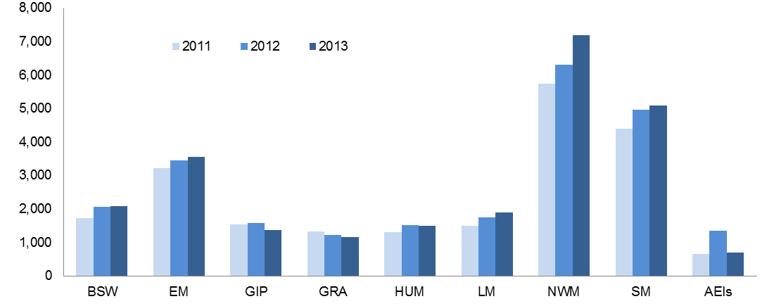

|  |  |  |  |  |  |
| --- | --- | --- | --- | --- | --- |
| BSW | Barwon South West | HUM | Hume | NWM | North Western Metropolitan |
| GRA | Grampians | GIP | Gippsland | SM | Southern Metropolitan |
| LMR | Loddon Mallee | EM | Eastern Metropolitan | AEIs | Adult Education Institutes |

Table 1.25.1: Government subsidised ACFE Board Priority Learners enrolled in pre-accredited programs with Learn Local (ACE) providers, 2008-2013

|  |  |  |  |  |  |  |
| --- | --- | --- | --- | --- | --- | --- |
|  | **2008** | **2009** | **2010** | **2011** | **2012** | **2013** |
| CALD (LOTE) | 4,100 | 4,300 | 4,900 | 5,700 | 6,800 | 6,600 |
| Disability | 4,600 | 4,200 | 4,900 | 4,800 | 5,600 | 6,100 |
| Disengaged Youth | 900 | 400 | 1,000 | 600 | 900 | 1,000 |
| Early school leavers | 7,400 | 6,000 | 5,900 | 4,900 | 5,200 | 5,300 |
| Indigenous | 400 | 220 | 340 | 340 | 410 | 450 |
| Males 45 to 64 | 2,800 | 2,500 | 2,700 | 2,400 | 2,700 | 2,600 |
| Unemployed | 5,400 | 5,200 | 5,700 | 5,300 | 6,300 | 6,900 |
| Vulnerable workers | 5,300 | 4,400 | 5,100 | 4,900 | 5,700 | 5,500 |

Note: ACFE Board Priority Learner categories are not mutually exclusive. Detail on these categories is available at: [www.education.vic.gov.au/Documents/about/research/acfepublications/hardtoreachlearn.pdf](http://www.education.vic.gov.au/Documents/about/research/acfepublications/hardtoreachlearn.pdf)

Table 1.25.2: Change in government subsidised ACFE Board Priority Learners enrolled in pre-accredited programs with Learn Local (ACE) providers

|  |  |  |  |
| --- | --- | --- | --- |
|  | **% change 2008-2013** | **% change 2011-2013** | **% change 2012 - 2013** |
| CALD (LOTE) | 62% | 16% | -3% |
| Disability | 32% | 29% | 9% |
| Disengaged Youth | 16% | 70% | 16% |
| Early school leavers | -28% | 8% | 2% |
| Indigenous | 12% | 33% | 8% |
| Males 45 to 64 | -9% | 6% | -4% |
| Unemployed | 26% | 29% | 9% |
| Vulnerable workers | 3% | 11% | -3% |

Note: ACFE Board Priority Learner categories are not mutually exclusive. Detail on these categories is available at: [www.education.vic.gov.au/Documents/about/research/acfepublications/hardtoreachlearn.pdf](http://www.education.vic.gov.au/Documents/about/research/acfepublications/hardtoreachlearn.pdf)

### Learn Local (ACE) Accredited training

|  |
| --- |
| Key Points  * Learn Local providers’ accredited program delivery has increased over 2011 to 2013. Learn Locals reported an overall 8 per cent increase in students taking accredited programs over 2011 to 2013 (an additional 2,200 students). In contrast, there were 6,600 fewer students (-18 per cent) reported over 2012 (36,300 students) to 2013 (29,700 students). * The general trend for accredited delivery into regional Victoria over 2011 to 2013 was a decrease in reported student numbers. The exception to this trend was in regional North West Victoria, which experienced a five per cent increase in students. In contrast, the general trend for metropolitan Melbourne regional areas was increased accredited students over 2011 to 2013. The exception to this trend was metropolitan sections of North Eastern Victoria which experienced reduced student numbers (a 15 per cent reduction). The Adult Education Institutes reported a 2 per cent increase (100 additional students) in accredited delivery over 2011 to 2013. This contrasts a 13 per cent reduction in accredited numbers between 2012 and 2013. * In nearly all cases, there were significant increases in accredited students identified by the ACFE Board Priority Learner group categories over 2011 to 2013. For example, Learn Local delivery of accredited courses to Culturally and Linguistically Diverse (CALD) students increased by 1,900 over 2011 to 2013 (up 28 per cent). Similarly, there were 1,700 more Unemployed Victorians in accredited training with Learn Local providers over 2011 to 2013 (up 18 per cent). More vulnerable workers[5] underwent accredited training in 2013 than in 2011 (up 26 per cent to 7,300 students in 2013). The increases on 2011 reported delivery across the majority of ACFE Board Priority Learner groups contrast to twelve-month results for 2012-2013 where, for example, Early School Leavers enrolled in nationally accredited courses with Learn Local providers reported a single decrease of 2,200 enrolled learners between 2012 and 2013 (-24 per cent). In summary, the increased ACFE Board priority group students between 2011 and 2013 represented a significant uptake of these learner types into Learn Local (ACE) settings. |

Table 1.26.1: Government subsidised accredited training, Learn Local (ACE) providers, 2008-2013

|  |  |  |  |  |  |  |
| --- | --- | --- | --- | --- | --- | --- |
|  | **2008** | **2009** | **2010** | **2011** | **2012** | **2013** |
| Course Enrolments | 27,900 | 30,200 | 27,100 | 33,300 | 45,800 | 36,900 |
| Student Contact Hours(millions) | 5.4 | 6.6 | 6.7 | 8.5 | 11.9 | 9.6 |
| Students | 24,000 | 25,700 | 23,700 | 27,500 | 36,300 | 29,700 |

Table 1.26.2: Change in government subsidised accredited training, Learn Local (ACE) providers

|  |  |  |  |
| --- | --- | --- | --- |
|  | **% change 2008-2013** | **% change 2011-2013** | **% change 2012 - 2013** |
| Course Enrolments | 32% | 11% | -19% |
| Student Contact Hours(millions) | 79% | 13% | -19% |
| Students | 24% | 8% | -18% |

Table 1.27.1: Government subsidised students in accredited training with Learn Local (ACE) providers   
by departmental region, 2008-2013

|  |  |  |  |  |  |  |
| --- | --- | --- | --- | --- | --- | --- |
| **Delivery Location** | **2008** | **2009** | **2010** | **2011** | **2012** | **2013** |
| South-Western | 5,300 | 6,200 | 5,600 | 8,700 | 14,500 | 8,500 |
| North-Western | 4,800 | 5,200 | 4,900 | 5,600 | 7,000 | 7,700 |
| North-Eastern | 5,700 | 5,600 | 4,600 | 4,500 | 5,000 | 4,100 |
| South-Eastern | 4,100 | 4,700 | 5,300 | 5,300 | 5,800 | 5,900 |
| AEIs | 4,100 | 4,000 | 3,300 | 3,400 | 4,000 | 3,500 |
| **Total** | **24,000** | **25,700** | **23,700** | **27,500** | **36,300** | **29,700** |

AEIs: Adult Education Institutes

Table 1.27.2: Change in government subsidised students in accredited training with Learn Local (ACE) providers by departmental region

|  |  |  |  |
| --- | --- | --- | --- |
| **Delivery Location** | **% change 2008-2012** | **% change 2011-2013** | **% change 2012 - 2013** |
| South-Western | 60% | 66% | -41% |
| North-Western | 60% | 26% | 9% |
| North-Eastern | -28% | 11% | -18% |
| South-Eastern | 44% | 10% | 2% |
| AEIs | -15% | 2% | -13% |
| **Total** | **24%** | **8%** | **-18%** |

AEIs: Adult Education Institutes

Figure 1.9: Government subsidised students in accredited training with Learn Local (ACE) providers   
by regional area, 2011, 2012, 2013

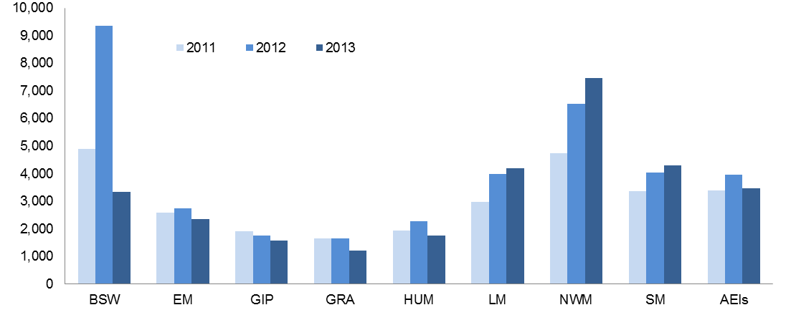

|  |  |  |  |  |  |
| --- | --- | --- | --- | --- | --- |
| BSW | Barwon South West | HUM | Hume | NWM | North Western Metropolitan |
| GRA | Grampians | GIP | Gippsland | SM | Southern Metropolitan |
| LMR | Loddon Mallee | EM | Eastern Metropolitan | AEIs | Adult Education Institutes |

Table 1.28.1: Government subsidised ACFE Board Priority Learners enrolled in accredited programs with Learn Local (ACE) providers, 2008-2013

|  |  |  |  |  |  |  |
| --- | --- | --- | --- | --- | --- | --- |
|  | **2008** | **2009** | **2010** | **2011** | **2012** | **2013** |
| CALD (LOTE) | 6,000 | 6,300 | 5,600 | 6,700 | 9,000 | 8,600 |
| Disability | 3,500 | 3,500 | 3,500 | 4,600 | 6,000 | 5,400 |
| Disengaged Youth | 1,500 | 2,000 | 1,700 | 2,600 | 3,700 | 3,100 |
| Early school leavers | 6,000 | 6,400 | 5,600 | 7,100 | 9,100 | 6,900 |
| Indigenous | 310 | 340 | 340 | 460 | 570 | 550 |
| Males 45 to 64 | 1,600 | 1,800 | 1,700 | 2,100 | 2,600 | 2,200 |
| Unemployed | 6,100 | 7,300 | 6,900 | 9,400 | 13,700 | 11,100 |
| Vulnerable workers | 4,700 | 5,100 | 4,800 | 5,800 | 7,300 | 7,300 |

Note: ACFE Board Priority Learner categories are not mutually exclusive. Detail on these categories is available at: [www.education.vic.gov.au/Documents/about/research/acfepublications/hardtoreachlearn.pdf](http://www.education.vic.gov.au/Documents/about/research/acfepublications/hardtoreachlearn.pdf)

Table 1.28.2: Change in government subsidised ACFE Board Priority Learners enrolled in accredited programs with Learn Local (ACE) providers

|  |  |  |  |
| --- | --- | --- | --- |
|  | **% change 2008-2013** | **% change 2011-2013** | **% change 2012 - 2013** |
| CALD (LOTE) | 43% | 28% | -4% |
| Disability | 55% | 18% | -10% |
| Disengaged Youth | 102% | 18% | -17% |
| Early school leavers | 16% | -2% | -24% |
| Indigenous | 80% | 20% | -3% |
| Males 45 to 64 | 39% | 9% | -13% |
| Unemployed | 82% | 18% | -19% |
| Vulnerable workers | 55% | 27% | 1% |

Note: ACFE Board Priority Learner categories are not mutually exclusive. Detail on these categories is available at: [www.education.vic.gov.au/Documents/about/research/acfepublications/hardtoreachlearn.pdf](http://www.education.vic.gov.au/Documents/about/research/acfepublications/hardtoreachlearn.pdf)

# Learners Facing Barriers to Participation

## Vocational Training Delivery to Learner Cohorts Facing Barriers

Young people and adult learners who may be members of more than one equity group, can have complex and multiple learning needs, and may have contact with a suite of government services and programs. There is a significant evidence base that demonstrates the value and importance of education and training to these population cohorts. However, higher needs learners may face a combination of barriers to effective engagement in education and training including low levels of previous educational achievement, low aspirations, and poor access to training and broader barriers such as poverty, homelessness and poor health.

Vocational training has continued to be a critical enabler in opening up pathways for higher needs and disadvantaged learners through the provision of tailored, individualised services, often in partnership with other service providers.

Table 2.1.1: Students undertaking Government subsidised training by selected learner cohort*, 2008 – 2013

|  |  |  |  |  |  |  |
| --- | --- | --- | --- | --- | --- | --- |
|  | **2008** | **2009** | **2010** | **2011** | **2012** | **2013** |
| Indigenous | 4,400 | 4,300 | 4,800 | 5,600 | 6,200 | 6,500 |
| Students with a disability | 23,900 | 23,600 | 27,200 | 34,100 | 40,300 | 40,500 |
| CALD | 58,100 | 62,100 | 70,600 | 97,300 | 126,400 | 137,500 |
| Unemployed | 41,800 | 50,200 | 62,500 | 89,300 | 118,500 | 134,800 |
| **Young people without Year 12, not at school and enrolled in Cert II or above** | | | | | | |
| Aged 15-19 years | 23,100 | 22,600 | 26,300 | 28,900 | 29,500 | 24,700 |
| **Older students not holding a Cert III or above** | | | | | | |
| Aged 20-64 years | 125,700 | 131,800 | 149,600 | 214,000 | 266,200 | 260,700 |

*The above cohorts of students are not mutually exclusive.

**Table 2.1.2: Change in numbers of students undertaking Government subsidised training by selected learner cohort\***

|  |  |  |  |
| --- | --- | --- | --- |
|  | **% change 2008-2013** | **% change 2011-2013** | **% change 2012-2013** |
| Indigenous | 49% | 16% | 5% |
| Students with a disability | 69% | 18% | 1% |
| CALD | 136% | 41% | 9% |
| Unemployed | 223% | 51% | 14% |
| Aged 15-19 without year 12, not at school and enrolled in Cert II or above | 7% | -15% | -16% |
| Aged 20-64 not holding a Cert III or above | 107% | 22% | -2% |

*The above cohorts of students are not mutually exclusive.

Figure 2.1: Annual percentage growth from 2008 in the numbers of students undertaking Government subsidised training by selected learner cohort

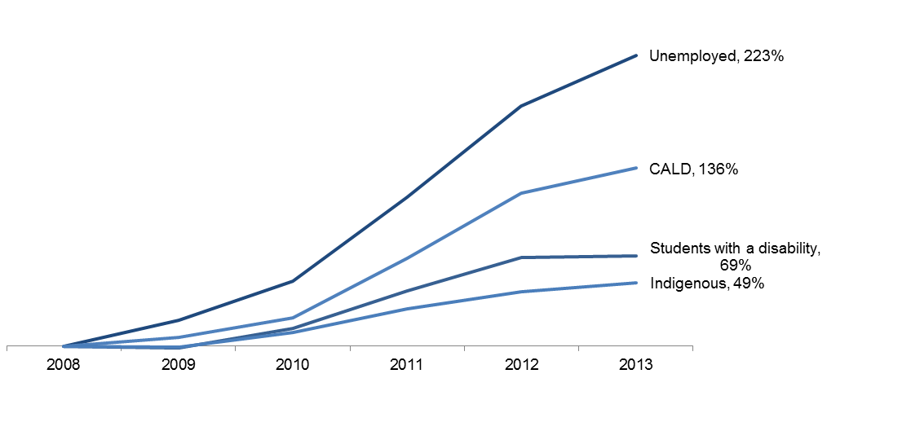

*CALD, Culturally and Linguistically Diverse

## Indigenous Students

### Enrolments

|  |
| --- |
| Key Points  * There were 6,500 Indigenous students enrolled in 8,600 government subsidised courses in 2013. * Proportionally, 36 per cent of government subsidised enrolments undertaken by Indigenous students in 2013 were in Certificate I to II levels and 52 per cent were at the Certificate III and above. * Of those enrolments in industry-specific qualifications (5,400 enrolments) which exclude foundation skills and short courses in 2013, 37 per cent were in courses related to specialised or in shortage occupations. |

Table 2.2.1: Indigenous students: Government subsidised enrolments by qualification level, 2008 – 2013

|  |  |  |  |  |  |  |
| --- | --- | --- | --- | --- | --- | --- |
| **Qualification level** | **2008** | **2009** | **2010** | **2011** | **2012** | **2013** |
| Cert I-II | 3,200 | 2,500 | 2,800 | 3,200 | 2,900 | 3,100 |
| Cert III-IV | 2,000 | 2,200 | 2,300 | 3,100 | 3,600 | 4,000 |
| Diploma & Above | 350 | 400 | 450 | 550 | 600 | 500 |
| Module Only | 850 | 400 | 400 | 400 | 500 | 350 |
| Secondary, SoA and other | 550 | 700 | 650 | 350 | 600 | 750 |
| **Total** | **7,000** | **6,200** | **6,600** | **7,600** | **8,200** | **8,600** |

SoA: Statement of Attainment.

Table 2.2.2: Change in number of government subsidised enrolments undertaken by Indigenous students by qualification level

|  |  |  |  |
| --- | --- | --- | --- |
| **Qualification level** | **% change 2008-2013** | **% change 2011-2013** | **% change 2012-2013** |
| Cert I-II | -4% | -3% | 7% |
| Cert III-IV | 93% | 29% | 9% |
| Diploma & Above | 41% | -9% | -16% |
| Module Only | -63% | -20% | -36% |
| Secondary, SoA and other | 36% | 110% | 31% |
| **Total** | **23%** | **14%** | **5%** |

SoA: Statement of Attainment.

## Students with a Disability

### Enrolments

|  |
| --- |
| Key Points  * There were 40,500 students with a disability enrolled in 57,900 government subsidised courses in 2013. * Forty two per cent of government subsidised enrolments undertaken by students with disability were in Certificate III and above levels. * Of those enrolments in industry-specific qualifications (27,200 enrolments) which exclude foundation skills and short courses in 2013, 35 per cent were in courses related to specialised or in shortage occupations. |

Table 2.3.1: Students with a disability: government subsidised enrolments by qualification level,   
2008 – 2013

|  |  |  |  |  |  |  |
| --- | --- | --- | --- | --- | --- | --- |
| **Qualification level** | **2008** | **2009** | **2010** | **2011** | **2012** | **2013** |
| Cert I-II | 13,300 | 11,200 | 12,400 | 16,300 | 20,000 | 20,900 |
| Cert III-IV | 8,600 | 9,000 | 11,000 | 16,500 | 21,200 | 20,400 |
| Diploma & Above | 3,300 | 3,600 | 4,000 | 4,900 | 5,000 | 3,900 |
| Module Only | 8,300 | 8,400 | 8,300 | 7,200 | 7,700 | 8,700 |
| Secondary, SoA and other | 2,800 | 2,500 | 2,800 | 3,200 | 3,800 | 4,100 |
| **Total** | **36,300** | **34,700** | **38,400** | **48,000** | **57,600** | **57,900** |

SoA: Statement of Attainment.

Table 2.3.2: Change in number of government subsidised enrolments undertaken by students with a disability by qualification level

|  |  |  |  |
| --- | --- | --- | --- |
| **Qualification level** | **% change 2008-2013** | **% change 2011-2013** | **% change 2012-2013** |
| Cert I-II | 57% | 28% | 4% |
| Cert III-IV | 136% | 23% | -4% |
| Diploma & Above | 17% | -20% | -22% |
| Module Only | 4% | 21% | 14% |
| Secondary, SoA and other | 48% | 28% | 7% |
| **Total** | **59%** | **21%** | **0%** |

SoA: Statement of Attainment.

## Students with a Culturally and Linguistically Diverse (CALD) Background

### Enrolments

|  |
| --- |
| Key Points  * There were 137,500 students from a CALD background enrolled in 183,500 government subsidised courses in 2013. * Forty two per cent of government subsidised enrolments undertaken by students with disability were in Certificate III and above levels. * Of those enrolments in industry-specific qualifications (116,200 enrolments) which exclude foundation skills and short courses in 2013, 45 per cent were in courses related to specialised or in shortage occupations. |

Table 2.4.1: Students from a CALD background: government subsidised enrolments by qualification level, 2008 – 2013

|  |  |  |  |  |  |  |
| --- | --- | --- | --- | --- | --- | --- |
| **Qualification level** | **2008** | **2009** | **2010** | **2011** | **2012** | **2013** |
| Cert I-II | 19,800 | 20,100 | 20,400 | 28,500 | 41,600 | 49,500 |
| Cert III-IV | 30,000 | 30,700 | 38,500 | 62,000 | 88,900 | 97,700 |
| Diploma & Above | 13,400 | 15,700 | 17,300 | 22,400 | 23,200 | 19,000 |
| Module Only | 13,000 | 11,600 | 12,100 | 11,700 | 10,700 | 11,600 |
| Secondary, SoA and other | 5,000 | 5,400 | 5,400 | 6,200 | 8,400 | 5,600 |
| **Total** | **81,100** | **83,500** | **93,800** | **130,700** | **172,800** | **183,500** |

SoA: Statement of Attainment.

Table 2.4.2: Change in number of government subsidised enrolments undertaken by students from a CALD background by qualification level

|  |  |  |  |
| --- | --- | --- | --- |
| **Qualification level** | **% change 2008-2013** | **% change 2011-2013** | **% change 2012-2013** |
| Cert I-II | 151% | 74% | 19% |
| Cert III-IV | 226% | 58% | 10% |
| Diploma & Above | 42% | -15% | -18% |
| Module Only | -10% | 0% | 8% |
| Secondary, SoA and other | 12% | -10% | -33% |
| **Total** | **126%** | **40%** | **6%** |

SoA: Statement of Attainment.

## Unemployed Students

### Enrolments

|  |
| --- |
| Key Points  * The number of government subsidised course enrolments undertaken by unemployed students in 2013 was 182,700 which were undertaken by 134,800 unemployed students. * Enrolments in Diploma and above courses undertaken by unemployed students in 2013 were lower than the corresponding figures in 2011 and 2012. * Of those enrolments in industry-specific qualifications (111,200 enrolments) which exclude foundation skills and short courses in 2013, 38 per cent were in courses related to specialised or in shortage occupations. |

Table 2.5.1: Unemployed students: government subsidised enrolments by qualification level, 2008 – 2013

|  |  |  |  |  |  |  |
| --- | --- | --- | --- | --- | --- | --- |
| **Qualification level** | **2008** | **2009** | **2010** | **2011** | **2012** | **2013** |
| Cert I-II | 18,800 | 21,600 | 25,700 | 37,000 | 54,100 | 66,800 |
| Cert III-IV | 17,400 | 21,200 | 30,200 | 54,500 | 77,200 | 87,000 |
| Diploma & Above | 9,100 | 10,700 | 13,200 | 16,600 | 15,700 | 13,200 |
| Module Only | 13,000 | 11,700 | 10,600 | 8,300 | 7,900 | 8,800 |
| Secondary, SoA and other | 5,300 | 6,000 | 6,300 | 6,500 | 8,000 | 6,900 |
| **Total** | **63,600** | **71,200** | **86,000** | **123,000** | **162,900** | **182,700** |

SoA: Statement of Attainment.

Table 2.5.2: Change in number of government subsidised enrolments undertaken by unemployed students by qualification level

|  |  |  |  |
| --- | --- | --- | --- |
| **Qualification level** | **% change 2008-2013** | **% change 2011-2013** | **% change 2012-2013** |
| Cert I-II | 255% | 80% | 23% |
| Cert III-IV | 401% | 60% | 13% |
| Diploma & Above | 44% | -21% | -16% |
| Module Only | -32% | 6% | 12% |
| Secondary, SoA and other | 31% | 7% | -14% |
| **Total** | **187%** | **49%** | **12%** |

SoA: Statement of Attainment.

## Young People (Aged 15 to 19) without Year 12 or Equivalent and Not at School

### Enrolments

|  |
| --- |
| Key Points  * The total number of government subsidised enrolments of young people without a Year 12 or equivalent and not in school at Certificate II and above was 29,300 in 2013. This figure is lower than the corresponding figures in 2010, 2011 and 2012. * Of those enrolments in industry-specific qualifications (24,700 enrolments) which exclude foundation skills courses in 2013, 40 per cent were in courses related to specialised or in shortage occupations. |

Table 2.6.1: Youth transition: government subsidised enrolments Cert II and above by students aged 15 to 19 who did not complete Year 12 or equivalent and not at school, 2008 – 2013

|  |  |  |  |  |  |  |
| --- | --- | --- | --- | --- | --- | --- |
|  | **2008** | **2009** | **2010** | **2011** | **2012** | **2013** |
| Cert II | 8,300 | 8,600 | 10,800 | 12,700 | 12,000 | 10,000 |
| Cert III-IV | 16,500 | 15,800 | 18,400 | 20,400 | 22,100 | 18,700 |
| Diploma & Above | 650 | 800 | 850 | 1,800 | 950 | 600 |
| **Total** | **25,500** | **25,200** | **30,000** | **34,800** | **35,100** | **29,300** |

Table 2.6.2: Change in number of government subsidised enrolments undertaken by Young People (Aged 15 to 19) Without Year 12 or Equivalent and Not at School by qualification level

|  |  |  |  |
| --- | --- | --- | --- |
|  | **% change 2008-2013** | **% change 2011-2013** | **% change 2012-2013** |
| Cert II | 20% | -21% | -17% |
| Cert III-IV | 13% | -8% | -15% |
| Diploma & Above | -7% | -66% | -39% |
| **Total** | **15%** | **-16%** | **-17%** |

## Students with Low Prior Qualifications

### Enrolments

|  |
| --- |
| Key Points  * In 2013, there were 260,700 students who were aged 20-64 and not holding a Certificate III or above qualification enrolled in 342,000 government subsidised courses. * Of those enrolments in industry-specific qualifications (252,600 enrolments) which exclude foundation skills courses in 2013, 41 per cent were in courses related to specialised or in shortage occupations. |

Table 2.7.1: Government subsidised enrolments by students aged 20-64 not holding a Cert III or above, 2008 – 2013

|  |  |  |  |  |  |  |
| --- | --- | --- | --- | --- | --- | --- |
|  | **2008** | **2009** | **2010** | **2011** | **2012** | **2013** |
| Course Enrolments | 164,100 | 166,200 | 185,400 | 271,800 | 345,700 | 342,000 |
| Up-Skilling | 92,500 | 100,200 | 118,600 | 190,600 | 251,500 | 241,100 |

Up-skilling refers to studying at a higher level than their current qualification.

Table 2.7.2: Change in the number of government subsidised enrolments by students aged 20-64 not holding a Cert III or above

|  |  |  |  |
| --- | --- | --- | --- |
|  | **% change 2008-2013** | **% change 2011-2013** | **% change 2012-2013** |
| Course Enrolments | 108% | 26% | -1% |
| Up-Skilling | 161% | 26% | -4% |

Up-skilling refers to studying at a higher level than their current qualification.

## Foundation Level Training

An efficient and effective training market is vital to provide better outcomes for students and employers, as well as the wider Victorian community. It is particularly important to make sure school leavers and adults without solid literacy and numeracy skills are given the opportunity to acquire them. These skills will greatly improve their chances of employment, provide opportunities for further education and broader social participation.

The latest OECD study on adult literacy and numeracy[6] (Program for the International Assessment of Adult Competencies) suggests that there is a significant proportion of the adult population with very low skills in literacy and numeracy, likely to be of a level to limit their effective participation in the economy: about 14% (or 518,000) of Victorians aged 15-64 had low level of skills (proficiency level 1 or below) in literacy and 22% (or 818,600) had low level of skills in numeracy. These individuals would benefit from foundation type courses.

A study undertaken by the Australian Industry Group *Getting it Right: Foundation Skills for the Workforce* found that employers continue to be concerned about the low levels of workplace literacy and numeracy, with 93 per cent of employers identifying some impact on their business.

There were changes in subsidy and VTG arrangements associated with Foundation courses of study at the end of 2013. To ensure a consistent series of data on like courses are reported, a broader definition of “Foundation” is used in this section and in other sections of this report, i.e. Foundation includes Foundation skills, workplace preparation, educational pathways and low level LOTE courses

|  |
| --- |
| Key Points  * In 2013 there were 157,200 government subsidised enrolments in foundation skills courses. This was significantly higher than in 2011 and 2012. |

Figure 2.3: Government subsidised enrolments in foundation skills courses, 2008 – 2012,   
2011, 2012 and 2013

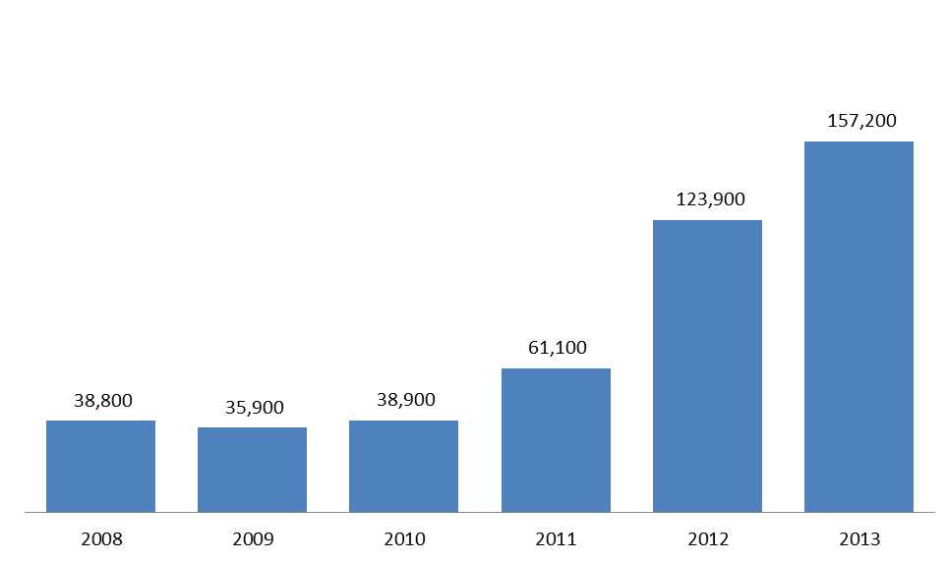

Table 2.8.1: Government subsidised student contact hours in foundation skills courses, 2008-2013

|  |  |  |  |  |  |  |
| --- | --- | --- | --- | --- | --- | --- |
|  | **2008** | **2009** | **2010** | **2011** | **2012** | **2013** |
| Student contact hours | 9.7 | 10.4 | 9.5 | 14.7 | 22.6 | 30.8 |

Table 2.8.2: Change in government subsidised student contact hours in foundation skills courses

|  |  |  |  |
| --- | --- | --- | --- |
|  | **% change 2008-2013** | **% change 2011-2013** | **% change 2012-2013** |
| Student contact hours | 217% | 110% | 36% |

Table 2.9.1: Government subsidised students in foundation skills courses by age group, 2008-2013

|  |  |  |  |  |  |  |
| --- | --- | --- | --- | --- | --- | --- |
|  | **2008** | **2009** | **2010** | **2011** | **2012** | **2013** |
| 15 to 19 | 10,500 | 10,800 | 12,600 | 19,200 | 39,400 | 48,300 |
| 20 to 24 | 4,600 | 4,100 | 5,000 | 8,500 | 22,500 | 31,000 |
| 25 to 44 | 15,200 | 13,100 | 13,400 | 20,700 | 37,300 | 48,700 |
| 45 to 64 | 7,300 | 6,700 | 7,000 | 11,200 | 20,400 | 24,900 |
| Under 15, over 64, not stated | 1,300 | 1,200 | 1,000 | 1,400 | 4,200 | 4,300 |
| **Total** | **38,800** | **35,900** | **38,900** | **61,100** | **123,900** | **157,200** |

Table 2.9.2: Change in government subsidised students in foundation skills courses by age group

|  |  |  |  |
| --- | --- | --- | --- |
|  | **% change 2008-2013** | **% change 2011-2013** | **% change 2012-2013** |
| 15 to 19 | 362% | 151% | 22% |
| 20 to 24 | 577% | 264% | 38% |
| 25 to 44 | 219% | 135% | 31% |
| 45 to 64 | 242% | 123% | 22% |
| Under 15, over 64, not stated | 244% | 197% | 1% |
| **Total** | **305%** | **157%** | **27%** |

# Alignment of Training to Industry Skills Needs

### Introduction

The demand driven system for vocational training allows businesses, students and training providers to respond to the changing needs of the economy. Over the period between 2012 and 2013 there have been shifts towards training delivered in areas that better meet the training requirements of the Victorian economy. The training market has been dynamic and responsive in seeking to align with these areas of need.

There has been a reduction in courses that experienced unprecedented high levels of enrolments in 2012 that were not aligned with the employment trends of related industries. Challenges remain as government seeks to support apprenticeships in a climate of business contraction in trade related industries as well as managing growth in training areas that are not aligned with industry or student needs such as foundation skills for individuals who already have well developed literacy, numeracy and workplace skills and recognition of prior learning in unlicensed occupations.

The Victorian Government released the *Refocusing Vocational Training* (RVT) in Victoria reform package in May 2012 to shift training activity to areas of industry and economic need. Under the new subsidy bands, weightings have been refined to apply at the course level to strengthen Government investment in training for specialised skills, training to address skills in shortage, training related to areas of growing employment opportunity and sectors delivering essential services. The reforms also assessed the extent to which government investment is required to stimulate delivery of, and participation in, this training to meet industry needs.

Overall, the highest subsidy levels have been provided to courses where contribution to the economy is assessed as high, and where government subsidy is seen as essential in enabling delivery and participation in training. Lower subsidy levels may indicate evidence of over-supply, or that less government support is required to promote training in these areas. For example, diplomas often attract lower subsidy rates in recognition of the greater private benefits flowing to students from completing these qualifications and because students can access financial support through VET FEE-HELP to meet upfront costs.

|  |
| --- |
| Key Points  * Proportionally there has been a marked shift in commencement patterns when comparing 2013 with Pre-July 2012. Data from 2013 shows that 69 per cent of all government subsidised commencing enrolments were within subsidy bands A and B, compared with 49 per cent of commencements in subsidy bands A and B over the same period in 2012. Courses such as the Certificate III in Carpentry, Certificate III in Aged Care, Certificate III in Automotive Mechanical Technology, Certificate III in Driving Operations and the Certificate III in Electrotechnology Electrician are represented in these funding bands. * Courses with less vocational outcome, or labour market requirement (Band D and E) represented 9 per cent of all government subsidised commencements in 2013. It was 31 per cent over the same period in 2012. |

Figure 3.1: Government subsidised commencing course enrolments: proportion of commencing enrolments by subsidy band, Pre-July 2012, 2013, July-December 2012

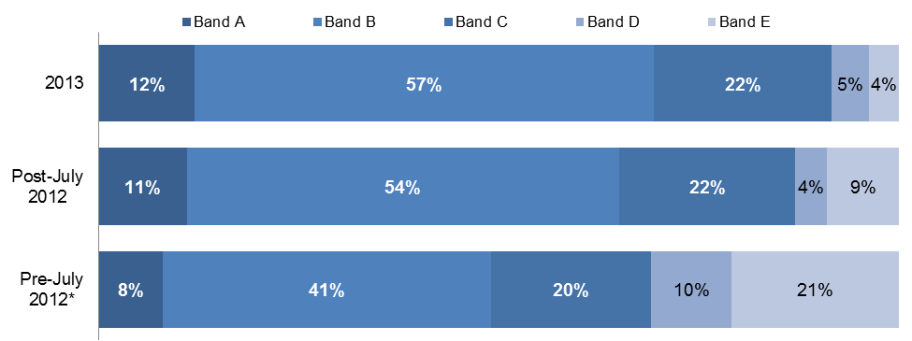

*Pre-July 2012 refers to January to June 2012. Subsidy bands were introduced in 2012 and apply specifically to qualifications in 2012 and onward. In order to allow comparison with previous years, superseded courses have been assigned a subsidy band for analysis purposes only based on the bands of the current course to which they most closely align.

## Enrolments by Industry and Occupation

### Enrolments by Industry

Victorian reforms in vocational training enhance the alignment between vocational training and the needs of industry. For students this provides the opportunity for improved career and education pathways and employment outcomes following completion of training. Analysis of vocational training data has shown a good alignment between share of employment and share of training delivery in Victoria's largest industries (also refer to Figure 3.2 for a comparison between employment and enrolment by industry):

* 60 per cent of training was delivered in the six highest employing Victorian industry sectors, which account for 59 per cent of all Victorian jobs - Health Care and Social Assistance, Retail Trade, Manufacturing, Professional, Scientific and Technical Services, Construction and Education and Training.
* There were around 448,100 enrolments in all industry-specific training, including 60,300 enrolments in Cross-industry training, which encompasses a broad range of skills applicable to all Victorian industries.

**Figure 3.2: Industry share of Victorian employment and vocational training 2013**

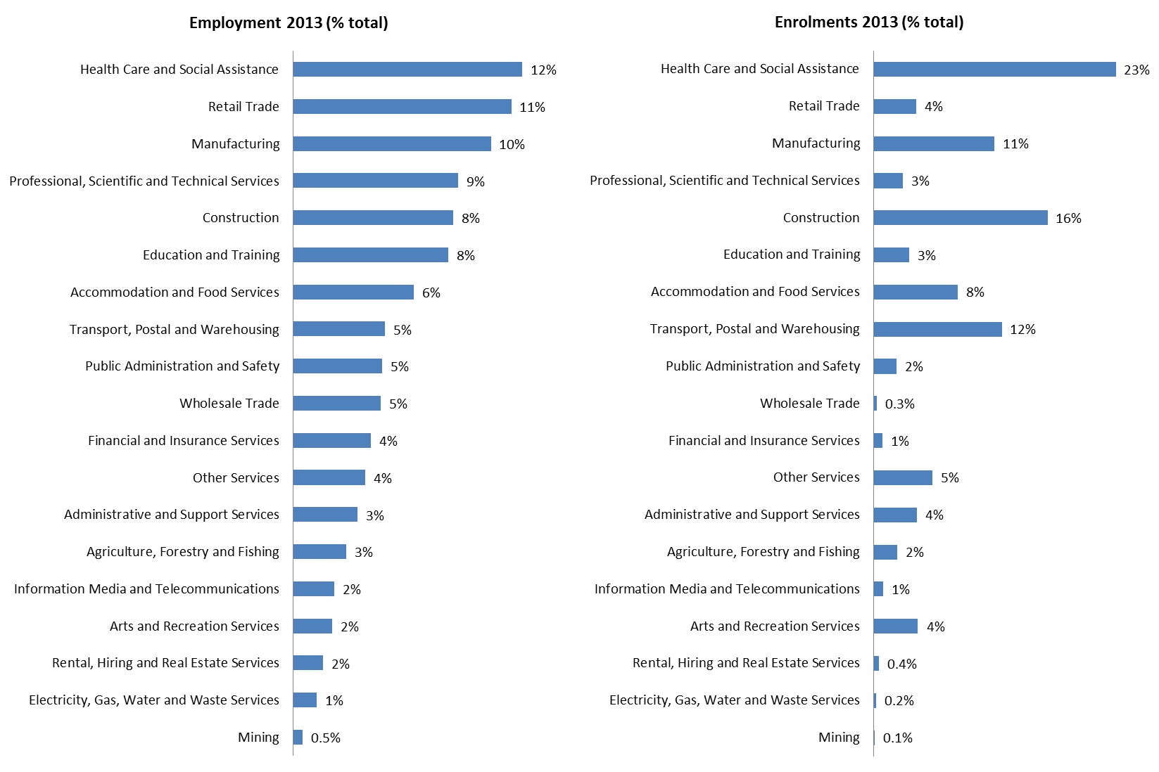

Figure 3.2 shows how training within industries is tracking against employment needs. The following table, Table 3.1, highlights the top enrolling industries. The table shows training in government subsidised qualifications, sorted highest to lowest by 2013 enrolments (excludes foundation training). Rank by industry share of Victorian employment and equivalent 2008 ranks are also displayed.

Table 3.1: Industry-specific[7] training and employment: 2013 vs. 2008

|  |  |  |  |  |  |  |
| --- | --- | --- | --- | --- | --- | --- |
| **Industry** | **2013 Enrolments** | | **Training Rank** | | **Employment Rank** | |
| **Number** | **Share** | **2013** | **2008** | **2013** | **2008** |
| Health Care and Social Assistance | 87,300 | 23% | 1 | 2 | 1 | 3 |
| Construction | 62,700 | 16% | 2 | 1 | 5 | 4 |
| Transport, Postal and Warehousing | 46,100 | 12% | 3 | 10 | 8 | 8 |
| Manufacturing | 43,500 | 11% | 4 | 3 | 3 | 1 |
| Accommodation and Food Services | 30,300 | 8% | 5 | 4 | 7 | 7 |
| Other Services | 21,100 | 5% | 6 | 9 | 12 | 11 |
| Arts and Recreation Services | 15,900 | 4% | 7 | 7 | 16 | 16 |
| Administrative and Support Services | 15,600 | 4% | 8 | 6 | 13 | 13 |
| Retail Trade | 15,400 | 4% | 9 | 5 | 2 | 2 |
| Education and Training | 12,700 | 3% | 10 | 12 | 6 | 5 |
| Professional, Scientific and Technical Services | 10,500 | 3% | 11 | 8 | 4 | 6 |
| Agriculture, Forestry and Fishing | 8,300 | 2% | 12 | 11 | 14 | 14 |
| Public Administration and Safety | 8,100 | 2% | 13 | 13 | 9 | 9 |
| Information Media and Telecommunications | 3,300 | 1% | 14 | 14 | 15 | 15 |
| Financial and Insurance Services | 3,100 | 1% | 15 | 15 | 11 | 12 |
| Rental, Hiring and Real Estate Services | 1,700 | 0.4% | 16 | 17 | 17 | 17 |
| Wholesale Trade | 1,000 | 0.3% | 17 | 17 | 10 | 10 |
| Electricity, Gas, Water and Waste Services | 800 | 0.2% | 18 | 16 | 18 | 18 |
| Mining | 400 | 0.1% | 19 | 19 | 19 | 19 |
| **Industry specific** **training** | **387,800** | **100%** |  |  |  |  |
| Cross-industry training* | 60,300 | - | - | - | - | - |
| **Total industry training** | **448,100** | **-** | **-** | **-** | **-** | **-** |
| Notes: | | | | | | |
| 1. Cross-industry training (e.g. business administration, recordkeeping, computing) has been removed from the industry-specific analysis as this training develops business skills which are transferable across many industry sectors. | | | | | | |
| 2. Employment data has been sourced from Monash CoPS Labour Market Forecasts, 2013. | | | | | | |

### Subsidy bands analysis per industry

The table below shows the top five highest enrolments by industries for each subsidy band.

Table 3.2: Industry-specific training by funding band, 2013

|  |  |  |
| --- | --- | --- |
| **Industry by funding band** | **2013 Enrolments** | **% enrolments 2013** |
| **Band A** | | |
| Construction | 42,700 | 55% |
| Manufacturing | 10,200 | 13% |
| Other Services | 10,100 | 13% |
| Accommodation and Food Services | 7,300 | 9% |
| Retail Trade | 3,100 | 4% |
| Other industries | 4,000 | 5% |
| **Total (Band A)** | **77,400** | **100%** |
| **Band B** | | |
| Health Care and Social Assistance | 39,300 | 26% |
| Transport, Postal and Warehousing | 38,600 | 26% |
| Manufacturing | 24,000 | 16% |
| Construction | 14,300 | 9% |
| Accommodation and Food Services | 8,700 | 6% |
| Other industries | 26,100 | 17% |
| **Total (Band B)** | **151,000** | **100%** |
| **Band C** | | |
| Health Care and Social Assistance | 45,200 | 34% |
| Cross-industry | 33,900 | 25% |
| Education and Training | 8,700 | 7% |
| Administrative and Support Services | 6,900 | 5% |
| Transport, Postal and Warehousing | 5,900 | 4% |
| Other industries | 32,700 | 25% |
| **Total (Band C)** | **133,300** | **100%** |
| **Band D** | | |
| Cross-industry | 11,700 | 32% |
| Administrative and Support Services | 4,600 | 13% |
| Retail Trade | 4,200 | 12% |
| Public Administration and Safety | 3,500 | 10% |
| Professional, Scientific and Technical Services | 2,500 | 7% |
| Other industries | 9,700 | 27% |
| **Total (Band D)** | **36,200** | **100%** |
| **Band E** | | |
| Cross-industry | 11,600 | 33% |
| Accommodation and Food Services | 5,900 | 17% |
| Retail Trade | 5,600 | 16% |
| Arts and Recreation Services | 5,500 | 16% |
| Manufacturing | 3,800 | 11% |
| Other industries | 2,500 | 7% |
| **Total (Band E)** | **34,900** | **100%** |

|  |
| --- |
| Key Points  * In 2013, over half of delivery in Band A (apprenticeships and non-apprenticeships) were in the Construction industry. Manufacturing accounted for 13 per cent of all Band A enrolments. * At 26 per cent respectively, the largest blocks of delivery in Band B were in Health Care and Social Assistance and Transport, Postal and Warehousing. |

### Enrolments by Occupation

In 2013, the five highest numbers of enrolments within Bands A and B were in courses related to the following occupations:

* Aged or Disabled Carers (18,800 enrolments in 2013)
* Storepersons (15,000 enrolments in 2013)
* Truck Drivers (General) (14,600 enrolments in 2013)
* Engineering Production Systems Workers (13,600 enrolments in 2013)
* Motor Mechanics (8,400 enrolments in 2013)

Employment trends within these occupations are outlined in the table below and show employment numbers in 2012-13, average annual employment needs[8] over the next five years as well as patterns of forecast employment growth to 2017-18. Employment trends indicate growth in four of the five occupational groups related to highest number of courses in Bands A and B. Engineering Productions Systems Workers are forecast to see dampened demand over the next five years. These workers predominantly work in the Manufacturing industry, a critical industry for the Victorian economy undergoing significant industrial transition, and therefore remain a critical area for public investment in vocational training.

Table 3.3: Employment trends in selected occupations (Bands A & B), 2012-13 to 2017-18



The five highest numbers of enrolments within Bands D and E in 2013 were in courses related to the following occupations:

* Office Managers (12,400 enrolments in 2013)
* Sales Assistants (General) (6,900 enrolments in 2013)
* General Clerks (6,800 enrolments in 2013)
* Waiters (5,700 enrolments in 2013)
* Call or Contact Centre Workers (5,300 enrolments in 2013)

As above, Table 3.4 shows employment trends for occupations related to top five highest numbers of enrolments within Band D and E. Characteristic of these occupations in the Victorian labour market are jobs that have high levels of turnover, casual work and mixed employment prospects. Employment of Office Managers, for example, is likely to fall through to 2017-18. Sales Assistants, General Clerks, Call or Contact Centre Workers and Waiters are forecast to see employment growth, however present less of a requirement for vocational training investment made by government to support meeting this labour market need.

**Table 3.4: Employment trends in selected occupations (Band D & E), 2012-13 to 2017-18**



## Apprentices

Since July 2012 courses such as Apprenticeships, attract government subsidy at the highest level in recognition of current and projected future industry skill needs. Apprenticeships receive the highest level of subsidy, and enrolments for apprenticeships have increased by 3 per cent since 2008. In Victoria just over half (54 per cent) of all Apprentice enrolments in 2013 were in the Construction industry, a sector that has been facing some challenging business conditions over recent years. Apprentice numbers are highly correlated with business conditions and this close relationship is demonstrated in the chart below shows similar overall trends between apprenticeship commencements[9] and new dwelling commencements[10], especially in the last few years.

Figure 3.3: Number of apprenticeship commencements and new dwelling units commenced all sectors  
2000 to 2013

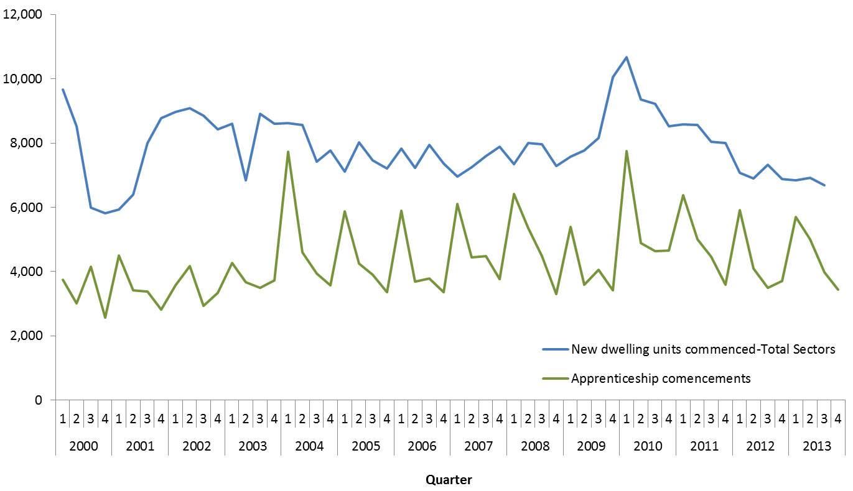

Table 3.5.1: Government subsidised enrolments by Apprentices by age, 2008–2013

|  |  |  |  |  |  |  |
| --- | --- | --- | --- | --- | --- | --- |
|  | **2008** | **2009** | **2010** | **2011** | **2012** | **2013** |
| 15 to 19 | 19,100 | 18,400 | 19,400 | 19,300 | 17,300 | 15,200 |
| 20 to 24 | 16,300 | 16,500 | 18,100 | 18,500 | 18,800 | 18,200 |
| 25 to 44 | 5,900 | 6,300 | 7,100 | 7,800 | 8,100 | 8,500 |
| 45 to 64 | 500 | 500 | 600 | 650 | 850 | 1,300 |
| Under 15, over 64, not stated | 50 | 30 | 20 | 20 | 10 | 30 |
| **Apprentices** | **41,900** | **41,600** | **45,300** | **46,300** | **45,000** | **43,200** |

Table 3.5.2: Change in government subsidised enrolments by Apprentices by age, 2008–2013

|  |  |  |  |
| --- | --- | --- | --- |
|  | **% change 2008-2013** | **% change 2011-2013** | **% change 2012-2013** |
| 15 to 19 | -20% | -21% | -12% |
| 20 to 24 | 11% | -2% | -3% |
| 25 to 44 | 43% | 10% | 5% |
| 45 to 64 | 159% | 92% | 53% |
| Under 15, over 64, not stated | -45% | 87% | 180% |
| **Apprentices** | **3%** | **-7%** | **-4%** |

Table 3.6.1: Government subsidised enrolments by Apprentices by qualification level, 2008–2013

|  |  |  |  |  |  |  |
| --- | --- | --- | --- | --- | --- | --- |
|  | **2008** | **2009** | **2010** | **2011** | **2012** | **2013** |
| Cert III-IV | 41,800 | 41,500 | 45,100 | 46,200 | 45,000 | 43,100 |
| Diploma & Above | 100 | 100 | 100 | 100 | 90 | 70 |

Table 3.6.2: Change in government subsidised enrolments by Apprentices by qualification level, 2008–2013

|  |  |  |  |
| --- | --- | --- | --- |
|  | **% change 2008-2013** | **% change 2011-2013** | **% change 2012-2013** |
| Cert III-IV | 3% | -7% | -4% |
| Diploma & Above | -30% | -35% | -23% |

Table 3.7.1: Government subsidised enrolments by Apprentices by industry, 2008- 2013

|  |  |  |  |  |  |  |
| --- | --- | --- | --- | --- | --- | --- |
|  | **2008** | **2009** | **2010** | **2011** | **2012** | **2013** |
| A: Agriculture, Forestry and Fishing | 50 | 40 | 30 | 30 | 50 | 80 |
| B: Mining | - | - | - | - | - | - |
| C: Manufacturing | 7,300 | 6,800 | 6,900 | 6,700 | 6,800 | 6,600 |
| D: Electricity, Gas, Water and Waste Services | 200 | 200 | 200 | 250 | 250 | 300 |
| E: Construction | 20,700 | 21,800 | 24,800 | 26,100 | 24,700 | 23,300 |
| F: Wholesale Trade | 100 | 90 | 100 | 100 | 90 | 40 |
| G: Retail Trade | 2,000 | 1,900 | 1,900 | 2,000 | 2,100 | 2,000 |
| H: Accommodation and Food Services | 3,100 | 2,800 | 2,800 | 2,600 | 2,700 | 3,000 |
| I: Transport, Postal and Warehousing | 20 | 10 | 20 | 10 | 10 | 0 |
| J: Information Media and Telecommunications | 30 | 30 | 10 | 0 | 0 | - |
| K: Financial and Insurance Services | - | 0 | 0 | - | - | - |
| L: Rental, Hiring and Real Estate Services | - | - | - | - | - | - |
| M: Professional, Scientific and Technical Services | 150 | 150 | 150 | 150 | 150 | 300 |
| N: Administrative and Support Services | 450 | 450 | 550 | 550 | 450 | 250 |
| O: Public Administration and Safety | 70 | 90 | 100 | 100 | 100 | 100 |
| P: Education and Training | - | - | - | - | - | - |
| Q: Health Care and Social Assistance | 100 | 100 | 100 | 100 | 80 | 70 |
| R: Arts and Recreation Services | 550 | 550 | 600 | 650 | 650 | 600 |
| S: Other Services | 7,200 | 6,700 | 7,000 | 6,800 | 6,800 | 6,500 |
| T: Cross-industry | 0 | 0 | 0 | - | 0 | - |
| U: Foundation Skills and LOTE | - | - | - | - | - | - |
| Not applicable / Unknown | 0 | - | - | - | - | 10 |
| **Total** | **41,900** | **41,600** | **45,300** | **46,300** | **45,000** | **43,200** |

Table 3.7.2: Change in government subsidised enrolments by Apprentices by industry, 2008- 2013

|  |  |  |  |
| --- | --- | --- | --- |
|  | **% change 2008-2013** | **% change 2011-2013** | **% change 2012-2013** |
| A: Agriculture, Forestry and Fishing | 78% | 135% | 63% |
| B: Mining | n/a | n/a | n/a |
| C: Manufacturing | -9% | -2% | -2% |
| D: Electricity, Gas, Water and Waste Services | 78% | 33% | 36% |
| E: Construction | 12% | -11% | -6% |
| F: Wholesale Trade | -60% | -62% | -49% |
| G: Retail Trade | 1% | -2% | -7% |
| H: Accommodation and Food Services | -2% | 14% | 10% |
| I: Transport, Postal and Warehousing | -80% | -73% | -77% |
| J: Information Media and Telecommunications | -100% | -100% | -100% |
| K: Financial and Insurance Services | n/a | n/a | n/a |
| L: Rental, Hiring and Real Estate Services | n/a | n/a | n/a |
| M: Professional, Scientific and Technical Services | 86% | 82% | 85% |
| N: Administrative and Support Services | -38% | -53% | -44% |
| O: Public Administration and Safety | 55% | 3% | -9% |
| P: Education and Training | n/a | n/a | n/a |
| Q: Health Care and Social Assistance | -26% | -32% | -16% |
| R: Arts and Recreation Services | 7% | -7% | -8% |
| S: Other Services | -9% | -4% | -5% |
| T: Cross-industry | -100% | n/a | -100% |
| U: Foundation Skills and LOTE | n/a | n/a | n/a |
| Not applicable / Unknown | 200% | n/a | n/a |
| **Total** | **3%** | **-7%** | **-4%** |

## Trainees

Traineeships have increased by 8 per cent since 2008. However, when compared to 2011 and 2012, there has been a decline in enrolments in Traineeships in 2013. The decline is primarily driven by a fall in enrolments in courses that now attract subsidy at the lowest level (band E), where there was unprecedented high level of enrolments that did not match employment trends for related industries. The reduction in traineeship enrolments is also attributable to changes to Commonwealth government incentives[11].

The chart below shows that the decline is predominantly from courses that attract the lowest subsidy (band E) which are deemed to have less vocational outcome or labour market requirement and reflect the oversupply in training that was being delivered. Courses in this group are such as Certificate II in Retail, Certificate III in Retail, Certificate III in Hospitality, Certificate III in Process Manufacturing, and Certificate III in Customer Contact. There was a spike in these courses in 2012 and the 2013 reductions need to be seen in this context. In contrast there have been increases in enrolments in Traineeships that now attract subsidy at band B, reflecting industry need for graduates from these courses.

**Figure 3.4: Government subsidised traineeship enrolments by funding band, 2011 – 2013**

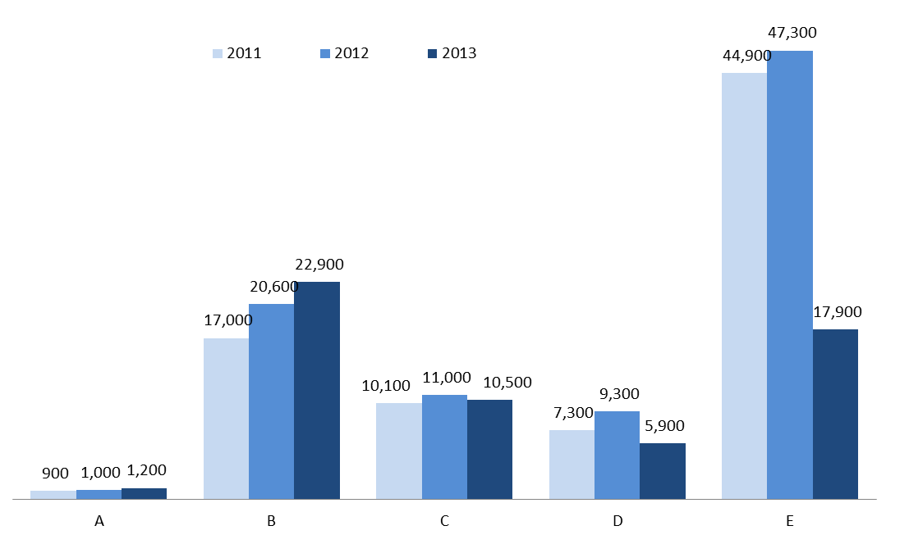

Table 3.8.1: Government subsidised enrolments by Trainees by age, 2008–2013

|  |  |  |  |  |  |  |
| --- | --- | --- | --- | --- | --- | --- |
|  | **2008** | **2009** | **2010** | **2011** | **2012** | **2013** |
| 15 to 19 | 21,300 | 20,800 | 22,700 | 26,100 | 25,500 | 14,400 |
| 20 to 24 | 12,900 | 11,000 | 12,500 | 15,300 | 15,500 | 9,800 |
| 25 to 44 | 14,500 | 12,400 | 14,800 | 24,600 | 29,600 | 20,400 |
| 45 to 64 | 4,800 | 4,600 | 6,500 | 13,600 | 18,000 | 13,300 |
| Under 15, over 64, not stated | 600 | 450 | 300 | 600 | 700 | 500 |
| **Trainees** | **54,000** | **49,200** | **56,900** | **80,200** | **89,300** | **58,400** |

Table 3.8.2: Change in Government subsidised enrolments by Trainees by age, 2008–2013

|  |  |  |  |
| --- | --- | --- | --- |
|  | **% change 2008-2013** | **% change 2011-2013** | **% change 2012-2013** |
| 15 to 19 | -32% | -45% | -43% |
| 20 to 24 | -24% | -36% | -37% |
| 25 to 44 | 41% | -17% | -31% |
| 45 to 64 | 177% | -3% | -26% |
| Under 15, over 64, not stated | -18% | -13% | -25% |
| **Trainees** | **8%** | **-27%** | **-35%** |

Table 3.9.1: Government subsidised enrolments by Trainees by qualification level, 2008–2013

|  |  |  |  |  |  |  |
| --- | --- | --- | --- | --- | --- | --- |
|  | **2008** | **2009** | **2010** | **2011** | **2012** | **2013** |
| Cert I-II | 10,200 | 11,100 | 11,700 | 8,900 | 4,200 | 2,600 |
| Cert III-IV | 42,600 | 36,800 | 42,500 | 62,900 | 72,100 | 49,300 |
| Diploma & Above | 1,100 | 1,300 | 2,700 | 8,400 | 13,000 | 6,500 |

Table 3.9.2: Change in government subsidised enrolments by Trainees by qualification level, 2008–2013

|  |  |  |  |
| --- | --- | --- | --- |
|  | **% change 2008-2013** | **% change 2011-2013** | **% change 2012-2013** |
| Cert I-II | -75% | -71% | -39% |
| Cert III-IV | 16% | -22% | -32% |
| Diploma & Above | 517% | -22% | -50% |

Table 3.10.1: Government subsidised enrolments by Trainees by industry, 2008- 2013

|  |  |  |  |  |  |  |
| --- | --- | --- | --- | --- | --- | --- |
|  | **2008** | **2009** | **2010** | **2011** | **2012** | **2013** |
| A: Agriculture, Forestry and Fishing | 1,000 | 1,100 | 1,100 | 1,700 | 2,100 | 2,500 |
| B: Mining | 40 | 50 | 20 | 20 | 30 | 90 |
| C: Manufacturing | 3,500 | 3,100 | 4,900 | 10,900 | 14,400 | 12,900 |
| D: Electricity, Gas, Water and Waste Services | 150 | 150 | 100 | 200 | 300 | 200 |
| E: Construction | 550 | 350 | 400 | 700 | 900 | 950 |
| F: Wholesale Trade | 100 | 100 | 200 | 450 | 550 | 300 |
| G: Retail Trade | 14,900 | 13,300 | 15,000 | 18,300 | 18,300 | 7,300 |
| H: Accommodation and Food Services | 8,000 | 7,900 | 8,500 | 10,100 | 10,700 | 5,600 |
| I: Transport, Postal and Warehousing | 3,400 | 2,600 | 3,100 | 5,200 | 6,500 | 6,000 |
| J: Information Media and Telecommunications | 150 | 150 | 150 | 150 | 150 | 300 |
| K: Financial and Insurance Services | 200 | 350 | 400 | 550 | 550 | 550 |
| L: Rental, Hiring and Real Estate Services | 250 | 250 | 250 | 350 | 400 | 250 |
| M: Professional, Scientific and Technical Services | 350 | 250 | 250 | 300 | 350 | 250 |
| N: Administrative and Support Services | 6,700 | 4,600 | 5,700 | 7,200 | 6,600 | 4,000 |
| O: Public Administration and Safety | 200 | 80 | 60 | 50 | 100 | 250 |
| P: Education and Training | 450 | 400 | 350 | 500 | 450 | 1,100 |
| Q: Health Care and Social Assistance | 6,100 | 6,400 | 6,700 | 7,500 | 7,800 | 6,700 |
| R: Arts and Recreation Services | 1,800 | 2,300 | 2,200 | 2,700 | 2,600 | 1,000 |
| S: Other Services | 650 | 650 | 550 | 550 | 500 | 300 |
| T: Cross-industry | 5,400 | 5,100 | 6,800 | 12,800 | 16,200 | 7,800 |
| Trainees | 54,000 | 49,200 | 56,900 | 80,200 | 89,300 | 58,400 |

Table 3.10.2: Change in government subsidised enrolments by Trainees by industry, 2008- 2013

|  |  |  |  |
| --- | --- | --- | --- |
|  | **% change 2008-2013** | **% change 2011-2013** | **% change 2012-2013** |
| A: Agriculture, Forestry and Fishing | 153% | 49% | 17% |
| B: Mining | 127% | 481% | 174% |
| C: Manufacturing | 268% | 18% | -10% |
| D: Electricity, Gas, Water and Waste Services | 8% | -20% | -38% |
| E: Construction | 73% | 32% | 1% |
| F: Wholesale Trade | 141% | -39% | -49% |
| G: Retail Trade | -51% | -60% | -60% |
| H: Accommodation and Food Services | -29% | -44% | -47% |
| I: Transport, Postal and Warehousing | 75% | 16% | -7% |
| J: Information Media and Telecommunications | 97% | 88% | 82% |
| K: Financial and Insurance Services | 164% | 4% | 2% |
| L: Rental, Hiring and Real Estate Services | 5% | -33% | -35% |
| M: Professional, Scientific and Technical Services | -19% | -15% | -20% |
| N: Administrative and Support Services | -40% | -44% | -39% |
| O: Public Administration and Safety | 17% | 390% | 153% |
| P: Education and Training | 151% | 121% | 149% |
| Q: Health Care and Social Assistance | 10% | -11% | -13% |
| R: Arts and Recreation Services | -44% | -62% | -60% |
| S: Other Services | -52% | -41% | -32% |
| T: Cross-industry | 45% | -39% | -52% |

## Training in Specialised and In-Shortage Related Occupations

Vocational training delivery that is meeting the skill requirements of industry is a core focus of the Refocusing Vocational Training reforms. In particular, training related to occupations identified as specialised or experiencing skill shortages that[12] enhance the productive capacity of the Victorian economy are a high priority for government investment.

'Specialised occupations’[13] are defined as occupations that have a long lead-time for training, high economic value and a significant match between training and employment.

‘Skill shortages’[14] exist when employers are unable to fill or have considerable difficulty filling vacancies for an occupation, or significant specialised skill needs within that occupation, at current levels of remuneration and conditions of employment, and in reasonably accessible locations.

Note: all data in this section is for government subsidised training by onshore domestic students in accredited AQF qualifications excluding foundation skills, education pathways and low-level LOTE courses.

|  |
| --- |
| Key Points Trends in 2013 indicate a refocusing of the training market towards a higher proportion of training delivery against most critical occupations:   * 184,400 enrolments in qualifications related to specialised or in shortage occupations in 2013. * In 2013, 41 per cent of training was for occupations which are either specialised or in shortage. In 2012 this figure was 32 per cent. * Marked difference between critical specialised or skill shortage occupations (14 per cent growth over 2012 - 2013) compared to non specialised or skill shortage training (23 per cent decrease). * Although, historically TAFE providers have delivered the majority of training in qualifications related to specialised or in shortage occupations, 2013 saw a marked increase in delivery across the whole training market with TAFE accounted for 47 per cent of training related to critical occupations and private RTOs accounted for 48 per cent of training. * The largest rise in specialised and skill shortage enrolments compared to 2012 has been in qualifications under Band A (up by 49 per cent). |

Figure 3.5: Government subsidised training delivery by responsiveness category

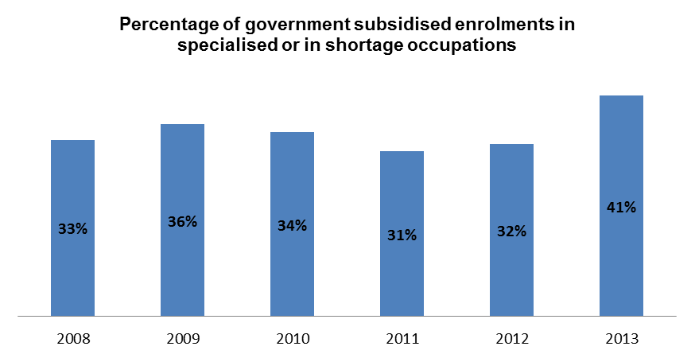

Figure 3.6: Government subsidised enrolments in specialised or skill shortage occupations per training provider type, 2011, 2012 and 2013

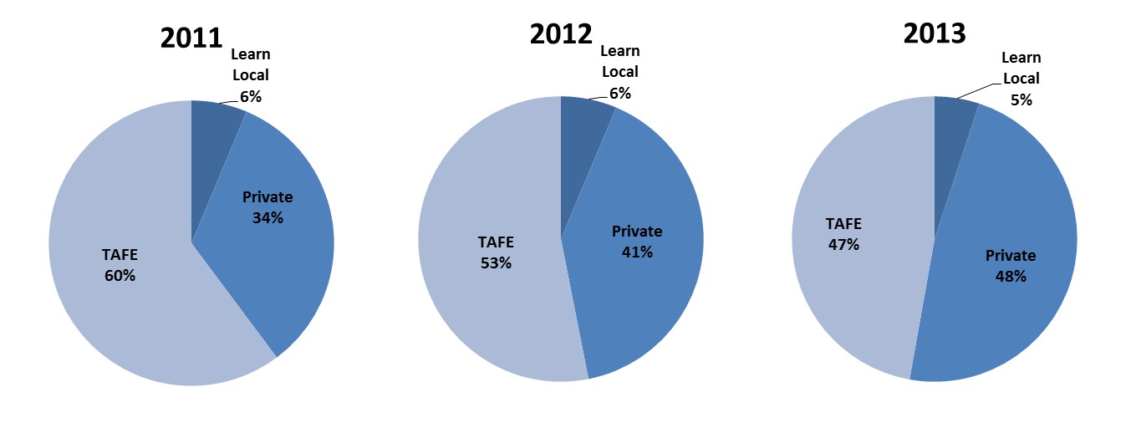

Table 3.11.1: Government subsidised training delivery for qualifications aligned to either specialised or skill shortage occupations, 2008 – 2013

|  |  |  |  |  |  |  |
| --- | --- | --- | --- | --- | --- | --- |
|  | **2008** | **2009** | **2010** | **2011** | **2012** | **2013** |
| Enrolments | 91,000 | 102,200 | 115,800 | 136,200 | 162,100 | 184,400 |
| Hours (millions) | 28.4 | 33.5 | 38.7 | 43.9 | 54.4 | 66.7 |
| Note: Enrolment numbers rounded to nearest 100. | | | | |  |  |

Table 3.11.2, Government subsidised training delivery for qualifications aligned to either specialised or skill shortage occupations

|  |  |  |  |
| --- | --- | --- | --- |
|  | **% change 2008-2013** | **% change 2011-2013** | **% change 2012-2013** |
| Enrolments | 103% | 35% | 14% |
| Hours (millions) | 135% | 52% | 22% |

Table 3.12.1: Government subsidised training delivery for qualifications not aligned to specialised or skill shortage occupations, 2008 – 2013

|  |  |  |  |  |  |  |
| --- | --- | --- | --- | --- | --- | --- |
|  | **2008** | **2009** | **2010** | **2011** | **2012** | **2013** |
| Enrolments | 185,100 | 182,900 | 221,000 | 306,600 | 343,200 | 263,700 |
| Hours (millions) | 46.9 | 49.2 | 61.8 | 86.3 | 109.8 | 83.6 |
| Note: Enrolment numbers rounded to nearest 100. | | | | |  |  |

Table 3.12.2, Change in Government subsidised training delivery for qualifications not aligned to specialised or skill shortage occupations

|  |  |  |  |
| --- | --- | --- | --- |
|  | **% change 2008-2013** | **% change 2011-2013** | **% change 2012-2013** |
| Enrolments | 42% | -14% | -23% |
| Hours (millions) | 78% | -3% | -24% |

Table 3.13.1: Government subsidised training delivery for qualifications aligned to specialised occupations, 2008 - 2013

|  |  |  |  |  |  |  |
| --- | --- | --- | --- | --- | --- | --- |
|  | **2008** | **2009** | **2010** | **2011** | **2012** | **2013** |
| Enrolments | 56,500 | 58,800 | 64,200 | 71,100 | 79,500 | 90,300 |
| Hours (millions) | 16.5 | 19.5 | 20.8 | 21.4 | 25.5 | 34.7 |
| Note: Enrolment numbers rounded to nearest 100. | | | | |  |  |

Table 3.13.2, Change in Government subsidised training delivery for qualifications not aligned to specialised or skill shortage occupations

|  |  |  |  |
| --- | --- | --- | --- |
|  | **% change 2008-2013** | **% change 2011-2013** | **% change 2012-2013** |
| Enrolments | 60% | 27% | 14% |
| Hours (millions) | 111% | 62% | 36% |

Table 3.14.1: Government subsidised training delivery for qualifications aligned to skill shortage occupations, 2008 - 2013[15]

|  |  |  |  |  |  |  |
| --- | --- | --- | --- | --- | --- | --- |
|  | **2008** | **2009** | **2010** | **2011** | **2012** | **2013** |
| Enrolments | 78,400 | 91,200 | 105,300 | 127,600 | 151,800 | 174,600 |
| Hours (millions) | 25.1 | 29.4 | 35.0 | 41.0 | 50.6 | 62.2 |
| Note: Enrolment numbers rounded to nearest 100. | | | | |  |  |

Table 3.14.2, Change in Government subsidised training delivery for qualifications not aligned to specialised or skill shortage occupations

|  |  |  |  |
| --- | --- | --- | --- |
|  | **% change 2008-2013** | **% change 2011-2013** | **% change 2012-2013** |
| Enrolments | 123% | 37% | 15% |
| Hours (millions) | 148% | -1% | 23% |

Table 3.15.1: Top 10 enrolling specialised or in shortage occupations, 2011, 2012 and 2013

|  |  |  |  |  |  |  |
| --- | --- | --- | --- | --- | --- | --- |
| **Occupation** | **2008** | **2009** | **2010** | **2011** | **2012** | **2013** |
| Child Carers | 7,300 | 9,000 | 14,300 | 19,700 | 25,600 | 30,100 |
| Aged and Disabled Carers | 6,400 | 8,200 | 8,800 | 13,000 | 16,900 | 20,400 |
| Truck Drivers | 2,600 | 4,400 | 4,600 | 7,500 | 10,600 | 14,600 |
| Welfare Support Workers | 4,500 | 5,200 | 6,200 | 7,800 | 9,500 | 11,600 |
| Motor Mechanics | 5,400 | 4,900 | 5,000 | 5,300 | 6,700 | 8,400 |
| Carpenters and Joiners | 7,600 | 7,900 | 8,600 | 9,100 | 8,000 | 8,000 |
| Electricians | 6,700 | 6,900 | 7,900 | 7,700 | 7,800 | 7,700 |
| Enrolled and Mothercraft Nurses | 4,600 | 4,800 | 5,300 | 6,400 | 7,200 | 7,600 |
| Plumbers | 5,000 | 5,400 | 6,300 | 7,100 | 7,200 | 7,100 |
| Cafe and Restaurant Managers | 2,400 | 5,200 | 4,500 | 6,300 | 9,200 | 6,500 |
| All other occupations | 38,500 | 40,300 | 44,200 | 46,300 | 53,300 | 62,400 |
| **Total** | **91,000** | **102,200** | **115,700** | **136,200** | **162,000** | **184,400** |

Note: Enrolment numbers rounded to nearest 100.

Table 3.15.2: Change in top 10 enrolling specialised or in shortage occupations, 2011, 2012 and 2013

|  |  |  |  |
| --- | --- | --- | --- |
| **Occupation** | **% change 2008-2013** | **% change 2011-2013** | **% change 2012-2013** |
| Child Carers | 315% | 53% | 18% |
| Aged and Disabled Carers | 220% | 58% | 21% |
| Truck Drivers | 467% | 94% | 37% |
| Welfare Support Workers | 158% | 49% | 22% |
| Motor Mechanics | 57% | 60% | 26% |
| Carpenters and Joiners | 5% | -12% | 0% |
| Electricians | 14% | -1% | -2% |
| Enrolled and Mothercraft Nurses | 64% | 18% | 5% |
| Plumbers | 42% | 0% | -2% |
| Cafe and Restaurant Managers | 173% | 2% | -30% |
| All other occupations | 270% | 93% | 19% |
| **Total** | 103% | 35% | 14% |

The following table highlights industry enrolments in qualifications related to either specialised or in shortage occupations

Table 3.16: Industry enrolments in qualifications related to either specialised or in shortage occupations

|  |  |  |  |  |  |  |  |  |  |  |  |  |
| --- | --- | --- | --- | --- | --- | --- | --- | --- | --- | --- | --- | --- |
| **Industry** | **Enrolments (Total industry specific qualifications)** | | | | | | **Enrolments (specialised OR in shortage)** | | | | | |
| **Share 2013** | **2011** | **2012** | **2013** | **% 2011 - 2013** | **% 2012 - 2013** | **Share 2013** | **2011** | **2012** | **2013** | **% 2011 - 2013** | **% 2012 - 2013** |
| Accommodation and Food Services | 7% | 35,500 | 44,600 | 30,300 | -15% | -32% | 6% | 8,000 | 11,800 | 10,900 | 36% | -8% |
| Administrative and Support Services | 3% | 20,600 | 21,600 | 15,600 | -24% | -28% | - | - | - | - | - | - |
| Agriculture, Forestry and Fishing | 2% | 9,500 | 9,800 | 8,300 | -13% | -15% | 0.4% | 600 | 600 | 700 | 17% | 17% |
| Arts and Recreation Services | 4% | 27,500 | 26,700 | 15,900 | -42% | -40% | 1% | 800 | 700 | 1,300 | 63% | 86% |
| Construction | 14% | 47,700 | 51,900 | 62,700 | 31% | 21% | 24% | 33,700 | 37,100 | 44,700 | 33% | 20% |
| *Cross-industry e.g. project managers* | 13% | 81,500 | 91,000 | 60,300 | -26% | -34% | 1% | 3,800 | 3,300 | 2,100 | -45% | -36% |
| Education and Training | 3% | 10,200 | 10,100 | 12,700 | 25% | 26% | 2% | 6,200 | 5,700 | 3,900 | -37% | -32% |
| Electricity, Gas, Water and Waste Services | 0.2% | 1,000 | 1,000 | 800 | -20% | -20% | 0.3% | 800 | 800 | 600 | -25% | -25% |
| Financial and Insurance Services | 1% | 6,700 | 6,300 | 3,100 | -54% | -51% | 0.0% | - | 100 | 100 | - | 0% |
| Health Care and Social Assistance | 19% | 61,400 | 77,600 | 87,300 | 42% | 13% | 43% | 55,300 | 70,300 | 79,500 | 44% | 13% |
| Information Media and Telecommunications | 1% | 3,800 | 3,900 | 3,300 | -13% | -15% | 0.3% | 500 | 500 | 500 | 0% | 0% |
| Manufacturing | 10% | 33,700 | 41,700 | 43,500 | 29% | 4% | 5% | 8,600 | 8,900 | 10,000 | 16% | 12% |
| Mining | 0.1% | 300 | 500 | 400 | 33% | -20% | - | - | - | - | - | - |
| Other Services | 5% | 19,500 | 21,100 | 21,100 | 8% | 0% | 4% | 4,700 | 5,900 | 7,400 | 57% | 25% |
| Professional, Scientific and Technical Services | 2% | 12,400 | 12,100 | 10,500 | -15% | -13% | 2% | 3,100 | 3,100 | 3,200 | 3% | 3% |
| Public Administration and Safety | 2% | 7,900 | 8,400 | 8,100 | 3% | -4% | 0.2% | 400 | 400 | 300 | -25% | -25% |
| Rental, Hiring and Real Estate Services | 0.4% | 1,600 | 2,300 | 1,700 | 6% | -26% | - | - | - | - | - | - |
| Retail Trade | 3% | 33,200 | 36,000 | 15,400 | -54% | -57% | 1% | 1,400 | 1,800 | 2,400 | 71% | 33% |
| Transport, Postal and Warehousing | 10% | 28,000 | 38,000 | 46,100 | 65% | 21% | 9% | 8,300 | 11,100 | 16,600 | 100% | 50% |
| Wholesale Trade | 0.2% | 900 | 900 | 1,000 | 11% | 11% | - | - | - | - | - | - |
| **Total** | **100%** | **442,900** | **505,500** | **448,100** | **1%** | **-11%** | **100%** | **136,200** | **162,100** | **184,200** | **35%** | **14%** |
| Note: Numbers rounded to nearest 100. |  |  |  |  |  |  |  |  |  |  |  |  |

1. This is based upon 2013 training activity data matched against the 2012 skills shortages list. Following finalisation of the 2013 Reports the 2013 Skills Shortages list was completed, when the 2013 list is applied to 2013 training activity data the percentage of government subsidised enrolments that were “in shortage” or specialised occupations increased to 43%. The 2013 Skills Shortages list will be used in future reporting of training activity.
2. Note that a course enrolment indicates an enrolment by a student in specified course at a registered training organisation. Training hours on the other hand measures the hours taken to deliver training. Total student hours is not an indicator of training provider revenue.
3. The 2012 estimated resident population published by the Australian Bureau of Statistics (Cat 3235.0) were used to calculate the participation rate for each regional area in 2013, as the 2013 population data by sub-state level is not yet available.
4. For the purposes of this report the term Learn Local is used interchangeably with Adult and Community Education (ACE). However it should be noted that only Learn Local organisations report through to the ACFE Board, ACE organisations are self-identified and are not required to report through to the Board. In 2013 there were a very small number of Learn Local organisations that self-identified to SVTS as Private RTOs and therefore are not included in the count of Learn Local organisations for the purpose of this report.
5. Vulnerable workers tend to be in low-paid jobs, are often under-employed, and face job insecurity and limited job opportunities. They might not be able to access entitlements such as superannuation, sick leave, maternity leave and have little if any access to training and development. For some, their vulnerability stems from low skills or poor qualifications.

   [www.education.vic.gov.au/Documents/about/research/acfepublications/hardtoreachlearn.pdf](http://www.education.vic.gov.au/Documents/about/research/acfepublications/hardtoreachlearn.pdf)
6. Australian Bureau of Statistics (9 October 2013), 42280DO001_201112 Programme for the International Assessment of Adult Competencies, Australia, 2011–12, Table 4 Literacy, Numeracy and Problem solving in technology-rich environments skill level of persons aged 15–64 years, By state or territory of usual residence.
7. Industry specific training includes all accredited vocational qualifications at Certificate I and above, but excludes generic training such as foundation skills, education pathways and low-level LOTE courses.
8. Monash Centre for Policy Studies (2012) Employment Forecasting Model.

   Average annual employment needs are average replacement demand and employment growth levels from 2011-12 through to 2016-17.
9. Commencements data is sourced from DEECD’s DELTA system which is used to manage and monitor training contracts. This data is used for this purpose only as the Victorian Training Market Report is based on VET training activity data.
10. Australian Bureau of Statistics, Building Activity, Australia, 8752.0 Table 34. Number of Dwelling Unit Commencements by Sector, States and Territories. Latest available data is September 2013.
11. The NCVER publication Apprentices & Trainees, Early trend estimates March Quarter 2013, noted that at a national level “The substantial growth in non-trade commencements up to the June quarter 2012 and the subsequent decline in the September quarter is predominately due to changes to Commonwealth incentive payments for existing workers, namely the removal of the commencement incentive payment for those apprenticeships and traineeships not on the National Skills Needs List. Under the changes, training needed to have commenced prior to 1 July 2012 to attract the old subsidy rate.”
12. To ensure the most robust alignment with vocational outcomes in the government funded training sector this section is limited to:

    * government subsidised training to onshore domestic students
    * training in accredited AQF qualifications at Certificate I and above i.e. short courses, non-award courses and non-accredited training is excluded
    * excludes courses which cannot be classified directly to an employment outcome in a particular occupation, such as training in generic foundation skills such as literacy and numeracy

   
13. Australian Workforce and Productivity Agency (2012) specialised occupation list.
14. HESG (2012) Skills Shortage list. Skill shortage definition from DEEWR Skills Shortage List
15. Historical enrolment numbers for qualifications aligned to skills shortage occupations reported in the 2013 Training Market Report are lower than those reported in the 2012 Training Market Report. This is due to changes made to occupational alignment to courses. In particular, changes made to coding for Certificate III in Electrotechnology Systems Electrician is the main driver behind the discrepancy. The course now aligns to the occupation Electrician (Special Class) which is not classified as a skills shortage occupation, whereas it was previously aligned to Electrician (General) which is classified as a shortage occupation.