Victorian Training Market Quarterly Report   
Q3 2013

Prepared by Department of Education and  
Early Childhood Development

Melbourne  
November 2013

©State of Victoria (Department of Education  
and Early Childhood Development) 2013

The copyright in this document is owned by the State of Victoria (Department of Education and Early Childhood Development), or in the case of some materials, by third parties (third party materials). No part may be reproduced by any process except in accordance with the provisions of the Copyright Act 1968, the National Education Access Licence for Schools (NEALS) (see below) or with permission.

An educational institution situated in Australia which is not conducted for profit, or a body responsible for administering such an institution may copy and communicate the materials, other than third party materials, for the educational purposes of the institution.

Authorised by the Department of Education  
and Early Childhood Development,   
2 Treasury Place, East Melbourne, Victoria, 3002

Contents

Executive Summary 5

The Policy Context of Vocational Training in Victoria 10

Notes about the data 12

Reporting scope 12

Vocational Training Summary 13

Vocational Training by Funding Type 13

Qualification Levels 16

Age Profile 20

Government Subsidised Regional Activity and Participation 22

Government Subsidised Delivery by Provider Type 28

Adult, Community and Further Education (ACFE) Performance 31

Learners Facing Barriers to Participation 37

Vocational Training Delivery to Learner Cohorts Facing Barriers 37

Indigenous Students 38

Students with a Disability 39

Students with a Culturally and Linguistically Diverse (CALD) Background 40

Unemployed Students 41

Young People (Aged 15 to 19) Without Year 12 or Equivalent and Not at School 42

Students with Low Prior Qualifications 43

Foundation Level Training 44

Alignment of Training to Industry Skills Needs 47

Training Activity by Industry 48

Training Activity by Occupation 51

Apprenticeships 52

Traineeships 55

Training in Specialised and In-Shortage Related Occupations 58

### Notes on data included in this report

The Victorian Training Market Report is compiled using training activity data submitted to the Department of Education and Early Child Development by funded training providers. Data included in the Report is based on the reported date, i.e. the date in which training activity data is submitted to the Department.   
Quarter 3 2013 includes training activity data that were submitted to the Department by end of third quarter in 2013 and reflects training activity during the first nine months of 2013.

### Data collection

Data included in this report are a snapshot in time. Quarterly figures for the current year are preliminary as the training activity is still in progress for the year. Therefore, these figures should be treated as indicative only. All data is subject to change until the end of the calendar year.

In some limited cases training activity data can be impacted by system issues, for example some TAFE institutes have informed the Department that they have been unable to report all their enrolments for the previous reporting period due to a backlog arising from the implementation of a new student management system. These enrolments are likely to be included in the report to be compiled from full 2013 activity data.

**Data interpretation**

Due to an unusually high spike in government subsidised training activity that occurred in 2012, just prior to changes to subsidy arrangements that came into effect in July of that year, this report includes comparisons of Q3 2013 with Q3 2011 and Q3 2012. This follows a similar approach used in the Q2 2013 report, to avoid any potentially misleading comparisons of quarterly training activity data for 2013 with just 2012.

**Data presentation**

Owing to the preliminary nature of this data, the Quarter 3 2013 figures should be treated as being indicative only. Figures are generally rounded to the nearest 100.

# Executive Summary

This Victorian Training Market Quarterly Report for Quarter 3 2013 is the latest in an on-going series of reports produced by the Department of Education and Early Childhood Development (DEECD). The aim of the report is to provide a summary of Victorian Vocational Education and Training (VET) market performance and responsiveness to industry needs. The third quarter (Q3) report provides an overview based on a snapshot of training activity data as reported at the end of September 2013.

### Context

With budgeted expenditure of $2.3 billion in 2013/14, the DEECD has specific responsibility for the government-subsidised Vocational Training market in Victoria to support industry in the provision of a highly skilled and capable workforce. The Victorian system does this through the *Victorian Training Guarantee*, which provides an unlimited number of government subsidised training places to people who meet the eligibility criteria. In July 2012, further reforms to the system refocused training subsidies away from over-supplied courses or those with little connection to job prospects and productivity towards courses of greatest economic benefit and future jobs growth.

### 2012 Outcomes (full year)

Victoria’s vocational education and training system performs well compared to other Australian jurisdictions. According to data published by the National Centre for Vocational Education Research (NCVER), in 2012 Victoria had the highest overall participation rate in VET of 15 to 64 year olds, higher than the national average and all other states and territories. In addition the numbers of students in the Victorian vocational system was higher than New South Wales (NSW), a state with a larger population, by about 53,000 students. In Australian Qualification Framework (AQF) Level 1 and above courses of study Victoria had about 100,000 more students than in NSW.

Participation in VET by 15 to 64 year olds in 2012, Government funded and public provider fee for service based on 2012 NCVER data and ABS population estimates

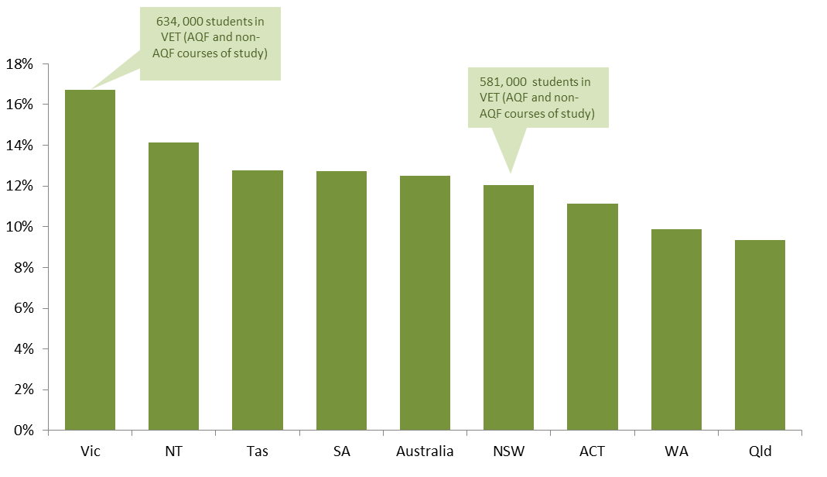

The Victorian training market has seen significant growth over the last five years. Between 2008 and 2012 there was a 76 per cent increase in government funded enrolments. Since the introduction of *Refocusing Vocational Training in Victoria (RVT)* reformsthere has been a shift to a greater number of enrolments in courses in “in shortage” skill areas. In 2012, enrolments for ‘in shortage’ occupations increased by 18 per cent to over 150,000 enrolments and training in specialised qualifications increased by 11 per cent to over 80,000 enrolments.

In 2012 there were 134,300 apprentices and trainees in government subsidised training. This was a 6 per cent increase compared to 2011.

The 2012 year experienced unprecedented growth in government subsidised training; this growth was influenced by changes to subsidy arrangements that came into effect in July of that year. Quarter 2 would normally represent about 60 per cent of reported year to date activity; the 2012 Q2 results represented 68 per cent of reported enrolments in that year.

As the market response to new approach to Government arrangements in 2012 somewhat distort year on year comparisons some caution should be used in making comparisons between quarters, for this reason the report includes comparisons of Q3 2013 with both Q3 2012 and Q3 2011.

### Q3 2013 Overview

Noting the issues associated with the unusually high level of reported delivery in 2012, there were approximately 529,900 government subsidised enrolments in Q3 2013, down 9 per cent when compared to Q3 2012, but still 21 per cent higher than Q3 2011.

There were 88,400 TAFE domestic fee for service[1] enrolments in Q3 2013. This is down by 12 per cent (11,500 enrolments) compared to Q3 2012, but up by 6 per cent (5,300) compared to the same period in 2011.

Government subsidised and TAFE Fee for service course enrolments, 2008-2012 and Q3 2011-2013

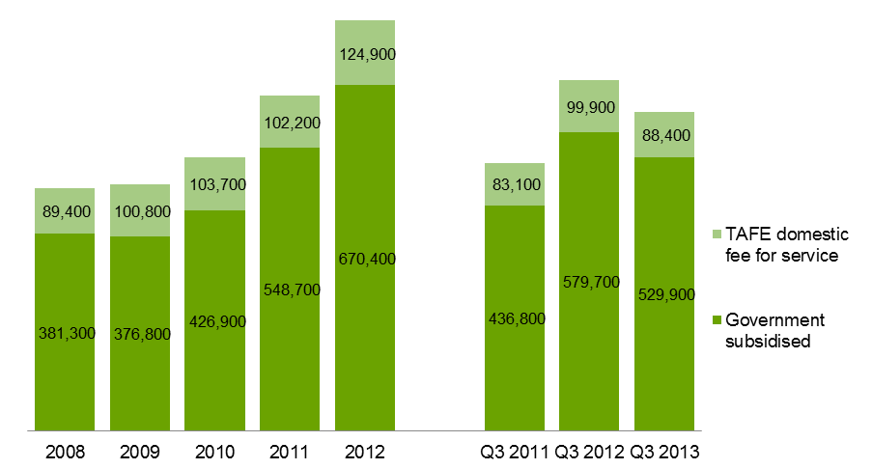

### Learners facing barriers to participation

Certain population groups face barriers to participation in education, training and the workforce. Education and training can be a key mechanism to improve their employment and life opportunities. There were approximately 107,800 unemployed students in government subsidised training in Q3 2013, this was up by 48 per cent and 9 per cent compared to the same period in 2011 and 2012, respectively. The number of Indigenous students enrolled in government subsidised training was 5,200 in Q3 2013, this was up by 13 per cent compared to Q3 2011 and 1 per cent compared to Q3 2012.

### Government Subsidised Training Delivery by Regional Area

Delivery of government subsidised training in each of the department’s four regions follows the state-wide trend that enrolments were lower in Q3 2013 compared to Q3 2012, but higher than Q3 2011, except for the North Eastern Region where government subsidised enrolments in Q3 2013 were higher than in Q3 2012. When enrolment data is further disaggregated into nine regional areas, the results show a more varied picture. Of particular note:

* Hume regional area: government subsidised enrolments in Q3 2013 were higher than the corresponding figures over the same period in 2011 and 2012. This was the only regional area with this pattern of enrolments.
* Eastern metropolitan, Gippsland and Barwon South West regional areas: government subsidised enrolments in Q3 2013 were lower than the corresponding figures in Q3 2011 and Q3 2012.

Government subsidised enrolments by regional area, Q3 2011- 2013

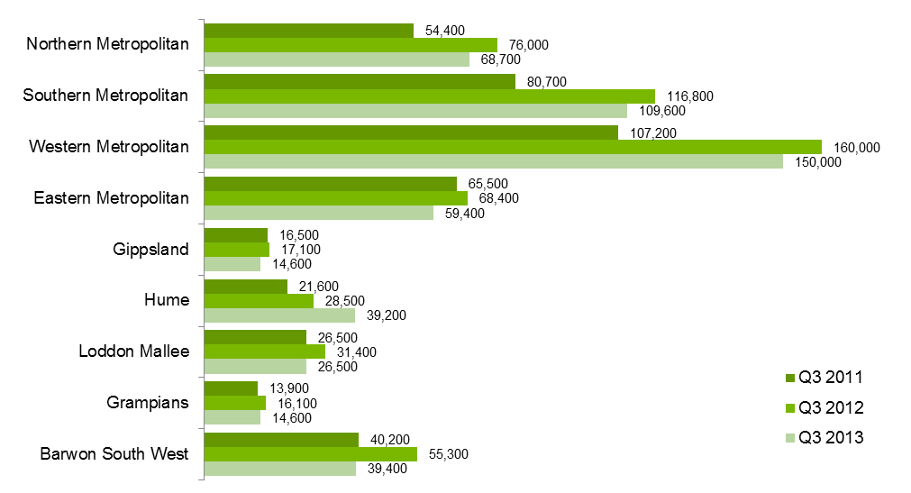

### Participation in Government Subsidised Training by Regional Area

When reporting government subsidised students by the area where they live as opposed to the area they undertake the training was delivered as shown above, student numbers in each of the four department’s regions follow the state-wide trend, i.e. student numbers were lower in Q3 2013 compared to Q3 2012, but higher than Q3 2011. But when student numbers are disaggregated into nine regional areas, the results show that Gippsland is the only regional area with student numbers in Q3 2013 lower than Q3 2011.

This data shows that while the Eastern metropolitan and Barwon south western areas had lower levels of training activity by the delivery location, the number of local residents who accessed government subsidised training actually increased between Q3 2011 and Q3 2013 in these areas.

Students undertaking government subsidised training by regional area of residence of student, Q3 2011- 2013

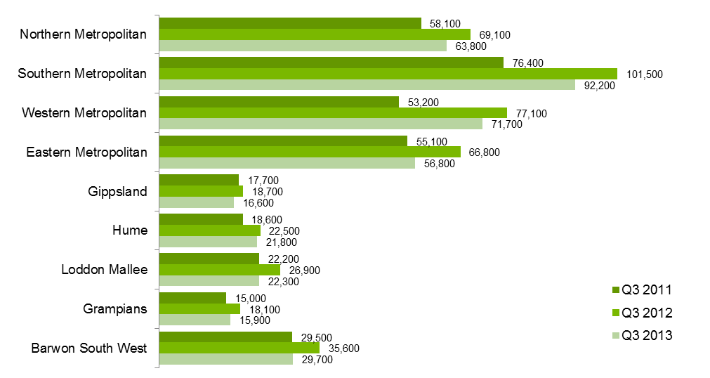

The estimated participation rate[2] of students aged 15-64 in government subsidised training shows that in Q3 2013, the Hume regional area had the highest participation rate, followed by Barwon South West. The lowest participation rate in government subsidised training was in the Eastern Metropolitan regional area.

Estimated participation rate2 of students aged 15-64 in government subsidised training by regional area, Q3 2013

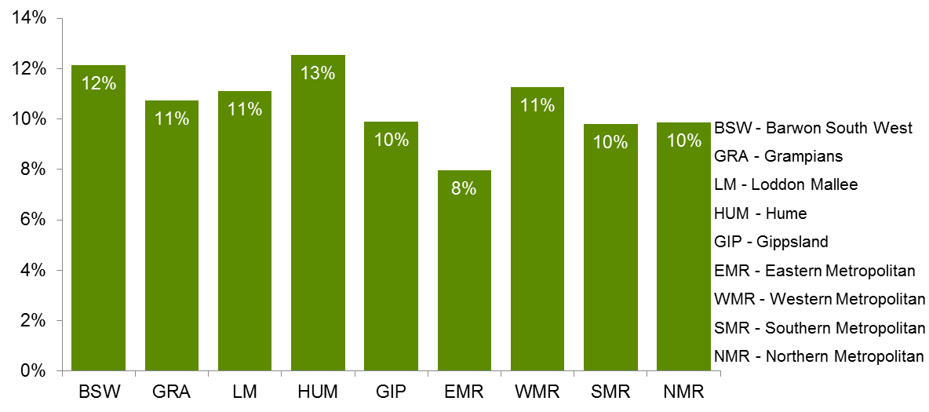

**Alignment of Government Investment in Training to Industry Skills Needs**

Under *RVT* the Government subsidises for training have been set to strengthen public investment in training in specialised skills, training to address skills in shortage and training related to areas of employment opportunity. The reforms also assessed the extent to which government investment is required to stimulate delivery of, and participation in, this training to meet industry needs. Overall, the highest subsidy levels have been allocated to courses where contribution to the economy is assessed as high, and where government subsidy is seen as essential in enabling delivery and participation in training.

There has been a marked shift in course commencement patterns since the RVT reforms were introduced in July 2012. Data from Q3 2013 show that about 70 per cent of all government subsidised course commencements were within subsidy bands A and B, which attract the highest level of subsidy. Course commencements within subsidy bands D and E were 9 per cent in Q3 2013.

Government subsidised commencing course enrolments: proportion** of commencing enrolments by subsidy band, Pre-July 2012, Q2 2013 and Q3 2013

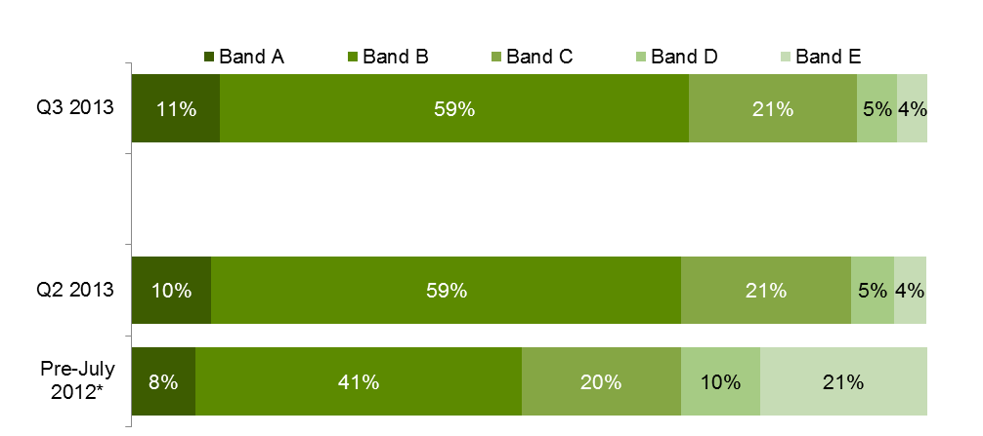

*Pre-July 2012 refers to January to June 2012. ** Due to rounding the sum may not add up to 100 per cent.

It has been fifteen months of market operation under the new market settings announced in 2012. There is early evidence that the introduction of subsidy bands, which saw twenty per cent of Government funded courses either retaining or attracting higher subsidy levels than before and reductions in areas that were experiencing unprecedented growth, has resulted in an adjustment to training demand and with it, a rebalancing of Government investment in 2013. Such adjustments are broadly aligned with key labour market requirements.

In Q3 2013 there were 39,800 government subsidised apprenticeship enrolments, which represents a 5 per cent decline on Q3 2012 and 7% on Q3 2011. In Q3 2013 there were 48,500 government subsidised enrolments in traineeships which was down on Q3 2012 by 39 per cent and 23 per cent on Q3 2011.

* Demand for courses that experienced historically high levels of enrolments in 2012 are adjusting to levels more consistent with labour market requirements. In particular the dampening in traineeship enrolments is attributable to a number of factors including Commonwealth government incentives[3], State Government subsidy levels and correction to high levels of enrolments in some Traineeship courses which had unprecedented high level of enrolments in 2012.
* Decline in apprenticeship training in Victoria is broadly consistent with national trends. While the level of Government subsidy levels for Apprenticeship training has been maintained or increased, subdued business conditions impacting on the construction industry in particular, has impacted on demand for apprentices.

The Q3 2013 results show substantial growth continuing for government subsidised Foundation courses. There were 136,200 government subsidised enrolments in Foundation courses in Q3 2013, this was up by 36 per cent on Q3 2012 and 209 per cent in Q3 2011.

## The Policy Context of Vocational Training in Victoria

### Reforms to Vocational Training

The introduction of the *Victorian Training Guarantee* (VTG) in 2008 resulted in significant growth in government subsidised training activity; however this was not necessarily always in areas of industry and economic need. In response, the Victorian Government released the *Refocusing Vocational Training (RVT) in Victoria* reform package in May 2012. The individual entitlement to a subsidised training place was retained and strengthened to ensure that businesses and students continued to be able to choose what and where they studied. The reform package also made sure that the cost of access remained sustainable and subsidies focused on areas of greatest public value. The public value of each course being assessed on the basis of its value to the economy in terms of jobs or productivity and the extent to which an incentive is needed to stimulate delivery of training by providers and participation by enough students to meet industry needs.

The movement of training uptake in response to subsidy bands introduced in July 2012 is further supported by Government reforms designed to provide Vocational Education and Training (VET) customers with better information about employment options and related training requirements and providing training providers, industry groups and regional stakeholders with timely information about industry skill requirements and training market responses. The impact of these reforms in particular will deepen as VET customers, RTOs and stakeholders of the training market continue to respond to the market signals that underpin the RVT policy settings.

### Strengthening of Contract Management and Market Monitoring

The reform package has led to stronger contract management. Providers seeking to offer government-subsidised training have to meet tough contract standards and there is now a framework which sets out expectations of training providers’ behaviour and contract compliance in a single document. The Victorian Registration and Qualifications Authority undertakes inspection and enforcement of standards and has strong regulatory powers.

The Market Monitoring Unit (MMU) was established under RVT to monitor market trends in government subsidised training in Victoria. The Unit is monitoring the efficiency, effectiveness and integrity of the Government’s subsidised training market.

The MMU has been monitoring the levels of and changes in training activity, and the levels of prices charged for training, both at an aggregate level and for particular market segments. In terms of prices, the MMU’s analysis indicates that there has been a spread of fee rates in 2013, as would be expected given that providers are able to set fees at a level that they believe reflects the cost and quality of their training. However, a particular concern arising through this analysis has been the prevalence of low fee rates, particularly when they occur in areas of high growth, with the MMU having further investigated these areas to determine if subsidy levels are appropriate.

### New Opportunities for Industry Leadership

A new Industry Participation Model has been implemented, which enables direct engagement with industry to ensure the training market is aligned with changes in industry need. The Industry Participation Model is specifically designed to strengthen the role of industry in shaping training market products, services and outcomes. The Department provides industry bodies and employers with channels and tools to communicate their needs and levels of satisfaction to RTOs, peers, potential VET students and Government.

The *Victorian Skills Gateway* website provides high quality accessible information so potential students, employers and industry groups can make informed decisions about their training choices. The website includes advice about courses, training providers, possible employment opportunities, and government assistance with the cost of training.

The Department provides the following opportunities to speak directly to Government about what is and isn’t working in the training system and shape sustainable solutions.

* Industry Roundtables – Monthly industry roundtables with the Minister to discuss the needs of specific industries and or regions.
* Industry Skills Consultative Committee (ISCC) – 12 senior members of industry, co-chaired by the Minister and an industry member. The ISCC meets 3 – 4 times a year to identify and address systemic issues hampering the responsiveness of the VET system.
* Issues based ISCC taskforces – the ISCC will auspice issues based taskforces to provide recommendations to Government on appropriate solutions for systemic issues
* DEECD Industry Skills Portfolio Teams focus on annual industry/sector consultations.
* Regional Market Facilitation Managers – ten located across metropolitan and non-metropolitan Victoria, talking directly to employers and VET stakeholders in the region to address their training issues and gather intelligence about training needs and system barriers.
* Industry in Transition and Specialist Training Initiative – funds projects that improve training market responsiveness and outcomes.

### Modernising TAFE

In addition to a focus on improving outcomes for students and industry, RVT in Victoria recognised that a modern vocational training system requires a network of well-functioning and modern TAFE institutes delivering in their areas of strength alongside other providers. As part of the RVT in Victoria reforms, the Government established an independent TAFE Reform Panel, to advise on ways to foster a strong, sustainable TAFE sector in an open and competitive training market. The TAFE Reform Panel’s final report: *A strong and sustainable Victorian TAFE sector* provides findings and 19 recommendations relating specifically to the state’s 14 TAFE institutes and four dual-sector universities. The Government has responded to these recommendations in *Next Steps for RVT in Victoria – Supporting a Modern Workforce*.

To strengthen Victorian TAFEs and encourage innovation in training delivery, the Government is:

* Providing $200 million for business transformation;
* Modernising constitutions and commercial objectives;
* Giving TAFEs greater control of assets;
* Reducing regulatory burden;
* Allowing TAFEs own control over work place relations;
* Removing the restrictions on TAFE being registered as Group Training Organisations;
* Reclassifying TAFE dual-sector.

## Notes about the data

This Report includes key metrics, such as training delivery by funding source, qualification level, age of learners, learners facing barriers to participation and regional activity. An analysis of the responsiveness of training delivery to specific occupational needs and industry are also provided.

The main source of vocational training statistics in this publication is the training activity database referred to as Skills Victoria Training System (SVTS). All government subsidised providers are required to submit their data using SVTS at least once a month in accordance with the Australian Vocational Education & Training Management Information Statistical Standard (AVETMISS). For TAFE Institutes, there is an additional regulatory requirement that they also submit their fee for service data.

For comparative purpose, this report includes most recent historical data on training activity over the same period, i.e. Quarter 3, in 2011 and 2012. Full year data between 2008 and 2012 are included to show longer term trends.

Data included in the report are a snapshot in time and based on data as reported to Higher Education and Skills Group (HESG) in the Department by training providers. Caution should be exercised when comparing current year data against figures over the same period in previous years. This is due to the way training providers upload their VET activity data which is not necessarily undertaken in a uniform manner while the training year is still in progress. In addition, adjustments are required to be made to VET activity data by providers after the end of a reporting period due to students withdrawing from modules or entire courses. In some limited cases some providers may not have fully submitted their data by end of third quarter which could marginally impact on the overall state result. Therefore, owing to the preliminary nature of VET data while the year is underway, figures reported for the end of third quarter in 2013 should be treated as being indicative only.

In some limited cases training activity data can be impacted by system issues, for example some TAFE institutes have informed the Department that they have been unable to report all their enrolments for the previous reporting period due to a backlog arising from the implementation of a new student management system. It is therefore important to note that the Quarter 3 2013 data may be an undercount of the actual enrolments. It is anticipated that these enrolments will be included in the full year report for 2013 to be published in early 2014.

Due to an unusually high spike in government subsidised training activity that occurred in 2012, just prior to changes to subsidy arrangements that came into effect in July of that year, this report includes comparisons of Q3 2013 with Q3 2011 and Q3 2012. This follows a similar approach used in the Q2 2013 report, to avoid any potentially misleading comparisons of quarterly training activity data for 2013 with just 2012.

The Q3 2013 data were extracted from SVTS as at 17 October 2013. Annual data included in this report may differ from data released by the National Centre for Vocational Education and Research (NCVER) due to use of different definitional rules and data being revised slightly prior to submission to NCVER.

Annual data included in this report may differ to those in previous publications as the DEECD is continuously updating classifications to improve data quality and consistency across years. For example the apportionment of enrolments between the apprentice/trainee categories is marginally different to what was reported previously, this is a result of a correction to the classification of some courses.

Data shown in the tables are rounded to the nearest 100 when the figures are greater than 1,000; to the nearest 50 when they are between 100 and 1,000; and to the nearest 10 when they are less than 100. The percentage changes between Q3 2011 & Q3 2013, and Q3 2012 & Q3 2013 are calculated based on the unrounded data.

## Reporting scope

This report includes government subsidised activities in all sectors at all qualification levels, and domestic fee for service activities in the TAFE sector at Australian Qualification Framework (Certificate I and above).

Fee for service activities below Certificate I in the domestic TAFE sector are not included, such as short courses. Fee for service activities that took place in the private RTO and Adult Community Education sectors are also outside the scope.

Since 2012, the scope of reporting of government subsidised training changed. ZC - Corrections delivery contracted directly with TAFE Institutes and ZP - Corrections funding through private prisons have been allocated to fee for service funding. Prior to 2012, these funded enrolments were allocated to government subsidised training.

# Vocational Training Summary

## Vocational Training by Funding Type

This section provides an overview of training activity measured in terms of course enrolments, student contact hours and student numbers.

|  |
| --- |
| Key Points The Q3 2013 data shows that:   * There were 529,900 government subsidised course enrolments, 160.3 million government subsidised student contact hours and 396,900 government subsidised students. * TAFE domestic fee for service activity at Australian Qualification Framework (AQF) Level 1 and above recorded 88,400 enrolments, 16.7 million student contact hours and 74,900 students. |

Table 1.1.1: Enrolments in vocational training by funding type, 2008–2012

|  |  |  |  |  |  |  |
| --- | --- | --- | --- | --- | --- | --- |
|  | **2008** | **2009** | **2010** | **2011** | **2012** | **% change 2008-2012** |
| Government subsidised | 381,300 | 376,800 | 426,900 | 548,700 | 670,400 | 76% |
| TAFE domestic fee for service* | 89,400 | 100,800 | 103,700 | 102,200 | 124,900 | 40% |
| **Total** | **470,700** | **477,600** | **530,600** | **650,900** | **795,300** | **69%** |

* Fee for Service figures are TAFE on-shore domestic AQF Level 1 and above.

Table 1.1.2: Enrolments in vocational training by funding type, Q3 2011, Q3 2012 and Q3 2013

|  |  |  |  |  |  |
| --- | --- | --- | --- | --- | --- |
|  | **Q3 2011** | **Q3 2012** | **Q3 2013** | **% change Q3 2011-Q3 2013** | **% change Q3 2012-Q3 2013** |
| Government subsidised | 436,800 | 579,700 | 529,900 | 21% | -9% |
| TAFE domestic fee for service* | 83,100 | 99,900 | 88,400 | 6% | -12% |
| **Total** | **520,000** | **679,600** | **618,400** | **19%** | **-9%** |

*Fee for Service figures are TAFE on-shore domestic AQF Level 1 and above.

Figure 1.1: Enrolments in vocational training by funding type, 2008–2012, Q3 2011, Q3 2012 and Q3 2013



Table 1.2.1: Student contact hours[4] (millions) by funding type, 2008–2012

|  |  |  |  |  |  |  |
| --- | --- | --- | --- | --- | --- | --- |
|  | **2008** | **2009** | **2010** | **2011** | **2012** | **% change 2008-2012** |
| Government subsidised | 87.4 | 95.6 | 112.4 | 146.9 | 188.8 | 116% |
| TAFE domestic fee for service* | 17.1 | 20.4 | 19.4 | 18.5 | 21.9 | 28% |
| **Total** | **104.5** | **116.0** | **131.8** | **165.5** | **210.7** | **102%** |

*Fee for Service figures are TAFE on-shore domestic AQF Level 1 and above.

Table 1.2.2: Student contact hours (millions) by funding type, Q3 2011, Q3 2012 and Q3 2013

|  |  |  |  |  |  |
| --- | --- | --- | --- | --- | --- |
|  | **Q3 2011** | **Q3 2012** | **Q3 2013** | **% change Q3 2011-Q3 2013** | **% change Q3 2012-Q3 2013** |
| Government subsidised | 132.7 | 175.4 | 160.3 | 21% | -9% |
| TAFE domestic fee for service* | 16.5 | 18.5 | 16.7 | 1% | -10% |
| **Total** | **149.2** | **194.0** | **177.0** | **19%** | **-9%** |

*Fee for Service figures are TAFE on-shore domestic AQF Level 1 and above.

Figure 1.2: student contact hours (millions) by funding type, 2008–2012, Q3 2011, Q3 2012 and Q3 2013

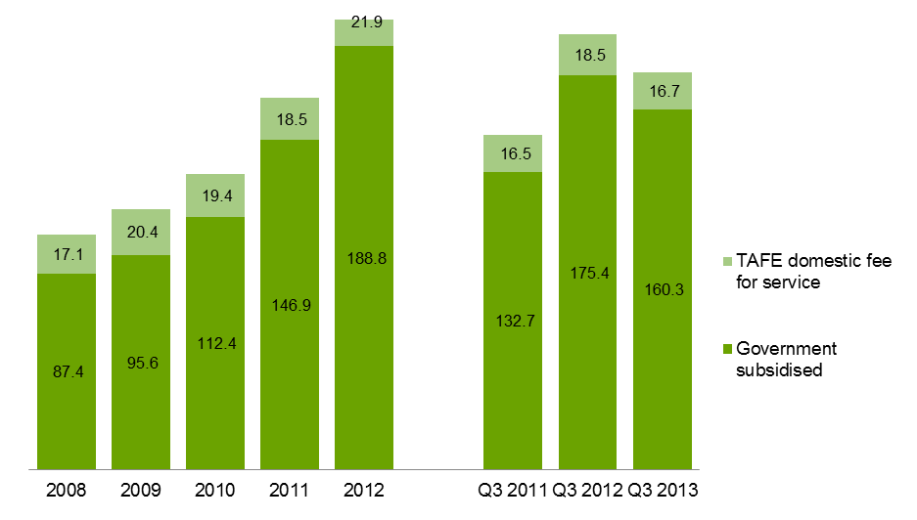

Table 1.3.1: Number of students by funding type, 2008–2012

|  |  |  |  |  |  |  |
| --- | --- | --- | --- | --- | --- | --- |
|  | **2008** | **2009** | **2010** | **2011** | **2012** | **% change 2008-2012** |
| Government subsidised | 294,700 | 299,600 | 339,200 | 430,300 | 509,800 | 73% |
| TAFE domestic fee for service* | 80,400 | 93,100 | 96,000 | 94,200 | 105,200 | 31% |
| **Total\*\*** | **366,700** | **381,300** | **422,500** | **512,900** | **603,200** | **64%** |

*Fee for Service figures are TAFE on-shore domestic AQF Level 1 and above.

**TAFE students whose enrolments are made up of a combination of government subsidies and self-funding have been counted in both funding categories. The total, however, has eliminated the duplicates.

Table 1.3.2: Number of students by funding type, Q3 2011, Q3 2012 and Q3 2013

|  |  |  |  |  |  |
| --- | --- | --- | --- | --- | --- |
|  | **Q3 2011** | **Q3 2012** | **Q3 2013** | **% change Q3 2011-Q3 2013** | **% change Q3 2012-Q3 2013** |
| Government subsidised | 350,500 | 442,500 | 396,900 | 13% | -10% |
| TAFE domestic fee for service* | 77,400 | 85,100 | 74,900 | -3% | -12% |
| **Total\*\*** | **418,700** | **518,000** | **462,000** | **10%** | **-11%** |

*Fee for Service figures are TAFE on-shore domestic AQF Level 1 and above.

**TAFE students whose enrolments are made up of a combination of government subsidies and self-funding have been counted in both funding categories. The total, however, has eliminated the duplicates.

Figure 1.3: Number of students by funding type, 2008–2012, Q3 2011, Q3 2012 and Q3 2013

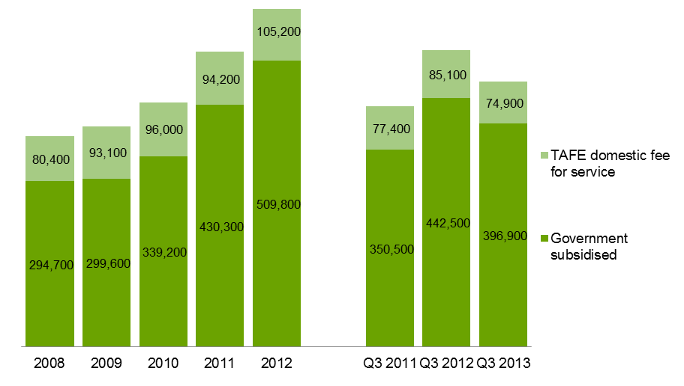

## Qualification Levels

Lower level qualifications such as Certificate I and II, provide literacy, numeracy, and work preparation skills to people without post-school qualifications so that they have the opportunity to go on to further study or find employment.

Mid-level skills are essential to the Victorian economy and help drive economic activity across the state. A significant proportion of apprenticeships and traineeships entail attainment of a mid-level qualification and are crucial to many key industries. Apprenticeships and traineeships are undertaken as a contract between the apprentice/trainee and an employer. While undertaking on-the-job learning, the apprentice/trainee receives complementary training through a vocational training provider.

### Government Subsidised Enrolments

| Key Points  * Government subsidised non-foundation course enrolments at the Certificate I to II levels were 35,200 and at the Certificate III-IV levels were 263,000 in Q3 2013. * Of the non-foundation courses of study, enrolments in Certificate III-IV represented the largest qualification group. * Government subsidised Foundation course enrolments at the Certificate I to II level were 110,400 and at the Certificate III-IV levels were 18,600 in Q3 2013. |
| --- |

Table 1.4.1: Government subsidised enrolments (non-Foundation) by qualification level, 2008–2012

|  |  |  |  |  |  |  |
| --- | --- | --- | --- | --- | --- | --- |
| **Qualification level** | **2008** | **2009** | **2010** | **2011** | **2012** | **% change 2008-2012** |
| Cert I-II | 65,100 | 65,100 | 73,400 | 79,900 | 64,100 | -1% |
| Cert III-IV | 158,800 | 159,100 | 194,800 | 278,400 | 348,400 | 119% |
| Diploma & Above | 55,700 | 63,700 | 71,200 | 90,300 | 94,800 | 70% |
| Module Only | 50,200 | 40,700 | 37,300 | 30,300 | 30,600 | -39% |
| Secondary, SoA and other | 20,600 | 20,300 | 19,500 | 15,900 | 14,100 | -32% |
| **Total (excl foundation courses)** | **350,400** | **348,900** | **396,200** | **494,900** | **552,000** | **58%** |

SoA – Statement of Attainment.

Table 1.4.2: Government subsidised enrolments (non-Foundation) by qualification level, Q3 2011, Q3 2012 and Q3 2013

|  |  |  |  |  |  |
| --- | --- | --- | --- | --- | --- |
| **Qualification level** | **Q3 2011** | **Q3 2012** | **Q3 2013** | **% change Q3 2011-Q3 2013** | **% change Q3 2012-Q3 2013** |
| Cert I-II | 61,000 | 55,100 | 35,200 | -42% | -36% |
| Cert III-IV | 220,300 | 302,300 | 263,000 | 19% | -13% |
| Diploma & Above | 78,600 | 90,600 | 63,100 | -20% | -30% |
| Module Only | 20,400 | 20,200 | 20,900 | 3% | 4% |
| Secondary, SoA and other | 12,500 | 11,700 | 11,600 | -7% | -1% |
| **Total (excl foundation courses)** | **392,700** | **479,800** | **393,800** | **0.3%** | **-18%** |

SoA – Statement of Attainment.

Table 1.5.1: Government subsidised enrolments (Foundation) by qualification level, 2008–2012

|  |  |  |  |  |  |  |
| --- | --- | --- | --- | --- | --- | --- |
| **Qualification level** | **2008** | **2009** | **2010** | **2011** | **2012** | **% change 2008-2012** |
| Cert I-II | 22,100 | 18,500 | 20,400 | 39,500 | 90,600 | 310% |
| Cert III-IV | 6,600 | 6,800 | 6,900 | 9,500 | 17,600 | 167% |
| Secondary, SoA and other | 2,200 | 2,600 | 3,400 | 4,900 | 10,300 | 359% |
| **Total** | **30,900** | **27,900** | **30,700** | **53,900** | **118,500** | **283%** |

SoA – Statement of Attainment.

Table 1.5.2: Government subsidised enrolments (Foundation) by qualification level, Q3 2011, Q3 2012   
and Q3 2013

|  |  |  |  |  |  |
| --- | --- | --- | --- | --- | --- |
| **Qualification level** | **Q3 2011** | **Q3 2012** | **Q3 2013** | **% change Q3 2011-Q3 2013** | **% change Q3 2012-Q3 2013** |
| Cert I-II | 31,800 | 76,600 | 110,400 | 248% | 44% |
| Cert III-IV | 8,400 | 14,400 | 18,600 | 122% | 29% |
| Secondary, SoA and other | 4,000 | 8,900 | 7,200 | 78% | -20% |
| **Total** | **44,100** | **99,900** | **136,200** | **209%** | **36%** |

SoA – Statement of Attainment.

### TAFE Domestic Fee for Service Enrolments

| Key Points  * Proportionally, enrolments in Certificate III-IV (non-Foundation) were the largest qualification group amongst TAFE domestic fee for service enrolments at Australian Qualification Framework Level 1 and above courses. |
| --- |

Table 1.6.1: TAFE domestic fee for service enrolments (non-Foundation) by qualification level (AQF1+), 2008–2012

|  |  |  |  |  |  |  |
| --- | --- | --- | --- | --- | --- | --- |
| **Qualification level** | **2008** | **2009** | **2010** | **2011** | **2012** | **% change 2008-2012** |
| Cert I-II | 33,200 | 41,200 | 44,200 | 43,200 | 46,300 | 39% |
| Cert III-IV | 38,300 | 41,200 | 40,500 | 40,900 | 52,900 | 38% |
| Diploma & Above | 7,300 | 8,000 | 8,300 | 8,500 | 10,200 | 39% |
| Higher Education | 750 | 1,000 | 1,300 | 1,400 | 1,600 | 118% |
| **Total (excl foundation courses)** | **79,500** | **91,400** | **94,300** | **94,100** | **110,900** | **39%** |

Table 1.6.2: TAFE domestic fee for service enrolments (non-Foundation) by qualification level (AQF1+), Q3 2011, Q3 2012 and Q3 2013

|  |  |  |  |  |  |
| --- | --- | --- | --- | --- | --- |
| **Qualification level** | **Q3 2011** | **Q3 2012** | **Q3 2013** | **% change Q3 2011-Q3 2013** | **% change Q3 2012-Q3 2013** |
| Cert I-II | 35,400 | 36,500 | 31,800 | -10% | -13% |
| Cert III-IV | 32,400 | 41,500 | 33,600 | 4% | -19% |
| Diploma & Above | 7,400 | 8,800 | 8,900 | 20% | 1% |
| Higher Education | 1,400 | 1,600 | 1,400 | 4% | -9% |
| **Total (excl foundation courses)** | **76,546** | **88,420** | **75,667** | **-1%** | **-14%** |

Table 1.7.1: TAFE domestic fee for service enrolments (Foundation) by qualification level (AQF1+),   
2008–2012

|  |  |  |  |  |  |  |
| --- | --- | --- | --- | --- | --- | --- |
| **Qualification level** | **2008** | **2009** | **2010** | **2011** | **2012** | **% change 2008-2012** |
| Cert I-II | 8,100 | 7,200 | 7,300 | 6,300 | 11,500 | 42% |
| Cert III-IV | 1,700 | 2,200 | 2,100 | 1,900 | 2,500 | 40% |
| **Total** | **9,900** | **9,400** | **9,400** | **8,100** | **13,900** | **41%** |

Table 1.7.2: TAFE domestic fee for service enrolments (Foundation) by qualification level (AQF1+),   
Q3 2011, Q3 2012 and Q3 2013

|  |  |  |  |  |  |
| --- | --- | --- | --- | --- | --- |
| **Qualification level** | **Q3 2011** | **Q3 2012** | **Q3 2013** | **% change Q3 2011-Q3 2013** | **% change Q3 2012-Q3 2013** |
| Cert I-II | 5,000 | 9,500 | 10,500 | 111% | 11% |
| Cert III-IV | 1,600 | 2,100 | 2,200 | 39% | 7% |
| **Total** | **6,584** | **11,526** | **12,747** | **94%** | **11%** |

### Government Subsidised Student Contact Hours

|  |
| --- |
| Key Points  * Government subsidised student contact hours at Certificate III to IV levels in Q3 2013 accounted for 93.5 million hours. |

Table 1.8.1: Government subsidised student contact hours (millions) by qualification level, 2008–2012

|  |  |  |  |  |  |  |
| --- | --- | --- | --- | --- | --- | --- |
| **Qualification level** | **2008** | **2009** | **2010** | **2011** | **2012** | **% change 2008-2012** |
| Cert I-II | 14.2 | 15.2 | 17.5 | 22.6 | 27.9 | 97% |
| Cert III-IV | 44.9 | 48.8 | 59.1 | 81.7 | 112.8 | 151% |
| Diploma & Above | 22.9 | 26.0 | 30.9 | 36.2 | 41.2 | 79% |
| Module Only | 1.4 | 1.6 | 1.6 | 1.3 | 1.4 | 0% |
| Secondary, SoA and other | 3.9 | 4.0 | 3.3 | 5.2 | 5.5 | 40% |
| **Total** | **87.4** | **95.6** | **112.4** | **146.9** | **188.8** | **116%** |

SoA: Statement of Attainment.

Table 1.8.2: Government subsidised student contact hours (millions) by qualification level, Q3 2011,   
Q3 2012 and Q3 2013

|  |  |  |  |  |  |
| --- | --- | --- | --- | --- | --- |
| **Qualification level** | **Q3 2011** | **Q3 2012** | **Q3 2013** | **% change Q3 2011-Q3 2013** | **% change Q3 2012-Q3 2013** |
| Cert I-II | 19.2 | 24.5 | 28.3 | 48% | 16% |
| Cert III-IV | 72.4 | 102.4 | 93.5 | 29% | -9% |
| Diploma & Above | 36.4 | 42.3 | 31.7 | -13% | -25% |
| Module Only | 1.0 | 1.0 | 1.0 | 10% | 6% |
| Secondary, SoA and other | 3.8 | 5.3 | 5.7 | 51% | 9% |
| **Total** | **132.7** | **175.4** | **160.3** | **21%** | **-9%** |

SoA: Statement of Attainment.

Figure 1.4: Government subsidised student contact hours by qualification level (AQF1+ only),   
Q3 2011, Q3 2012 and Q3 2013

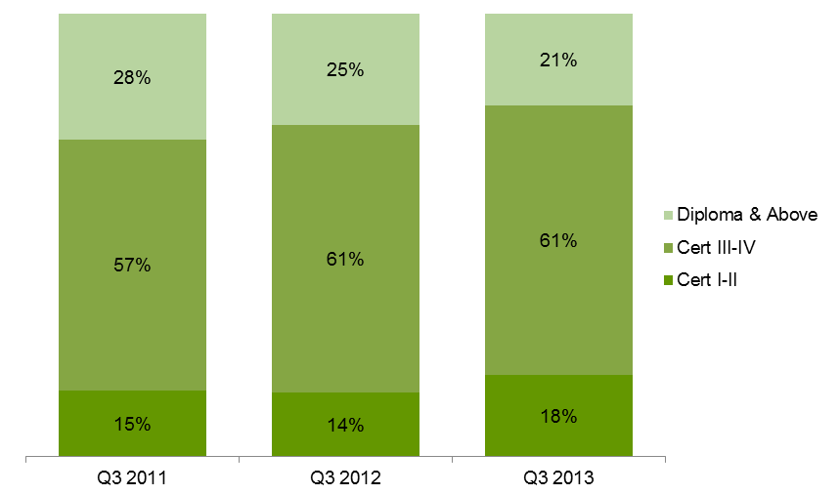

## Age Profile

### Vocational Training Delivery by Age Group

To enable the increased workforce participation levels required by the Victorian economy over the next decade, improved engagement with education and training by all age groups is required. The vocational training system is also focused on accessibility and gender equality, ensuring all Victorians have the same opportunity to succeed in their lives and maintain well-being through education and training.

### Students by Age Group in Government Subsidised Training

|  |
| --- |
| Key Points  * The number of government subsidised students was 396,900 in Q3 2013. Students aged 15 to 24 accounted for 44 per cent of all students undertaking government subsidised training. * Aged 15-19 is the only age cohort with student numbers in Q3 2013 which were lower than the numbers for the same age group in Q3 2011 and Q3 2012. |

Table 1.9.1: Government subsidised students by age group, 2008–2012

|  |  |  |  |  |  |  |
| --- | --- | --- | --- | --- | --- | --- |
| **Age group** | **2008** | **2009** | **2010** | **2011** | **2012** | **% change 2008-2012** |
| 15 to 19 | 74,400 | 76,000 | 88,300 | 108,700 | 120,500 | 62% |
| 20 to 24 | 58,800 | 59,200 | 71,400 | 87,800 | 100,900 | 72% |
| 25 to 44 | 99,700 | 102,400 | 112,600 | 148,500 | 180,200 | 81% |
| 45 to 64 | 51,100 | 52,900 | 60,200 | 77,100 | 96,400 | 89% |
| Under 15, over 64, not stated | 10,700 | 9,200 | 6,700 | 8,100 | 11,800 | 10% |
| **Total** | **294,700** | **299,600** | **339,200** | **430,300** | **509,800** | **73%** |

Table 1.9.2: Government subsidised students by age group, Q3 2011, Q3 2012 and Q3 2013

|  |  |  |  |  |  |
| --- | --- | --- | --- | --- | --- |
| **Age group** | **Q3 2011** | **Q3 2012** | **Q3 2013** | **% change Q3 2011-Q3 2013** | **% change Q3 2012-Q3 2013** |
| 15 to 19 | 90,300 | 106,100 | 87,700 | -3% | -17% |
| 20 to 24 | 75,300 | 90,900 | 83,200 | 11% | -8% |
| 25 to 44 | 119,200 | 155,100 | 143,600 | 20% | -7% |
| 45 to 64 | 60,200 | 81,800 | 73,700 | 22% | -10% |
| Under 15, over 64, not stated | 5,600 | 8,600 | 8,700 | 56% | 1% |
| **Total** | **350,500** | **442,500** | **396,900** | **13%** | **-10%** |

### Students by Age Group in TAFE Domestic Fee for Service

|  |
| --- |
| Key Points  * The number of students enrolled in TAFE domestic fee for service at AQF Level 1 and above was 74,900 in Q3 2013. Thirty seven per cent of students were aged between 15 and 24 years. * Similar to the trend in government subsidised provision, aged 15-19 is the only age cohort with student numbers in Q3 2013 lower than the corresponding numbers in Q3 2011 and Q3 2012. |

Table 1.10.1: TAFE domestic fee for service (AQF1+): students by age group, 2008–2012

|  |  |  |  |  |  |  |
| --- | --- | --- | --- | --- | --- | --- |
| **Age group** | **2008** | **2009** | **2010** | **2011** | **2012** | **% change 2008-2012** |
| 15 to 19 | 22,900 | 26,400 | 28,800 | 28,300 | 28,900 | 26% |
| 20 to 24 | 9,300 | 11,100 | 11,400 | 10,300 | 11,600 | 25% |
| 25 to 44 | 29,700 | 34,800 | 34,500 | 34,100 | 40,600 | 37% |
| 45 to 64 | 16,500 | 18,400 | 19,300 | 19,500 | 22,100 | 34% |
| Under 15, over 64, not stated | 2,000 | 2,400 | 2,100 | 2,100 | 2,000 | -3% |
| **Total** | **80,400** | **93,100** | **96,000** | **94,200** | **105,200** | **31%** |

Table 1.10.2: TAFE domestic fee for service (AQF1+): students by age group, Q3 2011, Q3 2012   
and Q3 2013

|  |  |  |  |  |  |
| --- | --- | --- | --- | --- | --- |
| **Age group** | **Q3 2011** | **Q3 2012** | **Q3 2013** | **% change Q3 2011-Q3 2013** | **% change Q3 2012-Q3 2013** |
| 15 to 19 | 24,600 | 23,200 | 18,800 | -24% | -19% |
| 20 to 24 | 8,800 | 9,600 | 9,000 | 2% | -7% |
| 25 to 44 | 27,400 | 32,800 | 30,700 | 12% | -7% |
| 45 to 64 | 15,000 | 17,900 | 15,300 | 2% | -15% |
| Under 15, over 64, not stated | 1,600 | 1,500 | 1,300 | -24% | -18% |
| **Total** | **77,400** | **85,100** | **74,900** | **-3%** | **-12%** |

## Government Subsidised Regional Activity and Participation

For the purpose of providing an overview of government subsidised regional training activity, training data are presented for the four departmental regions. In addition, government subsidised training data are further disaggregated into nine small areas to provide a more granular level of detail on training delivery and participation.

South-Western departmental region comprises Barwon South West, Grampians and Western Metropolitan regional areas. North-Western departmental region comprises Loddon Mallee and Northern Metropolitan regional areas. North-Eastern departmental region comprises Hume and Eastern Metropolitan regional areas. South-Eastern departmental region comprises Gippsland and Southern Metropolitan regional areas.

### Regional Delivery

This section focuses on the delivery of government subsidised training by location as defined by four departmental regions or nine regional areas. Training courses could be undertaken by students who live locally or outside the area.

|  |
| --- |
| Key Points  * Similar to the overall state-wide trend, government subsidised courses delivered in Q3 2013 across four departmental regions were lower compared to Q3 2012, but higher compared to Q3 2011, except the North Eastern region where courses delivered in Q3 2013 were higher than in Q3 2012. * Further disaggregation of the delivery data into nine regional areas, they show that there were some regional variations against the overall state-wide trend:   + Courses delivered in Hume regional area in Q3 2013 were higher than in Q3 2011 and Q3 2012;   + Courses delivered in Gippsland, Eastern Metropolitan and Barwon South West regional areas were lowered in Q3 2013 compared to Q3 2011 and Q3 2012. * The increase in government subsidised course delivery in Hume in Q3 2013 has occurred across all Australian Qualification Levels: Certificate I to II (up 52 per cent), Certificate III to IV (up 44 per cent) and Diploma & Above (up 0.5 per cent) compared to Q3 2012. The large increase in delivery was associated with:   + An increase in enrolments at the Certificate IIII to IV levels. This was predominantly driven by a significant increase in Other courses of study (i.e. non-apprenticeship/traineeship and non-foundation courses) (up by 65% from 9,500 in Q3 2012 to 15,600 in Q3 2013) and a 17 per cent increase in apprenticeship courses (from 1,700 in Q3 2012 to 2,000 in Q3 2013).   + Enrolments that have been increasing from Q3 2011, Q3 2012 to Q3 2013 are found in industry sectors, such as:     - Construction (from 1,900 in Q3 2011 to 5,000 in Q3 2013);     - Education and Training (from 400 in Q3 2011 to 2,300 in Q3 2013);     - Health Care and Social Assistance (from 3,100 in Q3 2011 to 5,100 in Q3 2013);     - Manufacturing (from 2,700 in Q3 2011 to 3,200 in Q3 2013);     - Transport, Postal and Warehousing (from 1,600 in Q3 2011 to 2,600 in Q3 2013). * Government subsidised courses delivered in Gippsland regional area in Q3 2013 were 12 per cent lower than Q3 2011 and 14 per cent lower than Q3 2012. Training activity were lower across almost all industry sectors, except Transport, Postal and Warehousing which increased from 250 in Q3 2011 to 1,100 in Q3 2013. * Government subsidised courses delivered in Eastern Metropolitan regional area in Q3 2013 were 9 per cent and 13 per cent lower compared to Q3 2011 and Q3 2012, respectively. The deliveries were lower across all industry sectors, except Manufacturing which increased to 3,000 in Q3 2013 from 2,100 in Q3 2011. * Government subsidised courses delivered in Barwon South West regional area in Q3 2013 were 2 per cent and 29 per cent lower compared to Q3 2011 and Q3 2012, respectively. The deliveries were lower across most industry sectors, except Other Services (increased from 1,400 in Q3 2011 to 1,900 in Q3 2013) and Information Media and Telecommunications (increased from 200 in Q3 2011 to 500 in Q3 2013). |

Table 1.11.1: Government subsidised enrolments by departmental region, 2008–2012

|  |  |  |  |  |  |  |
| --- | --- | --- | --- | --- | --- | --- |
| **Delivery Location** | **2008** | **2009** | **2010** | **2011** | **2012** | **% change 2008-2012** |
| South-Western | 119,600 | 115,800 | 139,400 | 202,900 | 267,800 | 124% |
| North-Western | 70,500 | 80,300 | 84,700 | 101,500 | 124,400 | 77% |
| North-Eastern | 84,700 | 78,200 | 84,800 | 100,900 | 110,400 | 30% |
| South-Eastern | 90,300 | 90,000 | 104,300 | 128,100 | 157,100 | 74% |
| **All regions total** | **364,400** | **363,900** | **412,600** | **532,200** | **656,800** | **80%** |
| Other* | 17,400 | 13,400 | 15,100 | 17,600 | 15,000 | -13% |
| **Total VET** | **381,300** | **376,800** | **426,900** | **548,700** | **670,400** | **76%** |

*Other: online and workplace delivery.

Table 1.11.2: Government subsidised enrolments by departmental region, Q3 2011, Q3 2012   
and Q3 2013

|  |  |  |  |  |  |
| --- | --- | --- | --- | --- | --- |
| **Delivery Location** | **Q3 2011** | **Q3 2012** | **Q3 2013** | **% change Q3 2011-Q3 2013** | **% change Q3 2012-Q3 2013** |
| South-Western | 161,300 | 231,400 | 203,900 | 26% | -12% |
| North-Western | 81,000 | 107,400 | 95,200 | 18% | -11% |
| North-Eastern | 87,200 | 96,900 | 98,500 | 13% | 2% |
| South-Eastern | 97,300 | 133,900 | 124,200 | 28% | -7% |
| **All Regions Total** | **425,900** | **567,400** | **519,900** | **22%** | **-8%** |
| Other | 12,100 | 13,400 | 11,100 | -8% | -17% |
| **Total VET** | **436,800** | **579,700** | **529,900** | **21%** | **-9%** |

*Other: online and workplace delivery.

Table 1.12.1: Government subsidised enrolments by regional area, 2008–2012

|  |  |  |  |  |  |  |
| --- | --- | --- | --- | --- | --- | --- |
| **Delivery Location** | **2008** | **2009** | **2010** | **2011** | **2012** | **% change 2008-2012** |
| Barwon South West | 28,800 | 31,800 | 35,800 | 50,100 | 62,500 | 117% |
| Grampians | 14,600 | 16,200 | 15,000 | 17,200 | 18,900 | 29% |
| Loddon Mallee | 23,600 | 27,900 | 28,300 | 32,800 | 37,100 | 57% |
| Hume | 29,100 | 26,000 | 24,700 | 27,300 | 34,400 | 18% |
| Gippsland | 26,700 | 22,400 | 22,500 | 20,500 | 19,700 | -26% |
| Eastern Metropolitan | 55,500 | 52,200 | 60,100 | 73,600 | 76,000 | 37% |
| Western Metropolitan | 76,300 | 67,900 | 88,600 | 135,800 | 186,400 | 144% |
| Southern Metropolitan | 63,600 | 67,700 | 81,800 | 107,600 | 137,400 | 116% |
| Northern Metropolitan | 46,900 | 52,400 | 56,400 | 68,700 | 87,300 | 86% |
| **Total Regions total** | **364,400** | **363,900** | **412,600** | **532,200** | **656,800** | **80%** |

Table 1.12.2: Government subsidised enrolments by regional area, Q3 2011, Q3 2012 and Q3 2013

|  |  |  |  |  |  |
| --- | --- | --- | --- | --- | --- |
| **Delivery Location** | **Q3 2011** | **Q3 2012** | **Q3 2013** | **% change Q3 2011-Q3 2013** | **% change Q3 2012-Q3 2013** |
| Barwon South West | 40,200 | 55,300 | 39,400 | -2% | -29% |
| Grampians | 13,900 | 16,100 | 14,600 | 5% | -9% |
| Loddon Mallee | 26,500 | 31,400 | 26,500 | 0% | -16% |
| Hume | 21,600 | 28,500 | 39,200 | 81% | 38% |
| Gippsland | 16,500 | 17,100 | 14,600 | -12% | -14% |
| Eastern Metropolitan | 65,500 | 68,400 | 59,400 | -9% | -13% |
| Western Metropolitan | 107,200 | 160,000 | 150,000 | 40% | -6% |
| Southern Metropolitan | 80,700 | 116,800 | 109,600 | 36% | -6% |
| Northern Metropolitan | 54,400 | 76,000 | 68,700 | 26% | -10% |
| **All Regions Total** | **425,900** | **567,400** | **519,900** | **22%** | **-8%** |

### Regional Participation

This section presents data on students undertaking government subsidised training by the area where they live in. Areas are defined as four departmental regions or nine regional areas. Students may undertake their training locally or travel to locations outside their region.

|  |
| --- |
| Key Points  * Similar to the overall state-wide trend, the numbers of students who participated in government subsidised training from four departmental regions in Q3 2013 were lower compared to Q3 2012, but higher compared to Q3 2011. * When data was further disaggregated into nine regional areas, they show that there were some regional variations against the overall state-wide trend:   + The number of students undertaking government subsidised training who lived in Gippsland regional area in Q3 2013 was lower compared to Q3 2011 and Q3 2012. The decline in student numbers in Q3 2013 was across all age groups.   + The numbers of government subsidised students from Barwon South West and Loddon Mallee regional areas in Q3 2013 were lower compared to Q3 2012, but similar to Q3 2011. * In terms of the participation rate of students aged 15-64 in government subsidised vocational education and training in Q3 2013, Hume regional area had the highest estimated participation rate, followed by Barwon South West regional area. The lowest participation rate was in Eastern Metropolitan regional area. |

Table 1.13.1: Government subsidised students by residential location - departmental region, 2008–2012

|  |  |  |  |  |  |  |
| --- | --- | --- | --- | --- | --- | --- |
| **Residential location** | **2008** | **2009** | **2010** | **2011** | **2012** | **% change 2008-2012** |
| South-Western | 75,700 | 100,900 | 114,200 | 153,900 | 199,200 | 163% |
| North-Western | 69,700 | 67,700 | 75,800 | 97,600 | 111,100 | 59% |
| North-Eastern | 65,500 | 64,800 | 71,600 | 89,000 | 101,700 | 55% |
| South-Eastern | 78,900 | 80,000 | 92,000 | 115,800 | 137,300 | 74% |
| **All Regions Total** | **289,800** | **293,400** | **331,900** | **424,500** | **502,400** | **73%** |
| Other* | 4,900 | 6,200 | 7,300 | 5,800 | 7,400 | 51% |
| **Total students** | **294,700** | **299,600** | **339,200** | **430,300** | **509,800** | **73%** |

*Other includes not stated, unknown, interstate or overseas.

Table 1.13.2: Government subsidised students by residential location - departmental region, Q3 2011,   
Q3 2012 and Q3 2013

|  |  |  |  |  |  |
| --- | --- | --- | --- | --- | --- |
| **Residential location** | **Q3 2011** | **Q3 2012** | **Q3 2013** | **% change Q3 2011-Q3 2013** | **% change Q3 2012-Q3 2013** |
| South-Western | 120,200 | 172,600 | 152,800 | 27% | -11% |
| North-Western | 80,300 | 96,000 | 86,100 | 7% | -10% |
| North-Eastern | 73,700 | 89,300 | 78,700 | 7% | -12% |
| South-Eastern | 94,100 | 120,200 | 108,800 | 16% | -9% |
| **All Regions Total** | **345,800** | **436,400** | **390,900** | **13%** | **-10%** |
| Other* | 4,800 | 6,100 | 6,000 | 26% | -2% |
| **Total students** | **350,500** | **442,500** | **396,900** | **13%** | **-10%** |

*Other includes not stated, unknown, interstate or overseas.

Table 1.14.1: Government subsidised students by residential area – regional area, 2008–2012

|  |  |  |  |  |  |  |
| --- | --- | --- | --- | --- | --- | --- |
| **Residential location** | **2008** | **2009** | **2010** | **2011** | **2012** | **% change 2008-2012** |
| Barwon South West | 24,500 | 26,300 | 29,000 | 36,100 | 41,300 | 68% |
| Grampians | 13,900 | 14,400 | 15,400 | 18,400 | 21,400 | 53% |
| Loddon Mallee | 20,500 | 21,000 | 21,900 | 27,400 | 31,500 | 53% |
| Hume | 21,300 | 19,900 | 20,000 | 23,200 | 26,500 | 24% |
| Gippsland | 21,900 | 19,100 | 20,700 | 21,500 | 21,200 | -3% |
| Eastern Metropolitan | 44,300 | 44,900 | 51,600 | 65,800 | 75,200 | 70% |
| Western Metropolitan | 37,200 | 40,300 | 48,200 | 67,500 | 89,700 | 141% |
| Southern Metropolitan | 57,000 | 60,900 | 71,400 | 94,300 | 116,100 | 104% |
| Northern Metropolitan | 49,100 | 46,600 | 53,900 | 70,300 | 79,600 | 62% |
| **All Regions Total** | **289,800** | **293,400** | **331,900** | **424,500** | **502,400** | **73%** |

Table 1.14.2: Government subsidised students by residential area – regional area, Q3 2011,   
Q3 2012 and Q3 2013

|  |  |  |  |  |  |
| --- | --- | --- | --- | --- | --- |
| **Residential location** | **Q3 2011** | **Q3 2012** | **Q3 2013** | **% change Q3 2011-Q3 2013** | **% change Q3 2012-Q3 2013** |
| Barwon South West | 29,500 | 35,600 | 29,700 | 0% | -17% |
| Grampians | 15,000 | 18,100 | 15,900 | 7% | -12% |
| Loddon Mallee | 22,200 | 26,900 | 22,300 | 0% | -17% |
| Hume | 18,600 | 22,500 | 21,800 | 17% | -3% |
| Gippsland | 17,700 | 18,700 | 16,600 | -6% | -11% |
| Eastern Metropolitan | 55,100 | 66,800 | 56,800 | 3% | -15% |
| Western Metropolitan | 53,200 | 77,100 | 71,700 | 35% | -7% |
| Southern Metropolitan | 76,400 | 101,500 | 92,200 | 21% | -9% |
| Northern Metropolitan | 58,100 | 69,100 | 63,800 | 10% | -8% |
| **All Regions Total** | **345,800** | **436,400** | **390,900** | **13%** | **-10%** |

Figure 1.5: Estimated participation rate[5] of students aged 15-64 in government subsidised training by regional area, Q3 2013



## Government Subsidised Delivery by Provider Type

|  |
| --- |
| Key Points  * The number of government subsidised enrolments in the TAFE sector (233,300) in Q3 2013 was marginally lower than that in Private RTOs sector (239,300). * The proportional share of government subsidised delivery at AQF levels in TAFE, Private RTOs and ACE sectors suggests each sector has a different focus with various strengths and specialisation in the courses that they delivered. * For example, the TAFE sector had a large share of government subsidised enrolments in Mining, Electricity, Gas, Water & Waste Services, Construction, Information Media & Telecommunications, and Professional, Scientific and Technical Services in Q3 2013. Private RTOs sector had a large share of delivery in Wholesale Trade, Retail Trade, Accommodation & Food Services, Transport, Postal & Warehousing, Financial & Insurance Services, and Administrative & Support Services. * In terms of the proportional share of the delivery of government subsidised training within each the sector, Foundation Skills and LOTE course enrolments accounted for the largest area of training in both TAFE and ACE sectors (35 per cent and 51 per cent, respectively). For the Private RTOs sector, Health Care and Social Assistance had the largest share (18 per cent). * Government subsidised enrolments at Certificate III and IV levels made up the largest share of courses in TAFE (46 per cent) and Private RTOs (67 per cent). * TAFEs account for 60 per cent of the proportional share of the delivery of Foundation and LOTE course of study, Private RTOs account for 29 per cent and ACE 12 per cent. |

Table 1.15: Government subsidised delivery by provider number*, 2008–2012, Q3 2011, Q3 2012 and   
Q3 2013

|  |  |  |  |  |  |  |  |  |  |
| --- | --- | --- | --- | --- | --- | --- | --- | --- | --- |
|  | **2008** | **2009** | **2010** | **2011** | **2012** |  | **Q3 2011** | **Q3 2012** | **Q3 2013** |
| ACE | 342 | 320 | 316 | 309 | 298 |  | 291 | 286 | 272 |
| PRIV | 201 | 246 | 344 | 422 | 445 |  | 405 | 432 | 426 |
| TAFE | 18 | 18 | 18 | 18 | 18 |  | 18 | 18 | 18 |

* The above providers include those providing pre-accredited and accredited subsidised training. The number of training providers with a 2013 Service Agreement was 488 as at November 2013.

Table 1.16.1: Government subsidised enrolments by provider type, 2008–2012

|  |  |  |  |  |  |  |
| --- | --- | --- | --- | --- | --- | --- |
|  | **2008** | **2009** | **2010** | **2011** | **2012** | **% change 2008-2012** |
| ACE | 73,800 | 68,300 | 63,800 | 64,600 | 80,200 | 9% |
| PRIV | 54,000 | 57,400 | 99,800 | 220,700 | 308,800 | 472% |
| TAFE | 253,500 | 251,100 | 263,300 | 263,500 | 281,400 | 11% |
| **Total** | **381,300** | **376,800** | **426,900** | **548,700** | **670,400** | **76%** |

Table 1.16.2: Government subsidised enrolments by provider type, Q3 2011, Q3 2012 and Q3 2013

|  |  |  |  |  |  |
| --- | --- | --- | --- | --- | --- |
|  | **Q3 2011** | **Q3 2012** | **Q3 2013** | **% change Q3 2011-Q3 2013** | **% change Q3 2012-Q3 2013** |
| ACE | 47,800 | 62,300 | 57,300 | 20% | -8% |
| PRIV | 157,500 | 255,100 | 239,300 | 52% | -6% |
| TAFE | 231,500 | 262,200 | 233,300 | 1% | -11% |
| **Total** | **436,800** | **579,700** | **529,900** | **21%** | **-9%** |

Figure 1.6: Proportional share of Government subsidised enrolments by provider type, Q3 2011, Q3 2012 and Q3 2013

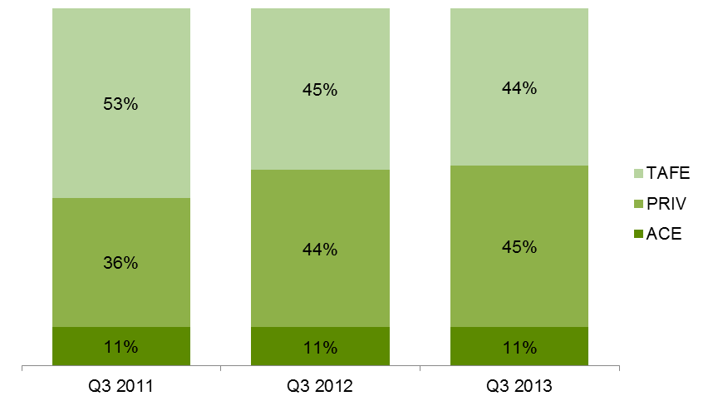

Table 1.17: Government subsidised enrolments (AQF1+), proportional share across provider types by industry, Q3 2013

|  |  |  |  |  |
| --- | --- | --- | --- | --- |
|  | **TAFE** | **Private RTOs** | **ACE** | **Total (number)** |
| A: Agriculture, Forestry and Fishing | 53% | 45% | 2% | 5,300 |
| B: Mining | 79% | 21% | 0% | 300 |
| C: Manufacturing | 38% | 62% | 0% | 32,900 |
| D: Electricity, Gas, Water and Waste Services | 84% | 16% | 0% | 600 |
| E: Construction | 70% | 30% | 0% | 49,400 |
| F: Wholesale Trade | 15% | 84% | 1% | 800 |
| G: Retail Trade | 25% | 72% | 3% | 13,200 |
| H: Accommodation and Food Services | 25% | 70% | 4% | 23,100 |
| I: Transport, Postal and Warehousing | 23% | 77% | 0% | 31,200 |
| J: Information Media and Telecommunications | 81% | 17% | 2% | 3,100 |
| K: Financial and Insurance Services | 13% | 86% | 0% | 2,700 |
| L: Rental, Hiring and Real Estate Services | 51% | 49% | 0% | 1,500 |
| M: Professional, Scientific and Technical Services | 95% | 5% | 0% | 9,900 |
| N: Administrative and Support Services | 27% | 70% | 3% | 12,200 |
| O: Public Administration and Safety | 33% | 67% | 0% | 6,600 |
| P: Education and Training | 47% | 43% | 10% | 10,000 |
| Q: Health Care and Social Assistance | 31% | 58% | 11% | 72,500 |
| R: Arts and Recreation Services | 54% | 42% | 4% | 14,100 |
| S: Other Services | 54% | 44% | 3% | 18,100 |
| T: Cross-industry | 28% | 68% | 4% | 52,200 |
| U: Foundation Skills and LOTE | 60% | 29% | 12% | 130,200 |
| Not applicable / Unknown | 36% | 44% | 20% | 300 |
| **Total (AQF1+)** | **45%** | **49%** | **6%** | **490,300** |

Table 1.18: Government subsidised enrolments (AQF1+), summary of selected characteristics within provider type, Q3 2013

This table provides summary information of selected characteristics within TAFE, private RTOs and ACE sectors in Q3 2013.

## Adult, Community and Further Education (ACFE) Performance

### Learn Local (ACE) Pre-accredited and Accredited training

Through the Adult, Community and Further Education (ACFE) Board, the Victorian Government funds 298 [Learn Local adult and community education (ACE) organisations](http://www.education.vic.gov.au/training/learners/learnlocal/pages/default.aspx), including two adult education institutions, the Council for Adult Education ([CAE](http://www.cae.edu.au/)) and Adult Multicultural Education Services ([AMES](http://www.ames.net.au/)) to deliver pre-accredited training to Victorians with limited prior educational attainment and limited access to vocational education and training. Learn Local providers support learners’ personal development in the knowledge, skills and attributes necessary to participate in society and secure employment. In addition to pre-accredited program delivery, there are 117 Learn Local providers that additionally are registered training organisations (RTOs) delivering accredited provision. This chapter of the report provides a snapshot of the contribution of the Learn Local (ACE) sector to government funded vocational training in Victoria.

The Victorian Government recently launched *Learn Local: Focusing on the Future*. This strategy has been developed by the Department of Education and Early Childhood Development and the ACFE Board in consultation with Learn Local peak bodies and providers. The strategy recognises Learn Local providers’ current opportunities and challenges in the context of recent training market reforms and confirms their role in providing a supportive and inclusive learning environment for people to engage in high quality training. *Learn Local: Focusing on the Future* sets out the actions that government will undertake to help the sector meet its potential, sharpen its focus and improve its sustainability and responsiveness.

The ratio between pre-accredited and accredited programs in Q3 2013 was consistent with previous years, where pre-accredited activity comprised 43 per cent of all Learn Local providers’ Government funded enrolments and accredited activity was 57 per cent of Learn Local delivery to date (respectively 24,800 course enrolments and 32,500 course enrolments).

### Learn Local (ACE) Pre-accredited training

| Key Points  * Of the Learn Local (ACE) sector’s total annual delivery to Q3 2013, the delivery of pre-accredited enrolments included an additional purchased 9,300 pre-accredited enrolments over the Q2 reported level, an increase of 38 per cent. This represents an across the board increase in purchased delivery, including increased delivery for the critical priority of improving the digital literacy of the Victorian workforce. * The Learn Locals’ pre-accredited enrolments in Q3 2013 had increased 10 per cent on Q3 2012 levels and 21 per cent on Q3 2011 levels, in line with the annual increases in ACFE Board allocated scheduled hours to Learn Local providers. * Learn Locals’ pre-accredited delivery particularly in the South Western and North Eastern regions in Q3 2013 had significant reported increases when compared to the same period in 2011 and 2012 (respectively 40 per cent and 24 per cent more pre-accredited enrolments). The increases occurred across metropolitan, regional and rural areas. * Pre-accredited delivery by Learn Local (ACE) providers in Q3 2013 increased in all ACFE Board Priority Learner group categories. For example, there were 700 more unemployed Victorians in pre-accredited training in the period Q3 2012 to Q2 2013 (a 19 per cent increase). However, the Q3 2013 learners numbered an additional 1,300 additional unemployed learners on Q3 2011 (a 39 per cent increase). Similarly, Culturally and Linguistically Diverse (CALD) learners increased in pre-accredited programs by 5 per cent on Q3 2012 (an additional 200 learners). The increase of CALD learners in pre-accredited programs from Q3 2011 to Q3 2013 was an additional 1,300 learners (a 36 per cent increase). |
| --- |

Table 1.19.1: Government subsidised pre-accredited training, Learn Local (ACE) providers, 2008-2012

|  |  |  |  |  |  |  |
| --- | --- | --- | --- | --- | --- | --- |
|  | **2008** | **2009** | **2010** | **2011** | **2012** | **% change 2008-2012** |
| Course Enrolments | 45,800 | 38,100 | 36,700 | 31,200 | 34,500 | -25% |
| Student Contact Hours(millions) | 1.7 | 1.6 | 1.9 | 1.5 | 1.7 | 0.2% |
| Students | 28,000 | 23,600 | 23,900 | 21,400 | 24,200 | -14% |

Table 1.19.2: Government subsidised pre-accredited training, Learn Local (ACE) providers, Q3 2011,   
Q3 2012 and Q3 2013

|  |  |  |  |  |  |
| --- | --- | --- | --- | --- | --- |
|  | **Q3 2011** | **Q3 2012** | **Q3 2013** | **% change Q3 2011 – Q3 2013** | **% change Q3 2012 – Q3 2013** |
| Course Enrolments | 20,400 | 22,500 | 24,800 | 21% | 10% |
| Student Contact Hours(millions) | 1.0 | 1.2 | 1.4 | 31% | 13% |
| Students | 14,300 | 16,600 | 17,600 | 23% | 6% |

Table 1.20.1: Government subsidised students in pre-accredited training with Learn Local (ACE) providers by departmental region, 2008-2012

|  |  |  |  |  |  |  |
| --- | --- | --- | --- | --- | --- | --- |
| **Delivery Location** | **2008** | **2009** | **2010** | **2011** | **2012** | **% change 2008-2012** |
| South-Western | 5,800 | 5,500 | 6,000 | 5,500 | 6,100 | 6% |
| North-Western | 5,300 | 4,800 | 5,300 | 4,800 | 5,200 | -2% |
| North-Eastern | 6,900 | 5,600 | 5,300 | 4,500 | 5,000 | -28% |
| South-Eastern | 10,000 | 7,700 | 6,500 | 5,900 | 6,500 | -35% |
| AEIs | 60 | 60 | 800 | 700 | 1,300 | 2071% |
| **Total** | **28,000** | **23,600** | **23,900** | **21,400** | **24,200** | **-14%** |

AEIs: Adult Education Institutes

Table 1.20.1: Government subsidised students in pre-accredited training with Learn Local (ACE) providers by departmental region, Q3 2011, Q3 2012 and Q3 2013

|  |  |  |  |  |  |
| --- | --- | --- | --- | --- | --- |
| **Delivery Location** | **Q3 2011** | **Q3 2012** | **Q3 2013** | **% change Q3 2011 – Q3 2013** | **% change Q3 2012 – Q3 2013** |
| South-Western | 3,400 | 4,000 | 4,700 | 40% | 19% |
| North-Western | 3,500 | 3,500 | 3,700 | 5% | 4% |
| North-Eastern | 2,900 | 3,600 | 3,600 | 24% | 2% |
| South-Eastern | 4,500 | 4,700 | 4,900 | 10% | 5% |
| AEIs | 50 | 900 | 700 | 1171% | -27% |
| **Total** | **14,300** | **16,600** | **17,600** | **23%** | **6%** |

AEIs: Adult Education Institutes

Figure 1.7: Government subsidised students in pre-accredited training with Learn Local (ACE) providers by regional area, Q3 2011, Q3 2012 and Q3 2013

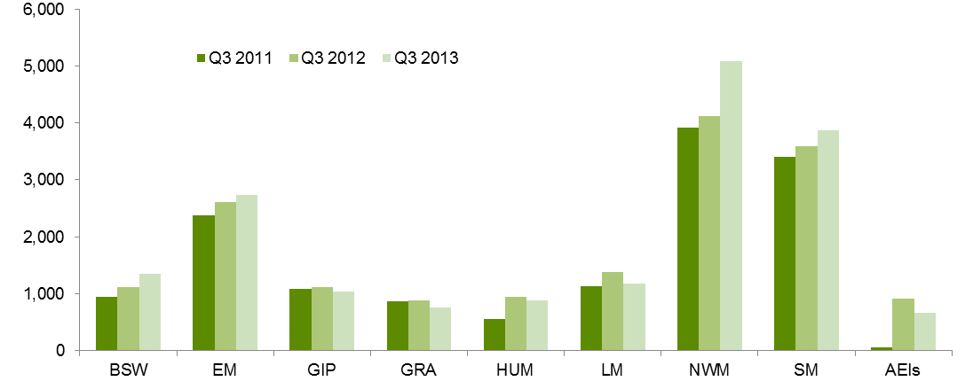

|  |  |  |  |  |  |
| --- | --- | --- | --- | --- | --- |
| BSW | Barwon South West | HUM | Hume | NWM | North Western Metropolitan |
| GRA | Grampians | GIP | Gippsland | SM | Southern Metropolitan |
| LMR | Loddon Mallee | EM | Eastern Metropolitan | AEIs | Adult Education Institutes |

Table 1.21.1: Government subsidised ACFE Board Priority Learners enrolled in pre-accredited programs with Learn Local (ACE) providers, 2008-2012

|  |  |  |  |  |  |  |
| --- | --- | --- | --- | --- | --- | --- |
|  | **2008** | **2009** | **2010** | **2011** | **2012** | **% change 2008-2012** |
| CALD (LOTE) | 4,100 | 4,300 | 4,900 | 5,700 | 6,800 | 67% |
| Disability | 4,600 | 4,200 | 4,900 | 4,800 | 5,600 | 21% |
| Disengaged Youth* | 900 | 400 | 1,000 | 600 | 900 | 0% |
| Early school leavers | 7,400 | 6,000 | 5,900 | 4,900 | 5,200 | -29% |
| Indigenous | 400 | 220 | 340 | 340 | 410 | 3% |
| Males 45 to 64 | 2,800 | 2,500 | 2,700 | 2,400 | 2,700 | -6% |
| Unemployed | 5,400 | 5,200 | 5,700 | 5,300 | 6,300 | 16% |
| Vulnerable workers | 5,300 | 4,400 | 5,100 | 4,900 | 5,700 | 7% |

Note: ACFE Board Priority Learner categories are not mutually exclusive. Detail on these categories is available at: [www.education.vic.gov.au/Documents/about/research/acfepublications/hardtoreachlearn.pdf](http://www.education.vic.gov.au/Documents/about/research/acfepublications/hardtoreachlearn.pdf)

Table 1.21.2: Government subsidised ACFE Board Priority Learners enrolled in pre-accredited programs with Learn Local (ACE) providers, Q3 2011, Q3 2012 and Q3 2013

|  |  |  |  |  |  |
| --- | --- | --- | --- | --- | --- |
|  | **Q3 2011** | **Q3 2012** | **Q3 2013** | **% change Q3 2011 – Q3 2013** | **% change Q3 2012 – Q3 2013** |
| CALD (LOTE) | 3,600 | 4,700 | 4,900 | 36% | 5% |
| Disability | 3,500 | 4,000 | 4,500 | 30% | 12% |
| Disengaged Youth | 300 | 500 | 600 | 105% | 12% |
| Early school leavers | 3,300 | 3,500 | 3,900 | 16% | 10% |
| Indigenous | 250 | 290 | 260 | 4% | -10% |
| Males 45 to 64 | 1,600 | 1,800 | 1,900 | 15% | 2% |
| Unemployed | 3,400 | 4,000 | 4,700 | 39% | 19% |
| Vulnerable workers | 3,300 | 3,900 | 3,900 | 17% | 0% |

Note: ACFE Board Priority Learner categories are not mutually exclusive. Detail on these categories is available at: [www.education.vic.gov.au/Documents/about/research/acfepublications/hardtoreachlearn.pdf](http://www.education.vic.gov.au/Documents/about/research/acfepublications/hardtoreachlearn.pdf)

### Learn Local (ACE) Accredited training

| Key Points  * Learn Local (ACE) providers’ accredited course enrolments declined by 7,300 enrolments over Q3 2012 to Q3 2013, a reduction of 18 per cent. However, from Q3 2011 to Q3 2013 there was an increase in accredited enrolments by 5,200 or 19 per cent. * Across Departmental regions only the North Western region showed increases in the number accredited course enrolments delivered in that area between Q3 2012 and Q3 2013. In comparison to Q3 2011, all Departmental regions, except Northern Eastern region, showed increases. Across the smaller regional areas there were increases from Q3 2012 to Q2 2013, ranging from the high for Loddon Mallee with a 122 per cent increase and 11% for Gippsland. Between Q3 2012 and Q3 2013 the regional areas of Barwon south western, Eastern metropolitan, Gippsland, Grampians and Hume all experience some degree of decline. While the other areas of Loddon Mallee, North west metropolitan and Southern metropolitan all experienced increases in the delivery of accredited enrolments between Q3 2012 to Q3 2013. * The Adult Education Institutes reported 300 fewer accredited enrolments in Q3 2013 on same period in the preceding year (a decrease of 8 per cent). This still represents a four per cent increase in accredited delivery (100 enrolments) against Q3 2011. * Learn Local (ACE) providers’ reported accredited enrolments for all ACFE Board Priority Learner group categories in Q3 2013 for the most part decreased on Q3 2012 levels. The Early School Leaver priority group reported a single decrease of 1,700 (22 per cent) enrolled accredited learners in the twelve months of Q3 2012 to Q3 2013. This contrasts to the 4 per cent growth in Early School Leavers between Q3 2011 and Q3 2013 (an additional 200 learners). The increased enrolments across all ACFE Board priority groups between Q3 2011 and Q3 2013 represented a significant uptake of these learner types into Learn Local (ACE) settings. There were 2,100 additional unemployed Victorians in accredited programs over Q3 2011 to Q3 2013 (a 28 per cent increase). Similarly, 1,600 more vulnerable workers[6] participated in accredited program in Q3 2013 than for the same period in 2011 (a 34 per cent increase); and 1,800 more Culturally and Linguistically Diverse learners in Q3 2013 than in Q3 2011 (a 32 per cent increase). |
| --- |

Table 1.22.1: Government subsidised accredited training, Learn Local (ACE) providers, 2008-2012

|  |  |  |  |  |  |  |
| --- | --- | --- | --- | --- | --- | --- |
|  | **2008** | **2009** | **2010** | **2011** | **2012** | **% change 2008-2012** |
| Course Enrolments | 27,900 | 30,200 | 27,100 | 33,300 | 45,800 | 64% |
| Student Contact Hours(millions) | 5.4 | 6.6 | 6.7 | 8.5 | 11.9 | 120% |
| Students | 24,000 | 25,700 | 23,700 | 27,500 | 36,300 | 51% |

Table 1.22.2: Government subsidised accredited training, Learn Local (ACE) providers, Q3 2011,   
Q3 2012 and Q3 2013

|  |  |  |  |  |  |
| --- | --- | --- | --- | --- | --- |
|  | **Q3 2011** | **Q3 2012** | **Q3 2013** | **% change Q3 2011 - Q3 2013** | **% change Q3 2012 – Q3 2013** |
| Course Enrolments | 27,300 | 39,800 | 32,500 | 19% | -18% |
| Student Contact Hours(millions) | 7.4 | 11.2 | 9.1 | 23% | -18% |
| Students | 23,000 | 31,800 | 26,200 | 14% | -17% |

Table 1.23.1: Government subsidised students in accredited training with Learn Local (ACE) providers   
by departmental region, 2008-2012

|  |  |  |  |  |  |  |
| --- | --- | --- | --- | --- | --- | --- |
| **Delivery Location** | **2008** | **2009** | **2010** | **2011** | **2012** | **% change 2008-2012** |
| South-Western | 5,300 | 6,200 | 5,600 | 8,700 | 14,500 | 173% |
| North-Western | 4,800 | 5,200 | 4,900 | 5,600 | 7,000 | 46% |
| North-Eastern | 5,700 | 5,600 | 4,600 | 4,500 | 5,000 | -12% |
| South-Eastern | 4,100 | 4,700 | 5,300 | 5,300 | 5,800 | 41% |
| AEIs | 4,100 | 4,000 | 3,300 | 3,400 | 4,000 | -2% |
| **Total** | **24,000** | **25,700** | **23,700** | **27,500** | **36,300** | **51%** |

AEIs: Adult Education Institutes

Table 1.23.2: Government subsidised students in accredited training with Learn Local (ACE) providers   
by departmental region, Q3 2011, Q3 2012 and Q3 2013

|  |  |  |  |  |  |
| --- | --- | --- | --- | --- | --- |
| **Delivery Location** | **Q3 2011** | **Q3 2012** | **Q3 2013** | **% change Q3 2011 – Q3 2013** | **% change Q3 2012 – Q3 2013** |
| South-Western | 6,800 | 12,900 | 7,600 | 12% | -41% |
| North-Western | 4,900 | 5,700 | 6,700 | 39% | 17% |
| North-Eastern | 3,800 | 4,500 | 3,600 | -5% | -20% |
| South-Eastern | 4,500 | 5,100 | 5,100 | 12% | -1% |
| AEIs | 3,100 | 3,500 | 3,200 | 4% | -8% |
| **Total** | **23,000** | **31,800** | **26,200** | **14%** | **-17%** |

AEIs: Adult Education Institutes

Figure 1.7: Government subsidised students in accredited training with Learn Local (ACE) providers   
by regional area, Q3 2011, Q3 2012 and Q3 2013

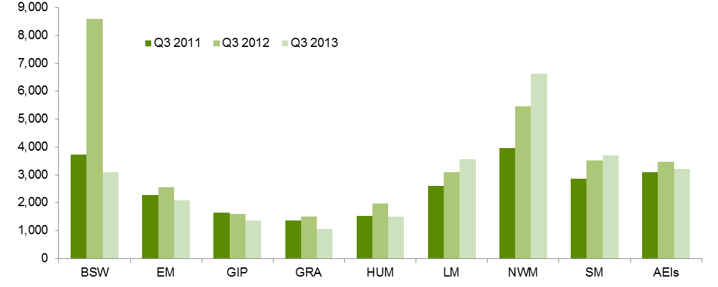

|  |  |  |  |  |  |
| --- | --- | --- | --- | --- | --- |
| BSW | Barwon South West | HUM | Hume | NWM | North Western Metropolitan |
| GRA | Grampians | GIP | Gippsland | SM | Southern Metropolitan |
| LMR | Loddon Mallee | EM | Eastern Metropolitan | AEIs | Adult Education Institutes |

Table 1.24.1: Government subsidised ACFE Board Priority Learners enrolled in accredited programs with Learn Local (ACE) providers, 2008-2012

|  |  |  |  |  |  |  |
| --- | --- | --- | --- | --- | --- | --- |
|  | **2008** | **2009** | **2010** | **2011** | **2012** | **% change 2008-2012** |
| CALD (LOTE) | 6,000 | 6,300 | 5,600 | 6,700 | 9,000 | 49% |
| Disability | 3,500 | 3,500 | 3,500 | 4,600 | 6,000 | 72% |
| Disengaged Youth | 1,500 | 2,000 | 1,700 | 2,600 | 3,700 | 142% |
| Early school leavers | 6,000 | 6,400 | 5,600 | 7,100 | 9,100 | 53% |
| Indigenous | 310 | 340 | 340 | 460 | 570 | 85% |
| Males 45 to 64 | 1,600 | 1,800 | 1,700 | 2,100 | 2,600 | 60% |
| Unemployed | 6,100 | 7,300 | 6,900 | 9,400 | 13,700 | 125% |
| Vulnerable workers | 4,700 | 5,100 | 4,800 | 5,800 | 7,300 | 53% |

Note: ACFE Board Priority Learner categories are not mutually exclusive. Detail on these categories is available at: [www.education.vic.gov.au/Documents/about/research/acfepublications/hardtoreachlearn.pdf](http://www.education.vic.gov.au/Documents/about/research/acfepublications/hardtoreachlearn.pdf)

Table 1.24.2: Government subsidised ACFE Board Priority Learners enrolled in accredited programs with Learn Local (ACE) providers, Q3 2011, Q3 2012 and Q3 2013

|  |  |  |  |  |  |
| --- | --- | --- | --- | --- | --- |
|  | **Q3 2011** | **Q3 2012** | **Q3 2013** | **% change Q3 2011 -  Q3 2013** | **% change Q2 2012 - Q2 2013** |
| CALD (LOTE) | 5,700 | 7,600 | 7,500 | 32% | -3% |
| Disability | 3,900 | 5,400 | 4,900 | 23% | -9% |
| Disengaged Youth | 2,100 | 3,300 | 2,800 | 34% | -13% |
| Early school leavers | 6,000 | 7,900 | 6,200 | 4% | -22% |
| Indigenous | 380 | 470 | 490 | 28% | 4% |
| Males 45 to 64 | 1,700 | 2,100 | 1,900 | 14% | -12% |
| Unemployed | 7,700 | 11,700 | 9,800 | 28% | -16% |
| Vulnerable workers | 4,800 | 6,300 | 6,400 | 34% | 1% |

Note: ACFE Board Priority Learner categories are not mutually exclusive. Detail on these categories is available at: [www.education.vic.gov.au/Documents/about/research/acfepublications/hardtoreachlearn.pdf](http://www.education.vic.gov.au/Documents/about/research/acfepublications/hardtoreachlearn.pdf)

# Learners Facing Barriers to Participation

## Vocational Training Delivery to Learner Cohorts Facing Barriers

Young people and adult learners who may be members of more than one equity group, can have complex and multiple learning needs, and may have contact with a suite of government services and programs. There is a significant evidence base that demonstrates the value and importance of education and training to these population cohorts. However, higher needs learners may face a combination of barriers to effective engagement in education and training including low levels of previous educational achievement, low aspirations, and poor access to training and broader barriers such as poverty, homelessness and poor health.

Vocational training has continued to be a critical enabler in opening up pathways for higher needs and disadvantaged learners through the provision of tailored, individualised services, often in partnership with other service providers.

Table 2.1.1: Students undertaking Government subsidised training by selected learner cohort*, 2008 – 2012

|  |  |  |  |  |  |  |
| --- | --- | --- | --- | --- | --- | --- |
|  | **2008** | **2009** | **2010** | **2011** | **2012** | **% change 2008-2012** |
| Indigenous | 4,400 | 4,300 | 4,800 | 5,600 | 6,200 | 42% |
| Students with a disability | 23,900 | 23,600 | 27,200 | 34,100 | 40,300 | 68% |
| CALD | 58,100 | 62,100 | 70,600 | 97,300 | 126,400 | 117% |
| Unemployed | 41,800 | 50,200 | 62,500 | 89,300 | 118,500 | 184% |
| Aged 15-19 without year 12, not at school and enrolled in Cert II or above | 23,100 | 22,600 | 26,300 | 28,900 | 29,500 | 28% |
| Aged 20-64 not holding a Cert III or above | 125,700 | 131,800 | 149,600 | 214,000 | 266,200 | 112% |

*The above cohorts of students are not mutually exclusive.

Table 2.1.2: Students undertaking Government subsidised training by selected learner cohort*, Q3 2011, Q3 2012 and Q3 2013

|  |  |  |  |  |  |
| --- | --- | --- | --- | --- | --- |
|  | **Q3 2011** | **Q3 2012** | **Q3 2013** | **% change Q3 2011-Q3 2013** | **% change Q3 2012-Q3 2013** |
| Indigenous | 4,600 | 5,200 | 5,200 | 13% | 1% |
| Students with a disability | 28,800 | 34,200 | 33,500 | 16% | -2% |
| CALD | 77,600 | 107,700 | 106,200 | 37% | -1% |
| Unemployed | 72,600 | 98,500 | 107,800 | 48% | 9% |
| Aged 15-19 without year 12, not at school and enrolled in Cert II or above | 25,100 | 26,000 | 20,900 | -17% | -20% |
| Aged 20-64 not holding a Cert III or above | 174,450 | 229,950 | 212,100 | 22% | -8% |

*The above cohorts of students are not mutually exclusive.

## Indigenous Students

### Enrolments

|  |
| --- |
| Key Points  * There were 5,200 Indigenous students enrolled in 6,900 government subsidised courses in Q3 2013. * Proportionally, just over half of courses in Australian Qualification Framework Level 1 plus (51 per cent) undertaken by Indigenous students in Q3 2013 were in Certificate III to IV levels. * Of those enrolments in industry-specific qualifications (4,400 enrolments) which exclude foundation skills and short courses in Q3 2013, 37 per cent were in courses related to specialised or in shortage occupations. |

Table 2.2.1: Indigenous students: Government subsidised enrolments by qualification level, 2008 – 2012

|  |  |  |  |  |  |  |
| --- | --- | --- | --- | --- | --- | --- |
| **Qualification level** | **2008** | **2009** | **2010** | **2011** | **2012** | **% change 2008-2012** |
| Cert I-II | 3,200 | 2,500 | 2,800 | 3,200 | 2,900 | -10% |
| Cert III-IV | 2,000 | 2,200 | 2,300 | 3,100 | 3,600 | 77% |
| Diploma & Above | 350 | 400 | 450 | 550 | 600 | 68% |
| Module Only | 850 | 400 | 400 | 400 | 500 | -42% |
| Secondary, SoA and other | 550 | 700 | 650 | 350 | 600 | 4% |
| **Total** | **7,000** | **6,200** | **6,600** | **7,600** | **8,200** | **16%** |

SoA: Statement of Attainment.

Table 2.2.2: Indigenous students: Government subsidised enrolments by qualification level, Q3 2011, Q3 2012 and Q3 2013

|  |  |  |  |  |  |
| --- | --- | --- | --- | --- | --- |
| **Qualification level** | **Q3 2011** | **Q3 2012** | **Q3 2013** | **% change Q3 2011-Q3 2013** | **% change Q3 2012-Q3 2013** |
| Cert I-II | 2,500 | 2,300 | 2,600 | 4% | 9% |
| Cert III-IV | 2,500 | 3,100 | 3,200 | 27% | 2% |
| Diploma & Above | 450 | 600 | 500 | 2% | -16% |
| Module Only | 350 | 350 | 200 | -43% | -44% |
| Secondary, SoA and other | 300 | 500 | 550 | 78% | 11% |
| **Total** | **6,000** | **6,800** | **6,900** | **14%** | **1%** |

SoA: Statement of Attainment.

## Students with a Disability

### Enrolments

|  |
| --- |
| Key Points  * There were 33,500 students with a disability enrolled in 47,700 government subsidised courses in Q3 2013. * Forty three per cent of AQF course enrolments undertaken by students with disability were in Certificate III and above levels. * Of those enrolments in industry-specific qualifications (23,000 enrolments) which exclude foundation skills and short courses in Q3 2013, 36 per cent were in courses related to specialised or in shortage occupations. |

Table 2.3.1: Students with a disability: government subsidised enrolments by qualification level,   
2008 – 2012

|  |  |  |  |  |  |  |
| --- | --- | --- | --- | --- | --- | --- |
| **Qualification level** | **2008** | **2009** | **2010** | **2011** | **2012** | **% change 2008-2012** |
| Cert I-II | 13,300 | 11,200 | 12,400 | 16,300 | 20,000 | 50% |
| Cert III-IV | 8,600 | 9,000 | 11,000 | 16,500 | 21,200 | 145% |
| Diploma & Above | 3,300 | 3,600 | 4,000 | 4,900 | 5,000 | 50% |
| Module Only | 8,300 | 8,400 | 8,300 | 7,200 | 7,700 | -8% |
| Secondary, SoA and other | 2,800 | 2,500 | 2,800 | 3,200 | 3,800 | 39% |
| **Total** | **36,300** | **34,700** | **38,400** | **48,000** | **57,600** | **59%** |

SoA: Statement of Attainment.

Table 2.3.2: Students with a disability: government subsidised enrolments by qualification level,  
Q3 2011, Q3 2012 and Q3 2013

|  |  |  |  |  |  |
| --- | --- | --- | --- | --- | --- |
| **Qualification level** | **Q3 2011** | **Q3 2012** | **Q3 2013** | **% change Q3 2011-Q3 2013** | **% change Q3 2012-Q3 2013** |
| Cert I-II | 13,300 | 16,800 | 17,800 | 34% | 6% |
| Cert III-IV | 13,700 | 18,100 | 16,800 | 22% | -7% |
| Diploma & Above | 4,600 | 4,800 | 3,600 | -21% | -25% |
| Module Only | 5,100 | 5,100 | 6,000 | 18% | 16% |
| Secondary, SoA and other | 2,500 | 3,000 | 3,500 | 38% | 15% |
| **Total** | **39,200** | **48,000** | **47,700** | **22%** | **-1%** |

SoA: Statement of Attainment.

## Students with a Culturally and Linguistically Diverse (CALD) Background

### Enrolments

|  |
| --- |
| Key Points  * There were 106,200 students from a CALD background enrolled in 143,300 government subsidised courses in Q3 2013. More than half (56 per cent) of course enrolments at AQF Level 1 and above were in Certificate III to IV levels. * Enrolments in Diploma and above courses undertaken by students from a CALD background in Q3 2013 were lower than the corresponding figures in Q3 2011 and Q3 2012. * Of those enrolments in industry-specific qualifications (89,200 enrolments) which exclude foundation skills and short courses in Q2 2013, 45 per cent were in courses related to specialised or in shortage occupations. |

Table 2.4.1: Students from a CALD background: government subsidised enrolments by qualification level, 2008 – 2012

|  |  |  |  |  |  |  |
| --- | --- | --- | --- | --- | --- | --- |
| **Qualification level** | **2008** | **2009** | **2010** | **2011** | **2012** | **% change 2008-2012** |
| Cert I-II | 19,800 | 20,100 | 20,400 | 28,500 | 41,600 | 110% |
| Cert III-IV | 30,000 | 30,700 | 38,500 | 62,000 | 88,900 | 196% |
| Diploma & Above | 13,400 | 15,700 | 17,300 | 22,400 | 23,200 | 73% |
| Module Only | 13,000 | 11,600 | 12,100 | 11,700 | 10,700 | -17% |
| Secondary, SoA and other | 5,000 | 5,400 | 5,400 | 6,200 | 8,400 | 67% |
| **Total** | **81,100** | **83,500** | **93,800** | **130,700** | **172,800** | **113%** |

SoA: Statement of Attainment.

Table 2.4.2: Students from a CALD background: government subsidised enrolments by qualification level,   
Q3 2011, Q3 2012 and Q3 2013

|  |  |  |  |  |  |
| --- | --- | --- | --- | --- | --- |
| **Qualification level** | **Q3 2011** | **Q3 2012** | **Q3 2013** | **% change Q3 2011-Q3 2013** | **% change Q3 2012-Q3 2013** |
| Cert I-II | 22,200 | 34,900 | 41,500 | 87% | 19% |
| Cert III-IV | 47,600 | 75,000 | 72,600 | 53% | -3% |
| Diploma & Above | 19,600 | 22,100 | 16,600 | -15% | -25% |
| Module Only | 7,900 | 7,300 | 8,000 | 1% | 9% |
| Secondary, SoA and other | 4,700 | 7,000 | 4,700 | 2% | -33% |
| **Total** | **101,900** | **146,300** | **143,300** | **41%** | **-2%** |

SoA: Statement of Attainment.

## Unemployed Students

### Enrolments

|  |
| --- |
| Key Points  * The number of government subsidised course enrolments undertaken by unemployed students in Q3 2013 was 148,100 which were undertaken by 107,800 unemployed students. About one in two AQF courses undertaken by unemployed students was in Certificate III to IV levels. * Enrolments in Diploma and above courses undertaken by unemployed students in Q3 2013 were lower than the corresponding figures in Q3 2011 and Q3 2012. * Of those enrolments in industry-specific qualifications (87,600 enrolments) which exclude foundation skills and short courses in Q3 2013, 38 per cent were in courses related to specialised or in shortage occupations. |

Table 2.5.1: Unemployed students: government subsidised enrolments by qualification level, 2008 – 2012

|  |  |  |  |  |  |  |
| --- | --- | --- | --- | --- | --- | --- |
| **Qualification level** | **2008** | **2009** | **2010** | **2011** | **2012** | **% change 2008-2012** |
| Cert I-II | 18,800 | 21,600 | 25,700 | 37,000 | 54,100 | 188% |
| Cert III-IV | 17,400 | 21,200 | 30,200 | 54,500 | 77,200 | 344% |
| Diploma & Above | 9,100 | 10,700 | 13,200 | 16,600 | 15,700 | 72% |
| Module Only | 13,000 | 11,700 | 10,600 | 8,300 | 7,900 | -39% |
| Secondary, SoA and other | 5,300 | 6,000 | 6,300 | 6,500 | 8,000 | 52% |
| **Total** | **63,600** | **71,200** | **86,000** | **123,000** | **162,900** | **156%** |

SoA: Statement of Attainment.

Table 2.5.2: Unemployed students: government subsidised enrolments by qualification level,   
Q3 2011, Q3 2012 and Q3 2013

|  |  |  |  |  |  |
| --- | --- | --- | --- | --- | --- |
| **Qualification level** | **Q3 2011** | **Q3 2012** | **Q3 2013** | **% change Q3 2011-Q3 2013** | **% change Q3 2012-Q3 2013** |
| Cert I-II | 29,300 | 43,600 | 56,900 | 94% | 30% |
| Cert III-IV | 43,100 | 65,600 | 67,300 | 56% | 2% |
| Diploma & Above | 15,300 | 15,100 | 12,200 | -20% | -19% |
| Module Only | 5,500 | 4,900 | 5,700 | 4% | 16% |
| Secondary, SoA and other | 5,000 | 6,700 | 6,000 | 20% | -11% |
| **Total** | **98,300** | **136,000** | **148,100** | **51%** | **9%** |

SoA: Statement of Attainment.

## Young People (Aged 15 to 19) Without Year 12 or Equivalent and Not at School

### Enrolments

|  |
| --- |
| Key Points  * The total number of government subsidised enrolments at Certificate II and above of young people without a Year 12 or equivalent and not in school was 24,800 Q3 2013. This figure is lower than the corresponding figures in Q3 2011 and Q3 2012. * Of those enrolments in industry-specific qualifications (20,800 enrolments) which exclude foundation skills courses in Q3 2013, 42 per cent were in courses related to specialised or in shortage occupations. |

Table 2.6.1: Youth transition: government subsidised enrolments Cert II and above by students aged 15 to 19 who did not complete Year 12 or equivalent and not at school, 2008 – 2012

|  |  |  |  |  |  |  |
| --- | --- | --- | --- | --- | --- | --- |
|  | **2008** | **2009** | **2010** | **2011** | **2012** | **% change 2008-2012** |
| Cert II | 8,300 | 8,600 | 10,900 | 12,700 | 12,000 | 44% |
| Cert III-IV | 16,500 | 15,800 | 18,400 | 20,400 | 22,100 | 34% |
| Diploma & Above | 650 | 800 | 850 | 1,100 | 900 | 45% |
| **Total** | **25,500** | **25,200** | **30,100** | **34,100** | **35,000** | **37%** |

Table 2.6.2: Youth transition: government subsidised enrolments Cert II and above by students aged 15 to 19 who did not complete Year 12 or equivalent and not at school, Q3 2011, Q3 2012 and Q3 2013

|  |  |  |  |  |  |
| --- | --- | --- | --- | --- | --- |
|  | **Q3 2011** | **Q3 2012** | **Q3 2013** | **% change Q3 2011-Q3 2013** | **% change Q1 2012-Q1 2013** |
| Cert II | 10,700 | 10,700 | 8,400 | -21% | -22% |
| Cert III-IV | 17,500 | 19,300 | 15,800 | -9% | -18% |
| Diploma & Above | 1,600 | 900 | 550 | -65% | -40% |
| **Total** | **29,700** | **31,000** | **24,800** | **-17%** | **-20%** |

## Students with Low Prior Qualifications

### Enrolments

|  |
| --- |
| Key Points  * In Q2 2013, there were 212,100 students who were aged 20-64 and not holding a Certificate III or above qualification enrolled in 278,500 government subsidised courses. * Of enrolments in industry-specific qualifications (201,100 enrolments) which exclude foundation skills and short courses in Q2 2013, 41 per cent were in courses related to specialised or in shortage occupations. |

Table 2.7.1: Government subsidised enrolments by students aged 20-64 not holding a Cert III or above, 2008 – 2012

|  |  |  |  |  |  |  |
| --- | --- | --- | --- | --- | --- | --- |
|  | **2008** | **2009** | **2010** | **2011** | **2012** | **% change 2008-2012** |
| Course Enrolments | 164,100 | 166,200 | 185,400 | 271,800 | 345,700 | 111% |
| Up-Skilling | 92,500 | 100,200 | 118,600 | 190,600 | 251,500 | 172% |

Up-skilling refers to studying at a higher level than their current qualification.

Table 2.7.2: Government subsidised enrolments by students aged 20-64 not holding a Cert III or above,   
Q3 2011, Q3 2012 and Q3 2013

|  |  |  |  |  |  |
| --- | --- | --- | --- | --- | --- |
|  | **Q3 2011** | **Q3 2012** | **Q3 2013** | **% change Q3 2011-Q3 2013** | **% change Q3 2012-Q3 2013** |
| Course Enrolments | 216,300 | 296,800 | 278,500 | 29% | -6% |
| Up-Skilling | 155,600 | 220,100 | 193,900 | 25% | -12% |

Up-skilling refers to studying at a higher level than their current qualification.

## Foundation Level Training

An efficient and effective training market is vital to provide better outcomes for students and employers, as well as the wider Victorian community. It is particularly important to make sure school leavers and adults without solid literacy and numeracy skills are given the opportunity to acquire them. These skills will greatly improve their chances of employment, provide opportunities for further education and broader social participation.

The latest OECD study on adult literacy and numeracy (Program for the International Assessment of Adult Competencies) suggests that there is a significant proportion of the adult population with very low skills in literacy and numeracy, likely to be of a level to limit their effective participation in the economy: about 14% (or 518,000) of Victorians aged 15-64 had low level of skills (proficiency level 1 or below) in literacy and 22% (or 818,600) had low level of skills in numeracy. These individuals would benefit from foundation type courses. A recent study undertaken by the Australian Industry Group *Getting it Right: Foundation Skills for the Workforce* found that employers continue to be concerned about the low levels of workplace literacy and numeracy, with 93 per cent of employers identifying some impact on their business.

|  |
| --- |
| Key Points  * Enrolments in government subsidised foundation skills courses were 136,200 in Q3 2013. This figure is higher compared to the corresponding figures over the same period in 2011 and 2012. * In terms of students, there were 111,000 government subsidised students enrolled in these courses in Q3 2013. Nearly half (49 per cent) of these students were aged between 15 and 24 years. * The top three foundation skills course enrolments in Q3 2013 were Certificate I in Vocational Preparation, the Certificate II in General Education for Adults and the Certificate I in General Education for Adults. Enrolments in these courses accounted for 63 per cent of all government subsidised foundation course enrolments. |

Figure 2.1: Government subsidised enrolments in foundation skills courses, 2008 – 2012,   
Q3 2011, Q3 2012 and Q3 2013

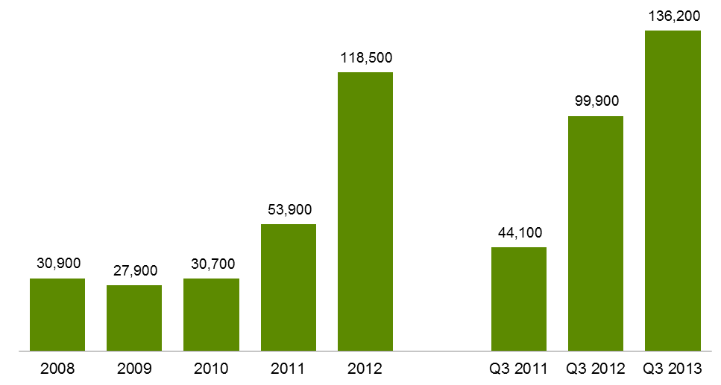

Table 2.8.1: Government subsidised student contact hours in foundation skills courses, 2008-2012

|  |  |  |  |  |  |  |
| --- | --- | --- | --- | --- | --- | --- |
|  | **2008** | **2009** | **2010** | **2011** | **2012** | **% change 2008-2012** |
| Student contact hours | 6.8 | 7.6 | 7.1 | 11.0 | 19.2 | 180% |

Table 2.8.2: Government subsidised student contact hours in foundation skills courses,   
Q3 2011, Q3 2012 and Q3 2013

|  |  |  |  |  |  |
| --- | --- | --- | --- | --- | --- |
|  | **Q3 2011** | **Q3 2012** | **Q3 2013** | **% change Q3 2011-Q3 2013** | **% change Q3 2012-Q3 2013** |
| Student contact hours | 9.7 | 16.4 | 24.7 | 154% | 50% |

Table 2.9.1: Government subsidised students in foundation skills courses by age group, 2008-2012

|  |  |  |  |  |  |  |
| --- | --- | --- | --- | --- | --- | --- |
|  | **2008** | **2009** | **2010** | **2011** | **2012** | **% change 2008-2012** |
| 15 to 19 | 5,100 | 5,200 | 6,600 | 11,200 | 27,900 | 451% |
| 20 to 24 | 2,700 | 2,500 | 3,100 | 6,000 | 18,800 | 602% |
| 25 to 44 | 11,200 | 9,700 | 10,300 | 16,400 | 31,400 | 179% |
| 45 to 64 | 5,300 | 4,800 | 5,100 | 8,700 | 16,600 | 214% |
| Under 15, over 64, not stated | 900 | 900 | 700 | 1,200 | 3,400 | 269% |
| **Total** | **25,200** | **23,200** | **25,700** | **43,500** | **98,100** | **289%** |

Table 2.9.2: Government subsidised students in foundation skills courses by age group,   
Q3 2011, Q3 2012 and Q3 2013

|  |  |  |  |  |  |
| --- | --- | --- | --- | --- | --- |
|  | **Q3 2011** | **Q3 2012** | **Q3 2013** | **% change Q3 2011-Q3 2013** | **% change Q3 2012-Q3 2013** |
| 15 to 19 | 9,200 | 23,500 | 31,500 | 243% | 34% |
| 20 to 24 | 4,800 | 16,100 | 22,700 | 376% | 41% |
| 25 to 44 | 13,100 | 26,200 | 36,000 | 174% | 38% |
| 45 to 64 | 6,900 | 13,900 | 18,000 | 160% | 29% |
| Under 15, over 64, not stated | 750 | 2,400 | 2,800 | 274% | 16% |
| **Total** | **34,800** | **82,200** | **111,000** | **219%** | **35%** |

Table 2.10: Top 13 government subsidised foundation skills course enrolments, Q3 2011, Q3 2012   
and Q3 2013

This table shows top 13 enrolments in government subsidised foundation courses of study in Q3 2013.  Q3 2011 and Q3 2012 data were provided for comparative purpose.

# Alignment of Training to Industry Skills Needs

### Introduction

Since the implementation of the RVT policy there have been shifts towards training delivered in areas that better meet the training requirements of the Victorian economy. The training market has been dynamic and responsive in seeking to align with these areas of need.

The trends towards more training in areas of specialised skills and in shortage occupations since 2008 has continued in 2013, as well as a shift towards courses that support sectors with significant projected employment growth.

There has been a reduction in courses that experienced unprecedented high levels of enrolments in 2012 that were not aligned with the employment trends of related industries. Challenges remain as government seeks to support apprenticeships in a climate of business contraction in trade related industries as well as managing growth in training areas that are not aligned with industry or student needs such as foundation skills for individuals who already have highly developed literacy, numeracy and workplace skills and RPL in unlicensed occupations.

Under the new subsidy bands, weightings have been refined to apply at the course level to strengthen Government investment in training for specialised skills, training to address skills in shortage, training related to areas of growing employment opportunity and sectors delivering essential services. The reforms also assessed the extent to which government investment is required to stimulate delivery of, and participation in, this training to meet industry needs.

Overall, the highest subsidy levels have been provided to courses where contribution to the economy is assessed as high, and where government subsidy is seen as essential in enabling delivery and participation in training.

|  |
| --- |
| Key Points  * Data from Q3 2013 show that about 70 per cent of all government subsidised commencing enrolments were within subsidy bands A and B. Courses such as the Certificate III in Electrotechnology Electrician, Certificate III in Carpentry, Certificate III in Aged Care and the course in Initial General Education for Adults are represented in these funding bands. * Courses with less vocational outcome, or labour market requirement (Band D & E) represented 9 per cent of all government subsidised commencements in Q3 2013. |

Figure 3.1: Government subsidised commencing course enrolments: proportion** of commencing enrolments by subsidy band, Pre-July 2012, Q2 2013 and Q3 2013



*Pre-July 2012 refers to January to June 2012. ** Due to rounding the sum may not add up to 100 per cent.

Subsidy bands were introduced in 2012 and apply specifically to qualifications in 2012 and onward. In order to allow comparison with previous years, superseded courses have been assigned a subsidy band for analysis purposes only based on the bands of the current course to which they most closely align.

## Training Activity by Industry

Victorian reforms in vocational training enhance the alignment between vocational training and the needs of industry. For students this provides the opportunity for improved career and education pathways and employment outcomes following completion of training. Analysis of vocational training data has shown a high correlation between share of employment and share of training delivery in Victoria's largest industries (also refer to figure below for a comparison between employment and enrolment by industry):

* Forty nine per cent of training was delivered in the five highest employing Victorian industry sectors, which account for 50 per cent of all Victorian jobs – Health Care and Social Assistance, Retail Trade, Manufacturing, Construction and Professional, Scientific and Technical Services. In Q3 2013, these five industries continue to make up nearly half of all industry-specific[7] enrolments.
* Health Care and Social Assistance, forecast to remain Victoria’s largest industry employer through to 2017[8], saw the highest enrolment growth for industry-specific training in 2012 (16,200 additional enrolments in 2012 when compared with 2011). In Q3 2013, training in courses related to Health Care and Social Assistance continued to grow with 72,500 enrolments (7 per cent growth between Q3 2012 and Q3 2013).
* There were around 359,800 enrolments in all industry-specific training, including 52,200 enrolments in Cross-industry training, which encompasses a broad range of skills applicable to all Victorian industries.

3.2: Industry share of Victorian employment and vocational training 2012

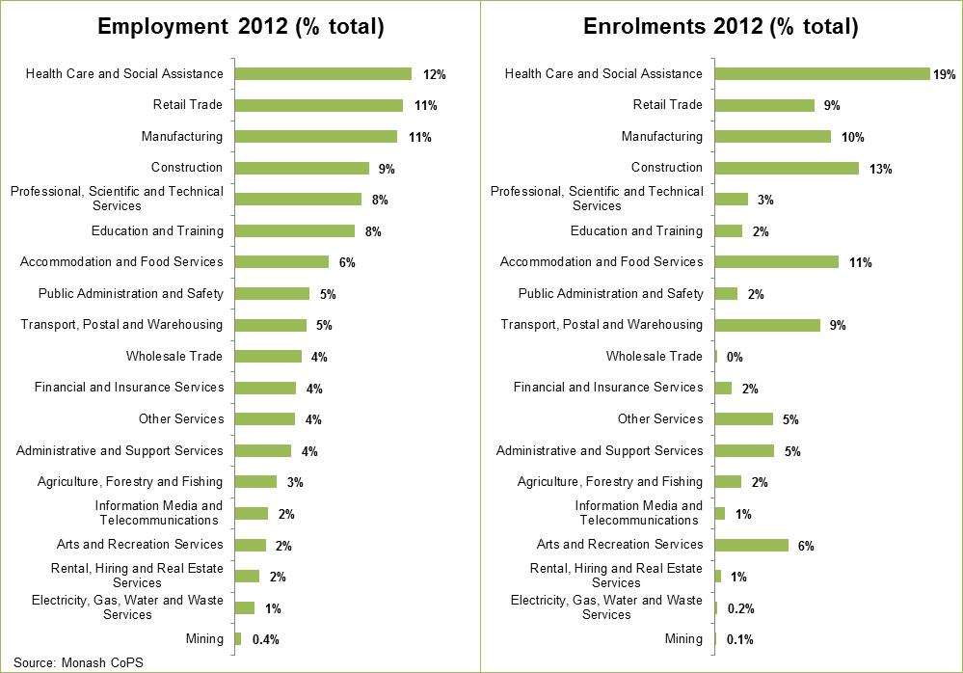

The following table shows training in government subsidised qualifications, sorted highest to lowest by 2012 enrolments (excludes foundation training). Rank by industry share of Victorian employment and equivalent 2008 ranks are also displayed.

Table 3.1: Industry-specific training and employment: 2012 vs. 2008[9]

This table shows training in government subsidised qualifications, sorted highest to lowest by 2012 enrolments (excludes foundation training).  Rank by industry share of Victorian employment and equivalent 2008 ranks are also displayed.

### Subsidy bands analysis per industry

The table below shows the top 5 highest enrolments by industries for each subsidy band.

Table 3.2: Industry-specific training by funding band, Q3 2013

|  |  |  |
| --- | --- | --- |
| **Industry by funding band** | **Q3 2013 enrolments** | **% enrolments Q3 2013** |
| **Band A** | | |
| Construction | 36,800 | 61% |
| Manufacturing | 11,300 | 19% |
| Other Services | 7,800 | 13% |
| Accommodation and Food Services | 3,200 | 5% |
| Agriculture, Forestry and Fishing | 500 | 1% |
| *Other industries* | *1,130* | *2%* |
| **Total (Band A)** | **60,730** | **100%** |
| **Band B** | | |
| Health Care and Social Assistance | 32,900 | 27% |
| Transport, Postal and Warehousing | 26,100 | 22% |
| Manufacturing | 17,300 | 14% |
| Construction | 9,600 | 8% |
| Accommodation and Food Services | 9,300 | 8% |
| *Other industries* | *25,300* | *21%* |
| **Total (Band B)** | **120,500** | **100%** |
| **Band C** | | |
| Health Care and Social Assistance | 37,700 | 34% |
| Cross-industry | 27,900 | 25% |
| Education and Training | 6,900 | 6% |
| Administrative and Support Services | 4,800 | 4% |
| Accommodation and Food Services | 4,200 | 4% |
| *Other industries* | *28,300* | 26% |
| **Total (Band C)** | **109,800** | **100%** |
| **Band D** | | |
| Cross-industry | 11,700 | 35% |
| Administrative and Support Services | 4,400 | 13% |
| Retail Trade | 3,600 | 11% |
| Public Administration and Safety | 2,600 | 8% |
| Professional, Scientific and Technical Services | 2,400 | 7% |
| *Other industries* | *9,100* | 27% |
| **Total (Band D)** | **33,800** | **100%** |
| **Band E** | | |
| Cross-industry | 11,700 | 34% |
| Retail Trade | 6,000 | 17% |
| Arts and Recreation Services | 5,700 | 16% |
| Accommodation and Food Services | 5,700 | 16% |
| Manufacturing | 3,900 | 11% |
| *Other industries* | *1,900* | *5%* |
| **Total (Band E)** | **34,900** | **100%** |

|  |
| --- |
| Key Points  * Over half of delivery in Band A (apprenticeships and non-apprenticeships) is in the Construction industry. * The largest block of delivery in Band B is for Health Care and Social Assistance (29 per cent) and Transport, Postal and Warehousing (23 per cent). |

## Training Activity by Occupation

In the third quarter of 2013, the 5 highest numbers of enrolments within Bands A and B were in courses related to the following occupations:

* Aged or Disabled Carer (14,700 enrolments in Q3 2013)
* Purchasing and Supply Logistics Clerks (12,200 enrolments in Q3 2013)
* Truck Driver (General) (7,800 enrolments in Q3 2013)
* Engineering Production Worker (6,400 enrolments in Q3 2013)
* Enrolled and Mothercraft Nurses (6,900 enrolments in Q3 2013)

Employment trends within these occupations are outlined in the table below and show employment numbers in 2011-12, average annual employment needs[10] over the next 5 years as well as patterns of forecast employment growth to 2016-17. Employment trends indicate growth in three of the five occupational groups related to highest number of courses in Bands A and B. Engineering Production Workers are forecast to see dampened demand over the next five years. These workers predominantly work in the Manufacturing industry, a critical industry for the Victorian economy undergoing significant industrial transition, and therefore remain a critical area for public investment in vocational training.

Table 3.3: Employment trends in selected occupations (Band A & B), 2011-12 to 2016-17

This table shows the forecast employment trends in occupations of Aged and Disabled Carees, Purchasing and Supply Logistic Clerk, Truck Driver, Engineering Production Worker and Enrolled and Mothercraft Nurse from 2011-12 to 2016-17. Government subsidised course enrolments in these occupations were in subsidy band A or B in Q3 2013.  

Source: Monash Centre for Policy Studies (2012) Employment Forecasting Model.

The 5 highest number of enrolments within Band D and E in Q3 2013 were in courses related to the following occupations:

* General Clerk (5,900 enrolments in Q3 2013)
* Office Manager (5,700 enrolments in Q3 2013)
* Sales Assistant (General) (4,800 enrolments in Q3 2013)
* Waiter (4,200 enrolments in Q3 2013)
* Factory Process Workers (other) (3,200 enrolments in Q3 2013)

As above, Table 3.4 shows employment trends for occupations related to top 5 highest numbers of enrolments within Band D and E. Characteristic of these occupations in the Victorian labour market are jobs that have high levels of turnover and mixed employment prospects. Office Managers, for example are likely to remain fairly stable through to 2016-17, while Sales Assistants and Factory Process Workers are forecast to decline. General Clerks and Waiters are forecast to see employment growth, however present less of a requirement for vocational training investment made by government to support meeting this labour market need.

Table 3.4: Employment trends in selected occupations (Band D & E), 2011-12 to 2016-17

This table shows the forecast employment trends in occupations of Occupation Manager, Sales Assistant (General), General Clerk, Waiter and Factory Process Worker (other) from 2011-12 to 2016-17. Government subsidised course enrolments in these occupations were in subsidy band D or E in Q3 2013.  Source: Monash Centre for Policy Studies (2012) Employment Forecasting Model.

## Apprenticeships

Since July 2012 courses such as Apprenticeships, attract government subsidy at the highest level in recognition of current and projected future industry skill needs. However, even though Apprenticeships receive the highest level of subsidy, due to external factors there has been a dampening of enrolments in Q3 2013 compared to same periods in 2011 and 2012. In Victoria just over half (54 per cent) of all Apprentice enrolments in Q3 2013 were in the Construction industry, this sector has been facing some challenging business conditions over recent years. Apprentice numbers are highly correlated with business conditions and this close relationship is demonstrated in the chart on the following page which shows similar trends between apprenticeship commencements[11] and new dwelling commencements[12], especially in the last few years.

Recent data released by the National Centre for Vocational Education Research (NCVER) show that Victoria is not the only jurisdiction that has experienced reductions in apprentices and trainees in-training in traditional trades. States such as NSW and Queensland are also having similar trends. This is likely reflective of difficult business conditions for this industry being faced across Australia.

Figure 3.3: Number of apprenticeship commencements and new dwelling units commenced all sectors  
Quarter 1 2000 to Quarter 3 2013

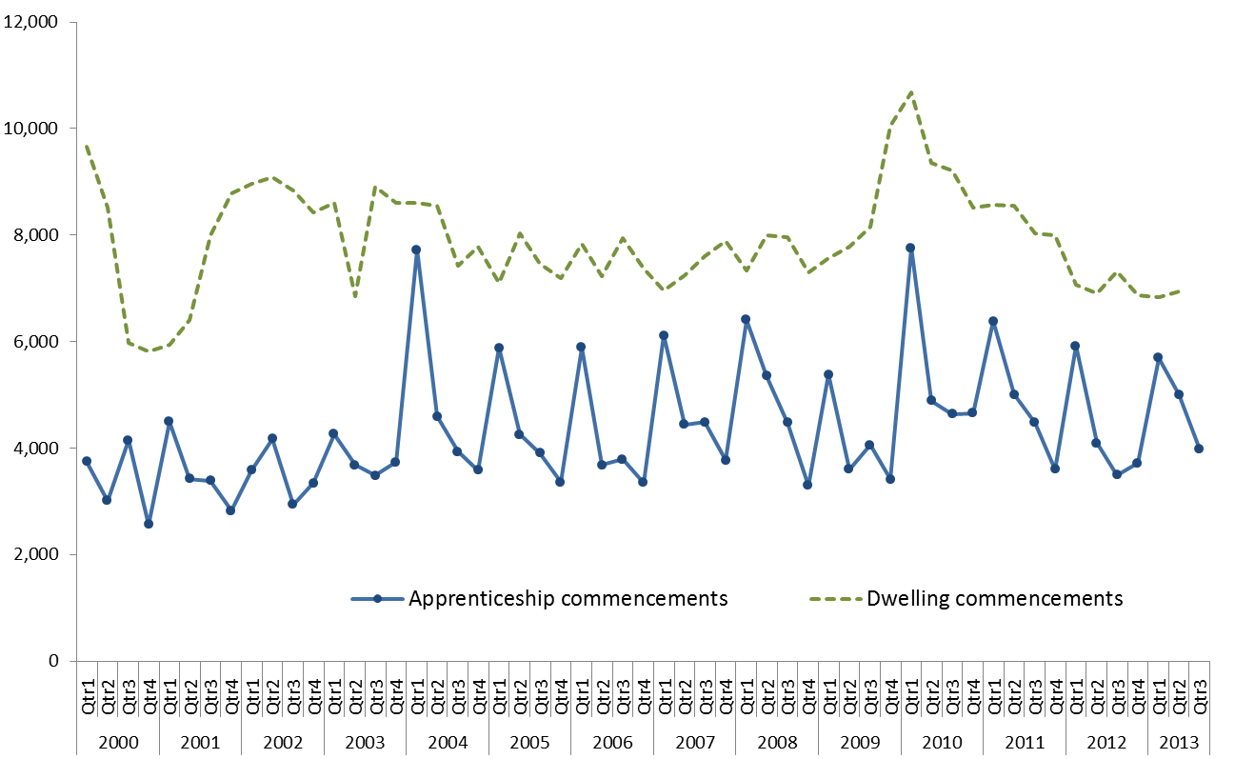

Figure 3.4: Number of Apprentices and trainees in-training in traditional trades, Vic, New South Wales and Queensland, Quarter 1 2008 – Quarter 4 2012 (NCVER)

This chart shows the number of apprentices and trainees in-training in traditional trades in Victoria, New South Wales and Queensland from Quarter 1 2008 to Quarter 4 2012.  These figures were sourced from the NCVER report.

Source: Apprentices and Trainees December 2012, VOCSTATS NCVER

Table 3.5.1: Government subsidised enrolments by apprentices by age, 2008–2012

|  |  |  |  |  |  |  |
| --- | --- | --- | --- | --- | --- | --- |
|  | **2008** | **2009** | **2010** | **2011** | **2012** | **% change 2008-2012** |
| 15 to 19 | 19,100 | 18,400 | 19,400 | 19,300 | 17,300 | -9% |
| 20 to 24 | 16,300 | 16,500 | 18,100 | 18,500 | 18,800 | 15% |
| 25 to 44 | 5,900 | 6,300 | 7,100 | 7,800 | 8,100 | 36% |
| 45 to 64 | 500 | 500 | 600 | 650 | 850 | 70% |
| Under 15, over 64, not stated | 50 | 30 | 20 | 20 | 10 | -80% |
| **Total** | **41,900** | **41,600** | **45,300** | **46,300** | **45,000** | **8%** |

Table 3.5.2: Government subsidised enrolments by apprentices by age, Q3 2011, Q3 2012 and Q3 2013

|  |  |  |  |  |  |
| --- | --- | --- | --- | --- | --- |
|  | **Q3 2011** | **Q3 2012** | **Q3 2013** | **% change Q3 2011-Q3 2013** | **% change Q3 2012-Q3 2013** |
| 15 to 19 | 17,500 | 15,900 | 13,700 | -22% | -13% |
| 20 to 24 | 17,500 | 17,900 | 17,300 | -1% | -3% |
| 25 to 44 | 7,200 | 7,300 | 7,800 | 8% | 6% |
| 45 to 64 | 650 | 650 | 1,000 | 61% | 52% |
| Under 15, over 64, not stated | 30 | 10 | 20 | -43% | 113% |
| **Total** | **42,900** | **41,800** | **39,800** | **-7%** | **-5%** |

|  |  |  |  |  |  |
| --- | --- | --- | --- | --- | --- |
|  |  |  |  |  |  |

Table 3.6: Government subsidised enrolments by apprentices by industry, Q3 2011, Q3 2012 and Q3 2013

|  |  |  |  |  |  |
| --- | --- | --- | --- | --- | --- |
|  | **Q3 2011** | **Q3 2012** | **Q3 2013** | **% change Q3 2011-Q3 2013** | **% change Q3 2012-Q3 2013** |
| A: Agriculture, Forestry and Fishing | 40 | 40 | 80 | 126% | 84% |
| C: Manufacturing | 6,300 | 6,200 | 6,200 | -1% | 1% |
| D: Electricity, Gas, Water and Waste Services | 250 | 250 | 200 | -20% | -17% |
| E: Construction | 24,300 | 23,200 | 21,700 | -11% | -7% |
| F: Wholesale Trade | 100 | 90 | 40 | -62% | -51% |
| G: Retail Trade | 1,800 | 1,900 | 1,800 | 1% | -4% |
| H: Accommodation and Food Services | 2,400 | 2,400 | 2,500 | 4% | 5% |
| M: Professional, Scientific and Technical Services | 150 | 150 | 200 | 47% | 55% |
| N: Administrative and Support Services | 500 | 450 | 250 | -51% | -46% |
| O: Public Administration and Safety | 90 | 100 | 100 | 5% | -8% |
| Q: Health Care and Social Assistance | 100 | 80 | 70 | -34% | -17% |
| R: Arts and Recreation Services | 600 | 600 | 550 | -6% | -7% |
| S: Other Services | 6,200 | 6,300 | 6,000 | -3% | -4% |
| **Total** | **42,900** | **41,800** | **39,800** | **-7%** | **-5%** |

## Traineeships

While there has been a decline in enrolments in Traineeships in Q3 2013, the decline has come from those courses that now attract the lowest levels of government subsidy, i.e. Band D and E. This is demonstrated on the figure on the next page which shows that the vast majority of the decline has come from courses that are deemed to have less vocational outcome or labour market requirement and hence attract the lowest subsidy levels (i.e. Band D and E). Courses in this group include Certificate II in Retail, Certificate III in Retail, Certificate III in Hospitality, Certificate III in Process Manufacturing, and Certificate III in Customer Contact. While the overall traineeship enrolments in Q3 2013 was lower compared to Q3 2011, when examined by subsidy band not only can it be seen where the decline has come from but it shows that there actually has been some growth in traineeships attracting subsidy at Band B, reflecting industry need for graduates from these courses. Other factors which may have impacted on the overall dampening of demand for traineeship courses has been changes to Commonwealth government incentives[13].

Figure 3.4: Government subsidised traineeship enrolments by funding band, Q3 2011, Q3 2012 and Q3 2013

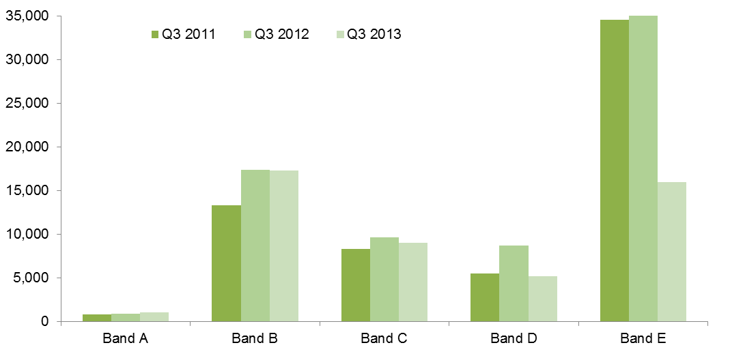

Table 3.7.1: Government subsidised enrolments by trainees by age, 2008–2012

|  |  |  |  |  |  |  |
| --- | --- | --- | --- | --- | --- | --- |
|  | **2008** | **2009** | **2010** | **2011** | **2012** | **% change 2008-2012** |
| 15 to 19 | 21,300 | 20,800 | 22,700 | 26,100 | 25,500 | 20% |
| 20 to 24 | 12,900 | 11,000 | 12,500 | 15,300 | 15,500 | 20% |
| 25 to 44 | 14,500 | 12,400 | 14,800 | 24,600 | 29,600 | 104% |
| 45 to 64 | 4,800 | 4,600 | 6,500 | 13,600 | 18,000 | 276% |
| Under 15, over 64, not stated | 600 | 450 | 300 | 600 | 700 | 10% |
| **Total** | **54,000** | **49,200** | **56,900** | **80,200** | **89,300** | **65%** |

Table 3.7.2: Government subsidised enrolments by trainees by age, Q3 2011, Q3 2012 and Q3 2013

|  |  |  |  |  |  |
| --- | --- | --- | --- | --- | --- |
|  | **Q3 2011** | **Q3 2012** | **Q3 2013** | **% change Q3 2011-Q3 2013** | **% change Q3 2012-Q3 2013** |
| 15 to 19 | 20,800 | 22,400 | 12,100 | -42% | -46% |
| 20 to 24 | 12,900 | 14,200 | 8,500 | -34% | -40% |
| 25 to 44 | 18,700 | 26,600 | 16,700 | -10% | -37% |
| 45 to 64 | 10,000 | 16,200 | 10,800 | 8% | -33% |
| Under 15, over 64, not stated | 250 | 500 | 350 | 35% | -23% |
| **Total** | **62,600** | **79,900** | **48,500** | **-23%** | **-39%** |

Table 3.8.1: Government subsidised enrolments by trainees by qualification level, 2008–2012

|  |  |  |  |  |  |  |
| --- | --- | --- | --- | --- | --- | --- |
|  | **2008** | **2009** | **2010** | **2011** | **2012** | **% change 2008-2012** |
| Cert I-II | 10,200 | 11,100 | 11,700 | 8,900 | 4,200 | -59% |
| Cert III-IV | 42,600 | 36,800 | 42,500 | 62,900 | 72,100 | 69% |
| Diploma & Above | 1,100 | 1,300 | 2,700 | 8,400 | 13,000 | 1128% |

Table 3.8.2: Government subsidised enrolments by trainees by qualification level, Q3 2011, Q3 2012 and Q3 2013

|  |  |  |  |  |  |
| --- | --- | --- | --- | --- | --- |
|  | **Q3 2011** | **Q3 2012** | **Q3 2013** | **% change Q2 2010-Q3 2013** | **% change Q3 2011-Q3 2013** |
| Cert I-II | 7,900 | 3,900 | 2,100 | -73% | -45% |
| Cert III-IV | 48,400 | 64,000 | 40,100 | -17% | -37% |
| Diploma & Above | 6,300 | 12,100 | 6,300 | 0% | -48% |

Table 3.9: Government subsidised enrolments by trainees by industry, Q3 2011, Q3 2012 and Q3 2013

|  |  |  |  |  |  |
| --- | --- | --- | --- | --- | --- |
|  | **Q3 2011** | **Q3 2012** | **Q3 2013** | **% change Q3 2011-Q3 2013** | **% change Q3 2012-Q3 2013** |
| A: Agriculture, Forestry and Fishing | 1,400 | 1,800 | 1,900 | 37% | 1% |
| B: Mining | 10 | 30 | 70 | 825% | 174% |
| C: Manufacturing | 7,400 | 12,800 | 9,300 | 27% | -27% |
| D: Electricity, Gas, Water and Waste Services | 150 | 250 | 150 | 10% | -39% |
| E: Construction | 500 | 750 | 850 | 70% | 10% |
| F: Wholesale Trade | 300 | 500 | 300 | -8% | -41% |
| G: Retail Trade | 14,200 | 16,300 | 6,400 | -55% | -61% |
| H: Accommodation and Food Services | 8,300 | 9,600 | 4,500 | -45% | -53% |
| I: Transport, Postal and Warehousing | 3,900 | 5,400 | 4,900 | 24% | -9% |
| J: Information Media and Telecommunications | 150 | 150 | 200 | 51% | 60% |
| K: Financial and Insurance Services | 400 | 500 | 450 | 15% | -8% |
| L: Rental, Hiring and Real Estate Services | 250 | 350 | 250 | -8% | -37% |
| M: Professional, Scientific and Technical Services | 250 | 300 | 250 | -14% | -27% |
| N: Administrative and Support Services | 5,700 | 6,000 | 3,300 | -43% | -46% |
| O: Public Administration and Safety | 40 | 80 | 200 | 376% | 121% |
| P: Education and Training | 400 | 400 | 1,000 | 146% | 156% |
| Q: Health Care and Social Assistance | 6,500 | 6,900 | 5,800 | -10% | -15% |
| R: Arts and Recreation Services | 2,300 | 2,300 | 950 | -59% | -60% |
| S: Other Services | 500 | 400 | 250 | -49% | -39% |
| T: Cross-industry | 10,100 | 15,000 | 7,400 | -26% | -51% |
| **Total** | **62,600** | **79,900** | **48,500** | **-23%** | **-39%** |

## Training in Specialised and In-Shortage Related Occupations

Vocational training delivery that is meeting the skill requirements of industry is a core focus of the Refocusing VET reforms. In particular, training related to occupations identified as specialised or experiencing skill shortages that[14] enhance the productive capacity of the Victorian economy are a high priority for government investment.

'Specialised occupations’[15] are defined as occupations that have a long lead-time for training, high economic value and a significant match between training and employment.

‘Skill shortages’[16] exist when employers are unable to fill or have considerable difficulty filling vacancies for an occupation, or significant specialised skill needs within that occupation, at current levels of remuneration and conditions of employment, and in reasonably accessible locations.

Note: all data in this section is for government subsidised training by onshore domestic students in accredited AQF qualifications excluding foundation skills, education pathways and low-level LOTE courses.

| Key Points Trends in the third quarter of 2013 indicate a refocusing of the training market towards a higher proportion of training delivery against most critical occupations:   * 148,100 enrolments in qualifications related to specialised or in shortage occupations in Q3 2013. * At Q3 2013 41 per cent of training was for occupations which are either specialised or in shortage. At the same point a year ago (Q3 2012) this figure was 32 per cent. * There is a marked difference between critical 'Specialised or Skill Shortage' occupations (5 per cent growth year on year) compared to 'Non Specialised or Skill Shortage' training (31 per cent decrease). * TAFE providers continue to deliver half of training in qualifications related to specialised or in shortage occupations, followed by private RTOs (45 per cent). * The largest rise in specialised and skill shortage enrolments compared to Q3 2012 have been in qualifications under Band A. |
| --- |

Figure 3.5: Government subsidised training delivery by responsiveness category

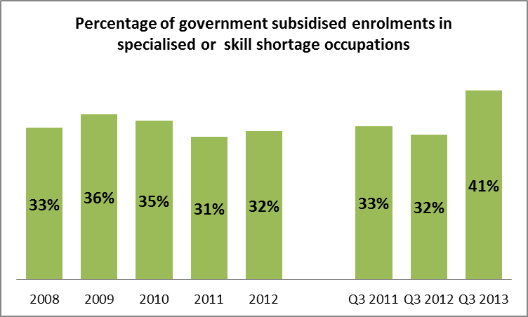

Figure 3.6: Government subsidised enrolments in specialised or skill shortage occupations per training provider type, Q3 2011, Q3 2012 and Q3 2013

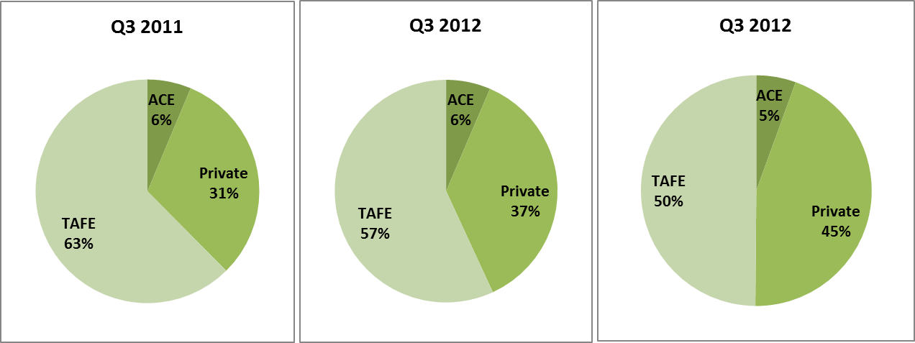

Table 3.10.1: Government subsidised training delivery for qualifications related to either specialised or skill shortage occupations, 2008 - 2012

|  |  |  |  |  |  |  |
| --- | --- | --- | --- | --- | --- | --- |
| **Either Specialised or Skill Shortage Qualifications** | | | | | | |
|  | 2008 | 2009 | 2010 | 2011 | 2012 | % 2008 - 2012 |
| **Enrolments** | 91,400 | 102,600 | 116,500 | 137,300 | 163,100 | 78% |
| **Hours** (millions) | 28.4 | 33.6 | 38.9 | 44.3 | 54.9 | 93% |

Table 3.10.2: Government subsidised training delivery for qualifications related to either specialised or in shortage occupations, Q32011, Q32012 and Q32013

|  |  |  |  |  |  |
| --- | --- | --- | --- | --- | --- |
| **Either Specialised or Skill Shortage Qualifications** | | | | | |
|  | Q3 2011 | Q3 2012 | Q3 2013 | % Q3 2011 - Q3 2013 | % Q3 2012 - Q3 2013 |
| **Enrolments** | 118,600 | 140,900 | 148,100 | 25% | 5% |
| **Hours** (millions) | 42.7 | 51.8 | 57.2 | 34% | 10% |

Table 3.11.1: Government subsidised training delivery for qualifications not related to specialised or skill shortage occupations, 2008 - 2012

|  |  |  |  |  |  |  |
| --- | --- | --- | --- | --- | --- | --- |
| **Not Specialised/Skill shortage Qualifications** | | | | | | |
|  | 2008 | 2009 | 2010 | 2011 | 2012 | % 2008 - 2012 |
| **Enrolments** | 184,700 | 182,500 | 220,300 | 305,500 | 342,300 | 85% |
| **Hours** (millions) | 46.8 | 49.1 | 61.4 | 85.9 | 109.3 | 134% |

Table 3.11.2: Government subsidised training delivery for qualifications related to either specialised or skill shortage occupations, Q32011, Q32012 and Q32013

|  |  |  |  |  |  |
| --- | --- | --- | --- | --- | --- |
| **Not Specialised/ Skill Shortage Qualifications** | | | | | |
|  | Q3 2011 | Q3 2012 | Q3 2013 | % Q3 2011 - Q3 2013 | % Q3 2012 - Q3 2013 |
| **Enrolments** | 236,300 | 305,200 | 211,700 | -10% | -31% |
| **Hours** (millions) | 76.2 | 102.3 | 73.4 | -4% | -28% |

Table 3.12.1: Government subsidised training delivery for qualifications related to specialised occupations, 2008 - 2012

|  |  |  |  |  |  |  |
| --- | --- | --- | --- | --- | --- | --- |
| **Qualifications Related to Specialised Occupations** | | | | | | |
|  | 2008 | 2009 | 2010 | 2011 | 2012 | % 2008 – 2012 |
| **Enrolments** | 57,000 | 59,300 | 64,900 | 72,300 | 80,300 | 41% |
| **Hours** (millions) | 16.6 | 19.6 | 21.1 | 21.8 | 25.9 | 56% |

Table 3.12.2: Government subsidised training delivery for qualifications related to specialised occupations, Q32011, Q32012 and Q32013

|  |  |  |  |  |  |
| --- | --- | --- | --- | --- | --- |
| **Qualifications Related to Specialised Occupations** | | | | | |
|  | Q3 2011 | Q3 2012 | Q3 2013 | % Q3 2011 - Q3 2013 | % Q3 2012 - Q3 2013 |
| **Enrolments** | 63,300 | 69,900 | 75,400 | 19% | 8% |
| **Hours** (millions) | 21.1 | 23.5 | 28.1 | 33% | 20% |

Table 3.13.1: Government subsidised training delivery for qualifications related to skill shortage occupations, 2008 - 2012

|  |  |  |  |  |  |  |
| --- | --- | --- | --- | --- | --- | --- |
| **Qualifications Related to Skill Shortage Occupations** | | | | | | |
|  | 2008 | 2009 | 2010 | 2011 | 2012 | % 2008 – 2012 |
| **Enrolments** | 84,200 | 95,900 | 108,900 | 129,400 | 152,400 | 81% |
| **Hours** (millions) | 26.7 | 31.7 | 36.9 | 42.1 | 50.9 | 90% |

Table 3.13.2: Government subsidised training delivery for qualifications related to skill shortage occupations, Q32011, Q32012 and Q32013

|  |  |  |  |  |  |
| --- | --- | --- | --- | --- | --- |
| **Qualifications Related to Skill Shortage Occupations** | | | | | |
|  | Q3 2011 | Q3 2012 | Q3 2013 | % Q3 2011 - Q3 2013 | % Q3 2012 - Q3 2013 |
| **Enrolments** | 112,600 | 131,900 | 140,100 | 24% | 6% |
| **Hours** (millions) | 40.6 | 48.7 | 53.7 | 32% | 10% |

Table 3.14: Top 10 enrolling specialised or in shortage occupations, 2011, 2012, Q3 2012 and Q3 2013

|  |  |  |  |  |  |
| --- | --- | --- | --- | --- | --- |
| **Occupation** | **2011** | **2012** | **Q3 2012** | **Q3 2013** | **% change Q3 2012 - Q3 2013** |
| Child Carers | 19,700 | 25,600 | 21,900 | 23,700 | 8% |
| Aged and Disabled Carers | 13,000 | 16,900 | 13,800 | 16,500 | 20% |
| Welfare Support Workers | 7,500 | 9,300 | 8,400 | 10,000 | 19% |
| Truck Drivers | 7,500 | 10,700 | 7,500 | 9,700 | 29% |
| Carpenters and Joiners | 9,100 | 8,000 | 7,400 | 7,200 | -3% |
| Electricians | 7,700 | 7,800 | 7,300 | 7,100 | -3% |
| Enrolled and Mothercraft Nurses | 6,400 | 7,200 | 6,800 | 7,000 | 3% |
| Motor Mechanics | 5,200 | 6,600 | 5,400 | 6,900 | 28% |
| Plumbers | 7,100 | 7,200 | 6,800 | 6,600 | -3% |
| Architectural, Building and Surveying Technicians | 3,100 | 5,000 | 4,300 | 4,800 | 12% |
| All other occupations | 50,800 | 58,500 | 51,400 | 48,600 | -5% |
|  |  |  |  |  |  |

The following table highlights industry enrolments in qualifications related to either specialised or in shortage occupations

Table 3.15: Industry enrolments in qualifications related to either specialised or in shortage occupations

|  |  |  |  |  |  |  |  |  |  |  |  |  |
| --- | --- | --- | --- | --- | --- | --- | --- | --- | --- | --- | --- | --- |
| **Industry** | **Enrolments (Total industry specific qualifications)** | | | | | | **Enrolments (Specialised OR In Shortage)** | | | | | |
| **Share Q3 2013** | **Q3 2011** | **Q3 2012** | **Q3 2013** | **% Q3 2011 - Q3 2013** | **% Q3 2012 - Q3 2013** | **Share Q3 2013** | **Q3 2011** | **Q3 2012** | **Q3 2013** | **% Q3 2011 - Q3 2013** | **% Q3 2012 - Q3 2013** |
| Accommodation and Food Services | 6% | 28,300 | 39,500 | 23,100 | -18% | -42% | 5% | 6,600 | 10,700 | 7,800 | -20% | -27% |
| Administrative and Support Services | 3% | 15,200 | 19,900 | 12,200 | -20% | -39% | - | - | - | - | 9% | - |
| Agriculture, Forestry and Fishing | 1% | 7,100 | 8,400 | 5,300 | -25% | -37% | 0% | 700 | 700 | 600 | -14% | -14% |
| Arts and Recreation Services | 4% | 22,700 | 25,600 | 14,100 | -38% | -45% | 1% | 400 | 500 | 1,100 | 175% | 120% |
| Construction | 14% | 41,800 | 44,300 | 49,400 | 18% | 12% | 25% | 30,300 | 32,100 | 36,300 | 20% | 13% |
| *Cross-industry e.g. project managers* | 15% | 62,000 | 84,000 | 52,200 | -16% | -38% | 1% | 3,500 | 3,200 | 2,000 | -43% | -38% |
| Education and Training | 3% | 8,800 | 8,800 | 10,000 | 14% | 14% | 2% | 5,000 | 5,000 | 3,200 | -36% | -36% |
| Electricity, Gas, Water and Waste Services | 0% | 900 | 900 | 600 | -33% | -33% | 0% | 700 | 700 | 500 | -29% | -29% |
| Financial and Insurance Services | 1% | 4,000 | 5,900 | 2,700 | -33% | -54% | 0% | 700 | 800 | 200 | -71% | -75% |
| Health Care and Social Assistance | 20% | 52,800 | 67,600 | 72,500 | 37% | 7% | 44% | 47,500 | 61,000 | 65,300 | 37% | 7% |
| Information Media and Telecommunications | 1% | 3,500 | 3,800 | 3,100 | -11% | -18% | 0% | 500 | 500 | 400 | -20% | -20% |
| Manufacturing | 9% | 26,200 | 35,300 | 32,900 | 26% | -7% | 6% | 8,000 | 8,300 | 8,700 | 9% | 5% |
| Mining | 0% | 200 | 400 | 300 | 50% | -25% | - | - | - | - | - | - |
| Other Services | 5% | 17,300 | 18,300 | 18,100 | 5% | -1% | 4% | 4,100 | 4,800 | 6,000 | 46% | 25% |
| Professional, Scientific and Technical Services | 3% | 12,000 | 11,800 | 9,900 | -18% | -16% | 2% | 3,000 | 3,000 | 2,700 | -10% | -10% |
| Public Administration and Safety | 2% | 5,300 | 6,700 | 6,600 | 25% | -1% | 0% | 300 | 400 | 300 | 0% | -25% |
| Rental, Hiring and Real Estate Services | 0% | 1,300 | 2,100 | 1,500 | 15% | -29% | - | - | - | - | - | - |
| Retail Trade | 4% | 25,500 | 32,500 | 13,200 | 175% | -59% | 1% | 1,200 | 1,500 | 2,000 | 67% | 33% |
| Transport, Postal and Warehousing | 9% | 19,300 | 29,300 | 31,200 | 20% | 6% | 7% | 6,200 | 7,800 | 11,000 | 77% | 41% |
| Wholesale Trade | 0% | 600 | 800 | 800 | -43% | 0% | - | - | - | - | - | - |
| **Total** | 100% | 355,000 | 446,100 | 359,800 | -36% | -19% | 100% | 118,600 | 140,900 | 148,100 | 25% | 5.1% |
|  |  |  |  |  |  |  |  |  |  |  |  |  |

1. TAFE fee for service figures include domestic AQF Level 1 and above. Refer to section on Reporting scope for further detail.
2. The 2012 estimated resident population published by the Australian Bureau of Statistics (Cat 3235.0) were used to calculate the participation rate for each regional area in Q3 2013, as the 2013 population data are not available until 2014.
3. The NCVER publication Apprentices & Trainees, Early trend estimates March Quarter 2013, noted that at a national level “The substantial growth in non-trade commencements up to the June quarter 2012 and the subsequent decline in the September quarter is predominately due to changes to Commonwealth incentive payments for existing workers, namely the removal of the commencement incentive payment for those apprenticeships and traineeships not on the National Skills Needs List. Under the changes, training needed to have commenced prior to 1 July 2012 to attract the old subsidy rate”.
4. Note that a course enrolment indicates an enrolment by a student in specified course at a registered training organisation. Training hours on the other hand measures the hours taken to deliver training. Total student hours is not an indicator of training provider revenue.
5. The 2012 estimated resident population published by the Australian Bureau of Statistics (Cat 3235.0) were used to calculate the participation rate for each regional area in Q3 2013, as the 2013 population data are not yet available.
6. Vulnerable workers tend to be in low-paid jobs, are often under-employed, and face job insecurity and limited job opportunities. They might not be able to access entitlements such as superannuation, sick leave, maternity leave and have little if any access to training and development. For some, their vulnerability stems from low skills or poor qualifications.

   [www.education.vic.gov.au/Documents/about/research/acfepublications/hardtoreachlearn.pdf](http://www.education.vic.gov.au/Documents/about/research/acfepublications/hardtoreachlearn.pdf)
7. Includes all accredited vocational qualifications at Certificate I and above, but excludes generic training such as foundation skills, education pathways and low-level LOTE courses.
8. DEECD subscribes to the Monash CoPS Economic Forecasts Model which provides employment and output forecasts down to the 3-digit ANZSIC level, occupational forecasts down to the 4-digit ANZSCO as well as high level aggregation forecasts of hours worked, and ASCED qualifications attained. This report utilises the COPS five year forecast to 2017 for analysis in the VET Industry Profiles.
9. Cross-industry training (e.g. business administration, recordkeeping, computing) has been removed from the industry-specific analysis as this training develops business skills which are transferable across many industry sectors.
10. Monash Centre for Policy Studies (2012) Employment Forecasting Model.

    Average annual employment needs are average replacement demand and employment growth levels from 2011-12 through to 2016-17.
11. Commencements data is sourced from DEECD’s DELTA system which is used to manage and monitor training contracts. This data is used for this purpose only as the Training Market Quarterly Report is based on VET training activity data.
12. Australian Bureau of Statistics, Building Activity, Australia, 8752.0 Table 34: Number of Dwelling Unit Commencements by Sector, States and Territories. The latest available data was Quarter 2 2013.
13. The NCVER publication Apprentices & Trainees, Early trend estimates March Quarter 2013, noted that at a national level “The substantial growth in non-trade commencements up to the June quarter 2012 and the subsequent decline in the September quarter is predominately due to changes to Commonwealth incentive payments for existing workers, namely the removal of the commencement incentive payment for those apprenticeships and traineeships not on the National Skills Needs List. Under the changes, training needed to have commenced prior to 1 July 2012 to attract the old subsidy rate.”
14. To ensure the most robust alignment with vocational outcomes in the government funded training sector this section is limited to:

    * government subsidised training to onshore domestic students
    * training in accredited AQF qualifications at Certificate I and above i.e. short courses, non-award courses and non-accredited training is excluded
    * excludes courses which cannot be classified directly to an employment outcome in a particular occupation, such as training in generic foundation skills such as literacy and numeracy

   
15. Australian Workforce and Productivity Agency (2012) specialised occupation list.
16. HESG (2012) Skills Shortage list. Skill shortage definition from DEEWR Skills Shortage List