Victorian Training Market Quarterly Report   
Q2 2013

Prepared by Department of Education and  
Early Childhood Development

Melbourne  
September 2013

©State of Victoria (Department of Education  
and Early Childhood Development) 2013

The copyright in this document is owned by the State of Victoria (Department of Education and Early Childhood Development), or in the case of some materials, by third parties (third party materials). No part may be reproduced by any process except in accordance with the provisions of the Copyright Act 1968, the National Education Access Licence for Schools (NEALS) (see below) or with permission.

An educational institution situated in Australia which is not conducted for profit, or a body responsible for administering such an institution may copy and communicate the materials, other than third party materials, for the educational purposes of the institution.

Authorised by the Department of Education  
and Early Childhood Development,   
2 Treasury Place, East Melbourne, Victoria, 3002

Contents

Executive Summary 5

The Policy Context of Vocational Training in Victoria 9

Reporting scope 11

Vocational Training Summary 13

Vocational Training by Funding Type 13

Qualification Levels 17

Age Profile 21

Government Subsidised Regional Activity 23

Government Subsidised Delivery by Provider Type 26

Adult, Community and Further Education (ACFE) Performance 29

Learners Facing Barriers to Participation 33

Vocational Training Delivery to Learner Cohorts Facing Barriers 33

Indigenous Students 34

Students with a Disability 35

Students with a Culturally and Linguistically Diverse (CALD) Background 36

Unemployed Students 37

Young People (Aged 15 to 19) Without Year 12 or Equivalent and Not at School 38

Older Students with Low Prior Qualifications 39

Foundation Level Training 40

Alignment of Training to Industry Skills Needs 43

Appendix 59

Recognition of Prior Learning 59

### Notes on data included in this report

The Victorian Training Market Report is compiled using training activity data submitted to the Department of Education and Early Child Development by funded training providers. Data included in the Report is based on the reported date, i.e. the date training activity data is submitted to the Department.   
Quarter 2 2013 includes training activity data that were submitted to the Department by end of second quarter which reflects training activity during the first six months of 2013.

### Data collection

Data included in this report are a snapshot in time. Quarterly figures for the current year are preliminary as the training activity is still in progress for the year. Therefore, these figures should be treated as indicative only. All data is subject to change until the end of the calendar year.

In some limited cases training activity data can be impacted by system issues, for example some TAFE institutes have informed the Department that they have been unable to report all their enrolments for the previous reporting period due to a backlog arising from the implementation of a new student management system. These enrolments are likely to be reported in the next quarter and will be included in the report to be compiled from full 2013 activity data.

**Data presentation**

Owing to the preliminary nature of this data, the Quarter 2 2013 figures should be treated as being indicative only. Figures are generally rounded to the nearest 100.

# Executive Summary

This Victorian Training Market Quarterly Report for Quarter 2 2013 is the latest in an on-going series of reports produced by the Department of Education and Early Childhood Development (DEECD). The aim of the report is to provide a summary of Victorian vocational education and training (VET) market performance and responsiveness to industry. The second quarter (Q2) report provides an overview based on a snapshot of training activity data as reported at the end of June 2013.

### Context

With expenditure of $2.5 billion in 2012/13, the DEECD has specific responsibility for the government-subsidised Vocational Training market in Victoria to support industry in the provision of a highly skilled and capable workforce. The Victorian system does this through the Victorian Training Guarantee, which provides an unlimited number of government subsidised training places to people who meet the eligibility criteria. In July 2012, further reforms to the system refocused training subsidies away from over-supplied courses or those with little connection to job prospects and productivity towards courses of greatest economic benefit and future jobs growth.

### 2012 Outcomes (full year)

Victoria’s vocational education and training system performs well compared to other Australian jurisdictions. According to data published by the National Centre for Vocational Education Research (NCVER), in 2012 Victoria had the highest overall participation rate in VET of 15 to 64 year olds, higher than the national average and all other states and territories. In addition the numbers of students in the Victorian vocational system was higher than New South Wales (NSW), a state with a larger population, by about 53,000 students. In Australian Qualification Framework (AQF) Level 1 and above courses of study Victoria had about 100,000 more students than in NSW.

Participation in VET by 15 to 64 year olds in 2012, Government funded and public provider fee for service based on 2012 NCVER data and ABS population estimates

The Victorian training market has seen significant growth over the last five years. Between 2008 and 2012 there was a 76 per cent increase in government funded enrolments. Since the introduction of *Refocusing Vocational Training in Victoria (RVT)* reformsthere has been a shift to a greater number of enrolments in courses in “in shortage” skill areas.

In 2012, enrolments for ‘in shortage’ occupations increased by 18 per cent to over 150,000 enrolments and training in specialised qualifications increased by 11 per cent to over 80,000 enrolments.

In 2012 there were 134,300 apprentices and trainees in government subsidised training. This was a 6 per cent increase compared to 2011.

The 2012 year experienced unprecedented growth in government subsidised training; this growth was influenced by changes to Government subsidy arrangements in July of that year. Quarter 2 would normally represent about 60 per cent of reported year to date activity; the 2012 Q2 results represented 68 per cent of reported enrolments in that year.

As the market response to new approach to Government arrangements in 2012 somewhat distort year on year comparisons some caution should be used in making comparisons between quarters, for this reason the report includes comparisons of Q2 2013 with both Q2 2012 and Q2 2011.

### Q2 2013 Overview

Noting the issues associated with the unusually high level of reported delivery in 2012, there were approximately 399,000 government subsidised enrolments in Q2 2013, down 13 per cent when compared to Q2 2012, but still 25 per cent higher than Q2 2011.

There were 64,600 TAFE domestic fee for service[1] enrolments in Q2 2013. This is down by 8 per cent (5,900) compared to Q2 2012, but up by 11 per cent (6,400 additional enrolments) compared to the same period in 2011.

Government subsidised and TAFE Fee for service course enrolments, 2008-2012 and Q2 2011-2013

### 

### Learners facing barriers to participation

Certain groups in the community face barriers to participation in education, training and the workforce. Education and training can be a key mechanism to lift their employment and life opportunities. There were approximately 78,600 unemployed students in government subsidised enrolments in Q2 2013, this was up by 2 per cent on the same period in 2012.

### Government Subsidised Training Delivery by Regional Area

Government subsidised training delivery in each of the department’s four regions follows the state-wide trend that enrolments were lower in Q2 2013 compared to Q2 2012, but higher than Q2 2011. When enrolment data further disaggregated into nine regional areas, the results show a slightly different picture:

* Hume regional area: government subsidised enrolments in Q2 2013 were higher than the corresponding figures over the same period in 2011 and 2012.
* Eastern metropolitan and Gippsland regional areas: government subsidised enrolments in Q2 2013 were lower than the corresponding figures in Q2 2011 and Q2 2012.

Government subsidised enrolments by regional area, Q2 2011- 2013



**Alignment of Government investment in Training to Industry Skills Needs**

Under *RVT* in Victoria subsidises for training have been set to strengthen Government investment in training in specialised skills, training to address skills in shortage and training related to areas of employment opportunity. The reforms also assessed the extent to which government investment is required to stimulate delivery of, and participation in, this training to meet industry needs. Overall, the highest subsidy levels have been provided to courses where contribution to the economy is assessed as high, and where government subsidy is seen as essential in enabling delivery and participation in training.

There has been a marked shift in course commencement patterns since the reforms were introduced in July 2012. Data from Q2 2013 show that 69 per cent of all government subsidised course commencing enrolments were within subsidy bands A and B. This compared with 49 per cent of commencements in subsidy bands A and B over the same period in 2012 (Pre-July 2012, i.e. January-June 2012). Course commencements within subsidy bands D and E were 9 per cent in Q2 2013, reduced from 31 per cent over the same period in 2012.

Government subsidised commencing course enrolments: proportion of commencing enrolments by subsidy band, Pre-July 2012, Q2 2013

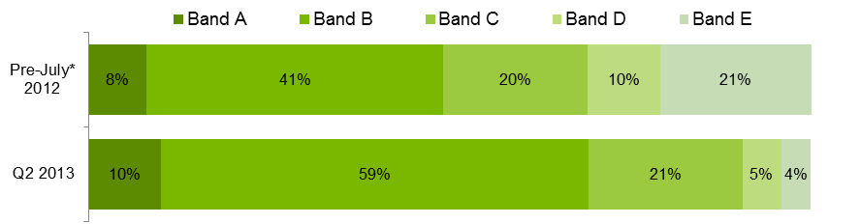

*Pre-July 2012 refers to January to June 2012.

It has been twelve months of market operation under the new market settings announced in 2012. There is early evidence that the introduction of subsidy bands, which saw twenty per cent of Government funded courses either retaining or attracting higher subsidy levels than before and reductions in areas that were experiencing unprecedented growth, has resulted in an adjustment to training demand and with it, a rebalancing of Government investment in the first half of 2013. Such adjustments are broadly aligned with key labour market requirements.

* There is a high correlation between an industry’s share of employment and share of training delivery in Victoria (pp. 45)
* Sectors that provide essential services and infrastructure (e.g. Health Care and Social Assistance, Transport Postal and Warehousing), and which are important to regional economies (Agriculture, Forestry, Fishing, Manufacturing and Mining) received an increase share of government funded enrolments than previous periods (pp. 46).
* There has been a modest increase in training to support specialist and in shortage occupations (and attract higher levels of Government subsidy), even in a period of subdued economic conditions and despite declines in other areas of training (pp. 55).

About 44 per cent of the decrease in government subsidised enrolments in Q2 2013 compared to Q2 2012 can be attributed to a reduction in apprenticeship and traineeship training. In Q2 2013 there were 75,500 government subsidised apprentice and trainee enrolments, which represents a 25 per cent decline (or 25,800 fewer enrolments) compared to Q2 2012.

* Demand for courses that experienced historically high levels of enrolments in 2012 are adjusting to levels more consistent with labour market requirements (pp.46). In particular the dampening in traineeship enrolments is attributable to a number of factors including Commonwealth government incentives[2], State Government subsidy levels and correction to high levels of enrolments in some Traineeship courses which had unprecedented high level of enrolments in 2012.
* 2013 second quarter results show a decline in apprenticeship training in Victoria that is consistent with national trends. While the level of Government subsidy levels for Apprenticeship training has been maintained or increased, dampened business conditions impacting on the construction industry in particular, has impacted on demand for apprentices.

The Q2 2013 results show substantial growth continuing for government subsidised Foundation courses. There were 96,100 government subsidised enrolments in Foundation courses in Q2 2013, this was up by 37 per cent on Q2 2012 and 136 per cent in Q2 2011.

The adjustment of training demand since the introduction of subsidy bands in July 2012 is further supported by Government reforms designed to provide Vocational Education and Training (VET) customers with better information about employment options and related training requirements and providing training providers, industry groups and regional stakeholders with timely information about industry skill requirements and training market responses. The impact of these reforms in particular will deepen as VET customers, RTOs and stakeholders of the training market continue to respond to the market signals that underpin the RVT policy settings.

## The Policy Context of Vocational Training in Victoria

### Reforms to Vocational Training

The introduction of the *Victorian Training Guarantee* (VTG) in 2008 resulted in significant growth in government subsidised activity; however this was not necessarily always in areas of industry and economic need. In response, the Victorian Government released the *Refocusing Vocational Training (RVT) in Victoria* reform package in May 2012. The individual entitlement to a subsidised training place was retained and strengthened to ensure that businesses and students continued to be able to choose what and where they studied. The reform package also made sure that the cost of access remained sustainable and subsidies focused on areas of greatest public value. The public value of each course is assessed on the basis of its value to the economy in terms of jobs or productivity and the extent to which an incentive is needed to stimulate delivery of training by providers and participation by enough students to meet industry needs.

The movement of training uptake in response to subsidy bands introduced in July 2012 is further supported by Government reforms designed to provide Vocational Education and Training (VET) customers with better information about employment options and related training requirements and providing training providers, industry groups and regional stakeholders with timely information about industry skill requirements and training market responses. The impact of these reforms in particular will deepen as VET customers, RTOs and stakeholders of the training market continue to respond to the market signals that underpin the RVT policy settings.

### Strengthening of Contract Management and Market Monitoring

The reform package has led to stronger contract management. Providers seeking to offer government-subsidised training have to meet tough contract standards and there is now a framework which sets out expectations of training providers’ behaviour and contract compliance in a single document. The Victorian Registration and Qualifications Authority undertakes inspection and enforcement of standards and has strong regulatory powers.

Strong performance management and quality assurance outcomes are being delivered by the Market Monitoring Unit which was established as part of the reforms. The Unit is monitoring the efficiency, effectiveness and integrity of the Government’s subsidised training market.

### New Opportunities for Industry Leadership

A new Industry Participation Model has been implemented, which enables direct engagement with industry to ensure the training market is aligned with changes in industry need. The Industry Participation Model is specifically designed to strengthen the role of industry in shaping training market products, services and outcomes. The Department provides industry bodies and employers with channels and tools to communicate their needs and levels of satisfaction to RTOs, peers, potential VET students and Government.

The *Victorian Skills Gateway* website provides high quality accessible information so potential students, employers and industry group can make informed decisions about their training choices. The website includes advice about courses, training providers, possible employment opportunities, and government assistance with the cost of training.

The Department provide the following opportunities to speak directly to Government about what is and isn’t working in the training system and shape sustainable solutions.

* Industry Roundtables – Monthly industry roundtables with the Minister to discuss the needs of specific industries and or regions.
* Industry Skills Consultative Committee (ISCC) – 12 senior members of industry, co-chaired by the Minister and an industry member. The ISCC meets 3 – 4 times a year to identify and address systemic issues hampering the responsiveness of the VET system.
* Issues based ISCC taskforces – the ISCC will auspice issues based taskforces to provide recommendations to Government on appropriate solutions for systemic issues
* DEECD Industry Skills Portfolio Teams focus on annual industry/sector consultations.
* Regional Market Facilitation Managers – ten located across metropolitan and non-metropolitan Victoria, talking directly to employers and VET stakeholders in the region to address their training issues and gather intelligence about training needs and system barriers.
* Industry in Transition and Specialist Training Initiative – funds projects that improve training market responsiveness and outcomes.

### Modernising TAFE

In addition to a focus on improving outcomes for students and industry, RVT in Victoria recognised that a modern vocational training system requires a network of well-functioning and modern TAFE institutes delivering in their areas of strength alongside other providers. As part of the RVT in Victoria reforms, the Government established an independent TAFE Reform Panel, to advise on ways to foster a strong, sustainable TAFE sector in an open and competitive training market. The TAFE Reform Panel’s final report: A Strong and Sustainable Victorian TAFE sector provides findings and 19 recommendations relating specifically to the state’s 14 TAFE institutes and four dual-sector universities. The Government has responded to these recommendations in *Next Steps for RVT in Victoria – Supporting a Modern Workforce*.

To strengthen Victorian TAFEs and encourage innovation in training delivery, the Government is:

* Providing $200 million for business transformation;
* Modernising constitutions and commercial objectives;
* Giving TAFEs greater control of assets;
* Reducing regulatory burden;
* Allowing TAFEs own control over work place relations;
* Removing the restrictions on TAFE being registered as Group Training Organisations;
* Reclassifying TAFE dual-sector.

### Recent refinements

Recently further refinements to subsidy arrangements were made to address some market distortions related to Foundation course and Recognition of Prior Learning.

* The Government also identified concerns with the consistency and quality of foundation skills training, including insufficient evidence of student need and training providers operating in a manner that was not consistent with the spirit of the policy. People who already have highly developed literacy, numeracy and workplace skills shouldn’t be put through unnecessary foundation skills courses. Nor do we want to see learners repeating multiple foundation skills courses, without gaining the skills they need to successfully complete a vocational qualification or progress through their career.
* Recognition of prior learning helps improve the skill levels of Victorians in a modern economy. It is an efficient way of targeting training to identified skill gaps. For people working in industries going through significant transitions, it is a way of demonstrating their skills and qualifications to a new employer. However, there was evidence of provider-led growth in the higher subsidy levels in RPL delivery, which attracted a full 100 per cent subsidy, whilst RPL delivery in lower subsidy levels, which receives a 50 per cent subsidy, declined.

The Government has implemented these changes to better target training support within the existing eligibility rules. It is anticipated that these refinements will dampen the significant growth recently seen in RPL and Foundation training growth in the future.

Notes about the data

This Report includes key metrics, such as training delivery by funding source, qualification level and age of learners, higher needs learners and regional activity. An analysis of the responsiveness of training delivery to specific occupational needs and industry are also provided.

The main source of vocational training statistics in this publication is the training activity database referred to as Skills Victoria Training System (SVTS). All government subsidised providers are required to submit their data using SVTS at least once a month in accordance with the Australian Vocational Education & Training Management Information Statistical Standard (AVETMISS). For TAFE Institutes, there is an additional regulatory requirement that they also submit their fee for service data.

For comparative purpose, this report includes most recent historical data on training activity over the same period in 2011 and 2012. Full year data between 2008 and 2012 are included to show longer term trends.

Data included in the report are a snapshot in time and based on data as reported to Higher Education and Skills Group (HESG) in the Department by training providers. Caution should be exercised when comparing current year data against figures over the same period in previous years. This is due to the way training providers upload their VET activity data which is not necessarily undertaken in a uniform manner while the training year is still in progress. In addition, adjustments are required to be made to VET activity data by providers after the end of a reporting period due to students withdrawing from modules or entire courses. In some limited cases some providers may not have fully submitted their data by end of second quarter which could marginally impact on the overall state result. Therefore, owing to the preliminary nature of VET data while the year is underway, figures reported for the end of second quarter in 2013 should be treated as being indicative only.

In some limited cases training activity data can be impacted by system issues, for example some TAFE institutes have informed the Department that they have been unable to report all their enrolments for the previous reporting period due to a backlog arising from the implementation of a new student management system. It is therefore important to note that the preliminary 2013 data may be an undercount of the actual enrolments. It is anticipated that these enrolments will be included in the full year report for 2013 to be compiled in early 2014.

The Q2 2013 data were extracted from SVTS as at 30 July 2013. Figures may be revised slightly prior to submission to National Centre for Vocational Education and Research (NCVER).

Annual data included in this report may differ from data released by the NCVER due to use of different definitional rules.

Annual data included in this report may differ to those in previous publications as the DEECD is continuously updating classifications to improve data quality and consistency across years. For example the apportionment of enrolments between the apprentice/trainee categories is marginally different to what was reported previously, this is a result of a correction to the classification of some courses.

Data shown in the tables are rounded to the nearest 100 when the figures are greater than 1,000; to the nearest 50 when they are between 100 and 1,000; and to the nearest 10 when they are less than 100. The percentage changes between figures in Q2 2011 & Q2 2013, and Q2 2012 & Q2 2013 are calculated based on the reported data.

## Reporting scope

This report includes government subsidised activities in all sectors at all qualification levels, and domestic fee for service activities in the TAFE sector at Australian Qualification Framework (Certificate I and above).

Fee for service activities below Certificate I in the domestic TAFE sector are not included, such as short courses. Fee for service activities that took place in the private RTO and Adult Community Education sectors are also outside the scope.

Since 2012, the scope of reporting of government subsidised training changed. ZC - Corrections delivery contracted directly with TAFE Institutes and ZP - Corrections funding through private prisons have been allocated to fee for service funding. Prior to 2012, these funded enrolments were allocated to government subsidised training.

# Vocational Training Summary

## Vocational Training by Funding Type

### Vocational Training Delivery by Funding Type

This section provides an overview of training activity measured in terms of course enrolments, student contact hours and student numbers.

|  |
| --- |
| Key Points The Q2 2013 data shows that:   * There were 399,000 government subsidised course enrolments, 119.7 million government subsidised student contact hours and 307,700 government subsidised students. * TAFE domestic fee for service activity at Australian Qualification Framework (AQF) Level 1 and above recorded 64,600 enrolments, 12.2 million student contact hours and 56,200 students. |

Table 1.1.1: Enrolments in vocational training by funding type, 2008–2012

|  |  |  |  |  |  |  |
| --- | --- | --- | --- | --- | --- | --- |
|  | **2008** | **2009** | **2010** | **2011** | **2012** | **% change 2008-2012** |
| Government subsidised | 381,300 | 376,800 | 426,900 | 548,700 | 670,400 | 76% |
| TAFE domestic fee for service* | 89,400 | 100,800 | 103,700 | 102,200 | 124,900 | 40% |
| **Total** | **470,700** | **477,600** | **530,600** | **650,900** | **795,300** | **69%** |

* Fee for Service figures are TAFE on-shore domestic AQF Level 1 and above.

Table 1.1.2: Enrolments in vocational training by funding type, Q2 2011, Q2 2012 and Q2 2013

|  |  |  |  |  |  |
| --- | --- | --- | --- | --- | --- |
|  | **Q2 2011** | **Q2 2012** | **Q2 2013** | **% change Q2 2011-Q2 2013** | **% change Q2 2012-Q2 2013** |
| Government subsidised | 320,400 | 458,100 | 399,000 | 25% | -13% |
| TAFE domestic fee for service* | 58,200 | 70,500 | 64,600 | 11% | -8% |
| **Total** | **378,600** | **528,600** | **463,600** | **22%** | **-12%** |

*Fee for Service figures are TAFE on-shore domestic AQF Level 1 and above.

Figure 1.1: Enrolments in vocational training by funding type, 2008–2012, Q2 2011, Q2 2012 and Q2 2013

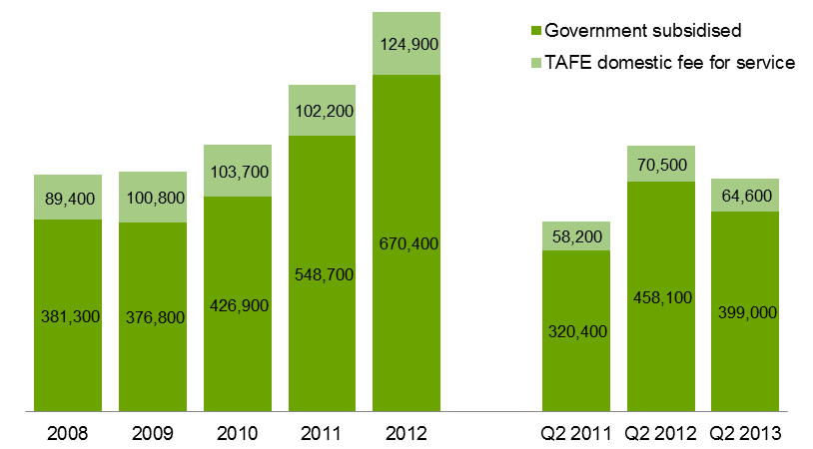

Table 1.2.1: Student contact hours[3] (millions) by funding type, 2008–2012

|  |  |  |  |  |  |  |
| --- | --- | --- | --- | --- | --- | --- |
|  | **2008** | **2009** | **2010** | **2011** | **2012** | **% change 2008-2012** |
| Government subsidised | 87.4 | 95.6 | 112.4 | 146.9 | 188.8 | 116% |
| TAFE domestic fee for service* | 17.1 | 20.4 | 19.4 | 18.5 | 21.9 | 28% |
| **Total** | **104.5** | **116.0** | **131.8** | **165.5** | **210.7** | **102%** |

*Fee for Service figures are TAFE on-shore domestic AQF Level 1 and above.

Table 1.2.2: Student contact hours (millions) by funding type, Q2 2011, Q2 2012 and Q2 2013

|  |  |  |  |  |  |
| --- | --- | --- | --- | --- | --- |
|  | **Q2 2011** | **Q2 2012** | **Q2 2013** | **% change Q2 2011-Q2 2013** | **% change Q2 2012-Q2 2013** |
| Government subsidised | 99.0 | 136.5 | 119.7 | 21% | -12% |
| TAFE domestic fee for service* | 11.8 | 13.6 | 12.2 | 3% | -11% |
| **Total** | **110.8** | **150.1** | **131.9** | **19%** | **-12%** |

*Fee for Service figures are TAFE on-shore domestic AQF Level 1 and above.

Figure 1.2: student contact hours (millions) by funding type, 2008–2012, Q2 2011, Q2 2012 and Q2 2013

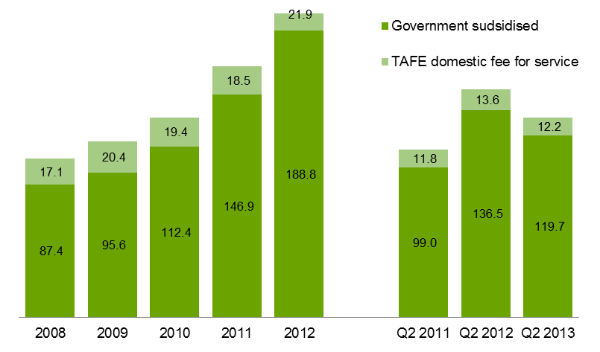

Table 1.3.1: Number of students by funding type, 2008–2012

|  |  |  |  |  |  |  |
| --- | --- | --- | --- | --- | --- | --- |
|  | **2008** | **2009** | **2010** | **2011** | **2012** | **% change 2008-2012** |
| Government subsidised | 294,700 | 299,600 | 339,200 | 430,300 | 509,800 | 73% |
| TAFE domestic fee for service* | 80,400 | 93,100 | 96,000 | 94,200 | 105,200 | 31% |
| **Total\*\*** | **366,700** | **381,300** | **422,500** | **512,900** | **603,200** | **64%** |

*Fee for Service figures are TAFE on-shore domestic AQF Level 1 and above.

**TAFE students whose enrolments are made up of a combination of government subsidies and self-funding have been counted in both funding categories. The total, however, has eliminated the duplicates.

Table 1.3.2: Number of students by funding type, Q2 2011, Q2 2012 and Q2 2013

|  |  |  |  |  |  |
| --- | --- | --- | --- | --- | --- |
|  | **Q2 2011** | **Q2 2012** | **Q2 2013** | **% change Q2 2011-Q2 2013** | **% change Q2 2012-Q2 2013** |
| Government subsidised | 268,000 | 356,900 | 307,700 | 15% | -14% |
| TAFE domestic fee for service* | 54,800 | 62,500 | 56,200 | 3% | -10% |
| **Total\*\*** | **317,000** | **413,100** | **357,300** | **13%** | **-14%** |

*Fee for Service figures are TAFE on-shore domestic AQF Level 1 and above.

**TAFE students whose enrolments are made up of a combination of government subsidies and self-funding have been counted in both funding categories. The total, however, has eliminated the duplicates.

Figure 1.3: Number of students by funding type, 2008–2012, Q2 2011, Q2 2012 and Q2 2013

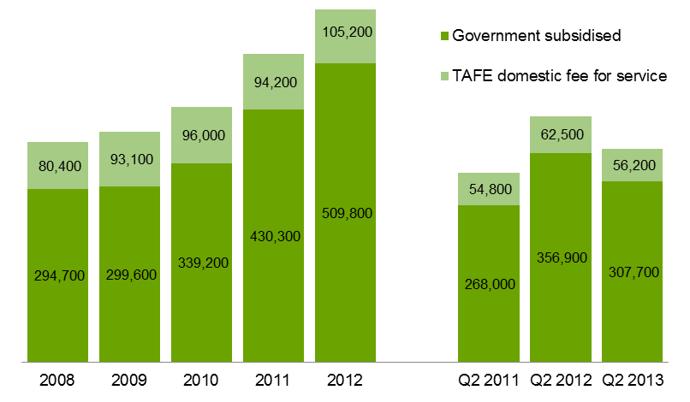

## Qualification Levels

State and Commonwealth governments want students to obtain qualifications, rather than take short courses (e.g. through module only delivery). Lower level qualifications such as Certificate I and II, provide literacy, numeracy, and work preparation skills to people without post-school qualifications so that they have the opportunity to go on to further study or find employment.

Mid-level skills are essential to the Victorian economy and help drive economic activity across the state. A significant proportion of apprenticeships and traineeships entail attainment of a mid-level qualification and are crucial to many key industries. Apprenticeships and traineeships are undertaken as a contract between the apprentice/trainee and an employer. While undertaking on-the-job learning, the apprentice/trainee receives complementary training through a vocational training provider.

Higher level qualifications have grown in demand by industry and the labour market, with the demand for high level skills growing at 2.5 times the rate of unskilled jobs[4]. To meet this demand, state and Commonwealth governments have focused on raising the qualification profile of Australians over the last decade. Higher level vocational training qualifications (diploma and above) can provide entry to higher skilled jobs and to further study – including at university level where vocational training graduates may be able to obtain credits towards their studies.

### Vocational Training Delivery by Qualification Level, Government Subsidised Enrolments

| Key Points  * Government subsidised enrolments at the Certificate I to II levels (non-Foundation) were 25,100 in Q2 2013. The number of government subsidised enrolments in Certificate III-IV courses were 201,900 in Q2 2013. * Proportionally Certificate III-IV (non-Foundation) represented the largest qualification group of non-Foundation courses of study. * Government subsidised enrolment at the Certificate I to II level (Foundation) were 77,500 in Q2 2013. The number of government subsidised enrolments in Certificate III-IV (Foundation) courses were 13,700 in Q2 2013. |
| --- |

Table 1.4.1: Government subsidised enrolments (non-Foundation) by qualification level, 2008–2012

|  |  |  |  |  |  |  |
| --- | --- | --- | --- | --- | --- | --- |
| **Qualification level** | **2008** | **2009** | **2010** | **2011** | **2012** | **% change 2008-2012** |
| Cert I-II | 65,100 | 65,100 | 73,400 | 79,900 | 64,100 | -1% |
| Cert III-IV | 158,800 | 159,100 | 194,800 | 278,400 | 348,400 | 119% |
| Diploma & Above | 55,700 | 63,700 | 71,200 | 90,300 | 94,800 | 70% |
| Module Only | 50,200 | 40,700 | 37,300 | 30,300 | 30,600 | -39% |
| Secondary, SoA and other | 20,600 | 20,300 | 19,500 | 15,900 | 14,100 | -32% |
| **Total (excl foundation courses)** | **350,400** | **348,900** | **396,200** | **494,900** | **552,000** | **58%** |

SoA – Statement of Attainment.

Table 1.4.2: Government subsidised enrolments (non-Foundation) by qualification level, Q2 2011, Q2 2012 and Q2 2013

|  |  |  |  |  |  |
| --- | --- | --- | --- | --- | --- |
| **Qualification level** | **Q2 2011** | **Q2 2012** | **Q2 2013** | **% change Q2 2011-Q2 2013** | **% change Q2 2012-Q2 2013** |
| Cert I-II | 41,400 | 44,000 | 25,100 | -39% | -43% |
| Cert III-IV | 162,400 | 241,600 | 201,900 | 24% | -16% |
| Diploma & Above | 62,900 | 77,000 | 53,700 | -15% | -30% |
| Module Only | 13,200 | 12,700 | 12,800 | -2% | 1% |
| Secondary, SoA and other | 9,000 | 9,300 | 9,400 | 4% | 1% |
| **Total (excl foundation courses)** | **288,800** | **384,500** | **302,900** | **5%** | **-21%** |

SoA – Statement of Attainment.

Table 1.5.1: Government subsidised enrolments (Foundation) by qualification level, 2008–2012

|  |  |  |  |  |  |  |
| --- | --- | --- | --- | --- | --- | --- |
| **Qualification level** | **2008** | **2009** | **2010** | **2011** | **2012** | **% change 2008-2012** |
| Cert I-II | 22,100 | 18,500 | 20,400 | 39,500 | 90,600 | 310% |
| Cert III-IV | 6,600 | 6,800 | 6,900 | 9,500 | 17,600 | 167% |
| Secondary, SoA and other | 2,200 | 2,600 | 3,400 | 4,900 | 10,300 | 359% |
| **Total** | **30,900** | **27,900** | **30,700** | **53,900** | **118,500** | **283%** |

SoA – Statement of Attainment.

Table 1.5.2: Government subsidised enrolments (Foundation) by qualification level, Q2 2011, Q2 2012 and Q2 2013

|  |  |  |  |  |  |
| --- | --- | --- | --- | --- | --- |
| **Qualification level** | **Q2 2011** | **Q2 2012** | **Q2 2013** | **% change Q2 2011-Q2 2013** | **% change Q2 2012-Q2 2013** |
| Cert I-II | 22,900 | 57,100 | 77,500 | 239% | 36% |
| Cert III-IV | 6,000 | 10,100 | 13,700 | 128% | 36% |
| Secondary, SoA and other | 2,700 | 6,500 | 4,800 | 80% | -25% |
| **Total** | **31,600** | **73,600** | **96,100** | **204%** | **31%** |

SoA – Statement of Attainment.

### Vocational Training Delivery by Qualification Level, TAFE Domestic Fee for Service Enrolments

| Key Points  * Proportionally, enrolments in Certificate I-II (non-Foundation) were the largest qualification group amongst TAFE domestic fee for service enrolments across Australian Qualification Framework courses. |
| --- |

Table 1.6.1: TAFE domestic fee for service enrolments (non-Foundation) by qualification level (AQF1+), 2008–2012

|  |  |  |  |  |  |  |
| --- | --- | --- | --- | --- | --- | --- |
| **Qualification level** | **2008** | **2009** | **2010** | **2011** | **2012** | **% change 2008-2012** |
| Cert I-II | 33,200 | 41,200 | 44,200 | 43,200 | 46,300 | 39% |
| Cert III-IV | 38,300 | 41,200 | 40,500 | 40,900 | 52,900 | 38% |
| Diploma & Above | 7,300 | 8,000 | 8,300 | 8,500 | 10,200 | 39% |
| Higher Education | 750 | 1,000 | 1,300 | 1,400 | 1,600 | 118% |
| **Total (excl foundation courses)** | **79,500** | **91,400** | **94,300** | **94,100** | **110,900** | **39%** |

Table 1.6.2: TAFE domestic fee for service enrolments (non-Foundation) by qualification level (AQF1+), Q2 2011, Q2 2012 and Q2 2013

|  |  |  |  |  |  |
| --- | --- | --- | --- | --- | --- |
| **Qualification level** | **Q2 2011** | **Q2 2012** | **Q2 2013** | **% change Q2 2011-Q2 2013** | **% change Q2 2012-Q2 2013** |
| Cert I-II | 25,200 | 27,100 | 24,200 | -4% | -10% |
| Cert III-IV | 22,100 | 27,200 | 23,300 | 6% | -14% |
| Diploma & Above | 5,200 | 6,800 | 6,800 | 31% | 0% |
| Higher Education | 1,300 | 1,400 | 1,300 | 2% | -4% |
| **Total (excl foundation courses)** | **53,666** | **62,370** | **55,606** | **4%** | **-11%** |

Table 1.7.1: TAFE domestic fee for service enrolments (Foundation) by qualification level (AQF1+),   
2008–2012

|  |  |  |  |  |  |  |
| --- | --- | --- | --- | --- | --- | --- |
| **Qualification level** | **2008** | **2009** | **2010** | **2011** | **2012** | **% change 2008-2012** |
| Cert I-II | 8,100 | 7,200 | 7,300 | 6,300 | 11,500 | 42% |
| Cert III-IV | 1,700 | 2,200 | 2,100 | 1,900 | 2,500 | 40% |
| **Total** | **9,900** | **9,400** | **9,400** | **8,100** | **13,900** | **41%** |

Table 1.7.2: TAFE domestic fee for service enrolments (Foundation) by qualification level (AQF1+),   
Q2 2011, Q2 2012 and Q2 2013

|  |  |  |  |  |  |
| --- | --- | --- | --- | --- | --- |
| **Qualification level** | **Q2 2011** | **Q2 2012** | **Q2 2013** | **% change Q2 2011-Q2 2013** | **% change Q2 2012-Q2 2013** |
| Cert I-II | 3,500 | 6,700 | 7,400 | 112% | 11% |
| Cert III-IV | 1,000 | 1,500 | 1,600 | 54% | 9% |
| **Total** | **4,545** | **8,159** | **9,026** | **99%** | **11%** |

### Vocational Training Delivery by Qualification Level, Government Subsidised Student Contact Hours

|  |
| --- |
| Key Points  * Government subsidised student contact hours at Certificate I to II levels in Q2 2013 were 19.5 million hours, 65 per cent of these contact hours were in delivery of foundation courses of study. |

Table 1.8.1: Government subsidised student contact hours (millions) by qualification level, 2008–2012

|  |  |  |  |  |  |  |
| --- | --- | --- | --- | --- | --- | --- |
| **Qualification level** | **2008** | **2009** | **2010** | **2011** | **2012** | **% change 2008-2012** |
| Cert I-II | 14.2 | 15.2 | 17.5 | 22.6 | 27.9 | 97% |
| Cert III-IV | 44.9 | 48.8 | 59.1 | 81.7 | 112.8 | 151% |
| Diploma & Above | 22.9 | 26.0 | 30.9 | 36.2 | 41.2 | 79% |
| Module Only | 1.4 | 1.6 | 1.6 | 1.3 | 1.4 | 0% |
| Secondary, SoA and other | 3.9 | 4.0 | 3.3 | 5.2 | 5.5 | 40% |
| **Total** | **87.4** | **95.6** | **112.4** | **146.9** | **188.8** | **116%** |

SoA: Statement of Attainment.

Table 1.8.2: Government subsidised student contact hours (millions) by qualification level, Q2 2011,   
Q2 2012 and Q2 2013

|  |  |  |  |  |  |
| --- | --- | --- | --- | --- | --- |
| **Qualification level** | **Q2 2011** | **Q2 2012** | **Q2 2013** | **% change Q2 2011-Q2 2013** | **% change Q2 2012-Q2 2013** |
| Cert I-II | 13.8 | 18.8 | 19.5 | 42% | 4% |
| Cert III-IV | 52.8 | 77.6 | 69.0 | 31% | -11% |
| Diploma & Above | 28.8 | 34.7 | 25.8 | -10% | -26% |
| Module Only | 0.6 | 0.7 | 0.7 | 6% | 3% |
| Secondary, SoA and other | 3.0 | 4.7 | 4.8 | 58% | 3% |
| **Total** | **99.0** | **136.5** | **119.7** | **21%** | **-12%** |

SoA: Statement of Attainment.

Figure 1.4: Government subsidised student contact hours by qualification level (AQF1+ only), Q2 2012 and Q2 2013

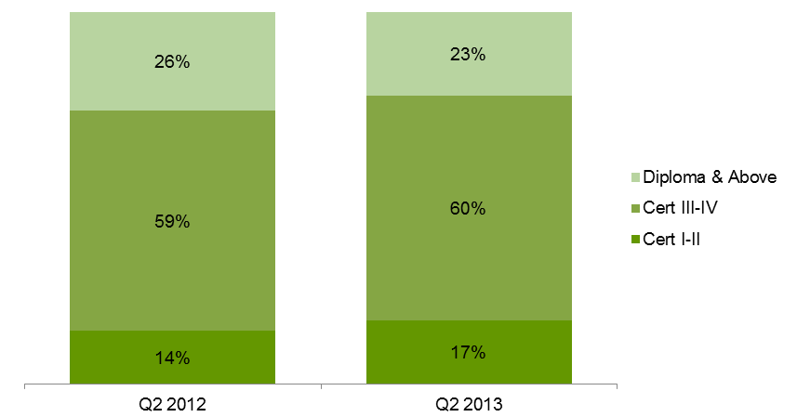

## Age Profile

### Vocational Training Delivery by Age Group

To enable the increased workforce participation levels required by the Victorian economy over the next decade, improved engagement with education and training by all age groups is required. The vocational training system is also focused on accessibility and gender equality, ensuring all Victorians have the same opportunity to succeed in their lives and maintain well-being through education and training.

### Students by Age Group in Government Subsidised Training

|  |
| --- |
| Key Points  * The number of government subsidised students was 307,700 in Q2 2013. Students aged 15 to 24 accounted for 44 per cent of all government subsidised students. * Aged 15-19 is the only age cohort with student numbers in Q2 2013 lower than the numbers for the same age group in Q2 2011 and Q2 2012. |

Table 1.9.1: Government subsidised students by age group, 2008–2012

|  |  |  |  |  |  |  |
| --- | --- | --- | --- | --- | --- | --- |
| **Age group** | **2008** | **2009** | **2010** | **2011** | **2012** | **% change 2008-2012** |
| 15 to 19 | 74,400 | 76,000 | 88,300 | 108,700 | 120,500 | 62% |
| 20 to 24 | 58,800 | 59,200 | 71,400 | 87,800 | 100,900 | 72% |
| 25 to 44 | 99,700 | 102,400 | 112,600 | 148,500 | 180,200 | 81% |
| 45 to 64 | 51,100 | 52,900 | 60,200 | 77,100 | 96,400 | 89% |
| Under 15, over 64, not stated | 10,700 | 9,200 | 6,700 | 8,100 | 11,800 | 10% |
| **Total** | **294,700** | **299,600** | **339,200** | **430,300** | **509,800** | **73%** |

Table 1.9.2: Government subsidised students by age group, Q2 2011, Q2 2012 and Q2 2013

|  |  |  |  |  |  |
| --- | --- | --- | --- | --- | --- |
| **Age group** | **Q2 2011** | **Q2 2012** | **Q2 2013** | **% change Q2 2011-Q2 2013** | **% change Q2 2012-Q2 2013** |
| 15 to 19 | 70,800 | 87,300 | 69,000 | -2% | -21% |
| 20 to 24 | 60,900 | 76,700 | 67,500 | 11% | -12% |
| 25 to 44 | 88,300 | 122,500 | 108,700 | 23% | -11% |
| 45 to 64 | 44,100 | 63,600 | 56,200 | 27% | -12% |
| Under 15, over 64, not stated | 3,900 | 6,900 | 6,300 | 62% | -8% |
| **Total** | **268,000** | **356,900** | **307,700** | **15%** | **-14%** |

### TAFE Domestic Fee for Service Students by Age Group

|  |
| --- |
| Key Points  * The number of students enrolled in TAFE domestic fee for service at AQF Level 1 and above was 56,200 in Q2 2013. Forty per cent of students were aged between 15 and 24 years. * Similar to the trend in government subsidised provision, aged 15-19 is the only age cohort with student numbers in Q2 2013 lower than the corresponding numbers in Q2 2011 and Q2 2012. |

Table 1.10.1: TAFE domestic fee for service (AQF1+): students by age group, 2008–2012

|  |  |  |  |  |  |  |
| --- | --- | --- | --- | --- | --- | --- |
| **Age group** | **2008** | **2009** | **2010** | **2011** | **2012** | **% change 2008-2012** |
| 15 to 19 | 22,900 | 26,400 | 28,800 | 28,300 | 28,900 | 26% |
| 20 to 24 | 9,300 | 11,100 | 11,400 | 10,300 | 11,600 | 25% |
| 25 to 44 | 29,700 | 34,800 | 34,500 | 34,100 | 40,600 | 37% |
| 45 to 64 | 16,500 | 18,400 | 19,300 | 19,500 | 22,100 | 34% |
| Under 15, over 64, not stated | 2,000 | 2,400 | 2,100 | 2,100 | 2,000 | -3% |
| **Total** | **80,400** | **93,100** | **96,000** | **94,200** | **105,200** | **31%** |

Table 1.10.2: TAFE domestic fee for service (AQF1+): students by age group, Q2 2011, Q2 2012   
and Q2 2013

|  |  |  |  |  |  |
| --- | --- | --- | --- | --- | --- |
| **Age group** | **Q2 2011** | **Q2 2012** | **Q2 2013** | **% change Q2 2011-Q2 2013** | **% change Q2 2012-Q2 2013** |
| 15 to 19 | 20,000 | 19,500 | 15,900 | -20% | -18% |
| 20 to 24 | 6,300 | 7,000 | 6,500 | 3% | -8% |
| 25 to 44 | 18,000 | 22,900 | 22,000 | 23% | -4% |
| 45 to 64 | 9,600 | 12,200 | 11,000 | 15% | -10% |
| Under 15, over 64, not stated | 950 | 900 | 800 | -18% | -12% |
| **Total** | **54,800** | **62,500** | **56,200** | **3%** | **-10%** |

## Government Subsidised Regional Activity

Government subsidised enrolment numbers are presented for the four departmental regions for the purpose of providing an overview of regional training activity. In this report government subsidised enrolments are further disaggregated into nine regional areas to provide more granular level of detail on training activity.

South-Western departmental region comprises Barwon South West, Grampians and Western Metropolitan regional areas. North-Western departmental region comprises Loddon Mallee and Northern Metropolitan regional areas. North-Eastern departmental region comprises Hume and Eastern Metropolitan regional areas. South-Eastern departmental region comprises Gippsland and Southern Metropolitan regional areas.

Enrolment figures presented in this section refer to delivery activity at the regional level and do not necessarily reflect local participation.

|  |
| --- |
| Key Points  * Similar to the overall state-wide trend, government subsidised enrolment numbers across four department administrative regions (delivery location) in Q2 2013 were lower compared to Q1 2012, but higher compared to Q2 2011. * Further disaggregation of regions’ data into nine regional areas, the Q2 2013 data show three regional areas experiencing different enrolment trends compared to the state-wide picture: Hume regional area has a 30 per cent increase in government subsidised enrolments compared to Q2 2012 and 89 per cent increase compared to Q2 2011. However, the results for Gippsland and Eastern Metropolitan regional areas in Q2 2013 were lower than those in Q2 2011 and Q2 2012. * The growth in government subsidised enrolments in Hume in Q2 2013 has occurred across all Australian Qualification Levels: Certificate I to II (up 40 per cent), Certificate III to IV (up 32 per cent) and Diploma & Above (up 3 per cent) compared to Q2 2012. The large increase in enrolments in Hume regional area was associated with:   + Increase in course enrolments at Certificate I to II levels that was mainly driven by a significant increase in foundation skills courses (up 165 per cent, from 2,300 in Q2 2012 to 6,000 in Q2 2013).   + Enrolments that have been increasing from Q2 2011, Q2 2012 to Q2 2013 are found in industry sectors, such as:     - Education and Training (from 250 in Q2 2011 to 2,100 in Q2 2013);     - Health Care and Social Assistance (from 2,400 in Q2 2011 to 3,900 in Q2 2013);     - Manufacturing (from 2,300 in Q2 2011 to 2,600 in Q2 2013).     - Transport, Postal and Warehousing (from 950 in Q2 2011 to 1,600 in Q2 2013); * Government subsidised enrolments in Gippsland regional area in Q2 2013 were 19 per cent lower than Q2 2011 and 25 per cent lower than Q2 2012. The declines in enrolments were across almost all industry sectors, except Transport, Postal and Warehousing which has increased from 160 in Q2 2011 to 590 in Q2 2013. * Government subsidised enrolments in Eastern Metropolitan regional area in Q2 2013 were 9 per cent lower than Q2 2011 and 18 per cent lower than Q2 2012. The declines in enrolments were across all industry sectors. |

Table 1.11.1: Government subsidised enrolments by departmental region, 2008–2012

|  |  |  |  |  |  |  |
| --- | --- | --- | --- | --- | --- | --- |
| **Delivery Location** | **2008** | **2009** | **2010** | **2011** | **2012** | **% change 2008-2012** |
| South-Western | 119,600 | 115,800 | 139,400 | 202,900 | 267,800 | 124% |
| North-Western | 70,500 | 80,300 | 84,700 | 101,500 | 124,400 | 77% |
| North-Eastern | 84,700 | 78,200 | 84,800 | 100,900 | 110,400 | 30% |
| South-Eastern | 90,300 | 90,000 | 104,300 | 128,100 | 157,100 | 74% |
| **All regions total** | **364,400** | **363,900** | **412,600** | **532,200** | **656,800** | **80%** |
| Other* | 17,400 | 13,400 | 15,100 | 17,600 | 15,000 | -13% |
| **Total VET** | **381,300** | **376,800** | **426,900** | **548,700** | **670,400** | **76%** |

*Other: online and workplace delivery.

Table 1.11.2: Government subsidised enrolments by departmental region, Q2 2011, Q2 2012   
and Q2 2013

|  |  |  |  |  |  |
| --- | --- | --- | --- | --- | --- |
| **Delivery Location** | **Q2 2011** | **Q1 2012** | **Q1 2013** | **% change Q2 2011-Q1 2013** | **% change Q2 2012-Q2 2013** |
| South-Western | 114,900 | 183,500 | 155,500 | 35% | -15% |
| North-Western | 60,900 | 83,800 | 72,800 | 20% | -13% |
| North-Eastern | 65,300 | 78,200 | 74,300 | 14% | -5% |
| South-Eastern | 72,600 | 104,400 | 91,200 | 26% | -13% |
| **All regions total** | **313,200** | **448,400** | **392,200** | **25%** | **-13%** |
| Other* | 7,500 | 10,400 | 7,300 | -2% | -29% |
| **Total VET** | **633,600** | **906,500** | **791,200** | **50%** | **-25%** |

*Other: online and workplace delivery.

Table 1.12.1: Government subsidised enrolments by regional area, 2008–2012

|  |  |  |  |  |  |  |
| --- | --- | --- | --- | --- | --- | --- |
| **Delivery Location** | **2008** | **2009** | **2010** | **2011** | **2012** | **% change 2008-2012** |
| Barwon South West | 28,800 | 31,800 | 35,800 | 50,100 | 62,500 | 117% |
| Grampians | 14,600 | 16,200 | 15,000 | 17,200 | 18,900 | 29% |
| Loddon Mallee | 23,600 | 27,900 | 28,300 | 32,800 | 37,100 | 57% |
| Hume | 29,100 | 26,000 | 24,700 | 27,300 | 34,400 | 18% |
| Gippsland | 26,700 | 22,400 | 22,500 | 20,500 | 19,700 | -26% |
| Eastern Metropolitan | 55,500 | 52,200 | 60,100 | 73,600 | 76,000 | 37% |
| Western Metropolitan | 76,300 | 67,900 | 88,600 | 135,800 | 186,400 | 144% |
| Southern Metropolitan | 63,600 | 67,700 | 81,800 | 107,600 | 137,400 | 116% |
| Northern Metropolitan | 46,900 | 52,400 | 56,400 | 68,700 | 87,300 | 86% |
| **Total Regions total** | **364,400** | **363,900** | **412,600** | **532,200** | **656,800** | **80%** |

Table 1.12.2: Government subsidised enrolments by regional area, Q2 2011, Q2 2012 and Q2 2013

|  |  |  |  |  |  |  |
| --- | --- | --- | --- | --- | --- | --- |
| **Delivery Location** | **Q2 2011** | | **Q2 2012** | **Q2 2013** | **% change Q2 2011-Q2 2013** | **% change Q2 2012-Q2 2013** |
| Barwon South West | | 28,300 | 46,100 | 31,000 | 10% | -33% |
| Grampians | | 10,400 | 12,600 | 11,200 | 8% | -11% |
| Loddon Mallee | | 19,600 | 25,800 | 20,800 | 6% | -20% |
| Hume | | 15,100 | 22,100 | 28,700 | 89% | 30% |
| Gippsland | | 12,300 | 13,300 | 10,000 | -19% | -25% |
| Eastern Metropolitan | | 50,100 | 56,100 | 45,800 | -9% | -18% |
| Western Metropolitan | | 76,200 | 124,900 | 113,400 | 49% | -9% |
| Southern Metropolitan | | 60,300 | 91,100 | 81,200 | 35% | -11% |
| Northern Metropolitan | | 41,300 | 58,000 | 52,000 | 26% | -10% |
| **Total Regions total** | | **313,200** | **448,400** | **392,200** | **25%** | **-13%** |

## Government Subsidised Delivery by Provider Type

### Government subsidised delivery

|  |
| --- |
| Key Points  * TAFE and Private RTOs sectors had almost equal numbers of government subsidised enrolments as at Q2 2013, i.e. each provider sector captured a 45 per cent share in government subsidised enrolments. * The proportional share of government subsidised delivery at AQF levels in TAFE, Private RTOs and ACE sectors suggests each sector has a different focus with various strengths and specialisation in the courses that they delivered. * For example, the TAFE sector had a large share of government subsidised enrolments in Mining, Electricity, Gas, Water & Waste Services, Construction, Information Media & Telecommunications, and Professional, Scientific and Technical Services in Q2 2013. Private RTOs sector had a large share of delivery in Wholesale Trade, Retail Trade, Accommodation & Food Services, Transport, Postal & Warehousing, Financial & Insurance Services, and Administrative & Support Services. * In terms of the proportional share of delivering government subsidised training within the sector, Foundation Skills and LOTE enrolments accounted for the largest area of training in both TAFE and ACE sectors (34 per cent and 50 per cent, respectively). For the Private RTOs sector, Health Care and Social Assistance had the largest share (18 per cent). * Government subsidised enrolments at Certificate III and IV levels made up the largest share of qualifications in TAFE (46 per cent) and Private RTOs (69 per cent). |

Table 1.13: Government subsidised delivery by provider number*, 2008–2012, Q2 2011, Q2 2012 and   
Q2 2013

|  |  |  |  |  |  |  |  |  |  |
| --- | --- | --- | --- | --- | --- | --- | --- | --- | --- |
|  | **2008** | **2009** | **2010** | **2011** | **2012** |  | **Q2 2011** | **Q2 2012** | **Q2 2013** |
| ACE | 342 | 320 | 316 | 309 | 298 |  | 274 | 271 | 251 |
| PRIV | 201 | 246 | 344 | 422 | 445 |  | 377 | 423 | 416 |
| TAFE | 18 | 18 | 18 | 18 | 18 |  | 18 | 18 | 18 |

* The above providers include those providing pre-accredited and accredited subsidised training. The number of training providers with a 2013 Service Agreement was 488 as at September 2013

Table 1.14.1: Government subsidised enrolments by provider type, 2008–2012

|  |  |  |  |  |  |  |
| --- | --- | --- | --- | --- | --- | --- |
|  | **2008** | **2009** | **2010** | **2011** | **2012** | **% change 2008-2012** |
| ACE | 73,800 | 68,300 | 63,800 | 64,600 | 80,200 | 9% |
| PRIV | 54,000 | 57,400 | 99,800 | 220,700 | 308,800 | 472% |
| TAFE | 253,500 | 251,100 | 263,300 | 263,500 | 281,400 | 11% |
| **Total** | **381,300** | **376,800** | **426,900** | **548,700** | **670,400** | **76%** |

Table 1.14.2: Government subsidised enrolments by provider type, Q2 2011, Q2 2012 and Q2 2013

|  |  |  |  |  |  |
| --- | --- | --- | --- | --- | --- |
|  | **Q2 2011** | **Q2 2012** | **Q2 2013** | **% change Q2 2011-Q2 2013** | **% change Q2 2012-Q2 2013** |
| ACE | 32,500 | 45,100 | 40,000 | 23% | -11% |
| PRIV | 112,000 | 200,500 | 179,900 | 61% | -10% |
| TAFE | 175,900 | 212,500 | 179,100 | 2% | -16% |
| **Total** | **320,400** | **458,100** | **399,000** | **25%** | **-13%** |

Figure 1.5: Government subsidised enrolments by provider type, Q2 2012 and Q2 2013

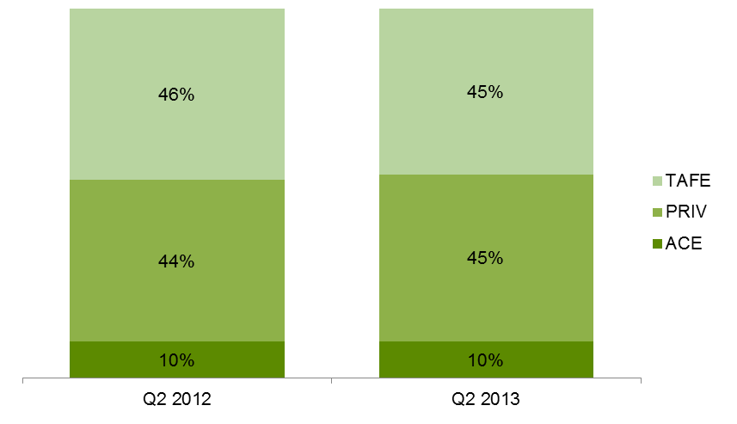

Table 1.15: Government subsidised enrolments (AQF1+), proportional share across provider types by industry, Q2 2013

|  |  |  |  |  |
| --- | --- | --- | --- | --- |
|  | **TAFE** | **Private RTOs** | **ACE** | **Total (number)** |
| A: Agriculture, Forestry and Fishing | 54% | 45% | 2% | 4,100 |
| B: Mining | 83% | 17% | 0% | 250 |
| C: Manufacturing | 38% | 62% | 0% | 26,500 |
| D: Electricity, Gas, Water and Waste Services | 74% | 26% | 0% | 350 |
| E: Construction | 69% | 30% | 0% | 37,600 |
| F: Wholesale Trade | 19% | 81% | 1% | 600 |
| G: Retail Trade | 24% | 73% | 3% | 10,900 |
| H: Accommodation and Food Services | 25% | 72% | 3% | 17,000 |
| I: Transport, Postal and Warehousing | 21% | 79% | 0% | 20,900 |
| J: Information Media and Telecommunications | 84% | 14% | 2% | 2,600 |
| K: Financial and Insurance Services | 12% | 88% | 0% | 2,000 |
| L: Rental, Hiring and Real Estate Services | 45% | 55% | 0% | 1,200 |
| M: Professional, Scientific and Technical Services | 95% | 5% | 0% | 8,600 |
| N: Administrative and Support Services | 27% | 70% | 3% | 9,500 |
| O: Public Administration and Safety | 34% | 66% | 0% | 4,500 |
| P: Education and Training | 48% | 42% | 10% | 7,700 |
| Q: Health Care and Social Assistance | 31% | 58% | 11% | 56,300 |
| R: Arts and Recreation Services | 54% | 43% | 4% | 11,800 |
| S: Other Services | 54% | 43% | 3% | 14,400 |
| T: Cross-industry | 27% | 69% | 4% | 42,700 |
| U: Foundation Skills and LOTE | 64% | 24% | 12% | 92,300 |
| Not applicable / Unknown | 8% | 14% | 78% | 80 |
| **Total (AQF1+)** | **46%** | **48%** | **6%** | **371,900** |

Table 1.16: Government subsidised enrolments (AQF1+), summary of selected characteristics within provider type, Q2 2013



## Adult, Community and Further Education (ACFE) Performance

### ACFE Accredited and Pre-accredited enrolments

| Key Points  * Accredited enrolments were 61 per cent of all delivery reported by ACFE providers in Q2 2013 (24,500 course enrolments). The industry sectors with greatest course enrolments were Foundation Skills and LOTE courses, at 13,500 course enrolments, and Health Care and Social Assistance at 6,100 course enrolments. * Pre-accredited enrolments at 15,500 included an additional purchased 1,100 reported enrolments, represent an across the board increase in purchased delivery with particular emphasis on increasing digital literacy. |
| --- |

Table 1.17.1: Government subsidised ACFE enrolments, 2008-2012

|  |  |  |  |  |  |  |
| --- | --- | --- | --- | --- | --- | --- |
|  | **2008** | **2009** | **2010** | **2011** | **2012** | **% change 2008-2012** |
| Accredited | 27,900 | 30,200 | 27,100 | 33,300 | 45,800 | 64% |
| Pre-Accredited | 45,800 | 38,100 | 36,700 | 31,200 | 34,500 | -25% |

Table 1.17.2: Government subsidised ACFE enrolments, Q2 2011, Q2 2012 and Q2 2013

|  |  |  |  |  |  |
| --- | --- | --- | --- | --- | --- |
|  | **Q2 2011** | **Q2 2012** | **Q2 2013** | **% change Q2 2011 - Q2 2013** | **% change Q2 2012 - Q2 2013** |
| Accredited | 19,500 | 30,800 | 24,500 | 25% | -20% |
| Pre-Accredited | 12,900 | 14,300 | 15,500 | 20% | 8% |

Table 1.18.1: Government subsidised ACFE student contact hours (millions), 2008-2012

|  |  |  |  |  |  |  |
| --- | --- | --- | --- | --- | --- | --- |
|  | **2008** | **2009** | **2010** | **2011** | **2012** | **% change 2008-2012** |
| Accredited | 5.4 | 6.6 | 6.7 | 8.5 | 11.9 | 120% |
| Pre-Accredited | 1.7 | 1.6 | 1.9 | 1.5 | 1.7 | 0.2% |

Table 1.18.2: Government subsidised ACFE student contact hours (millions), Q2 2011, Q2 2012 and   
Q2 2013

|  |  |  |  |  |  |
| --- | --- | --- | --- | --- | --- |
|  | **Q2 2011** | **Q2 2012** | **Q2 2013** | **% change Q2 2011 - Q2 2013** | **% change Q2 2012 - Q2 2013** |
| Accredited | 5.3 | 8.3 | 6.9 | 30% | -17% |
| Pre-Accredited | 0.7 | 0.8 | 0.9 | 34% | 14% |

|  |  |  |  |  |  |  |  |  |  |  |  |  |  |  |  |  |  |  |  |  |  |  |  |  |  |  |  |  |  |  |  |  |  |  |  |  |  |  |  |  |  |  |  |  |  |  |  |  |  |  |  |  |  |  |  |  |  |  |  |  |  |  |  |  |  |  |  |  |  |  |  |  |  |  |  |  |  |  |  |  |  |  |  |  |  |  |  |  |  |  |  |  |  |  |  |  |  |
| --- | --- | --- | --- | --- | --- | --- | --- | --- | --- | --- | --- | --- | --- | --- | --- | --- | --- | --- | --- | --- | --- | --- | --- | --- | --- | --- | --- | --- | --- | --- | --- | --- | --- | --- | --- | --- | --- | --- | --- | --- | --- | --- | --- | --- | --- | --- | --- | --- | --- | --- | --- | --- | --- | --- | --- | --- | --- | --- | --- | --- | --- | --- | --- | --- | --- | --- | --- | --- | --- | --- | --- | --- | --- | --- | --- | --- | --- | --- | --- | --- | --- | --- | --- | --- | --- | --- | --- | --- | --- | --- | --- | --- | --- | --- | --- | --- | --- |
| ACFE students by regional area  | Key Points  * The South-Western Region reported the greatest volume of combined pre-accredited and accredited delivery in a given Region, at 8,500 course enrolments. The Adult Education Institutes reported 9 per cent (2,900 enrolments) of all combined pre-accredited and accredited delivery in Q2 2013. * Within the Departmental regions, the North Western metropolitan regional area reported the greatest single volume of activity in Q2 2013, at 7,800 course enrolments. Barwon South Western was the non-metropolitan regional area with greatest reported activity, at 3,300 course enrolments. | | --- |   Table 1.19.1: Government subsidised ACFE students by departmental region, accredited and  pre-accredited, 2008-2012   |  |  |  |  |  |  |  | | --- | --- | --- | --- | --- | --- | --- | | **Delivery Location** | **2008** | **2009** | **2010** | **2011** | **2012** | **% change 2008-2012** | | South-Western | 10,600 | 11,200 | 10,800 | 13,500 | 19,700 | 85% | | North-Western | 9,600 | 9,500 | 9,700 | 9,700 | 11,500 | 20% | | North-Eastern | 12,100 | 10,800 | 9,500 | 8,800 | 9,500 | -22% | | South-Eastern | 13,600 | 12,000 | 11,400 | 10,900 | 11,900 | -13% | | AEIs | 4,100 | 4,000 | 3,900 | 3,900 | 4,900 | 19% | | **Total** | **50,000** | **47,500** | **45,400** | **46,700** | **57,400** | **15%** |   AEIs: Adult Education Institutes  Table 1.19.2: Government subsidised ACFE students by departmental region, accredited and  pre-accredited, Q2 2011, Q2 2012 and Q2 2013   |  |  |  |  |  |  | | --- | --- | --- | --- | --- | --- | | **Delivery Location** | **Q2 2011** | **Q2 2012** | **Q2 2013** | **% change Q2 2011 - Q2 2013** | **% change Q2 2012 - Q2 2013** | | South-Western | 6,700 | 12,300 | 8,500 | 26% | -31% | | North-Western | 5,500 | 6,400 | 7,200 | 30% | 13% | | North-Eastern | 4,900 | 6,200 | 5,000 | 2% | -19% | | South-Eastern | 6,200 | 7,100 | 7,000 | 13% | -1% | | AEIs | 2,500 | 3,000 | 2,900 | 16% | -4% | | **Total** | **25,800** | **34,900** | **30,600** | **18%** | **-12%** |   AEIs: Adult Education Institutes  Figure 1.6: Government subsidised ACFE students by regional area, accredited and pre-accredited,  Q2 2011, Q2 2012 and Q2 2013 | | | | | |
|  | | | | | |
| BSW | Barwon South West | HUM | Hume | NWM | North Western Metropolitan |
| GRA | Grampians | GIP | Gippsland | SM | Southern Metropolitan |
| LMR | Loddon Mallee | EM | Eastern Metropolitan | AEIs | Adult Education Institutes |

### ACFE students by higher needs categories

| Key Points  * Unemployed students made up the largest number of higher needs students at ACFE organisations and Adult Education Institutions, followed by students from a CALD background or vulnerable workers. * The smallest student count of higher needs learners in the quarter were Indigenous learners, being 1.7 per cent of all students enrolled with ACFE providers (500 students). Indigenous learners are overrepresented within ACFE delivery this quarter, as Indigenous Victorians comprised 0.7 per cent of the state’s population in the 2011 census. |
| --- |

Table 1.20.1: Government subsidised hard to reach students, accredited and pre-accredited Learn Local Organisations and Adult Education Institutions, 2008-2012

|  |  |  |  |  |  |  |
| --- | --- | --- | --- | --- | --- | --- |
|  | **2008** | **2009** | **2010** | **2011** | **2012** | **% change 2008-2012** |
| CALD (LOTE) | 9,600 | 10,000 | 9,900 | 11,400 | 14,500 | 51% |
| Disability | 7,700 | 7,300 | 8,000 | 8,800 | 10,800 | 39% |
| Disengaged Youth | 2,100 | 2,200 | 2,300 | 3,000 | 4,100 | 96% |
| Early school leavers | 12,800 | 12,000 | 11,000 | 11,500 | 13,600 | 6% |
| Indigenous | 700 | 550 | 650 | 750 | 900 | 35% |
| Males 45 to 64 | 4,300 | 4,200 | 4,200 | 4,300 | 5,000 | 15% |
| Unemployed | 10,800 | 11,900 | 12,000 | 13,900 | 18,700 | 73% |
| Vulnerable workers | 9,500 | 9,000 | 9,100 | 9,900 | 11,700 | 24% |

Note: Hard to reach categories are not mutually exclusive.

Table 1.20.2: Government subsidised hard to reach students, accredited and pre-accredited Learn Local Organisations and Adult Education Institutions, Q2 2011, Q2 2012 and Q2 2013

|  |  |  |  |  |  |
| --- | --- | --- | --- | --- | --- |
|  | **Q2 2011** | **Q2 2012** | **Q2 2013** | **% change Q2 2011 - Q2 2013** | **% change Q2 2012 - Q2 2013** |
| CALD (LOTE) | 6,400 | 8,700 | 8,700 | 37% | 0% |
| Disability | 5,300 | 6,800 | 6,600 | 26% | -3% |
| Disengaged Youth | 1,600 | 2,800 | 2,300 | 42% | -17% |
| Early school leavers | 6,400 | 8,300 | 6,900 | 8% | -17% |
| Indigenous | 400 | 500 | 500 | 27% | 3% |
| Males 45 to 64 | 2,200 | 2,700 | 2,500 | 16% | -7% |
| Unemployed | 7,300 | 11,000 | 9,800 | 34% | -11% |
| Vulnerable workers | 5,600 | 7,200 | 7,200 | 29% | -1% |

Note: Hard to reach categories are not mutually exclusive.

# Learners Facing Barriers to Participation

## Vocational Training Delivery to Learner Cohorts Facing Barriers

Young people and adult learners who may be members of more than one equity group, can have complex and multiple learning needs, and may have contact with a suite of government services and programs. There is a significant evidence base that demonstrates the value and importance of education and training to these population cohorts. However, higher needs learners may face a combination of barriers to effective engagement in education and training including low levels of previous educational achievement, low aspirations, and poor access to training and broader barriers such as poverty, homelessness and poor health.

Vocational training has continued to be a critical enabler in opening up pathways for higher needs and disadvantaged learners through the provision of tailored, individualised services, often in partnership with other service providers.

Table 2.1.1: Government subsidised students by selected learner cohort*, 2008 – 2012

|  |  |  |  |  |  |  |
| --- | --- | --- | --- | --- | --- | --- |
|  | **2008** | **2009** | **2010** | **2011** | **2012** | **% change 2008-2012** |
| Indigenous | 4,400 | 4,300 | 4,800 | 5,600 | 6,200 | 42% |
| Students with a disability | 23,900 | 23,600 | 27,200 | 34,100 | 40,300 | 68% |
| CALD | 58,100 | 62,100 | 70,600 | 97,300 | 126,400 | 117% |
| Unemployed | 41,800 | 50,200 | 62,500 | 89,300 | 118,500 | 184% |
| Aged 15-19 without year 12, not at school and enrolled in Cert II or above | 23,100 | 22,600 | 26,300 | 28,900 | 29,500 | 28% |
| Aged 20-64 not holding a Cert III or above | 125,700 | 131,800 | 149,600 | 214,000 | 266,200 | 112% |

*The above cohorts of students are not mutually exclusive.

Table 2.1.2: Government subsidised students by selected learner cohort*, Q2 2011, Q2 2012 and Q2 2013

|  |  |  |  |  |  |
| --- | --- | --- | --- | --- | --- |
|  | **Q2 2011** | **Q2 2012** | **Q2 2013** | **% change Q2 2011-Q2 2013** | **% change Q2 2012-Q2 2013** |
| Indigenous | 3,500 | 4,100 | 3,900 | 13% | -5% |
| Students with a disability | 22,200 | 27,600 | 26,400 | 19% | -4% |
| CALD | 58,300 | 84,900 | 80,700 | 39% | -5% |
| Unemployed | 53,000 | 77,000 | 78,600 | 48% | 2% |
| Aged 15-19 without year 12, not at school and enrolled in Cert II or above | 19,600 | 21,500 | 16,700 | -15% | -22% |
| Aged 20-64 not holding a Cert III or above | 131,700 | 184,500 | 163,050 | 24% | -12% |

*The above cohorts of students are not mutually exclusive.

## Indigenous Students

### Enrolments

|  |
| --- |
| Key Points  * There were 3,900 Indigenous students enrolled in 5,200 government subsidised courses in Q2 2013. * Proportionally, more than half of Australian Qualification Framework course enrolments (52 per cent) undertaken by Indigenous students in Q2 2013 were in Certificate III to IV levels. * Of those enrolments in industry-specific qualifications (3,400 enrolments) which exclude foundation skills and short courses in Q2 2013, 40 per cent were in courses related to specialised or in shortage occupations. |

Table 2.2.1: Indigenous students: Government subsidised enrolments by qualification level, 2008 – 2012

|  |  |  |  |  |  |  |
| --- | --- | --- | --- | --- | --- | --- |
| **Qualification level** | **2008** | **2009** | **2010** | **2011** | **2012** | **% change 2008-2012** |
| Cert I-II | 3,200 | 2,500 | 2,800 | 3,200 | 2,900 | -10% |
| Cert III-IV | 2,000 | 2,200 | 2,300 | 3,100 | 3,600 | 77% |
| Diploma & Above | 350 | 400 | 450 | 550 | 600 | 68% |
| Module Only | 850 | 400 | 400 | 400 | 500 | -42% |
| Secondary, SoA and other | 550 | 700 | 650 | 350 | 600 | 4% |
| **Total** | **7,000** | **6,200** | **6,600** | **7,600** | **8,200** | **16%** |

SoA: Statement of Attainment.

Table 2.2.2: Indigenous students: Government subsidised enrolments by qualification level, Q2 2011, Q2 2012 and Q2 2013

|  |  |  |  |  |  |
| --- | --- | --- | --- | --- | --- |
| **Qualification level** | **Q2 2011** | **Q2 2012** | **Q2 2013** | **% change Q2 2011-Q2 2013** | **% change Q2 2012-Q2 2013** |
| Cert I-II | 1,600 | 1,800 | 1,800 | 14% | 5% |
| Cert III-IV | 1,900 | 2,600 | 2,400 | 25% | -8% |
| Diploma & Above | 400 | 500 | 400 | 1% | -16% |
| Module Only | 100 | 200 | 150 | 29% | -17% |
| Secondary, SoA and other | 300 | 300 | 400 | 46% | 36% |
| **Total** | **4,300** | **5,300** | **5,200** | **20%** | **-2%** |

SoA: Statement of Attainment.

## Students with a Disability

### Enrolments

|  |
| --- |
| Key Points  * There were 26,400 students with a disability enrolled in 36,000 government subsidised courses in Q2 2013. * About forty five per cent of AQF course enrolments undertaken by students with disability were in Certificate I to II levels. * Of those enrolments in industry-specific qualifications (18,000 enrolments) which exclude foundation skills and short courses in Q2 2013, 36 per cent were in courses related to specialised or in shortage occupations. |

Table 2.3.1: Students with a disability: government subsidised enrolments by qualification level,   
2008 – 2012

|  |  |  |  |  |  |  |
| --- | --- | --- | --- | --- | --- | --- |
| **Qualification level** | **2008** | **2009** | **2010** | **2011** | **2012** | **% change 2008-2012** |
| Cert I-II | 13,300 | 11,200 | 12,400 | 16,300 | 20,000 | 50% |
| Cert III-IV | 8,600 | 9,000 | 11,000 | 16,500 | 21,200 | 145% |
| Diploma & Above | 3,300 | 3,600 | 4,000 | 4,900 | 5,000 | 50% |
| Module Only | 8,300 | 8,400 | 8,300 | 7,200 | 7,700 | -8% |
| Secondary, SoA and other | 2,800 | 2,500 | 2,800 | 3,200 | 3,800 | 39% |
| **Total** | **36,300** | **34,700** | **38,400** | **48,000** | **57,600** | **59%** |

SoA: Statement of Attainment.

Table 2.3.2: Students with a disability: government subsidised enrolments by qualification level,  
Q2 2011, Q2 2012 and Q2 2013

|  |  |  |  |  |  |
| --- | --- | --- | --- | --- | --- |
| **Qualification level** | **Q2 2011** | **Q2 2012** | **Q2 2013** | **% change Q2 2011-Q2 2013** | **% change Q2 2012-Q2 2013** |
| Cert I-II | 9,600 | 12,900 | 13,500 | 40% | 4% |
| Cert III-IV | 10,100 | 14,500 | 13,200 | 30% | -9% |
| Diploma & Above | 3,800 | 4,300 | 3,100 | -18% | -27% |
| Module Only | 3,400 | 3,500 | 3,600 | 8% | 5% |
| Secondary, SoA and other | 1,800 | 2,300 | 2,600 | 46% | 11% |
| **Total** | **28,700** | **37,500** | **36,000** | **26%** | **-4%** |

SoA: Statement of Attainment.

## Students with a Culturally and Linguistically Diverse (CALD) Background

### Enrolments

|  |
| --- |
| Key Points  * There were 80,700 students from a CALD background enrolled in 104,200 government subsidised courses in Q2 2013. More than half (56 per cent) of course enrolments at AQF Level 1 and above were in Certificate III to IV levels. * Enrolments in Diploma and above courses undertaken by students from a CALD background in Q2 2013 were lower than the corresponding figures in Q2 2011 and Q2 2012. * Of those enrolments in industry-specific qualifications (66,000 enrolments) which exclude foundation skills and short courses in Q2 2013, 44 per cent were in courses related to specialised or in shortage occupations. |

Table 2.4.1: Students from a CALD background: government subsidised enrolments by qualification level, 2008 – 2012

|  |  |  |  |  |  |  |
| --- | --- | --- | --- | --- | --- | --- |
| **Qualification level** | **2008** | **2009** | **2010** | **2011** | **2012** | **% change 2008-2012** |
| Cert I-II | 19,800 | 20,100 | 20,400 | 28,500 | 41,600 | 110% |
| Cert III-IV | 30,000 | 30,700 | 38,500 | 62,000 | 88,900 | 196% |
| Diploma & Above | 13,400 | 15,700 | 17,300 | 22,400 | 23,200 | 73% |
| Module Only | 13,000 | 11,600 | 12,100 | 11,700 | 10,700 | -17% |
| Secondary, SoA and other | 5,000 | 5,400 | 5,400 | 6,200 | 8,400 | 67% |
| **Total** | **81,100** | **83,500** | **93,800** | **130,700** | **172,800** | **113%** |

SoA: Statement of Attainment.

Table 2.4.2: Students from a CALD background: government subsidised enrolments by qualification level,   
Q2 2011, Q2 2012 and Q2 2013

|  |  |  |  |  |  |
| --- | --- | --- | --- | --- | --- |
| **Qualification level** | **Q2 2011** | **Q2 2012** | **Q2 2013** | **% change Q2 2011-Q2 2013** | **% change Q2 2012-Q2 2013** |
| Cert I-II | 15,600 | 26,300 | 28,100 | 80% | 7% |
| Cert III-IV | 33,500 | 57,400 | 53,800 | 60% | -6% |
| Diploma & Above | 15,400 | 18,300 | 13,800 | -10% | -25% |
| Module Only | 5,000 | 4,500 | 4,900 | -2% | 9% |
| Secondary, SoA and other | 3,300 | 5,600 | 3,700 | 14% | -34% |
| **Total** | **72,800** | **112,100** | **104,300** | **43%** | **-7%** |

SoA: Statement of Attainment.

## Unemployed Students

### Enrolments

|  |
| --- |
| Key Points  * The number of government subsidised course enrolments undertaken by unemployed students in Q2 2013 was 105,400 which were undertaken by 78,600 unemployed students. About one in two AQF courses enrolled in by unemployed students was in Certificate III to IV levels. * Enrolments in Diploma and above courses undertaken by unemployed students in Q2 2013 were lower than the corresponding figures in Q2 2011 and Q2 2012. * Of those enrolments in industry-specific qualifications (64,500 enrolments) which exclude foundation skills and short courses in Q2 2013, 38 per cent were in courses related to specialised or in shortage occupations. |

Table 2.5.1: Unemployed students: government subsidised enrolments by qualification level, 2008 – 2012

|  |  |  |  |  |  |  |
| --- | --- | --- | --- | --- | --- | --- |
| **Qualification level** | **2008** | **2009** | **2010** | **2011** | **2012** | **% change 2008-2012** |
| Cert I-II | 18,800 | 21,600 | 25,700 | 37,000 | 54,100 | 188% |
| Cert III-IV | 17,400 | 21,200 | 30,200 | 54,500 | 77,200 | 344% |
| Diploma & Above | 9,100 | 10,700 | 13,200 | 16,600 | 15,700 | 72% |
| Module Only | 13,000 | 11,700 | 10,600 | 8,300 | 7,900 | -39% |
| Secondary, SoA and other | 5,300 | 6,000 | 6,300 | 6,500 | 8,000 | 52% |
| **Total** | **63,600** | **71,200** | **86,000** | **123,000** | **162,900** | **156%** |

SoA: Statement of Attainment.

Table 2.5.2: Unemployed students: government subsidised enrolments by qualification level, Q2 2011, Q2 2012 and Q2 2013

|  |  |  |  |  |  |
| --- | --- | --- | --- | --- | --- |
| **Qualification level** | **Q2 2011** | **Q2 2012** | **Q2 2013** | **% change Q2 2011-Q2 2013** | **% change Q2 2012-Q2 2013** |
| Cert I-II | 19,900 | 31,900 | 38,300 | 93% | 20% |
| Cert III-IV | 29,500 | 51,300 | 48,900 | 66% | -5% |
| Diploma & Above | 12,700 | 13,400 | 10,200 | -20% | -24% |
| Module Only | 3,400 | 3,000 | 3,400 | -1% | 12% |
| Secondary, SoA and other | 3,500 | 5,000 | 4,600 | 31% | -7% |
| **Total** | **68,900** | **104,600** | **105,400** | **53%** | **1%** |

SoA: Statement of Attainment.

## Young People (Aged 15 to 19) Without Year 12 or Equivalent and Not at School

### Enrolments

|  |
| --- |
| Key Points  * The total number of government subsidised enrolments at Certificate II and above of young people without a Year 12 or equivalent and not in school was 19,300 Q1 2013. This number is lower than the corresponding figures in Q2 2011 and Q2 2012. * Of those enrolments in industry-specific qualifications (16,300 enrolments) which exclude foundation skills courses in Q2 2013, 44 per cent were in courses related to specialised or in shortage occupations. |

Table 2.6.1: Youth transition: government subsidised enrolments Cert II and above by students aged 15 to 19 who did not complete Year 12 or equivalent and not at school, 2008 – 2012

|  |  |  |  |  |  |  |
| --- | --- | --- | --- | --- | --- | --- |
|  | **2008** | **2009** | **2010** | **2011** | **2012** | **% change 2008-2012** |
| Cert II | 8,300 | 8,600 | 10,900 | 12,700 | 12,000 | 44% |
| Cert III-IV | 16,500 | 15,800 | 18,400 | 20,400 | 22,100 | 34% |
| Diploma & Above | 650 | 800 | 850 | 1,100 | 900 | 45% |
| **Total** | **25,500** | **25,200** | **30,100** | **34,100** | **35,000** | **37%** |

Table 2.6.2: Youth transition: government subsidised enrolments Cert II and above by students aged 15 to 19 who did not complete Year 12 or equivalent and not at school, Q2 2011, Q2 2012 and Q2 2013

|  |  |  |  |  |  |
| --- | --- | --- | --- | --- | --- |
|  | **Q2 2011** | **Q2 2012** | **Q2 2013** | **% change Q2 2011-Q2 2013** | **% change Q1 2012-Q1 2013** |
| Cert II | 7,500 | 8,600 | 6,300 | -16% | -26% |
| Cert III-IV | 13,800 | 15,900 | 12,500 | -9% | -21% |
| Diploma & Above | 1,200 | 850 | 450 | -62% | -45% |
| **Total** | **22,500** | **25,300** | **19,300** | **-14%** | **-24%** |

## Older Students with Low Prior Qualifications

### Enrolments

|  |
| --- |
| Key Points  * In Q2 2013, there were 163,050 students who were aged 20-64 and not holding a Certificate III or above qualification enrolled in 207,400 government subsidised courses. * Of enrolments in industry-specific qualifications (154,800 enrolments) which exclude foundation skills and short courses in Q2 2013, 40 per cent were in courses related to specialised or in shortage occupations. |

Table 2.7.1: Government subsidised enrolments by students aged 20-64 not holding a Cert III or above, 2008 – 2012

|  |  |  |  |  |  |  |
| --- | --- | --- | --- | --- | --- | --- |
|  | **2008** | **2009** | **2010** | **2011** | **2012** | **% change 2008-2012** |
| Course Enrolments | 164,100 | 166,200 | 185,400 | 271,800 | 345,700 | 111% |
| Up-Skilling | 92,500 | 100,200 | 118,600 | 190,600 | 251,500 | 172% |

Up-skilling refers to studying at a higher level than their current qualification.

Table 2.7.2: Government subsidised enrolments by students aged 20-64 not holding a Cert III or above,   
Q2 2011, Q2 2012 and Q2 2013

|  |  |  |  |  |  |
| --- | --- | --- | --- | --- | --- |
|  | **Q2 2011** | **Q2 2012** | **Q2 2013** | **% change Q2 2011-Q2 2013** | **% change Q2 2012-Q2 2013** |
| Course Enrolments | 156,500 | 233,100 | 207,400 | 32% | -11% |
| Up-Skilling | 115,600 | 176,500 | 150,200 | 30% | -15% |

Up-skilling refers to studying at a higher level than their current qualification.

## Foundation Level Training

An efficient and effective training market is vital to provide better outcomes for students and employers, as well as the wider Victorian community. It is particularly important to make sure school leavers and adults without solid literacy and numeracy skills are given the opportunity to acquire them. These skills will greatly improve their chances of employment, provide opportunities for further education and broader social participation.

|  |
| --- |
| Key Points  * Enrolments in government subsidised foundation skills courses were 96,100 in Q2 2013. This figure is higher compared to the corresponding figures over the same period in 2011 and 2012. * In terms of students, there were 82,400 government subsidised students enrolled in these courses in Q2 2013. More than half (51 per cent) of these students were aged between 15 and 24 years. * The top three foundation skills course enrolments in Q2 2013 were Certificate I in Vocational Preparation, the Certificate II in General Education for Adults and the Certificate I in General Education for Adults. Enrolments in these courses accounted for 63 per cent of all government subsidised foundation course enrolments. |

Figure 2.1: Government subsidised enrolments in foundation skills courses, 2008 – 2012, Q2 2011,   
Q2 2012 and Q1 2013

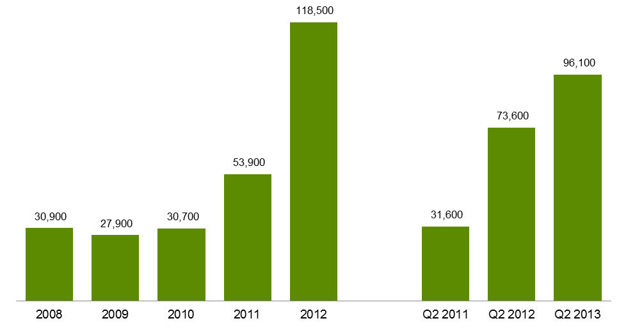

Table 2.8.1: Government subsidised student contact hours in foundation skills courses, 2008-2012

|  |  |  |  |  |  |  |
| --- | --- | --- | --- | --- | --- | --- |
|  | **2008** | **2009** | **2010** | **2011** | **2012** | **% change 2008-2012** |
| Student contact hours | 6.8 | 7.6 | 7.1 | 11.0 | 19.2 | 180% |

Table 2.8.2: Government subsidised student contact hours in foundation skills courses, Q2 2011, Q2 2012 and Q2 2013

|  |  |  |  |  |  |
| --- | --- | --- | --- | --- | --- |
|  | **Q2 2011** | **Q2 2012** | **Q2 2013** | **% change Q2 2011-Q2 2013** | **% change Q2 2012-Q2 2013** |
| Student contact hours | 7.3 | 12.6 | 17.2 | 136% | 37% |

Table 2.9.1: Government subsidised students in foundation skills courses by age group, 2008-2012

|  |  |  |  |  |  |  |
| --- | --- | --- | --- | --- | --- | --- |
|  | **2008** | **2009** | **2010** | **2011** | **2012** | **% change 2008-2012** |
| 15 to 19 | 5,100 | 5,200 | 6,600 | 11,200 | 27,900 | 451% |
| 20 to 24 | 2,700 | 2,500 | 3,100 | 6,000 | 18,800 | 602% |
| 25 to 44 | 11,200 | 9,700 | 10,300 | 16,400 | 31,400 | 179% |
| 45 to 64 | 5,300 | 4,800 | 5,100 | 8,700 | 16,600 | 214% |
| Under 15, over 64, not stated | 900 | 900 | 700 | 1,200 | 3,400 | 269% |
| **Total** | **25,200** | **23,200** | **25,700** | **43,500** | **98,100** | **289%** |

Table 2.9.2: Government subsidised students in foundation skills courses by age group, Q2 2011, Q2 2012 and Q2 2013

|  |  |  |  |  |  |
| --- | --- | --- | --- | --- | --- |
|  | **Q2 2011** | **Q2 2012** | **Q2 2013** | **% change Q2 2011-Q2 2013** | **% change Q2 2012-Q2 2013** |
| 15 to 19 | 6,800 | 17,900 | 24,700 | 262% | 38% |
| 20 to 24 | 3,500 | 12,100 | 17,100 | 390% | 41% |
| 25 to 44 | 9,500 | 19,000 | 25,300 | 166% | 33% |
| 45 to 64 | 5,200 | 10,400 | 13,200 | 154% | 26% |
| Under 15, over 64, not stated | 500 | 2,200 | 2,100 | 333% | 0% |
| **Total** | **25,500** | **61,600** | **82,400** | **223%** | **34%** |

Table 2.10: Top 13 government subsidised foundation skills course enrolments, Q2 2011, Q2 2012 and   
Q2 2013



# Alignment of Training to Industry Skills Needs

### Introduction

Over the period between Q2 2012 and Q2 2013 there have been shifts towards training delivered in areas that better meet the training requirements of the Victorian economy. The training market has been dynamic and responsive in seeking to align with these areas of need.

The trends towards more training in areas of specialised skills and in shortage occupations since 2008 has continued in 2013, as well as a shift towards courses that support sectors with significant projected employment growth.

There has been a reduction in courses that experienced unprecedented high levels of enrolments in 2012 that were not aligned with the employment trends of related industries. Challenges remain as government seeks to support apprenticeships in a climate of business contraction in trade related industries as well as managing growth in training areas that are not aligned with industry or student needs such as foundation skills for individuals who already have highly developed literacy, numeracy and workplace skills and RPL in unlicensed occupations.

Under the new subsidy bands, weightings have been refined to apply at the course level to strengthen Government investment in training for specialised skills, training to address skills in shortage, training related to areas of growing employment opportunity and sectors delivering essential services. The reforms also assessed the extent to which government investment is required to stimulate delivery of, and participation in, this training to meet industry needs.

Overall, the highest subsidy levels have been provided to courses where contribution to the economy is assessed as high, and where government subsidy is seen as essential in enabling delivery and participation in training.

|  |
| --- |
| Key Points  * Proportionally there has been a marked shift in commencement patterns when comparing Q2 2013 with Pre-July 2012. Data from Q2 2013 show that 69 per cent of all government subsidised commencing enrolments were within subsidy bands A and B. This compared with 49 per cent of commencements in subsidy bands A and B over the same period in 2012. Courses such as the Certificate III in Electrotechnology Electrician, Certificate III in Carpentry, Certificate III in Aged Care and the course in Initial General Education for Adults are represented in these funding bands. * Courses with less vocational outcome, or labour market requirement (Band D & E) represented 9 per cent of all government subsidised commencements in Q2 2013. It was 31 per cent over the same period in 2012. |

Figure 3.1: Government subsidised commencing course enrolments: proportion of commencing enrolments by subsidy band, Pre-July 2012, Q2 2013, July-December 2012

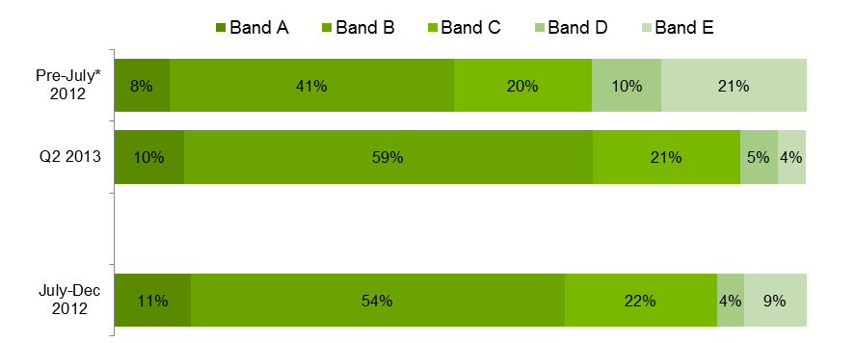

*Pre-July 2012 refers to January to June 2012.

Subsidy bands were introduced in 2012 and apply specifically to qualifications in 2012 and onward. In order to allow comparison with previous years, superseded courses have been assigned a subsidy band for analysis purposes only based on the bands of the current course to which they most closely align.

### Enrolments by Industry

Victorian reforms in vocational training enhance the alignment between vocational training and the needs of industry. For students this provides the opportunity for improved career and education pathways and employment outcomes following completion of training. Analysis of vocational training data has shown a high correlation between share of employment and share of training delivery in Victoria's largest industries (also refer to figure below for a comparison between employment and enrolment by industry):

* Fifty-three per cent of training was delivered in the five highest employing Victorian industry sectors, which account for 50 per cent of all Victorian jobs – Health Care and Social Assistance, Retail Trade, Manufacturing, Construction and Professional, Scientific and Technical Services. In Q2 2013, these five industries continue to make up 50 per cent of all industry-specific[5] enrolments.
* Health Care and Social Assistance, forecast to remain Victoria’s largest industry employer through to 2017[6], saw the highest enrolment growth for industry-specific training in 2012 (16,200 additional enrolments in 2012 when compared with 2011). In Q2 2013, training in courses related to Health Care and Social Assistance continued to grow with 56,400 enrolments (4 per cent growth between Q2 2012 and Q2 2013).
* In addition to the 414,000 enrolments in industry-specific training, there were 91,000 enrolments in Cross-industry training, which encompasses a broad range of skills applicable to all Victorian industries.

3.2: Industry share of Victorian employment and vocational training 2012

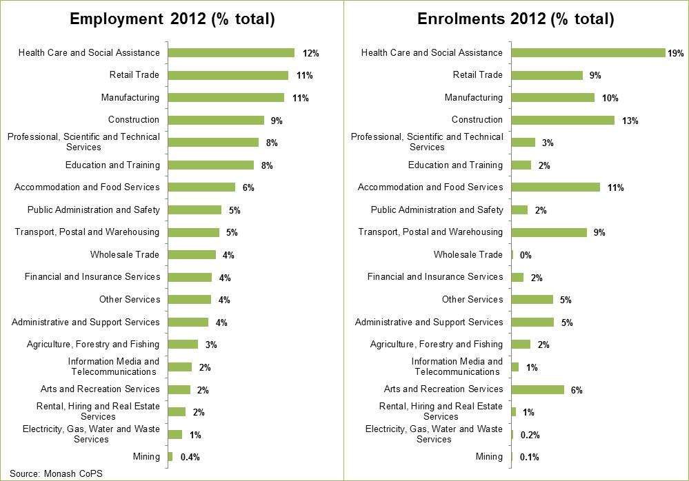

The following table shows training in government subsidised qualifications, sorted highest to lowest by 2012 enrolments (excludes foundation training). Rank by industry share of Victorian employment and equivalent 2008 ranks are also displayed.

Table 3.1: Industry-specific training and employment: 2012 vs. 2008[7]



### Subsidy bands analysis per industry

The table below shows the top 5 industries for each subsidy band.

Table 3.2: Industry-specific training by funding band, Q2 2013

|  |  |
| --- | --- |
| **Funding band** | **% enrolments Q2 2013** |
| **Band A** | |
| Construction | 55% |
| Manufacturing | 15% |
| Other Services | 13% |
| Accommodation and Food Services | 8% |
| Retail Trade | 4% |
| **Band B** | |
| Health Care and Social Assistance | 30% |
| Transport, Postal and Warehousing | 21% |
| Manufacturing | 16% |
| Construction | 8% |
| Accommodation and Food Services | 6% |
| **Band C** | |
| Health Care and Social Assistance | 35% |
| Cross-industry e.g. project managers | 25% |
| Education and Training | 7% |
| Professional, Scientific and Technical Services | 5% |
| Administrative and Support Services | 4% |
| **Band D** | |
| Cross-industry e.g. project managers | 35% |
| Administrative and Support Services | 13% |
| Retail Trade | 10% |
| Professional, Scientific and Technical Services | 8% |
| Arts and Recreation Services | 7% |
| **Band E** | |
| Cross-industry e.g. project managers | 34% |
| Retail Trade | 17% |
| Accommodation and Food Services | 16% |
| Arts and Recreation Services | 14% |
| Manufacturing | 12% |

|  |
| --- |
| Key Points  * Over half of delivery in Band A (apprenticeships and non-apprenticeships) is in the Construction industry. * The largest block of deliver in Band B is for Health Care and Social Assistance (30 per cent) and Transport, Postal and Warehousing (21 per cent) |

### Enrolments by Occupation

In the second quarter of 2013, the 5 highest numbers of enrolments within Bands A and B were in courses related to the following occupations:

* Aged or Disabled Carer (11,200 enrolments in Q2 2013)
* Warehouse Administrator (8,250 enrolments in Q2 2013)
* Engineering Production Worker (6,400 enrolments in Q2 2013)
* Electrician (General) (6,400 enrolments in Q2 2013)
* Truck Driver (General) (6,100 enrolments in Q2 2013)

Employment trends within these occupations are outlined in the table below and show employment numbers in 2011-12, average annual employment needs[8] over the next 5 years as well as patterns of forecast employment growth to 2016-17. Employment trends indicate growth in four of the five occupational groups related to highest number of courses in Bands A and B. Engineering Productions Workers are forecast to see dampened demand over the next five years. These workers predominantly work in the Manufacturing industry, a critical industry for the Victorian economy undergoing significant industrial transition, and therefore remain a critical area for public investment in vocational training.

Table 3.3: Employment trends in selected occupations (Band A & B), 2011-12 to 2016-17



Source: Monash Centre for Policy Studies (2012) Employment Forecasting Model.

The 5 highest number of enrolments within Band D and E in Q2 2013 were in courses related to the following occupations:

* Office Manager (10,800 enrolments in Q2 2013)
* Sales Assistant (General) (5,450 enrolments in Q2 2013)
* General Clerk (5,350 enrolments in Q2 2013)
* Waiter (4,200 enrolments in Q2 2013)
* Factory Process Workers (other) (4,000 enrolments in Q2 2013)

As above, Table 3.5 shows employment trends for occupations related to top 5 highest numbers of enrolments within Band D and E. Characteristic of these occupations in the Victorian labour market are jobs that have high levels of turnover and mixed employment prospects. Office Managers, for example are likely to remain fairly stable through to 2016-17, while Sales Assistants and Factory Process Workers are forecast to decline. General Clerks and Waiters are forecast to see employment growth, however present less of a requirement for vocational training investment made by government to support meeting this labour market need.

Table 3.4: Employment trends in selected occupations (Band D & E), 2011-12 to 2016-17

Source: Monash Centre for Policy Studies (2012) Employment Forecasting Model.

**Enrolments by Apprentices**

Since July 2012 courses such as Apprenticeships, attract government subsidy at the highest level in recognition of current and projected future industry skill needs. However, even though Apprenticeships receive the highest level of subsidy, due to external factors there has been a dampening of enrolments in Q2 2013 compared to Q2 2012 and Q2 2011. In Victoria just over half (55 per cent) of all Apprentice enrolments in Q2 2013 were in the Construction industry, this sector has been facing some challenging business conditions over recent years. Apprentice numbers are highly correlated with business conditions and this close relationship is demonstrated in the chart on the following page which shows similar trends between apprenticeship commencements[9] and new dwelling commencements[10], especially in the last few years.

Recent data released by the National Centre for Vocational Education Research (NCVER) show that Victoria is not the only jurisdiction that has experienced reductions in apprentices and trainees in-training in traditional trades. States such as NSW and Queensland are also having similar trends. This is probably reflective of difficult business conditions for this industry being faced across Australia.

Figure 3.3: Number of apprenticeship commencements and new dwelling units commenced all sectors  
Quarter 1 2000 to Quarter 2 2013

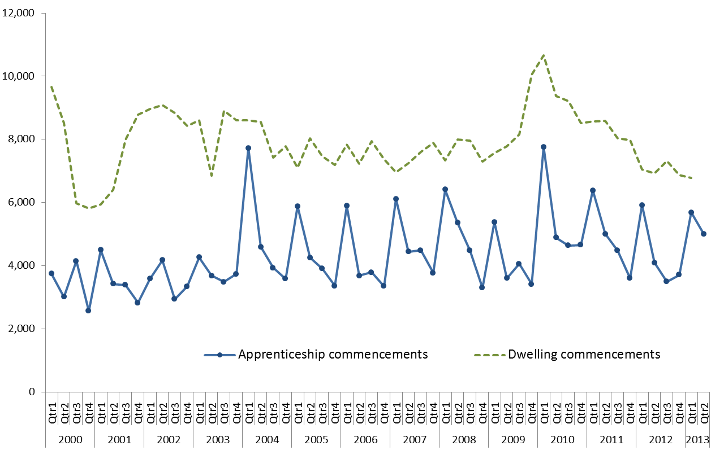

Figure 3.4: Number of Apprentices and trainees in-training in traditional trades, Vic, New South Wales and Queensland, Quarter 1 2008 – Quarter 4 2012 (NCVER)



Source: Apprentices and Trainees December 2012, VOCSTATS NCVER

Table 3.5.1: Government subsidised enrolments by apprentices by age, 2008–2012

|  |  |  |  |  |  |  |
| --- | --- | --- | --- | --- | --- | --- |
|  | **2008** | **2009** | **2010** | **2011** | **2012** | **% change 2008-2012** |
| 15 to 19 | 19,100 | 18,400 | 19,400 | 19,300 | 17,300 | -9% |
| 20 to 24 | 16,300 | 16,500 | 18,100 | 18,500 | 18,800 | 15% |
| 25 to 44 | 5,900 | 6,300 | 7,100 | 7,800 | 8,100 | 36% |
| 45 to 64 | 500 | 500 | 600 | 650 | 850 | 70% |
| Under 15, over 64, not stated | 50 | 30 | 20 | 20 | 10 | -80% |
| **Apprentices** | **41,900** | **41,600** | **45,300** | **46,300** | **45,000** | **8%** |

Table 3.5.2: Government subsidised enrolments by apprentices by age, Q2 2011, Q2 2012 and Q2 2013

|  |  |  |  |  |  |
| --- | --- | --- | --- | --- | --- |
|  | **Q2 2011** | **Q2 2012** | **Q2 2013** | **% change Q2 2011-Q2 2013** | **% change Q2 2012-Q2 2013** |
| 15 to 19 | 14,700 | 13,900 | 11,400 | -22% | -18% |
| 20 to 24 | 15,800 | 16,600 | 15,500 | -2% | -7% |
| 25 to 44 | 6,300 | 6,600 | 6,600 | 6% | 1% |
| 45 to 64 | 550 | 600 | 800 | 44% | 36% |
| Under 15, over 64, not stated | 40 | 10 | 20 | -63% | 114% |
| **Apprentices** | **37,400** | **37,700** | **34,400** | **-8%** | **-9%** |
|  |  |  |  |  |  |

Table 3.6: Government subsidised enrolments by apprentices by industry, Q2 2011, Q2 2012 and   
Q2 2013

|  |  |  |  |  |  |
| --- | --- | --- | --- | --- | --- |
|  | **Q2 2011** | **Q2 2012** | **Q2 2013** | **% change Q2 2011-Q2 2013** | **% change Q2 2012-Q2 2013** |
| A: Agriculture, Forestry and Fishing | 30 | 40 | 70 | 109% | 82% |
| C: Manufacturing | 5,400 | 5,600 | 5,400 | -1% | -3% |
| D: Electricity, Gas, Water and Waste Services | 250 | 200 | 10 | -97% | -97% |
| E: Construction | 21,200 | 21,000 | 19,000 | -10% | -10% |
| F: Wholesale Trade | 100 | 90 | 40 | -58% | -51% |
| G: Retail Trade | 1,500 | 1,700 | 1,500 | -3% | -11% |
| H: Accommodation and Food Services | 2,100 | 2,100 | 2,000 | -6% | -5% |
| M: Professional, Scientific and Technical Services | 100 | 100 | 150 | 11% | 18% |
| N: Administrative and Support Services | 450 | 450 | 250 | -44% | -43% |
| O: Public Administration and Safety | 80 | 90 | 100 | 19% | 2% |
| Q: Health Care and Social Assistance | 100 | 80 | 60 | -43% | -31% |
| R: Arts and Recreation Services | 550 | 550 | 500 | -2% | -6% |
| S: Other Services | 5,500 | 5,700 | 5,400 | -2% | -6% |
| **Apprentices** | **37,400** | **37,700** | **34,400** | **-8%** | **-9%** |

**Enrolments by Trainees**

While there has been a decline in enrolments in Traineeships in Q2 2013, this has come from courses that now attract subsidy at the lowest level (band E), where there was unprecedented high level of enrolments that did not match employment trends for related industries. The reduction in traineeship enrolments is also attributable to changes to Commonwealth government incentives[11].

The chart on the opposite page shows that the decline is predominantly from courses in that attract the lowest subsidy (band E) which are deemed to have less vocational outcome or labour market requirement. Courses in group are such as Certificate II in Retail, Certificate III in Retail, Certificate III in Hospitality, Certificate III in Process Manufacturing, and Certificate III in Customer Contact. There was a spike in these courses in 2012 and the 2013 reductions need to be seen in this context. In contrast there has been an increase in enrolments in Traineeships that now attract subsidy at band B, reflecting industry need for graduates from these courses.

Figure 3.4: Government subsidised traineeship enrolments by funding band, Q2 2011, Q2 2012 and   
Q2 2013



Table 3.7.1: Government subsidised enrolments by trainees by age, 2008–2012

|  |  |  |  |  |  |  |
| --- | --- | --- | --- | --- | --- | --- |
|  | **2008** | **2009** | **2010** | **2011** | **2012** | **% change 2008-2012** |
| 15 to 19 | 21,300 | 20,800 | 22,700 | 26,100 | 25,500 | 20% |
| 20 to 24 | 12,900 | 11,000 | 12,500 | 15,300 | 15,500 | 20% |
| 25 to 44 | 14,500 | 12,400 | 14,800 | 24,600 | 29,600 | 104% |
| 45 to 64 | 4,800 | 4,600 | 6,500 | 13,600 | 18,000 | 276% |
| Under 15, over 64, not stated | 600 | 450 | 300 | 600 | 700 | 10% |
| **Trainees** | **54,000** | **49,200** | **56,900** | **80,200** | **89,300** | **65%** |

Table 3.7.2: Government subsidised enrolments by trainees by age, Q2 2011, Q2 2012 and Q2 2013

|  |  |  |  |  |  |
| --- | --- | --- | --- | --- | --- |
|  | **Q2 2011** | **Q2 2012** | **Q2 2013** | **% change Q2 2011-Q2 2013** | **% change Q2 2012-Q2 2013** |
| 15 to 19 | 15,500 | 17,300 | 9,900 | -36% | -43% |
| 20 to 24 | 10,300 | 11,700 | 7,300 | -29% | -38% |
| 25 to 44 | 13,700 | 21,300 | 14,300 | 4% | -33% |
| 45 to 64 | 7,300 | 12,900 | 9,400 | 29% | -28% |
| Under 15, over 64, not stated | 200 | 350 | 300 | 66% | -14% |
| **Trainees** | **46,900** | **63,600** | **41,100** | **-12%** | **-35%** |

Table 3.8.1: Government subsidised enrolments by trainees by qualification level, 2008–2012

|  |  |  |  |  |  |  |
| --- | --- | --- | --- | --- | --- | --- |
|  | **2008** | **2009** | **2010** | **2011** | **2012** | **% change 2008-2012** |
| Cert I-II | 10,200 | 11,100 | 11,700 | 8,900 | 4,200 | -59% |
| Cert III-IV | 42,600 | 36,800 | 42,500 | 62,900 | 72,100 | 69% |
| Diploma & Above | 1,100 | 1,300 | 2,700 | 8,400 | 13,000 | 1128% |

Table 3.8.2: Government subsidised enrolments by trainees by qualification level, Q2 2011, Q2 2012 and Q2 2013

|  |  |  |  |  |  |
| --- | --- | --- | --- | --- | --- |
|  | **Q2 2011** | **Q2 2012** | **Q2 2013** | **% change Q2 2011-Q2 2013** | **% change Q2 2011-Q2 2013** |
| Cert I-II | 6,800 | 3,100 | 1,600 | -77% | -51% |
| Cert III-IV | 35,900 | 51,000 | 33,600 | -6% | -34% |
| Diploma & Above | 4,200 | 9,400 | 5,900 | 39% | -37% |

Table 3.9: Government subsidised enrolments by trainees by industry, Q2 2011, Q2 2012 and Q2 2013

|  |  |  |  |  |  |
| --- | --- | --- | --- | --- | --- |
|  | **Q2 2011** | **Q2 2012** | **Q2 2013** | **% change Q2 2011-Q2 2013** | **% change Q2 2012-Q2 2013** |
| A: Agriculture, Forestry and Fishing | 1,000 | 1,500 | 1,500 | 50% | 2% |
| B: Mining | 10 | 10 | 50 | 800% | 440% |
| C: Manufacturing | 5,300 | 10,100 | 7,800 | 45% | -23% |
| D: Electricity, Gas, Water and Waste Services | 100 | 250 | 150 | 26% | -41% |
| E: Construction | 350 | 700 | 800 | 147% | 16% |
| F: Wholesale Trade | 200 | 400 | 250 | 22% | -35% |
| G: Retail Trade | 10,700 | 12,300 | 5,500 | -49% | -55% |
| H: Accommodation and Food Services | 6,000 | 7,600 | 3,600 | -40% | -53% |
| I: Transport, Postal and Warehousing | 2,900 | 4,000 | 4,000 | 41% | 1% |
| J: Information Media and Telecommunications | 100 | 90 | 100 | 12% | 33% |
| K: Financial and Insurance Services | 350 | 400 | 350 | -3% | -21% |
| L: Rental, Hiring and Real Estate Services | 200 | 350 | 200 | 0% | -43% |
| M: Professional, Scientific and Technical Services | 200 | 250 | 200 | -5% | -24% |
| N: Administrative and Support Services | 4,400 | 4,900 | 2,800 | -37% | -43% |
| O: Public Administration and Safety | 30 | 70 | 90 | 190% | 28% |
| P: Education and Training | 350 | 350 | 950 | 180% | 169% |
| Q: Health Care and Social Assistance | 5,100 | 5,800 | 5,000 | -3% | -13% |
| R: Arts and Recreation Services | 1,900 | 2,200 | 850 | -57% | -63% |
| S: Other Services | 400 | 350 | 200 | -45% | -39% |
| T: Cross-industry | 7,300 | 12,000 | 6,700 | -8% | -44% |
| **Trainees** | **46,900** | **63,600** | **41,100** | **-12%** | **-35%** |

### Training in Specialised and In-Shortage Related Occupations

Vocational training delivery that is meeting the skill requirements of industry is a core focus of the Refocusing VET reforms. In particular, training related to occupations identified as specialised or experiencing skill shortages that[12] enhance the productive capacity of the Victorian economy are a high priority for government investment.

'Specialised occupations’[13] are defined as occupations that have a long lead-time for training, high economic value and a significant match between training and employment.

‘Skill shortages’[14] exist when employers are unable to fill or have considerable difficulty filling vacancies for an occupation, or significant specialised skill needs within that occupation, at current levels of remuneration and conditions of employment, and in reasonably accessible locations.

Note: all data in this section is for government subsidised training by onshore domestic students in accredited AQF qualifications excluding foundation skills, education pathways and low-level LOTE courses.

| Key Points Trends in the second quarter of 2013 indicate a refocussing of the training market towards a higher proportion of training delivery against most critical occupations:   * 112,900 enrolments in qualifications related to specialised or in shortage occupations in Q2 2013. * At Q2 2013 40 per cent of training was for occupations which are either specialised or in shortage. At the same point a year ago (Q2 2012) this figure was 31 per cent. * Marked difference between critical 'Specialised or Skill Shortage' occupations (0.2 per cent growth year on year) compared to 'Non Specialised or Skill Shortage' training (33 per cent decrease). * TAFE providers continue to deliver the bulk of training in qualifications related to specialised or in shortage occupations (accounting for half of enrolments), followed by private RTOs (44 per cent). However, enrolments have increased at private RTOs. * The largest rise in specialised and skill shortage enrolments compared to Q2 2012 have been in qualifications under Band A. |
| --- |

Figure 3.5: Government subsidised training delivery by responsiveness category

|  |
| --- |
|  |

Figure 3.6: Government subsidised enrolments in specialised or skill shortage occupations per training provider type, Q2 2011, Q2 2012 and Q2 2013

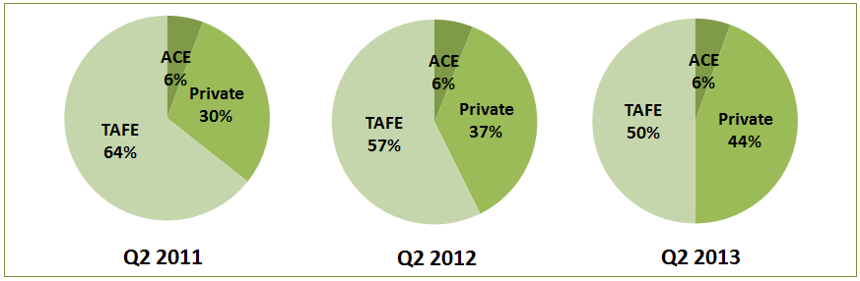

Table 3.10.1: Government subsidised training delivery for qualifications related to either specialised or skill shortage occupations, 2008 - 2012

|  |  |  |  |  |  |  |
| --- | --- | --- | --- | --- | --- | --- |
| **Either Specialised or Skill Shortage Qualifications** | | | | | | |
|  | 2008 | 2009 | 2010 | 2011 | 2012 | % 2008 - 2012 |
| **Enrolments** | 91,400 | 102,600 | 116,500 | 137,300 | 163,100 | 78% |
| **Hours** (millions) | 28.4 | 33.6 | 38.9 | 44.3 | 54.9 | 93% |

Table 3.10.2: Government subsidised training delivery for qualifications related to either specialised or in shortage occupations, Q2 2011, Q2 2012 and Q2 2013

|  |  |  |  |  |  |
| --- | --- | --- | --- | --- | --- |
| **Either Specialised or Skill Shortage Qualifications** | | | | | |
|  | Q2 2011 | Q2 2012 | Q2 2013 | % Q2 2011 - Q2 2013 | % Q2 2012 - Q2 2013 |
| **Enrolments** | 92,900 | 112,700 | 112,900 | 22% | 0.2% |
| **Hours** (millions) | 33.4 | 40.5 | 41.8 | 25% | 3% |

Table 3.11.1: Government subsidised training delivery for qualifications not related to specialised or skill shortage occupations, 2008 - 2012

|  |  |  |  |  |  |  |
| --- | --- | --- | --- | --- | --- | --- |
| **Not Specialised/Skill shortage Qualifications** | | | | | | |
|  | 2008 | 2009 | 2010 | 2011 | 2012 | % 2008 - 2012 |
| **Enrolments** | 184,700 | 182,500 | 220,300 | 305,500 | 342,300 | 85% |
| **Hours** (millions) | 46.8 | 49.1 | 61.4 | 85.9 | 109.3 | 134% |

Table 3.11.2: Government subsidised training delivery for qualifications related to either specialised or skill shortage occupations, Q2 2011, Q2 2012 and Q2 2013

|  |  |  |  |  |  |
| --- | --- | --- | --- | --- | --- |
| **Not Specialised/ Skill Shortage Qualifications** | | | | | |
|  | Q2 2011 | Q2 2012 | Q2 2013 | % Q2 2011 - Q2 2013 | % Q2 2012 - Q2 2013 |
| **Enrolments** | 169,900 | 248,300 | 166,700 | -2% | -33% |
| **Hours** (millions) | 55.0 | 79.4 | 56.5 | 3% | -29% |

Table 3.12.1: Government subsidised training delivery for qualifications related to specialised occupations, 2008 - 2012

|  |  |  |  |  |  |  |
| --- | --- | --- | --- | --- | --- | --- |
| **Qualifications Related to Specialised Occupations** | | | | | | |
|  | 2008 | 2009 | 2010 | 2011 | 2012 | % 2008 – 2012 |
| **Enrolments** | 57,000 | 59,300 | 64,900 | 72,300 | 80,300 | 41% |
| **Hours** (millions) | 16.6 | 19.6 | 21.1 | 21.8 | 25.9 | 56% |

Table 3.12.2: Government subsidised training delivery for qualifications related to specialised occupations, Q2 2011, Q2 2012 and Q2 2013

|  |  |  |  |  |  |
| --- | --- | --- | --- | --- | --- |
| **Qualifications Related to Specialised Occupations** | | | | | |
|  | Q2 2011 | Q2 2012 | Q2 2013 | % Q2 2011 - Q2 2013 | % Q2 2012 - Q2 2013 |
| **Enrolments** | 50,600 | 57,700 | 58,100 | 15% | 1% |
| **Hours** (millions) | 16.9 | 18.0 | 20.0 | 19% | 11% |

Table 3.13.1: Government subsidised training delivery for qualifications related to skill shortage occupations, 2008 - 2012

|  |  |  |  |  |  |  |
| --- | --- | --- | --- | --- | --- | --- |
| **Qualifications Related to Skill Shortage Occupations** | | | | | | |
|  | 2008 | 2009 | 2010 | 2011 | 2012 | % 2008 – 2012 |
| **Enrolments** | 84,200 | 95,900 | 108,900 | 129,400 | 152,400 | 81% |
| **Hours** (millions) | 26.7 | 31.7 | 36.9 | 42.1 | 50.9 | 90% |

Table 3.13.2: Government subsidised training delivery for qualifications related to skill shortage occupations, Q2 2011, Q2 2012 and Q2 2013

|  |  |  |  |  |  |
| --- | --- | --- | --- | --- | --- |
| **Qualifications Related to Skill Shortage Occupations** | | | | | |
|  | Q2 2011 | Q2 2012 | Q2 2013 | % Q2 2011 - Q2 2013 | % Q2 2012 - Q2 2013 |
| **Enrolments** | 88,600 | 105,600 | 107,300 | 21% | 2% |
| **Hours** (millions) | 31.8 | 38.1 | 39.6 | 24% | 4% |

Table 3.14: Top 10 enrolling specialised or in shortage occupations, Q2 2011, Q2 2012 and Q2 2013

|  |  |  |  |  |  |
| --- | --- | --- | --- | --- | --- |
| Occupation | 2011 | 2012 | Q2 2012 | Q2 2013 | % change Q2 2012 - Q2 2013 |
| **Child Care Worker** | 19,700 | 25,600 | 17,900 | 18,500 | 3% |
| **Aged or Disabled Carer** | 13,000 | 16,900 | 10,500 | 12,200 | 16% |
| **Electrician (General)** | 7,700 | 7,800 | 6,400 | 6,400 | 0% |
| **Truck Driver (General)** | 7,500 | 10,700 | 5,100 | 6,100 | 20% |
| **Enrolled Nurse** | 6,400 | 7,200 | 5,700 | 5,900 | 4% |
| **Plumber (General)** | 7,000 | 7,200 | 5,900 | 5,600 | -5% |
| **Carpenter** | 8,500 | 7,600 | 6,200 | 5,600 | -10% |
| **Motor Mechanic (General)** | 5,100 | 6,500 | 4,300 | 5,100 | 19% |
| **Disabilities Services Officer** | 3,900 | 4,900 | 3,400 | 3,700 | 9% |
| **Building Associate** | 2,700 | 4,600 | 3,100 | 3,600 | 16% |
| **All other occupations** | 55,500 | 63,800 | 44,100 | 40,200 | -9% |

The following table highlights industry enrolments in qualifications related to either specialised or in shortage occupations

Table 3.15: Industry enrolments in qualifications related to either specialised or in shortage occupations

|  |  |  |  |  |  |  |  |  |  |  |  |  |
| --- | --- | --- | --- | --- | --- | --- | --- | --- | --- | --- | --- | --- |
| **Industry** | **Enrolments (All industry specific qualifications)** | | | | | | **Enrolments (Specialised OR In Shortage)** | | | | | |
| **Share Q2 2013** | **Q2 2011** | **Q2 2012** | **Q2 2013** | **% Q2 2011 - Q2 2013** | **% Q2 2012 - Q2 2013** | **Share Q2 2013** | **Q2 2011** | **Q2 2012** | **Q2 2013** | **% Q2 2011 - Q2 2013** | **% Q2 2012 - Q2 2013** |
| Accommodation and Food Services | 9% | 20,500 | 30,500 | 17,000 | -17% | -44% | 3% | 5,300 | 6,800 | 5,200 | -2% | -24% |
| Administrative and Support Services | 5% | 11,100 | 16,500 | 9,500 | -14% | -42% | - | - | - | - | - | - |
| Agriculture, Forestry and Fishing | 3% | 4,500 | 6,300 | 4,100 | -9% | -35% | 0% | 500 | 600 | 500 | 0% | -17% |
| Arts and Recreation Services | 5% | 18,200 | 22,500 | 11,800 | -35% | -48% | 1% | 400 | 500 | 1,000 | 150% | 100% |
| Construction | 12% | 33,400 | 36,400 | 37,600 | 13% | 3% | 27% | 25,500 | 27,500 | 28,100 | 10% | 2% |
| *Cross-industry e.g. project managers* | 19% | 43,400 | 70,400 | 42,700 | -2% | -39% | 6% | 2,800 | 2,700 | 1,600 | -43% | -41% |
| Education and Training | 2% | 6,600 | 7,000 | 7,700 | 17% | 10% | 5% | 3,500 | 4,100 | 2,600 | -26% | -37% |
| Electricity, Gas, Water and Waste Services | 0% | 600 | 800 | 300 | -50% | -63% | 1% | 500 | 600 | 200 | -60% | -67% |
| Financial and Insurance Services | 0% | 2,300 | 5,300 | 2,000 | -13% | -62% | 0% | 500 | 700 | 200 | -60% | -71% |
| Health Care and Social Assistance | 11% | 40,000 | 54,100 | 56,400 | 41% | 4% | 30% | 35,900 | 48,600 | 51,000 | 42% | 5% |
| Information Media and Telecommunications | 1% | 3,000 | 3,500 | 2,600 | -13% | -26% | 0% | 400 | 400 | 300 | -25% | -25% |
| Manufacturing | 10% | 20,100 | 27,000 | 26,500 | 32% | -2% | 11% | 6,700 | 6,900 | 6,800 | 1% | -1% |
| Mining | 0% | 100 | 300 | 200 | 100% | -33% | - | - | - | - | - | - |
| Other Services | 5% | 13,700 | 15,200 | 14,400 | 5% | -5% | 5% | 3,400 | 3,900 | 4,500 | 32% | 15% |
| Professional, Scientific and Technical Services | 5% | 10,300 | 10,500 | 8,600 | -17% | -18% | 4% | 2,300 | 2,400 | 2,100 | -9% | -13% |
| Public Administration and Safety | 1% | 3,600 | 5,300 | 4,500 | 25% | -15% | 2% | 200 | 300 | 200 | 0% | -33% |
| Rental, Hiring and Real Estate Services | 0% | 900 | 1,800 | 1,200 | 33% | -33% | - | - | - | - | - | - |
| Retail Trade | 7% | 17,800 | 26,100 | 10,900 | -39% | -58% | 2% | 1,000 | 1,200 | 1,500 | 50% | 25% |
| Transport, Postal and Warehousing | 4% | 12,100 | 20,900 | 20,900 | 73% | 0% | 3% | 4,100 | 5,400 | 7,000 | 71% | 30% |
| Wholesale Trade | 0% | 500 | 700 | 600 | 20% | -14% | - | - | - | - | - | - |
| **Total** | 100% | 262,700 | 361,000 | 279,600 | 6% | -23% | 100% | 92,900 | 112,700 | 112,900 | 22% | 0.2% |

# Appendix

## Recognition of Prior Learning

Recognition of Prior Learning (RPL[15]) helps improve the skill levels of Victorians in a modern economy. It is an efficient way of targeting training to identified skill gaps. For people working in industries going through significant transitions, it is a way of demonstrating their skills and qualifications to a new employer. From 1 July 2012 the quality requirements for organisations accredited to sign-off on RPL were strengthened. The Victorian Government is committed to working with training providers to ensure that the right people are offered relevant training to develop the basic skills they need to do their jobs well.

As part of Refocusing Vocational Training in Victoria the Government has an ongoing role of monitoring the training market, with a focus on quality, price and competition. Learners are entitled to expect quality training and value for money. As part of government's ongoing role to monitor the training market we have seen in the first half of 2013 evidence of some providers enrolling people skills recognition programs that are not delivering value to them or to their employer. Particularly there is evidence of provider-led growth of RPL in Band A courses which attracts a 100 per cent subsidy (RPL delivery in Band B to E courses receive a 50 per cent subsidy.

The figure below shows the RPL training in Band A compared to Bands B to E as reported Q2 2011 to Q2 2013. At Q2 2013 40 per cent of Band A delivery has been RPL, compared to 13 per cent for the same courses at Q2 2012 and 9 per cent at Q2 2011.

Some courses in Band A saw particularly high growth e.g. a nearly six-fold increase in RPL for automotive courses, and a nearly ten-fold increase in courses relating to plastering, and wall lining and tiling. Despite the value of RPL the majority of delivery must be focussed on training new or updated skills which are relevant for the modern workforce.

Band A courses that were receiving 100 per cent of the usual subsidy for RPL will now receive 50 per cent, in line with the vast majority of courses. For qualifications required for licensing or registration – such as Nursing and Childcare – the Government will retain a 100 per cent subsidy for RPL delivery. This is necessary where experienced workers who have previously not been required to hold formal qualifications are affected by new legislation introducing this requirement. The refinements to the system will only apply to new students commencing training.

Figure A.1: RPL by funding band, Q2 2011, Q2 2012 and Q2 2013

1. TAFE fee for service figures include domestic AQF Level 1 and above. Refer to section on Reporting scope for further detail.
2. The NCVER publication Apprentices & Trainees, Early trend estimates March Quarter 2013, noted that at a national level “The substantial growth in non-trade commencements up to the June quarter 2012 and the subsequent decline in the September quarter is predominately due to changes to Commonwealth incentive payments for existing workers, namely the removal of the commencement incentive payment for those apprenticeships and traineeships not on the National Skills Needs List. Under the changes, training needed to have commenced prior to 1 July 2012 to attract the old subsidy rate.”
3. Note that a course enrolment indicates an enrolment by a student in specified course at a registered training organisation. Training hours on the other hand measures the hours taken to deliver training. Total student hours is not an indicator of training provider revenue.
4. Skills for Australians http://www.dpmc.gov.au/publications/skills_for_all_australians/chapter1_overview.html
5. Includes all accredited vocational qualifications at Certificate I and above, but excludes generic training such as foundation skills, education pathways and low-level LOTE courses.
6. DEECD subscribes to the Monash CoPS Economic Forecasts Model which provides employment and output forecasts down to the 3-digit ANZSIC level, occupational forecasts down to the 4-digit ANZSCO as well as high level aggregation forecasts of hours worked, and ASCED qualifications attained. This report utilises the COPS five year forecast to 2017 for analysis in the VET Industry Profiles.
7. Cross-industry training (e.g. business administration, recordkeeping, computing) has been removed from the industry-specific analysis as this training develops business skills which are transferable across many industry sectors.
8. Monash Centre for Policy Studies (2012) Employment Forecasting Model.

   Average annual employment needs are average replacement demand and employment growth levels from 2011-12 through to 2016-17.
9. Commencements data is sourced from DEECD’s DELTA system which is used to manage and monitor training contracts. This data is used for this purpose only as the Training Market Quarterly Report is based on VET training activity data.
10. Australian Bureau of Statistics, Building Activity, Australia, 8752.0 Table 34. Number of Dwelling Unit Commencements by Sector, States and Territories.
11. The NCVER publication Apprentices & Trainees, Early trend estimates March Quarter 2013, noted that at a national level “The substantial growth in non-trade commencements up to the June quarter 2012 and the subsequent decline in the September quarter is predominately due to changes to Commonwealth incentive payments for existing workers, namely the removal of the commencement incentive payment for those apprenticeships and traineeships not on the National Skills Needs List. Under the changes, training needed to have commenced prior to 1 July 2012 to attract the old subsidy rate.”
12. To ensure the most robust alignment with vocational outcomes in the government funded training sector this section is limited to:

    * government subsidised training to onshore domestic students
    * training in accredited AQF qualifications at Certificate I and above i.e. short courses, non-award courses and non-accredited training is excluded
    * excludes courses which cannot be classified directly to an employment outcome in a particular occupation, such as training in generic foundation skills such as literacy and numeracy

   
13. Australian Workforce and Productivity Agency (2012) specialised occupation list.
14. HESG (2012) Skills Shortage list. Skill shortage definition from DEEWR Skills Shortage List
15. Recognition of Current Competency (RCC) delivery has been included in this analysis