**THE GOVERNMENT FUNDED TRAINING MARKET — AN OVERVIEW**

The first half of 2020 has been challenging, with new commencements in all government funded training activity lower than the same period in 2019, reflecting the significant impact the COVID-19 crisis has had on Victoria.

Notwithstanding the overall decline in commencements, continuing enrolments increased (up 11 per cent, 12,000) resulting in a smaller decline in total enrolments (down 6.2 per cent, 14,048) compared to the same period in 2019. The increase in continuing enrolments reflects the successful implementation of the Free TAFE initiative in 2019 and is expected to contribute to a strong 2021 recovery.

Free TAFE is improving access to training

The Free TAFE initiative focuses on reducing the financial barrier for students so they can train in courses that lead to jobs in demand in the Victorian economy. By the end of 2019, more than 39,700 students had commenced training in Free TAFE courses, nearly an 88 per cent increase in commencements in these courses compared with 2018.

While new Free TAFE commencements were down 36 per cent in the first half of 2020 when compared with 2019, they remain 11 per cent higher than for the first half of 2018. Further, the successful implementation of Free TAFE in 2019 has resulted in an increase in continuing enrolments in these courses.

Training supports positive outcomes for all Victorians

The TAFE and Training System continues to play a pivotal role in supporting our most disadvantaged and/or disengaged students to access and stay connected with training.

Positive trends in greater participation in training from Indigenous students, students with a disability and unemployed students are expected to return during the recovery from the COVID-19 crisis in 2021.

**Free TAFE Course List Training**

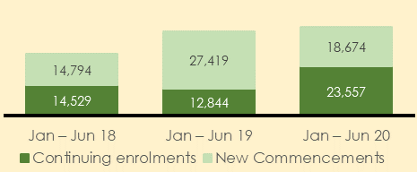

* Data shows training (TAFE Network) for courses on the 2020 Free TAFE List. Not Free TAFE initiative.

**Government-Funded Commencements by Provider  
  Type**

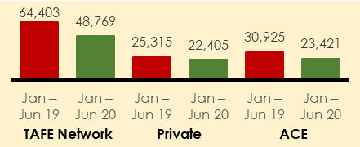

**Change In Government-Funded Commencements   
  by Key Cohorts**

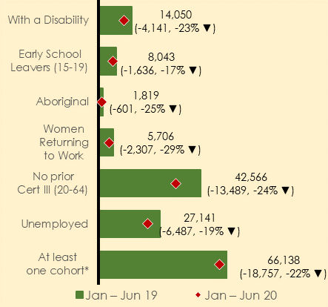

*\*Student can be in more than one key cohort.*

**DELIVERING HIGH QUALITY TRAINING THAT IS STRONGLY ALIGNED TO JOBS**

The *Skills First* reforms continue to better align VET delivery to Government priority areas.

However, due to COVID-19 restrictions, in the first half of 2020 there has been an overall decline of 20 per cent in new commencements in courses aligned to at least one Government priority area, compared to the same time in 2019.

In particular, new commencements in courses on the Free TAFE for Priority Courses List related to training the Family Violence workforce have been affected; and the decline in new apprenticeships and high-value traineeships has been impacted by a contraction in employment and a reduction in the availability of work placement opportunities due to the pandemic restrictions.

The *Skills First* reforms are helping refocus skills development towards better meeting the Victorian economy’s workforce needs. The top four industries by commencements are in the Health Care and Social Assistance, Construction, Professional, Scientific and Technical Services, and Education and Training sectors. Enrolments in courses aligned to these four industry sectors accounted for 63 per cent of industry aligned commencements in the January to June 2020 period. In all four industries, the TAFE Network continues to play a leading role in provision.

Work is progressing to recover from the COVID-19 crisis and maintain the momentum under *Skills First*

The TAFE and Training sector has a critical role in supporting Victorians to re-skill and upskill and drive economic recovery in the post-COVID-19 economy.

The Skills for Economic Recovery package as well as other Government initiatives will make it easier for people with pre-existing qualifications to retrain and improve access to training for Victorians impacted by coronavirus, particularly women and young people. This includes the Course in Introduction to the NDIS (skill set), as well as $3.9 million for an additional 11,000 places in accredited short courses and skill sets in construction across TAFE and industry-owned Registered Training Organisations until June 2021. The new JobTrainer Fund will also support an additional 50,000 training places across Victoria.

**Government-Funded Commencements in   
  Government Priority Areas\***

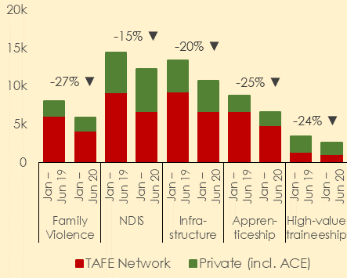

*\* See data notes for further detail of government priority areas*

**Government-Funded Commencements by  
  Regions**



*\* Other includes where location is unknown or not stated.*

**TOP 4 INDUSTRY AREAS FOR GOVERNMENT-  
  FUNDED COMMENCEMENTS, JANUARY-JUNE 20**

**Construction**

**Health Care and Social Assistance**

**Education and Training**

**Professional, Scientific and Technical Services**

# NOTES ON THE DATA

## Data source

The source of data in this report is DET’s training activity database referred to as the Skills Victoria Training System (SVTS). This administrative data is reported to DET by government-funded training providers.

SVTS data included in this report may differ to previous publications as classifications are updated from time to time to improve data quality and consistency across years. In addition, changes to reporting and data standards may lead to minor revisions to data previously reported.

SVTS data presented in this report is not comparable to other publicly available data such as:

* National Centre for Vocational Education Research (NCVER) data — while the NCVER data for Victoria is sourced from data submitted by the Victorian Department of Education and Training, due to statistical and counting rules there will be marginal differences between Departmental data and NCVER data.
* Budget Paper No. 3 (Chaper 2 – Department performance statements) — because of counting rules and definitions differences.

The measures used in this report are course commencements and course enrolments. Course commencements show the number of new (those that begin) course enrolments in a given year, as courses often take more than one year to complete. Course enrolments include both new commencements and continuing enrolments. A student may be enrolled in more than one course at a training provider during a given reporting period.

## Fee Free TAFE Priority Courses List

The Training Market Highlights report Free TAFE based on the 2020 Fee Free TAFE priority Courses List as at January 2020.

Two new courses were added to the Free TAFE for Priority Courses List in January 2020 to support the government priority of further developing the early childhood education and development workforce.

Data for 2020 and 2019 relate to training funded under the initiative. Data for 2019 are adjusted to include a proxy for the Diploma and Certificate III in Early Childhood Education and Care which were

added the Free TAFE Priority Course List for 2020. Data for 2018 are government funded training in TAFE Network providers that relate to qualifications on the Free TAFE Priority Course List for 2020.

## Learn Local and Adult and Community Education (ACE)

The Training Market Report classifies providers as TAFE Network (which includes both TAFEs and Dual Sector Universities), Adult and Community Education (ACE) or private. Only Learn Local organisations report activity through to the Adult, Community and Further Education Board, while ACE organisations are self-identified and are not required to do so. Some Learn Local organisations self-identify as private RTOs and are therefore not included in the ACE definition.

## Government priorities and industry classifications

Government priority areas are not mutually exclusive. A number of courses service both the Family Violence and NDIS workforces, and a number of Apprenticeships support the Infrastructure development workforce.

Industry classifications included in this Report are defined as per the Australian and New Zealand Standard Industrial Classifications (ANZSIC). Where a qualification is considered relevant across several industries, enrolments have been proportionally allocated across relevant ANZSIC industries using employment data as a guide.

## Regional analysis

Data on regional training is reported by the region in which the training was delivered (as distinct from the region where the student lives). Note a course can be delivered to a student across multiple regions. In these cases, the course commencement will be counted in each region in which it was delivered. Consequently, for data presented by delivery region, totals may not match the sum of their components.

## Data scope

This report covers government-funded training activity only. Training activity for January to June 2020 is compared with the same period in 2019 to provide a picture of changes and trends over time.