ACFE BOARD CAPACITY AND INNOVATION FUND
ROUND 11 CATEGORY 1 PROVIDER INITIATED PROJECTS - PROGRESS REPORT
1 October 2019
CONTACT DETAILS
Organisation: |  |  |  |  |  |  | Project Manager:
Project Title: |  |  |  |  |  |  | Phone:
Project Aims: |  |  |  |  |  |  | Email:
% of Budget expended (estimate) |  |  |  |  |  |  | Progress report prepared by: (name)
% of Project completed (estimate) |  |  |  |  |  |  | Progress report prepared on: (date)
STATUS OF PROJECT OUTCOMES - You have previously identified what you intend to achieve by the end of this project in the final Output & Outcome Summary Report – this section requires you to provide an update on the status of these OUTCOMES
PROJECT OUTCOMES - Cut and paste into here the OUTCOME from your Output and Outcome summary report. |  |  |  |  | STATUS UPDATE - For each specific outcome noted in your application and the nominated measure for each of these, please outline details (dot points are sufficient) of what you have achieved to date. Please include:  - specific numbers to date for any actions that have a numerical nomination  - details on any resources being developed and how you are progressing  - information on how you have gone about meeting these outcomes
STATUS OF PROJECT OUTPUTS - You have previously identified what you intend to achieve by the end of this project in the final Output & Outcome Summary Report – this section requires you to provide an update on the status of these OUTPUTS
PROJECT OUTPUTS - Cut and paste into here the OUTPUTS from your Output and Outcomes summary report. |  |  |  |  | STATUS UPDATE - For each specific output noted in your application, please provide details of where you are up to in achieving these outputs. Please include details on: the extent of the current impact compared to the final expected impact ; your approach to sustaining any resources or partnerships developed
MEASURING IMPACT - How is your project progressing in supporting improved engagement, pathways and attainment for the priority learner cohort(s) your project is focusing on?
PROGRESS AGAINST PROJECT PLAN AND MILESTONES - Provide details and supporting evidence that your project is on track to achieve project outcomes and outputs by the completion date.
RISKS – Please Identify any risks that may impact on the delivery of this projects against the specified contract end date which may impact on the project outcomes/outputs. Please identify strategies for addressing these using the table below.
Risk | Likelihood of Occurrence |  |  |  |  |  |  | Consequences |  |  |  |  |  | Risk Mitigation
 | Almost Certain | Likely | Possible | Unlikely |  | Rare |  | Insignificant | Minor | Moderate |  | Major | Severe
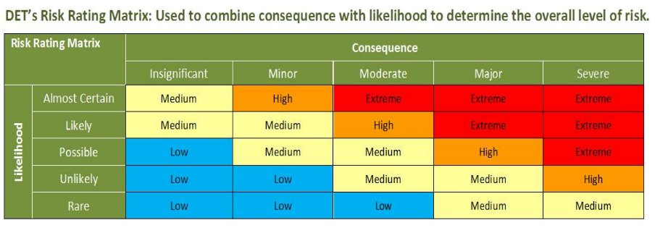

I declare that the information contained in the report is true and correct and that all records and receipts for expenses have been retained by the above organisation.
Organisation Manager/Committee of Management/Accountant  Print full name: ………………………………………………………………  Position in organisation: …………………….…………………………….  Phone: …………………………………………...........................................  Signed: ……………………………….……………………………………..  Date: / / |  | Project Manager *This section must be signed by the project officer.  Print full name: …………………………………………………..  Position in organisation: ………………………………………….  Phone: ………………………………..........................................  Signed: ……………………….……………………………………  Date: / /
Please sign and submit the report to your regional office
Office Use only (Regional Manager will complete this section)
Recommend release milestone payment | Approved | Not Approved
Regional Manager Approval (payments (where applicable) will be released subject to the approval of the report by the appropriate Regional Manager and the appropriate financial delegate)
Print full name: …………………………………………………………………
Regional Manager (insert region): …………………….………….……
Payment amount: (if applicable) ………………………………………..
Signed: ……………………………….……………………………………..
Date: / /

