Bushfire and Emergency Management Self-Assessment

Introduction
The Bushfire and Emergency Management Self-Assessment has been modelled on that developed by the Department of Education and Early Childhood Development (DEECD) in conjunction with Municipal Association of Victoria (MAV), Catholic Education Commission of Victoria (CECV) and the Association of Independent Schools of Victoria (AISV) for use by Victorian schools and children’s services.
While it may appear your organisation is at limited or no risk from bushfire, the survey examines general emergency management arrangements. As a result, all organisations should consider completing and reflecting on the assessment.
This self assessment is for your internal use. The information generated will not be collected by ACFE, and ACFE staff will not provide advice on the outcomes or action you should take. Following completion of the self-assessment, it is recommended that you review your Emergency Management Plans, particularly if you believe that the self assessment identifies areas of concern. You may also wish to contact the emergency services in your area for advice or further information.

Instructions
- The tool consists of 115 items. It is preferable that you respond to them all.
- The assessment will take approximately 60 minutes to complete, depending on the complexity of the site and the availability of source information.
- The majority of questions require two assessments:
  - how “important” the matter is to your organisation
  - the “performance” of your organisation in relation to the relevant matter
- Responses to each statement are recorded on a scale of 1 to 7 scale where 1 = very low and 7 = very high (e.g. 1 = the matter is of minor importance or the performance is very poor and 7 = matter is extremely important or performance is extremely strong).
- Some questions require one choice to be made from a range of possible responses; a small number of questions/statements allow for multiple responses.
- In analysing the information you gather you may wish to look particularly at those areas where you have ranked the importance of the matter as high or very high and your performance as poor or very poor.
- Organisation details
  - Sites occupied by the organisation
- Organisation name:
- Name and street address of main operating site | Name:
 | Address:
- Person completing the assessment | Name  Role
- Is this self-assessment for the main operating site of the organisation? | Yes No
- Number of operating sites the organisation has. (Note: Assessments should be completed for each site). | 1 2  3 5
  - Further Information
- Name of site emergency contact
- Email address of emergency contact
- Phone number of emergency contact
- After hours contact number of emergency contact

- Bushfire risks of the site
- Most prominent vegetation around the site (Please select one)  See page 18 for Vegetation classifications guide | Forests  Woodlands  Tall Heaths  Short Heath  Rainforests  Grasslands  Managed Land  None (urban environment)
- Shortest distance in metres between buildings on the site and the most prominent vegetation? (Please select one) | less than100m  100m or more
- Steepest downhill slope from buildings on the site to the most prominent vegetation? (Please select one)  See page 19 for Slope assessment guide | 0º (flat or uphill only)  0 – 4º downhill  5 – 9º downhill  10 – 14º downhill  15 º +
Each of the previous three questions provide an indication of the relative bushfire risk of your site. The CFA (www.cfa.vic.gov.au) provides an online self assessment tool for households which may also provide useful indication of bushfire risk for ACE organisations.

- Other hazard risks of the site
Estimate the extent of risk or hazard to the site posed by the following in the forthcoming year on a scale from low (1) to high (7).
- wild fire (i.e. sudden fire identified in the immediate vicinity of the site) | Low to high 1 to 7
- fire within the site | Low to high 1 to 7
- flood | Low to high 1 to 7
- wind damage or storm damage | Low to high 1 to 7
- risks during construction on the site | Low to high 1 to 7
- hazardous industries close to the site (e.g., hazardous industries, chemicals, chlorination plants) | Low to high 1 to 7
- hazardous structures or transport systems close to the site (e.g. railway or road with risk of accident or spillage) | Low to high 1 to 7
- other (specify below) | Low to high 1 to 7

- People on the site and site activities
  - People who use the site (Complete this section to reflect an average operating day)
- Typical number of participants on the site (Please select one) | 1 – 25  26-50  51-100  101-300  301-600
- Age range of participants on the site (Please select all that apply) | under 16  16 - 60  over 60
- Typical number of staff on the site | 1 - 10  11 – 20  More than 20
- Number of on-site staff who have emergency management training and experience (e.g. SES or first aid experience)? | 0  1 – 5  6 – 10  More than 10
- Number of on-site staff who are current CFA volunteers? | 0  1-3  4-5  More than 5
- Number of participants with English as a second language? | 0-10  11-20  21-30  More than 30
- Number of participants with a disability which could affect their capacity to respond in an emergency? | 0-10  11-20  More than 20
- Number of people with documented medical conditions which could impact upon our emergency arrangements? | 0-10  11-20  More than 20

  - Uses of the site
- If the site includes a residential facility (e.g. live in or boarding facility) what is the maximum number of people who stay overnight on the site? | No residential facility  1 – 20  21 – 40  More than 40
- The site operates outside normal business hours | Yes  No
- The site operates at weekends and during school holidays | Yes  No
  - Transport to and from the site

The approximate percentages of participants who use the following modes of transport to the site are:
- Walk/ride | 0 – 20%  21% – 40%  41% - 60%  61% - 80%  81% - 100%
- Drive | 0 – 20%  21% – 40%  41% - 60%  61% - 80%  81% - 100%
- Public transport (including taxis) | 0 – 20%  21% – 40%  41% - 60%  61% - 80%  81% - 100%
- Some or all of the participants travel through areas of high bushfire risk on their journey to the site | Yes  No  Don’t know
- Likelihood of all the roads into and away from the city/town/community being compromised in the event of a severe bushfire? | Low to high 1 to 7

- Site infrastructure and management of the site infrastructure risk
  - Physical layout of the site
- Number of buildings on the site (including sheds, garages etc) | 1 – 5  6 or more
Predominant construction of the buildings on the site
- Walls | Concrete  Steel sheet  Masonry  Timber  Other
- Roofs | Clay/Concrete tiles  Steel tiles  Steel sheet  Other metal sheeting  Non-metal sheeting  Other
- The predominant type of window glass at the site is | Fire protected  Standard
- There are buildings on the site with underfloor space that is unsealed externally | Yes  No
- There are buildings on the site with roof space that is unsealed externally | Yes  No
- Is building or site construction work in progress or planned within the next six months? | Yes  No
  - Management of physical risks
- There is appropriate management of materials which may easily be ignited (including removal of overhanging branches, dry grass, flammable debris and rubbish around and under buildings, gutter cleaning, storage of wheelie bins in a secure area, regular emptying and secure storage of industrial rubbish bins, cut back of vegetation) | Performance 1 to 7  Importance 1 to 7
- Storage of all flammable materials, including gas, paints, sealant etc complies with legislated safety standards | Performance 1 to 7  Importance 1 to 7
- All designated building exits are continuously kept clear of obstructions and are safe for use by all users. | Performance 1 to 7  Importance 1 to 7
- Computer back-up information is stored offsite (including computer server, administration and other records) | Performance 1 to 7  Importance 1 to 7

Please list any improvements that could be made to ensure the appropriate management of all materials which can be easily ignited (e.g. litter, rubbish bins, items which will easily ignite from ember attack or radiant heat)

- The site’s infrastructure uses in an emergency
  - Emergency management capability
- The emergency management plan indicates an assembly point within the site grounds? | Yes  No
- If the assembly point indicated in the emergency management plan is on the site grounds, it is: | Grass  Hard surface (eg gravel)  Building  Other

If the assembly point is a building , what is the predominant construction of:
- Walls | Concrete  Steel sheet  Masonry (brick)  Timber  Other  Not a building
- Roof | Clay/Concrete tiles  Steel tiles  Steel sheet  Other metal sheeting  Non-metal sheeting  Other  Not a building
- Glass | Fire protected  Standard
- Is the underfloor space completely sealed externally? | Yes  No  Not a building
- Is the roof space completely sealed externally? | Yes  No  Not a building
- The emergency management plan assembly point has appropriate water, sanitation, first aid, equipment such as fire blankets and communications equipment | Performance 1 to 7  Importance 1 to 7
- There is good access for large vehicles such as trucks and buses to all important areas of the site during an emergency (e.g. buses, fire trucks, other emergency vehicles will have good access even in the event of a fire when one access route is blocked for example by one or more cars) | Performance 1 to 7  Importance 1 to 7
- There is appropriate space for large vehicles such as buses and trucks to turn around (e.g. buses, fire trucks, other emergency vehicles will have appropriate space to turn even in the event of a fire if a turning area is blocked for example by one or more cars) | Performance 1 to 7  Importance 1 to 7
    - Community designated emergency management plan assembly point on site
- Is an area or building on the site a designated community emergency management plan assembly point? | Yes  No
- If an area/building on the site is a designated community emergency management plan assembly point, is it the same assembly point as the site’s assembly point? | Yes  No (details below)
  - Emergency management equipment
- Fire protection systems and equipment are tested and verified as functional at least annually (e.g. fire hydrants, hose reels alarms etc are tested at least annually by fire services or appropriate contractors) | Performance 1 to 7  Importance 1 to 7
- Appropriate records of the testing of fire protection systems and equipment (including inspection logs or similar) are maintained. | Performance 1 to 7  Importance 1 to 7
- Operating instructions are appropriately displayed for all fire protection equipment | Performance 1 to 7  Importance 1 to 7
- Portable fire extinguishers are accessible and appropriately maintained (regular visual inspections, checking of gauges (where fitted) serviceability checks) | Performance 1 to 7  Importance 1 to 7
- Fire blankets are appropriately maintained and accessible | Performance 1 to 7  Importance 1 to 7
- Fire hose reels are appropriately maintained and accessible (i.e. fire hose reels are regularly unrolled, inspected for leaks and any cabinet is kept unlocked) | Performance 1 to 7  Importance 1 to 7
- Fire hydrants are appropriately maintained and accessible (i.e. including inspection for serviceability and tested every 6 months) | Performance 1 to 7  Importance 1 to 7
- Internal fire sprinkler system (if fitted) is appropriately maintained (including regular inspection by a qualified third party) | Performance 1 to 7  Importance 1 to 7
- Water pumping equipment for fire fighting (water tank connections for fire appliances, fire water pressure pumps (fixed), portable pumps for fire fighting) is appropriately maintained and accessible | Performance 1 to 7  Importance 1 to 7
- Water supply (e.g. bore with pump, tank above ground, gravity feed for use, public water mains, tank on-ground, tank in-ground, storage dam) is appropriately maintained and accessible | Performance 1 to 7  Importance 1 to 7
- Roof mounted fire sprinkler system (if fitted) is appropriately maintained (including regular inspection by a qualified third party) | Performance 1 to 7  Importance 1 to 7
- Emergency warning system is appropriately maintained (including testing and training of relevant staff) | Performance 1 to 7  Importance 1 to 7
- Smoke alarms are appropriately maintained and tested and any batteries regularly replaced. | Performance 1 to 7  Importance 1 to 7
- First aid kits are regularly restocked and reviewed for use by dates. | Performance 1 to 7  Importance 1 to 7
- Access is available to emergency information through AM/FM radio (including equipment that works without mains power) | Performance 1 to 7  Importance 1 to 7
- Telephone contact can be maintained without mains power (e.g. telephone handsets that work without mains power, mobile phones, satellite phone) | Performance 1 to 7  Importance 1 to 7
- Hand-operated fire alarms or portable sirens are available | Performance 1 to 7  Importance 1 to 7
- People on site know how to use the fire protection and communication equipment | Performance 1 to 7  Importance 1 to 7
- Up to date fire warning and evacuation notices are clearly displayed near doorways in all occupied areas | Performance 1 to 7  Importance 1 to 7
- First aid kits are available in the event of an emergency. | Performance 1 to 7  Importance 1 to 7
- There is an appropriate supply of drinking water in an emergency (including alternative sources in the event of a power failure) | Performance 1 to 7  Importance 1 to 7

- Emergency management roles, responsibilities and processes
  - Oversight and Culture
- The Committee of Management or Board has appropriate oversight of emergency management planning (i.e. an understanding of emergency management planning and its importance) | Performance 1 to 7  Importance 1 to 7
- There is clear leadership and lines of responsibility in relation to emergency management planning | Performance 1 to 7  Importance 1 to 7
- The site emergency management plan and bushfire plan are reviewed by emergency services (e.g., CFA, MFB, Victoria Police, SES) | Performance 1 to 7  Importance 1 to 7
  - Development of the emergency management plan
- The person accountable for ensuring the development and implementation of the emergency management plan: | Name:  Title:
- The emergency management is regularly maintained and updated | Performance 1 to 7  Importance 1 to 7
- The person/body responsible for formally approving the emergency management plan (including signing off each time the emergency management plan is reviewed and updated) | Committee of Management  CEO/Manager  Other
- There is adequate involvement of the appropriate emergency services authorities in developing the emergency management plan (i.e. relationships established or re-established with emergency services such as CFA, MFB, SES, Ambulance Victoria or Victoria Police when developing and updating the plan) | Performance 1 to 7  Importance 1 to 7
- The emergency management plan identifies the main risks and hazards (i.e. includes actions required, persons responsible, communication and evacuation plans, etc in the event of such a risk or hazard arising) | Performance 1 to 7  Importance 1 to 7
- Appropriate people are involved in developing the emergency management plan | Performance 1 to 7  Importance 1 to 7
  - Emergency Management Plan content
- The emergency management plan is appropriately comprehensive (including the main risks and hazards, actions required, persons responsible, communication, succession, evacuation plans, consideration of wider community risks (e.g. roads) etc) | Performance 1 to 7  Importance 1 to 7
- The emergency management plan deals appropriately with the management of a bushfire emergency (including actions required, persons responsible, communication and evacuation plans etc in the event of a bushfire) | Performance 1 to 7  Importance 1 to 7
- The emergency management plan is adjusted as appropriate to take into account current and future construction works (e.g. where people or vehicular access is changed either temporarily or permanently) | Performance 1 to 7  Importance 1 to 7
- An appropriately detailed back-up plan is outlined in the emergency management plan (i.e. in case the primary plan cannot be executed due to danger, unavailability of key emergency management staff etc) | Performance 1 to 7  Importance 1 to 7
- The emergency management plan takes account of staff being away the responsibilities of staff that may have responsibilities away from the school in an emergency (e.g. CFA volunteers, home-based care responsibilities) | Performance 1 to 7  Importance 1 to 7
- There is appropriate capacity to carry out the emergency management plan (i.e. sufficient staff to carry out key roles including using fire equipment, supervising evacuations, searching rooms, handling communications, assisting those with disabilities or injuries, etc) | Performance 1 to 7  Importance 1 to 7

    - People considered in the emergency management plan
- Class rolls and staff lists are readily accessible in an emergency (i.e. to account for all students and staff) | Performance 1 to 7  Importance 1 to 7
- The emergency management plan takes appropriate account of less-mobile people and those with a disability (including appropriate assembly areas, evacuation routes for people with disabilities, appropriate one-on-one assistance allocated, special vehicle access arrangements made) | Performance 1 to 7  Importance 1 to 7
- The emergency management plan takes appropriate account of communication to people with a language background other than English | Performance 1 to 7  Importance 1 to 7
- The emergency management plan takes appropriate account of on site residents. | Performance 1 to 7  Importance 1 to 7
- The emergency management plan takes account of contractors and other visitors. | Performance 1 to 7  Importance 1 to 7
    - Plan roles and responsibilities
- An appropriate person responsible for making key decisions (e.g. evacuation of the site) in the event of an emergency is clearly identified in the emergency management plan and is aware of their responsibilities. | Performance 1 to 7  Importance 1 to 7
- Appropriate alternative arrangements to account for key emergency management plan staff being unavailable are included in the plan. | Performance 1 to 7  Importance 1 to 7
- Not being overly dependent on emergency services in order to execute the emergency management plan | Performance 1 to 7  Importance 1 to 7
    - Monitoring and triggers
- An appropriate monitoring system is in place on days of high fire danger to trigger initiation of the emergency management plan (e.g. listening to ABC radio, watching for smoke and links to emergency services) | Performance 1 to 7  Importance 1 to 7
- An individual has clear responsibility for “triggering” the emergency management response | Performance 1 to 7  Importance 1 to 7
    - Evacuation process
- The emergency management plan includes an appropriate plan and criteria for evacuating the site (if this is the safer option) | Performance 1 to 7  Importance 1 to 7
- The emergency management plan includes an appropriate plan and criteria for remaining on the site (if this is the safer option) | Performance 1 to 7  Importance 1 to 7
- The emergency management plan will enable all persons to be evacuated safely if the decision is to leave the site | Performance 1 to 7  Importance 1 to 7
  - Training and testing
- Staff are appropriately trained in how to execute the emergency management plan (i.e. staff members with specific roles in the plan have been trained and where required, equipped to carry out their roles) | Performance 1 to 7  Importance 1 to 7
- Key elements of the emergency management plan are tested/practised (e. full fire drill, evacuation, staff practice operating emergency management equipment) | each month  three or four times a year  twice a year  annually  Never
- The last time all the main elements of the emergency management plan were tested/practiced (i.e. full fire drill, evacuation, etc) | this month  3 months ago  6 months ago  12 months ago  Never tested
  - Communication of the emergency management plan
- The emergency management plan is regularly communicated to all key parties (e.g. staff, students, committee members, volunteers, site visitors) | Performance 1 to 7  Importance 1 to 7
- Local emergency services understand the emergency management plan (e.g. documentation of the plan being discussed with local fire authorities, CFA, MFB and SES, Ambulance Victoria, Victoria Police) including their involvement. | Performance 1 to 7  Importance 1 to 7
- Staff, participants and volunteers understand the emergency management plan including their involvement and the procedures that apply | Performance 1 to 7  Importance 1 to 7
- There is an established process to contact emergency services in the event of a bushfire emergency | Performance 1 to 7  Importance 1 to 7
- Commentary on bushfire risk management
Describe the key challenges you face in preparing for and managing bushfire or emergencies at your site
Describe any specific initiatives you have in place now to improve your bushfire and emergency management planning and preparedness
- Vegetation classification
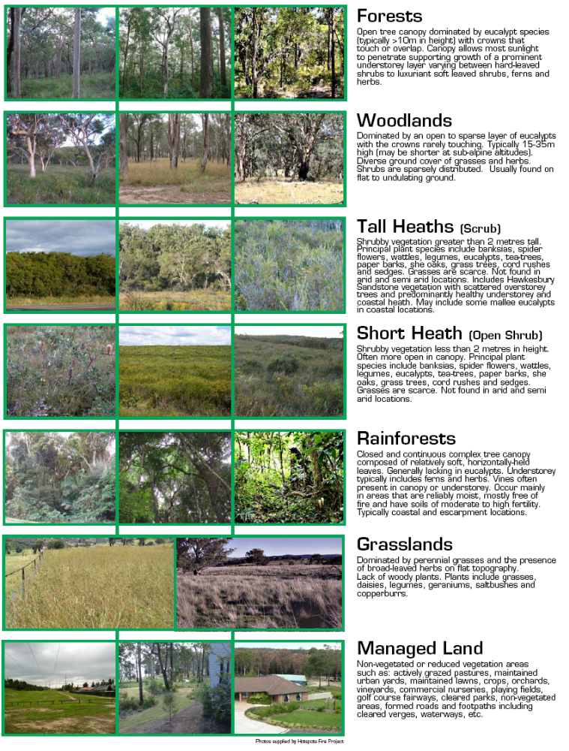
- Slope assessment



