ADULT, COMMUNITY AND FURTHER EDUCATION BOARD
2020 PRE-ACCREDITED TRAINING DELIVERY GUIDELINES

CONTENTS
PRE-ACCREDITED TRAINING DELIVERY GRANT FUNDING PROCESS 4
ADULT, COMMUNITY AND FURTHER EDUCATION (ACFE) BOARD PRE-ACCREDITED TRAINING DELIVERY GRANT FUND 5
PURPOSE OF THESE GUIDELINES 5
PURPOSE OF GOVERNMENT SUBSIDISED PRE-ACCREDITED TRAINING 5
PRIORITIES FOR 2020 PRE-ACCREDITED TRAINING 5
THE PRE-ACCREDITED QUALITY FRAMEWORK 5
ROLE OF THE ACFE BOARD 6
ROLE OF THE ACFE REGIONAL COUNCILS 7
LOCATION OF REGIONAL COUNCIL AREAS 7
ROLE OF PROVIDERS 7
ROLE OF DEPARTMENT OF EDUCATION AND TRAINING 8
ELIGIBILITY CRITERIA 9
LEARNER ELIGIBILITY CRITERIA 9
ASYLUM SEEKER ELIGIBILITY CRITERIA 9
PRIVACY NOTICE FOR STUDENT ENROLMENT 9
PROVIDER ELIGIBILITY CRITERIA 10
HOW TO APPLY FOR PRE-ACCREDITED FUNDING 11
WEBINARS AND REGIONAL FORUM INFORMATION 11
COMPLETING AND SUBMITTING THE DELIVERY PLAN 11
DELIVERY PLAN AND A-FRAME ASSESSMENT 13
NOTIFICATIONS OF OUTCOMES 13
PAYMENT AND REPORTING DATES 14
TRAINING DELIVERY SUPPORT GRANT (TDSG) 14
REGIONAL LOADING 14
FEE CONCESSION ARRANGEMENTS FOR PRE-ACCREDITED DELIVERY 15
COURSE FEES 15
REPORTING – DATA QUALITY 16
STUDENT MANAGEMENT SYSTEM 16
REPORTING PRE-ACCREDITED DELIVERY 16
REPORTING FEE CONCESSION ARRANGEMENTS FOR PRE-ACCREDITED DELIVERY 16
INSTRUCTIONS FOR UPLOADING PRE-ACCREDITED DATA TO THE SKILLS VICTORIA TRAINING SYSTEM (SVTS) 17
RECONCILIATION OF PRE-ACCREDITED FUNDING 17
SAMS2— SERVICE AGREEMENT 18
RECORDKEEPING 18
SERVICE PLAN 18
SERVICE PLAN VARIATIONS 18
SUBCONTRACTING 18
WORK EXPERIENCE 19
INSURANCE 19
COMPLIANCE 20
SERVICE AGREEMENT COMPLIANCE CERTIFICATE (SACC) 20
HOW TO COMPLETE THE SACC FORM? 20
COMMUNICATION WITH LEARN LOCAL PROVIDERS 21
WHO DO I CONTACT IF I NEED ASSISTANCE 21
BRANDING REQUIREMENTS 22
LEARN LOCAL BRAND GUIDELINES 22
PUBLICITY AND ACKNOWLEDGEMENT GUIDELINES 22
THIS ACKNOWLEDGEMENT MUST BE MADE IN: 22
USEFUL LINKS 22

PRE-ACCREDITED TRAINING DELIVERY TIMELINE
Action |  | Date
2020 Expression of Interest (EOI) open. For more information, see Department of Education and Training (DET) website | Open 3 September  Close 30 September
Download the 2020 Pre-accredited Training Delivery Guidelines and the 2020 Delivery Plan template. | From 3 September
Attend a webinar session. Register for a webinar here. | 11 & 13 September
Attend a regional forum in your area. Your regional office will send you an invitation closer to the date. | Throughout September
Prepare Delivery Plan and A-frames (page 11 to 13) and submit your Delivery Plan and A-frames to: training.participation@edumail.vic.gov.au | By 30 September
Department staff review EOIs | September/October
Department confirm EOI outcomes with providers | End October
A Service Plan will be loaded into SAMs2 for your authorised signatory to accept. | Early December
Adult, Community and Further Education (ACFE) Board commences processing first payments. | January 2020
Contact your regional office for more information. | Anytime

PRE-ACCREDITED TRAINING DELIVERY GRANT FUNDING PROCESS
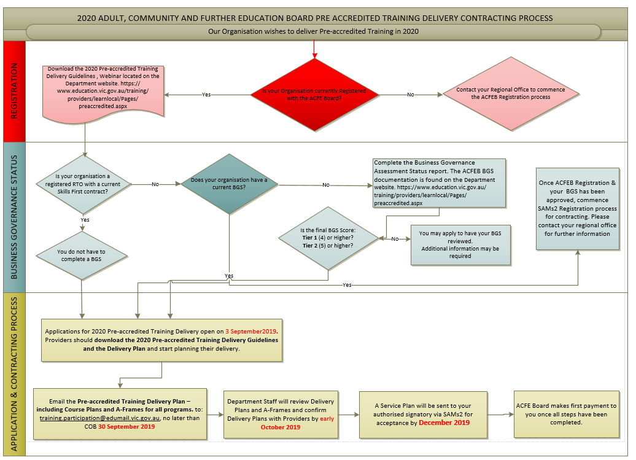

ADULT, COMMUNITY AND FURTHER EDUCATION (ACFE) BOARD PRE-ACCREDITED TRAINING DELIVERY GRANT FUND

Purpose of These GUIDELINES
The information provided in these guidelines has been developed to assist Learn Local providers, AMES Australia and CAE in planning their delivery of pre-accredited training in 2020.

Purpose of government subsidised pre-accredited training
Pre-accredited training programs are short modular courses which focus on creating pathways for learners to further education and training or a pathway to employment.
The primary purpose of pre-accredited education and training is to provide opportunities that engage and initiate vocational pathways for the most educationally disadvantaged learners.
Pre-accredited courses address the particular needs of adults who have experienced barriers to education in the past and find it difficult to undertake accredited courses as their first step into vocational training, particularly those learners who have not achieved Year 12 or an equivalent qualification.
Programs are designed to be flexible to meet learners' needs and support them to return to study, improve their literacy and numeracy skills, gain a qualification, broaden their employment options and learn new skills.
Pre-accredited training programs are unique and separate from accredited training programs, with their own A-frames (Course and Session Plans) and objectives.

Priorities for 2020 pre-accredited training
The ACFE Board’s priorities for the allocation of pre-accredited training funds are based on demographic data and the Board’s strategic objectives. It is expected that proposed programs will seek to meet the needs of learners experiencing educational disadvantage and facilitate learning gain.
The ACFE Board has identified the following learner groups for specific emphasis in pre-accredited programs:
- Women seeking to re-enter the workforce after significant time away, women who have experienced or are experiencing family violence
- Early school leavers, both mature and youth
- Low skilled and vulnerable workers
- Indigenous people
- Unemployed and underemployed people
- People from culturally or linguistically diverse backgrounds
- Disengaged young people
- People with a disability.

THE PRE-ACCREDITED QUALITY FRAMEWORK
All pre-accredited programs must satisfy and be designed in line with the Pre-accredited Quality Framework (PQF), using the required tools and principles, to be eligible for funding.
The PQF is a system of interrelated processes that ensure quality and continuous improvement in the cycle of planning, developing, implementing and reviewing pre-accredited courses.
The PQF provides assurance to all stakeholders (including learners, the community, employers and the ACFE Board) that pre-accredited programs provide quality learning experiences.
As a quality improvement mechanism, the PQF aims to improve outcomes for learners not ready to undertake an accredited course, but wishing to improve their skills to secure employment, access further study, and to build their capacity to engage and remain a part of a complex and fast-changing society.
The PQF supports teachers and managers to plan, develop, teach and review pre-accredited courses. It is comprised of a number of components (described below), which are available as a series of volumes electronically on the DET website.

A-frame
The central component of the PQF is the A-frame. The A-frame provides for the development of adult-centered learning, for planning, delivering and documenting educational practices, and includes practical templates (the Course Plan and the Session Plan) for planning pre-accredited courses.
Providers contracted by the ACFE Board to deliver pre-accredited programs must use the A-frame to design and develop these programs. Copies of Course Plans and Session Plans for any pre-accredited program subsidised by the ACFE Board must be provided to the Board if requested.
Program Evaluation
Through the ACFE Board’s quality framework, pre-accredited providers are required to undertake ongoing evaluation of their pre-accredited programs. This evaluation is a collaborative peer appraisal process that promotes a shared understanding of what constitutes quality course design, delivery and outcomes for learners. Evaluated courses have documented evidence to provide an assurance to the ACFE Board that the courses they subsidise are of high quality.
It is expected that feedback will be sought from participants in pre-accredited programs, in alignment with the objectives of the Department’s annual Victorian Student Satisfaction Survey. All pre-accredited courses must be evaluated annually by providers.

role of the ACFE Board
The Adult, Community and Further Education (ACFE) Board is a statutory authority under the Education and Training Reform Act 2006. Its role is to plan and promote adult learning, allocate resources, develop policies, and advise the Minister for Training and Skills on matters related to adult education in Victoria.
Through the Board, the Victorian Government provides funding to Learn Local providers, AMES Australia and the CAE, to deliver education and training programs to a broad range of Victorians over compulsory school leaving age, with a special focus on people who have had limited prior access to education.
The ACFE Board allocates resources to eight Regional Council areas (Barwon South West, Eastern Metropolitan, Gippsland, Grampians, Hume, Loddon Mallee, North West Metropolitan, and Southern Metropolitan) under a fixed annual budget.
The distribution of resources to Regional Council areas is determined by a demographically driven formula based on the 2016 Census data, moderated by demonstrated demand and provider capacity to deliver.
The formula is calculated on the Regional Council area’s share of the Victorian working age population (people aged 15–69 who are not attending school) with a weighting for the proportion of the Regional Council area population who are educational disadvantaged.
Within the context of a fixed budget, the Board aims to equitably distribute Government funds, taking into account state-wide needs and informed by Regional Council advice.
More information on the ACFE Board is available on the DET website.

ROLE OF THE ACFE REGIONAL COUNCILS
The eight ACFE Regional Councils are established in line with the Education and Training Reform Act 2006. Using their different expertise and local knowledge about adult education, Regional Councils advise the ACFE Board on the needs of adult education across their region. They also contribute to state-wide planning and policy development.

LOCATION OF REGIONAL COUNCIL AREAS

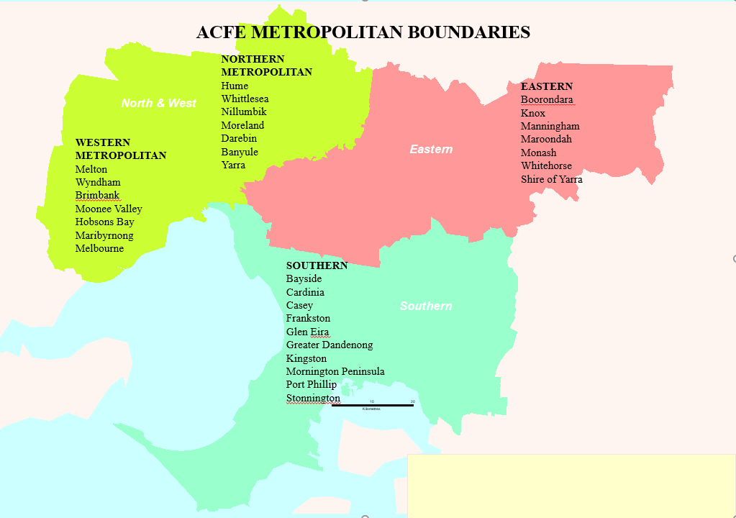

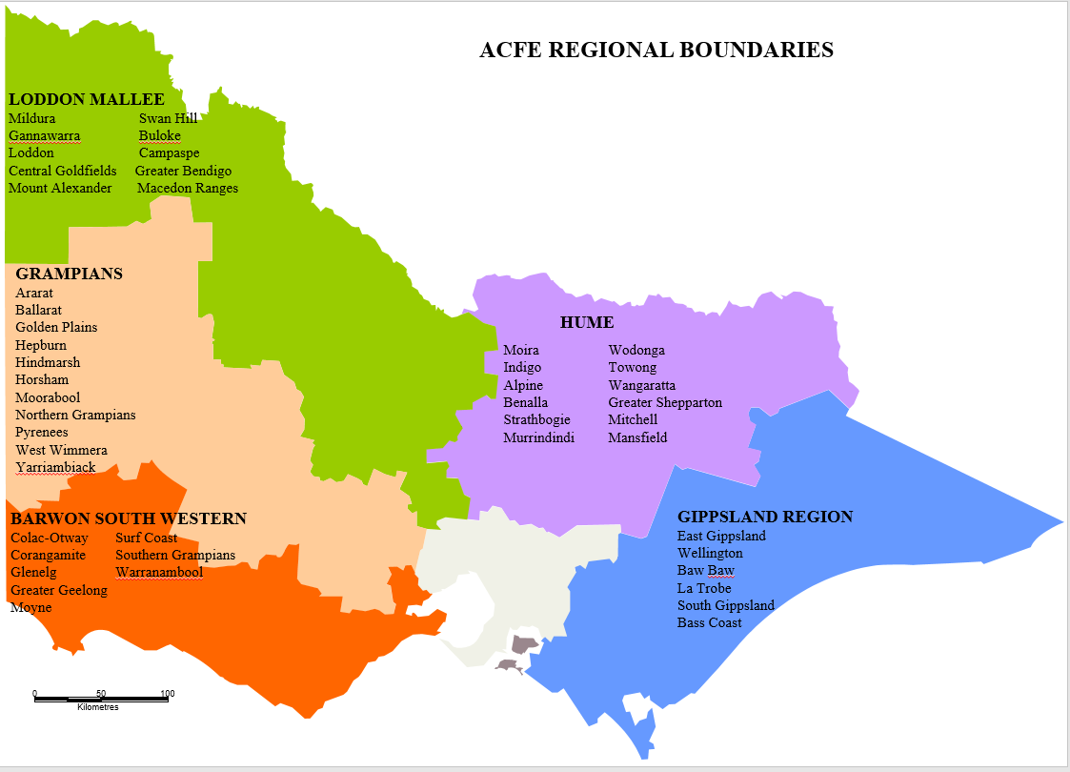

ROLE OF PROVIDERS
The role of Learn Local providers is to design and deliver a wide range of education and community programs, including government subsidised pre-accredited training, which meets the needs of disadvantaged learners.
Contracted pre-accredited providers deliver accessible, locally based training throughout Victoria, including in places where there are fewer training options. They are among Victoria’s most valuable community assets, improving the lives and prospects of many Victorians, and playing a positive role in strengthening local economies and communities.

Role of DEPARTMENT of Education and Training
The role of the Department is to manage the procurement of student contact hours, within the parameters set by the ACFE Board, execute and monitor contracts with contracted providers within the delegations set by the Board, and make regular reports to the Board on progress towards the targets set in contracts and in meeting broader strategic priorities.
The Department manages the procurement process to determine training delivery at the Local Government Area (LGA) through a formal Expression of Interest (EOI) process, following the ACFE Board’s allocation of resources to Regional Council areas. The Expression of Interest process is outlined in detail on page 11 of these guidelines.

Eligibility Criteria

LEARNER Eligibility Criteria
To be eligible to enroll in government subsidised pre-accredited training, learners must meet the following criteria:
 |  | ELIGIBILE | NOT ELIGIBLE
LEARNER eligibility CRITERIA | Australian Citizen | 
 | Holder of an Australian permanent visa | 
 | New Zealand citizen | 
 | A prisoner held at a prison, within the meaning of the Corrections Act 1986.
 | Detained under the Mental Health Act 1986; or the Crimes (Mental Impairment and Unfitness to be Tried) Act 1997 or the Sentencing Act 1991 at the Thomas Embling Hospital.
 | Detained (other than on weekend detention) under the Children, Youth and Families Act 2005 or the Sentencing Act 1991 or who is held on remand in the Malmsbury Juvenile Justice Centre or Parkville Youth Residential Centre.
 | Enrolled at school

ASYLUM SEEKER ELIGIBILITY CRITERIA
ASYLUM SEEKERS | Asylum seekers in specified visa categories, referred by Jobs Victoria Employment Network providers to pre-accredited pre-employment programs. | 
Citizenship requirements apply for accessing all other ACFE Board pre-accredited training programs.
There is currently no exemption for asylum seekers to participate in ACFE Board subsidised programs, other than Jobs Victoria Employment Network referred clients (above). Asylum seekers in specified visa categories are separately eligible for specific Department-funded asylum seeker VET programs.

PRIVACY NOTICE FOR STUDENT ENROLMENT
When enrolling learners in government subsidised pre-accredited training, providers are required to use the student enrolment privacy notice set out in the latest version of the Victorian VET Student Statistical Collection Guidelines.
The Student Enrolment Privacy Notice is located on page 176, Appendix 1 of the Victorian VET Student Statistic Guidelines.
The privacy notice must be used in all enrolment forms for all students who are commencing or re-enrolling. Providers may need to add further information to cover their training provider’s use of student data.
Where electronic enrolment forms are provided, appropriate electronic confirmation procedures should be implemented for the student to confirm that the details provided are correct and that the student has accepted the privacy notice. Please ensure that you are using the latest version of these Victorian VET Student Statistical Collection Guidelines at all times.

PROVIDER Eligibility Criteria
To be eligible to receive government subsidised pre-accredited training delivery grant funding, providers must meet the following criteria:
 |  | DESCRIPTION | LEARN LOCAL | AMES & CAE | LEARN LOCAL RTO
PROVIDER ELIGIBILITY CRITERIA | ACFE REGISTRATION | - Providers must be registered with the ACFE Board or be covered under the Education and Training Reform Act 2006.  - Registration does not guarantee funding.  - For information on registration with the ACFE Board, see: Become a registered Learn Local provider on the Department website. |  |  | 
 | ACFE BOARD BUSINESS AND GOVERNANCE STATUS ASSESSMENT (BGS) | Providers must have a current BGS that has passed the assessment criteria to be eligible for funding. Note: The financial report upon which the BGS assessment is completed must also be submitted with the BGS Assessment.  The following organisation categories are exempted from the BGS submission requirements:  - Registered Training Organisations (RTO) with Skills First Contracts.  - Providers operating under the auspices of Local Government.  For more information about the BGS assessment process, see: Business and governance status assessment on the Department website. |  |  | Must have a current Skills First contract
 | STUDENT MANAGEMENT SYSTEM AND ADMINISTRATION | - Contracted providers must maintain an Australian Vocational Education and Training Management Information Statistical Standard (AVETMISS) compliant, up-to-date student management system, and meet the requirements in the Victorian VET Student Statistical Data Collection Guidelines.  - Must have appropriate and sufficient personnel trained in the use of their Student Management System and the Skills Victoria Training System (SVTS), to ensure integrity, accuracy and currency of data and reporting. |  |  | 
 | DELIVERY PLAN | - Must submit a Delivery Plan that reflects ACFE Board and relevant regional priorities, accompanied by course plans for all proposed programs (and session plans for new programs).  - To be eligible to receive funding, a pre-accredited course must be a minimum of 20 hours duration and part of total program delivery of at least 500 student contact hours (SCH) for the calendar year. |  |  | 
 | SAMs2 REGISTRATION | - Once ACFE Board registration and BGS has been approved, commence SAMs2 registration process for contracting by contacting your regional office. |  |  | 
 | If you wish to deliver pre-accredited training in 2020 but have not delivered in 2019, please contact your regional office as soon as possible. See: Regions on the DET website.

HOW TO APPLY FOR PRE-ACCREDITED FUNDING

Webinars and regional forum INFORMATION
The Department, in collaboration with the VET Development Centre (VDC), are facilitating two webinars in September 2019.
The webinars will focus on priorities for 2020 pre-accredited training delivery, as well as the Learner Engagement A-frame Program (LEAP), and the timelines associated with the EOI process.
All Learn Local providers are encouraged to participate in a webinar and attend a regional forum.
Webinar | Date | Time
Webinar session 1 | Wednesday, 11 September 2019 | 12.30pm – 1.30pm
Webinar session 2 | Friday, 13 September 2019 | 12.30pm – 1.30pm
Webinar presentation | From Wednesday, 18 September 2019 | DET website
Regional forums | Throughout September 2019 | TBA by Regional Office

Webinar registration
Please register for a webinar here. Once registration is complete, you will be emailed a confirmation booking. Your webinar participation link will be emailed to you seven (7) days prior to the webinar and again on the day of the webinar.
In order to participate effectively in the webinar, please check that you have:
- your booking confirmation and participation link
- a strong internet connection
- headphones to hear the presentation
- Google Chrome, installed and ready for use as your web browser (Safari for MAC users) to view the webinar.
If you are unable to participate in a webinar, the presentation will be available on the DET website and the Learn Local Facebook page from Wednesday, 18 September 2019.

Regional forums
Regional forums will be scheduled throughout September to discuss regional priorities and the development of Delivery Plans. Invitations will be sent out by regional offices.

Completing and submitting the delivery plan
The EOI process is conducted through the submission of a Delivery Plan. The Delivery Plan forms the basis for the Department to negotiate and approve the allocation of subsidised pre-accredited training by LGA across the state, in the three program categories, with providers.

The Delivery Plan template is used for both pre-accredited training delivery and the Learner Engagement A-frame Program (LEAP) submissions.
There are three tabs within the Delivery Plan spreadsheet: Tab 1 Instructions, Tab 2 Pre-accredited Training Delivery Plan and Tab 3 LEAP Delivery Plan.
If you are also applying for the LEAP program, see instructions for the LEAP Delivery Plan in the LEAP Guidelines.
For the pre-accredited Delivery Plan:
- Select the pre-accredited training delivery tab (2)
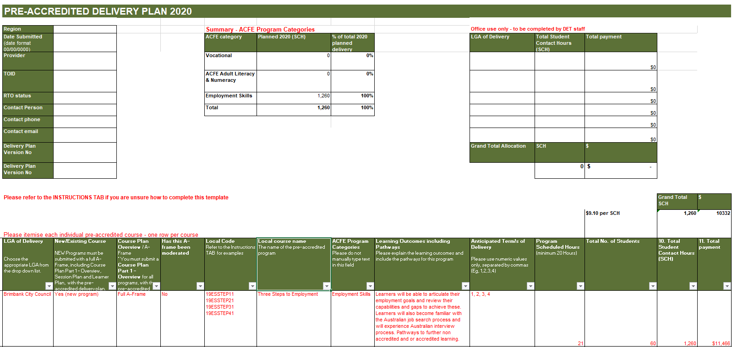
- Prepare Delivery Plan by Local Government Area (LGA) and list course modules in order of your priority as not all your proposed course modules may be funded.
- Local Course Codes must be developed for all pre-accredited programs to facilitate effective reporting.
- Use local course codes for Delivery Plans and reporting.
- Do not use a national or state recognised course for Delivery Plans or reporting.
- Codes should be alphanumeric and up to 12 characters in length with no spaces.
- Delivery Plan codes must match SVTS data codes, i.e. Year, Local Name, Course name. E.g. Three Steps to Employment would be 203STEPS2EMP.
- Program Categories are used to classify all pre-accredited programs contracted by the Board as follows:
- Adult Literacy and Numeracy: Training in literacy and numeracy skills, including teaching English language to people from culturally and linguistically diverse backgrounds, for example English as a Second Language (ESL)
- Employment Skills: Training in basic skills to support work or further learning, such as communications, teamwork and problem solving, job search and return to study skills
- Vocational Programs: Introduction to vocational education that assists people with skills acquisition required specific occupations to start work, return to work or to change jobs.
- Courses that are over 100 SCH (for pre-accredited) may be reviewed and moderated across regions by the Department.
- A-frames
  - To be eligible to receive funding, a pre-accredited course must be:
    - a minimum of 20 hours duration
    - Part of total program delivery of at least 500 student contact hours (SCH) for the calendar year.
    - Course Plans must be submitted for all modules being proposed in your Delivery Plan at the time of submitting the Delivery Plan.
    - All sections of the A-frame (including Course Plan and Session Plan) should be completed and submitted if you are proposing to deliver a new course in 2020.
    - The latest evaluated version of Course Plans and Session Plans should be submitted. Evaluated courses have documented evidence to provide an assurance to the ACFE Board that the courses they subsidise are of high quality. All pre-accredited courses must be evaluated annually by providers.
    - A-frame templates, including course plans and session plans, are available on the DET website at Pre-accredited Quality Framework.
    - Prepare for submission: Course Plans (for existing courses) or full A-frame including Course Plans and Session Plans (for new courses).
- Submit your Delivery Plan and/or Course plans (for existing courses) or full A-frame (for new courses) by COB 30 September 2019 via email to training.participation@edumail.vic.gov.au.
Note: Once submitted to the training participation inbox, you will receive a confirmation of submission. If you do not receive confirmation within one week, please contact DET.

DELIVERY PLAN AND A-FRAME Assessment
All Delivery Plans and A–frames will be subject to the following assessment criteria:
- quality of Course Plans and Session Plans
- clear evidence that the proposed course aims to lead to further education and employment
- the course is targeted at the needs of educationally disadvantaged adults
- evidence of course evaluation
- relevance of the proposed course to local community and regional area priority needs
- the provider’s history of delivery to contract
- The capacity of provider to meet delivery and reporting standards.

Notifications of Outcomes
Providers will be formally notified via email regarding approval of their Delivery Plan and associated A-frames. A Service Plan will be sent to your organisation’s signatory via SAMs2 once all steps have been completed for execution in December 2019. Check and ensure that your organisation’s contact details and signatories are up to date in SAMs2.
Note: Your signatory will have a five day window to review and accept the Service Plan, after which SAMs2 will automatically accept on behalf of your signatory. Your first milestone payment will be processed once all steps are complete.

PAYMENT AND REPORTING DATES
Consistent with 2019, the subsidy per Student Contact Hours (SCH) will remain at $9.10 in 2020.
Providers contracted for 2020 Pre-accredited Training Delivery will receive payment upon successful completion of the identified milestone in the 2020 pre-accredited training Service Plan.
Once processed, payments will appear in an organisation’s bank account up to a week or later, depending on payment processing dates.
Payments may be delayed where any issue has ‘locked’ the agreement or a Service Plan for changes (e.g. signatories, bank account changes, service plan and name changes).
Payments will be processed in SAMs2 where sufficient data has been uploaded in SVTS.
It is expected that 100% of contracted student contact hours will be delivered in 2020.
2020 Payment & Reporting Schedule
No. | Payment  Processing date | Payment percentage (%) | Cumulative payment percentage (%) | Requirement for release of payment
1 | January | 35% | 35% | Contract execution
2 | April | 25% | 60% | 25% enrolments reported by 30 March
3 | August | 20% | 80% | 55% enrolments reported by 31 July
4 | October | 20% | 100% | 75% enrolments reported by 30 September

Training Delivery Support Grant (TDSG)
The Training Delivery Support Grant (TDSG) provides funds to eligible providers to purchase resources or equipment that will support delivery of quality programs and services to learners facing barriers to participation and attainment in education and training.
A grant of $5,500.00 (excluding GST) will be paid to contracted providers that have a current contract with the ACFE Board to deliver government subsidised pre-accredited training in 2020.
For more information, see: Training Delivery Support Guidelines.

Regional Loading
As part of a coordinated strategy to grow regional delivery, the ACFE Board committed $2.6 million over three years, beginning in 2018, to fund a 20 percent regional loading for pre-accredited training delivered in regional Victoria. Payments are based upon reported data for delivery that occurs in the identified postcode areas. The regional loading is currently $1.82 per hour which is 20 per cent of the student contact hour rate.
This measure is intended to increase regional participation in the context of the persistent challenge of achieving viable class sizes in regional areas.
The first payment of the pre-accredited regional loading will be processed in March 2020 and will be based upon 2019 reported delivery in SVTS in the designated eligible postcodes up to the contracted target. (See Appendix A)
The payment will be calculated by multiplying the loading rate by 50 percent of the total 2019 reported eligible delivery hours.
Subsequent payments will be processed based on a reconciliation of 2020 reported eligible delivery early in 2021.

Fee concession arrangements for pre-accredited delivery
Some learners in pre-accredited programs are eligible for fee concessions. The ACFE Board has a budget to reimburse providers for a proportion of the revenue foregone by granting fee concessions to learners in government subsidised pre-accredited programs. Final SVTS data reports will be the source for calculating these payments. Ensure concessions are flagged appropriately when uploading your statistical data to SVTS in order to be considered for a reimbursement.
For more information, see: Course fees

Course Fees
Fees and charges for training and further education are set by the provider. A government subsidised course attracts the level of contribution set by the Minister for Training and Skills, and is subject to other conditions set by the Minister.
For further information see: Course fees on the DET Website.

REPORTING – DATA QUALITY
In accordance with the terms and conditions of your Service Agreement Section 4.9, the ACFE Board may in its discretion give notice to contracted providers to repay unacquitted funds as part of its pre-accredited reported data analysis against the agreed Service Plan and approved Delivery Plan.
Accurately reporting the delivery of pre-accredited training programs is essential to assist the ACFE Board in understanding and responding to community need for pre-accredited training delivery.

Student Management System
Providers contracted to deliver pre-accredited training with the ACFE Board must meet the requirements in the Victorian VET Student Statistical Data Collection Guidelines and maintain an AVETMISS compliant, up-to-date student management system and must upload data through SVTS to meet the requirements as evidence of meeting agreed 2020 pre-accredited SCHs.
Contracted providers must ensure that staff are trained in the use of their Student Management System and the SVTS to ensure integrity, accuracy and currency of reported data.

Reporting Pre-accredited DELIVERY
All contracted providers must ensure that they accurately report all pre-accredited delivery in accordance with the agreed Delivery Plan and must report in SVTS by the following dates:
Reporting & Payment schedule
No. | Reporting Requirement | Payment Processing date
1 | Contract execution | January
2 | 25% enrolments reported by 30 March | April
3 | 55% enrolments reported by 31 July | August
4 | 75% enrolments reported by 30 September | October
Contracted providers should report their pre-accredited SCH data quarterly at a minimum, or where requested monthly, according to the payment schedule in these guidelines.
- Contracted providers can upload their pre-accredited data at any time.
- Students do not need to have fully completed a pre-accredited course before the data is reported.
- For assistance please submit an SVTS enquiry, or consult the SVTS Login User Guide.

Reporting Fee Concession Arrangements for Pre-Accredited Delivery
Some learners in pre-accredited programs are eligible for fee concessions. Final SVTS data reports will be the source for calculating these payments. Ensure concessions are flagged appropriately when uploading your statistical data to SVTS in order to be considered for a reimbursement.
For pre-accredited enrolments, providers must cite and save a copy of the learner’s concession card as evidence. The following concession cards are accepted as evidence of eligibility:
- H - Health Care Card
- P - Age Pension, Carers Pension, Disability Support Pension, Partner Allowance, Widow Allowance, Wife Pension
- V - Veteran Gold Card Concession.

Instructions for Uploading PRE-ACCREDITED Data to the Skills Victoria Training System (SVTS)
- Pre-accredited delivery data should be identified ONLY as ‘Code 61— Community based Adult Education Provider’ in SVTS
- Please use the following Funding Source State Codes for these programs:
- Pre-accredited Training: “ACE”
- Reconnect clients referred to pre-accredited programs: “ACR”
- Asylum seekers referred by Jobs Victoria Employment Networks to pre-accredited pre-employment programs: “ACJ”
- LEAP: “ACE” (standard pre-accredited code), but indicating ‘ACL20’ in the provider’s own designated Course Code. For reporting of LEAP, please see LEAP Guidelines.
- DET-funded Asylum Seeker Language and Literacy Program: “ASE”.
- Report pre-accredited programs with the Module VET flag set to “Y”.
- Learn Local RTOs must report all data including pre-accredited program data and accredited course data in the same SVTS upload.
- Report every pre-accredited program via SVTS with the same Local Code and Local Name used in your Delivery Plan (even if a different name is used to advertise the course).
- Report as Modules only. Do not report as a module linked to a courses. For SVTS reporting purposes, modules are the unit of delivery in pre-accredited programs.
- Pre-accredited training must not be:
- linked in reporting to a Training Package Qualification or a nationally recognised accredited module or course
- Marketed as accredited training. The names and codes of advertised courses or modules must be local
- Assessed for the purpose of award or credit.
Contracted providers need to ensure the following when uploading data to SVTS:
- Check the SVTS website Validation History listing to confirm a successful upload has been completed.
- Check the SVTS website Error/Warning Report and rectify any errors in the data.
- Check that the SVTS data matches the number of SCH uploaded.
A successful final data upload must be completed by 15 January 2020 to the SVTS website with all data errors addressed.

Reconciliation of Pre-Accredited FUNDING
Contracted providers are required to deliver to their SCH targets as outlined in their SAMs2 contract and approved delivery plan. The ACFE Board may give notice to the contracted provider to repay unacquitted funds as part of its pre-accredited reported data analysis against the agreed Service Plan and approved Delivery Plan.
Providers should monitor the delivery and reporting of pre-accredited training regularly and put strategies in place to ensure that contract requirements are met. Where providers identify a possible under-delivery against their contract, they should contact their regional office immediately to discuss a mitigation strategy.
The Department may contact contacted providers where any issues are identified.

SAMS2— SERVICE AGREEMENT
The current ACFE Board Service Agreement cycle is aligned to the Department of Education and Training’s cycle which commenced 1 January 2017 and ends 30 June 2019.
Note: Due to delays in finalising the terms and conditions for the next service agreement business cycle, the Victorian Council of Social Services (VCOSS) has requested that DET extend the end date of all service agreements to 31 December 2019 to provide certainty to funded organisations. The Secretary of the Department has agreed to this request and as a result your organisation’s existing Service Agreement will be varied to change the end date to 31 December 2019. Further information about the Service Agreement extension can be here
Providers offered pre-accredited training delivery subsidies enter into an agreement with the ACFE Board. This agreement between the provider and the ACFE Board will be made via a Service Agreement in the SAMs2 system.
The Service Agreement:
- Outlines the general terms and conditions on which it is made. For more information, see: Terms and Conditions of the Service Agreement.
- Establishes the principles guiding the relationship between the ACFE Board and the provider.
- Obtains the provider’s commitment to support government policies that have a bearing on the provision of adult, community and further education to Victorians.
More information about the Service Agreement is available on the DHHS SAMs2 Funded Agency Channel (FAC).

recordkeeping
Section 6 of the Service Agreement details the requirements for Organisations to keep full and accurate records for all services delivered under the Agreement.

Service Plan
Service Plans listed in Schedule 1–3 of the Service Agreement group together like service activities specific to a program area, and identify the Department/region/division/group providing funding and as negotiated annually on behalf of the ACFE Board.
Where a variation to a provider’s Delivery Plan is approved, should the variation include a change in total student contact hours, or to the distribution of hours by LGA, a Variation Agreement with a revised Service Plan will be issued through SAMs2.

Service Plan Variations
Providers proposing to vary their contracted Delivery Plans must obtain prior approval by the Department before making any changes and commencing delivery.
Variations to the Delivery Plan that include changes to LGA targets or payments, can be requested during two variation windows offered between April–May and July–August each year.
Please ensure that the Chairperson (or approved delegate) of your organisation approves any variation prior to submitting a request. An email to the regional office from your approved delegate is sufficient.

Subcontracting
Providers wishing to enter into a subcontracting arrangement to deliver pre-accredited training, must comply with the terms and conditions listed in Clause 10— Assignment and Subcontracting of the Service Agreement.

Work Experience
All government subsidised pre-accredited programs delivered must comply with the policy outlined in the Pre-accredited Work Experience Guidelines. These guidelines are based on current best practice in the sector. They support work experience which is safe, easily administered, and valuable for learners, providers and industry and provides advice on legal and insurance coverage to safeguard learners, providers and host employers.
The Pre-accredited Work Experience Guidelines, a recording of the webinar and a FAQ document are all available on the Department website.

Insurance
Under the Terms and Conditions of the Service Agreement contracted providers who deliver pre-accredited training must ensure they have appropriate insurance coverage for its operation and business risks with one or more of the following:
- the Victorian Managed Insurance Authority or, if the Organisation is a Council, Liability Mutual Insurance
- an insurer authorised under the Insurance Act 1973 (Commonwealth)
- An insurer approved in writing by the Authority.
Contracted providers must:
- Provide the Authority with proof of the Organisation's insurance cover on request.
- Maintain appropriate insurance coverage for the Term, and, if those policies are underwritten on a 'claims made' basis, for no less than six years after the completion of the Services.
- Undertake periodic reviews to make sure the Organisation's operational and business risks are adequately insured, particularly in regard to public and products liability and professional indemnity risks.

COMPLIANCE

Service Agreement Compliance Certificate (SACC)
Providers funded by the ACFE Board are required to complete a Service Agreement Compliance Certification (SACC).
The SACC consists of a series of questions to be completed annually by the funded organisations, which certifies compliance with Service Agreement requirements. The questions relate to:
- financial management - that the organisation has used funding as outlined in their Service Agreement, is financially viable, has prepared its financial reports and any audit reports and maintains an asset register
- risk management - that risks are managed in accordance with the Australian/New Zealand Risk Management Standard
- staff safety screening - that referee checks, police record checks and, if relevant, Working with Children Checks have been completed
- privacy - that the organisation’s practices and systems are compliant with the Privacy and Data Protection Act 2014 and the Health Records Act 2001 to protect personal and health information
- ACFE Board Business and Governance Status (BGS) - the organisation has submitted an up-to-date BGS assessment or is eligible for an exemption to the BGS requirement under the current ACFE Board Guidelines.
By submitting a SACC form, organisations are making a commitment to the Authority that they have appropriate systems in place to comply with the relevant Service Agreement requirements.

How to complete the SACC Form?
The SACC notifications will be emailed to your organisation via SAMs2 and is due 90 days after the end of your organisation's reporting period. However, if your organisation's annual general meeting (AGM) is after the due date you can insert your organisation's AGM date in SAMs2 and the SACC due date will automatically update to seven days after the AGM.
Organisations should ensure the Contacts tab in SAMs2 is updated regularly to avoid delays in this process.
- The SACC will need to be completed in My Agency, the secure area of the Funded Agency Channel (FAC) website, where organisations update records and information regarding their funded services.
- Within My Agency, registered users will enter the Service Agreement Module (SAM) and be required to complete and submit their organisation's Service Agreement Compliance Certification (SACC).
- The SACC can be saved at any time, allowing for different areas of your organisation to individually complete different sections.
- Once completed, the SACC should be submitted by an authorised person, such as the Director, Chairperson, Chief Executive Officer, President, Principal or Treasurer.
Further information about how to complete the SACC Form is available on the DHHS website.

COMMUNICATION WITH PROVIDERS
The Department, on behalf of the ACFE Board, provides regular memos, information and advice to providers. See Notifications.
In addition, provider forums and information sessions are arranged at regular intervals to give the Department and providers the opportunity to meet and discuss issues, share experiences, knowledge and expertise. These can be face-to-face or electronically via forums and webinars.
Your regional office will provide further correspondence, information and support.

who do i contact if i need assistance
All enquiries regarding the Pre-accredited Training Delivery procurement process should be directed to your regional office. Contracted providers delivering across multiple Department regions should contact the Regional Engagement Support Unit.
South Western Victoria Region (SWV) Barwon South Western, Grampians Regional Council Areas
Georgina Ryder, Manager SWV | 5215 5204 | ryder.georgina.se@edumail.vic.gov.au
Ruth Barnes, Senior Project Officer | 5215 5205 | barnes.ruth.e@edumail.vic.gov.au
David Harris, Senior Project Officer | 5215 5203 | harris.david.d1@edumail.vic.gov.au
Peter McNabb, Project Officer | 5215 5202 | mcnabb.peter.p@edumail.vic.gov.au
South Eastern Victoria Region (SEV) Southern Metropolitan and Gippsland Regional Council Areas
Robyn Downie, Manager SEV | 8765 5701 | downie.robyn.m@edumail.vic.gov.au
Jeremy Brewer, Senior Project Officer | 8765 5703 | brewer.jeremy.d@edumail.vic.gov.au
Val Macgregor, Senior Project Officer | 8765 5700 | macgregor.valerie.j@edumail.vic.gov.au
Marcia Thomas, Senior Project Officer (Gipp) | 8768 5700 | thomas.marcia.j@edumail.vic.gov.au
Irene Desiatov, Project Officer | 8765 5754 | desiatov.irene.I@edumail.vic.gov.au
North Western Victoria Region (NWV) Loddon-Mallee and North Western Metropolitan Regional Council Areas
Kaye Callaghan, Manager NWV | 4433 7582 | callaghan.kaye.k@edumail.vic.gov.au
Larry Price, Senior Project Officer | 4433 0638 | price.lawrence.l@edumail.vic.gov.au
Simon Flood, Senior Project Officer | 7022 0580 | flood.simon.p@edumail.vic.gov.au
Ash Prasad/Holly Pettigrew, Project Officer | 4433 7637 | pettigrew.holly.g@edumail.vic.gov.au
North Eastern Victoria Region (NEV) Eastern Metropolitan and Hume Regional Council Areas
Julie Hebert , Manager NEV | 7022 1802 | hebert.julie.a@edumail.vic.gov.au
Iwona Jonasz, , Senior Project Officer | 7022 1804 | jonasz.iwona.i@edumail.vic.gov.au
Sue O’Brien, Senior Project Officer | 7022 1805 | obrien.susanne.e@edumail.vic.gov.au
Janine Summers, Project Officer | 7022 1806 | summers.janine.j@edumail.vic.gov.au
Regional Engagement Support Unit
Teresa Durka, Manager | 7022 1601 | durka.teresa.t@edumail.vic.gov.au
Andrew Kaighin, Senior Project Officer | 7022 1598 | kaighin.andrew.m@edumail.vic.gov.au
Effie Kene, Project Officer | 7022 1599 | kene.effie.e@edumail.vic.gov.au
Anna Oxley, Project Officer | 7022 0164 | oxley.anna.m@edumail.vic.gov.au

BRANDING REQUIREMENTS

Learn Local Brand guidelines
The Learn Local Brand Guidelines is the official style guide for all visual aspects of the Learn Local brand. The guidelines contain the design specifications for each aspect of the brand identity as well as explanations and examples of key principles and typical applications.

Publicity and Acknowledgement Guidelines
All providers are required to adhere to the Victorian Government Acknowledgement and Publicity Guidelines. If you have any questions in relation to these guidelines please contact your regional office.
Under clause 4.17 of the Service Agreement, providers must acknowledge the funding support provided by the Victorian Government for the services funded.

This acknowledgement must be made in:
- publications and publicity related to services funded – for example, websites, media releases, print and electronic documents and speeches/launches
- An organisation’s annual report.
No acknowledgement is required for general administrative notices or messages such as weekly newsletters relating to operational aspects of the business. These guidelines are focused on publications that directly relate to services funded by the Victorian Government.
By acknowledging this support, providers are informing the community about how public funding is spent.
For a copy of the current Acknowledgment and Publicity Guidelines for Victorian Government funding support, see: Victorian Government Acknowledgement and Publicity Guidelines.

USEFUL LINKS
Registration and Business and Governance Status Assessment (BGS)
- ACFE Board registration
- Business and Governance Status Assessment (BGS)
Data Reporting
- Australian Vocational Education and Training Management Information Statistical Standard (AVETMISS)
- Data collection
- Skills Victoria Training System (SVTS)
Learn Local Resources

- Victorian Government Acknowledgement and Publicity Guidelines
- Curriculum resources
- Fire risk management
- Learn Local toolkit
- Memos and communication
- Microsoft agreement
- Pre-accredited Quality Framework
- Victorian VET Student Statistical Collection Guidelines
- Course fees

APPENDIX A - ACFE REGIONAL LOADING POSTCODES
Postcode | Postcode | Postcode | Postcode | Postcode | Postcode | Postcode | Postcode | Postcode | Postcode
3212 | 3271 | 3330 | 3413 | 3490 | 3564 | 3631 | 3699 | 3816 | 3890
3213 | 3272 | 3331 | 3414 | 3491 | 3565 | 3633 | 3700 | 3818 | 3891
3214 | 3273 | 3332 | 3415 | 3494 | 3566 | 3634 | 3701 | 3820 | 3892
3215 | 3274 | 3333 | 3418 | 3496 | 3567 | 3635 | 3704 | 3821 | 3893
3216 | 3275 | 3334 | 3419 | 3498 | 3568 | 3636 | 3705 | 3822 | 3895
3217 | 3276 | 3340 | 3420 | 3500 | 3570 | 3637 | 3707 | 3823 | 3896
3218 | 3277 | 3342 | 3423 | 3501 | 3571 | 3638 | 3708 | 3824 | 3898
3219 | 3278 | 3345 | 3424 | 3505 | 3572 | 3639 | 3709 | 3825 | 3900
3220 | 3279 | 3350 | 3431 | 3506 | 3573 | 3640 | 3711 | 3831 | 3902
3221 | 3280 | 3351 | 3434 | 3507 | 3575 | 3641 | 3712 | 3832 | 3903
3222 | 3281 | 3352 | 3435 | 3509 | 3576 | 3643 | 3713 | 3833 | 3904
3223 | 3282 | 3355 | 3437 | 3512 | 3579 | 3644 | 3714 | 3835 | 3909
3224 | 3283 | 3356 | 3438 | 3515 | 3580 | 3646 | 3715 | 3840 | 3921
3225 | 3284 | 3357 | 3440 | 3516 | 3581 | 3649 | 3717 | 3841 | 3922
3226 | 3285 | 3360 | 3442 | 3517 | 3583 | 3658 | 3718 | 3842 | 3923
3227 | 3286 | 3361 | 3444 | 3518 | 3584 | 3659 | 3719 | 3844 | 3925
3228 | 3287 | 3363 | 3446 | 3520 | 3585 | 3660 | 3720 | 3847 | 3945
3230 | 3289 | 3364 | 3447 | 3521 | 3586 | 3662 | 3722 | 3850 | 3946
3231 | 3292 | 3370 | 3448 | 3522 | 3588 | 3663 | 3723 | 3851 | 3950
3232 | 3293 | 3371 | 3450 | 3523 | 3589 | 3664 | 3724 | 3852 | 3951
3233 | 3294 | 3373 | 3451 | 3525 | 3590 | 3665 | 3725 | 3854 | 3953
3234 | 3300 | 3374 | 3453 | 3527 | 3591 | 3666 | 3726 | 3856 | 3954
3235 | 3301 | 3375 | 3458 | 3529 | 3594 | 3669 | 3727 | 3857 | 3956
3236 | 3302 | 3377 | 3460 | 3530 | 3595 | 3670 | 3728 | 3858 | 3957
3237 | 3303 | 3378 | 3461 | 3531 | 3596 | 3671 | 3730 | 3859 | 3958
3238 | 3304 | 3379 | 3462 | 3533 | 3597 | 3672 | 3732 | 3860 | 3959
3239 | 3305 | 3380 | 3463 | 3537 | 3599 | 3673 | 3733 | 3862 | 3960
3240 | 3309 | 3381 | 3464 | 3540 | 3607 | 3675 | 3735 | 3864 | 3962
3241 | 3310 | 3384 | 3465 | 3542 | 3608 | 3676 | 3736 | 3865 | 3964
3242 | 3311 | 3385 | 3467 | 3544 | 3610 | 3677 | 3737 | 3869 | 3965
3243 | 3312 | 3387 | 3468 | 3546 | 3612 | 3678 | 3738 | 3870 | 3966
3249 | 3314 | 3388 | 3469 | 3549 | 3614 | 3682 | 3739 | 3871 | 3967
3250 | 3315 | 3390 | 3472 | 3550 | 3616 | 3683 | 3740 | 3873 | 3971
3251 | 3317 | 3391 | 3475 | 3551 | 3617 | 3685 | 3741 | 3874 | 3979
3254 | 3318 | 3392 | 3477 | 3552 | 3618 | 3687 | 3744 | 3875 | 3984
3260 | 3319 | 3393 | 3478 | 3555 | 3619 | 3688 | 3746 | 3878 | 3987
3264 | 3321 | 3395 | 3480 | 3556 | 3620 | 3689 | 3747 | 3880 | 3988
3265 | 3322 | 3396 | 3482 | 3557 | 3621 | 3690 | 3749 | 3882 | 3990
3266 | 3323 | 3400 | 3483 | 3558 | 3622 | 3691 | 3756 | 3885 | 3991
3267 | 3324 | 3401 | 3485 | 3559 | 3623 | 3694 | 3758 | 3886 | 3992
3268 | 3325 | 3407 | 3487 | 3561 | 3624 | 3695 | 3763 | 3887 | 3995
3269 | 3328 | 3409 | 3488 | 3562 | 3629 | 3697 | 3764 | 3888 | 3996
3270 | 3329 | 3412 | 3489 | 3563 | 3630 | 3698 | 3779 | 3889

