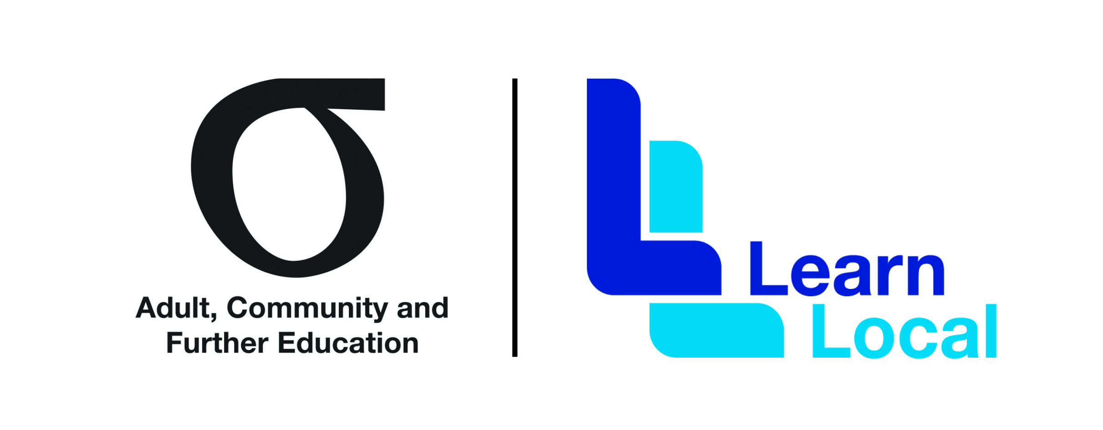

2020 Professional Development Events Calendar for Learn Local pre-accredited training workforces

Last updated: 10 July 2020

This professional development calendar lists all of the opportunities available to the pre-accredited training workforce for the remainder of 2020. The calendar will be updated regularly as information become available. Please note that each training workshop has its own unique registration process and contact for enquiries.
New

Training: Learn Local business support –“Preparing your pre-accredited business for a new future’ Webinar
Outline: This Webinar will discuss 5 steps to Ensuring Business Success in extreme times. It wil provide an overview of current Covid-19 impacts on running a business and how to prepare business for recovery once re-opening becomes possible using the 5 steps of Knowing where you are, deciding your NEW normal, planning finances, attracting clients and offering quick management tools to ensure the business stays on track to achieve desired outcomes.

Target Audience: Pre-accredited business managers and co-ordinators
Locations and times: WEBINAR via VDC: Duration - 1 hour
10.00am-11.00am
Thursday 16th July 2020
Monday -20th July 2020 (repeat)

Registration register here

Enquiries: Ross Jennings, Small Business Mentoring Service

Phone: 1300 816 817

Email: programs@sbms.org.au

Training: Learn Local business support – Strategic and Project Planning – Half day workshop now online plus follow up one on one mentoring

Outline: This Workshop to be run online due to COVID via Zoom, plus a follow-up one on one mentoring event will help you build a new future for your Learn Local pre-accredited business post the 2020 Bushfires and Covid-19 Pandemic and put you in a stronger place should such events happen again.

The workshop will show you: How to Create, Write and Implement a meaningful strategic plan using a simple structure/template provided: How to Develop a Project Plan that properly determines needs of your Project. How to make a project be delivered correctly, on time and on budget.

The workshop includes workbooks (physical and electronic) plus an electronic copy of all relevant slides and tools/templates discussed in the program.

Note: A follow up private mentoring support session of 1-1.5 hours delivered at your Learn Local at a mutually convenient time will assist you with development and creation of your pre-accredited strategic project plan as a deliverable.

Target Audience: Pre-accredited business managers and co-ordinators

Locations/times: Please register for online workshop in your region as far as possible
Location | Dates and times
Pakenham Region | 04.08.2020  10.00 - 13.00
Melbourne CBD Region | 06.08.2020  10.00 - 13.00
Bendigo Region | 13.08.2020  10.00 - 13.00
Ararat Region | 18.08.2020  10.00 - 13.00
Glen Waverley Region | 26.08.2020  10.00 - 13.00
Wangaratta Region | 01.09.2020  13.00-16.00
Geelong Region | 09.09.2020  10.00 - 13.00
Morwell Region | 10.09.2020  10.00 - 13.00
Enquiries:  Registration | Ross Jennings, Small Business Mentoring Service  Phone: 1300 816 817  Email: programs@sbms.org.au  Learn Local business support program  Registration limit of 2 per Learn Local and 20 per venue

Training: Learn Local business support – pre-accredited marketing to your community –Half day workshop now online plus one on one mentoring
Outline This Workshop (wherein social distancing will be maintained) plus a follow up one on one mentoring event will help you better understand the core skills needs of your community and create appropriate and effective marketing communications to get pre-accredited programs back on track in the shortest time possible post the 2020 Bushfires and Covid-19 Pandemic
The workshop covers the needs of both your pre-accredited business and your community. It provides marketing concepts and tools to enhance communication with your community by understanding: Why people ‘buy’ from you and how to Create a bridge between their needs and yours.
Note: A follow up private mentoring support session of 1-1.5 hours delivered at your Learn Local at a mutually convenient time will assist you with developing an appropriate marketing campaign based on an understanding of the needs of your community as a deliverable from participation.
Target Audience: Pre-accredited business managers and co-ordinators
Locations/times: Please register for online workshop in your region as far as possible
Location | Dates and times
Glen Waverley Region | 05.08.2020  10.00 - 13.00
Wangaratta Region | 12.08.2020  10.00 - 13.00
Geelong Region | 19.08.2020  10.00 - 13.00
Morwell Region | 20.08.2020  10.00 - 13.00
Pakenham Region | 25.08.2020  10.00 - 13.00
Melbourne CBD Region | 27.08.2020  10.00 - 13.00
Bendigo Region | 02.09.2020  10.00 - 13.00
Ararat Region | 03.09.2020  10.00-13.00
Enquiries:  Registration | Ross Jennings, Small Business Mentoring Service  Phone: 1300 816 817 Mobile Phone : 0409 016 517  Email: programs@sbms.org.au  Learn Local business support program  Registration limit of 2 per Learn Local and 20 per venue

Training Moving pre-accredited training online - Webinar series
Outline: As a response to COVID19, a series of four webinars on moving pre-accredited training online through approaches suitable for pre-accredited learners have commenced to be run by ACEVic. The webinars discuss and showcase innovative delivery and good practice across the sector during these times. The webinars are being run one per month from May to August 2020.
Target Audience: Pre-accredited educators
Further information: View upcoming webinars and register: https://www.acevic.org.au/events/

Training VDC Learn Local program online
Outline: The Department continues to fund a Learn Local professional development program run by the VET Development Centre that is now online. The program comprises of an Access, Choice & Equity Series of 4 virtual workshops with hour follow up sessions for pre-accredited educators mainly on outreach and engagement, learner support and wellbeing, teaching and learning and pathways for a diverse range of learners, and a Leadership & Governance Masterclass series of four virtual workshops with an hour follow up session for Learn Local coordinators and committees of management to drive organisational performance. There also is also a workshop for Learn Locals on Responding to family violence in an adult learning environment.
Target Audience: Pre-accredited educators and leaders
Registration: Open now here: https://vdc.edu.au/funded-opportunities/#number_2

