Department of Education and Training
Higher Education and Skills Group
Participation, Inclusion and Regional Engagement — Branch Memo
TO: ACFE Board
ACFE Regional Councils
Adult education institutions
Peak bodies and key stakeholders
PIRE Branch staff
Learn Local providers — ALL
FROM: Edu De Hue, A/Director — Participation, Inclusion and Regional Engagement Branch
DATE: 19/11/2019
SUBJECT: CGEA Professional Development (PD) Session

Actions

- Interested Learn Local providers to register for half-day CGEA PD session, Monday 9 December 2019, at Victoria University, 300 Flinders Street, Melbourne, by close of business 2 December by completing and emailing attached form to: Fiona.Mcmahon@vu.edu.au.

Certificates of General Education for Adults

The ACFE Board owns and maintains accredited curriculum, including Certificates in General Adult Education (CGAE Introductory, I II and III, IV).

Victoria University is the Curriculum Maintenance Manager (CMM) for these courses.

CGEA Professional Development

Victoria University CMM is conducting a half-day CGEA professional development session.

The half-day session will provide the opportunity to learn about using a project-based approach to develop literacy and numeracy skills in CGEA programs. It will provide an overview of three programs that employ this approach and offer a workshop for participants to develop skills in planning a project-based approach for delivery of CGEA courses.

This is an ACFE Board funded activity. There is no cost to participants. Priority will be given to Learn Local prrepresentatives. There is a limit of two registrations from any one organisation and a total of 30 participants.

Registration

Learn Local providers can register for the half-day CGEA PD session, Monday 9 December 2019 at Victoria University, 300 Flinders Street, Melbourne, by completing the attached application form and emailing it to: Fiona.Mcmahon@vu.edu.au.

Registrations will be received until close of business 2 December 2019.
CMM CGEA Half day PD 1 2019
Monday 9 December
10.00 a.m. – 1.00 p.m.
Victoria University, 300 Flinders Street, Level 9: Room 915

Registration from 9.30 a.m.

Tea and coffee on arrival

10.00am – 10.05 a.m. Welcome and introductions

Nadia Casarotto/Fiona Mcmahon: Curriculum Maintenance Manager (CMM) General Studies and Further Education.

Session 1: 10.05 a.m. – 11.15a.m Using a project based approach to develop literacy and numeracy skills

This session will provide an overview of three programs that employ a project-based approach:
- Victoria University Polytechnic, Majella Grainger: Pop up café
The Pop-up Cafe on Footscray Nicholson campus is a simulated workplace that caters to multiple learning styles. In addition to developing literacy and numeracy skills, students also develop 21st century skills encompassing creativity/innovation, planning, organising, communicating ideas and information, team work, problem solving and critical thinking.

- North Melbourne Language & Learning, Sam Navarria and Sharon Hurley: Community raft building project
NMLL embraces project based learning because it brings together a variety of learning modes and learning contexts, and can be embedded in diverse curriculum frameworks. Its value may therefore be relevant in the delivery of the CGEA and curriculum such as the EAL Framework, the CSWE, and other AQF qualifications.
The recent Raft Building Project was part of Refuge, a five-year climate change preparedness project run by Arts House in North Melbourne. The students were introduced to the project by Arts House staff, with the NMLL class teacher providing scaffolding and preparatory activities to support students’ participation in a number of project streams. The development of literacy and numeracy skills and extensive language practice were features of the project. Of equal value was putting into action many of the employability skills required for successful performance in workplaces.

- Victoria University Polytechnic, Gabriella Zibell: A project based approach to health
The CGEA 3 Health and Community Service focused course at the Polytechnic’s St Albans campus is a bespoke program offered to students who are interested in pursuing studies in health related areas in VET and HE, but who need to consolidate their literacy and/or numeracy skills. This program is built around health related projects across all units. The course itself is designed to run as a project for a semester where each activity builds a scaffolded learning model and links across the units in the curriculum, seamlessly culminating in a final presentation comprising delivery of an oral essay and a collection of lab reports.

11.15 – 11.20 Introduction to workshop activity

11.20 – 11.40 Morning tea (networking and informal discussion)

Session 2: 11.40 – 12.40 Workshop Activity: Practical session - Planning a project based approach

This session will enable participants to work collaboratively to explore and identify project-based approaches in their delivery of CGEA courses.

12.45-1.00 Feedback and Close

This is an ACFE Board funded activity – no cost to participants.
Priority will be given to Learn Local representatives.
Program subject to change.

Majella Grainger
Majella is a teacher in General Education at Victoria University Polytechnic. She has many years’ experience in teaching the CGEA curriculum. Due to her expertise and knowledge of the cohort she was invited to develop the CGEA 1 (Intro) program to meet the needs of those students who require more fundamental skills. Her student centred approach is inclusive and practical, preparing such students with appropriate life and learning skills to meet the needs of the “real” world.

Sam Navarria, and Sharon Hurley
Sam is currently the Education and Compliance Manager and Sharon is an EAL teacher, at North Melbourne Language and Learning. Sam and Sharon have had many years’ experience in the management and the delivery of local, state and federally funded programs.

Gabriella Zibell
Gabriella is an educator and team leader at Victoria University Polytechnic. She has broad experience across a range of settings and disciplines including English language, linguistics and mathematics. Gabriella believes that any unit in the CGEA can be adapted to project-based delivery, she uses this model extensively in her teaching practice.

Victoria University 300 Flinders St Melbourne

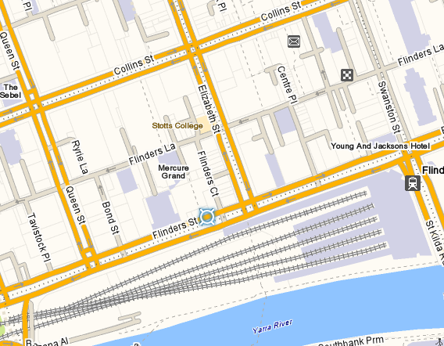

CMM CGEA Half Day PD
REGISTRATION FORM
Monday 9th December 2019
10.00AM – 1.00PM (registration from 9.30am)

Victoria University, 300 Flinders Street, Melbourne
Level 9 Room 915
Please complete this form and return via email to: Fiona.Mcmahon@vu.edu.au
no later than close of business: Monday 2nd December 2019
Inquiries please phone 9919 7744 / 5300
Please note that due to restrictions on numbers (30 participants) there is a limit of 2 registrations from any one organisation.

PARTICIPANT DETAILS
Name:
Current Position:
Organisation:
Street Address:
Suburb: |  |  |  | Postcode:
Mobile: |  | Email:
Special Dietary Requirements:

(To complete this form electronically, use TAB to move forward and SHIFT+TAB to move backward from section to section)

