Operational protocols for referral and enrolment into Learn Local pre-employment pre-accredited training courses for Jobs Victoria registered asylum seekers
Background
The Adult, Community and Further Education (ACFE) Board has approved the inclusion of Jobs Victoria registered asylum seekers into Jobs Victoria identified Board subsidised pre-employment, pre-accredited programs offered by Learn Local providers.

Jobs Victoria Employment Network partners (Jobs Victoria partners) are funded by the Department of Jobs, Precincts and Regions (DJPR). These partners deliver assistance that is tailored to the particular needs of jobseekers and the local area, including job search support, work preparation, active engagement with employers to identify suitable employment opportunities and placement into jobs. Participants registered with and benefiting from assistance include eligible asylum seekers.

This cross-government pilot initiative, administered by the Department of Education and Training (DET) in partnership with DJPR may facilitate a pathway into accredited training and/or employment.

To be eligible, asylum seekers must be Jobs Victoria registered and must hold a current valid Bridging Visa class ‘E’ (BVE), or a valid Temporary Protection Visa (TPV) or a valid Safe Haven Enterprise Visa (SHEV), with work and study rights. This will ensure that the asylum seeker is exempt from the citizenship/eligibility criteria requirements to access subsidised ACFE Board pre-employment pre-accredited programs.

New operational process for enrolling Jobs Victoria registered Asylum Seekers

The process for Jobs Victoria registered asylum seekers to be referred to an ACFE Board subsidised pre-employment pre-accredited program, delivered by a Learn Local provider, is as follows:
- The Jobs Victoria partner identifies that a Jobs Victoria registered asylum seeker client needs new skills to become more employable. The Jobs Victoria partner determines that the employment skills could be gained through enrolment in an identified pre-employment pre-accredited program.
- The Jobs Victoria partner consults with a Learn Local provider to identify a suitable ACFE Board subsidised pre-employment pre-accredited program.
- The Jobs Victoria partner completes Part A of a Jobs Victoria Referral Form– pre-employment pre-accredited training program including details of the identified program (see Attachment 1).
- The Jobs Victoria partner emails this form to the Learn Local provider, who then makes contact with the Jobs Victoria client to complete Part B of the referral form.
- The Learn Local provider completes visa verification check is done through the Visa Entitlement Verification Online (VEVO) to ensure the asylum meets the eligibility exemption requirements for enrolment. VEVO is available at: https://immi.homeaffairs.gov.au/visas/already-have-a-visa/check-visa-details-and-conditions/check-conditions-online/for-organisations. If required, the Learn Local provider may contact the Asylum Seeker Resource Centre (03 9274 9807) for advice on the use of VEVO.
- Once the visa and entitlements of the Jobs Victoria referred asylum seeker have been validated, the Learn Local provider will then assess whether the Jobs Victoria registered asylum seeker client is suitable for the pre-employment pre-accredited program as per standard pre-employment procedures.
- The Learn Local provider returns a copy of the completed form to the Jobs Victoria partner for their records, along with an invoice for payment of tutorial fees.
- Learn Local providers charge any eligible students enrolling in a pre-accredited program a maximum of $50 per calendar year to cover tutorial fees. The Jobs Victoria partner will cover the cost of these tutorial fees as agreed with DJPR. This will be a maximum of $50 per calendar year.
- Jobs Victoria partners can refer an eligible asylum seeker to more than one program each year. Each time a new program referral is made; the Jobs Victoria partner will update Part A of the referral form and email this form to the Learn Local provider.
A summary of the Learn Local provider activities in relation to the new operational process is at Attachment 2.

Record Keeping
Both the Jobs Victoria provider and the Learn Local provider must retain copies of all documentation demonstrating that the asylum seeker is suitable to enrol in an ACFE Board subsidised pre-employment pre-accredited program. This includes retention of documentation that demonstrates the asylum seeker is exempt from the citizenship/eligibility criteria for accessing government subsidised training confirmed by a visa verification check.

The required documentation is for audit, reporting and evaluation purposes. Documents will include the completed Jobs Victoria Referral Form and tuition fee invoices, which may need to provided upon request to DET and the DJPR.

Learn Local and Jobs Victoria Contacts

Jobs Victoria Contact Learn Local Contact
Phone: 1300 208 575 Contact Regional Managers

Attachment 1 – Jobs Victoria Referral Form example

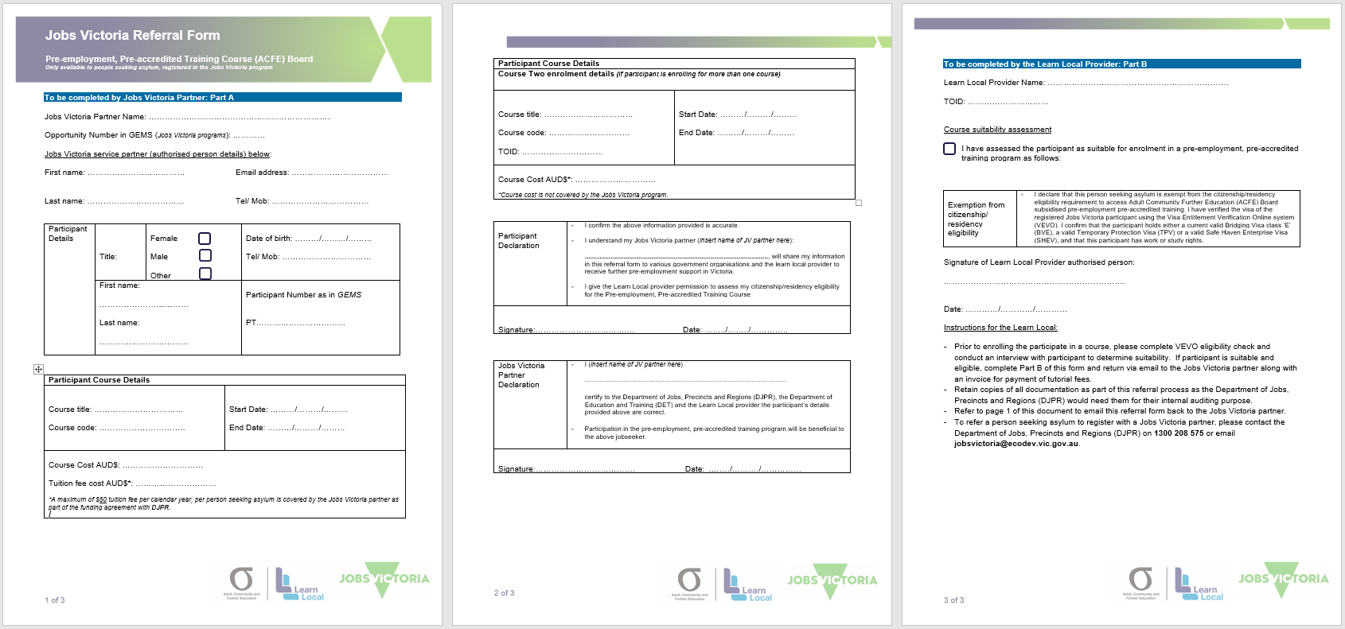

Attachment 2 - Summary of Learn Local provider activities in relation to the new operational process for enrolling Jobs Victoria registered Asylum Seekers

