ACFE BOARD
2019 PRE-ACCREDITED TRAINING DELIVERY
GUIDELINES

2019 PRE-ACCREDITED TRAINING DELIVERY
ALLOCATION PROCESS TIMELINE

Action Date
Expression of Interest (EOI) open. For more information, see Memo. | 7 August
Download the 2019 Pre-accredited Training Delivery Guidelines and the 2019 Delivery Plan template. | From 7 August
Check eligibility requirements.
Prepare Delivery Plan and course plans.
Two webinar sessions are available, register here. | 14 August  17August
A regional workshop is available in your area. Your regional office will send you an invitation closer to the date. | September
Submit your delivery and course plans to: training.participation@edumail.vic.gov.au | By 10 September
DET staff review EOIs. | 10 September
DET confirm final allocations by LGA with providers | By 10 October
A Service Plan will be loaded into SAMs 2 for your authorised signatory to accept. | December
ACFE Board commences processing first payments. | January 2019
Contact your regional office for more information. | Anytime

CONTENTS
_Toc19173353
PURPOSE OF THESE GUIDELINES 4
PURPOSE OF GOVERNMENT SUBSIDISED PRE-ACCREDITED TRAINING 4
THE ROLE OF THE ACFE BOARD 4
PRIORITIES FOR PRE-ACCREDITED TRAINING 4
ELIGIBILITY CRITERIA FOR PRE-ACCREDITED TRAINING DELIVERY FUNDING 5
WHO CAN ENROL IN GOVERNMENT SUBSIDISED PRE-ACCREDITED TRAINING? 6
ACFE REGIONAL COUNCILS 6
ROLE OF REGIONAL COUNCILS 7
LOCATION OF REGIONAL COUNCILS 7
RESOURCE ALLOCATION BY REGIONAL COUNCIL AREA 7
PROVIDER ALLOCATION ASSESSMENT CRITERIA 8
HOW TO APPLY FOR PRE-ACCREDITED TRAINING DELIVERY FUNDING 10
WEBINARS AND WORKSHOPS 10
COMPLETING AND SUBMITTING THE DELIVERY PLAN 10
A-FRAMES AND COURSE PLANS 11
WORK EXPERIENCE 12
VARIATIONS TO THE PRE-ACCREDITED DELIVERY PLAN 12
SAMS 2— SERVICE AGREEMENT 12
SERVICE PLAN 13
UNACQUITTED FUNDS— RECONCILIATION OF THE PRE-ACCREDITED TRAINING DELIVERY PLAN 13
SUBCONTRACTING 13
PAYMENT RELEASE AND REPORTING DATES 13
TRAINING DELIVERY SUPPORT GRANT (TDSG) 14
FEE CONCESSION ARRANGEMENTS FOR PRE-ACCREDITED DELIVERY 14
REGIONAL LOADING 14
HOW TO COMPLETE THE SACC FORM? 16
INSURANCE 16
REPORTING – DATA QUALITY 18
INSTRUCTIONS FOR UPLOADING DATA TO THE SKILLS VICTORIA TRAINING SYSTEM (SVTS) 18
THE PRE-ACCREDITED QUALITY FRAMEWORK 20
COMMUNICATION WITH LEARN LOCAL PROVIDERS 22
BRANDING REQUIREMENTS 22
PRIVACY NOTICE FOR STUDENT ENROLMENT 22
USEFUL LINKS 22

Introduction
Victoria’s adult community education sector has a long and proud history. Currently, more than 300 Learn Local providers (Learn Local organisations and Adult Education Institutions) deliver a wide range of education and community programs, including government subsidised pre-accredited training to almost 28,000 Victorians. Learn Local providers have a great record of supporting Victorians who face barriers in accessing education and training, and in building people’s capabilities and confidence for work and life.
Learn Local providers deliver accessible, locally based training throughout Victoria including in places where there are fewer training options. They are among Victoria’s most valuable community assets, improving the lives and prospects of many Victorians, and playing a positive role in strengthening local economies and communities.

Purpose of These GUIDELINES
The information provided in these guidelines has been developed to assist Learn Local providers in planning their delivery of pre-accredited training in 2019.

Purpose of government subsidised pre-accredited training
The primary purpose of pre-accredited training is to engage the most educationally disadvantaged learners and initiate vocational and/or employment pathways for them.

The role of the ACFE Board
The Adult, Community and Further Education (ACFE) Board is a statutory authority under the Education and Training Reform Act 2006. Its role is to plan and promote adult learning, allocate resources, develop policies, and advise the Minister for Training and Skills on matters related to adult education in Victoria.
Through the Board, the Victorian Government provides funding to community organisations known as Learn Local providers, including two Adult Education Institutions (the Centre for Adult Education (CAE) and AMES Australia) to deliver education and training programs to a broad range of Victorians over compulsory school leaving age, with a special focus on people who have had limited prior access to education.
The Board’s priorities, criteria and processes for the allocation of pre-accredited training funds are based on demographic data and the Board’s strategic objectives.
More information on the ACFE Board is available on the DET website.

Priorities for pre-accredited training
The ACFE Board has identified the following learner groups for specific emphasis in pre-accredited programs:
- Women seeking to re-enter the workforce after significant time away, women who have experienced or are experiencing family violence
- early school leavers, both mature and youth
- low skilled and vulnerable workers
- Indigenous people
- unemployed and underemployed people
- people from culturally or linguistically diverse backgrounds
- disengaged young people
- people with a disability.

Eligibility Criteria for Pre-Accredited Training DELIVERY FUNDING
To be eligible to receive government subsidised pre-accredited training delivery program funding, organisations must:
- Be registered with the ACFE Board, and have applied for registration in 2019, or be an Adult Education Institution.
Registration does not guarantee funding. For more information on registration with the ACFE Board, see: Guidelines and Criteria for Registration with the Adult, Community and Further Education Board
- Have a current satisfactory ACFE Board Business and Governance Status Assessment (BGS), or have a current Skills First government subsidised accredited training contract.
More information about the BGS is available on the DET website.
- Maintain an Australian Vocational Education and Training Management Information Statistical Standard (AVETMISS) compliant, up-to-date student management system, and meet the requirements in the Victorian VET Student Statistical Data Collection Guidelines.
- Have appropriate and sufficient personnel trained in the use of their Student Management System and the Skills Victoria Training System (SVTS), to ensure integrity, accuracy and currency of data and reporting.
- Submit a Delivery Plan that reflects ACFE Board and relevant regional priorities, accompanied by course plans for all proposed 2019 programs, by 10 September 2018.
To be eligible to receive funding, a pre-accredited course must be:
- a minimum of 20 hours duration
- part of total program delivery of at least 500 student contact hours (SCH) for the calendar year.
PLEASE NOTE
If you wish to deliver pre-accredited training in 2019 but have not delivered in 2018, please contact your regional office as soon as possible.

Who can enrol in GOVERNMENT subsidised pre-accredited training?
Learners must be:
- an Australian citizen
- a holder of an Australian permanent visa
- a New Zealand citizen
- an asylum seeker client referred to a pre-employment pre-accredited program by a Jobs Victoria Employment Network provider, in one of the following specified visa categories: Bridging Visa E (BVE), Safe Haven Enterprise Visa (SHEV) or Temporary Protection Visa (TPV)
And not:
- a prisoner held at a prison, within the meaning of the Corrections Act 1986
- detained under the Mental Health Act 1986; or the Crimes (Mental Impairment and Unfitness to be Tried) Act 1997 or the Sentencing Act 1991 at the Thomas Embling Hospital
- detained (other than on weekend detention) under the Children, Youth and Families Act 2005 or the Sentencing Act 1991 or who is held on remand in the Malmsbury Juvenile Justice Centre or Parkville Youth Residential Centre
- enrolled at school
Citizenship requirements apply for accessing all ACFE Board pre-accredited training programs. There are currently no exemptions for asylum seekers to participate in government subsidised pre-accredited training through the ACFE Board, other than Jobs Victoria Employment Network -referred clients eligible from 1 July 2019. Asylum seekers in specified visa categories are eligible for specific Department-funded asylum seeker VET programs. For further information see the DET website.

ACFE REGIONAL COUNCILS
There are eight ACFE Regional Councils established in line with the Education and Training Reform Act 2006.
Regional Councils draw together different expertise and aspects of local knowledge about adult education to advise the ACFE Board on the needs of adult education across their region. They also contribute to statewide planning and policy development.

Role of REGIONAL Councils
Regional Councils prepare advice on local priority learner cohorts to inform and assist the ACFE Board in determining the allocation of pre-accredited training resources across Victoria. Each year Regional Councils provide advice on regional priorities based on their knowledge, research and local intelligence. Regional Councils prepare this advice based upon a consideration of the priorities and strategic objectives of the ACFE Board, relevant local demographic and training data, and the socio-economic and employment profile of the region and local intelligence on learner needs. Regional Workshops to discuss regional priorities and the development of Delivery Plans will be scheduled in regional locations throughout September 2018.

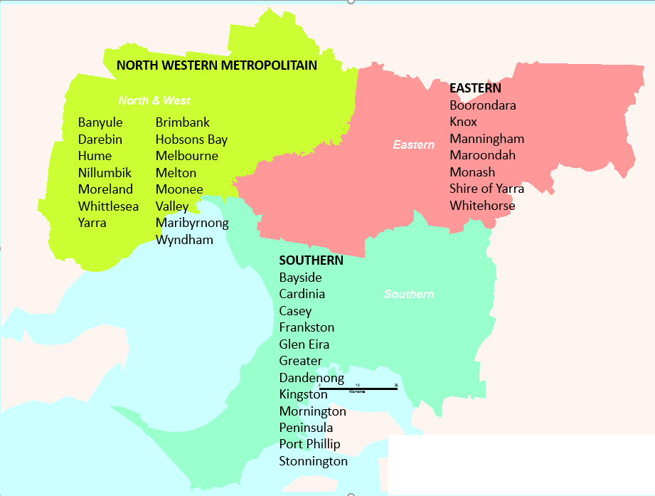
LOCATION OF REGIONAL COUNCILS
Barwon South Western
Eastern Metropolitan
Gippsland
Grampians
Hume
Loddon Mallee
North Western Metropolitan
Southern Metropolitan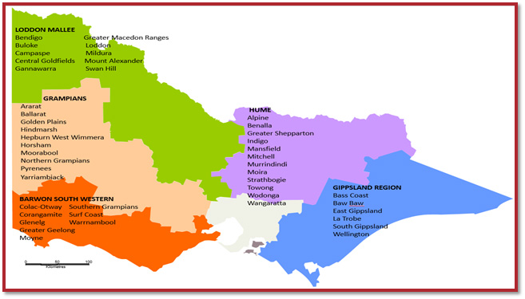

RESOURCE ALLOCATION by regional council area
The allocation of funds to Learn Local providers to deliver pre-accredited training programs will be managed by the Department of Education and Training (DET). The overarching aim is to support the achievement of the targets and learner outcomes identified in the 2016–19 ACFE Board Strategy.
The distribution of resources to Regional Council areas is determined by a demographically driven formula based on the 2016 Census data, moderated by demonstrated demand and provider capacity to deliver.
The formula is calculated:
- on the Regional Council area’s share of the Victorian working age population (people aged 15–69 who are not attending school)
- with a weighting for the proportion of the Regional Council area population who are educational disadvantaged.

PROVIDER ALLOCATION assessment criteria
All Delivery Plans and A–frames will be subject to the following assessment criteria:
- quality of Course Plans and Session Plans
- clear evidence that the proposed course aims to lead to further education and employment
- the course is targeted at the needs of priority learner cohorts
- evidence of course evaluation/moderation
- relevance of the proposed course to local community and regional area priority needs
- the provider’s history of delivery to contract
- the capacity of provider to meet delivery and reporting standards.

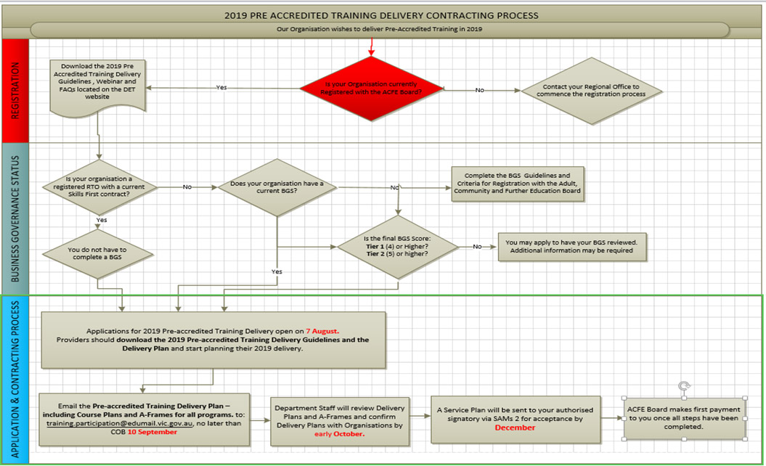
2019 GOVERNMENT SUBSIDISED PRE-ACCREDITED ALLOCATION PROCESS

HOW TO APPLY FOR PRE-ACCREDITED TRAINING DELIVERY FUNDING
- Check your eligibility outlined in the eligibility criteria of these guidelines.
- Download the 2019 Delivery Plan template and select the Pre-accredited Delivery Plan tab.
- Participate in a webinar and attend a regional workshop to help you prepare your application.
- Complete the Delivery Plan:
- by LGA
- in order of your priority, as not all your proposed course modules may be funded.
- Submit:
- for existing courses: course plans
- for new courses: a full A-frame, including course plans and session plans.
- Submit your application by COB 10 September 2018, via email to training.participation@edumail.vic.gov.au. Early submissions are appreciated.

Webinars and workshops
All Learn Local providers are encouraged to participate in a webinar and attend a regional workshop.
Forum Type | Date | Time
Webinar session 1 | Tuesday 14 August 2018 | 2.00pm – 3.00pm
Webinar session 2 | Friday 17 August 2018 | 2.00pm – 3.00pm
Webinar recording | From 20 August 2018 | DET website
Regional workshops | September 2018 | TBA by Regional Office

Webinars
The DET Regional Engagement and Support Unit, in partnership with the Vet Development Centre, (VDC) are facilitating two webinars in August 2018.
The webinars will focus on priorities for 2019 pre-accredited training delivery as well as the Learner Engagement A-frame Program (LEAP), and the timelines associated with the allocation process.

Webinar registration
Register for a webinar here. Once registration is complete, you will be emailed a confirmation booking and your webinar participation link.

Webinar requirements
Prior to the webinar, check that you have:
- your booking confirmation and participation link
- a stable internet connection
- headphones
- Google Chrome, as it is the optimal browser to view the webinar
- tested your PC/internet system to ensure you can view the webinar at the VDC test site.
Regional workshops
Regional workshops are being held in September. Invitations will be sent out by regional offices.

COMPLETING AND SUBMITTING THE DELIVERY PLAN
The EOI process is conducted through the submission of a Delivery Plan. The submitted Delivery Plan forms the basis for DET to negotiate and approve the allocation of subsidised pre-accredited training by LGA across the state, in the three program categories, with providers.
Once developed, please submit your EOI by COB 10 September 2018, via email to training.participation@edumail.vic.gov.au. Early submissions are appreciated. Once submitted to the training participation inbox, you will receive a confirmation of submission. If you do not receive confirmation within one week, please contact DET. In addition to submitting to the training participation inbox, may also wish to cc your regional office.
The 2019 Delivery Plan template is used for both Pre-accredited and LEAP program submissions.
- Select tab 2 for Pre-accredited Training Delivery Worksheet
- Prepare Delivery Plan by Local Government Area (LGA)
- List course modules in order of your priority.
- Courses that are over 100 SCH may be reviewed and moderated across regions by DET.

Local Course Codes
Course codes must be developed for all pre-accredited programs to facilitate effective reporting.
- Use local course codes for Delivery Plans and reporting.
- Do not use a national or state recognised course for Delivery Plans or reporting.
- Codes should be alphanumeric and up to 12 characters in length with no spaces.
- Delivery Plan codes must match SVTS data codes, i.e.:
Local Code (Subject Identifier), Local Name (Subject Name) and ACFE Category.
- Some initiatives, which may be separately funded, require the use of specific codes. For these initiatives providers must use the appropriate Funding Source State Code for the program. For example:
  - Asylum Seeker Language and Literacy Program: “ASE”
  - Reconnect: “ACR”
  - LEAP: “ACE” (standard pre-accredited code), but indicating ‘ACL19’ in the provider’s own designated Course Code.
Examples of how to create a local code are listed below.
Year | + | ACFE category | + | Local name | = | Local code
2019 | + | Vocational | + | Trade taster | = | 19TTASTE
2019 | + | Adult literacy and numeracy | + | Language and numeracy | = | 19ALNLLANNUM
2019 | + | Employment skills | + | Employment preparation | = | 19EMPPREP
More information is available on the DET website.

Program Categories
Program categories are used to classify all pre-accredited programs contracted by the Board as follows:

Adult Literacy and Numeracy: Training in literacy and numeracy skills including teaching English language to people from culturally and linguistically diverse backgrounds, for example English as a Second Language (ESL).

Employment Skills: Training in basic skills to support work or further learning, such as communications, teamwork and problem solving, job search and return to study skills.

Vocational Programs: Introduction to vocational education that assists people with skills acquisition required specific occupations to start work, return to work or to change jobs.

A-FRAMES AND COURSE PLANS
Course Plans must be submitted for all modules being proposed in your 2019 Delivery Plan at the time of submitting the Delivery Plan. All sections of the A-Frame (including Course Plan and Session Plan) should be completed and submitted if you are proposing to deliver a new course in 2019.
The latest moderated version of Course Plans and Session Plans should be submitted.
A-frame templates, including course plans and session plans, are available on the DET website.

WORK EXPERIENCE
All government subsidised pre-accredited programs delivered in 2019 must comply with the policy outlined in the Pre-Accredited Work Experience Guidelines.
These guidelines are based on current best practice in the sector. They support work experience which is safe, easily administered, and valuable for learners, providers and industry and provides advice on legal and insurance coverage to safeguard learners, providers and host employers.
The Pre-Accredited Work Experience Guidelines, a recording of the webinar and a Q and A document are all available on the DET website.

Variations to the Pre-accredited Delivery Plan
Training delivery and data reporting must match the agreed content in the Delivery Plan.
Providers proposing to vary their contracted Delivery Plans must obtain prior approval through the relevant Department staff before making any changes and commencing delivery.
Please ensure that the Chairperson (or approved delegate) of your organization approves any variation prior to submitting a request. An email to the regional office from your approved delegate is sufficient.
Variations to the Delivery Plan that include changes to LGA targets or payments, can be requested during two variation windows offered between April–May and July–August each year.

assessment and notification
DET staff will consider your proposed Delivery Plan in light of the ACFE Board priorities and the demand for training in each Local Government Area (LGA). DET staff will liaise with you if any issues are identified or further clarification is required.
Providers will be formally notified via email regarding approval of their Delivery Plan.
A Service Plan will be sent to your organisation’s signatory via SAMs 2 once all steps have been completed for execution in December 2018. Check and ensure that your organisation’s contact details and signatories are up to date in SAMs.
Please note: Your signatory will have a five day window to review and accept the Service Plan, after which SAMs will automatically accept on behalf of your signatory.
Your first milestone payment will be processed once all steps are complete.

SAMS 2— SERVICE AGREEMENT
The current ACFE Board Service Agreement cycle is aligned to the Department of Education and Training’s cycle which commenced 1 January 2017 and ends 30 June 2019.
Organisations offered re-accredited training delivery subsidies enter into an agreement with the ACFE Board. This agreement between the organisations and the ACFE Board will be made via a Service Agreement in the SAMS 2 system.
The Service Agreement:
- Outlines the general terms and conditions on which it is made. For more information, see: Terms and Conditions of the Service Agreement.
- Establishes the principles guiding the relationship between the ACFE Board and the organisation
- Obtains the organisation’s commitment to support government policies that have a bearing on the provision of adult, community and further education to Victorians.
More information about the Service Agreement is available on the DHHS SAMs Funded Agency Channel (FAC).

Service Plan
Service plans listed in Schedule 1–3 of the Service Agreement, group together like service activities specific to a program area, and identify the department/region/division/group providing funding and as negotiated annually on behalf of the ACFE Board.
Where a variation to a provider’s Delivery Plan is approved, should the variation include a change in total student contact hours, or to the distribution of hours by LGA, a Variation Agreement with a revised Service Plan will be issued through SAMs 2.

UNACQUITTED FUNDS— RECONCILIATION OF THE PRE-ACCREDITED TRAINING DELIVERY PLAN
Only data successfully reported via SVTS will be accepted by the ACFE Board as evidence of meeting agreed pre-accredited training delivery targets.
In accordance with the terms and conditions of your Service Agreement Section 4.9, the ACFE Board may in its discretion give notice to the Organisation to repay unacquitted funds as part of its pre- accredited reported data analysis against the agreed Service Plan and approved Delivery Plan.

SUBCONTRACTING
Providers wishing to enter into a subcontracting arrangement to deliver pre-accredited training, must comply with the terms and conditions listed in Clause 10— Assignment and Subcontracting of the Service Agreement:
10.1 The Organisation may not assign its rights or obligations under this Agreement without the Authority's prior written consent.
10.2 The Organisation may only Subcontract all or part of the Services with the Authority's prior written consent.
10.3 Without limiting clause 22 [The Authority's Consent], the Authority will only provide consent to a proposed
Subcontract if:
- the Organisation satisfies the Authority that the subcontractor can deliver the Services to be Subcontracted on the same terms and conditions as this Agreement
- the contract between the Organisation and the subcontractor is made on the same terms and conditions as this Agreement, including a term that expressly allows the Authority to access the subcontractor's premises or place of business to conduct a performance review or audit of the subcontractor on the same terms and conditions as clause 9 [Audit and Performance Review]
- the Organisation agrees to comply with any conditions imposed by the Authority as a condition of granting its consent.
10.4 The Organisation agrees that it is:
- responsible for the delivery of the Services including any part of the Services that is Subcontracted
- accountable for any acts, omissions and mistakes of any subcontractor in performing all or part of the Services as though they were the Organisation's own acts, omissions and mistakes.

PAYMENT RELEASE AND REPORTING DATES
Consistent with 2018, the subsidy per Student Contact Hours (SCH) will remain at $8.20 in 2019.
Providers contracted for 2019 Pre-accredited Training Delivery will receive payment upon successful completion of the identified milestone in the 2019 pre-accredited training service plan.
Once processed, payments will appear in an organisation’s bank account up to a week or more later, depending on payment processing dates.
Payments may be delayed where any issue has ‘locked’ the agreement or a Service Plan for changes (e.g. signatories, bank account changes, service plan and name changes).
Payments will be processed in SAMS where sufficient data has been uploaded in SVTS.
2019 Payment schedule
No. | Payment  processing  date | Payment percentage (%) | Cumulative payment percentage (%) | Requirement for release of payment
1 | January | 35 | 35 | Contract execution
2 | Late April | 25 | 60 | 25% enrolments reported by 30 March
3 | August | 25 | 85 | 60% enrolments reported by 15 July
4 | October | 15 | 100 | 80% enrolments reported by 30 September

TRAINING DELIVERY SUPPORT GRANT (TDSG)
The Training Delivery Support Grant (TDSG) provides funds to eligible providers to purchase resources or equipment that will support delivery of quality programs and services to learners facing barriers to participation and attainment in education and training.
A grant of $5,500.00 (excluding GST) will be paid to ACFE Board registered Learn Local providers and Adult Education Institutions that have a current contract with the ACFE Board to deliver government subsidised pre-accredited training in 2019.
For more information, see: Training Delivery Support Guidelines.

COURSE FEES
Fees and charges for training and further education are set by the provider. A government subsidised course attracts the level of contribution set by the Minister for Higher Education and Skills, and is subject to other conditions set by the Minister.
For further information see: Course Fees on the DET Website.

Fee concession arrangements for pre-accredited delivery
Some learners in pre-accredited programs are eligible for fee concessions. The ACFE Board has a budget to reimburse organisations for a proportion of the revenue foregone by granting fee concessions to learners in government subsidised pre-accredited programs. Final SVTS data reports will be the source for calculating these payments. Ensure concessions are flagged appropriately when uploading your statistical data to SVTS in order to be considered for a reimbursement.

REGIONAL LOADING
As part of a coordinated strategy to grow regional delivery, the ACFE Board committed $2.6 million over three years, beginning in 2018, to fund a 20 percent regional loading for pre-accredited training delivered in regional Victoria. Payments are based upon reported data for delivery that occurs in the identified postcode areas. The regional loading is currently $1.64 per hour which is 20 per cent of the student contact hour rate.
This measure is intended to increase regional participation in the context of the persistent challenge of achieving viable class sizes in regional areas.
The first payment of the pre-accredited regional loading will be processed in April 2019 and will be based upon 2018 reported delivery in SVTS in the designated eligible postcodes up to the contracted target.
The payment will be calculated by multiplying the loading rate by 50 percent of the total 2018 reported eligible delivery hours.
Subsequent payments will be processed based on a reconciliation of 2019 reported eligible delivery.

COMPLIANCE

SERVICE AGREEMENT COMPLIANCE CERTIFICATE (SACC)
Organisations funded by the ACFE Board are required to complete a Service Agreement Compliance Certification (SACC).
The SACC consists of a series of questions to be completed annually by the funded organisations, which certifies compliance with Service Agreement requirements. The questions relate to:
Financial management
That the organisation has used funding as outlined in their Service Agreement, is financially viable, has prepared its financial reports and any audit reports and maintains an asset register.
Risk management
That risks are managed in accordance with the Australian/New Zealand Risk Management Standard
Staff safety screening
That referee checks, police record checks and, if relevant, Working with Children Checks have been completed.
Privacy
That the organisation’s practices and systems are compliant with the Privacy and Data Protection Act 2014 and the Health Records Act 2001 to protect personal and health information.
ACFE Board Business and Governance Status
That the organisation has submitted an up-to-date BGS assessment or is eligible for an exemption to the BGS requirement under current ACFE Board Guidelines.
By submitting a SACC form, organisations are making a commitment to the Authority that they have appropriate systems in place to comply with the relevant Service Agreement requirements.

How TO complete the SACC Form?
The SACC notifications will be emailed to your organisation via SAMs 2 and is due 90 days after the end of your organisation's reporting period. However, if your organisation's annual general meeting (AGM) is after the due date you can insert your organisation's AGM date in SAM and the SACC due date will automatically update to seven days after the AGM.
Organisations should ensure the Contacts tab in SAMs 2 is updated regularly to avoid delays in this process.
- The SACC will need to be completed in My Agency, the secure area of the Funded Agency Channel (FAC) website, where organisations update records and information regarding their funded services.
- Within My Agency, registered users of funded organisations will enter the Service Agreement Module (SAM) and be required to complete and submit their organisation's Service Agreement Compliance Certification (SACC).
- The SACC can be saved at any time, allowing for different areas of your organisation to individually complete different sections.
- Once completed, the SACC should be submitted by an authorised person, such as the director, chairperson, chief executive officer, president, principal or treasurer.
For further information about how to complete the SACC Form on the DHHS website.

Insurance
Under the Terms and Conditions of the Service Agreement Learn Local providers and Adult Education Institutions who deliver Pre Accredited Training must ensure they have appropriate insurance coverage for its operation and business risks with one or more of the following:
- the Victorian Managed Insurance Authority or, if the Organisation is a Council, Liability Mutual Insurance
- an insurer authorised under the Insurance Act 1973 (Cth)
- an insurer approved in writing by the Authority
- provide the Authority with proof of the Organisation's insurance cover on request
- maintain appropriate insurance coverage for the Term, and, if those policies are underwritten on a 'claims made' basis, for no less than six years after the completion of the Services
- undertake periodic reviews to make sure the Organisation's operational and business risks are adequately insured, particularly in regard to public and products liability and professional indemnity risks.

REPORTING – DATA QUALITY
Accurately reporting the delivery of pre-accredited training programs is essential to assist the ACFE Board in understanding and responding to community need for pre-accredited training delivery. All providers must ensure that they accurately report all pre-accredited delivery in accordance with the agreed Delivery Plan.

STUDENT MANAGEMENT SYSTEM
Organisations contracted to deliver pre-accredited training with the ACFE Board, must meet the requirements in the Victorian VET Student Statistical Data Collection Guidelines and maintain an AVETMISS compliant, up-to-date student management system.
Organisations must ensure that appropriate and sufficient personnel trained in the use of their Student Management System and the SVTS are available to ensure integrity, accuracy and currency of data and reporting.

Reporting pre-accredited delivery
Learn Local providers and Adult Education Institutions must upload data through SVTS to meet the requirements in the Victorian VET Student Statistical Data Collection Guidelines. Only data successfully reported via SVTS will be accepted by the ACFE Board as evidence of meeting agreed 2019 pre-accredited training delivery targets.
Organisations must report their pre-accredited SCH data quarterly at a minimum, or where requested monthly, according to the payment schedule in these guidelines.
It is recommended that Learn Local providers report regularly to become familiar with the system and how to correct any errors.
- Learn Local providers can upload their pre-accredited data at any time.
- Students do not need to have fully completed a pre-accredited course before the data is reported.
- For assistance please submit an SVTS enquiry, or if you have problems logging in, please see the SVTS Login User Guide.
Funding Source State Codes
- Pre-accredited Training: “ACE”
- LEAP: “ACE: (standard pre-accredited code), but indicating ‘ACL 19’ in the provider’s own designated Course Code.
- Asylum seekers referred by Jobs Victoria Employment Networks to pre-accredited programs: “ACJ”
- Reconnect clients referred to pre-accredited programs: “ACR”
- DET-funded Asylum Seeker Language and Literacy programs: “ASE”

INSTRUCTIONS FOR UPLOADING DATA TO THE SKILLS VICTORIA TRAINING SYSTEM (svts)
- Identify ONLY as ‘Code 61— Community based Adult Education Provider’ in SVTS reporting
- Report pre-accredited programs with the Module VET flag set to “Y”.
- Learn Local RTOs must report pre-accredited program data and accredited course data in the same SVTS upload.
- Report every pre-accredited program via SVTS with the same local code and local name used in your Delivery Plan (even if a different name is used to advertise the course).
- The Local Code (Subject Identifier), Local Name (Subject Name) in your Delivery Plan must be reported identically in subsequent SVTS data uploads.

Item | Delivery Plan categories | SVTS categories*
Module Code | Local Code | Subject (Module/Unit of competency) Identifier
Module Name | Local Code | Subject (Module/Unit of competency) Name
* SVTS categories are detailed in the Victorian VET Student Statistical Collection Guidelines
Report as Modules only. Do not report as a module linked to courses. For SVTS reporting purposes, modules are the unit of delivery in pre-accredited programs.
Pre-accredited training must not be:
- Linked in reporting to a Training Package Qualification or a nationally recognised accredited module or course by use of a nationally recognised accredited course or module code.
- Marketed as accredited training. The names and codes of advertised courses or modules must be local.
- Assessed for the purpose of award or credit.

monitoring
DET staff will monitor the delivery of your reported data against your Service Plan with the ACFE Board. They will compare your reported delivery against the LGA of delivery in each of the three program categories in the Service Plan throughout the year. Your organisation will be contacted where any issues are identified.

THE PRE-ACCREDITED QUALITY FRAMEWORK
The Pre-accredited Quality Framework (PQF) is a quality improvement mechanism developed by the ACFE Board to improve outcomes for learners not ready to undertake an accredited course but wishing to improve their skills to secure employment, access further study, and to build their capacity to engage and remain a part of a complex and fast-changing society.
The PQF supports teachers and managers to plan, develop, teach and review pre-accredited courses. The PQF is comprised of a number of components such as the teaching guide or the induction guide.
All PQF components are available as a series of volumes electronically on the DET website.

A-frame— pre-accredited curriculum
The central component of the PQF is the pre-accredited curriculum model known as the A-frame. The A-frame provides for the development of adult centered learning, for planning, delivering and documenting educational practices, and includes practical templates (the course plan and the session plan) for planning pre-accredited courses.
Learn Local providers contracted by the ACFE Board to deliver pre-accredited programs must use the A-frame to design and develop these programs. Copies of course plans and session plans for any pre-accredited program subsidised by the ACFE Board must be provided to the Board if requested.

Moderation
The ACFE Board has developed moderation processes for subsidised pre-accredited programs. Moderation is a collaborative, peer appraisal process that promotes a shared understanding of what constitutes quality course design, delivery and outcomes for learners.
The PQF-moderated courses have documented evidence to provide an assurance to the ACFE Board that the courses they subsidise are of a high quality. All Pre-accredited courses must be moderated annually by providers.

who do i contact if i need assistance?

Role of Det of Education and Training Staff
The role of DET is to design and manage the allocation of funds within the parameters set by the ACFE Board, execute and monitor contracts with Learn Local providers within the delegations set by the Board, and make regular reports to the Board on progress towards the targets set in contracts and in meeting broader strategic priorities.
All enquiries regarding the 2019 Pre-accredited Training Delivery allocation process should be directed to your regional office. Adult Education Institutions and Learn Local providers delivering across multiple DET regions should contact the Regional Engagement Support Unit.
South Western Victoria Region (SWV)
Barwon South Western, Grampians Regional Council Areas
Georgina Ryder, Manager SWV | 5215 5204 | ryder.georgina.se@edumail.vic.gov.au
Ruth Barnes, Senior Project Officer | 5215 5205 | barnes.ruth.e@edumail.vic.gov.au
David Harris, Senior Project Officer | 5215 5203 | harris.david.d1@edumail.vic.gov.au
Peter McNabb, Project Officer | 5215 5202 | mcnabb.peter.p@edumail.vic.gov.au
South Eastern Victoria Region (SEV)
Southern Metropolitan and Gippsland Regional Council Areas
Robyn Downie, Manager SEV | 8765 5701 | downie.robyn.m@edumail.vic.gov.au
Jeremy Brewer, Senior Project Officer | 8765 5703 | brewer.jeremy.d@edumail.vic.gov.au
Val Macgregor, Senior Project Officer | 8765 5700 | macgregor.valerie.j@edumail.vic.gov.au
Marcia Thomas, Senior Project Officer (Gippsland) | 8768 5700 | thomas.marcia.j@edumail.vic.gov.au
Shalee Cameron, Project Officer | 8765 5754 | cameron.Shalee.M@edumail.vic.gov.au
North Western Victoria Region (NWV)
Loddon-Mallee and North Western Metropolitan Regional Council Areas
Kaye Callaghan, Manager NWV | 5440 3182 | callaghan.kaye.k@edumail.vic.gov.au
Larry Price, Senior Project Officer | 5440 3103 | price.lawrence.l@edumail.vic.gov.au
William Trimble, Senior Project Officer | 5440 3183 | trimble.william.r@edumail.vic.gov.au.
Ashwini Prasad, Project Officer | 5440 3171 | prasad.ashwini.a@edumail.vic.gov.au
North Eastern Victoria Region (NEV)
Eastern Metropolitan and Hume Regional Council Areas
Julie Hebert , Manager NEV | 8392 9342 | hebert.julie.a@edumail.vic.gov.au
Iwona Jonasz, , Senior Project Officer | 8392 9378 | jonasz.iwona.i@edumail.vic.gov.au
Sue O’Brien, Senior Project Officer | 8392 9341 | obrien.susanne.e@edumail.vic.gov.au
Janine Summers, Project Officer | 8392 9384 | summers.janine.j@edumail.vic.gov.au
Regional Engagement Support Unit
Teresa Durka, Manager | 7022 1601 | durka.teresa.t@edumail.vic.gov.au
Andrew Kaighin, Senior Project Officer | 7022 1598 | kaighin.andrew.m@edumail.vic.gov.au
Effie Kene, Project Officer | 7022 1599 | kene.effie.e@edumail.vic.gov.au

COMMUNICATION WITH LEARN LOCAL PROVIDERS
DET, on behalf of the ACFE Board, provides regular memos, information and advice to Providers. See Notifications
In addition, provider forums and information sessions are arranged at regular intervals to give DET and Learn Local providers the opportunity to meet and discuss issues, share experiences, knowledge and expertise. These can be face-to-face or electronically via forums and webinars.
Your regional office will provide further correspondence, information and support.

BRANDING REQUIREMENTS

Learn Local Brand guidelines
The Learn Local Brand Guidelines is the official style guide for all visual aspects of the Learn Local network brand. The guidelines contain the design specifications for each aspect of the brand identity as well as explanations and examples of key principles and typical applications.

Publicity and Acknowledgement Guidelines
All providers are required to adhere to the Victorian Government Acknowledgement and Publicity Guidelines. If you have any questions in relation to these guidelines you should contact the ACFE Governance and Planning Unit on 03 9637 2077.
Under clause 4.17 of the Service Agreement, providers must acknowledge the funding support provided by the Victorian Government for the services funded.
This acknowledgement must be made in:
- publications and publicity related to services funded – for example, websites, media releases, print and electronic documents and speeches/launches
- an organisation’s annual report.
No acknowledgement is required for general administrative notices or messages such as weekly newsletters relating to operational aspects of the business. These guidelines are focused on publications that directly relate to services funded by the Victorian Government.
By acknowledging this support, provider are informing the community about how public funding is spent.
For a copy of the current Acknowledgment and Publicity Guidelines for Victorian Government funding support, see: Victorian Government Acknowledgement and Publicity Guidelines.

PRIVACY NOTICE FOR STUDENT ENROLMENT
When enrolling learners in government subsidised pre-accredited training providers are required to use the student enrolment privacy notice set out in the latest version of the Victorian VET Student Statistical Collection Guidelines. The Student Enrolment Privacy Notice is located in Appendix 1.
The privacy notice must be used in all enrolment forms for all students who are commencing or re-enrolling. Providers may need to add further information to cover their training provider’s use of student data.
Where electronic enrolment forms are provided, appropriate electronic confirmation procedures should be implemented for the student to confirm that the details provided are correct and that the student has accepted the privacy notice.
Please ensure that you are using the latest version of these guidelines at all times.

USEFUL LINKS

Registration and Business and Governance Status Assessment (BGS)
- ACFE Board registration
- Business and Governance Status Assessment (BGS)

Data Reporting
- Australian Vocational Education and Training Management Information Statistical Standard (AVETMISS)

Data collection
- Skills Victoria Training System (SVTS)

Learn Local Resources
- Victorian Government Acknowledgement and Publicity Guidelines
- Curriculum resources
- Fire risk management
- Learn Local toolkit
- Memos and communication
- Microsoft agreement
- Pre-accredited Quality Framework
- Victorian VET Student Statistical Collection Guidelines
- Course fees

