Department of Education and Training
Higher Education and Skills Group
Participation, Inclusion and Regional Engagement — Branch Memo
TO: Registered Learn Local providers
ACFE Board
ACFE Regional Councils
Adult education institutions
Peak bodies
PIRE Branch staff
FROM: Joanne Favretto, A/Director, Participation, Inclusion and Regional Engagement Branch
DATE: 26 / July / 2019
SUBJECT: REMINDER: Learn Local trainers and tutors are invited to attend a professional development course on the PQF kit.

Actions
- Email your expression of interest along with your name, Learn Local, suburb and region to pqfprojectofficer@gmail.com, by 31 July 2019.

About the course
Designed for new and existing Learn Local trainers and tutors, the course will build and refresh knowledge and skills on teaching and learning in the pre-accredited environment.
The course will cover the use of the PQF kit for the development of pre-accredited training for adult learners. As part of the course, participants will also have the opportunity to develop an A-frame.
Comprised of 30 hours of training delivered over five days, the course will assist Learn Local tutors and trainers meet their professional development compliance requirements.
There has already been overwhelming positive feedback from those who have completed the course, reporting an improved understanding of the PQF, and an elevation of skills and confidence in developing and delivering pre-accredited training.
Developed by Rowville Neighbourhood Learning Centre, the course will be delivered across Victoria, according to the following timetable:
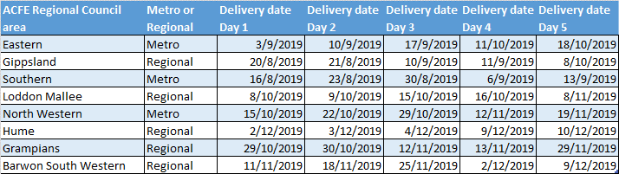

How to register your interest
To participate in the 30 hour course, please email pqfprojectofficer@gmail.com by 31 July 2019.
In your email, please include your name, Learn Local, suburb and region.
You will then be sent confirmation of the venue and location you will attend.
For enquiries, contact Kerry Cronjaeger at Rowville Neighbourhood Learning Centre on (03) 9764 1166.

