Family Learning Partnerships

2017 Program Guidelines

Introduction
The Family Learning Partnerships (FLP) Program guidelines provide an overview of the Adult and Community Further Education (ACFE) Board funded FLP Program, and an introduction to the Program’s background, purpose and overarching model.

Background
The ACFE Board, via the FLP Program, is committed to exploring ways to engage parents experiencing disadvantage in learning to help break the cycle of intergenerational disadvantage within families.
In line with the ACFE Board’s Strategic Plan 2016–19, the FLP Program contributes to building Learn Local Organisations’ (LLOs) capacity and partnership/network approaches and supports pathways to further education and employment. It is also an important contributor to the broader Education State agenda of ensuring that every Victorian is able to participate fully in society via access to quality skills and training.
Trial sites led by LLOs in 2015 established partnerships with schools, early childhood, community and health organisations to develop strategies for engaging parents experiencing disadvantage to participate in learning. The trial sites focused on three cohorts – Indigenous, vulnerable and newly arrived families.
The trial projects offered by each site were a mix of formal and informal approaches, which typically ran for 8–12 weeks. The emphasis was on providing relevant and flexible activities suited to the interests and learning needs of participating parents, delivered in a safe and supportive environment. The topics covered health and wellbeing issues, foundation and employability skills, motivation and perseverance and the participating parents’ engagement with society and their community. Importantly, the sites drew on parents’ innate aspiration for their children as a motivator for involvement; some sites also used shared activities with their children to encourage and support a parent’s attendance.

Context
Experience derived from previous trials and overseas studies shows that family learning approaches are successful because they draw on parents’ innate wish to support their children. This can be a powerful motivator in helping to overcome significant barriers to learning.
According to the Committee for Economic Development of Australia, four to six per cent of Australians experience entrenched intergenerational disadvantage. Building familial aspirations by providing information, support and access to education as a pathway to employment can break the cycle of generational disadvantage within families.
Research shows that parent’s educational attainment has an impact on families. Generally, adults who participate in education receive numerous benefits, including better personal development and wellbeing, employment outcomes and greater involvement in society. High parental engagement in education also produces positive outcomes for the child, which is known as the ripple effect.
The Learn Local sector is well placed to explore how to engage parents experiencing disadvantage in education and what is needed to support their transition to further training and employment. The FLP Program has provided a valuable opportunity for participating LLOs to understand the needs of families in their local community and build new partnerships or grow existing partnerships with local community providers, schools and early childhood organisations. It is an opportunity to collaborate with other LLOs that are participating in the FLP Program and to trial engagement techniques for new and previously hard to reach cohorts.

Creating the Ripple Effect
The traditional focus of family learning programs is on the learning outcomes for children and in some cases, the outcomes of both parent and child through shared learning activities.
The continuation of the ACFE Board’s FLP Program builds on these traditional models of family learning by focusing particularly on the learning outcomes of parents experiencing disadvantage whose educational attainment has the potential to benefit the wellbeing, educational outcomes and financial security of the whole family.
The FLP Program aims to engage and support parents to participate in learning and to set them on a pathway towards further education and employment.
To achieve this aim, the FLP Program will develop approaches for the following:
- forming strong collaborative partnerships between LLOs and other education or community based organisations ie. schools, community services, child care organisations etc.
- engaging and addressing barriers to learning for parents experiencing disadvantage
- using formal and informal learning activities to start parents on a pathway to further education and employment.
The previous trial sites engaged parents in learning using a variety of methods, including:
- introductory social activities
- informal learning
- intergenerational learning activities (parents and children together)
- enrolment in pre-accredited or accredited training.
The Evaluation noted that some of the critical factors for successful FLPs are:
- taking the time to develop and build trusting partnerships which are supported and developed via resources and structures
- engaging parents in locations where they feel comfortable
- demonstrating the relevance of learning to a parent’s life
- working with people who know the parents and their families
- developing specific strategies to address motivation and barriers to participation for parents
- building and maintaining connections to local support services to overcome barriers to a parent’s participation
- developing strategies to support parents’ progression towards further education and employment.
Based on the experience of previous trials, the FLP Program aims to achieve the following learner benefits:
- increased confidence
- increased aspirations
- increased knowledge and awareness of learning options and pathways
- increased access to support services
- increased participation in local community
- completion of informal and/or formal learning activities
- potential for flow on benefits to children/family aspiration and learning outcomes.

Family Learning Partnerships Program Model
The FLP Program is an opportunity for LLOs to build capacity and understanding about how education, particularly pre-accredited training, contributes to life outcomes for parents experiencing disadvantage, which will have flow on benefits for the whole family.
The FLP Program supports collaborative partnerships between LLOs and other education and community organisations to respond to the learning needs of parents experiencing disadvantage. These partnerships are responsible for identifying, understanding and responding to the needs of parents and the barriers preventing their participation in learning.
The partnerships will support and assist LLOs with the program and service delivery, identification of participants, marketing and provision of strategic support and advice. As a result, the partnerships draw on shared knowledge and networks to engage and connect parents to learning, and in turn, set them on a pathway towards further education and employment.
An overview of the FLP Program is at Appendix A.

Baseline data will be collected at the start of the project to track individual projects against the key outcomes listed below. This information will ensure that it is possible to assess participant engagement, retention and progress.
1) Engaging and addressing barriers to learning for parents experiencing disadvantage (social, economic or educational disadvantage).
2) Using formal and informal learning activities to help parents experiencing disadvantage to start a pathway to further education and employment.
3) Growing collaborative partnerships between participating LLOs, community based services and other educational organisations.
4) Effective and sustainable plans.

Communities of Practice (CoP)
The Department will work with new FLP participants and their partners to attend and contribute to existing place-based CoPs. The aim of the CoPs is that members become active participants who share knowledge, skills and experience through effective communication and shared resources. Participants may also identify as valuable subject matter experts who can provide leadership and advice to other organisations and groups. CoPs help build linkages between members and allow for greater knowledge sharing and insight into each other’s work.
CoPs are scheduled to meet on a quarterly basis in each region. Attendees will be representatives from LLOs and when available, their partnering organisations. A DET representative will also attend meetings to assist with facilitation and to capture information. Participating LLOs may also wish to communicate with each other outside of the formal meeting structure to develop engagement and participation strategies or seek advice.

The CoP model aims to:

• build strong foundations for the FLP

• build effective management and collaborative leadership

• encourage best practice

• build trust across Learn Local Organisation networks

• maintain motivation to actively participate in the FLP

Every six months, all FLP participants across Victoria will be invited to join a state-wide shared learning workshop, providing an opportunity to share learnings more broadly with all FLP participants.

The need to engage specialists or experts in particular areas of need will be identified during CoP meetings and will be engaged to attend the shared learning workshops to provide professional development for all participating LLO members.
Subject matter experts can provide information and advice on building skills related to:
- family violence and trauma
- drug, alcohol and addiction
- language or cultural barriers
- engagement and adult learning principles.

Support and Assistance
The day-to-day management and delivery of each project is the responsibility of the participating LLO and their partner organisations. Any problems, issues or risks can be discussed with the DET Project Manager as required.
It is important for each trial site to ensure that their staff are adequately supported. This means providing opportunities for them to de-brief and talk about the impact of their work on them both professionally and personally.
Any concerns should be raised with the LLO Program Manager, the DET Program Manager or key DET regional contacts who may use this feedback to contribute to sourcing and engaging professional development or expert support at the half yearly workshops for the benefit of all FLP participants.

Funding
The funding provided by the ACFE Board is designed to cover the costs of project delivery and establishing partnerships. Many sites have also sought funds from partners and other organisations to assist with their continued sustainability.

Each site will be required to submit a project budget, which includes the total funding contribution of $28,000 over two years from the ACFE Board to support each trial site’s implementation from June 2017 to June 2019. Participating LLOs will be asked to provide six monthly progress reports on project delivery. This will allow for tracking of project outputs and management of issues during the project life cycle. Please note: Please note that funding will be paid against key reporting milestones.

Application Process

To apply for FLP funding, LLOs should complete the attached Expression of Interest form and provide detailed responses to the following criteria questions:
- Please briefly describe your project proposal (no more than a page) and address how it will align to the outcomes of the Family Learning Partnerships Program?
- How will your project benefit families in your local community and respond to their learning needs and aspirations including connecting them to possible further education and/or employment pathways?
- What skills and previous experience does your organisation have in establishing community partnerships including any examples of previous successful partnerships with schools, early childhood services or other community organisations and/or Learn Local Organisations?
- How you will work in partnership with local organisations to actively participate in the Family Learning Partnerships Program and achieve sustainable outcomes for parents?

Successful FLPs should contribute to the ACFE Board’s strategic priorities through the following activities:
- Building quality of delivery through active participation in the CoP model that will provide opportunities for participating learn locals to seek support from one another collaborate and promote innovation in family learning.
- Aim to improve family learning practice and sustainability by facilitating collaboration to enable efficient management and administration, maximise resource utilisation, sharing of ideas and market intelligence. Incentivising the broader application of the FLP and sharing promising innovations between providers.
- Applications from LLOs who have experience working with disadvantaged or newly arrived families from the Horn-of-Africa are encouraged to apply.

Project Proposal responses in the expression of interest from will be assessed against the following criteria and key considerations by a departmental panel:
Criteria: | Key Considerations:
Completion of application | - Application is complete, concise, clear and all relevant information is provided.  - Application is submitted on time.
Partnering Arrangements | - Partnerships are identified and the project plan demonstrates the capability and capacity of the partnerships to be actively involved in project delivery.  - Applicants have assessed the readiness and availability of the proposed partnerships to contribute to the project.  - The principles and attributes of good partnerships are embedded in the partnering arrangements.
Project design is aligned to the FLP Program outcomes | - Engaging and addressing barriers to learning for parents experiencing disadvantage (social, economic or educational disadvantage).  - Using formal and informal learning activities to help parents experiencing disadvantage to start a pathway to further education and employment.  - Growing collaborative partnerships between participating LLOs, community based services and other educational organisations.  - Effective and sustainable plans.
Proposed project meets criteria | Responses to each criteria demonstrate ability and readiness to deliver a family learning project that is tailored to meet the needs of the local community.

Timelines
Successful organisations will be notified in writing and will be required to provide a detailed project implementation plan against the key outcomes over the life of the project. Successful participants will be invited to attend an induction workshop in June 2017 along with existing FLP participants.

Family Learning Partnerships Roles and Responsibilities
Below is an overview of the roles and expectations for each of those involved in the FLP Program.

Role of Learn Local participants:
- development of a sustainable project including engagement and learning strategies and pathways
- establish appropriate governance structures to ensure project progress and sustainability
- report risks to project delivery and seek assistance from the DET Program Manager
- participate in or lead evaluation activities to capture project outcomes
- maintain a focus on program outcomes (i.e. engagement of parents in their own learning and exploration of pathways into formal education and learning)
- develop and provide learning opportunities and assist participants to develop learning plans
- contribute to reports and resource development
- attend CoP meetings
- be active CoP participants by sharing knowledge, skills and experience.

Role of DET Program Manager:
- establish the CoP workgroups and membership, and ensure strong attendance from members
- oversee the day-to-day running of program sites
- coordinate workshops, meetings, activities and other communication mechanisms
- monitor and report on program measures and outcomes
- undertake ongoing planning activities throughout the program lifecycle
- liaison between Department, CoPs and participating LLOs
- report progress back to the ACFE Board and manage contracts.

Role of Community of Practice Groups
- development of members’ capabilities and professional skills
- building and exchanging knowledge
- sharing of experience, values, and expert insights
- helping participants address actual or potential problems
- assisting in the transfer of good practice
- capturing the ‘practice’ that underpins the community (e.g. the ideas, stories and documents that community members share)
- producing long-term benefits for service provision.

Role of Experts:
- Funding has been set aside to engage subject matter experts on an ‘as needs’ basis to provide practical advice and information to assist and support CoP members.
- Experts will be engaged to attend six-monthly workshops as part of the performance development of participating LLO members. Sessions may be made available via webinar.

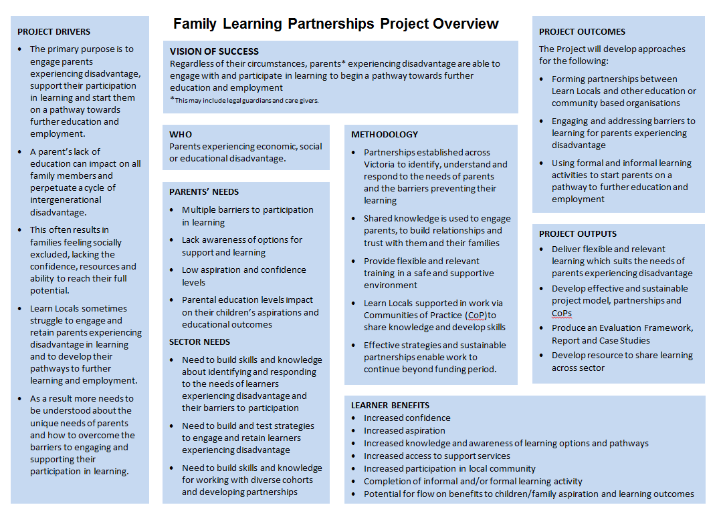
Appendix A

Appendix B
