Higher Education and Skills Group

Participation Branch Memo

Department of Education and Training

NUMBER: 2016 / May / 05

TO: Learn Local organisations, ACFE Board, ACFE Regional Councils, Participation Branch Staff

FROM: Ryan Collins, Acting Director, Participation Branch

DATE: 5 / 05 /2016

SUBJECT: It’s a Date! 2016 Learn Local Conference
____________________________________________________________________________________
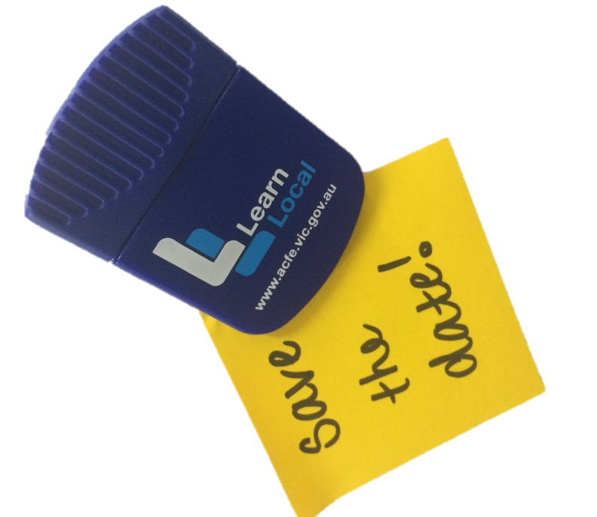
The ACFE Board are planning a Learn Local Conference for August 2016!

Please hold Tuesday 30th and Wednesday 31st August in your diaries for an exciting and engaging conference in Melbourne.

The Conference Learning from the Past: Planning for the Future will support and develop the work of Learn Locals beyond 2016.

Further details, including accommodation details will be provided shortly.

Places will be limited to 200 and every effort will be made to ensure that as many Learn Local organisations as possible are represented.

