CMM CGEA PD day 2015
Theme: Assessment Validation (session 3)
Thursday November 19th
9.30am – 3.30pm
Victoria University, 300 Flinders Street, Melbourne
Level 11, Room 11.07

Registration from 9.30am

Tea and coffee on arrival

Session 1: 10.00am – 10.20am Welcome and introduction : Overview of series: Room 11.07

Nadia Casarotto/Cheryl Bartolo Curriculum Maintenance Manager (CMM) General Studies and Further Education

This session provides a summary of the previous 2 sessions in this PD series and reviews the components which need to work together to create a quality assessment system.

Session 2: 10.20am – 11.30 pm Putting it all together: Bernadette Delaney-Room -11.07

This session will bring together the essential components of an assessment system with an emphasis on developing and analysing a sample CGEA assessment tool. It will identify key critical questions which must be considered in the design of CGEA assessment tools. The areas that will be covered will be professional competence of assessors, mapping the unit of competency requirements and the importance of constructing assessment exercises that suit your learners and cover the unit. You will examine how to develop assessment criteria to make your assessment judgements as well as what evidence you should keep.

11.30 – 11.50.am Morning tea (networking and informal discussion)

Session 3: 11.50am- 1.20pm Breakout sessions Rooms 10.49, 11.09, 11.10

This session will review the assessment tool discussed in session 2 to identify gaps in assessment and how these gaps can be addressed so there is full coverage of the unit/s.

Lunch:1.20pm-2.00pm

Session 4: 2.00-3.15pm Completing the assessment picture

This session will share ideas about assessment tasks from session 3. The session will highlight the benefits of using a range of assessment approaches. It will also include an opportunity for a question and answer session.

Please bring a copy of the following units with you:
VU21302 Engage with simple texts to participate in the community
VU21306 Create simple texts to participate in the community

This is an ACFE Board funded activity – no cost to participants. Priority will be given to Learn Local representatives. Program subject to change.

Bernadette Delaney has extensive experience in the Vocational Education and Training sector, in a wide variety of roles, including teaching, research, quality assurance and setting up training systems, as well as auditing of Registered Training Organisations.
She has designed, delivered and managed professional development projects at the national and state level and has delivered professional development in sessions and online for a range of VET practitioners.
Recently, she has researched assessment practices in a range of industry and education sectors. Bernadette advises RTOs on establishing training and assessment resources and meeting compliance standards, by professionally developing teaching staff. She also has been involved in the redesign and writing of training packages.

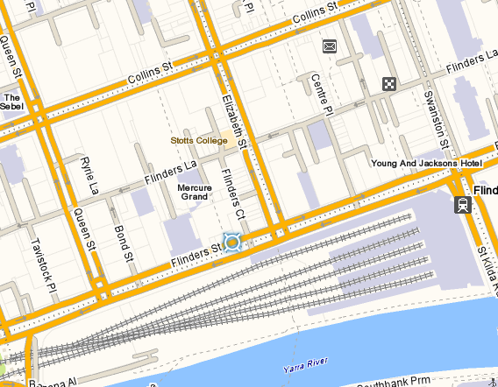
Victoria University 300 Flinders St Melbourne

